Shane Sarnac
Project Part 2 – Individual
Revamp Rezlife

Check out item / check in item

Use Case ID: | USR-012
Use Case Name: | Check out item (to a Resident)
Description: | The Community Assistant (CA) receives a notification that an item at the desk has been requested. The CA finds the item, indicates that the item is ready, and checks out the item to the requesting resident once the resident arrives.

Actors: | Community Assistant
Pre-conditions: | CA receives a notification that one or more items have been requested to be checked out by a resident.
Post-conditions: | The requested items are checked out to the requesting resident and logged with the items checked out, when the items were checked out, the Resident the items were checked out to, and the CA that checked out the items.
Frequency of Use: | Multiple times a day
Flow of Events:
   | Actor Action | System Response
  1 | Reads notification containing list of items and resident information | Displays list of items requested and resident information
  2 | Locates all items on list and places them in a staging area
  3 | Pushes button on request message indicating that the items are ready | Sends notification message to the requesting Resident indicating that the items are ready
  4 | Swipes requesting resident's BuffOne card to confirm identify | Reads swiped BuffOne card information and compares to key information stored in database, indicating whether it is ok to check out the items to the resident
  5 | Confirms checkout by clicking “Check out item” button | Updates item logs with the date, items checked out, resident checking out the items, and the CA that checked out the items
Variations: | 1. Resident requests items from the desk in person (removes need for step 3)
Exceptions: | If in step 4, the requesting resident fails to provide a BuffOne card or has been given status of being unable to checkout items, the CA should cancel transaction
Developer Notes:

Use Case ID: | USR-024
Use Case Name: | Check out item (Resident)
Description: | The Resident requests one or more items from the list of available items and picks them up once the CA indicates that the items are ready.

Actors: | Resident
Pre-conditions: | Resident successfully logs into system and Resident is allowed to check out items
Post-conditions: | The Resident Profile has a record of all items checked out
Frequency of Use: | Daily to Occassionally
Flow of Events:
   | Actor Action | System Response
  1 | Navigates to desk item checkout list | Displays checkout list
  2 | Checks item(s) wanted and clicks “Reserve Item” | Sends notification to CA listing all items. Displays notification once CA indicates that the items are ready.
  3 | Resident collects items from front desk after identification verification | Updates item logs with the date, items checked out, resident checking out the items, and the CA that checked out the items
Variations: | 1. The resident could avoid this case by simply going to the desk and requesting the items in person  3. If the resident is unable to provide a BuffOne card or fail identity verification processes, the resident cannot leave with the items and the database will not be updated
Exceptions:
Developer Notes:

Activity Diagram
Requirement ID: USR-012 and USR-024
Use Case ID: None, combined Use Cases from USR-012 and USR-024
Use Case Name: Check out Front Desk Item (Resident and CA)
Diagram Implementer: Shane Sarnac

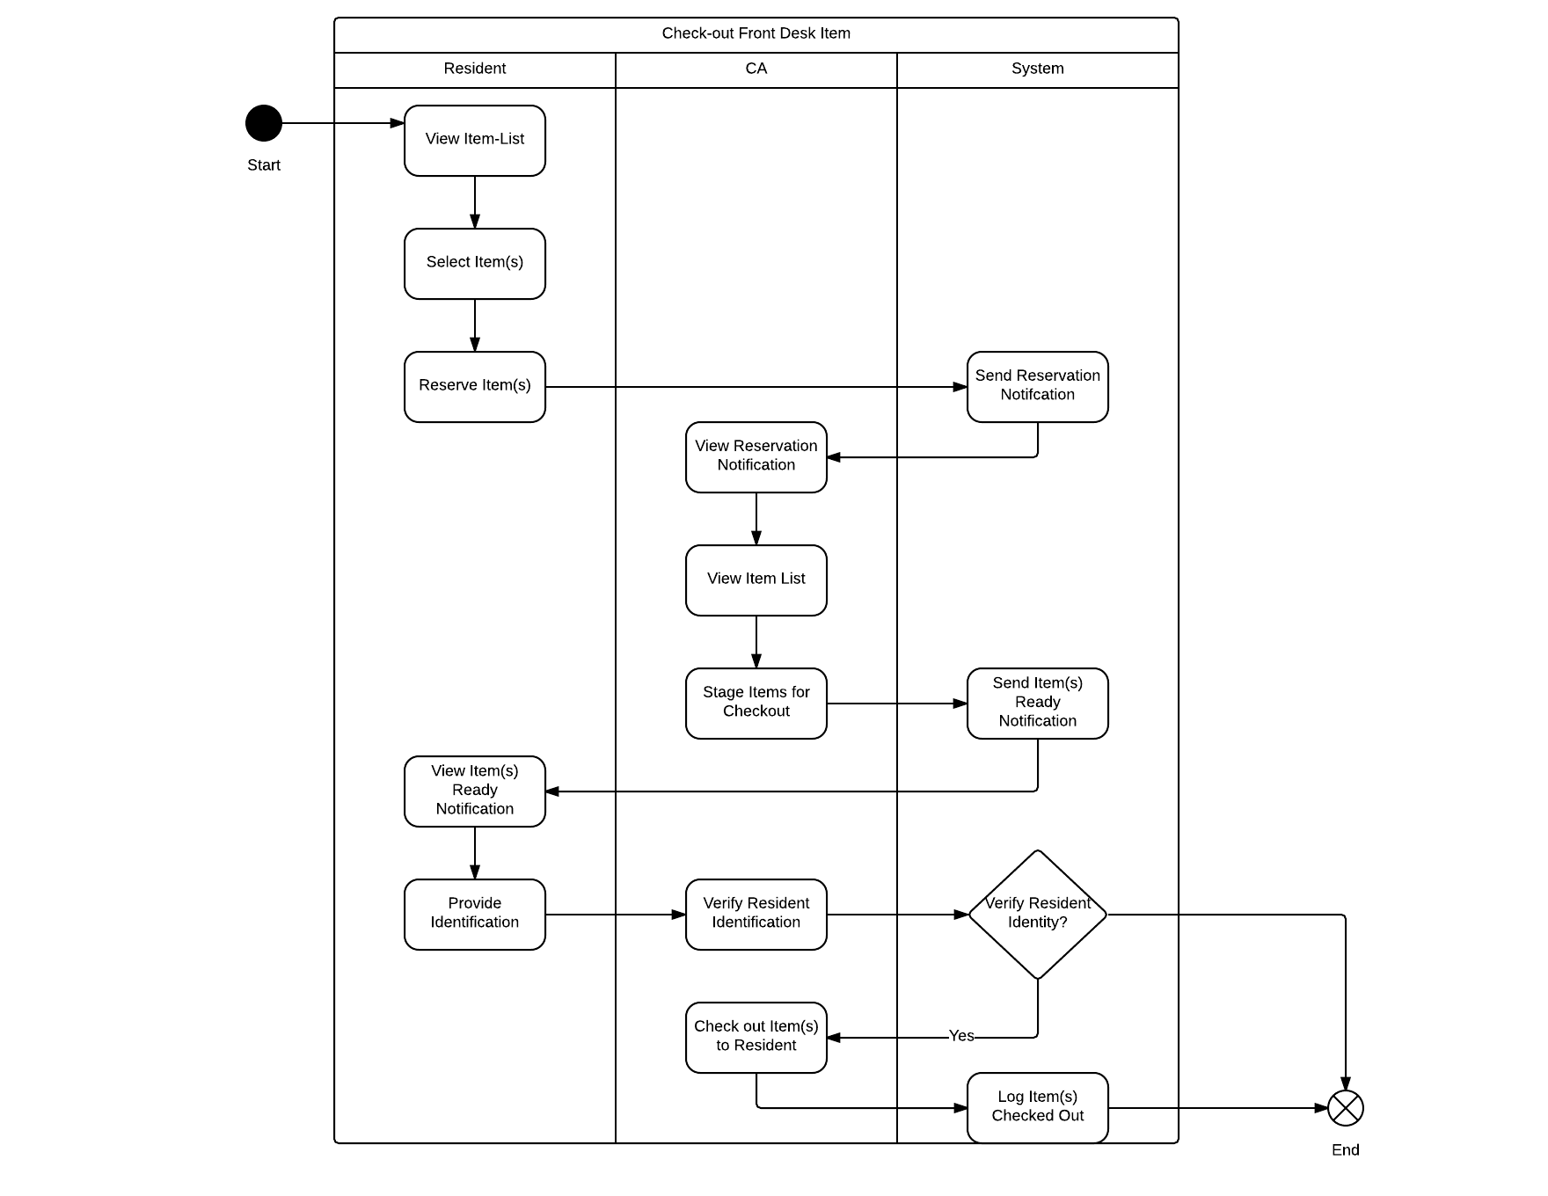
Sequence Diagram:
Requirement ID: USR-024
Use Case ID: USR-024
Use Case Name: Check out Front Desk Item (Resident)
Diagram Implementer: Shane Sarnac

