**Developing an IoT Android Application for Controlling and Monitoring a Smart Home System**

A REPORT SUBMITTED TO MANCHESTER METROPOLITAN UNIVERSITY FOR THE DEGREE OF BACHELOR OF SCIENCE IN THE FACULTY OF SCIENCE AND ENGINEERING



2021

By: Aubrey Monk

Supervisor: Dr Amna Eleyan

School of Computing, Mathematics and Digital Technology

Contents

Declaration ii

Acknowledgments iii

Abstract iv

List of Figures v

List vi

Abbreviations vii

Introduction 1

Literature 2

Design 3

Implementation 4

Evaluation 5

Conclusion 6

References 7

Bibliography 8

Appendices 9

# Declaration

No part of this project has been submitted in support of an application for any other degree or qualification at this or any other institute of learning. Apart from those parts of the project containing citations to the work of others, this project is my own unaided work. This work has been carried out in accordance with the Manchester Metropolitan University research ethics procedures and has received ethical approval number 2020-26247-20539.

Signed:

# Acknowledgments

I’d like to thank my project supervisor Dr Amna Eleyan for the support and guidance throughout this project and, for fantastic teaching throughout my time here.

I’d also like to thank: Dr David McLean, Connah Kendrick, Dr Bob Cherry, Marie Carrol, Stephen Gordon, Laurie Cooper, Dr Matthew Crossley, Dr Giovanni Masala, Dr Kristopher Welsh, Dr Mohammed Kaleem, Dr Matthew Shardlow, Dr Ryan Cunningham, Dr Nicholas Costen, Dr John Darby and Dr Ashley Williams for all being outstanding lecturers and tutors during my course and inspiring my passion for Computer Science.

Finally, I’d like to thank Luciano Gerber and Sandra Brooks for helping me through one of my toughest times here by offering tremendous guidance and support, I wouldn’t have made it this far without you.

My gratitude to you all for everything you have done.

# Abstract

The aim of this project is to design and develop an Android application capable of controlling and monitoring a smart home system.

This was done by creating an Android application capable of enabling a user to control and monitor smart home devices, a client which is connected to the devices and is capable of sending and receiving information between itself and the Android application, a database on which a user’s account information and currently active smart home devices are stored, and also an application programming interface to allow the Android application to communicate with the database. The project was successful as the application developed allowed a user to control and monitor several kinds of smart home devices effectively.

# List of Figures

# **List** **of** **Tables**

# Abbreviations

IoT Internet of Things

MQTT Message Queuing Telemetry Transport

PC Personal Computer

API Application Programming Interface

SQL Structured Query Language

JS JavaScript

TCP/IP Internet Protocol Suite

USB Universal Serial Bus

DDoS Distributed Denial of Service

UI User Interface

ERD Entity Relationship Diagram

# 1 Introduction

## 1.1 Project Background

Smart home automation systems have become increasingly common in the last decade due to the arrival of the Internet of Things (Ali et al., 2020). The Internet of Things is an “interconnection of sensing and actuating devices providing the ability to share information across platforms through a unified framework, developing a common operating picture for enabling innovative applications. This is achieved by seamless ubiquitous sensing, data analytics and information representation with Cloud computing as the unifying framework.” (Gubbi et al., 2013:1647) for IoT to be able to connect such a large number of devices it needs to have a flexible and layered architecture, the most basic model of IoT consists of a 3 layer architecture which includes the Perception, Network and Application layers (Choudhary and Jain 2016).

There are many different applications of IoT including wearables, agriculture, smart grids, hospitality, connected health, smart cities and more, but this project will be focused on its smart home automation applications. A smart home system is normally made up of IoT devices such as cameras, sensors, actuators, and appliances that can be accessed remotely, typically through a centralised hub or application (Rizvi et al., 2018) as shown in Figure 1 below.

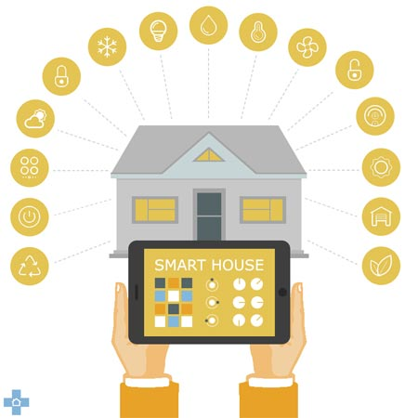

Figure 1: “The things home automation can do” (Source: Diy Doctor, 2020: online).

For IoT devices to be able to transmit data over a network they need to use a certain protocol, the main protocol that will be used in this project is MQTT which is very lightweight and usually runs over TCP/IP and uses a publish/subscribe concept to transfer information through a broker.

Smart home systems can also increase the quality of life for many (Miah and Khan 2019), especially for certain groups of people such as the blind and visually impaired. For instance, if a blind or visually impaired person needed to use one of the devices or appliances in their home, lock/unlock the doors or control the temperature/lights they can do so using a voice command through a smart home control application; this cuts out the need for any physical interaction making the task significantly easier. Also, sensors such as motion and sound can be used to monitor the well-being of the inhabitant and detect if any assistance is needed. A huge benefit of this system is that it is much more cost efficient and favourable than having the support of a personal assistant (Rizvi et al., 2018). Figure 2 below shows thirteen main benefits of smart home technology.

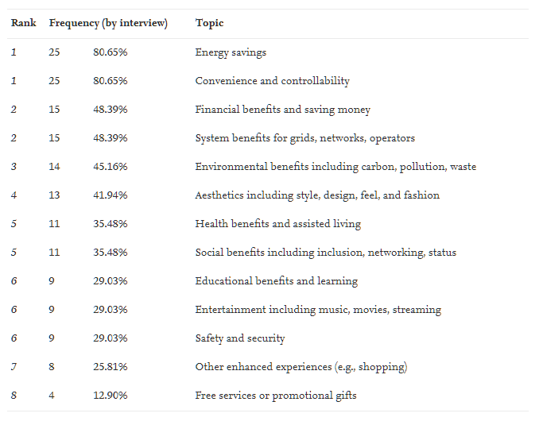

Figure 2: “Thirteen smart home technology benefits discussed by expert interview respondents” (Sovacool and Furszyfer Del Rio 2020).

Despite the numerous benefits of smart home technologies and systems they do come with many risks and social barriers, the main social barrier that is addressed within this project is the high cost of smart home systems and there accessibility towards a wider range of people.

The smart home devices used in this project are all Phidget devices which are inexpensive electronical components and sensors which can be connected to a computer via a USB connection. The project is made up of four main components: A React Native Android application, a JavaScript API, a MySQL relational database and a Java PC client. The Android application provides a user interface enabling a user to add their Phidget devices to the system and monitor/control the added Phidget devices. The Android application can communicate with a database via the API, the database used is a MySQL relational database running on the university’s ‘mudfoot’ server. This database can contain a user’s account information and connected Phidget devices, this means the system can support multiple users. The client runs on a computer that has all the Phidget devices connected to it, the Android application can communicate with this client through an MQTT broker, meaning that any Phidget devices connected can be controlled or monitored.

## 1.2 Aim

The aim of this project is to create an Android application that allows a user to control or monitor smart devices within their home, the system must be cost-effective, efficient and easy to use, this is so that it is more accessible to a wider range of people than some of the systems and devices that are currently on the market.

## 1.3 Objectives

* Find existing related works and mobile applications for controlling and monitoring smart home systems
* Identify user requirements and features
* Research and choose an appropriate software design methodology
* Research appropriate languages and technologies that can be used for Android applications, APIs, clients, databases, and voice recognition
* Research UI design that can be used for Android applications
* Research and choose appropriate smart home devices
* Design and Wireframe Android application
* Design database system
* Design API used to communicate with database system
* Design PC client that will be connected to the smart home devices
* Implementation of the Android application, database system, API and PC client and voice recognition
* Thoroughly test and evaluate the system and provide the results
* Conclude project with summary of the created application, the results produced and provide suggestions for further related works

## 1.4 Report Structure

* Chapter 1 – Introduction
* Chapter 2 – Literature Review
* Chapter 3 – Design
* Chapter 4 – Implementation
* Chapter 5 – Evaluation
* Chapter 6 – Conclusion

# **2 Literature Review**

## 2.1 Benefits of Smart Home Technology

There are numerous benefits of smart home technology, this section of the literature review will look at other research conducted towards identifying some of these benefits.

Smart home systems can make life significantly easier, more comfortable, and convenient. These systems are also able to provide peace of mind, for example if you’re away from home you can use these systems to monitor your house, for instance it could provide the ability to detect an intruder or provide help in case of an emergency, as you could potentially be notified when the fire alarm is activated and have the ability to unlock doors and call for help. Smart home technology also can provide assistance to the elderly and disabled that are living alone, it can be used to monitor health, contact carers/emergency services in case of an accident and also help with daily tasks that may be difficult to the user or even tasks that they may have forgotten to do (Robles and Kim 2010).

The first study found carried out multiple expert interviews and performed a frequency analysis of the benefits stated during these interviews, the results of which can be found in Figure 2 [Chapter 1.1]. The analysis results show that the most prominent benefits identified were energy savings and convenience/controllability. Others include safety and security as well as health benefits and assisted living. (Sovacool and Furszyfer Del Rio 2020).

Another study found carried out a national survey that characterised how the prospective users viewed the benefits of smart home technology; Figure 3 below shows these results.

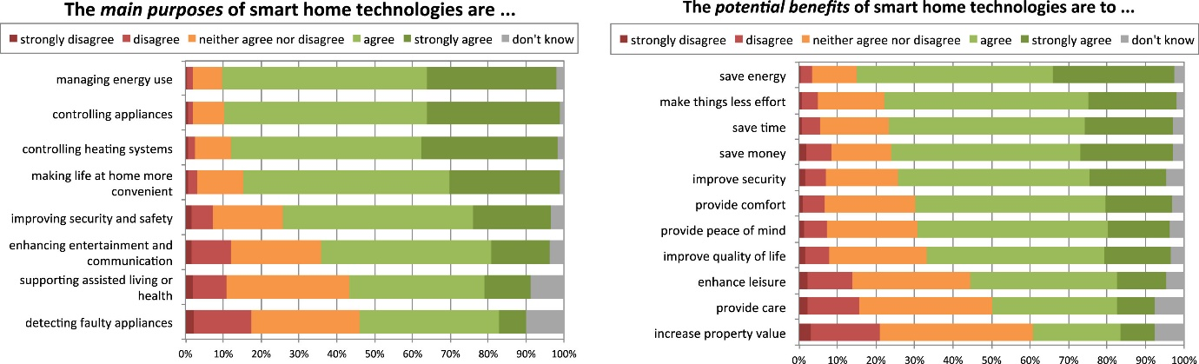

Figure 3: “Prospective users’ perceptions of the purpose & benefits of smart home technologies” (Wilson et al., 2017)

Again, we can see that some of the benefits identified by the participants include, managing/saving energy consumption and convenience, supporting assisted living and safety/security.

## 2.2 Security Risks and Social Barriers of Smart Home Technology

### 2.2.1 Security Risks

Network security is a major concern with smart home systems, private and personal information exists on two different mediums within a network, either it is stored physically on a hard disk or it can be transported across a network. Here are 5 known methods used to compromise this information:

* *Packet sniffers*
* *Password attacks*
* *IP Spoofing*
* *Man-in-the-middle attacks*
* *Distribution of sensitive internal information to external sources*

(Robles and Kim 2010).

Privacy is a major concern when it comes to this personal information, smart home systems could potentially have different devices, sensors and cameras that collect information. If someone obtained this data, it could be used for various malicious purposes. Another possibility is if a hacker gained access to an inhabitant’s passwords, they could use this to gain unwarranted access into the inhabitant’s home.

Another security threat is Distributed Denial of Service Attacks, a DDoS attack is a coordinated, large scale attack on a network’s resources or the availability of a systems services (Robles and Kim 2010). If an inhabitant relies on the services provided by their smart home, then a DDoS attack could provide major problems if the network or services are taken down for a long period of time.

### 2.2.2 Social Barriers

There are many different difficulties and social barrier when it comes to adopting smart home technology some of these include technical, conceptual and management issues (Balta-Ozkan et al. 2013). This section of the literature review will cover some of these in further detail.

Overall, the main reasons such barriers exist is due to the perceived risk of the consumer, normally stemming from uncertainty and possible negative consequences (Hong et al. 2020). A few perceived risks include performance risk, privacy risk, psychological risk, and financial risk. Consumer survey results show that financial risk is the main barrier for adopting smart home technologies (Hong et al. 2020). Another survey found also suggested that cost of these technologies posed as a barrier, multiple groups from the survey agreed that the adoption of this technology was only worthwhile for financially stable long-term home owners, excluding inhabitants of rented or council properties or those on a lower income (Balta-Ozkan et al. 2013).

## 2.3 Smart Home Hubs and Devices Currently on The Market

A smart home system typically comprises of multiple IoT devices normally connected to a central hub, however there are also standalone devices that do not requires a hub. This section of the literature review will cover existing smart home systems, hubs and devices that are currently on the market.

### 2.3.1 Google Nest Hub Max

The Google Nest Hub Max is a 10-inch smart display which supports Wi-Fi, Bluetooth, and Thread connections. From the display you can watch videos, play music, make video calls, and control any Google Home compatible devices. The Nest Hub Max retails at around £219 (Google 2021)

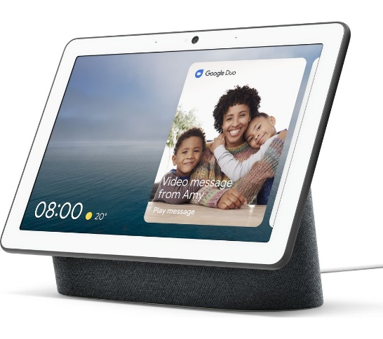

Figure 4: “Google Nest Hub Max” (Source: Google Store, 2021: online).

### 2.3.2 Amazon Echo (4th Gen)

The Amazon Echo is a smart speaker that acts as a smart home hub. It supports Bluetooth, Wi-Fi and Zigbee connections. The Amazon Echo uses Amazon Alexa as a voice assistant which allows the user to control smart devices through voice commands and configure complex routines and schedules. It also uses Zigbee radio which means it can connect to many different low power smart home devices such as sensors and lightbulbs. The Amazon Echo retails at around £89.99 (Amazon 2021)

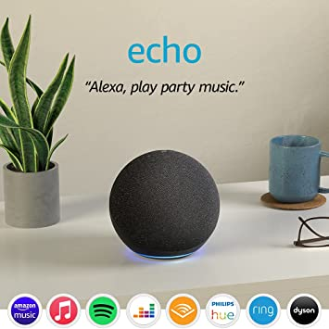

Figure 5: “Amazon Echo (4th Generation)” (Source: Amazon, 2021: online).

### 2.3.4 Samsung SmartThings Hub v3

Samsung SmartThings Hub v3 is a smart home hub, it supports Samsung’s own smart home devices but also many others on the market allowing you to control, monitor and schedule these devices via an IOS or Android mobile application. The Samsung SmartThings Hub v3 retails at around £90.98 (Amazon 2021)

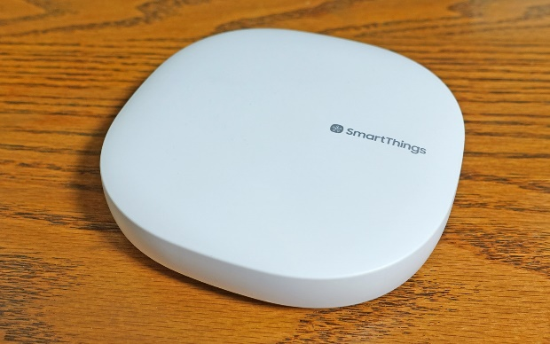

Figure 6: “Samsung SmartThings Hub V3” (Source: Tom’s Guide, 2021: online).

### 2.3.5 August Wi-Fi Smart Lock

The August Smart Lock is a battery powered lock that is controlled over a Wi-Fi connection. You are able to control the lock using the August mobile application and it also supports a very wide range of other hubs, platforms and devices including some of the previously mentioned smart home systems. The August Wi-Fi Smart Lock retails for around $249.99 (August 2021)

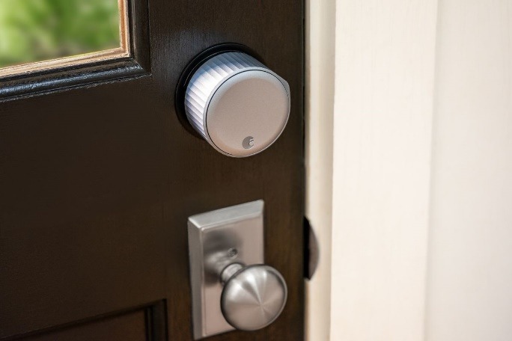

Figure 7: “August Wi-Fi Smart Lock” (Source: The Verge, 2021: online).

### 2.3.6 Phillips Hue

Phillips Hue is a range of smart lightbulbs and devices that support an extremely wide range of other platforms, smart hubs, and smart home systems. The reason Phillips Hue can support so many devices is because they have an open and accessible API allowing almost anyone to develop software for use with the Hue technology. There is also a Phillips Hue mobile application that allows for control of all the Phillips Hue devices over a Wi-Fi connection. The Phillips Hue Starter kit E27 retails for around £119.99 (Phillips 2021)

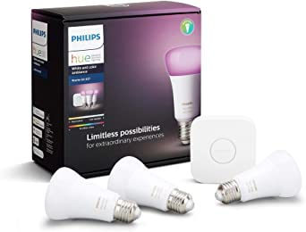

Figure 8: “Phillips Hue Starter Kit” (Source: Amazon, 2021: online).

## 2.4 Programming Languages and Technologies

### 2.4.1 Android applications

There are lots of different options when it comes to choosing a programming language for Android application development, some of the most popular languages include: C++, C#, Python, Corona, Java, Kotlin and JavaScript. The two that will be focused upon in this chapter are JavaScript and Java.

Java is an object orientated programming language and is the most popular language used for Android development. The benefits of Java are that it is high-level, has simple syntax, automatic memory management and has a large supporting community around it. However, a major drawback is that it takes a long time to develop in Java as it can have large and highly complex code.

JavaScript is used alongside many different frameworks when it comes to application development such as: Titanium, React Native, Meteor, Rachet and many other. The main framework that will be focused upon is React Native. React Native is an open-sourced framework created by Facebook and is used to develop applications for many different platforms. React native is easy to learn saving lots of time, its flexible in the sense that it is easy to upgrade and change code, it also offers high performance as applications written in React Native perform the same as a native application running on a specific platform, and unlike Java the code is not so large and complex as React is normally used for simpler applications.

### 2.4.2 APIs

Popular languages for the development of APIs include: Java, Python, NodeJS (JavaScript runtime environment) and C#. This section will be focusing on Python and NodeJS for API development.

Python is easy to use and very popular within all kinds of academia, it is dynamically typed and very flexible. However, Python is an interpreted language meaning that speed can sometimes be an issue.

NodeJS is a JavaScript runtime environment that offers a sturdy and robust technology stack, it fast, scalable in nature and supports JSON seamlessly. However, the complex nature of callback functions in NodeJS can cause lots of issues and can take time to debug. NodeJS can often experience bottlenecks with tasks that require high computation.

## 2.5 User Interface and Usability

### 2.5.1 The Golden Rules

Ben Shneiderman set out 8 Golden rules for an applications usability, they are as follows

1. *Strive for consistency*
2. *Seek universal usability*
3. *Offer informative feedback*
4. *Design dialogs to yield closure*
5. *Prevent errors*
6. *Permit easy reversal of actions*
7. *Keep users in control*
8. *Reduce short-term memory load*

These rules provide a starting point when taking an applications usability into account, they aim to increase a user’s productivity, increase competence, and give as much control as possible over a system (Shneiderman. et al., 2016).

### 2.5.2 Contrast, Colour, Size and Space

Contrast is important to consider when designing a UI, its primary purpose is to generate interest. It is important to have contrast between the primary actions of a screen/page and the other elements. Colours are typically divided into two groups, warms colours and cool colours. Typically, warm colours tend to overpower cool colours meaning they are good to use for the main elements of a screen/page (Williams 2021).

When choosing a colour scheme there are a few different accepted compositions that can be chosen from:

Triadic (Figure 9: “Triadic Colour Structure” (Source: visual composer, 2021: online)):



Split Complementary (Figure 9: “Split Complementary Colour Structure” (Source: visual composer, 2021: online)):

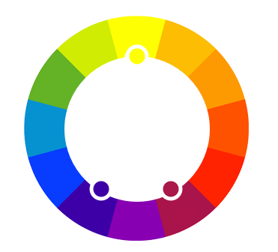

Analogous (Figure 9: “Analogous Colour Structure” (Source: visual composer, 2021: online)):

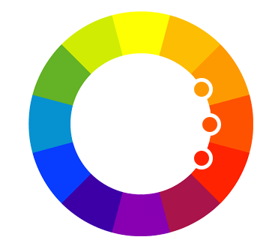

It is also important to consider the use of size and space when designing a UI, things emphasize or de-emphasize a specific elements of the UI whereas a good use of space can decrease visual noise and once again help the other main elements stand out (Williams 2021).

## 2.6 Summary of Literature Review

As revealed by this literature review there are multiple benefits of smart home technology that gives an incredible motivation into the development of this application and system. However, there are many risks and barriers to be considered such as security and most importantly financial risk for the consumer. Many of the products currently on the market would cost a large sum of money as you would need to purchase a smart home hub along with many smart devices. This project aims to deliver a smart home system that is secure and affordable. This will be done by taking security precautions during development of the system and to keep things affordable the project will be using inexpensive electronical components to act as the hub and smart home devices. Upon review, React Native will be chosen for the Android Applications development, Java will be chosen for the client (smart home hub) and NodeJS for the API. This project also aims to follow the “8 Golden Rules” [Chapter 2.5.1] for usability as closely as possible and hopes to create an efficient, easy to use and well thought out user interface that will allow a user to have full control over any smart devices in the home.

# 3 Design

The Design chapter cover all the tools, technology’s, languages, and design techniques that were considered before implementation of the system and the reasons behind these choices. This chapter also covers the development methodology and planning of the implementation required so that development could run as smoothly and efficiently as possible.

## 3.1 Development Methodology and Version control

The development methodology chosen for this project was the Waterfall methodology but with some aspects of the Agile methodology included at each stage of development so that if any bugs, problems or system changes arise occur they can be reviewed and dealt with easily. For version control of the system, GitHub was chosen.

### 3.1.1 Agile Development Methodology

The Agile methodology revolves around an iterative development of a system where features of the system are delivered incrementally as opposed to all at once, this means that features can be reviewed at each stage and feedback can be given. This type of development is low risk as if the requirements of the system change or bugs are found they can easily be dealt with before the system is finished.

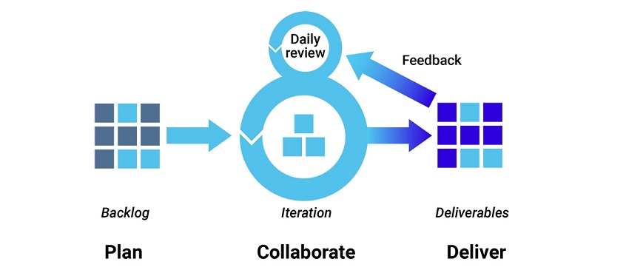

Figure 10: “Agile Development Methodology” (Source: Synopsys, 2021: online).

### 3.1.2 Waterfall Development Methodology

The Waterfall development methodology consists of certain steps that are completed in a linear fashion. Each phase must be completed before the next one can begin. This methodology is very simple however, it means that it is hard to react to requirement changes, bugs or other problems that may occur during the development process.

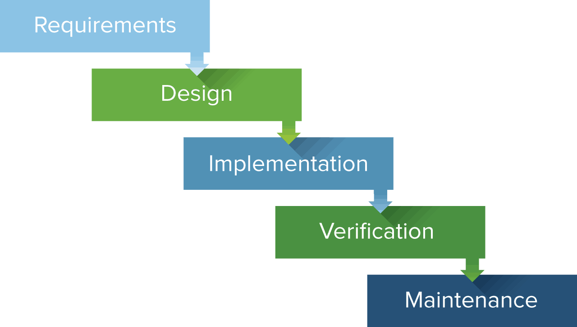

Figure 11: “Waterfall Development Methodology” (Source: Wikipedia, 2021: online).

### 3.1.3 Version Control

GitHub (<https://github.com/>) was the chosen platform for version control. GitHub is a platform for collaboration and version control of a project, you are able to commit your code to a repository hosted online, you can also create separate branches of the project that can be used for keeping bug fixes or certain features separate. You can access the project from any device by creating a pull request for a specific branch so that changes to the code can be made from anywhere. The repository for this project can be found here: <https://github.com/Aubrey-Monk/Smart-Home-System---3rd-Year-Project>

## 3.2 Overall System Design

The first major part of the design process to be considered was the overall design of the system, this was important as it led to choosing the appropriate technologies used in the system. It also gave insight into how each component interact with each other.

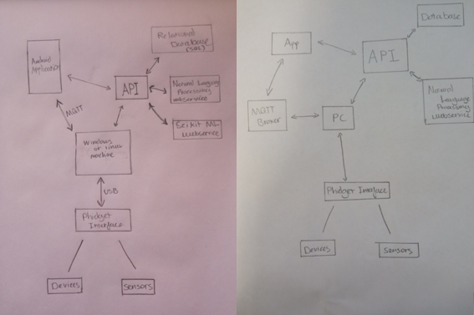

Figure 12: “First 2 Attempts at Overall System Design”

Figure 12 shows the first 2 diagrams created to illustrate overall system design, these were both drafts and came with issues and inconsistencies.

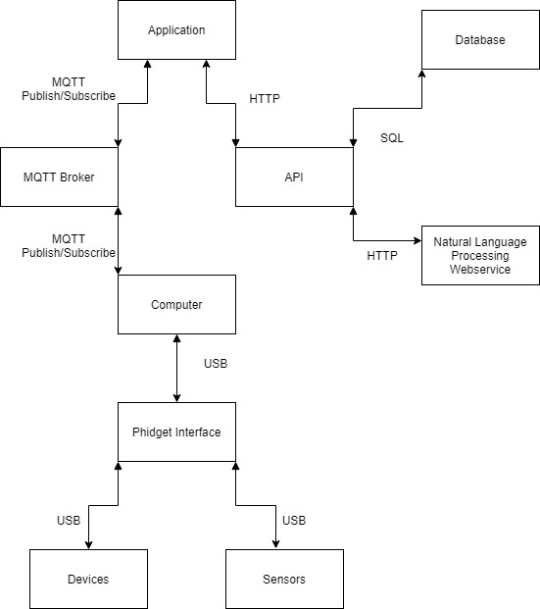

Figure 13: “Finalised Overall System Design”

Figure 13 shows the final diagram for the overall system design, the boxes show each individual component, the arrows show the direction of information travel and the labels represent the medium across which the information sent between the system is travelling.

## 3.4 Android Application Design

This section covers all the choices made and includes all the diagrams created when designing the Android Application.

### 3.4.1 Framework and Environment

The framework chosen to develop the application was React-Native, the application needs to be of little complexity to keep it efficient as possible, it also needs to be able to handle the API responses in a flexible manner. React-Native works well for both these purposes, it runs natively on the device so performance is great, and the UI options are extremely flexible. React code is quick to write and easy to learn which is also another great benefit of choosing this framework.

The development environment chosen was Visual Studio Code with the ESLint (Code Linter) and Prettier plugins, these were both used to improve code quality also, to reduce errors. The style guide chosen for the linter was Airbnb. Found here: <https://github.com/airbnb/javascript>

### 3.4.2 User Requirements

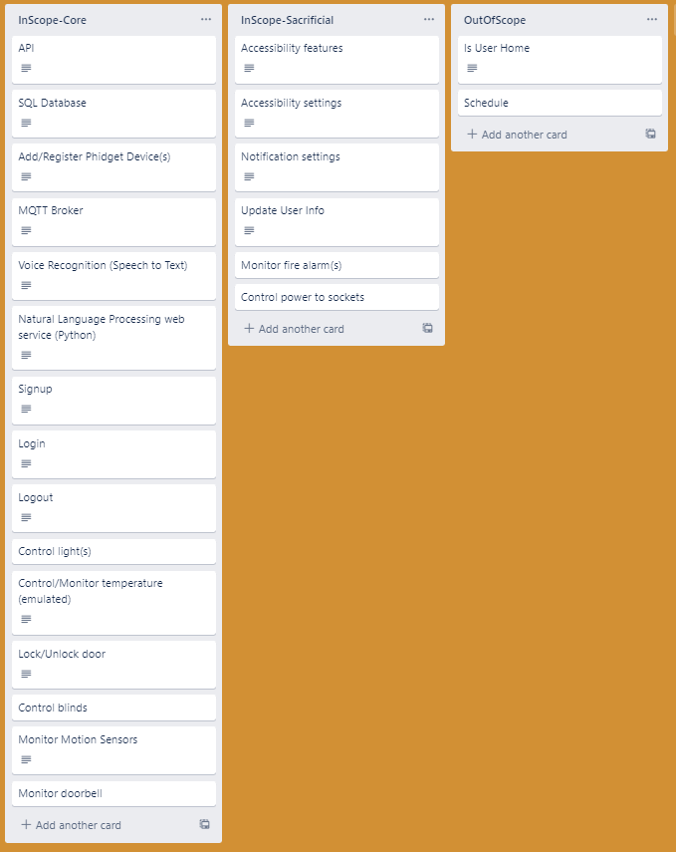

Figure 14: “Lists of Android Application Requirements”

Figure 14 outlines the user requirements of the application, it includes the core, sacrificial and out of scope requirements, this list was extremely useful in designing the rest of the application as it provided a basis of which features need to be included.

### 3.4.3 Use Case Diagram

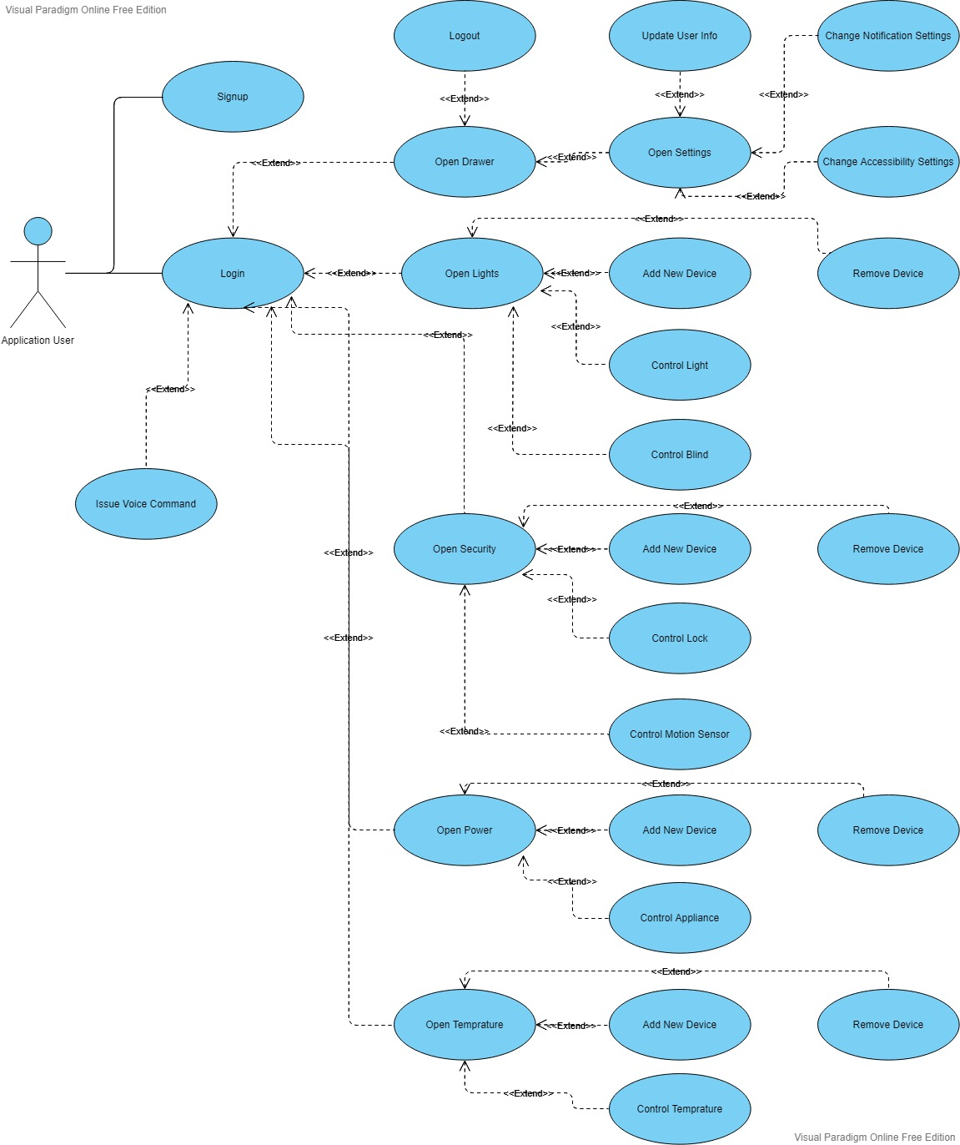

Figure 15: “Use Case Diagram of Android Application”

Figure 15 Is a Use Case diagram of the application and is used to see every possible action a user can perform; it visually represents the user requirements.

### 3.4.4 Draft Wireframe

Below is the draft wireframe of the application, drafting the wireframe proved important as it allowed a visualisation of application and aided in refining the UI design. It also provided insight into the navigation structure of the application.

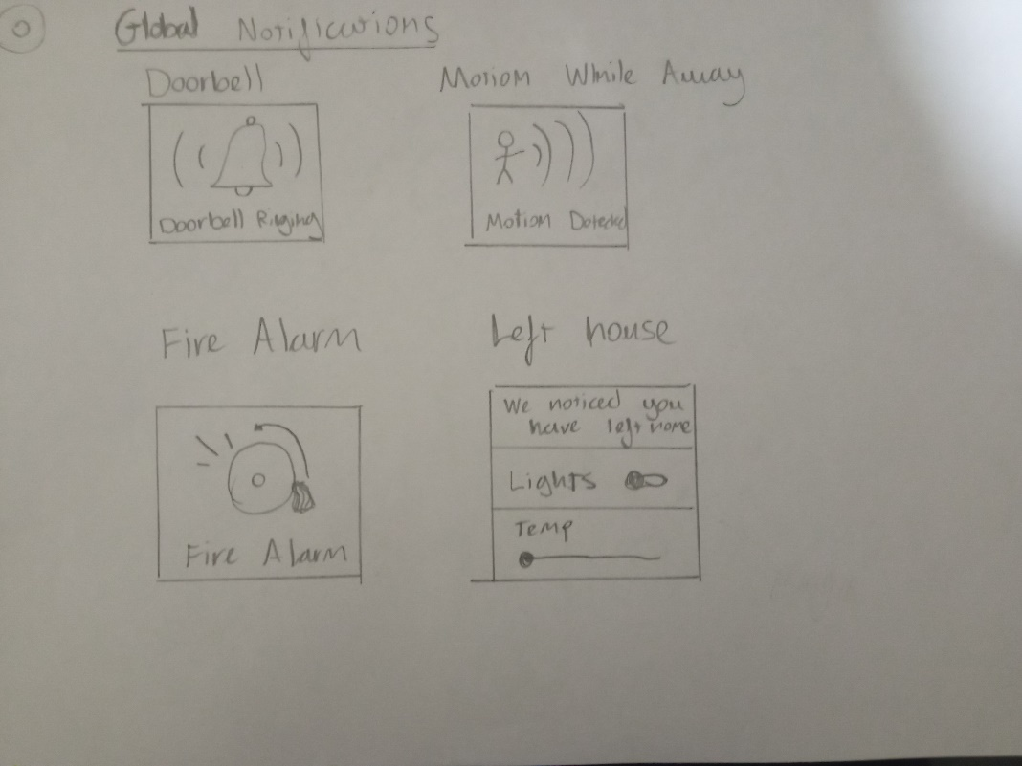

Figure 16: “Page 0 of Draft Wireframe”

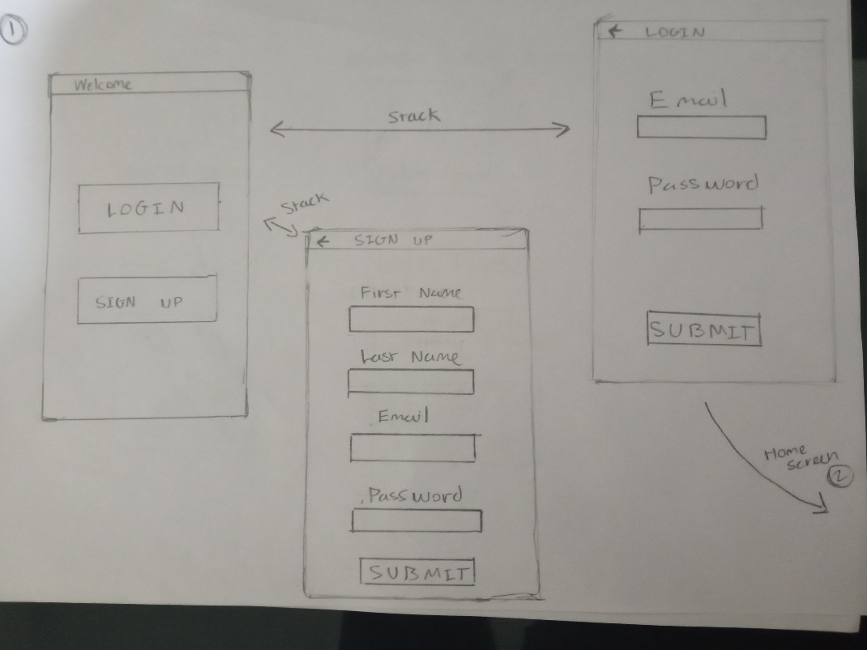

Figure 17: “Page 1 of Draft Wireframe”

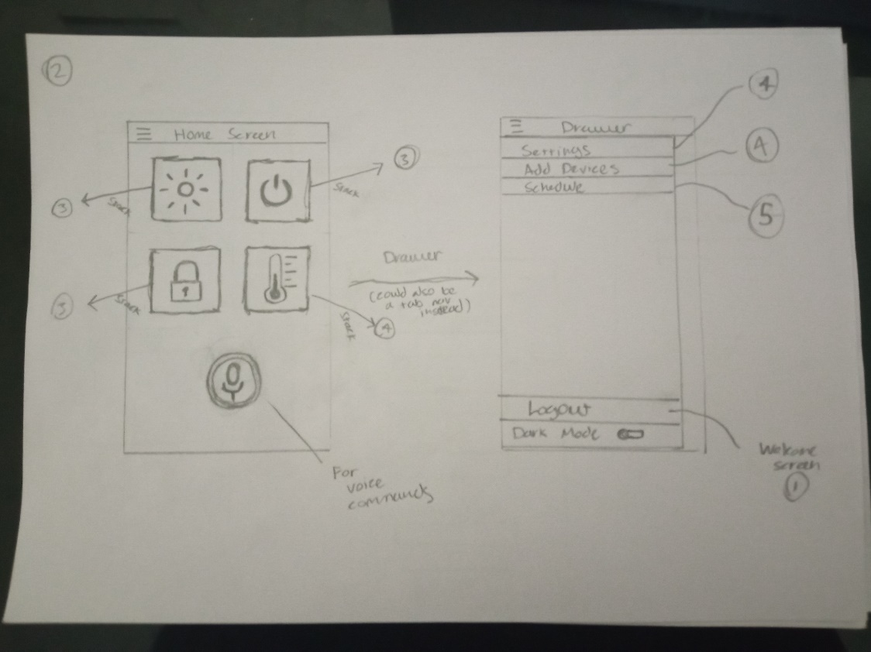

Figure 18: “Page 2 of Draft Wireframe”

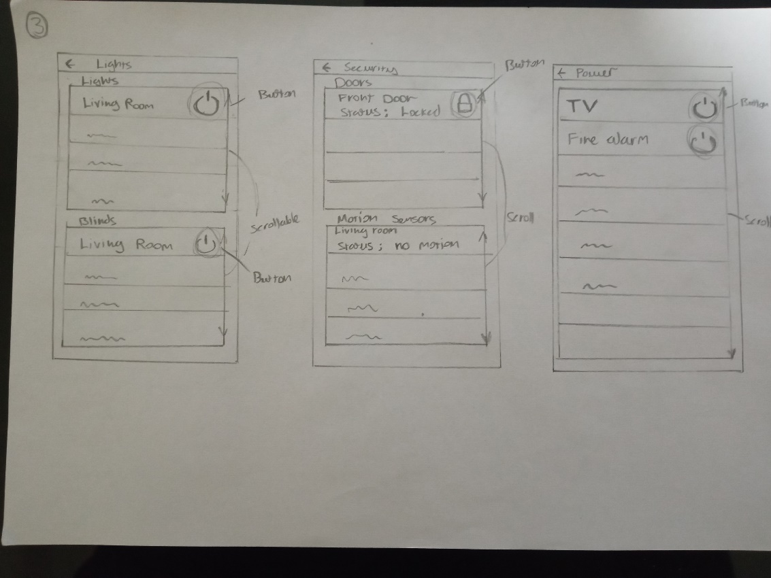

Figure 19: “Page 3 of Draft Wireframe”

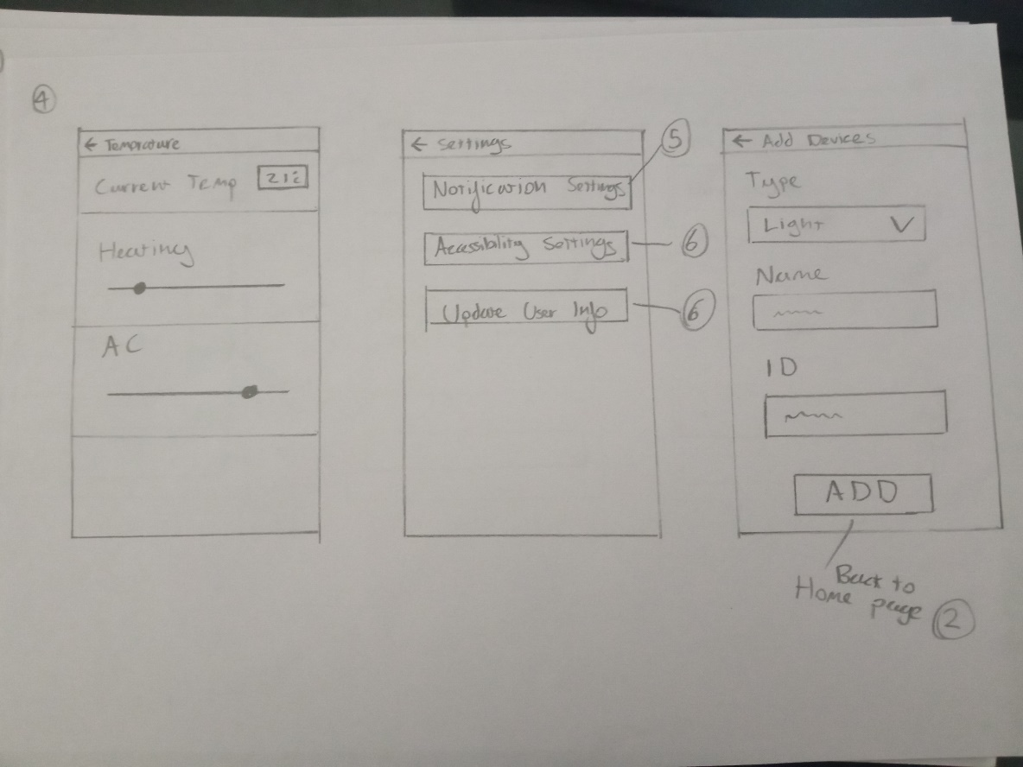

Figure 20: “Page 4 of Draft Wireframe”

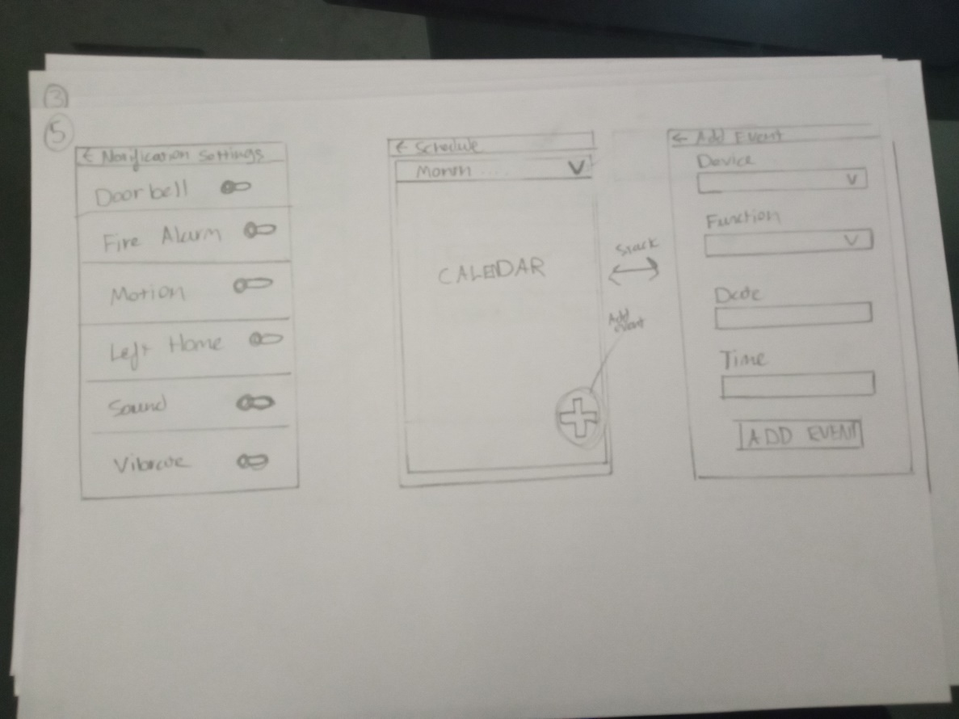

Figure 21: “Page 5 of Draft Wireframe”

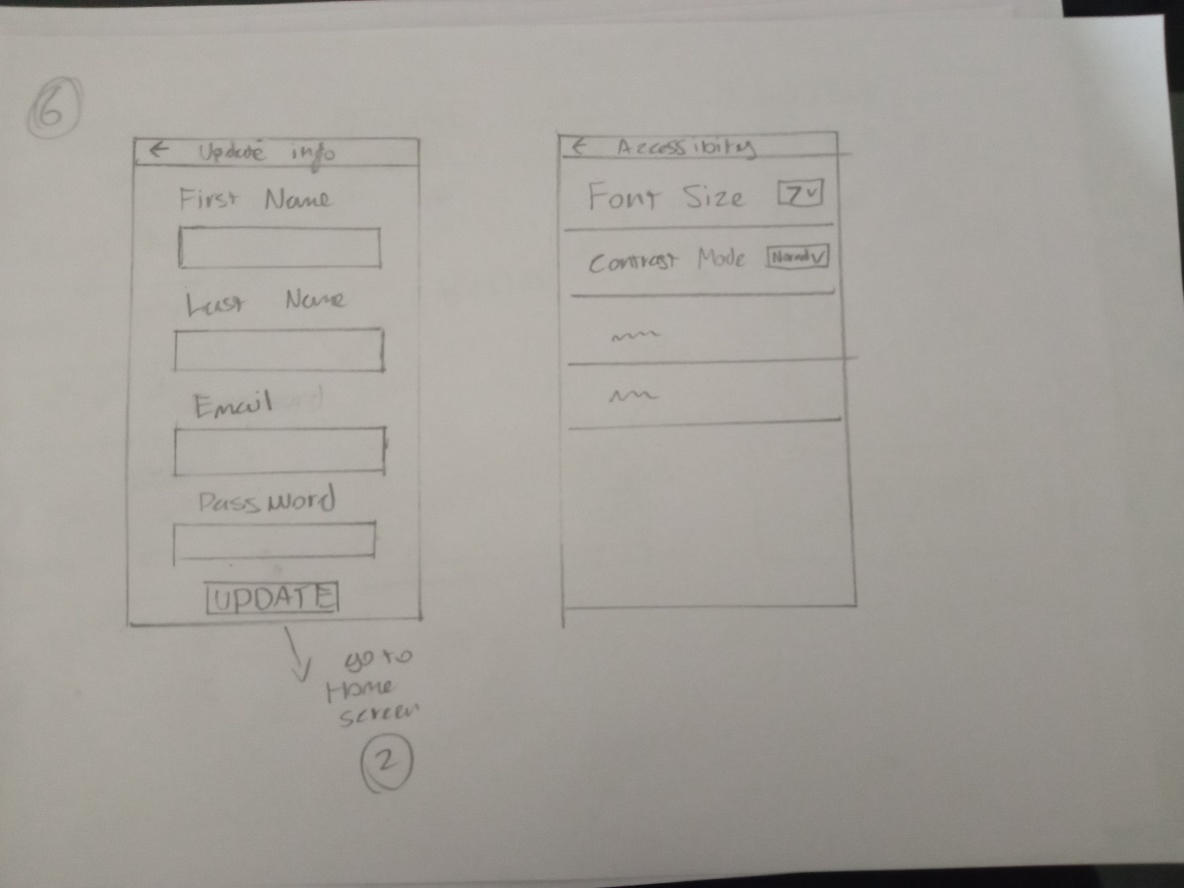

Figure 22: “Page 6 of Draft Wireframe”

### 3.4.5 Finalised Wireframe

Below is the finalised wireframe of the application, this wireframe is an improved version of the draft. This wireframe gave a clearer insight on which features weren’t necessary or would be too time consuming and it allowed for further refinement of the UI. Also, it provides valuable insight into how a user would interact with the interface and reduced time spent on implementation by providing the foundation of the applications design.

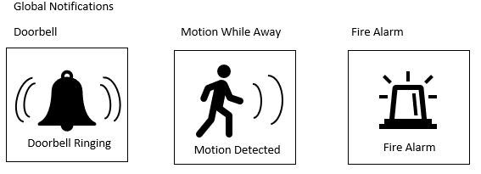

Figure 23: “Wireframe: Notifications”

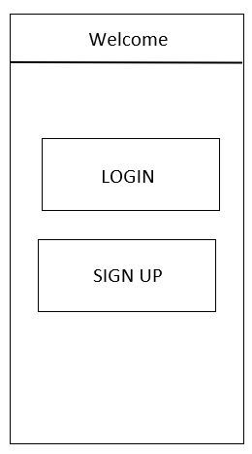

Figure 24: “Wireframe: Welcome Screen”

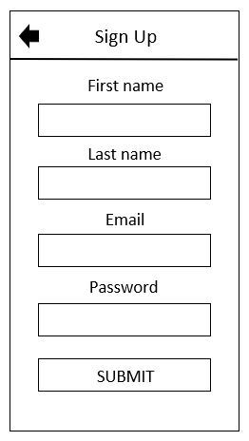

Figure 25: “Wireframe: Sign Up Screen”

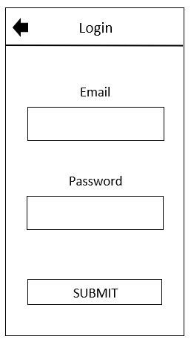

Figure 26: “Wireframe: Login Screen”

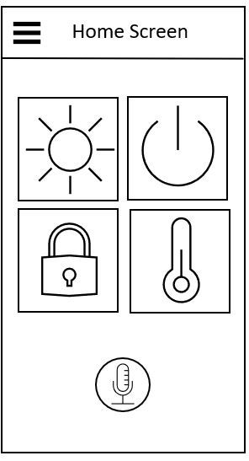

Figure 27: “Wireframe: Home Screen”

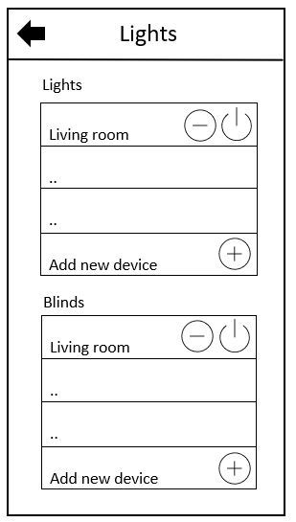

Figure 28: “Wireframe: Lights Screen”

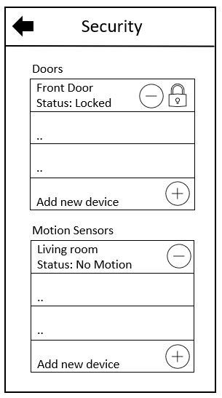

Figure 29: “Wireframe: Security Screen”

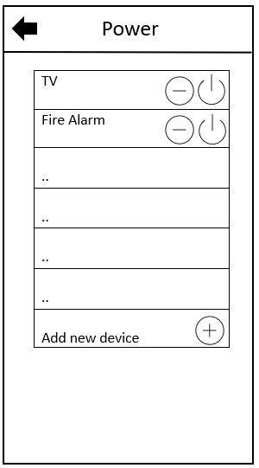

Figure 30: “Wireframe: Power Screen”

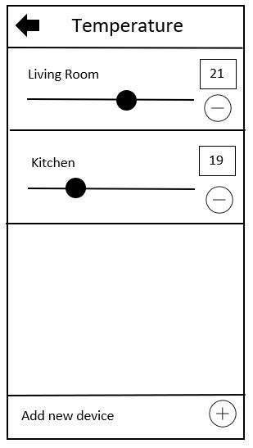

Figure 31: “Wireframe: Temperature Screen”

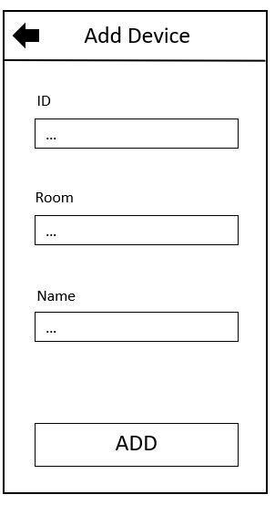

Figure 32: “Wireframe: Add Device Screen”

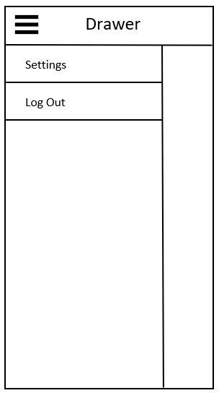

Figure 33: “Wireframe: Drawer”

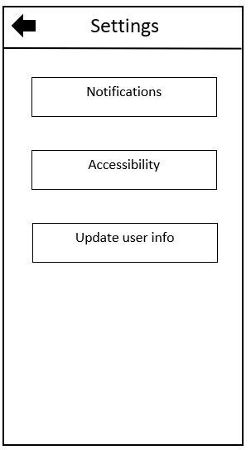

Figure 34: “Wireframe: Settings Screen”

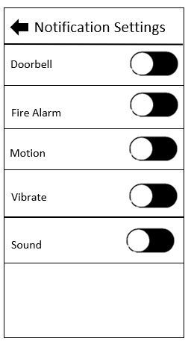

Figure 35: “Wireframe: Notification Settings Screen”

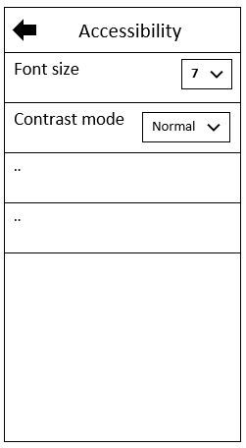

Figure 36: “Wireframe: Accessibility Settings Screen”

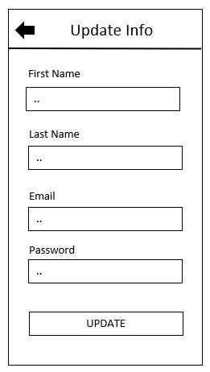

Figure 37: “Wireframe: Update User Info Screen”

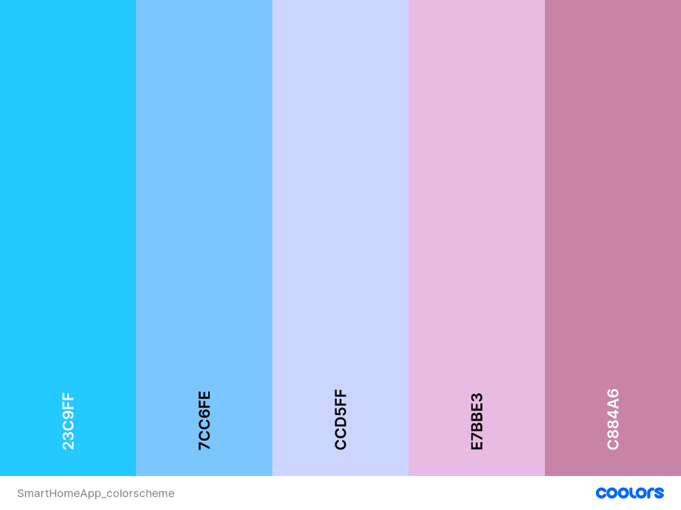

Figure 38: “Analogous Colour Scheme of Application”

### 3.4.6 Flowchart

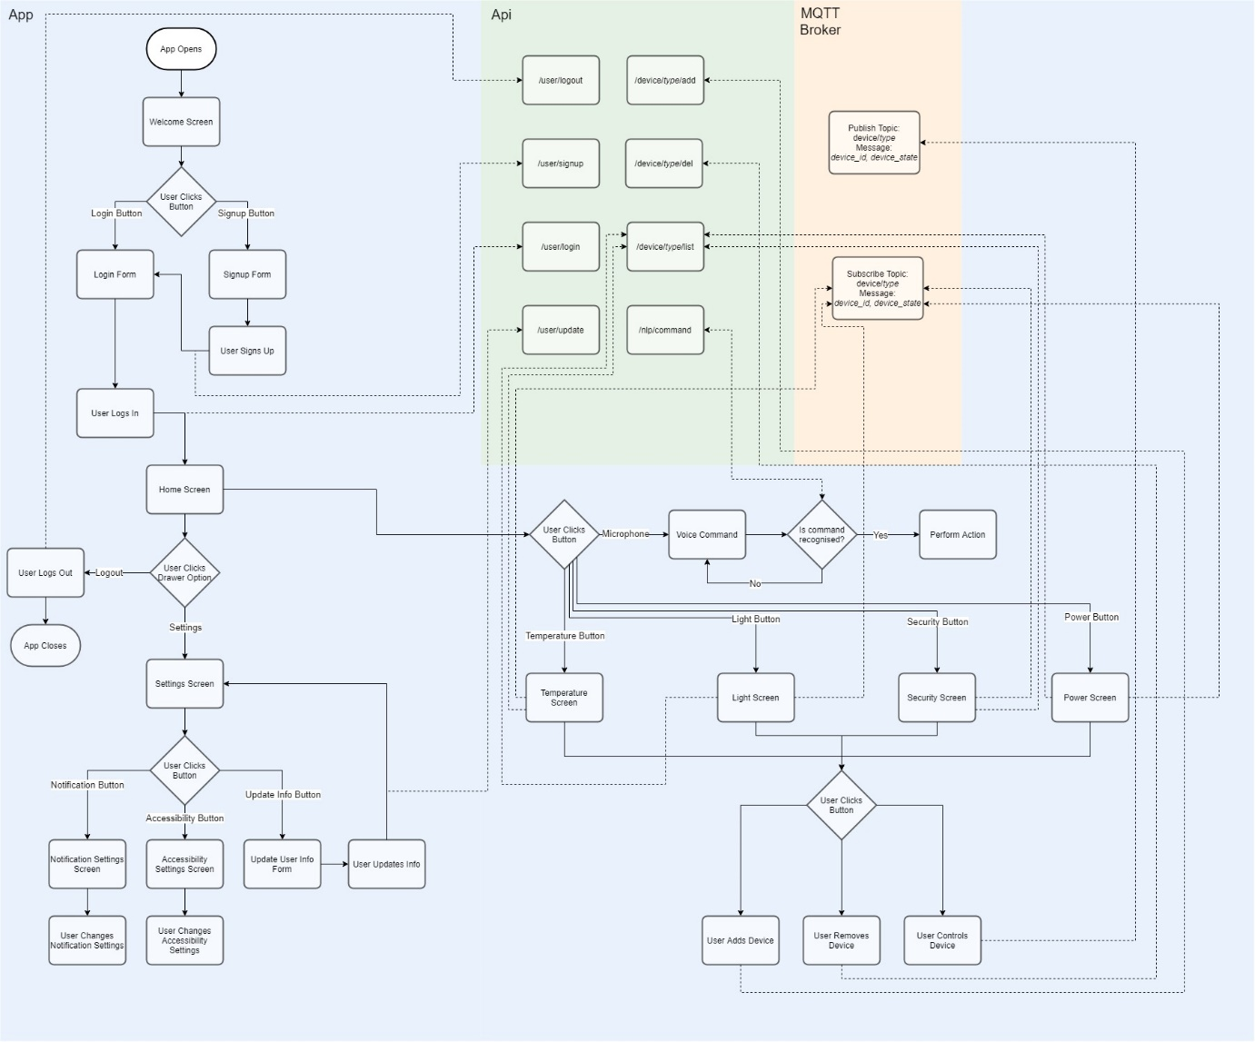

Figure 38: “Analogous Colour Scheme of Application”

Figure 38 is a flowchart of the Android Application, it provides an overview of the entire app including all the points at which the API is called, the broker is subscribed too and when a message is published to the broker. The flowchart breaks down the logic of the system into easy to follow instructions and provides another point of view to the structure of the application, it turns the complexities of the application into a comprehensible visual aid that will be crucial in the implementation stage as it will save considerable amounts of time.

## 3.5 Client Design

### 3.5.1 Language and Environment

The language chosen for the client is Java, the object-orientated nature of this language will prove incredibly useful when it comes to implementing this system as each Phidget device will require similar code to operate so the reusable code that objects provide is a perfect candidate, Java is also multithreaded which will be important when operating multiple Phidget devices at once. The development environment chosen was eclipse as it is standard for Java development, prettier was also used to format the code to ensure more readable code and higher standard of code quality.

### 3.5.2 Class Diagram

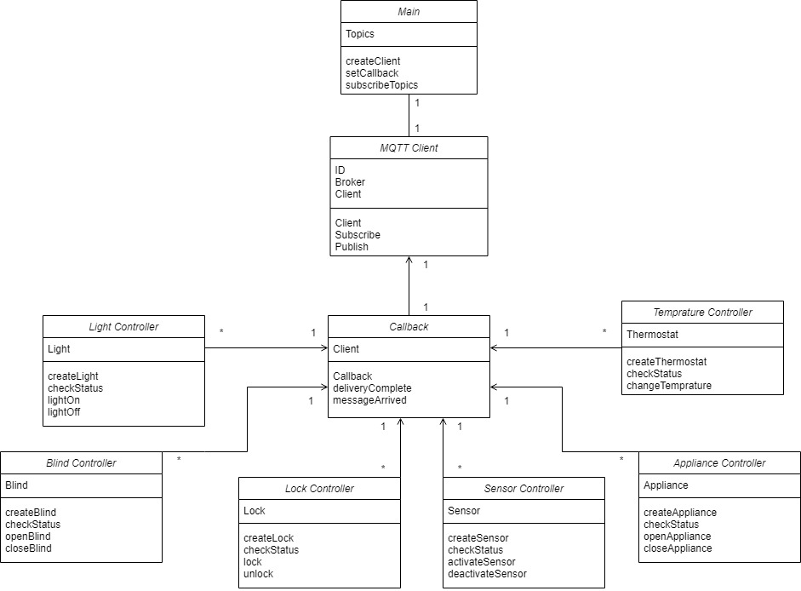

Figure 39: “Client Class Diagram”

Figure 39 shows the proposed classes and class relationships of the client, a rough outline of the properties and methods are also included for each class, the class diagram provides a visual model of the structure of the system. During implementation the class diagram can be used to easily translate the structure of the system into code.

## 3.6 API Design

### 3.6.1 Language and Environment

JavaScript was the chosen language for the API, more specifically NodeJS, a JavaScript runtime environment. NodeJS was chosen mainly for its high performance and its mellow learning curve. Another benefit of NodeJS it is extremely scalable meaning it will be easy to add features to the API in the future. The development environment chosen was again Visual Studio Code along with the prettier and ESLint plugins. Again, these plugins were both used to improve code quality also, to reduce errors. The style guide chosen was Airbnb. Found here: <https://github.com/airbnb/javascript>

### 3.6.2 Specification

When developing an API, creating an API specification is an extremely useful and versatile tool, it acts as design, documentation, and a way to standardize data exchange between web services within the system. The API specification created in this project was made using Swagger and was based off the CoffiDa API specification created by Dr Ashley Williams (Williams, A. 2021) which provided a brilliant starting point, template and gave insight into the development of the API. The full specification created for this project can be found here: <https://app.swaggerhub.com/apis/Aubrey-Monk/SmartHomeApp/1.0.0> Below a few screenshots have also been included, the JSON of the full specification has also been included in the product submission.

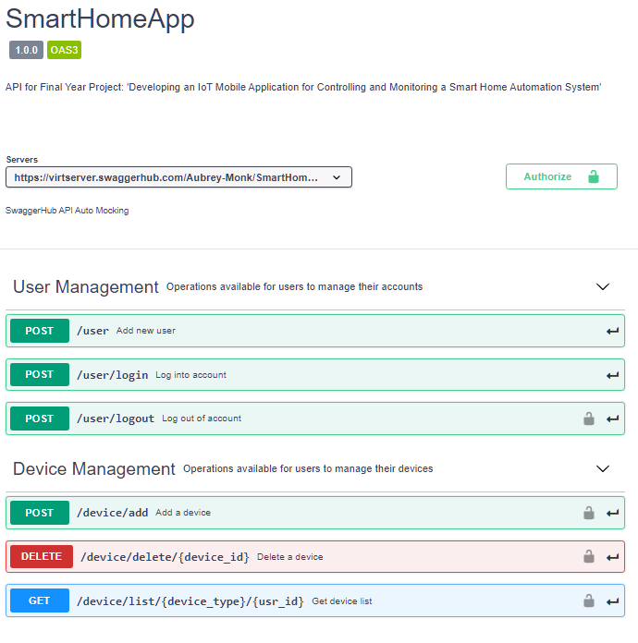

Figure 40: “API Specification”

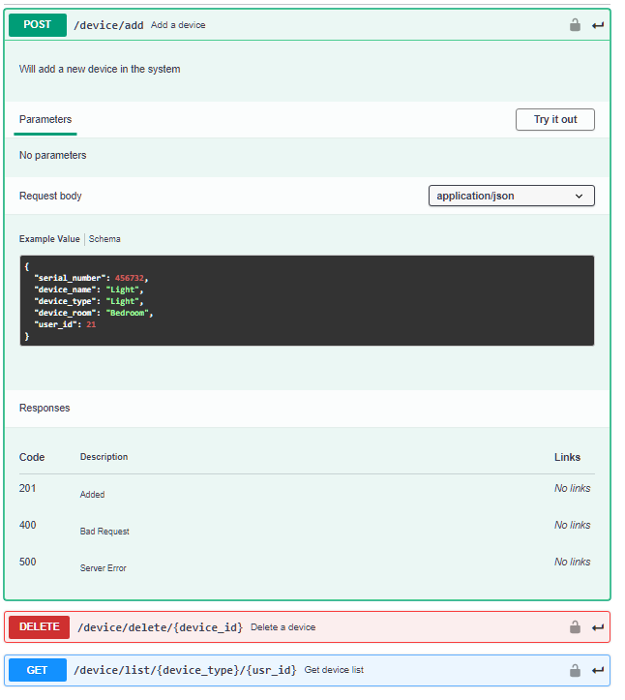

Figure 41: “API Specification: Add Device”

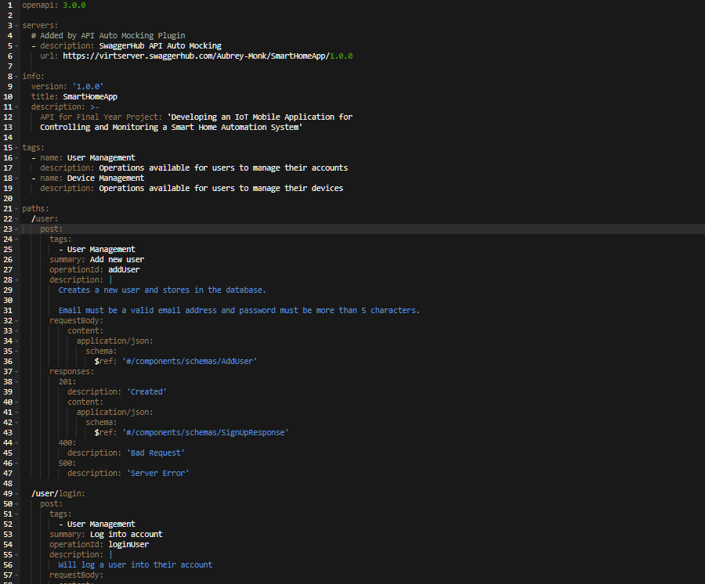

Figure 42: “API Specification: Code”

## 3.7 Database Design

### 3.7.1 Language and Environment

The database required for this project only needs to consist of 2 tables making it extremely simple, it will be written in SQL and hosted on the university’s MySQL “mudfoot” server. MySQL Workbench will be used to access the server and create the database tables.

### 3.7.2 Entity Relationship Diagram

Below are a few entity relationship diagrams created for the database system, they show the overall structure and relationship of the tables within the database system, this makes it very easy to implement the database.

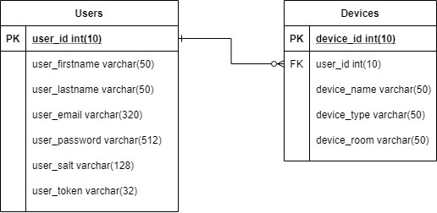

Figure 43: “First Database ERD”

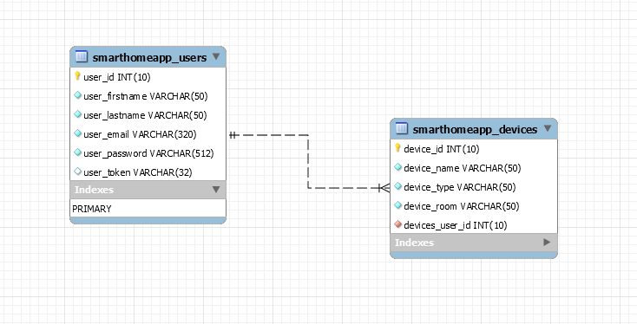

Figure 44: “Second Database ERD”

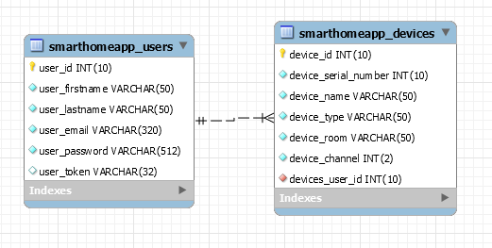

Figure 45: “Third Database ERD”

# References

Ali, Y. M. et al. (2020) “Voice Command Intelligent System (VCIS) for Smart Home Application using Mel-frequency cepstral coefficients and linear prediction coefficients”. *In International Conference on Semiconductor Materials and Technology (ICoSeMT 2019).* 1535 012008. Penang, Malaysia. 29-30 April 2019. IOP Publishing Ltd. pp. 1-9. [Online] [Accessed on 9th October 2020] <https://iopscience.iop.org/article/10.1088/1742-6596/1535/1/012008>

Gubbi, J. et al. (2013) “Internet of Things (IoT): A vision, architectural elements, and future directions”. *Future Generation Computer Systems*. Volume 29, Issue 7, September 2013. Pp. 1645-1660. [Online] [Accessed on 16th October 2020] DOI: [10.1016/j.future.2013.01.010](https://doi.org/10.1016/j.future.2013.01.010)

Choudhary, G. Jain, AK. (2016) “Internet of Things: A survey on architecture, technologies, protocols and challenges”. *In 2016 International Conference on Recent Advances and Innovations in Engineering (ICRAIE).* Jaipur, India. 23-25 December 2016. IEEE. [Online] [Accessed on 16th October 2020] <https://ieeexplore.ieee.org/abstract/document/7939537>

Rizvi, S. et al. (2018) “A Smart Home Appliances Power Management System for Handicapped, Elder and Blind People”. *In* *2018 4th International Conference on Computer and Information Sciences (ICCOINS).* Kuala Lumpur, Malaysia. 13-14 August 2018. IEEE. [Online] [Accessed on 11th October 2020] <https://ieeexplore.ieee.org/abstract/document/8510595>

Miah, J and Khan, RH. (2019) “Service Development of Smart Home Automation System: A Formal Method Approach”. *In* *CIIS 2019: The 2nd International Conference on Computational Intelligence and Intelligent Systems*. Bangkok, Thailand, November 2019. Association for Computing Machinery. pp. 161-167. [Online] [Accessed on 8th October 2020] <https://dl.acm.org/doi/10.1145/3372422.3372437>

Sovacool, B. K. and Furszyfer Del Rio, D. D. (2020) “Smart home technologies in Europe: A critical review of concepts, benefits, risks and policies” *Renewable and Sustainable Energy Reviews.* Volume 120, March 2020, 109663. [Online] [Accessed on 20th May 2021] <https://doi.org/10.1016/j.rser.2019.109663>

Wilson, C. et al. (2017) “Benefits and risks of smart home technologies” *Energy Policy*. Volume 3, April 2017, Pp. 72-83. [Online] [Accessed on 20th May 2021] <https://doi.org/10.1016/j.enpol.2016.12.047>

Robles, R. J. Kim, T (2010) “A Review on Security in Smart Home Development” *International Journal of Advanced Science and Technology*. Volume 15, February 2010, Pp. 13-21. [Online] [Accessed on 21st May 2021] <http://citeseerx.ist.psu.edu/viewdoc/download?doi=10.1.1.178.1685&rep=rep1&type=pdf>

Balta-Ozkan, N. et al. (2013) “Social barriers to the adoption of smart homes” *Energy Policy.*  Volume 63, December 2013, Pp. 363-374. [Online] [Accessed 21st May 2021] <https://doi.org/10.1016/j.enpol.2013.08.043>

Hong, A. et al. (2020) “What will be the possible barriers to consumers’ adoption of smart home services?” *Telecommunications Policy.*  Volume 44, Issue 2, March 2020, 101867. [Online] [Accessed 21st May 2021] <https://doi.org/10.1016/j.telpol.2019.101867>

Shneiderman, B. et al. (2016) *Designing the User Interface: Strategies for Effective Human-Computer Interaction* Sixth Edition, Pearson.

Williams, A. (2021) Manchester Metropolitan University *Week 2 UI-UX Design* Lecture from Mobile Applications Development Unit.

Williams, A. (2021) *CoffiDa Server* Manchester Metropolitan University [Online] [Accessed 22nd May 2021]<https://github.com/ash-williams/coffida_server>

Google. Google Store. (2021) *Nest Hub Max* [Online] [Accessed on 19th May 2021] <https://store.google.com/gb/product/google_nest_hub_max?hl=en-GB>

Amazon. (2021) *Echo (4th Generation)* [Online] [Accessed on 19th May 2021] <https://www.amazon.co.uk/dp/B08HB1TWCN/ref=s9_acsd_al_bw_c2_x_2_t?pf_rd_m=A3P5ROKL5A1OLE&pf_rd_s=merchandised-search-3&pf_rd_r=WCQNT922NX0ZFP7GD2N9&pf_rd_t=101&pf_rd_p=f33be48f-28a1-401a-b098-d34dd3c5d68d&pf_rd_i=14100223031>

Amazon. (2021) *SmartThings Hub (V3)* [Online] [Accessed on 19th May 2021] <https://www.amazon.co.uk/Samsung-GP-U999SJVLGEA-SmartThings-Hub-2018/dp/B07H9G68DW>

August. (2021) *August Wi-Fi Smart Lock* [Online] [Accessed on 19th May 2021] <https://august.com/products/august-wifi-smart-lock>

Phillips. (2021) *Hue Starter Kits* [Online] [Accessed on 19th May 2021] <https://www.philips-hue.com/en-gb/p/hue-white-and-colour-ambiance-starter-kit-e27/8718696685754#faq>

# Bibliography

<https://www.tomsguide.com/uk/us/best-smart-home-hubs,review-3200.html>

<https://www.pcmag.com/news/the-best-smart-home-devices>

<https://www.techradar.com/uk/reviews/gadgets/appliances/philips-hue-1124842/review>

<https://www.phidgets.com/>

<https://www.geeksforgeeks.org/top-programming-languages-for-android-app-development/>

<https://www.valuecoders.com/blog/technology-and-apps/top-javascript-frameworks-for-mobile-app-development/>

<https://en.wikipedia.org/wiki/React_Native>

<https://rapidapi.com/blog/programming-languages/>

<https://www.infoworld.com/article/2887974/a-developer-s-guide-to-the-pro-s-and-con-s-of-python.html>

<https://www.synopsys.com/blogs/software-security/top-4-software-development-methodologies/>

<https://www.altexsoft.com/blog/engineering/the-good-and-the-bad-of-node-js-web-app-development/>

# Appendices