**INSTRUCTIONS.** Read the steps first before doing them.

Screenshot every step. Do not crop your screenshots. 30 Points.

1. **Create a GitHub account (10 Points)**

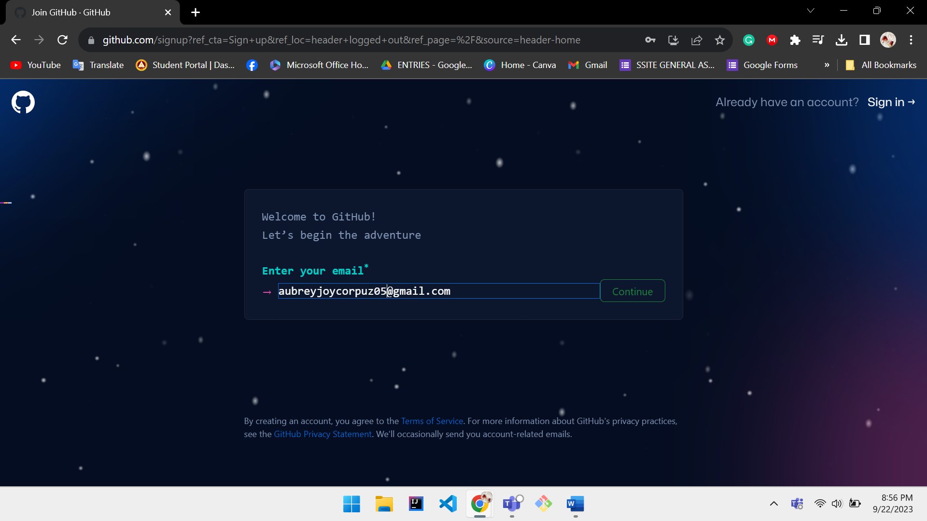

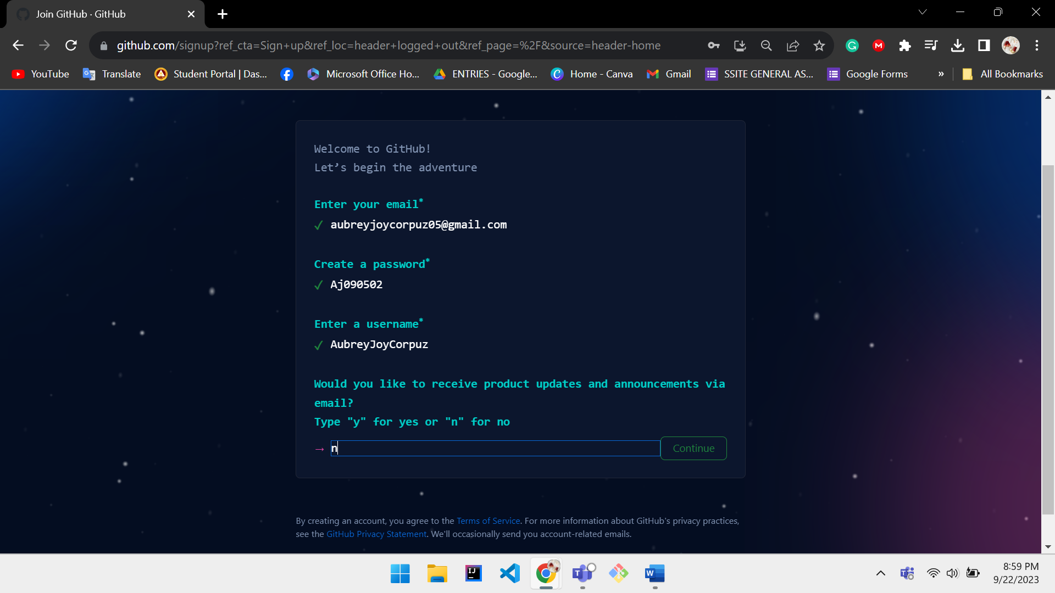

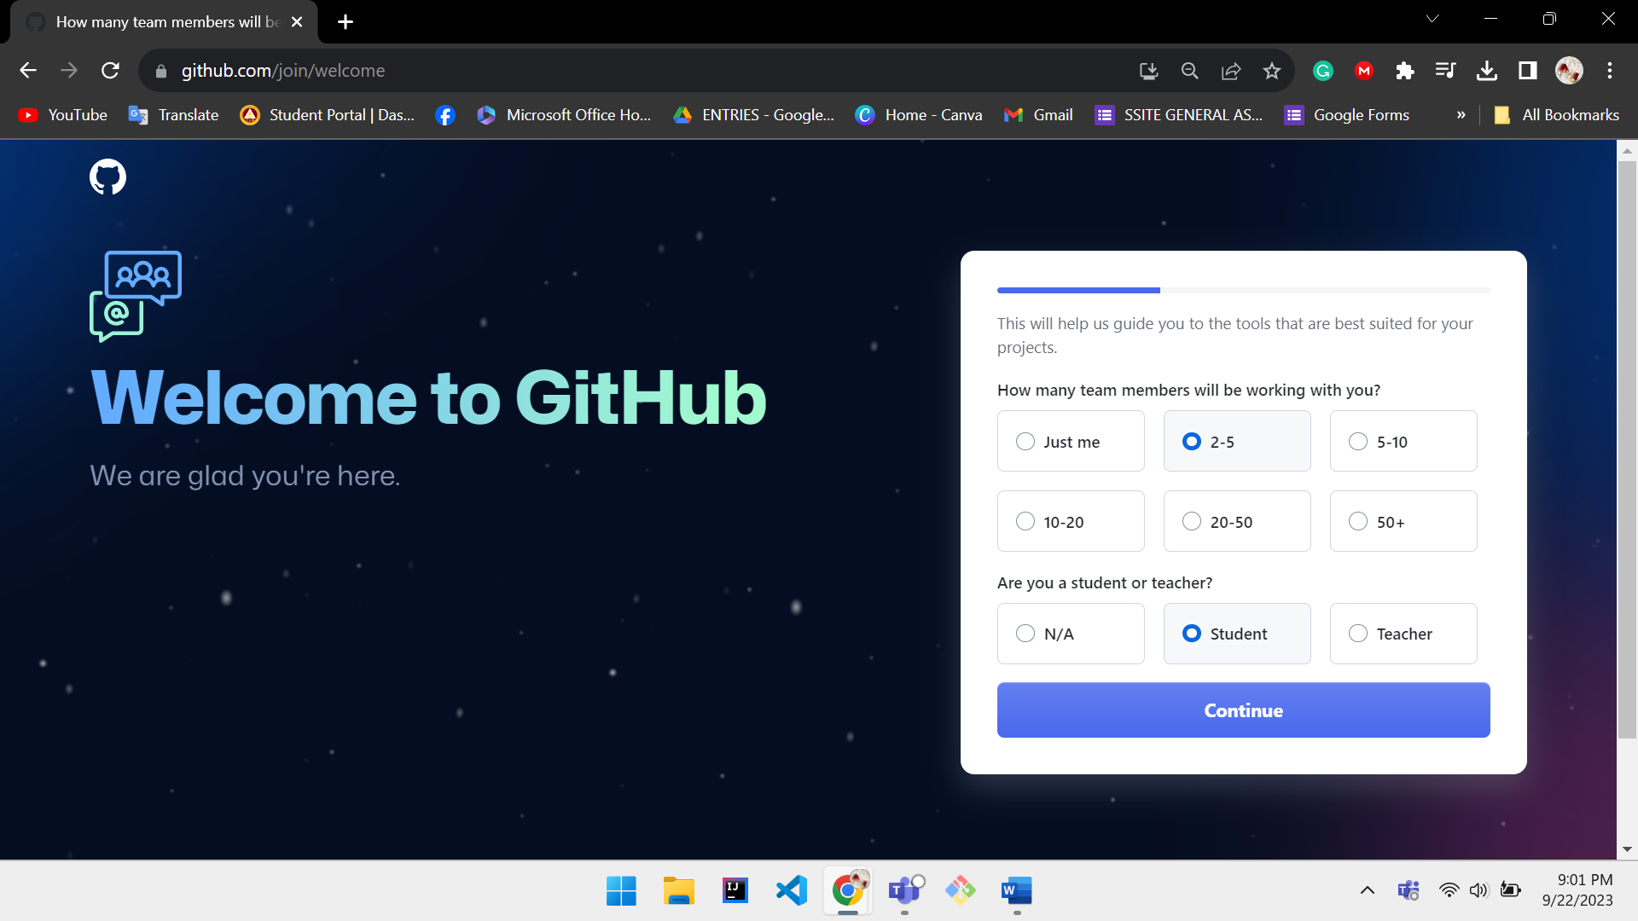

1. **On your account, create a repository named *Lastname_Firstname_Year&Section* (2 Points)**
   * **Your repository should be public (1 Point)**
   * **Add a short description (1 Point)**
   * **Note: Check “Inititalize this repository with a README” (1 Point)**

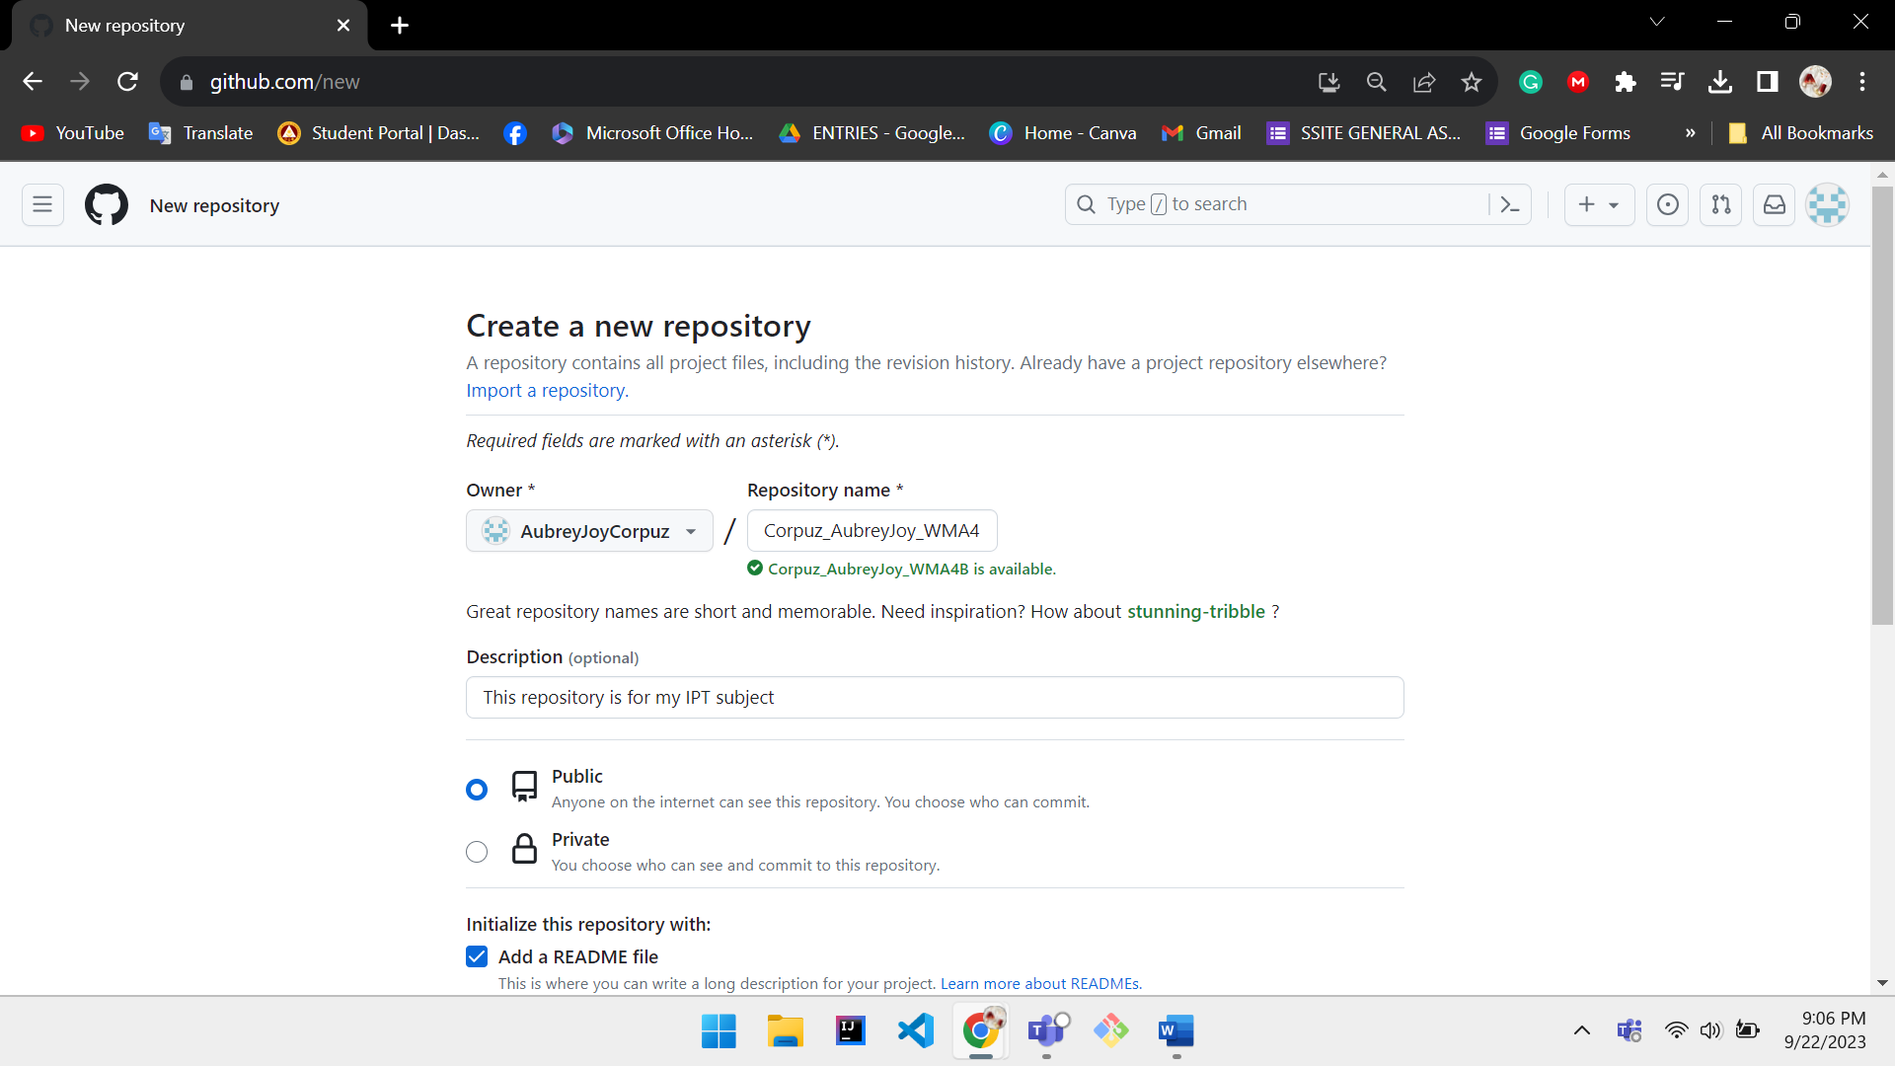

1. **On the left side, click the “Branch”**
   * **On the right side, click “New Branch”**

* + **Branch name should be “September 22 2023 IPT2 Activity” (5 Points)**

* + **Note: Do not change the source**
  + **Then Create (5 Points)**

1. **Under the September 22 2023 IPT2 Activity**
   * **On the right side, click the “Add file”**

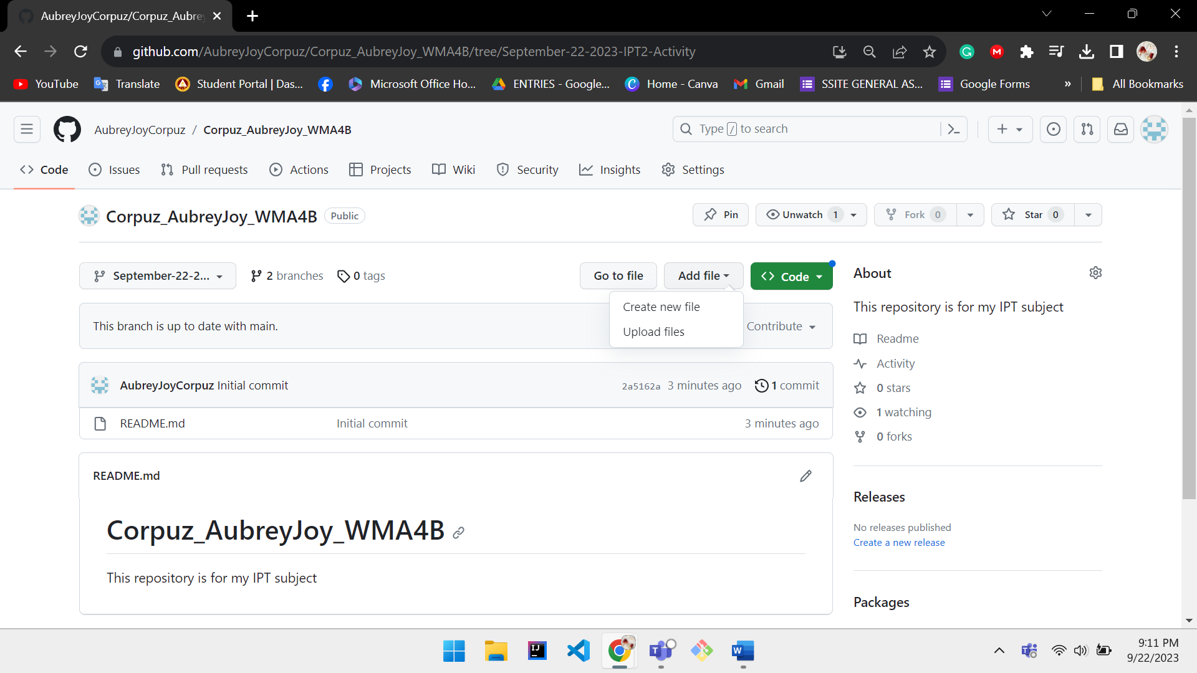

* + **Then upload the document file of your activity. (3 Points)**
  + **File name should be *Lastname_Firstname_DateOfTheActivity_Year&Section* (2 Points)**