WEBLOGIC巡检

http://10.49.1.3:7001/console/login/LoginForm.jsp

WEBLOGIC检测
硬件机型 |  | RX6600
是否集群 |  | 是
系统实际用户数 |  | 10
硬件检查，性能检查
WEBLOGIC进程
进入操作系统，登陆WEBLOIGC用户，命令：su – weblogic
Process | 进程情况 | 进入操作系统，登陆Weblogic用户  命令：# ps -ef | grep java
Process | 说明
Process | 进程状态
Log | 状态 | 命令：cd opt/bea/user_projects/domains/qg_domain/servers/appServer1/logs  切换规则：  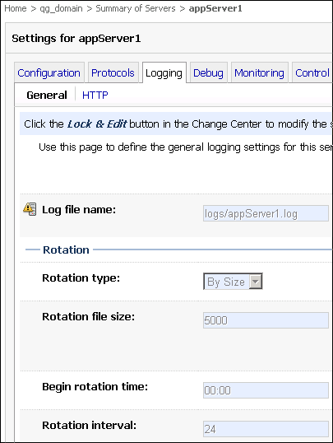  配置正常
Log | 运行情况 | 命令：vi appServer1.log
Log | 查看日志 | 命令：  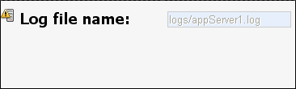  有错误才有日志  处理步骤
Application | 配置情况 | 标准配置  位置：/opt/mes-logs_main
Application | 运行情况 | 正常  Vi mes-hotrolling-app-error.log
Application | 应用日志 | /opt/mes-logs_main
Application | 查看状态
DataSource | 配置情况 | 标准配置  驱动，数据库实例，容量，数据源监控
DataSource | 驱动情况 | 检查数据库版本以及驱动
DataSource | 运行情况 | 正常
WEBLOGIC
su – oracle
sqlplus “/as sysdba”
 |  | 诊断结果及建议
ServerStatus | 节点状态 | 登陆http://hostname:port/console
ServerStatus | 配置情况
ServerStatus | 运行情况 | 正常  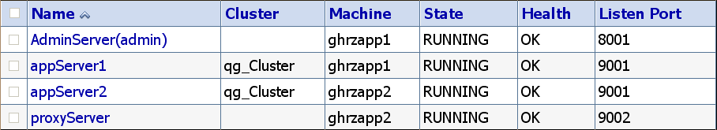
ServerStatus | 使用资源情况 | Home >Summary of Servers > appServer1 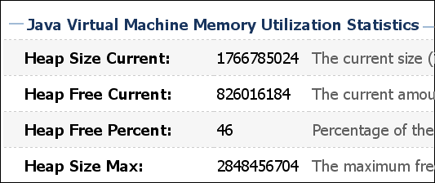
ClusterStatus | 节点状态 | Home >Summary of Environment > Summary of Servers
ClusterStatus | 集群状态 | Home >Summary of Clusters  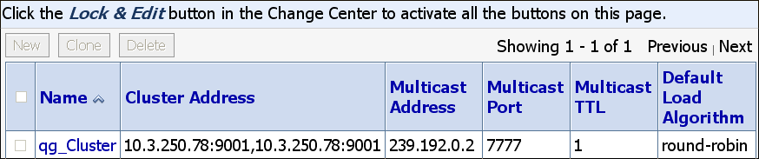
ClusterStatus | 集群包状态 | Home >Summary of Deployments  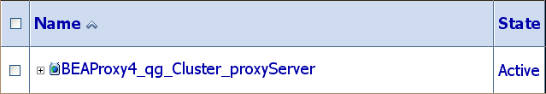
ClusterStatus | 空间使用率
ClusterStatus | 运行情况 | 正常
ClusterStatus | 安装位置及硬盘空间情况
ApplicationStatus | 应用包状态 | Home >Summary of Deployments  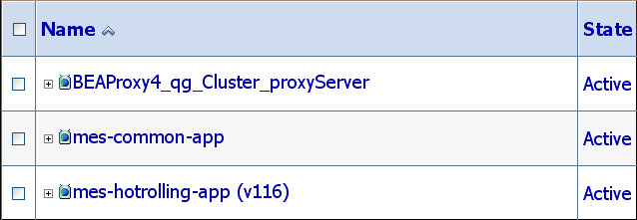
ApplicationStatus | 测试应用 | Home >Summary of Deployments > mes-hotrolling-app(v116)  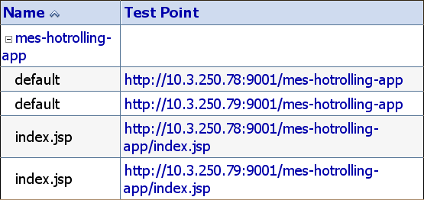
ApplicationStatus | 负载状态 | 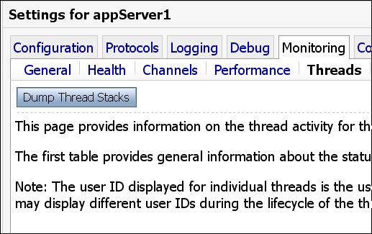  并发量以及业务负载，是否符合业务变化，线程比较高，加server
ApplicationStatus | 运行状态 | Home >Summary of Deployments > mes-hotrolling-app(v116) >status  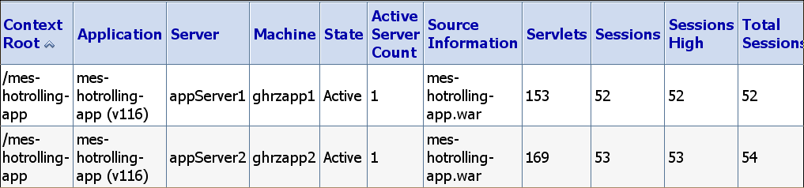
Performance | 配置情况
Performance | 硬件系统 | 内存溢出，磁盘IO等
Performance | 察看锁 | Windows:  Press Ctrl-Break on keyboard 3-5 times and the interval is 5-10 seconds  Unix:  ps –ef | grep weblogic  kill -3 <pid> 抓信息
Performance | 查看内存堆栈 | Ps –ef | grep weblogic  "%JAVA_HOME%\bin\java" -server – Xms512m – Xmx512m -classpath %CLASSPATH%
Performance | 优化java读写 | 启动本地性能包  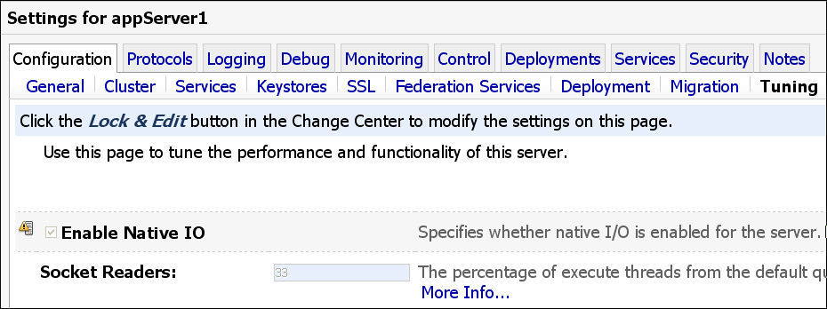
Performance | Backlog | STuning Connection Backlog Buffering  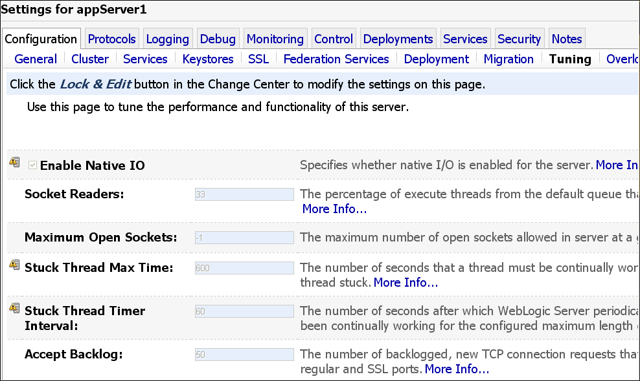  TCP允许接入连接个数
Performance | Use the Prepared Statement Cache | The prepared statement cache keeps compiled SQL statements in memory, thus avoiding a round-trip to the database when the same statement is used later. See Tuning JDBC Applications.
Performance | Use Local Interfaces | Use local-interfaces or use call-by-reference semantics to avoid the overhead of serialization when one EJB calls another or an EJB is called by a servlet/JSP in the same application. Note the following:  - In release prior to WebLogic Server 8.1, call-by-reference is turned on by default. For releases of WebLogic Server 8.1 and higher, call-by-reference is turned off by default. Older applications migrating to WebLogic Server 8.1 and higher that do not explicitly turn on call-by-reference may experience a drop in performance.  - This optimization does not apply to calls across different applications.
Performance | Measure Your Performance Metrics | After you have determined your performance criteria in Understand Your Performance Objectives, take measurements of the metrics you will use to quantify your performance objectives. See Load Testing Tools. The following sections provide information on measuring basic performance metrics:  - Monitor Disk and CPU Utilization  - Monitor Data Transfers Across the Network
Performance | 垃圾回收 | JDK版本有关

