LOGM 634 - Homework Set #2

Due 13 January 2017

# Chapter 4 – Exercises (30 Points)

1. From the Ebeling text - Exercise 4.1
2. From the Ebeling text - Exercise 4.5
3. From the Ebeling text - Exercise 4.20

# Chapter 5 – Exercises (30 Points)

1. From the Ebeling text - Exercise 5.4
2. From the Ebeling text - Exercise 5.8
3. From the Ebeling text - Exercise 5.9

##### 

# Summary Exercise (20 Points)

1. Use the system relational block diagram shown in Figure 1 and the component distributions to answer the following questions:
   1. What is the probability of system failure within 1200 hrs?
   2. What is the probability of system failure within 200 hrs, given it has lasted for 1000 hours?

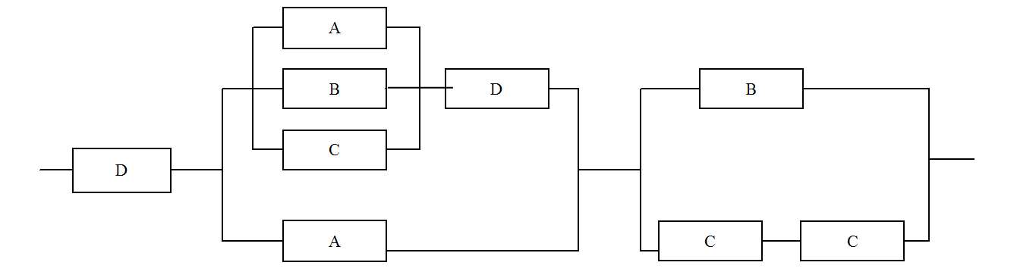

Reliability Block Diagram for Exercise 7

$$\begin{matrix}Component A & ∼EXP(θ=1/λ=1250 hrs) \\ Component B & ∼NOR(μ=1500 hrs, σ=325) \\ Component C & ∼WEIBULL(θ=1300 hrs, β=3.5) \\ Component D & ∼EXP(θ=1/λ=1500 hrs)\end{matrix}$$