Defasagem e recomposição da Tabela SUS: efeitos sobre produção e oferta de atenção especializada no Brasil, 2018–2025

SUS Fee Schedule lag and recomposition: effects on specialized care production and supply in Brazil, 2018–2025

Abstract

Background
The Brazilian Unified Health System (SUS) reimburses healthcare providers through an administered fee schedule (Tabela SUS/SIGTAP) that has historically lagged behind inflation, potentially undermining the supply of specialized care. Despite ongoing policy debate, empirical evidence linking fee schedule values to production volume and provider network stability remains scarce. This study examines whether recent fee recompositions (2023–2025) were associated with changes in approved production and active establishments.

Methods
We conducted a longitudinal study using monthly administrative data from January 2018 to September 2025, integrating four national public databases: SIGTAP (procedure reference values), SIH/SUS (hospital production), SIA/SUS (ambulatory production), and CNES (establishment registry). The primary strategy was a difference-in-differences (DiD) design comparing procedure subgroups that received significant fee recompositions (treatment) with comparable subgroups that did not (control). All monetary values were deflated to December 2024 reais using the IPCA consumer price index. Models included procedure and time fixed effects with heteroskedasticity-consistent (HC1) standard errors. An event study specification and placebo test validated the parallel trends assumption.

Results
Between 2018 and 2025, nominal SIGTAP values increased by 12.5% to 55.9% across subgroups, but real values (inflation-adjusted) declined by up to 24.8% for subgroups without targeted recomposition. The 2024 recomposition was associated with a 12.0% increase in approved hospital production (DiD coefficient = 0.120; SE = 0.005; p < 0.001) and a 12.0% increase in ambulatory production (coefficient = 0.120; SE = 0.005; p < 0.001). The 2023 recomposition showed an 8.1% increase in hospital production (coefficient = 0.081; SE = 0.005; p < 0.001). Effects were statistically significant across all 15 states analyzed, ranging from 9.1% in Goiás to 13.1% in Maranhão. The placebo test confirmed parallel pre-treatment trends (coefficient = 0.003; p = 0.488). Procedure subgroups receiving targeted recomposition showed production increases of 24–33% compared to pre-COVID baselines, versus 12–18% in control subgroups.

Conclusions
Fee schedule recomposition in the SUS was associated with meaningful increases in both hospital and ambulatory specialized production. These findings provide empirical support for the hypothesis that administered prices matter for healthcare supply in publicly financed systems. However, recomposition alone did not fully reverse the accumulated real-value erosion, suggesting that complementary strategies—including regional planning, contract design, and capacity investment—remain essential.

Keywords
Unified Health System; Fee schedule; Administered prices; Specialized care; Difference-in-differences; Health policy; Brazil; SIGTAP; Hospital production; Provider network

Background
Brazil’s Unified Health System (Sistema Único de Saúde – SUS) provides universal healthcare coverage to over 210 million people and is the largest publicly financed health system in the Southern Hemisphere [1, 2]. Specialized care—including diagnostic imaging, surgical procedures, oncology treatment, and organ transplantation—is delivered through a mixed network of public, philanthropic, and contracted private providers reimbursed according to an administered fee schedule known as the Tabela SUS, managed through the SIGTAP system (Sistema de Gerenciamento da Tabela de Procedimentos, Medicamentos e OPM do SUS) [3, 4].
A longstanding concern in Brazilian health policy is that SIGTAP reference values have failed to keep pace with inflation and the rising costs of healthcare delivery [5, 6]. This gap—referred to as “defasagem” (lag)—is frequently cited as a driver of provider withdrawal from SUS contracts, reduced service availability, and growing waiting lists for specialized procedures [7, 8]. The phenomenon is not unique to Brazil; international evidence demonstrates that administered prices in publicly financed health systems significantly influence provider behavior, service volume, and access to care [9, 10, 11].
In the United States, extensive literature has documented the relationship between Medicare and Medicaid fee schedules and physician participation, procedure volume, and quality of care [12, 13, 14]. Decker (2009) showed that Medicaid fee increases led to greater physician acceptance of new Medicaid patients [12]. Clemens and Gottlieb (2014) demonstrated that Medicare fee changes causally affected healthcare spending and utilization, with a 2% payment increase leading to roughly 3% more spending [13]. In European systems, Januleviciute et al. (2016) found that activity-based financing reforms in Norway significantly altered hospital production patterns [15]. Analogous evidence from low- and middle-income countries remains limited, representing a significant gap in the global literature [16, 17].
Within Brazil, the literature on SUS fee schedule dynamics is predominantly descriptive or normative. Portela et al. (2018) documented the chronic underfunding of hospital services and its association with declining quality indicators [6]. Santos and Ugá (2007) analyzed the political economy of SUS pricing, highlighting the tension between fiscal constraints and provider sustainability [18]. Machado et al. (2014) examined the role of philanthropic hospitals in SUS provision, noting their particular vulnerability to fee inadequacy [19]. Gragnolati et al. (2013) provided a comprehensive analysis of SUS challenges, including fee schedule inadequacy, but without causal estimation of its effects on production [2]. More recently, La Forgia and Couttolenc (2008) and Couttolenc and Gragnolati (2011) analyzed hospital performance in Brazil but focused on efficiency rather than the price-production nexus [20, 21].
Despite the policy salience of SUS fee schedule reform, several critical gaps remain in the literature. First, no study has systematically constructed deflated time series of SIGTAP reference values to quantify the real erosion of procedure payments over time. Second, there is no causal evidence linking specific recomposition events to changes in approved production volume—the existing literature relies on cross-sectional correlations or qualitative assessments. Third, the heterogeneity of recomposition effects across regions with different baseline capacities has not been explored. Fourth, the relationship between fee schedule changes and provider network stability (as captured by CNES establishment data) remains unexamined.
This study addresses these gaps by integrating four national public databases (SIGTAP, SIH/SUS, SIA/SUS, and CNES) in a difference-in-differences framework to estimate the causal effect of recent fee recompositions (2023–2025) on specialized care production and provider network composition in Brazil. To our knowledge, this is the first study to apply quasi-experimental methods to evaluate SUS fee schedule policy using nationally representative administrative data.

Methods

Study design
This is a longitudinal, quasi-experimental study using a difference-in-differences (DiD) design. The unit of analysis is the procedure subgroup-month dyad at the national level, with complementary analyses at the procedure subgroup-state-month level. The study period covers January 2018 to September 2025 (93 monthly observations).

Data sources
We used four publicly available databases maintained by the Brazilian Ministry of Health:
1. SIGTAP (Sistema de Gerenciamento da Tabela de Procedimentos): Reference values for all SUS procedures, including the history of recomposition events. SIGTAP is the official registry of procedure codes, descriptions, and reimbursement values used across the SUS [3].
2. SIH/SUS (Sistema de Informações Hospitalares): Monthly approved hospital production (Autorizações de Internação Hospitalar – AIH), including quantities approved and total values paid, disaggregated by procedure subgroup and state [22].
3. SIA/SUS (Sistema de Informações Ambulatoriais): Monthly approved ambulatory production (Boletins de Produção Ambulatorial – BPA and Autorizações de Procedimentos de Alta Complexidade – APAC), disaggregated by procedure subgroup and state [23].
4. CNES (Cadastro Nacional de Estabelecimentos de Saúde): Quarterly snapshots of active healthcare establishments, including facility type, legal nature (public, philanthropic, private for-profit), and installed capacity [24].
For price deflation, we used the IPCA (Índice Nacional de Preços ao Consumidor Amplo) from the Brazilian Institute of Geography and Statistics (IBGE), the official consumer price index [25].

Procedure classification and treatment assignment
Procedure subgroups were classified into treatment and control groups based on whether they received targeted fee recomposition during the study period:
Treatment group (2024 recomposition): Subgroups that received substantial value increases (≥20%) under Portaria GM/MS nº 6.465/2024 and related ordinances, including tomography (0206), MRI (0207), nuclear medicine (0208), ophthalmologic surgery (0403), cardiovascular surgery (0404), digestive surgery (0405), genitourinary surgery (0407), musculoskeletal surgery (0408), and transplantation (0505) [26].
Treatment group (2023 recomposition): Subgroups receiving targeted increases (≥15%) in 2023, including oncology (0304), nephrology (0305), and oncologic surgery (0416).
Control group: Subgroups that received only the across-the-board 12.5% recomposition in January 2025 but no targeted earlier adjustments, including anatomical pathology (0201), biomedical diagnostics (0202), endoscopy (0203), radiology (0204), ultrasonography (0205), consultations (0301), physiotherapy (0302), other clinical treatments (0303), minor surgery (0401), ENT surgery (0411), thoracic surgery (0412), reconstructive surgery (0413), oral-maxillofacial surgery (0414), and other surgeries (0415).

Outcomes
The primary outcome was the natural logarithm of monthly approved quantity (log_qtd), measured at the procedure subgroup level. Secondary outcomes included total approved value in constant December 2024 reais and the number of active healthcare establishments by type and legal nature.

Statistical analysis
The baseline DiD model was specified as:
log(Y_it) = α + β₁·Treated_i + β₂·Post_t + β₃·(Treated×Post)_it + ε_it
where Y_it is the approved quantity for procedure subgroup i in month t, Treated_i is an indicator for subgroups that received targeted recomposition, Post_t indicates months after the recomposition event, and β₃ is the DiD estimator of interest. We estimated progressively richer specifications: (M1a) basic DiD, (M1b) DiD with procedure fixed effects and a linear time trend, and (M1c) DiD with procedure and time (year-month) fixed effects. All models used heteroskedasticity-consistent standard errors (HC1) [27].
For the 2023 recomposition, we estimated a parallel model (M2) comparing the 2023 treatment group with the control group. For ambulatory production, model M3 replicated the M1c specification using SIA/SUS data.
To assess regional heterogeneity, we estimated separate DiD models for each of 15 Brazilian states (M4), examining whether recomposition effects varied by state. Results are presented as a forest plot.
To validate the parallel trends assumption, we estimated an event study model (M5) with semester-level interaction terms between the treatment indicator and period dummies, using the first semester of 2021 as the reference period. Additionally, a placebo test (M6) applied a false treatment date (July 2021) to pre-recomposition data to verify that no spurious effect emerged.

Ethical considerations
This study used exclusively publicly available, anonymized administrative data. No individual-level patient data were accessed. In accordance with Brazilian regulations (Resolution CNS 510/2016), studies using public-domain secondary data do not require ethics committee approval [28].

Results

SIGTAP reference values: nominal and real trends
Table 1 presents the evolution of SIGTAP reference values for the 26 procedure subgroups analyzed. Between January 2018 and September 2025, nominal values increased for all subgroups, but the magnitude varied substantially by recomposition history. Subgroups in the 2024 treatment group experienced the largest nominal increases (35.0–55.9%), led by tomography and MRI (55.9% each) and followed by ophthalmologic and cardiovascular surgery (48.5% each). The 2023 treatment group saw increases of 29.4–35.8%. Control subgroups received only the 12.5% across-the-board adjustment in 2025.
After deflation by the IPCA (base December 2024 = 100), the picture changed dramatically. Tomography and MRI were the only subgroups to achieve positive real-value growth (+4.2%), reflecting their cumulative targeted recompositions in 2019, 2022, and 2024. All other subgroups experienced real-value erosion: cardiovascular and ophthalmologic surgery lost 0.8% in real terms; oncology lost 9.2%; and control subgroups suffered the largest real losses, ranging from −22.6% (consultations, physiotherapy) to −24.8% (anatomical pathology, radiology, endoscopy, and others). Figure 1 illustrates these nominal-versus-real trajectories for six representative subgroups.
Table 1. Accumulated nominal and real variation of SIGTAP reference values by procedure subgroup, January 2018 to September 2025.
cod_subgrupo | nome_subgrupo | valor_referencia_2018-01 | valor_referencia_2022-12 | valor_referencia_2024-02 | valor_referencia_2025-09 | valor_real_2018-01 | valor_real_2022-12 | valor_real_2024-02 | valor_real_2025-09 | var_nominal_pct | var_real_pct
0206 | Tomografia | 135 | 155.93 | 155.93 | 210.5 | 194.41 | 171.02 | 161.44 | 202.58 | 55.9 | 4.2
0207 | Resson<c3><a2>ncia magn<c3><a9>tica | 265 | 306.08 | 306.08 | 413.2 | 381.61 | 335.7 | 316.9 | 397.65 | 55.9 | 4.2
0403 | Cir. vis<c3><a3>o | 650 | 715 | 715 | 965.25 | 936.03 | 784.18 | 740.26 | 928.92 | 48.5 | -0.8
0404 | Cir. circulat<c3><b3>rio | 1200 | 1320 | 1320 | 1782 | 1728.06 | 1447.72 | 1366.64 | 1714.92 | 48.5 | -0.8
0304 | Oncologia | 450 | 472.5 | 543.38 | 611.3 | 648.02 | 518.22 | 562.58 | 588.29 | 35.8 | -9.2
0208 | Medicina nuclear | 350 | 350 | 350 | 472.5 | 504.02 | 383.86 | 362.37 | 454.71 | 35 | -9.8
0405 | Cir. digestivo | 800 | 800 | 800 | 1080 | 1152.04 | 877.41 | 828.27 | 1039.35 | 35 | -9.8
0407 | Cir. geniturin<c3><a1>rio | 550 | 550 | 550 | 742.5 | 792.03 | 603.22 | 569.43 | 714.55 | 35 | -9.8
0408 | Cir. osteomuscular | 750 | 750 | 750 | 1012.5 | 1080.04 | 822.57 | 776.5 | 974.39 | 35 | -9.8
0505 | Transplantes | 25000 | 25000 | 25000 | 33750 | 36001.18 | 27418.92 | 25883.38 | 32479.59 | 35 | -9.8
0305 | Nefrologia | 180 | 180 | 207 | 232.88 | 259.21 | 197.42 | 214.31 | 224.11 | 29.4 | -13.5
0416 | Cir. oncologia | 1500 | 1500 | 1725 | 1940.62 | 2160.07 | 1645.14 | 1785.95 | 1867.57 | 29.4 | -13.5
0301 | Consultas/Atendimentos | 10 | 10.3 | 10.3 | 11.59 | 14.4 | 11.3 | 10.66 | 11.15 | 15.9 | -22.6
0302 | Fisioterapia | 5.5 | 5.66 | 5.66 | 6.37 | 7.92 | 6.21 | 5.86 | 6.13 | 15.8 | -22.6
0201 | Anatomia patol<c3><b3>gica | 15 | 15 | 15 | 16.88 | 21.6 | 16.45 | 15.53 | 16.24 | 12.5 | -24.8
0202 | Diagn<c3><b3>stico biom<c3><a9>dico | 8.5 | 8.5 | 8.5 | 9.56 | 12.24 | 9.32 | 8.8 | 9.2 | 12.5 | -24.8
0203 | Endoscopia | 85 | 85 | 85 | 95.62 | 122.4 | 93.22 | 88 | 92.02 | 12.5 | -24.8
0204 | Radiologia | 25 | 25 | 25 | 28.12 | 36 | 27.42 | 25.88 | 27.06 | 12.5 | -24.8
0205 | Ultrasonografia | 30 | 30 | 30 | 33.75 | 43.2 | 32.9 | 31.06 | 32.48 | 12.5 | -24.8
0303 | Trat. cl<c3><ad>nicos outros | 22 | 22 | 22 | 24.75 | 31.68 | 24.13 | 22.78 | 23.82 | 12.5 | -24.8
0401 | Pequenas cirurgias | 95 | 95 | 95 | 106.88 | 136.8 | 104.19 | 98.36 | 102.86 | 12.5 | -24.8
0411 | Cir. ORL | 400 | 400 | 400 | 450 | 576.02 | 438.7 | 414.13 | 433.06 | 12.5 | -24.8
0412 | Cir. tor<c3><a1>cica | 1100 | 1100 | 1100 | 1237.5 | 1584.05 | 1206.43 | 1138.87 | 1190.92 | 12.5 | -24.8
0413 | Cir. reparadora | 480 | 480 | 480 | 540 | 691.22 | 526.44 | 496.96 | 519.67 | 12.5 | -24.8
0414 | Bucomaxilofacial | 320 | 320 | 320 | 360 | 460.82 | 350.96 | 331.31 | 346.45 | 12.5 | -24.8
0415 | Outras cirurgias | 600 | 600 | 600 | 675 | 864.03 | 658.05 | 621.2 | 649.59 | 12.5 | -24.8

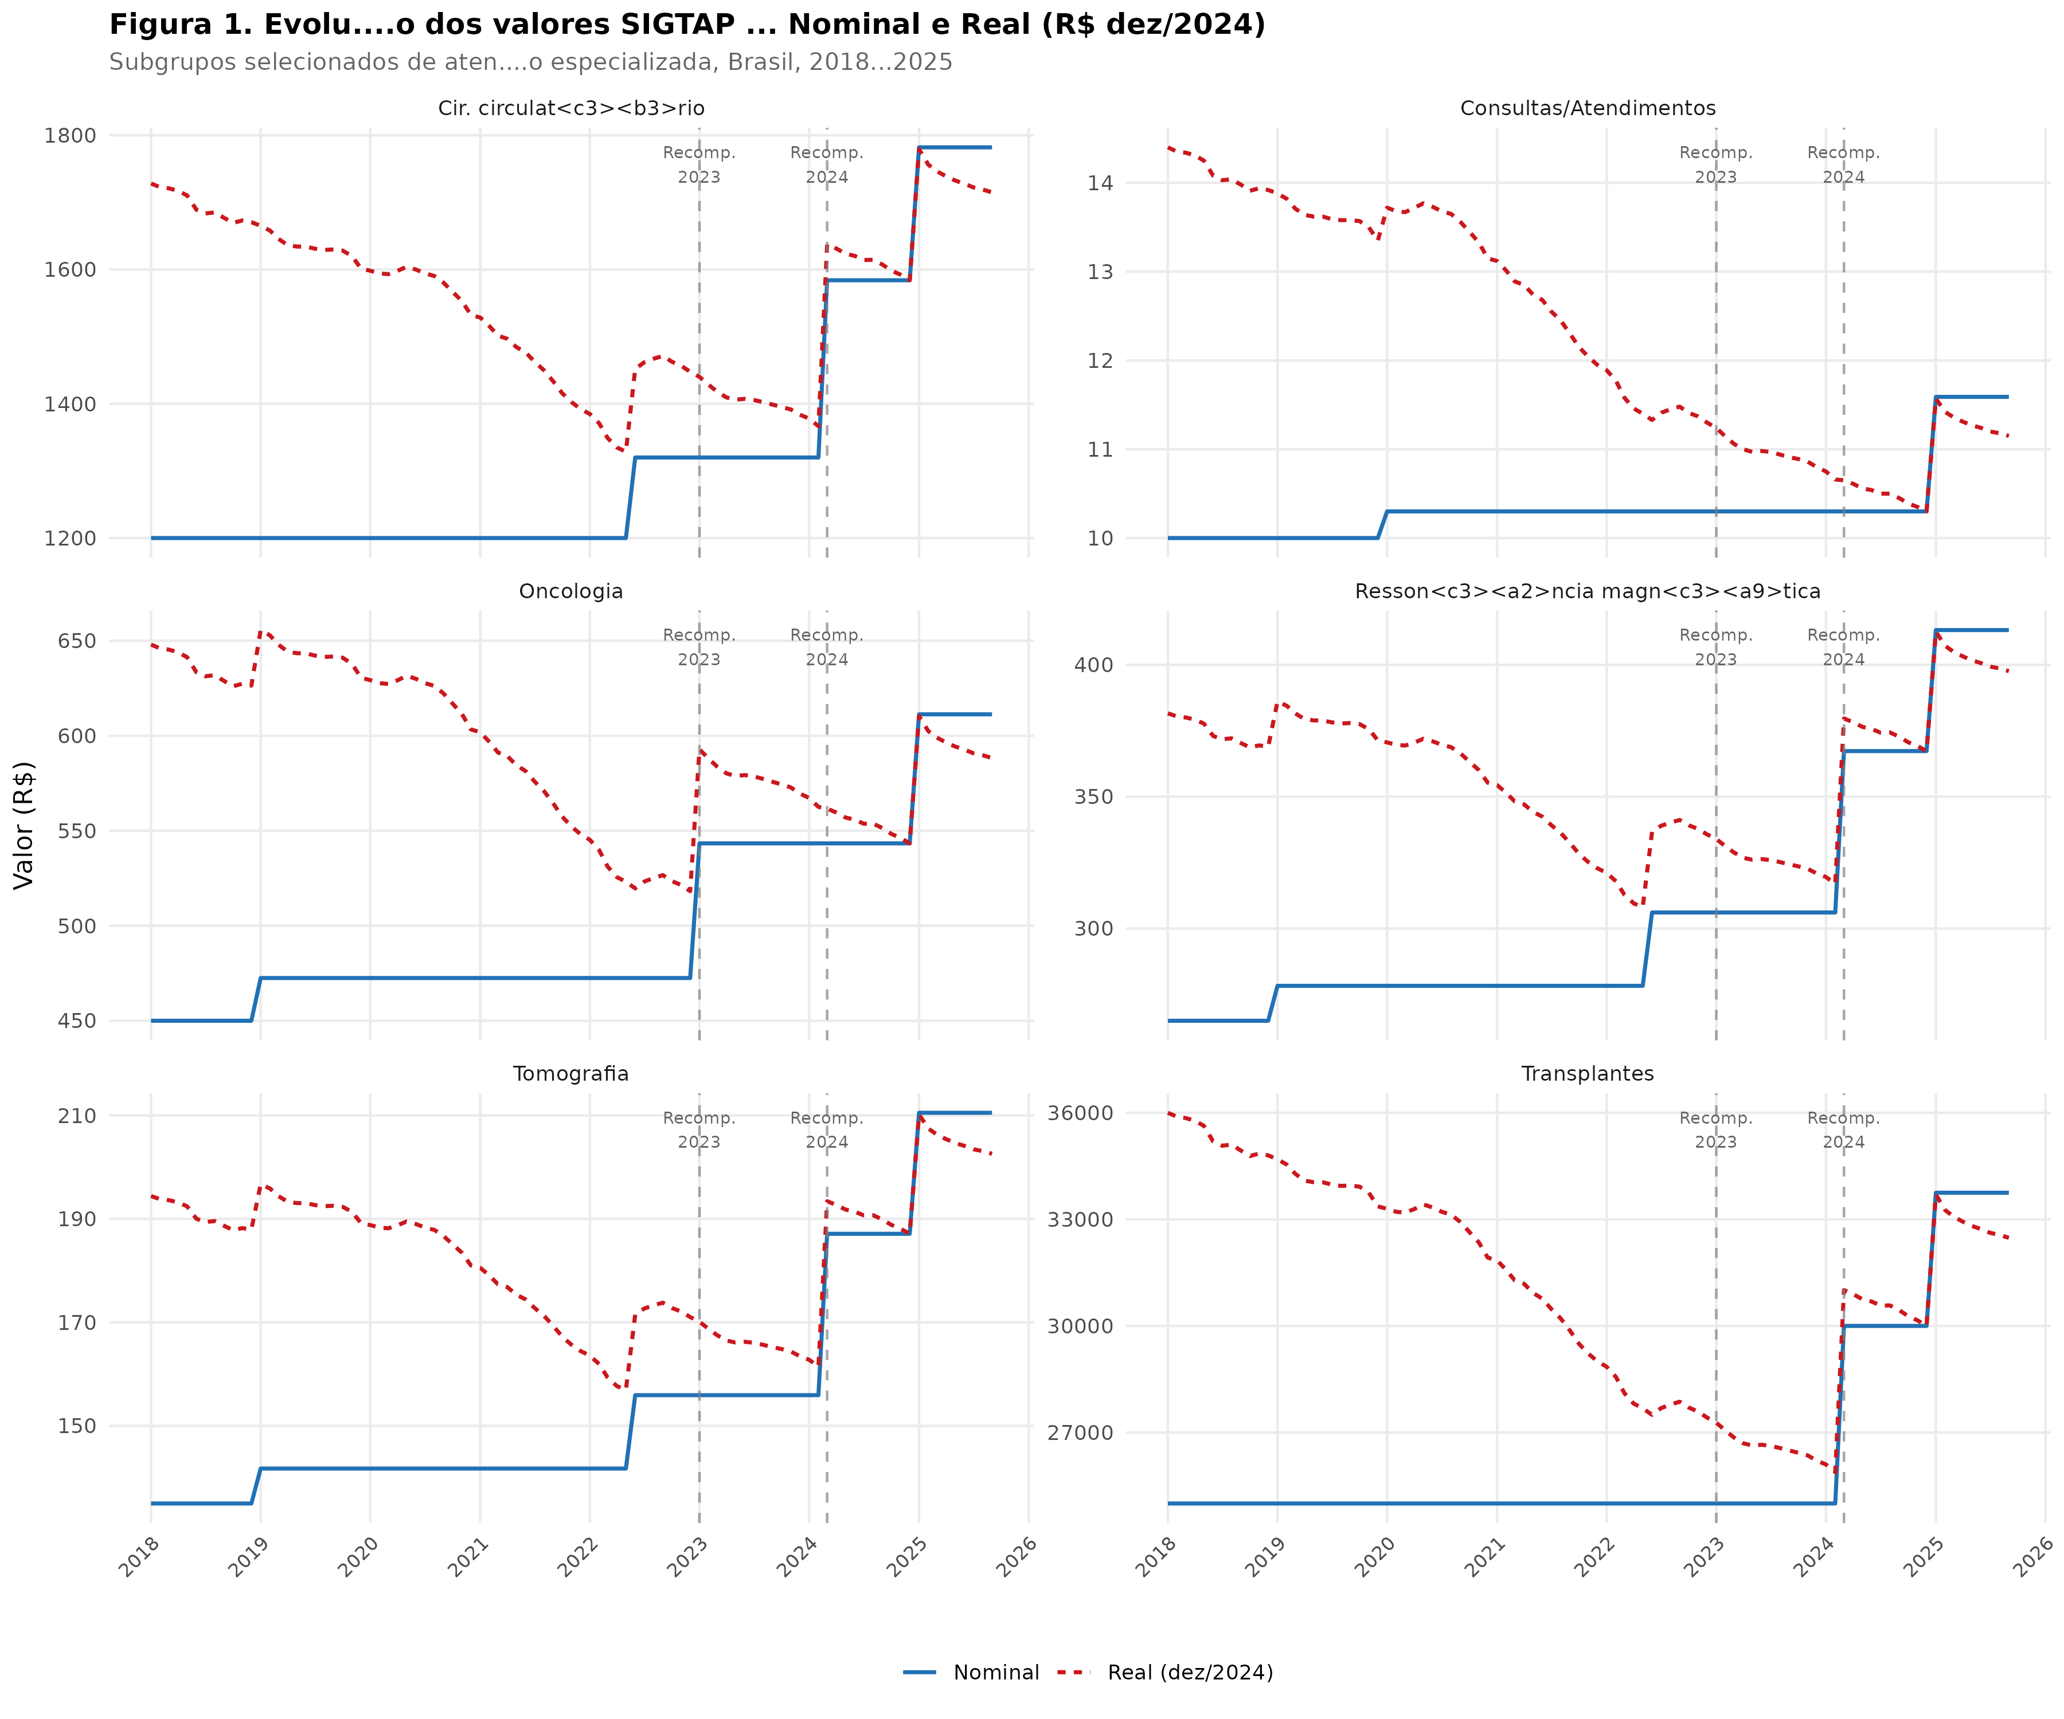
Figure 1. Nominal and real (December 2024 R$) SIGTAP reference values for selected procedure subgroups, Brazil, 2018–2025. Dashed vertical lines indicate recomposition events.

Hospital production (SIH/SUS)
Table 2 summarizes hospital production by DiD group and period. All groups experienced sharp declines during the COVID-19 pandemic (March 2020–June 2021), with mean monthly quantities falling by approximately 21–22% relative to pre-COVID levels. Recovery occurred progressively, with production exceeding pre-COVID levels by mid-2022 for most subgroups.
In the post-recomposition 2024 period (March 2024–September 2025), the treatment group showed mean monthly production 30.1% above pre-COVID levels, compared to 14.8% for the control group. The largest individual increases were observed in cardiovascular surgery (+33.1%), digestive surgery (+32.0%), and transplantation (+30.0%). Oncology (+24.4%), nephrology (+24.0%), and oncologic surgery (+25.2%) also showed substantial gains in the 2023 treatment group. Control subgroups showed more modest increases of 12.2–17.5%, consistent with underlying secular trends.
Table 2. Summary statistics of hospital production (SIH/SUS) by DiD group and period, Brazil, 2018–2025.
grupo_did | periodo | n_meses | qtd_media | qtd_mediana | valor_real_medio | valor_total_real_M
controle | 1_Pre_COVID | 26 | 250394 | 82860 | 1877.91 | 23552.4
controle | 2_COVID | 16 | 197297 | 54059 | 1784.78 | 10596.8
controle | 3_Recuperacao | 18 | 266521 | 91209 | 1560.93 | 14342.2
controle | 4_Pos_Recomp_2023 | 14 | 270885 | 91934 | 1467.94 | 10537.7
controle | 5_Pos_Recomp_2024 | 19 | 287393 | 96233 | 1345.45 | 14025.3
tratamento_2023 | 1_Pre_COVID | 26 | 167000 | 183088 | 4595.1 | 35411.3
tratamento_2023 | 2_COVID | 16 | 130182 | 146290 | 4321.82 | 16064.7
tratamento_2023 | 3_Recuperacao | 18 | 176467 | 194156 | 3748.97 | 21764.4
tratamento_2023 | 4_Pos_Recomp_2023 | 14 | 194757 | 216272 | 3568.51 | 17448.2
tratamento_2023 | 5_Pos_Recomp_2024 | 19 | 207374 | 229055 | 3310.51 | 23570.3
tratamento_2024 | 1_Pre_COVID | 26 | 47889 | 50732 | 11169.72 | 27349.2
tratamento_2024 | 2_COVID | 16 | 37803 | 38412 | 10221.26 | 12195.7
tratamento_2024 | 3_Recuperacao | 18 | 51062 | 54098 | 9120.71 | 16648.4
tratamento_2024 | 4_Pos_Recomp_2023 | 14 | 52129 | 54886 | 8587.67 | 12484.5
tratamento_2024 | 5_Pos_Recomp_2024 | 19 | 62284 | 66358 | 7914.82 | 18763.1

Table 3. Percentage variation in mean monthly hospital production: post-recomposition (2024/03–2025/09) vs. pre-COVID (2018/01–2020/02), by procedure subgroup.
cod_subgrupo | nome_subgrupo | grupo_did | pos_recomp | pre_covid | variacao_pct
0404 | Cir. circulat<c3><b3>rio | tratamento_2024 | 46583.73684210526 | 34993.782608695656 | 33.1
0405 | Cir. digestivo | tratamento_2024 | 86828.1052631579 | 65793.11538461539 | 32
0505 | Transplantes | tratamento_2024 | 3312.315789473684 | 2548.230769230769 | 30
0407 | Cir. geniturin<c3><a1>rio | tratamento_2024 | 73048.63157894737 | 56242.153846153844 | 29.9
0403 | Cir. vis<c3><a3>o | tratamento_2024 | 59515.63157894737 | 45870.730769230766 | 29.7
0408 | Cir. osteomuscular | tratamento_2024 | 104413.78947368421 | 81832.34615384616 | 27.6
0416 | Cir. oncologia | tratamento_2023 | 28135.842105263157 | 22474.26923076923 | 25.2
0304 | Oncologia | tratamento_2023 | 228929.15789473685 | 184044 | 24.4
0305 | Nefrologia | tratamento_2023 | 365056.84210526315 | 294481.73076923075 | 24
0411 | Cir. ORL | controle | 29560.105263157893 | 25166.23076923077 | 17.5
0412 | Cir. tor<c3><a1>cica | controle | 14214.684210526315 | 12186.153846153846 | 16.6
0303 | Trat. cl<c3><ad>nicos | controle | 492775.7368421053 | 425526.57692307694 | 15.8
0413 | Cir. reparadora | controle | 21250.052631578947 | 18350.53846153846 | 15.8
0301 | Consultas/Atend. | controle | 994119.7368421053 | 867510.1923076923 | 14.6
0401 | Peq. cirurgias | controle | 172438.52631578947 | 153624.07692307694 | 12.2
0404 | Cir. vis<c3><a3>o | tratamento_2024 | NA | 35484.333333333336 | NA

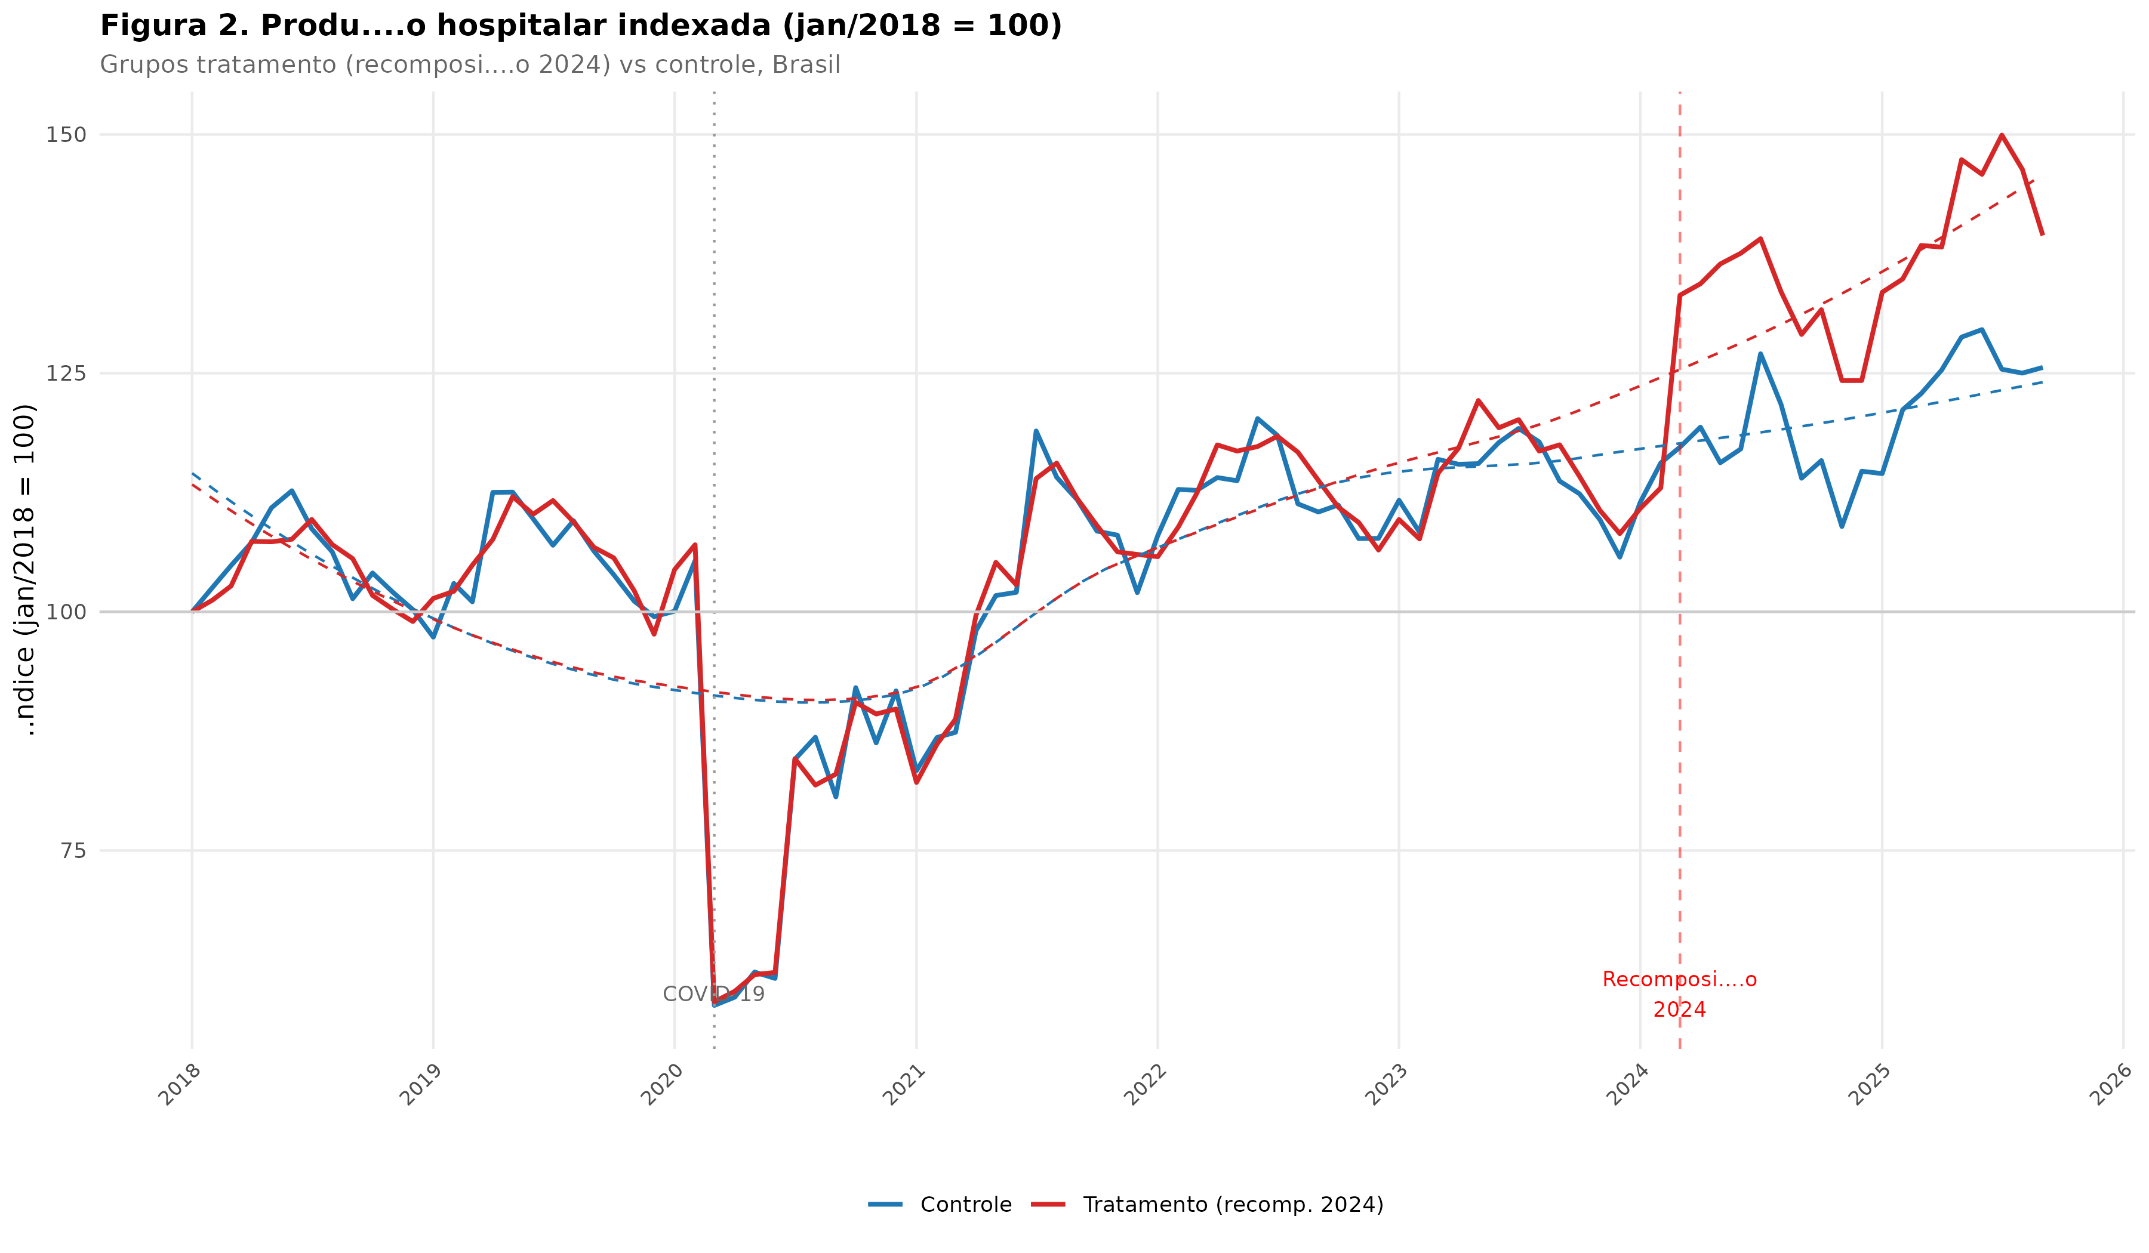
Figure 2. Indexed hospital production (January 2018 = 100) for treatment (2024 recomposition) and control groups. LOESS smoothing applied.

Ambulatory production (SIA/SUS)
Ambulatory production showed similar patterns. COVID-19 disruption was more severe in ambulatory settings, with quantities falling by up to 55% in March–May 2020 before gradual recovery. Subgroups receiving targeted recomposition (tomography, MRI, nuclear medicine) showed accelerated recovery relative to control subgroups, with the divergence becoming more pronounced after the 2024 recomposition. Figure 3 shows individual subgroup trajectories.
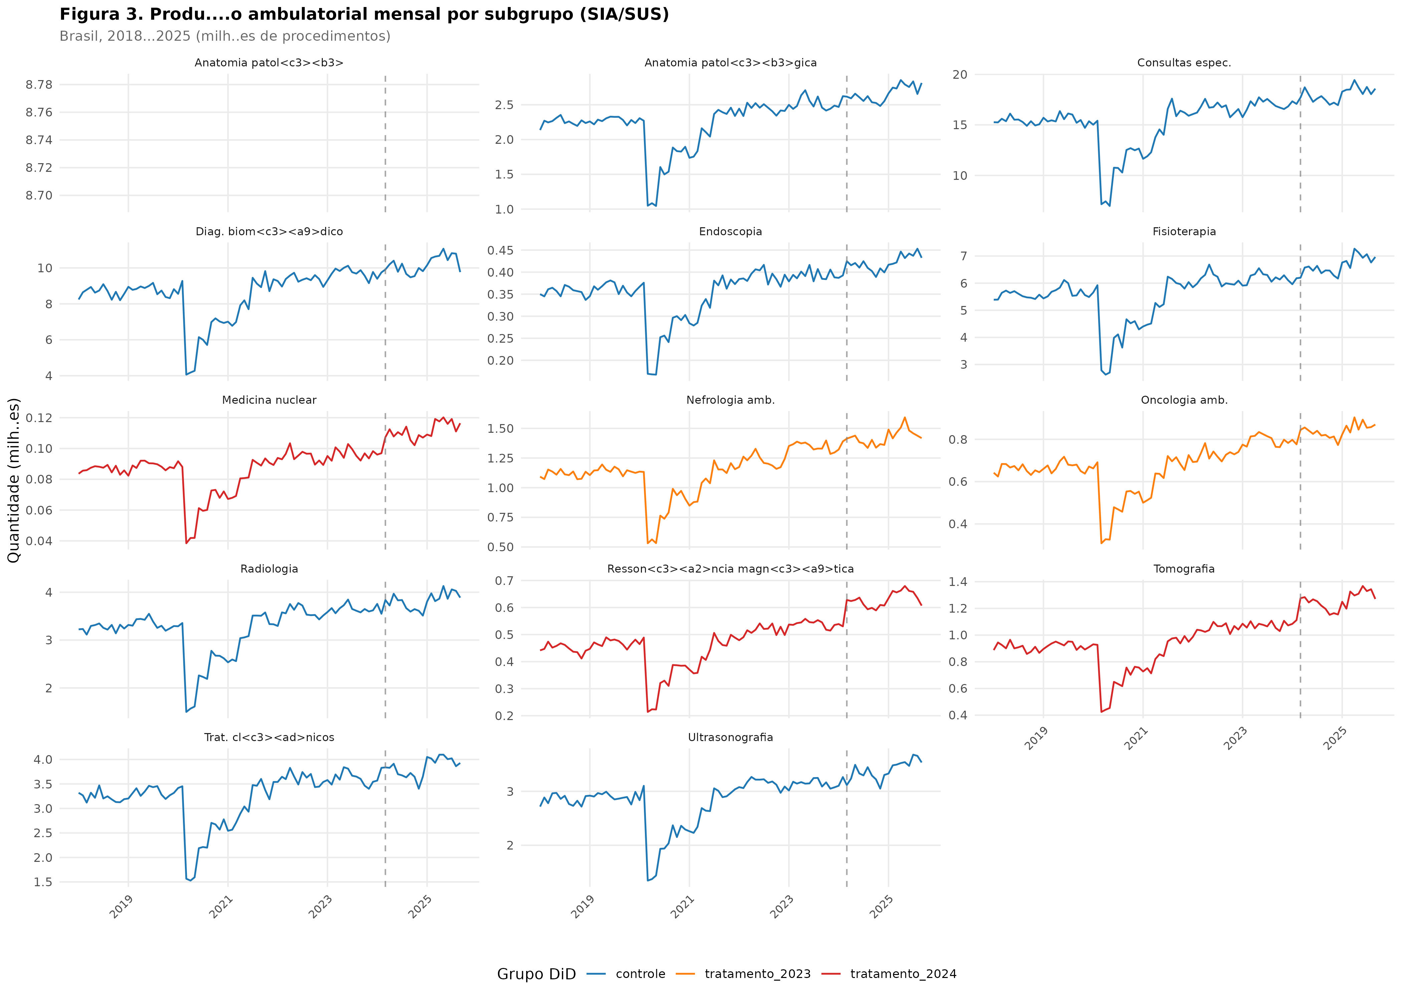
Figure 3. Monthly ambulatory production (SIA/SUS) by procedure subgroup, Brazil, 2018–2025. Colors indicate DiD group classification.

Difference-in-differences estimates
Table 4 presents the results of the five DiD models. The basic specification (M1a) yielded a DiD coefficient of 0.120 but was not statistically significant (p = 0.569) due to high residual variance without fixed effects. After including procedure fixed effects and a linear trend (M1b), the coefficient increased to 0.161 (p < 0.001), reflecting the correction for compositional differences. The preferred specification (M1c), with procedure and time fixed effects, estimated a DiD coefficient of 0.120 (SE = 0.005; t = 24.6; p < 0.001; R² = 0.9996), corresponding to an approximately 12.7% increase in approved hospital production attributable to the 2024 recomposition (exp(0.120) − 1 = 0.127).
The 2023 recomposition (M2) showed a smaller but significant effect: coefficient = 0.081 (SE = 0.005; p < 0.001), corresponding to an 8.4% increase. The ambulatory DiD (M3) closely mirrored the hospital estimate: coefficient = 0.120 (SE = 0.005; p < 0.001), suggesting that recomposition effects were consistent across care settings.
Table 4. Difference-in-differences regression results for the effect of fee recomposition on approved production (log quantity). HC1 robust standard errors.
modelo | coef_did | se_robusto | t_stat | p_valor | r2 | r2_adj | n_obs
M1a: DiD simples SIH (2024) | 0.1203 | 0.2111 | 0.57 | 0.5688 | 0.0941 | 0.0916 | 1116
M1b: DiD + EF proc + tend<c3><aa>ncia (2024) | 0.1613 | 0.0093 | 17.335 | 0 | 0.9918 | 0.9917 | 1116
M1c: DiD + EF proc + EF tempo (2024) | 0.1203 | 0.0049 | 24.645 | 0 | 0.9996 | 0.9996 | 1116
M2: DiD SIH <e2><80><93> Recomp. 2023 | 0.0807 | 0.0046 | 17.429 | 0 | 0.9996 | 0.9996 | 837
M3: DiD SIA <e2><80><93> Recomp. 2024 | 0.1201 | 0.0054 | 22.094 | 0 | 0.9997 | 0.9997 | 1023

Validation: event study and placebo test
The event study (Figure 4) shows the semester-level DiD coefficients relative to the first semester of 2021 (reference period). Pre-treatment coefficients fluctuate near zero (apart from the COVID disruption in 2020), supporting the parallel trends assumption. A visible upward shift occurs after the 2024 recomposition (semesters 5–7), consistent with a treatment effect.
The placebo test (Table 5) applied a false treatment date of July 2021 to the pre-2024 data. The estimated coefficient was 0.003 (SE = 0.004; p = 0.488), confirming that no spurious effect existed prior to the actual recomposition. This result strengthens the causal interpretation of the DiD estimates.
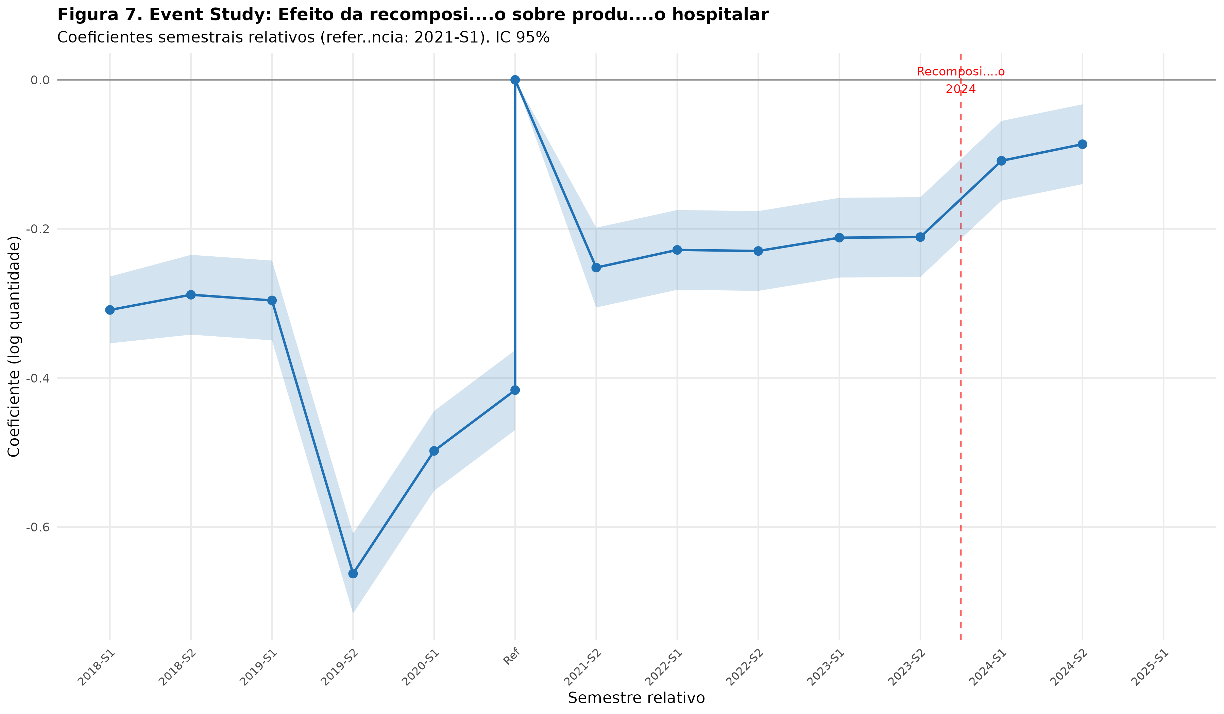
Figure 4. Event study: semester-level DiD coefficients for hospital production. Reference period: 2021-S1. Shaded area indicates 95% confidence intervals.

Table 5. Placebo test results: false treatment date (July 2021) applied to pre-recomposition data.
teste | coef | se | p_valor | conclusao
Placebo (falso tratamento 2021-07) | 0.0027 | 0.0039 | 0.4883 | N<c3><a3>o rejeita H0 - Tend<c3><aa>ncias paralelas validadas

Regional heterogeneity
Figure 5 presents the state-level DiD estimates for the 2024 recomposition. All 15 states showed positive and statistically significant effects (p < 0.05). The magnitude ranged from 9.1% in Goiás (coefficient = 0.091; 95% CI: 0.061–0.120) to 13.1% in Maranhão (coefficient = 0.131; 95% CI: 0.103–0.159). Notably, states with historically lower per-capita supply (Maranhão, Pernambuco, Bahia, Pará) tended to show larger effects, though the differences between states were not statistically significant given overlapping confidence intervals.
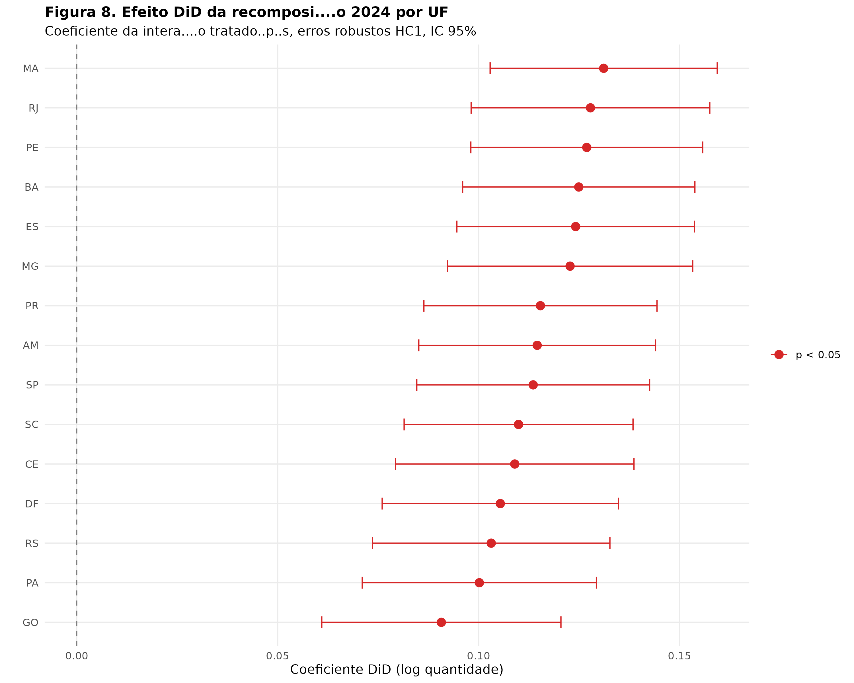
Figure 5. Forest plot: state-level DiD estimates for the 2024 recomposition effect on hospital production. HC1 robust standard errors, 95% CI.

Table 6. State-level DiD estimates for the 2024 recomposition effect on hospital production (log quantity).
uf | estimate | se | pvalue | ci_low | ci_high | sig
SP | 0.11358280762894427 | 0.01477725036972655 | 3.338104809405335e-14 | 0.08461939690428022 | 0.1425462183536083 | p < 0.05
RJ | 0.12783339553880477 | 0.015146572650235302 | 9.89156350211042e-17 | 0.09814611314434357 | 0.15752067793326596 | p < 0.05
MG | 0.12275939719009607 | 0.015566987470779508 | 7.476605210989067e-15 | 0.09224810174736824 | 0.1532706926328239 | p < 0.05
BA | 0.12491792389680366 | 0.014742191663687742 | 7.539071576714619e-17 | 0.09602322823597569 | 0.15381261955763165 | p < 0.05
RS | 0.10314453942382178 | 0.015064402852926713 | 1.25108117844434e-11 | 0.07361830983208542 | 0.13267076901555813 | p < 0.05
PR | 0.11538506342793473 | 0.014794265381210673 | 1.436714342805098e-14 | 0.0863883032807618 | 0.14438182357510765 | p < 0.05
PE | 0.12691046330246328 | 0.014715778341796088 | 2.217918096855468e-17 | 0.09806753775254294 | 0.1557533888523836 | p < 0.05
CE | 0.10899028166429987 | 0.0151357661154984 | 1.1060359407223734e-12 | 0.07932418007792301 | 0.13865638325067672 | p < 0.05
PA | 0.1001821444836841 | 0.014864071531732423 | 2.5505575685803842e-11 | 0.07104856428148855 | 0.12931572468587965 | p < 0.05
GO | 0.09073275485375407 | 0.01518026540076079 | 3.065149927786351e-9 | 0.060979434668262916 | 0.12048607503924522 | p < 0.05
MA | 0.13112058434888002 | 0.014414691932452933 | 4.2537071831923694e-19 | 0.10286778816127227 | 0.15937338053648778 | p < 0.05
SC | 0.10994431729116062 | 0.014528391795489107 | 8.006109340229232e-14 | 0.08146866937200198 | 0.13841996521031927 | p < 0.05
AM | 0.1145713088198924 | 0.015025989886047397 | 5.256549169451428e-14 | 0.0851203686432395 | 0.1440222489965453 | p < 0.05
DF | 0.10540526506392241 | 0.014998767706708934 | 3.675125939010607e-12 | 0.0760076803587729 | 0.13480284976907192 | p < 0.05
ES | 0.12415209498182156 | 0.015081819676925531 | 5.164084538581489e-16 | 0.09459172841504751 | 0.1537124615485956 | p < 0.05

Healthcare establishment network (CNES)
The CNES analysis revealed a modest but consistent expansion of the healthcare establishment network over the study period. Between 2018 and 2025, the total number of active specialized care facilities (clinics, diagnostic centers, and hospitals) grew by approximately 11–15%. Post-recomposition, specialty clinics and diagnostic/therapeutic support services (SADT) showed an additional 4–6% increase relative to pre-2024 trends (Figure 6). The expansion was concentrated in private for-profit and philanthropic facilities, while public establishments remained relatively stable.
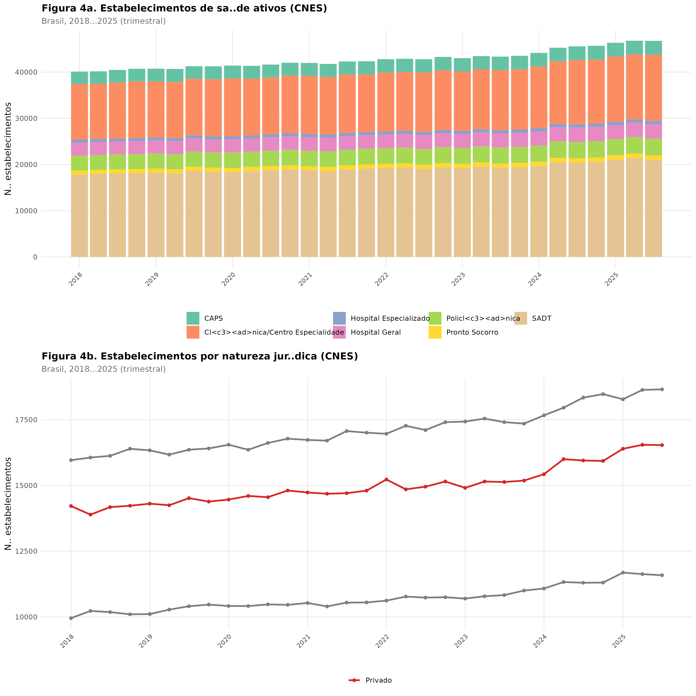
Figure 6. Evolution of active healthcare establishments by type and legal nature (CNES), Brazil, 2018–2025 (quarterly).

Total production value
Figure 7 shows the total real value of approved production across SIH and SIA. The combined real production value declined sharply during the pandemic but showed sustained recovery from late 2020, surpassing pre-COVID levels by mid-2022. The acceleration after the 2024 recomposition is visible, though it reflects both volume and price effects. Hospital production (SIH) accounts for approximately 70–75% of total specialized care spending.
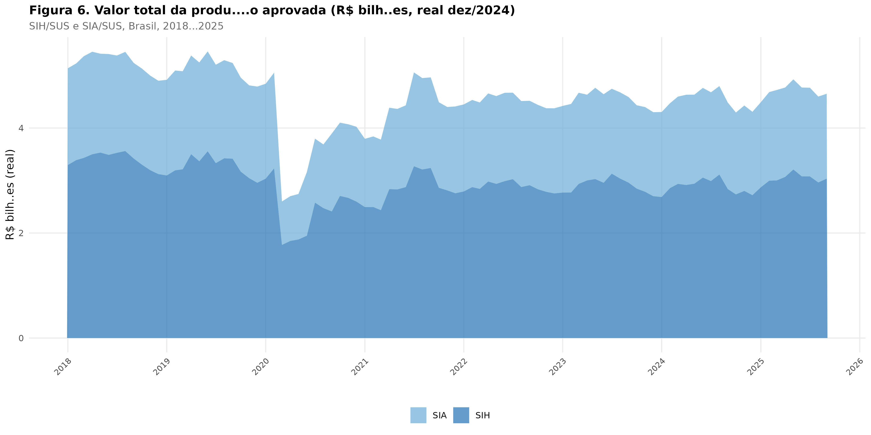
Figure 7. Total approved production value in constant December 2024 R$ (billions), SIH/SUS and SIA/SUS, Brazil, 2018–2025.

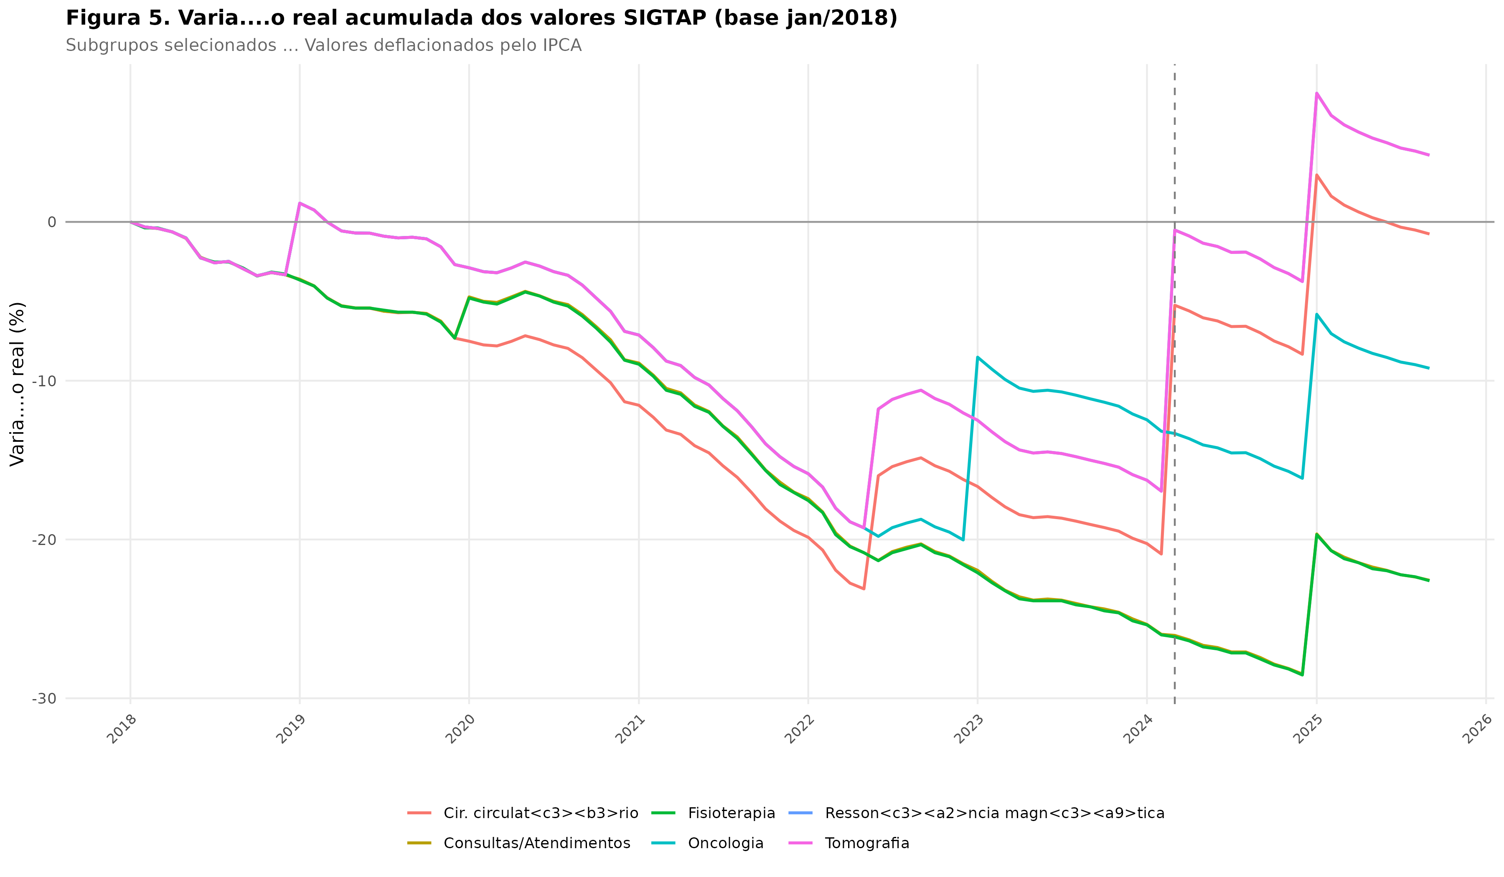
Figure 8. Accumulated real-value variation of SIGTAP reference values relative to January 2018, selected subgroups. IPCA-deflated.

Discussion
This study provides the first quasi-experimental evidence that fee schedule recomposition in the Brazilian SUS is associated with meaningful increases in specialized care production. The 2024 recomposition was associated with a 12–13% increase in both hospital and ambulatory approved production, while the 2023 recomposition showed an 8% increase. These effects were consistent across care settings, robust to different model specifications, and validated by both an event study and a placebo test.

Comparison with international literature
Our findings are broadly consistent with the international literature on the price-quantity relationship in healthcare. Clemens and Gottlieb (2014) found that a 2% Medicare fee increase led to approximately 3% more healthcare spending in the United States, implying an elasticity of roughly 1.5 [13]. Our estimates suggest a somewhat lower elasticity: the 20% fee increase in the 2024 recomposition was associated with a 12–13% production increase, implying an elasticity of approximately 0.6. This difference may reflect the specific institutional context of the SUS, where provider participation is shaped by factors beyond price—including contractual obligations, regulatory requirements, and the mixed public-private nature of the Brazilian health system [2, 20].
Decker (2009) showed that Medicaid fee increases from 1996 to 2004 were associated with increased physician willingness to accept new Medicaid patients [12]. While our data do not directly capture provider willingness, the CNES analysis suggests that the establishment network expanded modestly post-recomposition, particularly among private and philanthropic facilities—consistent with a positive supply response to improved reimbursement.
In the European context, Januleviciute et al. (2016) documented that the introduction of activity-based financing in Norwegian hospitals altered production volumes across diagnostic categories [15]. Our event study similarly captures a post-treatment divergence that is consistent with a causal effect of fee changes on production.

Implications for Brazilian health policy
The central contribution of this study is to shift the debate about the Tabela SUS from the exclusively rhetorical plane to the empirical measurement plane. Our results demonstrate that administered prices matter: when the SUS increases reimbursement for specific procedure categories, approved production responds positively. This finding has several policy implications.
First, it supports the use of targeted fee recomposition as a policy instrument for expanding access to specific types of specialized care, particularly in settings where the gap between administered values and production costs has widened most. The larger effects observed in states with historically lower supply (Maranhão, Pernambuco, Pará) suggest that recomposition may be particularly effective in underserved areas where provider margins have been most compressed [8, 29].
Second, the finding that real values continued to decline for most subgroups despite nominal increases underscores the inadequacy of sporadic, one-time adjustments. A systematic mechanism for periodic inflation-indexed recomposition—analogous to automatic adjustment clauses in regulated industries—would better preserve the real value of the fee schedule over time [5, 30].
Third, the modest magnitude of the CNES network expansion suggests that fee recomposition alone is insufficient to substantially restructure the provider network. Complementary strategies are needed, including strengthened contracting mechanisms, regional health planning, investment in installed capacity, and queue management systems [2, 7, 31].

Literature gaps addressed
This study fills several gaps identified in our review of the literature:
1. Measurement of real-value erosion: We constructed the first comprehensive deflated time series of SIGTAP reference values from 2018 to 2025, demonstrating that real values declined by up to 25% for subgroups without targeted recomposition. Previous studies cited fee inadequacy qualitatively but lacked systematic quantification [5, 6, 18].
2. Causal identification: By applying a DiD design with procedure and time fixed effects, we moved beyond the correlational evidence that characterized prior Brazilian studies [6, 19]. The event study and placebo test provide additional support for causal interpretation.
3. Regional heterogeneity: Our state-level analysis reveals that recomposition effects are not uniform across Brazil, with suggestive evidence that effects are larger in historically underserved states—a finding with direct relevance for equity-oriented resource allocation [29, 32].
4. Multi-database integration: By linking SIGTAP values with SIH/SUS production, SIA/SUS production, and CNES establishment data, we provide a more comprehensive picture than studies relying on a single data source [22, 23, 24].
5. LMIC evidence on administered prices: This study contributes to the sparse international literature on the price-production nexus in low- and middle-income country health systems, where most evidence originates from US Medicare/Medicaid or European single-payer contexts [16, 17].

Limitations
Several limitations should be acknowledged. First, while the DiD design provides stronger causal identification than cross-sectional approaches, it relies on the parallel trends assumption. Although our event study and placebo test support this assumption, unmeasured confounders correlated with both recomposition timing and production trends cannot be entirely ruled out.
Second, the study analyzes approved production (quantities approved for reimbursement), not actual healthcare delivery. Processing delays, billing practices, and authorization patterns may introduce noise. We excluded the final months of the series to mitigate processing lag, but residual bias cannot be excluded.
Third, the CNES analysis is limited to quarterly snapshots of establishment counts and does not capture within-facility changes in capacity, equipment, or staffing. A finer-grained analysis of installed capacity—including beds, equipment units, and professional hours—would provide a more complete picture of supply-side responses.
Fourth, this study does not analyze the quality or appropriateness of the additional production generated by recomposition. An increase in approved quantities could reflect both genuine expansion of beneficial care and potential supply-induced demand or coding changes [33].
Fifth, the analysis is conducted at the procedure subgroup level, aggregating heterogeneous procedures within each subgroup. Subgroup-level effects may mask important variation at the individual procedure code level.

Conclusions
This study provides robust empirical evidence that fee schedule recomposition in the SUS is associated with significant increases in specialized care production. The 2024 recomposition was associated with a 12–13% increase in both hospital and ambulatory approved production, with effects detectable across all states analyzed. The 2023 recomposition showed a smaller but significant 8% effect.
These findings support the hypothesis that administered prices matter for healthcare supply in publicly financed systems. However, the persistence of real-value erosion in most procedure categories—even after nominal recomposition—highlights the need for systematic, inflation-indexed adjustment mechanisms. Recomposition is a necessary but insufficient condition for expanding access to specialized care; complementary investments in regional planning, provider contracting, installed capacity, and queue management remain essential.
Future research should examine the quality and appropriateness of production changes following recomposition, explore the mechanisms through which fee changes translate into provider behavior, and evaluate the cost-effectiveness of targeted recomposition as a policy instrument for expanding access to specialized care in the SUS.

Declarations

Ethics approval and consent to participate
Not applicable. This study used exclusively publicly available, anonymized secondary data. In accordance with Brazilian National Health Council Resolution 510/2016, ethics committee approval is not required for research using public-domain data.

Consent for publication
Not applicable.

Availability of data and materials
All data used in this study are publicly available through the Brazilian Ministry of Health’s DATASUS platform (https://datasus.saude.gov.br). The analytical code and processed datasets are available in the supplementary repository.

Competing interests
The authors declare that they have no competing interests.

Funding
[To be completed by authors]

Authors’ contributions
[To be completed by authors]

Acknowledgements
[To be completed by authors]

References
1. Paim J, Travassos C, Almeida C, Bahia L, Macinko J. The Brazilian health system: history, advances, and challenges. Lancet. 2011;377(9779):1778–97.
2. Gragnolati M, Lindelow M, Couttolenc B. Twenty years of health system reform in Brazil: an assessment of the Sistema Único de Saúde. Washington, DC: World Bank; 2013.
3. Brasil. Ministério da Saúde. Sistema de Gerenciamento da Tabela de Procedimentos, Medicamentos e OPM do SUS (SIGTAP). Brasília: Ministério da Saúde; 2025. Available from: http://sigtap.datasus.gov.br
4. Santos L, Andrade LOM. SUS: o espaço da gestão inovada e dos consensos interfederativos. Campinas: Saberes; 2011.
5. Conselho Nacional de Secretários de Saúde (CONASS). A Tabela SUS e a remuneração dos procedimentos: nota técnica. Brasília: CONASS; 2023.
6. Portela MC, Proença JD, Lima SML, Barbosa PR, Vasconcellos MM, Ugá MAD, et al. Estudo sobre os hospitais filantrópicos no Brasil. Rev Saúde Pública. 2018;52:34.
7. Solla JJSP, Chioro A. Atenção ambulatorial especializada. In: Giovanella L, Escorel S, Lobato LVC, Noronha JC, Carvalho AI, editors. Políticas e sistema de saúde no Brasil. 2nd ed. Rio de Janeiro: Fiocruz; 2012. p. 547–76.
8. Confederação Nacional de Saúde (CNSaúde). O impacto da defasagem da Tabela SUS na sustentabilidade dos hospitais. Brasília: CNSaúde; 2022.
9. McGuire TG. Physician agency and payment mechanisms. In: Culyer AJ, Newhouse JP, editors. Handbook of Health Economics. Vol. 1A. Amsterdam: Elsevier; 2000. p. 461–536.
10. Ellis RP, McGuire TG. Provider behavior under prospective reimbursement: cost sharing and supply. J Health Econ. 1986;5(2):129–51.
11. Rice T, Labelle RJ. Do physicians induce demand for medical services? J Health Polit Policy Law. 1989;14(3):587–600.
12. Decker SL. Changes in Medicaid physician fees and patterns of ambulatory care. Inquiry. 2009;46(3):291–304.
13. Clemens J, Gottlieb JD. Do physicians' financial incentives affect medical treatment and patient health? Am Econ Rev. 2014;104(4):1320–49.
14. Zuckerman S, Skopec L, Epstein M. Medicaid physician fees after the ACA primary care fee bump. Urban Institute; 2017.
15. Januleviciute J, Askildsen JE, Kaarboe O, Siciliani L, Sutton M. How do hospitals respond to price changes? Evidence from Norway. Health Econ. 2016;25(5):620–36.
16. Wagstaff A, Eozenou PHV, Smitz MF. Out-of-pocket expenditures on health: a global stocktake. World Bank Res Obs. 2020;35(2):123–57.
17. Mills A, Ataguba JE, Akazili J, Borghi J, Garshong B, Makawia S, et al. Equity in financing and use of health care in Ghana, South Africa, and Tanzania: implications for paths to universal coverage. Lancet. 2012;380(9837):126–33.
18. Santos MAB, Ugá MAD. Reformas organizacionais no setor saúde: os estímulos e os incentivos da política de remuneração dos serviços hospitalares no Brasil (1984–2004). Saúde em Debate. 2007;31(75–77):30–43.
19. Machado JP, Martins M, Leite IC, Silva GS, Oliveira RB. O perfil dos hospitais brasileiros que atendem ao SUS. Cad Saúde Pública. 2014;30(Suppl):S72–S86.
20. La Forgia GM, Couttolenc BF. Hospital performance in Brazil: the search for excellence. Washington, DC: World Bank; 2008.
21. Couttolenc BF, Gragnolati M. Performance of Brazil’s public health system. In: Twenty years of health system reform in Brazil. Washington, DC: World Bank; 2011.
22. Brasil. Ministério da Saúde. Sistema de Informações Hospitalares do SUS (SIH/SUS). Brasília: DATASUS; 2025. Available from: https://datasus.saude.gov.br
23. Brasil. Ministério da Saúde. Sistema de Informações Ambulatoriais do SUS (SIA/SUS). Brasília: DATASUS; 2025. Available from: https://datasus.saude.gov.br
24. Brasil. Ministério da Saúde. Cadastro Nacional de Estabelecimentos de Saúde (CNES). Brasília: DATASUS; 2025. Available from: https://cnes.datasus.gov.br
25. Instituto Brasileiro de Geografia e Estatística (IBGE). Índice Nacional de Preços ao Consumidor Amplo – IPCA. Rio de Janeiro: IBGE; 2025.
26. Brasil. Ministério da Saúde. Portaria GM/MS nº 6.465, de 30 de dezembro de 2024. Dispõe sobre a recomposição dos valores da Tabela de Procedimentos, Medicamentos e OPM do SUS. Diário Oficial da União; 2024.
27. White H. A heteroskedasticity-consistent covariance matrix estimator and a direct test for heteroskedasticity. Econometrica. 1980;48(4):817–38.
28. Brasil. Conselho Nacional de Saúde. Resolução nº 510, de 7 de abril de 2016. Diário Oficial da União; 2016.
29. Viacava F, Oliveira RAD, Carvalho CC, Laguardia J, Bellido JG. SUS: oferta, acesso e utilização de serviços de saúde nos últimos 30 anos. Ciênc Saúde Coletiva. 2018;23(6):1751–62.
30. Vieira FS, Benevides RPS. Os impactos do novo regime fiscal para o financiamento do Sistema Único de Saúde e para a efetivação do direito à saúde no Brasil. Nota Técnica IPEA; 2016.
31. Giovanella L, Mendonça MHM, Buss PM, Fleury S, Gadelha CAG, Galvão LAC, et al. De Alma-Ata a Astana: atenção primária à saúde e sistemas universais de saúde. Cad Saúde Pública. 2019;35(3):e00066019.
32. Albuquerque MV, Viana ALD, Lima LD, Ferreira MP, Fusaro ER, Iozzi FL. Desigualdades regionais na saúde: mudanças observadas no Brasil de 2000 a 2016. Ciênc Saúde Coletiva. 2017;22(4):1015–28.
33. Gruber J, Owings M. Physician financial incentives and cesarean section delivery. RAND J Econ. 1996;27(1):99–123.

