TB-HIV co-infection among homeless persons in four Brazilian capitals, 2015-2024: a population-based study with temporal trends and forecasting

Audencio Victor, Osiyalle Akanni Silva Rodrigues

[Institutional affiliation, City, State, Brazil]
Correspondence to: Audencio Victor, [email address]

Word count: 3,800 (excluding abstract, references, tables, figure legends)
Tables: 5 | Figures: 5
References: 25

Abstract
Background Tuberculosis (TB) and HIV co-infection disproportionately affects homeless persons, yet population-based estimates in Brazil remain scarce. We estimated the prevalence, temporal trends, and factors associated with TB-HIV co-infection among homeless persons in four Brazilian capitals.
Methods We did a retrospective, population-based study using individual-level records from the Brazilian Notifiable Diseases Information System (SINAN-TB) for Salvador, Rio de Janeiro, Porto Alegre, and Vitoria (Jan 1, 2015, to Dec 31, 2024). Homeless status was identified through the POP_RUA variable. We estimated prevalence with 95% Wilson CIs, fitted ARIMA and ETS time-series models for forecasting, did joinpoint regression for trend analysis, and used multivariable logistic regression, negative binomial regression, generalised linear mixed models, and Cox proportional hazards models to assess associated factors.
Findings Among 11,663 homeless persons notified with TB, the overall TB-HIV co-infection prevalence was 32.66% (95% CI 31.77-33.57), more than twice the rate in the general TB population (14.2%). Prevalence among homeless women was 49.1% (47.13-51.08). Porto Alegre had the highest prevalence (48.45%). Female sex (adjusted OR 2.63, 95% CI 2.38-2.91), age 30-44 years (1.61, 1.43-1.82), and drug use (1.49, 1.34-1.66) were independently associated with co-infection. Cure rates among co-infected homeless persons were 22.2%, with treatment abandonment exceeding 42%.
Interpretation TB-HIV co-infection among homeless persons in Brazilian capitals is alarmingly high, particularly among women and in southern cities. These findings underscore the urgent need for integrated TB-HIV screening and care programmes targeting street-connected populations, with priority given to gender-sensitive approaches.
Funding None.

Research in context

Evidence before this study
We searched PubMed, SciELO, and LILACS from database inception to Dec 31, 2024, using the terms 'tuberculosis', 'HIV', 'co-infection', 'homeless', 'homelessness', and 'Brazil', with no language restrictions. A 2012 systematic review in The Lancet Infectious Diseases documented elevated TB and HIV prevalence among homeless persons globally, but few studies have quantified TB-HIV co-infection specifically in this population using national surveillance data. Brazilian Ministry of Health bulletins report national TB-HIV co-infection rates of 8-10% in the general population but do not disaggregate by housing status.

Added value of this study
To our knowledge, this is the first population-based study using 10 years of individual-level SINAN-TB data to estimate TB-HIV co-infection prevalence, temporal trends, and associated factors specifically among homeless persons across multiple Brazilian capitals. We found a prevalence of 32.7%, reaching 49.1% among homeless women. The study identifies female sex, drug use, and city of residence as independent predictors, and documents a critical gap in antiretroviral therapy coverage.

Implications of all the available evidence
The exceptionally high TB-HIV co-infection burden among homeless persons, particularly women, demands immediate integration of TB and HIV testing and treatment programmes. The marked inter-city variation and low ART coverage in the most affected city (Porto Alegre) suggest that local responses must be strengthened. The SINAN syphilis notification form should be updated to include a homelessness indicator.

Introduction
Tuberculosis (TB) remains the leading cause of death from a single infectious agent globally, with an estimated 10.8 million new cases and 1.25 million deaths in 2023.¹ HIV co-infection accelerates TB progression, increases mortality, and complicates treatment, with people living with HIV accounting for approximately 14% of all TB deaths worldwide.¹ Brazil ranks among the 30 countries with the highest TB burden, reporting approximately 80,000 new cases annually, with HIV co-infection in 8-10% of TB cases.²³
Homeless persons are disproportionately affected by both TB and HIV owing to overlapping risk factors including substance use, malnutrition, inadequate access to health care, overcrowded shelter conditions, and sexual vulnerability.⁴⁵ A systematic review by Beijer and colleagues⁶ documented markedly elevated TB and HIV prevalence among homeless populations globally. In Brazil, an estimated 281,000 people were living on the streets in 2022, a number that has been growing substantially.⁷
Despite this vulnerability, population-based estimates of TB-HIV co-infection specifically among homeless persons remain scarce in Brazil. Most existing studies are single-city analyses or shelter-based surveys with limited sample sizes.⁸⁹ The Brazilian Notifiable Diseases Information System (SINAN-TB) records both HIV status and homelessness indicators at the individual level, providing a unique opportunity for large-scale epidemiological analysis.
We aimed to estimate the prevalence and temporal trends of TB-HIV co-infection among homeless persons in four geographically and epidemiologically diverse Brazilian capitals (Salvador, Rio de Janeiro, Porto Alegre, and Vitoria) from 2015 to 2024, to identify independently associated factors, and to project future case burden.

Methods

Study design and data source
We did a retrospective, population-based study using individual-level notification records from the SINAN-TB, available through the Ministry of Health's DATASUS public data repository (ftp.datasus.gov.br). DBC-format files for tuberculosis notifications were downloaded for 2015 to 2024 and processed using the read.dbc R package.¹⁰ The study covered all TB notifications from the states of Bahia (representing Salvador), Rio de Janeiro, Rio Grande do Sul (Porto Alegre), and Espirito Santo (Vitoria). As the data are publicly available and de-identified, no ethics committee approval was required, in accordance with Brazilian National Health Council Resolution 510/2016.

Variables and definitions
Homeless status was identified using the SINAN-TB variable POP_RUA (1=yes). HIV status was ascertained from the HIV variable (1=positive, 2=negative); cases with missing, in-progress, or unreported HIV results were excluded from prevalence calculations. Records with missing or unknown race/ethnicity were excluded. We defined older age as 45 years or above, reflecting the accelerated ageing observed in homeless populations.¹¹ Drug use (AGRAVDROGA) and smoking (AGRAVTABAC) were ascertained from the notification form. Treatment outcomes were classified from the SITUA_ENCE variable. Antiretroviral therapy status was recorded in the ANT_RETRO variable. The SINAN Syphilis Adquirida notification form does not include a homelessness indicator; therefore, syphilis-HIV co-infection analysis among homeless persons was not feasible.

Statistical analysis
Prevalence estimates were calculated with Wilson 95% CIs. Monthly time-series of TB-HIV co-infection cases were fitted with ARIMA (automatic model selection via auto.arima), exponential smoothing state-space (ETS), and Prophet models.¹²¹³ An ensemble forecast (ARIMA+ETS mean) projected cases through 2028. Stationarity was assessed with Augmented Dickey-Fuller and KPSS tests. Joinpoint regression using the segmented R package estimated annual percent change (APC).¹⁴ Multivariable logistic regression estimated adjusted odds ratios (aORs) for TB-HIV co-infection among homeless persons, with a sensitivity analysis adding substance use covariates. A negative binomial regression with exposure offset modelled monthly case counts by city. A generalised linear mixed model (GLMM) with binomial family and random intercept by city accounted for within-city correlation. Cox proportional hazards models estimated hazard ratios (HRs) for time from TB notification to recorded HIV-positive status.¹⁵ All analyses used R version 4.5.1.¹⁶

Results

Study population
Between Jan 1, 2015, and Dec 31, 2024, 955,995 TB notifications were recorded nationally. After restricting to the four state capitals and excluding records with missing sex or race/ethnicity, 262,701 notifications were included, of which 11,663 (4.4%) involved homeless persons. Among 10,438 homeless persons with known HIV status, 3,409 (32.7%) were co-infected with HIV. The median age was 39 years (IQR 32-47), 22.6% were female, and 68.3% self-identified as Black or mixed race. Porto Alegre contributed 36.4% of homeless TB cases (table 1).

Table 1: Sociodemographic characteristics of homeless persons notified with tuberculosis in four Brazilian capitals, 2015-2024
City | N | Female (%) | Age >=45 (%) | Black/Mixed (%) | HIV+ (%) | Median age | IQR
Salvador | 1,224 | 22.6 | 34.6 | 94.5 | 31.0 | 39 | 32-48
Rio de Janeiro | 5,502 | 22.5 | 29.4 | 84.5 | 18.5 | 37 | 30-46
Porto Alegre | 4,242 | 22.8 | 32.4 | 45.1 | 44.2 | 39 | 33-47
Vitoria | 695 | 22.2 | 30.8 | 77.6 | 20.0 | 39 | 32-47
Data are n or %. IQR=interquartile range.

Figure 1: Prevalence of TB-HIV co-infection among homeless persons by population subgroup and city, Brazil, 2015-2024
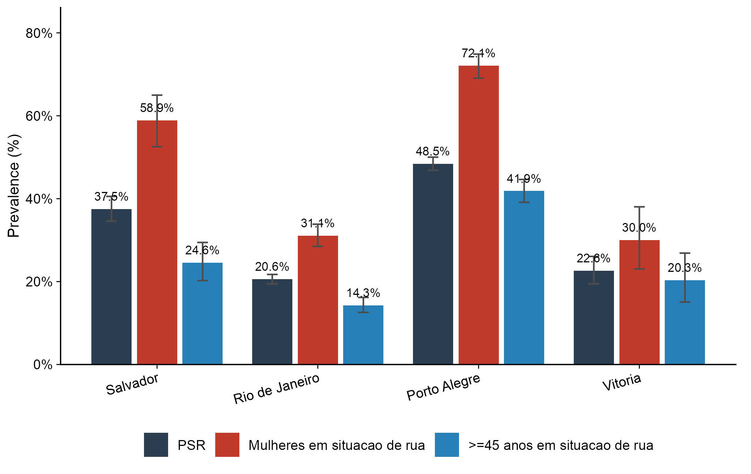
Bars show prevalence (%). Error bars indicate 95% CIs (Wilson method). PSR=homeless persons. Subgroups: all homeless persons, homeless women, and homeless persons aged 45 years or older.

Prevalence of TB-HIV co-infection
The overall TB-HIV co-infection prevalence among homeless persons was 32.66% (95% CI 31.77-33.57), compared with 14.25% in the general TB population (table 2). Among homeless women, prevalence was 49.1% (47.13-51.08), and among those aged 45 years or older, 26.36% (24.86-27.92). Porto Alegre had the highest city-specific prevalence at 48.45% (figure 1).

Table 2: Prevalence of TB-HIV co-infection by population group and city
Group | City | N tested | N positive | Prevalence (%) | 95% CI
Total | Todas | 221,350 | 31,550 | 14.25 | 14.11-14.4
Total | Salvador | 35,302 | 4,081 | 11.56 | 11.23-11.9
Total | Rio de Janeiro | 116,334 | 13,207 | 11.35 | 11.17-11.54
Total | Porto Alegre | 56,634 | 13,116 | 23.16 | 22.81-23.51
Total | Vitoria | 13,080 | 1,146 | 8.76 | 8.29-9.26
PSR | Todas | 10,438 | 3,409 | 32.66 | 31.77-33.57
PSR | Salvador | 1,010 | 379 | 37.52 | 34.59-40.55
PSR | Rio de Janeiro | 4,947 | 1,018 | 20.58 | 19.47-21.73
PSR | Porto Alegre | 3,866 | 1,873 | 48.45 | 46.87-50.02
PSR | Vitoria | 615 | 139 | 22.60 | 19.47-26.07
Mulheres | Todas | 69,488 | 10,388 | 14.95 | 14.69-15.22
Mulheres | Salvador | 11,616 | 1,263 | 10.87 | 10.32-11.45
Mulheres | Rio de Janeiro | 36,621 | 4,034 | 11.02 | 10.7-11.34
Mulheres | Porto Alegre | 17,613 | 4,784 | 27.16 | 26.51-27.82
Mulheres | Vitoria | 3,638 | 307 | 8.44 | 7.58-9.39
>=45 anos | Todas | 81,438 | 9,729 | 11.95 | 11.73-12.17
>=45 anos | Salvador | 14,921 | 1,186 | 7.95 | 7.53-8.39
>=45 anos | Rio de Janeiro | 40,526 | 3,931 | 9.70 | 9.42-9.99
>=45 anos | Porto Alegre | 21,310 | 4,234 | 19.87 | 19.34-20.41
>=45 anos | Vitoria | 4,681 | 378 | 8.08 | 7.33-8.89
Mulheres em situacao de rua | Todas | 2,450 | 1,203 | 49.10 | 47.13-51.08
Mulheres em situacao de rua | Salvador | 236 | 139 | 58.90 | 52.53-64.98
Mulheres em situacao de rua | Rio de Janeiro | 1,154 | 359 | 31.11 | 28.5-33.84
Mulheres em situacao de rua | Porto Alegre | 920 | 663 | 72.07 | 69.08-74.87
Mulheres em situacao de rua | Vitoria | 140 | 42 | 30.00 | 23.03-38.04
>=45 anos em situacao de rua | Todas | 3,175 | 837 | 26.36 | 24.86-27.92
>=45 anos em situacao de rua | Salvador | 334 | 82 | 24.55 | 20.24-29.44
>=45 anos em situacao de rua | Rio de Janeiro | 1,436 | 205 | 14.28 | 12.56-16.18
>=45 anos em situacao de rua | Porto Alegre | 1,228 | 514 | 41.86 | 39.13-44.64
>=45 anos em situacao de rua | Vitoria | 177 | 36 | 20.34 | 15.07-26.87
Homens em situacao de rua | Todas | 7,988 | 2,206 | 27.62 | 26.65-28.61
Homens em situacao de rua | Salvador | 774 | 240 | 31.01 | 27.85-34.35
Homens em situacao de rua | Rio de Janeiro | 3,793 | 659 | 17.37 | 16.2-18.61
Homens em situacao de rua | Porto Alegre | 2,946 | 1,210 | 41.07 | 39.31-42.86
Homens em situacao de rua | Vitoria | 475 | 97 | 20.42 | 17.04-24.28
CI=confidence interval (Wilson method).

Comparison with non-homeless TB patients
Compared with non-homeless TB patients, homeless persons had substantially higher TB-HIV co-infection (32.7% vs 13.4%), higher illicit drug use (68.3% vs 15.9%), lower cure rates (27% vs 64.6%), and higher treatment abandonment (38.4% vs 14.7%).

Figure 2: Monthly TB-HIV co-infection cases among homeless persons and ensemble forecast, 2015-2028
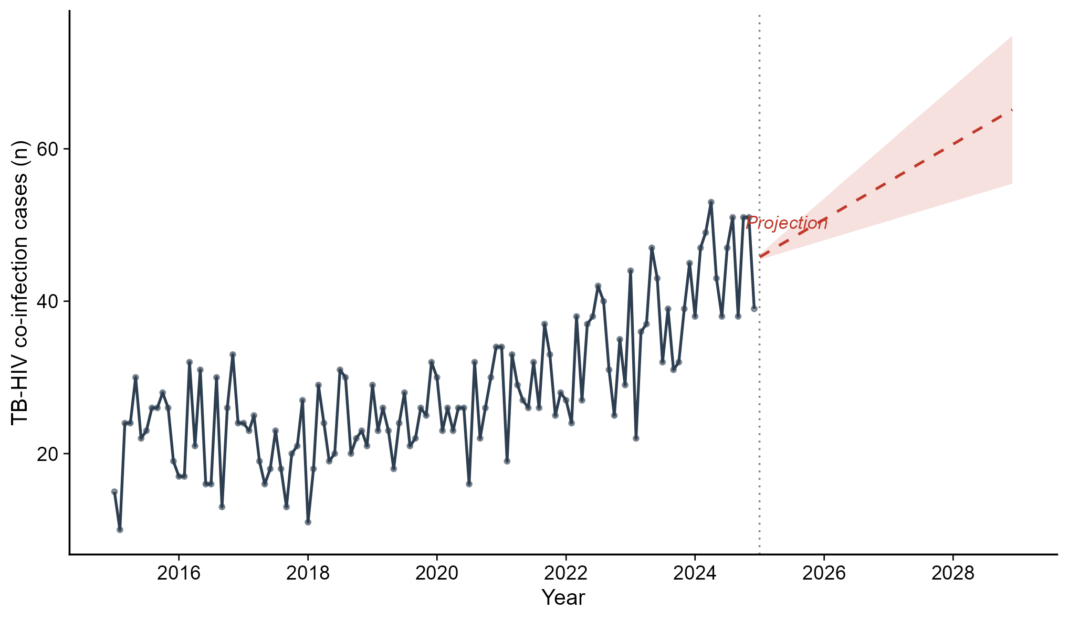
Solid line=observed monthly cases; dashed red line=ensemble forecast (ARIMA+ETS average); shaded area=prediction interval. Vertical dotted line marks the end of observed data (December 2024). All four capitals combined.

Temporal trends and forecasting
All time-series showed evidence of non-stationarity (KPSS p=0.01 for all series). The best-fitting ARIMA model for the main series was ARIMA(0,1,1). The ensemble forecast projects a continued upward trend through 2028 (figure 2). Joinpoint analysis identified two segments for most groups (table 3). For homeless persons overall, APC was +1.5% in the first segment followed by -3.0% in the second.

Table 3: Annual percent change (APC) from joinpoint regression analysis
Group | Segment | APC (%)
PSR (todas) | 1 | 1.51
PSR (todas) | 2 | -2.95
Mulheres PSR | 1 | 5.32
Mulheres PSR | 2 | -1.47
>=45 PSR | 1 | 2.85
>=45 PSR | 2 | 11.65
PSR Salvador | 1 | -6.67
PSR Salvador | 2 | 5.92
PSR Rio de Janeiro | 1 | 2.72
PSR Rio de Janeiro | 2 | -3.41
PSR Porto Alegre | 1 | 1.18
PSR Porto Alegre | 2 | -1.65
PSR Vitoria | 1 | -48.41
PSR Vitoria | 2 | 4.53
APC=annual percent change from log-linear segmented regression.

Figure 3: Temporal trend of TB-HIV co-infection prevalence among homeless persons by city, 2015-2024
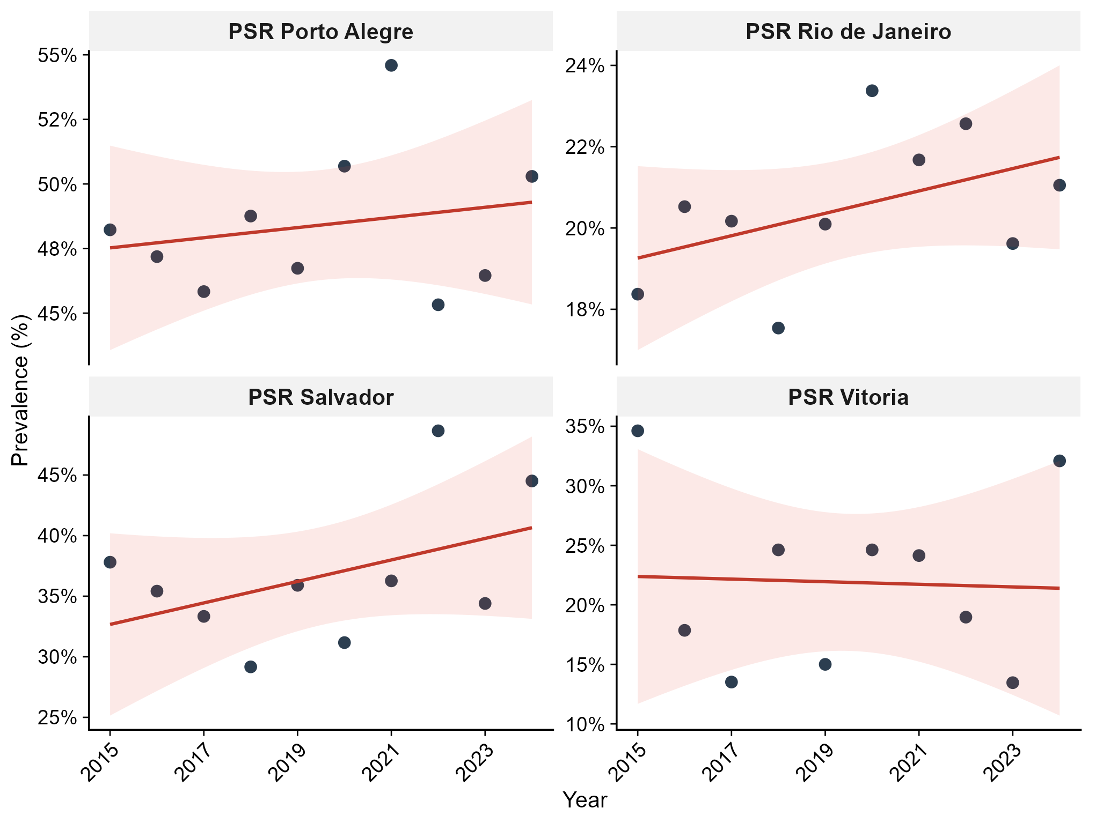
Points=observed annual prevalence; red line=fitted log-linear trend from joinpoint regression. Each panel represents one city.

Factors associated with TB-HIV co-infection
In multivariable logistic regression (table 4), female sex was the strongest predictor (aOR 2.63, 95% CI 2.38-2.91; p<0.0001). Age 30-44 years was associated with increased odds (1.61, 1.43-1.82; p<0.0001). Compared with Porto Alegre (reference), all other cities had significantly lower odds: Rio de Janeiro (0.26, 0.23-0.29), Vitoria (0.29, 0.23-0.36), and Salvador (0.63, 0.54-0.73). When substance use was added to the model, illicit drug use was independently associated (aOR 1.489, 95% CI 1.337-1.659; p<0.0001), while smoking was inversely associated (aOR 0.826, 0.75-0.909). The effect of female sex remained robust (aOR 2.55, 2.31-2.83).

Table 4: Multivariable logistic regression for TB-HIV co-infection among homeless persons
Variable | aOR (95% CI) | p value
Female sex | 2.632 (2.38-2.912) | 0.000
Age 0-17 | 0.738 (0.393-1.304) | 0.317
Age 30-44 | 1.613 (1.429-1.823) | 0.000
Age 45-59 | 1.074 (0.934-1.236) | 0.320
Age 60-69 | 0.574 (0.421-0.771) | 0.000
Age 70+ | 0.453 (0.212-0.879) | 0.028
Race: Branca | 1.181 (0.754-1.892) | 0.476
Race: Indigena | 0.628 (0.161-2.003) | 0.461
Race: Parda | 1.23 (0.788-1.967) | 0.373
Race: Preta | 1.292 (0.826-2.068) | 0.272
Rio de Janeiro | 0.258 (0.232-0.287) | 0.000
Salvador | 0.626 (0.535-0.732) | 0.000
Vitoria | 0.291 (0.234-0.359) | 0.000
Calendar trend | 1.159 (1.013-1.326) | 0.032
aOR=adjusted odds ratio. Reference: male, age 18-29, Porto Alegre.

Figure 4: Forest plot of adjusted odds ratios for TB-HIV co-infection among homeless persons
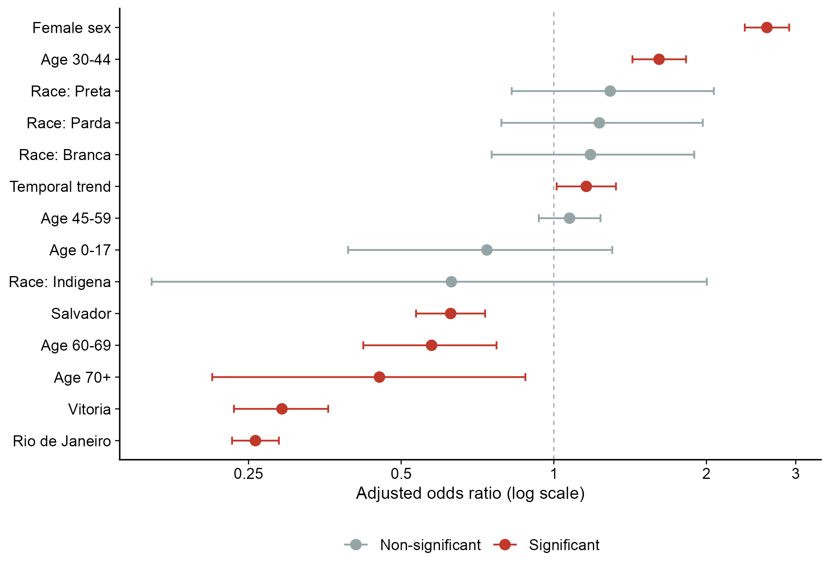
Red=statistically significant (p<0.05); grey=non-significant. Dashed vertical line at OR=1.0. Logarithmic scale. Reference categories: male sex, age 18-29 years, Porto Alegre.

Treatment outcomes and antiretroviral coverage
Among homeless persons with recorded treatment outcomes, those co-infected with HIV had lower cure rates (22.2% vs 31.2%) and higher mortality from non-TB causes (16.1% vs 11.4%). Treatment abandonment exceeded 42% regardless of HIV status. Antiretroviral therapy coverage among co-infected homeless persons varied by city: Rio de Janeiro (48%), Salvador (45.9%), Vitoria (44.6%), and Porto Alegre (36.8%).

Survival analysis
Kaplan-Meier analysis showed significant differences in time to co-infection across sex-age groups (log-rank p<0.0001; figure 5). In the Cox model (table 5), male sex was associated with lower hazard (HR 0.54, 95% CI 0.50-0.58; p<0.0001), as was age 45 years or older (0.87, 0.80-0.94; p=0.0003).

Table 5: Cox proportional hazards model for TB-HIV co-infection among homeless persons
Variable | HR (95% CI) | p value
Male sex | 0.536 (0.499-0.576) | 0.000
Age >=45 years | 0.865 (0.799-0.937) | 0.000
Rio de Janeiro | 0.423 (0.39-0.459) | 0.000
Salvador | 0.657 (0.584-0.74) | 0.000
Vitoria | 0.579 (0.485-0.691) | 0.000
Race: Branca | 0.694 (0.481-1) | 0.050
Race: Indigena | 0.395 (0.139-1.122) | 0.081
Race: Parda | 0.772 (0.536-1.112) | 0.165
Race: Preta | 0.777 (0.54-1.12) | 0.176
HR=hazard ratio. Reference: female, age <45, Porto Alegre, Amarela race.

Figure 5: Kaplan-Meier curves for probability of remaining HIV-negative after TB notification among homeless persons, 2015-2024
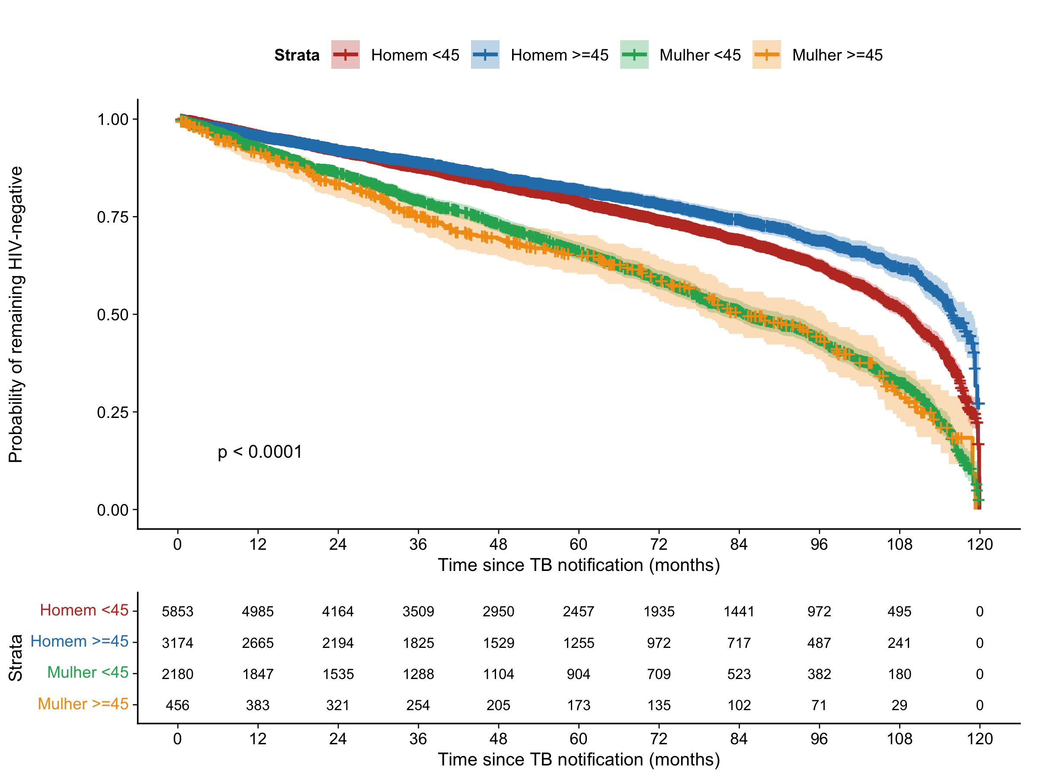
Stratified by sex and age group (>=45 years). Number at risk shown below. Log-rank p<0.0001. Four Brazilian capitals combined.

Discussion
In this population-based study of over 11,000 homeless persons with tuberculosis across four Brazilian capitals, we found that nearly one in three (32.7%) were co-infected with HIV, a rate more than twice that of the general TB population (14.2%). This finding is consistent with the systematic review by Beijer and colleagues,⁶ which documented substantially elevated TB and HIV prevalence among homeless populations worldwide, and aligns with city-level studies from Porto Alegre⁹¹⁰ and Sao Paulo.⁸
The most striking finding was the extraordinarily high TB-HIV co-infection prevalence among homeless women (49.1%), with nearly three in four homeless women with TB in Porto Alegre being co-infected (72.1%). Female sex conferred an adjusted OR of 2.63, making it the strongest independent predictor. This gender disparity likely reflects the intersection of sexual vulnerability, sex work, gender-based violence, and reduced access to preventive services among women experiencing homelessness.¹⁷¹⁸ These findings underscore the need for gender-sensitive approaches to TB-HIV integrated care.
Porto Alegre consistently showed the highest prevalence across all subgroups (48.5% overall, 72.1% among women), consistent with its known status as having one of the highest HIV prevalence rates among Brazilian capitals.⁹¹⁹ Paradoxically, Porto Alegre also had the lowest antiretroviral therapy coverage among co-infected homeless persons (36.8%), compared with 48.0% in Rio de Janeiro. This treatment gap, combined with abandonment rates exceeding 42% regardless of HIV status, highlights critical failures in retention along the TB-HIV care cascade for this population.
Illicit drug use was independently associated with TB-HIV co-infection (aOR 1.49), consistent with findings from Aldridge and colleagues⁴ documenting elevated morbidity among homeless persons with substance use disorders. Homeless persons co-infected with TB-HIV had substantially lower cure rates (22.2% vs 31.2%) and higher mortality from non-TB causes (16.1% vs 11.4%) compared with HIV-negative homeless TB patients, consistent with findings from Ranzani and colleagues.⁸
Our study has several limitations. First, we relied on passive notification data, which are subject to underdiagnosis and under-reporting. Second, the SINAN Syphilis notification form does not include a homelessness indicator; we recommend future iterations incorporate such a field. Third, the POP_RUA variable may under-identify homeless persons. Fourth, the survival analysis used time from notification as a proxy rather than true longitudinal follow-up. Finally, records with unknown race/ethnicity (~8%) were excluded.
In conclusion, TB-HIV co-infection among homeless persons in Brazilian capitals is alarmingly high, particularly among women and in cities with high background HIV prevalence. These findings have immediate policy implications: routine opt-out HIV testing for all homeless TB patients, integrated TB-HIV treatment with street outreach, gender-sensitive care models, and strengthened ART coverage especially in Porto Alegre. The SINAN system should include homelessness indicators across all notifiable diseases.

Contributors
AV and OASR conceived and designed the study. AV accessed and processed the data, performed the statistical analyses, and drafted the manuscript. OASR contributed to the interpretation of results and critical revision of the manuscript. Both authors had full access to all the data and had final responsibility for the decision to submit for publication.

Declaration of interests
We declare no competing interests.

Data sharing
All data used in this study are publicly available through the Brazilian Ministry of Health DATASUS repository (ftp://ftp.datasus.gov.br/dissemin/publicos/SINAN/). The complete analytical code in R is available from the corresponding author.

Acknowledgments
We thank the Brazilian Ministry of Health for maintaining publicly accessible health surveillance data through DATASUS.

Role of the funding source
This study received no external funding. The authors had no financial support for this work.

References
1 WHO. Global tuberculosis report 2024. Geneva: World Health Organization, 2024.
2 Brasil. Ministerio da Saude. Boletim Epidemiologico de Tuberculose 2024. Brasilia: Secretaria de Vigilancia em Saude, 2024.
3 Brasil. Ministerio da Saude. Boletim Epidemiologico de Tuberculose 2023. Brasilia: Secretaria de Vigilancia em Saude, 2023.
4 Aldridge RW, Story A, Hwang SW, et al. Morbidity and mortality in homeless individuals, prisoners, sex workers, and individuals with substance use disorders in high-income countries: a systematic review and meta-analysis. Lancet 2018; 391: 241-50.
5 Haddad MB, Wilson TW, Ijaz K, Marks SM, Moore M. Tuberculosis and homelessness in the United States, 1994-2003. JAMA 2005; 293: 2762-66.
6 Beijer U, Wolf A, Fazel S. Prevalence of tuberculosis, hepatitis C virus, and HIV in homeless people: a systematic review and meta-analysis. Lancet Infect Dis 2012; 12: 859-70.
7 Instituto de Pesquisa Economica Aplicada (IPEA). Estimativa da populacao em situacao de rua no Brasil. Brasilia: IPEA, 2023.
8 Ranzani OT, Carvalho CRR, Waldman EA, Rodrigues LC. The impact of being homeless on the unsuccessful outcome of treatment of pulmonary TB in Sao Paulo State, Brazil. BMC Med 2016; 14: 41.
9 Rossetto M, Brand EM, Rodrigues RM, et al. Coinfeccao tuberculose/HIV/aids em Porto Alegre, RS. Rev Gaucha Enferm 2019; 40: e20180033.
10 Cardoso FN. read.dbc: Read Data Stored in DBC (Compressed DBF) Files. R package. https://github.com/danicat/read.dbc (accessed March 15, 2026).
11 Fazel S, Geddes JR, Kushel M. The health of homeless people in high-income countries: descriptive epidemiology, health consequences, and clinical and policy recommendations. Lancet 2014; 384: 1529-40.
12 Hyndman RJ, Khandakar Y. Automatic time series forecasting: the forecast package for R. J Stat Softw 2008; 27: 1-22.
13 Taylor SJ, Letham B. Forecasting at scale. Am Stat 2018; 72: 37-45.
14 Muggeo VMR. Segmented: an R package to fit regression models with broken-line relationships. R News 2008; 8: 20-25.
15 Therneau TM, Grambsch PM. Modeling Survival Data: Extending the Cox Model. New York: Springer, 2000.
16 R Core Team. R: A Language and Environment for Statistical Computing. Vienna: R Foundation for Statistical Computing, 2025.
17 Gaspar RS, Nunes N, Nunes M, Rodrigues VP. Temporal analysis of reported cases of tuberculosis and of tuberculosis-HIV co-infection in Brazil between 2002 and 2012. J Bras Pneumol 2016; 42: 416-22.
18 Prado TN, Rajan JV, Miranda AE, et al. Clinical and epidemiological characteristics associated with unfavorable tuberculosis treatment outcomes in TB-HIV co-infected patients in Brazil. Braz J Infect Dis 2017; 21: 162-70.
19 Peruhype RC, Acosta LMW, Ruffino-Netto A, et al. Distribuicao da tuberculose em Porto Alegre: analise da magnitude e coinfeccao tuberculose-HIV. Rev Esc Enferm USP 2014; 48: 1035-43.
20 Swaminathan S, Padmapriyadarsini C, Narendran G. HIV-associated tuberculosis: clinical update. Clin Infect Dis 2010; 50: 1377-86.
21 Nery JS, Rodrigues LC, Rasella D, et al. Effect of Brazil's conditional cash transfer programme on tuberculosis incidence. Int J Tuberc Lung Dis 2017; 21: 790-96.
22 Brunello MEF, Chiaravalloti Neto F, Arcencio RA, et al. Areas de vulnerabilidade para co-infeccao HIV-aids/TB em Ribeirao Preto, SP. Rev Saude Publica 2011; 45: 556-63.
23 Crabtree-Ramirez B, Del Rio C, Grinsztejn B, Sierra-Madero J. HIV and tuberculosis in Latin America: progress and challenges. J Int AIDS Soc 2020; 23: e25489.
24 San Pedro A, Oliveira RM. Tuberculose e indicadores socioeconomicos: revisao sistematica da literatura. Rev Panam Salud Publica 2013; 33: 294-301.
25 Gupta V, Sugg N, Butners M, Allen-White G, Molnar A. Tuberculosis among the homeless - preventing another outbreak through community action. N Engl J Med 2015; 372: 1483-85.

