Table 1. Birth weight-, length-, head circumference-for-age z-scores using the WHO GS and GIGS-recommended growth standards (IG-21st NBS)
Gestational age category² | n | GIGS-recommended growth standard  (IG-21st NBS) | WHO GS | Mean difference between  GIGS and WHO z-scores¹
Weight-for-age z-score |  | Mean (SD) | Mean (SD) | Mean (SD)
Overall (28⁺⁰ to 42⁺⁶) | 599 | -1.21 (1.35) | -2.96 (0.68) | 1.75 (1.42)
Preterm (28⁺⁰ to 36⁺⁶) | 362 | -0.49 (1.2) | -3.07 (0.68) | 2.58 (1.23)
Very preterm (28⁺⁰ to 31⁺⁶) | 40 | 1.66 (1.06) | -3.46 (0.78) | 5.12 (0.84)
Moderately preterm (32⁺⁰ to 33⁺⁶) | 74 | 0.21 (0.76) | -3.3 (0.66) | 3.51 (0.39)
Late preterm (34⁺⁰ to 36⁺⁶) | 248 | -1.05 (0.74) | -2.94 (0.63) | 1.89 (0.52)
Term (37⁺⁰ to 42⁺⁶) | 237 | -2.31 (0.67) | -2.8 (0.65) | 0.5 (0.45)
Early term (37⁺⁰ to 38⁺⁶) | 168 | -2.07 (0.57) | -2.79 (0.63) | 0.72 (0.25)
Full term (39⁺⁰ to 40⁺⁶) | 49 | -2.8 (0.56) | -2.92 (0.75) | 0.12 (0.24)
Late term (41⁺⁰ to 42⁺⁶) | 20 | -3.06 (0.39) | -2.6 (0.48) | -0.47 (0.15)
Length-for-age z-score |  | Mean (SD) | Mean (SD) | Mean (SD)
Overall (28⁺⁰ to 42⁺⁶) | 597 | -1.31 (1.26) | -3.02 (1.03) | 1.71 (1.33)
Preterm (28⁺⁰ to 36⁺⁶) | 361 | -0.76 (1.16) | -3.24 (1) | 2.49 (1.11)
Very preterm (28⁺⁰ to 31⁺⁶) | 39 | 0.91 (0.86) | -3.9 (0.94) | 4.81 (0.73)
Moderately preterm (32⁺⁰ to 33⁺⁶) | 74 | -0.16 (0.92) | -3.48 (0.98) | 3.32 (0.45)
Late preterm (34⁺⁰ to 36⁺⁶) | 248 | -1.2 (0.93) | -3.07 (0.96) | 1.87 (0.47)
Term (37⁺⁰ to 42⁺⁶) | 236 | -2.15 (0.89) | -2.67 (0.98) | 0.52 (0.51)
Early term (37⁺⁰ to 38⁺⁶) | 168 | -2 (0.79) | -2.78 (0.88) | 0.78 (0.27)
Full term (39⁺⁰ to 40⁺⁶) | 48 | -2.46 (1.08) | -2.57 (1.2) | 0.11 (0.25)
Late term (41⁺⁰ to 42⁺⁶) | 20 | -2.64 (0.84) | -2.01 (0.93) | -0.64 (0.2)
Head circumference-for-age z-score |  | Mean (SD) | Mean (SD) | Mean (SD)
Overall (28⁺⁰ to 42⁺⁶) | 597 | -0.28 (1.31) | -1.97 (1.18) | 1.69 (1.24)
Preterm (28⁺⁰ to 36⁺⁶) | 361 | 0.17 (1.19) | -2.21 (1.18) | 2.38 (1.1)
Very preterm (28⁺⁰ to 31⁺⁶) | 39 | 1.84 (1.05) | -2.94 (1.19) | 4.78 (0.84)
Moderately preterm (32⁺⁰ to 33⁺⁶) | 74 | 0.3 (1.18) | -2.81 (1.3) | 3.11 (0.53)
Late preterm (34⁺⁰ to 36⁺⁶) | 248 | -0.13 (0.97) | -1.92 (1.02) | 1.79 (0.37)
Term (37⁺⁰ to 42⁺⁶) | 236 | -0.98 (1.16) | -1.61 (1.1) | 0.63 (0.47)
Early term (37⁺⁰ to 38⁺⁶) | 168 | -0.79 (1.08) | -1.66 (1.05) | 0.88 (0.21)
Full term (39⁺⁰ to 40⁺⁶) | 48 | -1.38 (1.3) | -1.61 (1.3) | 0.23 (0.19)
Late term (41⁺⁰ to 42⁺⁶) | 20 | -1.68 (1.03) | -1.19 (0.96) | -0.49 (0.22)

¹Differences calculated with GIGS z-scores - WHO z-scores, so a positive difference here means GIGS z-scores were larger than the WHO z-scores; ² Gestational age categories (weeks^{+days})

Table 2. Prevalence of WAZ <-2, LAZ <-2, HCAZ <-2 at birth using the WHO GS relative to the IG-21st NBS
Gestational age category¹ | n | WHO GS  n (%) | GIGS  n (%) | Sensitivity  (95% CI) | Specificity  (95% CI)
Weight-for-age (WAZ) <-2
Overall (28⁺⁰ to 42⁺⁶) | 599 | 560 (93.6) | 176 (29.4) | 30.2 (26.4–34.2) | 82.1 (66.5–95.2)
Preterm (28⁺⁰ to 36⁺⁶) | 362 | 346 (95.6) | 22 (6.1) | 6.4 (4.9–9.5) | 100 (79.4–100)
Very preterm (28⁺⁰ to 31⁺⁶) | 40 | 39 (97.5) | 0 (0.0) | 0 (0–0) | 100 (25–100)
Moderately preterm (32⁺⁰ to 33⁺⁶) | 74 | 72 (97.3) | 0 (0.0) | 0 (0–0) | 100 (15.8–100)
Late preterm (34⁺⁰ to 36⁺⁶) | 248 | 235 (94.8) | 22 (8.9) | 9.4 (6.3–13.8) | 100 (75.3–100)
Term (37⁺⁰ to 42⁺⁶) | 237 | 214 (90.3) | 154 (65.0) | 68.7 (62.7–74.8) | 69.4 (47.8–86.8)
Early term (37⁺⁰ to 38⁺⁶) | 168 | 153 (91.3) | 85 (50.6) | 56.8 (48.6–64.7) | 100 (59.5–100)
Full term (39⁺⁰ to 40⁺⁶) | 49 | 46 (93.9) | 51 (92.8) | 100 (37.5–85.5) | 0 (0–0)
Late term (41⁺⁰ to 42⁺⁶) | 20 | 18 (90.0) | 20 (100) | 100 (81.5–100) | 0 (0–84.2)
Length-for-age (LAZ) <-2
Overall (28⁺⁰ to 42⁺⁶) | 597 | 505 (84.6) | 187 (31.3) | 35.6 (31.5–40.0) | 92.4 (84.9–96.9)
Preterm (28⁺⁰ to 36⁺⁶) | 361 | 322 (89.2) | 52 (14.4) | 16.1 (12.3–20.6) | 100 (91–100)
Very preterm (28⁺⁰ to 31⁺⁶) | 39 | 38 (97.4) | 0 (0.0) | 0 (0–0) | 100 (25–100)
Moderately preterm (32⁺⁰ to 33⁺⁶) | 74 | 68 (91.9) | 0 (0.0) | 0 (0–5.3) | 100 (54.1–100)
Late preterm (34⁺⁰ to 36⁺⁶) | 248 | 216 (87.1) | 52 (21.0) | 24.1 (18.5–30.3) | 100 (89.1–100)
Term (37⁺⁰ to 42⁺⁶) | 236 | 183 (77.5) | 135 (57.2) | 69.9 (62.7–76.5) | 86.8 (74.7–94.5)
Early term (37⁺⁰ to 38⁺⁶) | 168 | 140 (83.3) | 85 (51.2) | 61.4 (52.8–69.5) | 100 (87.7–100)
Full term (39⁺⁰ to 40⁺⁶) | 48 | 34 (70.8) | 30 (62.5) | 81.3 (64.1–92.2) | 100 (75.9–100)
Late term (41⁺⁰ to 42⁺⁶) | 20 | 9 (45.0) | 16 (80.0) | 100 (66.4–100) | 36.4 (10.9–69.2)
Head-circumference-for-age (HCAZ) <-2
Overall (28⁺⁰ to 42⁺⁶) | 597 | 276 (46.2) | 57 (9.5) | 19.6 (15.1–24.7) | 99.1 (97.3–99.8)
Preterm (28⁺⁰ to 36⁺⁶) | 361 | 193 (53.5) | 15 (4.2) | 4.7 (2.2–8.7) | 100 (87.8–100)
Very preterm (28⁺⁰ to 31⁺⁶) | 39 | 30 (76.9) | 0 (0.0) | 0 (0–11.6) | 100 (64.6–100)
Moderately preterm (32⁺⁰ to 33⁺⁶) | 74 | 56 (75.7) | 2 (2.7) | 3.6 (0.4–12.3) | 100 (81.5–100)
Late preterm (34⁺⁰ to 36⁺⁶) | 248 | 107 (43.1) | 7 (2.8) | 6.5 (2.7–13.0) | 100 (97.1–100)
Term (37⁺⁰ to 42⁺⁶) | 236 | 83 (35.2) | 42 (17.8) | 34.2 (25.5–43.6) | 97.8 (93.5–99.4)
Early term (37⁺⁰ to 38⁺⁶) | 168 | 61 (36.3) | 23 (13.7) | 37.7 (25.6–51.6) | 100 (93.5–100)
Full term (39⁺⁰ to 40⁺⁶) | 48 | 19 (39.6) | 19 (39.6) | 54.2 (29.1–77.1) | 100 (75.9–100)
Late term (41⁺⁰ to 42⁺⁶) | 20 | 5 (25.0) | 6 (30.0) | 100 (47.8–100) | 93.3 (68.1–99.8)
¹Gestational age categories (weeks^{+days})

Figure 1a-c illustrates the birth WAZ z scores, LAZ z-scores, and HCAZ z-scores among children using the WHO GS compared with the IG-21st NBS.

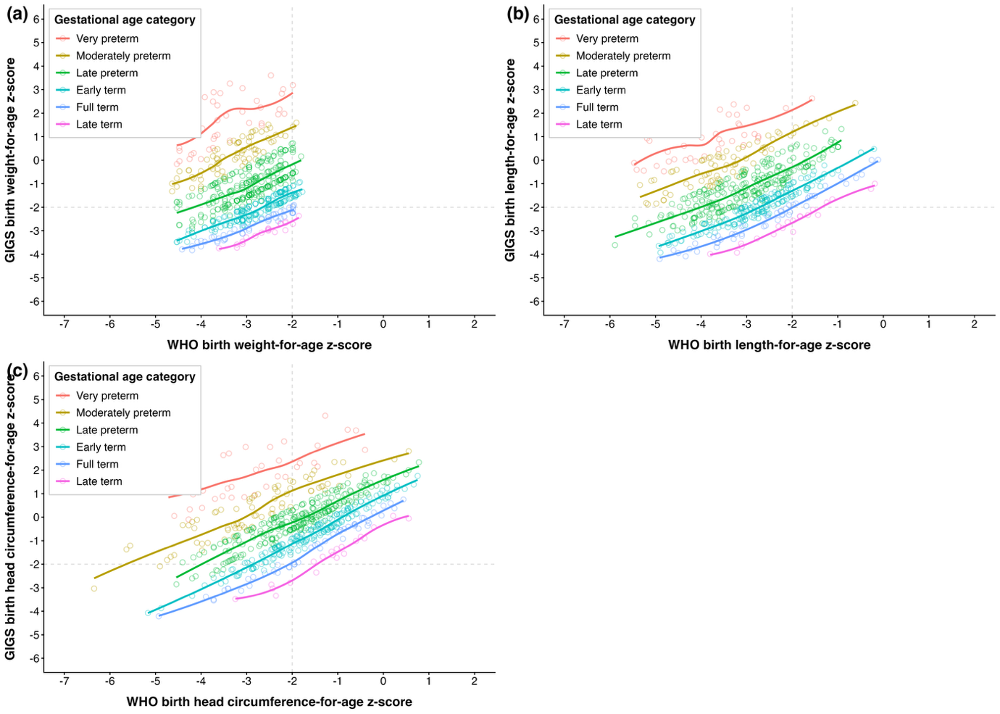

Figure 1a-c: (a) birth weight-for-age z score, (b) birth length-for-age z-score, (c), head circumference-for-age z-score among children using the WHO GS compared with the IG-21st NBS Note: Grey lines indicate the <-2 z-score cut-off for growth outcomes

Table 3. Mean changes in WAZ, LAZ, and HCAZ z-scores at birth to 6 months

Gestational age category | n | GIGS Mean (SD) | WHO Mean (SD)
Weight-for-age z-score
Overall (28⁺⁰ to 42⁺⁶) | 529 | 0.14 (1.39) | 1.51 (1.13)
Preterm (28⁺⁰ to 36⁺⁶) | 314 | –0.11 (1.31) | 1.67 (1.09)
Very preterm (28⁺⁰–31⁺⁶) | 36 | –0.23 (0.91) | 1.75 (0.92)
Moderately preterm (32⁺⁰–33⁺⁶) | 61 | –0.51 (1.18) | 1.77 (1.13)
Late preterm (34⁺⁰–36⁺⁶) | 217 | 0.16 (1.05) | 1.63 (1.11)
Term (37⁺⁰ to 42⁺⁶) | 215 | 0.79 (1.24) | 1.27 (1.14)
Early term (37⁺⁰–38⁺⁶) | 147 | 0.5 (1.16) | 1.22 (1.14)
Full term (39⁺⁰–40⁺⁶) | 48 | 1.04 (1.19) | 1.34 (1.21)
Late term (41⁺⁰–42⁺⁶) | 20 | 1.89 (0.99) | 1.42 (0.96)
Length-for-age z-score
Overall (28⁺⁰ to 42⁺⁶) | 528 | –0.37 (1.3) | 0.8 (1.18)
Preterm (28⁺⁰ to 36⁺⁶) | 314 | –0.63 (1.24) | 1.01 (1.18)
Very preterm (28⁺⁰–31⁺⁶) | 36 | –1.75 (1.04) | 1.17 (0.97)
Moderately preterm (32⁺⁰–33⁺⁶) | 61 | –0.95 (1.16) | 1.24 (1.12)
Late preterm (34⁺⁰–36⁺⁶) | 217 | –0.31 (1.07) | 0.93 (1.14)
Term (37⁺⁰ to 42⁺⁶) | 214 | –0.01 (1.2) | 0.49 (1.11)
Early term (37⁺⁰–38⁺⁶) | 147 | –0.24 (1.18) | 0.54 (1.12)
Full term (39⁺⁰–40⁺⁶) | 47 | 0.2 (1.22) | 0.4 (1.21)
Late term (41⁺⁰–42⁺⁶) | 20 | 1.13 (0.86) | 0.49 (0.85)
Head circumference-for-age z-score
Overall (28⁺⁰ to 42⁺⁶) | 528 | –0.35 (1.35) | 0.98 (1.24)
Preterm (28⁺⁰ to 36⁺⁶) | 314 | –0.61 (1.36) | 1.19 (1.25)
Very preterm (28⁺⁰–31⁺⁶) | 36 | –1.07 (1.38) | 1.49 (1.39)
Moderately preterm (32⁺⁰–33⁺⁶) | 61 | –0.94 (1.35) | 1.14 (1.13)
Late preterm (34⁺⁰–36⁺⁶) | 217 | –0.24 (1.04) | 0.99 (1.14)
Term (37⁺⁰ to 42⁺⁶) | 214 | –0.08 (1.12) | 0.69 (1.18)
Early term (37⁺⁰–38⁺⁶) | 147 | –0.25 (1.13) | 0.73 (1.14)
Full term (39⁺⁰–40⁺⁶) | 47 | 0.13 (1.38) | 0.63 (1.13)
Late term (41⁺⁰–42⁺⁶) | 20 | 0.74 (0.87) | 0.26 (0.92)

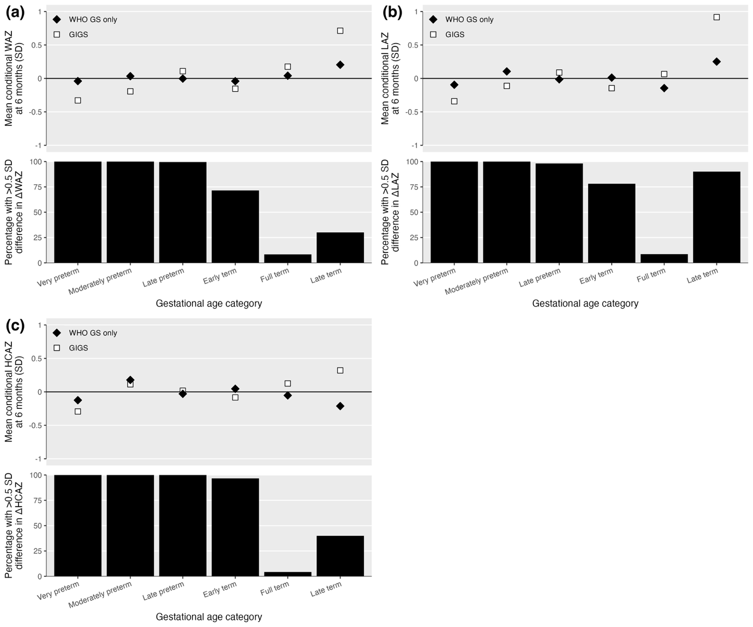

Figure 2a-c: Mean conditional growth panels for WAZ, LAZ, HCAZ at birth to 6 months

