Supplementary Figures
Cross sectional analysis:

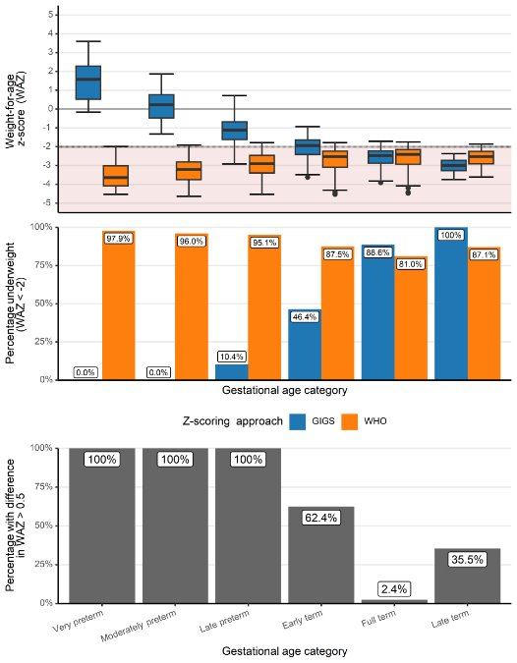
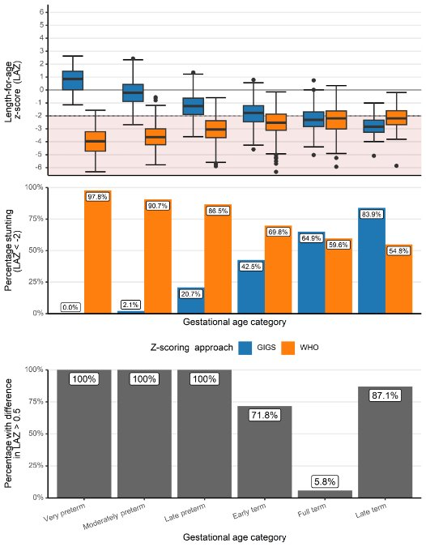
a) b)

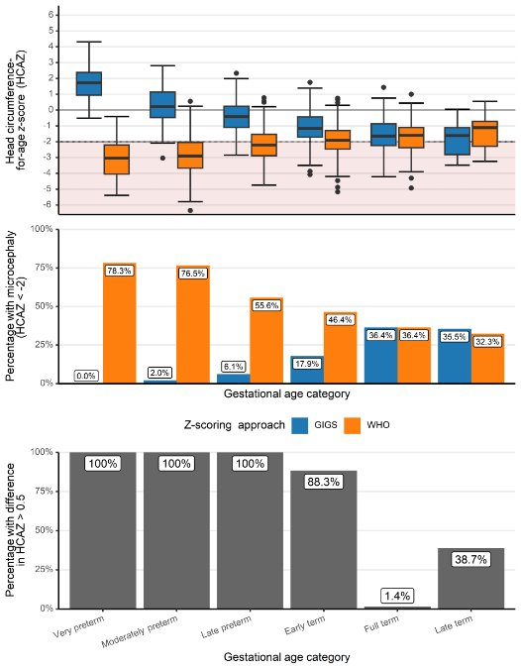
c)

Figure S1a-c: Proportion of infants with >0.5 SD difference in z-scores between WHO and GIGS standards for (a) weight-for-age (WAZ), (b) length-for-age (LAZ), and (c) head circumference-for-age (HCAZ), by gestational age category

Longitudinal analysis: Basic analysis
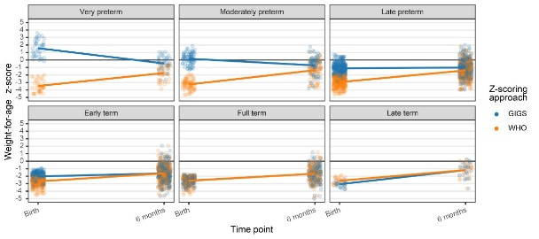
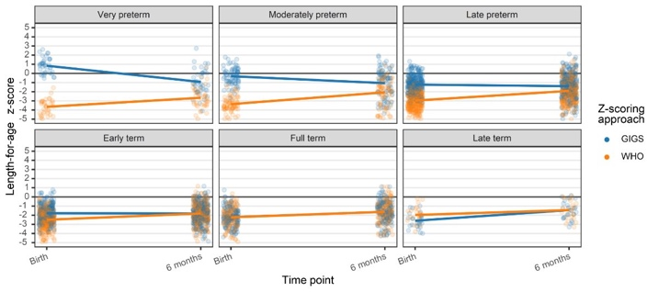

a) b)

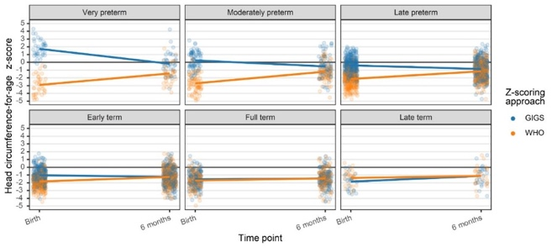

c)

Figure S2a-c: birth - 6 months ΔWAZ, Δ LAZ, ΔHCAZ

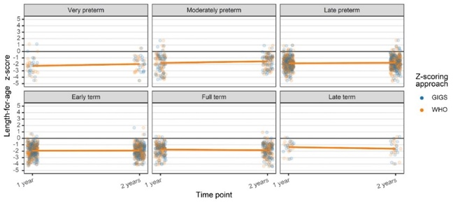
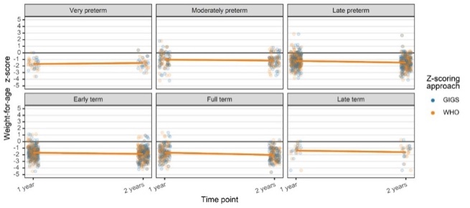
a) b)

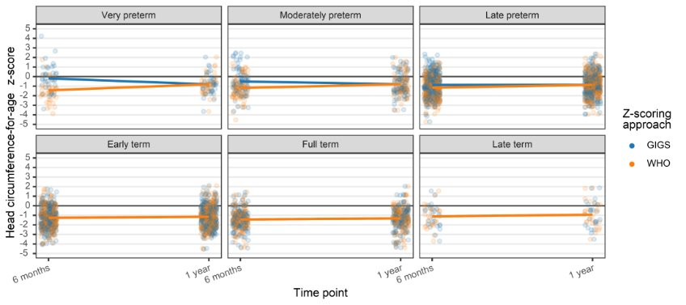
c)

Figure S3ac-3: 6 - 12 months ΔWAZ, ΔLAZ, Δ HCAZ

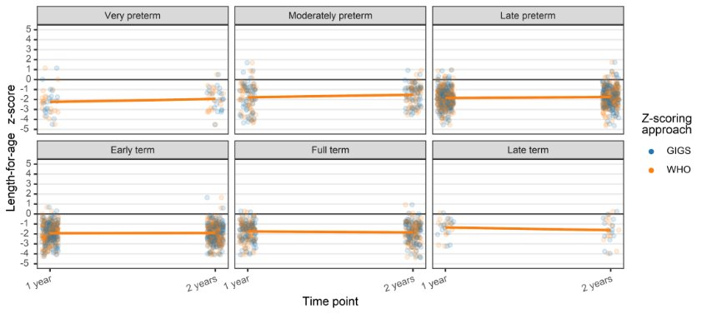
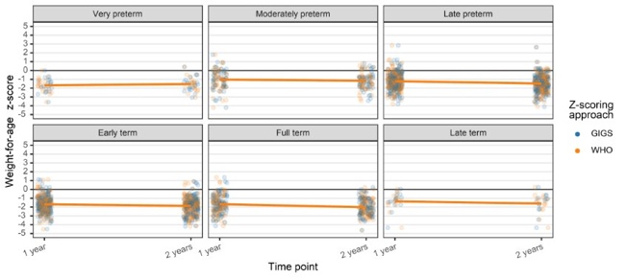
a) b)

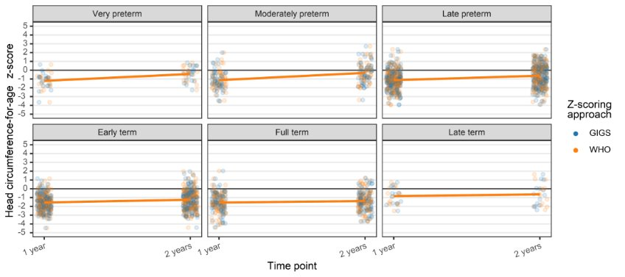

c)

Figure S4a-c: 12-24 months ΔWAZ, ΔLAZ, ΔHCAZ

Longitudinal analysis: Conditional growth
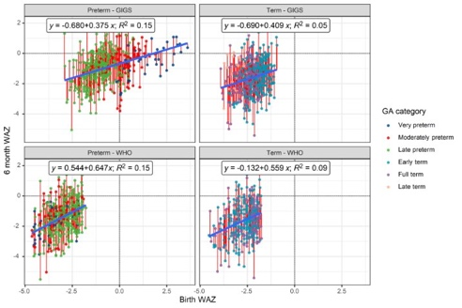
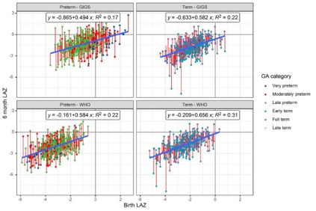
Birth – 6 months
a) b)

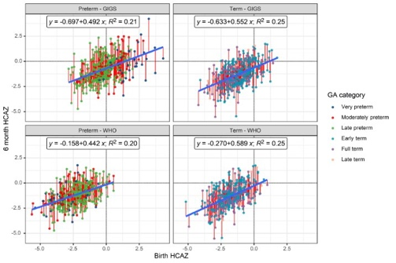
c)

Figure S5a-c: Conditional growth models from birth – 6 months (WAZ, LAZ, HCAZ)

6 - 12 months
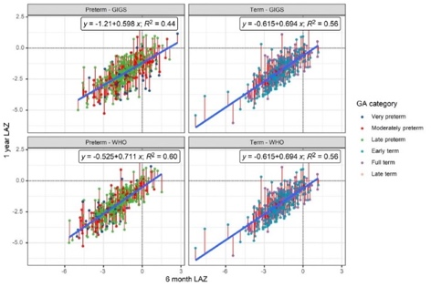
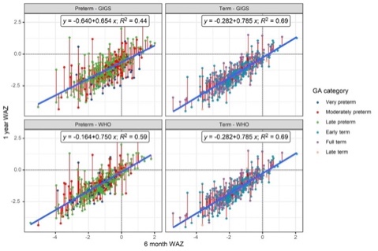
a) b)

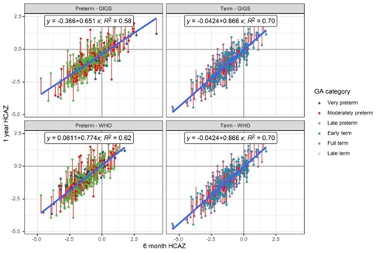

c)

Figure S6a-c: Conditional growth models from 6 - 12 months (WAZ, LAZ, HCAZ)
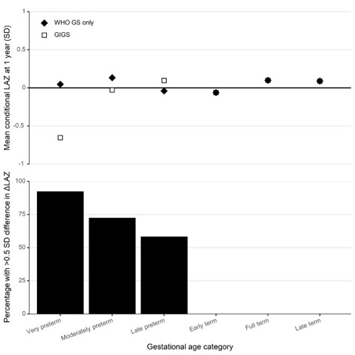
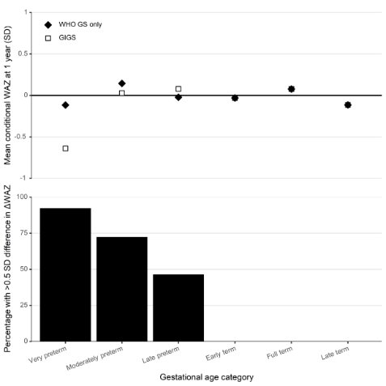
a) b)

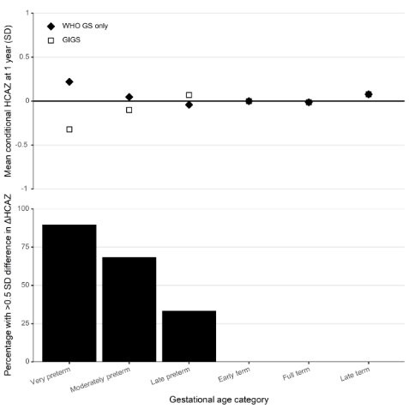
c)

Figure 7a-c: Conditional growth model panels from 6 – 12 months (WAZ, LAZ, HCAZ)

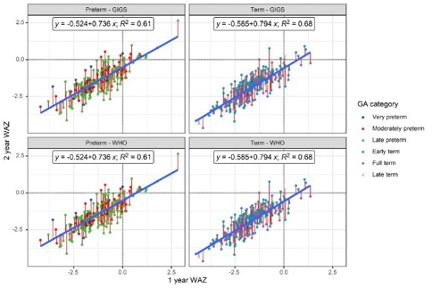
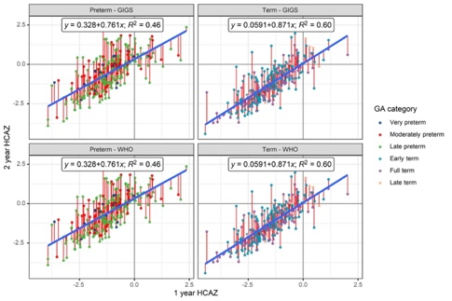
12-24 months
a) b)

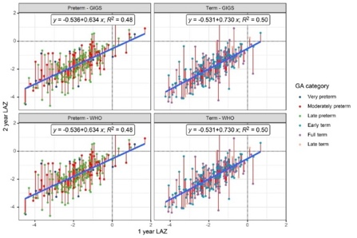
c)

Figure 8a-c: Conditional growth plots from 12 – 24 months (WAZ, LAZ, HCAZ)

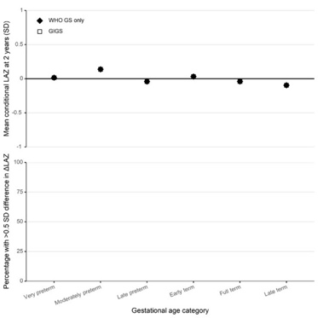
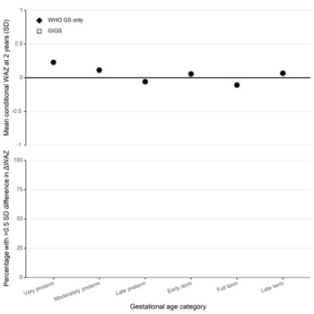
a)

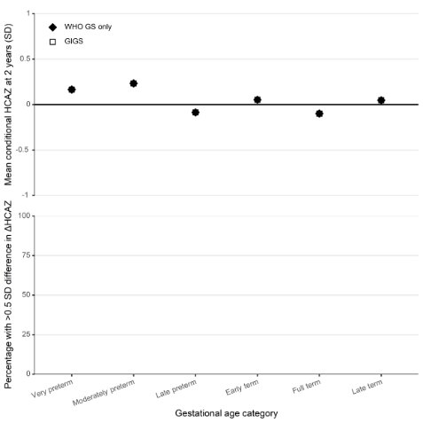
c)

Figure 9a-c: 12 - 24 months conditional growth panels (WAZ, LAZ, HCAZ)

