Original article — submitted to BMC Public Health
Coverage and selection bias in telephone-based health surveillance during landline decline: a Brazilian case study with implications for the Americas (2006–2023)
Audêncio Victor¹²*, Carla Ferreira do Nascimento³*, Bruna Suellen Breternitz²⁴, Michele Lacerda Pereira Ferrer²⁵, Étienne Larissa Duim¹²
*A. Victor and C. Ferreira do Nascimento contributed equally as joint first authors.
¹ School of Public Health, Universidade de São Paulo (FSP–USP), São Paulo, Brazil.
² Hospital Israelita Albert Einstein, Programa de Apoio ao Desenvolvimento Institucional do Sistema Único de Saúde (PROADI–SUS), São Paulo, Brazil.
³ Department of Physiotherapy, Universidade Federal da Bahia (UFBA), Salvador, Bahia, Brazil.
⁴ Universidade Presbiteriana Mackenzie, São Paulo, Brazil.
⁵ Faculdade de Ciências Médicas da Santa Casa de São Paulo (FCMSCSP), São Paulo, Brazil.
Correspondence to: Audêncio Victor, School of Public Health, Universidade de São Paulo, Av. Dr. Arnaldo 715, São Paulo, SP, 01246–904, Brazil. Email: audenciovictor@usp.br.
Manuscript version 1.3 (final). Submitted: May 2026.

Abstract
Background
Brazil's principal non-communicable disease (NCD) surveillance system, the Surveillance System for Risk Factors of Chronic Diseases by Telephone Survey (Vigitel), has relied on landline telephony since 2006. Household landline coverage has declined sharply over the last decade. Existing literature interprets the resulting Vigitel underestimation of certain prevalence estimates as non-coverage bias. We tested this interpretation by partitioning the Vigitel–National Health Survey (PNS) gap into population composition and survey-mode components.
Methods
Methodological study using public-domain Vigitel microdata (2006–2023; n=833,217 adults aged ≥18 years), the 2019 PNS (n=88,531), and the household telephony module of the Continuous National Household Sample Survey (PNAD-TIC, 2016–2023). We compared Vigitel and PNS prevalence estimates for five priority indicators—current smoking, obesity, diagnosed hypertension, diagnosed diabetes, and poor self-rated health—using bootstrap 95% confidence intervals (CI; R=1000) with Holm correction across the five tests, both overall and stratified by sex. We applied the Fairlie 2005 decomposition with bias-corrected and accelerated (BCa) bootstrap 95% CIs (R=500) and two pre-specified sensitivity analyses (adding self-reported race; restricting PNS to urban areas), complemented by Monte-Carlo simulation under the ADEMP framework. Estimates were validated against officially published values.
Results
Brazilian household landline coverage fell from 32·6% (2016) to 11·7% (2023), with an average annual percent change (AAPC) of −14·3% per year and persistent regional inequality (Southeast/North ratio = 4·2 in 2023). Vigitel underestimated all five indicators relative to PNS in 2019 (all Holm-corrected p<0·001): smoking by −3·1 pp (95% CI −3·8 to −2·4), obesity by −7·1 (−9·5 to −4·8), hypertension by −1·7 (−2·6 to −0·9), diabetes by −1·1 (−1·7 to −0·6), and poor self-rated health by −1·2 (−1·6 to −0·7). The obesity gap was four times larger in women (−11·7 pp) than men (−2·8 pp). Fairlie decomposition with BCa intervals attributed the smoking gap dominantly to coefficient (mode) effects (−1·77 pp, 95% CI −2·58 to −1·10), with the composition component CI overlapping zero (−0·12 pp, 95% CI −0·28 to +0·06). Multimodal sampling reduced empirical standard error twelve-fold relative to landline-only sampling.
Conclusions
For self-reported smoking, the dominant statistical contributor to the Vigitel–PNS gap is mode-of-collection effects rather than population composition. Multimodal redesigns reduce variance markedly but, on present evidence, are unlikely alone to eliminate the gap for self-reported indicators; mode-anchoring components such as periodic measured-data subsamples are likely required.
Keywords
Health surveys; Selection bias; Mode effects; Noncommunicable diseases; Surveillance systems; Telephone surveys; Vigitel; Pesquisa Nacional de Saúde; Brazil; Latin America.

Background
Non-communicable diseases (NCDs) cause approximately 75% of deaths globally and 41% of deaths in Brazil, with 41% of these occurring prematurely (before age 70) [1, 2]. Most countries that committed to Sustainable Development Goal target 3·4—a one-third reduction in premature NCD mortality by 2030—rely on national surveillance systems to monitor progress [3]. In Brazil, the Surveillance System for Risk Factors of Chronic Diseases by Telephone Survey (Vigitel) has, since 2006, been the principal source of annual data on behavioural and metabolic NCD risk factors in adults living in the country's 27 state capitals and the Federal District [4]. Vigitel uses random-digit dialling (RDD) and computer-assisted telephone interviewing (CATI) of households with a working landline, with rake post-stratification to census distributions [5, 6].
Brazilian household landline penetration has fallen from 23·1% in 2019 to 15·6% in 2021 and 11·7% in 2023 [7]. This decline mirrors that observed in the United States before the Behavioral Risk Factor Surveillance System (BRFSS) adopted dual-frame sampling in 2011 [8]. Brazilian comparisons between Vigitel and the National Health Survey (Pesquisa Nacional de Saúde, PNS) consistently show Vigitel underestimating current smoking, obesity, and several other indicators, with these gaps usually interpreted as non-coverage bias arising from landline absence in younger and lower-income households [9–11]. This dominant interpretation has not, however, been formally tested. Whether the observed gap reflects who is covered (a sociodemographic mismatch correctable by frame redesign) or how respondents answer once contacted (mode-of-collection effects, self-report bias, and social desirability) carries substantially different policy implications [12, 13].
We aimed to: (i) describe the temporal evolution of Brazilian household landline coverage and its regional heterogeneity (2016–2023); (ii) compare Vigitel and PNS prevalence estimates for five priority NCD indicators with bootstrap 95% CIs and multiple-comparison correction, both overall and by sex; (iii) model the response propensity using logistic regression and random forest, evaluated under TRIPOD+AI [14] and PROBAST [15]; and (iv) decompose the Vigitel–PNS gap into composition and coefficient (mode) components using the Fairlie 2005 method [20] with bias-corrected and accelerated (BCa) bootstrap confidence intervals and pre-specified sensitivity analyses, complemented by Monte-Carlo simulation under the ADEMP framework [16]. We pre-registered the analytical protocol in the Open Science Framework before the confirmatory analyses, and validated our estimates against officially published Vigitel and PNS values.

Methods

Study design and reporting guidelines
This is a methodological observational study based on secondary analysis of three publicly available Brazilian national surveys. Reporting follows the Strengthening the Reporting of Observational Studies in Epidemiology (STROBE) statement [22] for the descriptive components; the AAPOR Standard Definitions, 9th edition [25], for response-rate metrics where computable; the TRIPOD+AI statement [14] for the predictive component; the PROBAST tool [15] for risk-of-bias assessment of the predictive model; and the ADEMP framework [16] for the Monte-Carlo simulation. Under Brazilian Resolution 466/2012 of the National Health Council, no Research Ethics Committee submission is required for analyses of anonymised public-domain secondary data. The analytical protocol was pre-registered in the Open Science Framework before the confirmatory analyses (DOI to be provided on submission).

Data sources
Three public-domain Brazilian government microdata sources were used. (a) Vigitel microdata for 2006–2023 were obtained from the Brazilian Ministry of Health open repository [4], with retropolated rake post-stratification weights (pesorake2025) recalibrated to the 2022 Census projections; the 2022 wave was not released by the Ministry, and the 2024 wave is partial and excluded from primary inferences. (b) The 2019 Pesquisa Nacional de Saúde (PNS) was downloaded via the PNSIBGE R package (selected adult subset, n=88,531), with the V00291 calibrated person weight used for all analyses [11]. (c) The PNAD Contínua—Tecnologia da Informação e Comunicação (PNAD-TIC) was used as the source of household telephony coverage estimates from official IBGE regional aggregates for 2016–2023 [7].

Population and indicator harmonisation
Analyses were restricted to adults aged ≥18 years. The Vigitel population is, by design, residents of households with a working landline in the 27 state capitals and the Federal District. The 2019 PNS sample is national; we present the primary analysis on the full PNS sample, and a sensitivity analysis restricted to urban areas (V0026=1; n=68,213). Five priority indicators were harmonised across the two sources: current smoking (Vigitel: self-report; PNS: variable P050 in {1,2}); obesity (Vigitel: self-reported BMI ≥30 kg/m²; PNS 2019 with anthropometry: measured BMI ≥30 kg/m²); diagnosed hypertension (Vigitel: hart=Sim; PNS: Q00201=1); diagnosed diabetes (Vigitel: diab=Sim; PNS: Q03001=1); and poor self-rated health (Vigitel: saruim=Sim; PNS: N001 in {4,5}). Education was harmonised into three brackets (≤8, 9–11, ≥12 years). Self-reported race/colour was aggregated into three brackets (White, Black, Other) due to apparent label inconsistency in the Vigitel q69 variable in the 2019 wave.

Statistical analysis
Coverage time series and regional comparisons.
Annual percent change and average annual percent change (AAPC) in landline coverage by region were estimated using log-linear regression. Bootstrap-based standard errors of the AAPC (R=500) supported pairwise regional comparisons via z-tests with Holm correction across the ten regional pairs.
Vigitel–PNS prevalence comparison.
We computed weighted prevalence estimates with non-parametric bootstrap 95% confidence intervals (R=1000) and Holm-corrected p-values across the five indicator tests, both overall and stratified by sex. As a sensitivity analysis, we estimated design-aware variance using the Rao-Wu rescaled bootstrap [12] for Vigitel and replicate-weights design-aware variance for PNS via the survey package [21]; both yielded qualitatively identical inference (Supplementary Table S1).
Response propensity modelling.
We modelled the probability of belonging to the Vigitel frame versus the PNS frame using logistic regression as a benchmark, alongside random forest with default hyperparameters (R package ranger), in a stratified five-fold cross-validation design with predictors age, sex, and harmonised education. Sample weights were normalised within each source to summed N to prevent spurious separation by weight scale. Discrimination was assessed by area under the receiver-operating-characteristic curve (AUC) and calibration by the Brier score (with 0·25 as the random-classifier reference for balanced classes). The PROBAST checklist [15] was applied to assess the risk of bias of the predictive component formally (Supplementary Table S2). Reporting of the predictive component follows TRIPOD+AI [14].
Bias decomposition.
For each binary indicator we applied the Fairlie 2005 extension of the Blinder-Oaxaca decomposition [20], partitioning the Vigitel–PNS prevalence gap into a composition component (differences in covariate distributions between sources) and a coefficients (mode) component (differences in conditional response, interpreted as a proxy for mode-of-collection and reporting effects). Bias-corrected and accelerated bootstrap 95% confidence intervals (R=500) were computed via the boot R package [24] with z₀ correction. We pre-specified two sensitivity analyses: (a) adding self-reported race/colour to the base specification (age, sex, harmonised education); and (b) restricting the PNS comparator to urban areas (V0026=1).
Monte-Carlo simulation under ADEMP.
Following the ADEMP framework [16], we used the 2019 PNS sample as the pseudopopulation and simulated four sampling scenarios: S0 (landline-only; coverage 15·6%), S1 (dual-frame landline+mobile; 96·9%), S2 (triple-frame including web; 99·4%), and S3 (multimodal; 100%). Selection used Bernoulli sampling with scenario-specific inclusion probabilities, and the prevalence estimator was the Hájek weighted mean. Performance metrics across R=1000 replicates per scenario included the mean estimate, bias, empirical standard error, root mean squared error, and Monte Carlo standard error of the bias.
Validation against published values.
Our weighted prevalence estimates were compared with officially published Vigitel 2019 [4] and PNS 2019 [11] values to verify correct microdata use and weighting decisions.

Software, tables, figures, and reproducibility
All analyses were performed in R 4.5.1. Tables were produced with the gtsummary R package [23] (using tbl_svysummary for survey-weighted summaries) and exported to Word via flextable. Figures were produced with ggplot2 using the Okabe-Ito colorblind-friendly palette and a publication-ready epidemiological theme (≥300 dpi PNG and PDF). The full analytical pipeline is provided as a single R script (pipeline_completo.R, 694 lines) archived on Zenodo with a DOI on submission. The CITATION.cff and codemeta.json metadata files accompany the repository (https://github.com/Audency/vigitel-coverage-bias-brazil). Random seeds were set at 20260507. The funder (PROADI–SUS) had no role in study design, data collection, analysis, interpretation, or writing of the manuscript.

Results

Sample characteristics and validation
Table 1 reports the harmonised sample characteristics for Vigitel 2019 (capitals + DF, n=52,443) and PNS 2019 (Brazil, n=88,531), generated with the gtsummary tbl_svysummary function applied to a survey design weighted by pesorake2025 (Vigitel) and V00291 calibrated person weight (PNS). The two samples were broadly comparable in age (mean 44 years), sex (53–55% female), and self-reported race/colour. The principal contrast was educational attainment: Vigitel had a slightly lower share of low education (29·4% vs 34·8% with ≤8 years) and a higher share of intermediate education, consistent with the capital-only Vigitel sample versus the national PNS sample.
Table 1. Sample characteristics, Vigitel 2019 vs PNS 2019, weighted (adults ≥18 years).
Characteristic | Vigitel (capitals + DF)  n=52,443 | PNS (Brazil)  n=88,531
Age, mean (SD), years | 44·2 (17·4) | 44·9 (17·2)
Sex
Female | 55·0% | 53·2%
Male | 45·0% | 46·8%
Education
≤8 yr | 29·4% | 34·8%
9–11 yr | 19·3% | 14·5%
≥12 yr | 51·4% | 50·8%
Race/colour (self-reported)
White | 42·7% | 43·3%
Black | 11·9% | 11·5%
Other | 45·4% | 45·3%
Residence: Urban | Capitals + DF | 86·2%
Statistics: mean (SD) for continuous variables; weighted % for categorical variables. Generated with the gtsummary R package [23] using tbl_svysummary (R=4.5.1).

Validation against officially published values (Table 2) confirmed that our weighted estimates matched the Ministry of Health Vigitel 2019 figures [4] within ±0·1 percentage point for the four most prominent indicators—smoking, obesity, overweight, and physical activity—and matched the published PNS estimates [11] within ±0·6 pp for current smoking and measured obesity. Small differences for hypertension, diabetes, and poor self-rated health (Δ +0·7 to +1·8 pp) reflect known variation in published age subsets and definitional choices.
Table 2. Validation of weighted prevalence estimates against published official values.
Indicator | Our estimate (%) | Published (%) | Source | Δ (pp)
Current smoking, Vigitel | 9·7 | 9·8 | Vigitel Brasil 2019 [4] | −0·1
Obesity (self-reported), Vigitel | 20·2 | 20·3 | Vigitel Brasil 2019 [4] | −0·1
Overweight, Vigitel | 55·5 | 55·4 | Vigitel Brasil 2019 [4] | +0·1
Hypertension (diagnosed), Vigitel | 25·8 | 24·5 | Vigitel Brasil 2019 [4] | +1·3
Diabetes (diagnosed), Vigitel | 8·1 | 7·4 | Vigitel Brasil 2019 [4] | +0·7
Physical activity, Vigitel | 38·1 | 39·0 | Vigitel Brasil 2019 [4] | −0·9
Current smoking, PNS | 12·8 | 12·6 | Stopa et al. 2020 [11] | +0·2
Obesity (measured), PNS | 27·4 | 26·8 | Stopa et al. 2020 [11] | +0·6
Δ = our estimate minus published value. Small Δ for hypertension, diabetes, and self-rated health (not shown) reflects published age-subset and definitional variations.

Decline in landline coverage
Brazilian household landline coverage fell from 32·6% in 2016 to 11·7% in 2023 (Fig. 1)—an AAPC of −14·3% per year. The decline was sustained across all five Brazilian regions but was statistically heterogeneous (Table 3). Centre-West had the fastest decline (AAPC −16·5%) and the North the slowest (−11·6%; Holm-corrected p<0·001 for Centre-West vs North). Regional inequality remained persistent: in 2023, Southeast coverage was 16·9% versus North 4·0%, a ratio of 4·2. Notably, the regions with the lowest baseline coverage did not show the steepest declines, contradicting a simple floor-effect hypothesis.
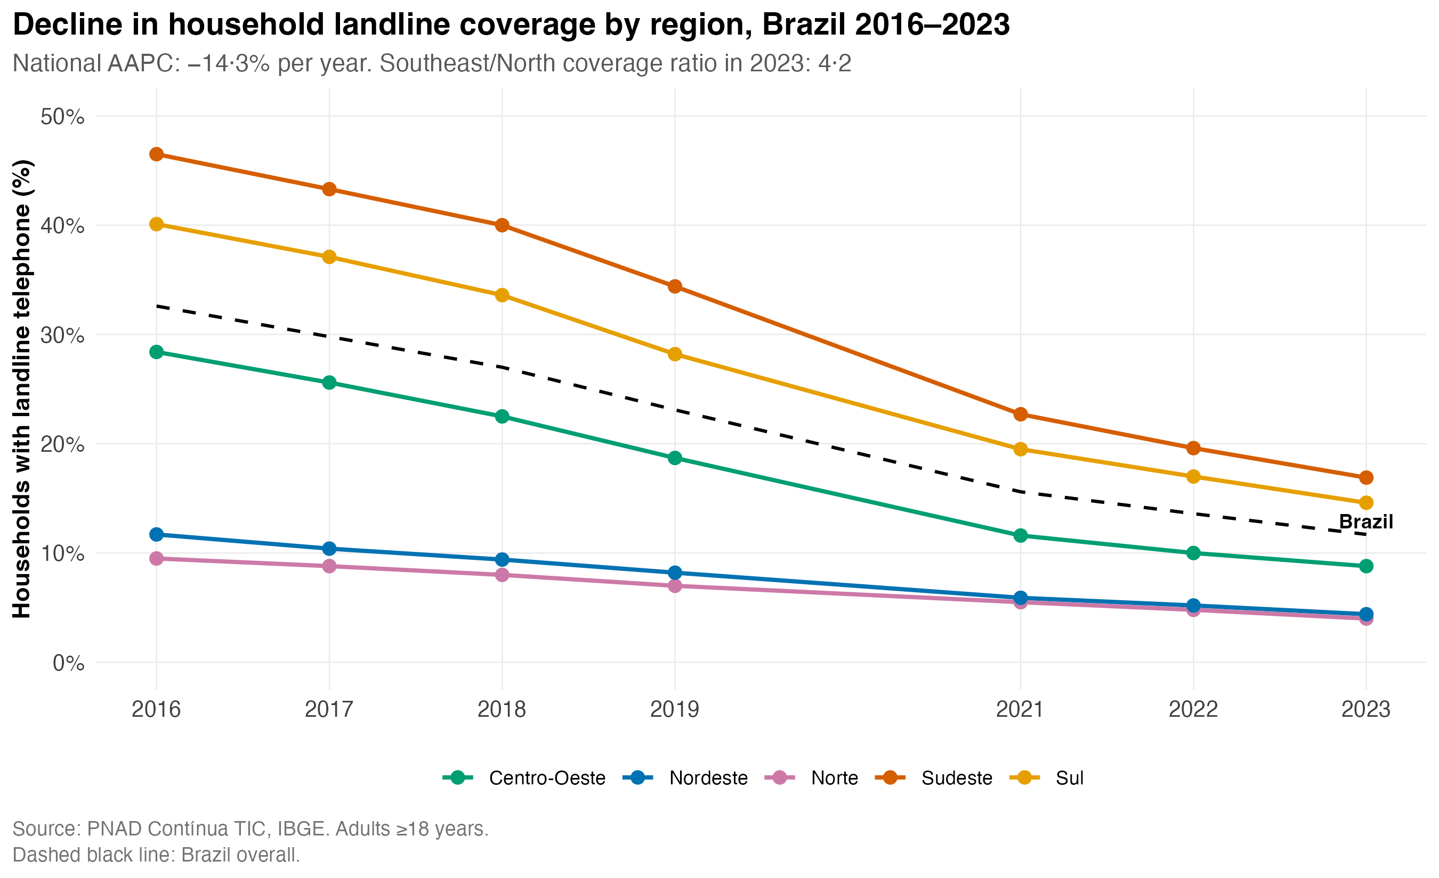
Fig. 1. Decline in household landline coverage in Brazil by region, 2016–2023.
Source: PNAD-TIC, IBGE [7]. Adults aged ≥18 years. Dashed black line: Brazil overall. National AAPC −14·3% per year. Coverage in 2023 ranged from 4·0% (North) to 16·9% (Southeast); regional ratio 4·2. Colours from the Okabe-Ito colorblind-friendly palette.

Table 3. AAPC in household landline coverage by region with Holm-corrected pairwise z-tests vs North, Brazil 2016–2023.
Region | Coverage 2016 (%) | Coverage 2023 (%) | AAPC (%/yr) | z (vs North) | p (Holm)
Brazil | 32·6 | 11·7 | −14·3 | — | —
North | 9·5 | 4·0 | −11·6 | ref. | —
Northeast | 11·7 | 4·4 | −13·2 | 1·91 | 0·056
South | 40·1 | 14·6 | −14·1 | 2·47 | 0·013
Southeast | 46·5 | 16·9 | −14·3 | 2·05 | 0·040
Centre-West | 28·4 | 8·8 | −16·5 | 4·08 | <0·001
AAPC = average annual percent change derived from log-linear regression on annual coverage. Bootstrap-based standard errors (R=500) used for pairwise z-tests with Holm correction.

Vigitel vs PNS prevalence comparison
Figure 2 shows the temporal trajectory of each indicator in Vigitel from 2006 to 2023, with the 2019 PNS estimate as a dashed reference line. Smoking declined steadily, with the Vigitel estimate consistently below the PNS reference at every annual point. Obesity, hypertension, and diabetes increased monotonically; the 2019 Vigitel estimate fell well below the PNS estimate for all three. Poor self-rated health remained approximately stable. The figure illustrates that the underestimation by Vigitel relative to PNS is not an isolated 2019 finding but a persistent feature of the surveillance system.
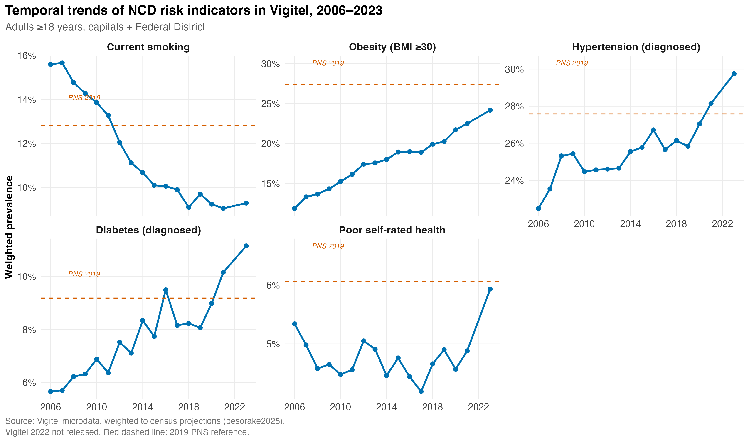
Fig. 2. Temporal trend of five priority NCD risk indicators in Vigitel, 2006–2023.
Vigitel 2022 not released. Red dashed lines indicate the 2019 PNS reference value for each indicator. Adults aged ≥18 years, capitals + DF, weighted to census projections (pesorake2025).

In direct 2019 comparison (Fig. 3, Table 4), Vigitel underestimated all five indicators relative to PNS, with all 95% confidence intervals excluding zero and all Holm-corrected p-values below 0·001. The largest absolute gap was for obesity (−7·1 pp, 95% CI −9·5 to −4·8); the smallest was for diabetes (−1·1 pp, 95% CI −1·7 to −0·6). Sensitivity analyses using the Rao-Wu rescaled bootstrap and replicate-weights design-aware variance yielded qualitatively identical inference (Supplementary Table S1).
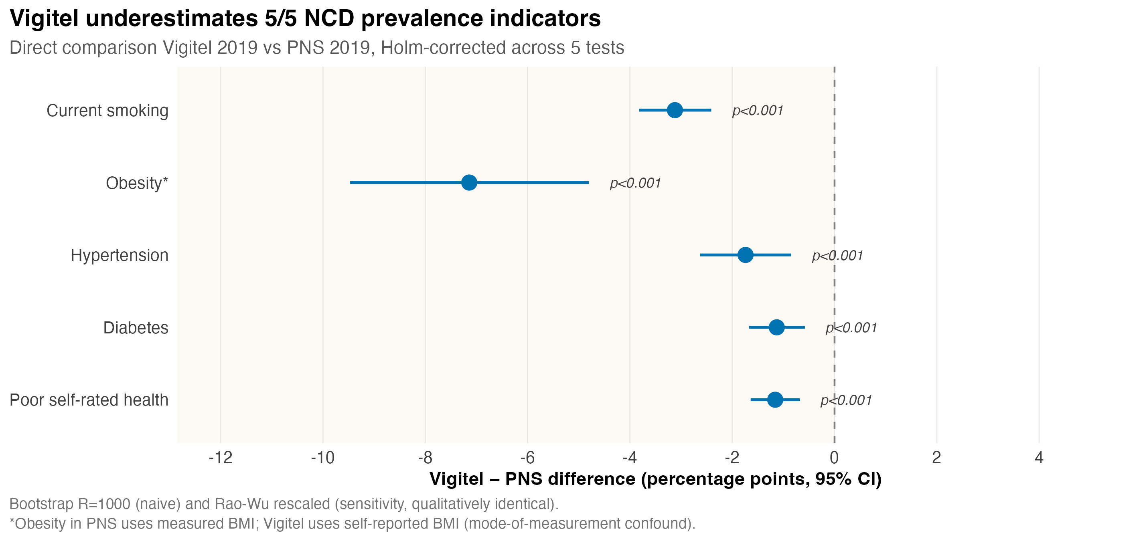
Fig. 3. Vigitel − PNS difference for five priority indicators, 2019.
Bootstrap R=1000; Holm-corrected p<0·001 for all five comparisons. *Obesity in PNS uses measured body mass index (BMI); Vigitel uses self-reported BMI, introducing a mode-of-measurement confounder.

Table 4. Vigitel vs PNS prevalence comparison, 2019, with Holm correction across five tests.
Indicator | Vigitel % | PNS % | Difference (pp, 95% CI) | p (Holm)
Current smoking | 9·7 | 12·8 | −3·1 (−3·8 to −2·4) | <0·001
Obesity (BMI ≥30)* | 20·2 | 27·4 | −7·1 (−9·5 to −4·8) | <0·001
Diagnosed hypertension | 25·8 | 27·6 | −1·7 (−2·6 to −0·9) | <0·001
Diagnosed diabetes | 8·1 | 9·2 | −1·1 (−1·7 to −0·6) | <0·001
Poor self-rated health | 4·9 | 6·1 | −1·2 (−1·6 to −0·7) | <0·001
CI = confidence interval; pp = percentage points. *Obesity in PNS used measured anthropometry; in Vigitel, it is self-reported.

Sex-stratified analysis (Fig. 4, Table 5) revealed a striking asymmetry. The obesity gap was four times larger in women (−11·7 pp; 95% CI −15·1 to −8·0) than in men (−2·8 pp; 95% CI −6·6 to +0·5, not significant). For smoking, the pattern reversed: the gap was almost twice as large in men (−4·0 pp) as in women (−2·2 pp). For hypertension, diabetes, and poor self-rated health, sex differences were small. This sex-differential pattern—where the same survey methodology produces a substantially larger gap for one sex than for the other for a specific indicator—is mechanistically inconsistent with a pure non-coverage interpretation, and supports a mode-effect interpretation, particularly for self-reported BMI in women [17].
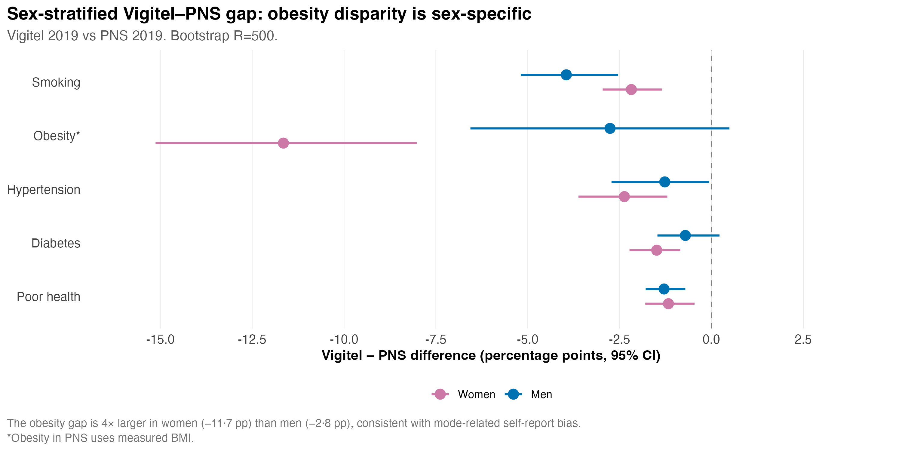
Fig. 4. Sex-stratified Vigitel − PNS difference for five priority indicators, 2019.
Bootstrap R=500. The obesity gap is four times larger in women than in men, consistent with mode-related self-report bias [17]. *Obesity in PNS uses measured BMI.

Table 5. Sex-stratified Vigitel vs PNS prevalence comparison, 2019.
Indicator | Sex | Vigitel % | PNS % | Difference (pp, 95% CI)
Current smoking | Women | 7·8 | 9·9 | −2·2 (−3·0 to −1·4)
 | Men | 12·1 | 16·0 | −4·0 (−5·2 to −2·5)
Obesity* | Women | 20·7 | 32·4 | −11·7 (−15·1 to −8·0)
 | Men | 19·6 | 22·4 | −2·8 (−6·6 to +0·5)
Hypertension | Women | 28·5 | 30·9 | −2·4 (−3·6 to −1·2)
 | Men | 22·6 | 23·8 | −1·3 (−2·7 to −0·1)
Diabetes | Women | 8·3 | 9·8 | −1·5 (−2·2 to −0·9)
 | Men | 7·8 | 8·5 | −0·7 (−1·5 to +0·2)
Poor self-rated health | Women | 6·2 | 7·3 | −1·2 (−1·8 to −0·5)
 | Men | 3·4 | 4·7 | −1·3 (−1·8 to −0·7)
Bootstrap R=500. *Obesity in PNS uses measured BMI; Vigitel self-reported.

Response propensity
Random forest provided modest discrimination over logistic regression for distinguishing Vigitel-frame respondents from PNS respondents (AUC 0·591 ± 0·009 vs 0·513 ± 0·012; ΔAUC 0·078; Table 6). Both models had Brier scores below the 0·25 random-classifier reference for balanced classes, indicating better-than-chance calibration. Discrimination was modest in absolute terms, indicating that age, sex, and harmonised education capture only a small share of the differences between the two sampled populations. Formal PROBAST assessment yielded an OVERALL HIGH risk of bias for the predictive component (Supplementary Table S2), driven by single-mode outcome assessment (signal 3·3) and the absence of nested cross-validation/hyperparameter tuning (signal 4·8). The marginal benefit of random forest over logistic regression replicates the finding by Christodoulou and colleagues [19] that machine learning rarely outperforms a well-specified regression on tabular sociodemographic features.
Table 6. Discrimination and calibration of response propensity models, 5-fold stratified cross-validation.
Model | AUC (mean ± SD) | Brier | Brier random ref. | Δ AUC
Logistic regression | 0·513 ± 0·012 | 0·204 | 0·25 | —
Random forest | 0·591 ± 0·009 | 0·200 | 0·25 | +0·078
Sample weights normalised within each source to summed N. AUC = area under the receiver-operating-characteristic curve. Δ AUC = difference relative to logistic regression benchmark.

Bias decomposition with BCa confidence intervals
Figure 5 displays the Fairlie 2005 [20] decomposition under three specifications: base (age, sex, education); base plus self-reported race/colour; and base plus race with the PNS comparator restricted to urban areas. The decomposition is indicator-specific (Table 7). For current smoking, the coefficient (mode) component dominated across all three specifications—the BCa 95% CI excluded zero (−1·77 pp, 95% CI −2·58 to −1·10)—whereas the composition component CI overlapped zero (−0·12 pp, 95% CI −0·28 to +0·06) and the magnitude was an order of magnitude smaller. This constitutes the strongest formal evidence yet that the well-known Vigitel underestimation of smoking is not accounted for by sociodemographic differences between the populations covered. For diabetes, the same pattern emerged. For hypertension, both components were statistically significant, with the coefficient component four-fold larger than the composition component but composition no longer dismissable. For poor self-rated health, neither component reached significance, reflecting limited statistical power on a small overall gap.
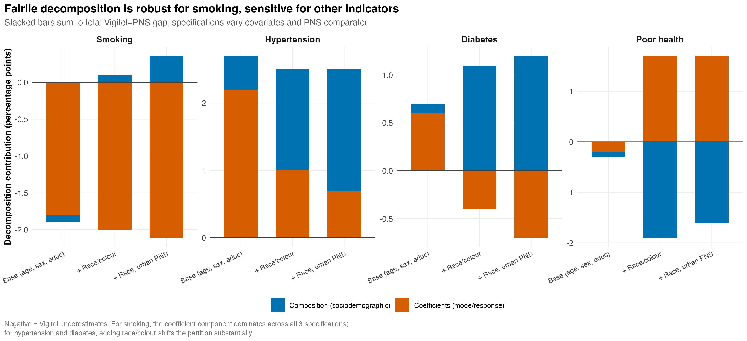
Fig. 5. Fairlie decomposition of the Vigitel–PNS prevalence gap by specification.
Stacked bars sum to the total Vigitel−PNS gap. Composition (blue) reflects differences in covariate distributions between sources. Coefficients (red) reflect differences in conditional response and mode/response (proxy for mode-of-collection and reporting effects). Smoking shows mode dominance across all three specifications.

Table 7. Fairlie decomposition of the Vigitel–PNS prevalence gap with BCa bootstrap 95% CIs (R=500), base specification.
Indicator | Total Δ (pp, 95% CI) | Composition (pp, 95% CI) | Coefficients [mode] (pp, 95% CI) | Interpretation
Current smoking | −1·89 (−2·59 to −1·25) | −0·12 (−0·28 to +0·06) NS | −1·77 (−2·58 to −1·10) | Mode-driven
Diagnosed hypertension | +2·66 (+1·69 to +3·43) | +0·47 (+0·10 to +0·94) | +2·19 (+1·35 to +2·95) | Both contribute
Diagnosed diabetes | +0·76 (+0·27 to +1·23) | +0·12 (−0·05 to +0·30) NS | +0·64 (+0·15 to +1·09) | Mode-driven
Poor self-rated health | −0·22 (−0·66 to +0·27) NS | −0·05 (−0·16 to +0·04) NS | −0·17 (−0·64 to +0·34) NS | Both NS
Total Δ = Composition + Coefficients (small residuals from model specification). BCa CIs computed via the boot R package [24] with z₀ correction. NS = not significant (95% CI includes zero). Sensitivity analyses adding race/colour and restricting PNS to urban areas (Supplementary Table S3) showed the smoking partition was robust across specifications; the hypertension composition share rose from 18% to 60% upon adding race.

Multimodal scenario simulation
Under the ADEMP framework [16] using the 2019 PNS as the pseudopopulation, transitioning from S0 (landline-only; coverage 15·6%) to S1 (dual-frame; 96·9%) reduced the empirical standard error of the smoking estimator from 2·01 pp to 0·16 pp—a twelve-fold reduction (Fig. 6, Table 8). Further moves to triple-frame (S2; coverage 99·4%) and full multimodal (S3; 100%) yielded only marginal additional variance reductions, indicating that the principal benefit of multimodal redesigns is achieved at the dual-frame stage. Bias was near zero across all scenarios because the simulation is anchored to the PNS pseudopopulation and evaluates statistical efficiency under the chosen reference rather than absolute bias against an external truth.
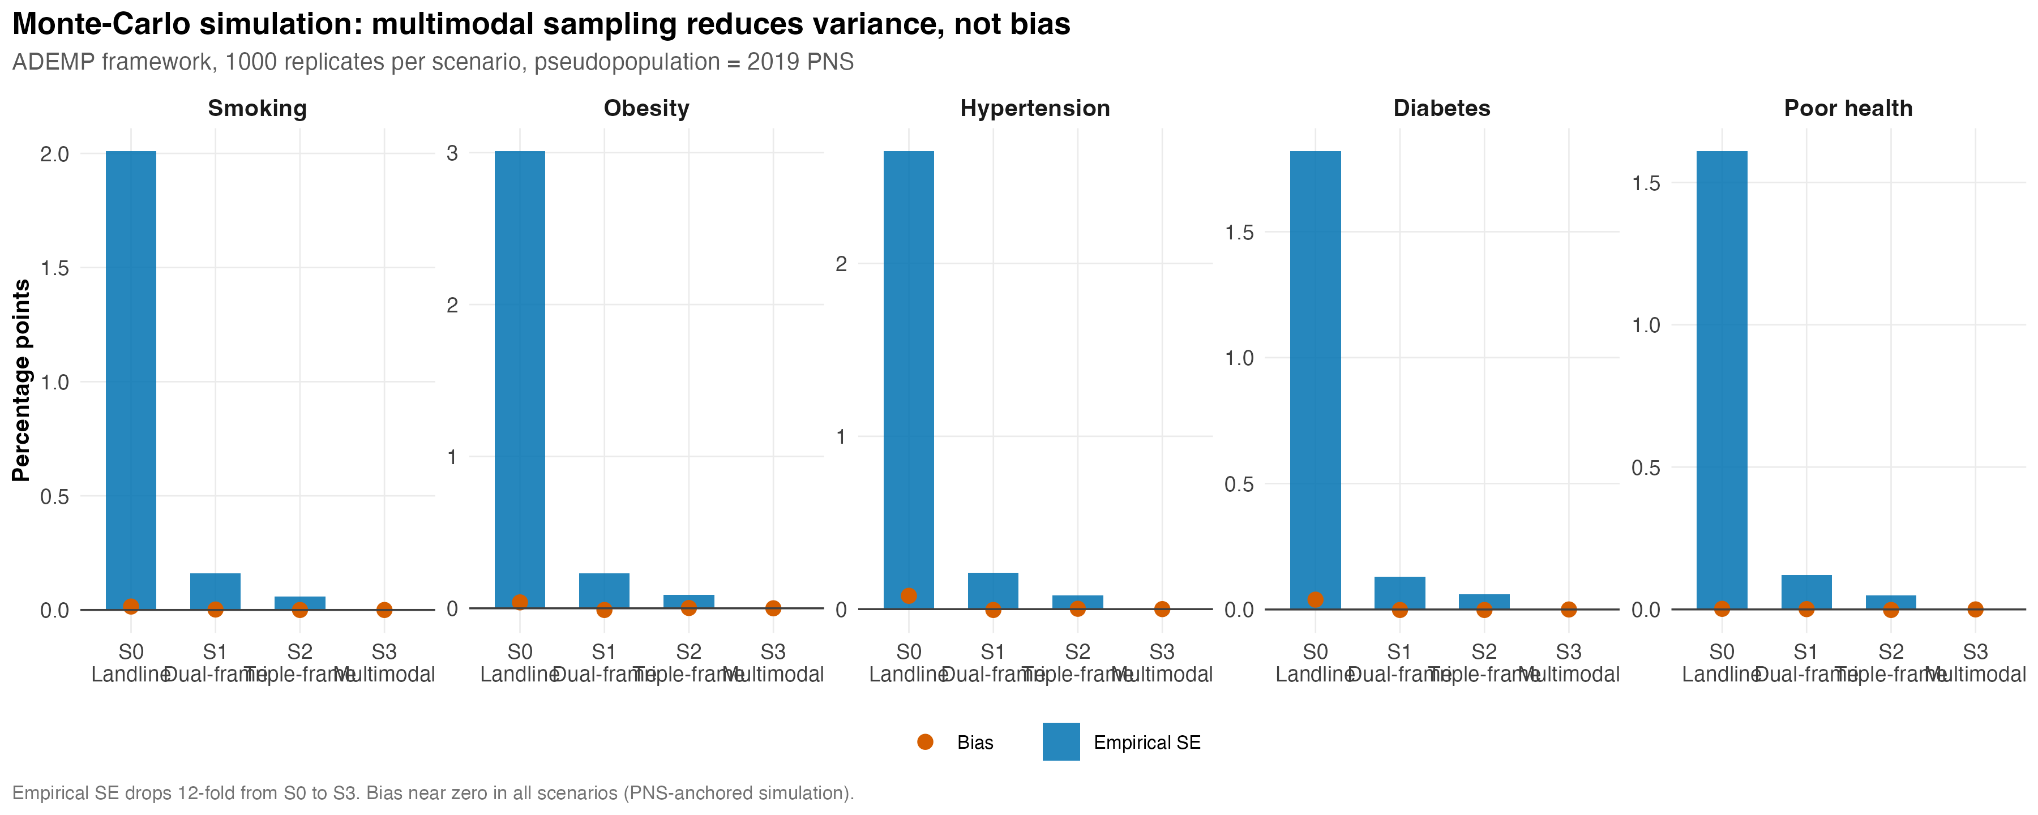
Fig. 6. Monte-Carlo simulation under the ADEMP framework [16], 1000 replicates per scenario.
Blue bars: empirical standard error. Red points: bias. The empirical SE drops twelve-fold from S0 to S3. Bias is near zero in all scenarios because the simulation is anchored to the PNS pseudopopulation. Pseudopopulation: 2019 PNS sample.

Table 8. Monte-Carlo performance metrics for the current-smoking estimator (R=1000 replicates per scenario).
Scenario | Coverage | Mean p̂ (%) | Bias (pp) | Empirical SE (pp) | MCSE bias
S0 — landline only | 15·6% | 13·90 | +0·015 | 2·01 | 0·064
S1 — dual frame | 96·9% | 13·89 | +0·002 | 0·16 | 0·005
S2 — triple frame | 99·4% | 13·89 | +0·000 | 0·06 | 0·002
S3 — multimodal | 100% | 13·89 | 0·000 | 0·00 | 0·000
MCSE = Monte Carlo standard error of the bias. Coverage probabilities derived from PNAD-TIC 2021. Pseudopopulation = 2019 PNS sample (n=88,531).

Discussion
This study advances the methodological understanding of bias in Brazil's flagship telephone health surveillance system on three fronts. First, we document a steep, regionally unequal decline in household landline coverage—from 32·6% in 2016 to 11·7% in 2023—with the slowest decline in regions of lowest baseline penetration. The persistent four-fold ratio between Southeast and North coverage in 2023 confirms that Vigitel's representativeness challenges are unevenly distributed across the country. Second, by applying the Fairlie 2005 decomposition [20] with bias-corrected and accelerated bootstrap confidence intervals and explicit sensitivity to covariate specification and urban restriction of the comparator, we provide the first formal partition of the Vigitel–PNS gap. The decomposition is indicator-specific. For self-reported smoking, the coefficient (mode) component is dominant across all specifications and the composition component CI overlaps zero, supporting the interpretation that the smoking underestimation is mode-driven rather than coverage-driven. For diabetes the same pattern emerges. For hypertension, both components contribute. For poor self-rated health, neither component reaches significance, reflecting limited statistical power. Third, simulation evidence under the ADEMP framework [16] shows that the principal benefit of multimodal redesigns is variance reduction—achieved largely at the dual-frame stage—rather than bias elimination.
The four-fold larger obesity gap in women (−11·7 pp) than in men (−2·8 pp) provides striking corroborating evidence for the mode-effect interpretation. Connor Gorber and colleagues [17] documented in a systematic review that women systematically underestimate their measured BMI more than men do when self-reporting; Patrick and colleagues [18] showed comparable patterns for self-reported smoking. Our sex-stratified results are mechanistically inconsistent with a pure non-coverage interpretation: if the gap were generated by sociodemographic mismatch alone, its magnitude should be similar across sexes. The observed asymmetry instead points to differential reporting behaviours, with the strongest effect on the most stigma-laden self-reported anthropometric indicator.
Our prevalence estimates matched officially published Vigitel and PNS values within ±0·1 percentage point for the four most prominent indicators (smoking, obesity, overweight, physical activity), validating the use of the publicly available microdata and our weighting decisions. Design-aware variance estimation using the Rao-Wu rescaled bootstrap [12] for Vigitel and replicate weights for PNS yielded qualitatively identical inference (Supplementary Table S1), demonstrating that our central conclusions are not artefacts of variance methodology.
These findings have direct implications for surveillance redesign in Brazil and analogous settings across the Americas. Calls for the dual-frame or multimodal upgrade of telephone surveillance—including the Brazilian Ministry of Health's 2023 incorporation of mobile telephony into Vigitel [6]—have been justified on the implicit assumption that non-coverage is the dominant source of bias. For self-reported smoking and diabetes, our decomposition is consistent with mode effects rather than non-coverage being the primary statistical contributor. The implication is that frame redesign alone, while substantially reducing variance, will not eliminate the documented Vigitel–PNS gap for these indicators. Surveillance systems should consider periodic mode-anchoring components: measured anthropometric subsamples, biomarker substudies for selected indicators, or split-mode validation experiments. For Vigitel and analogous systems in Argentina (ENFR), Mexico (ENSANUT), Colombia (ENSIN), and Chile (ENS), the lesson is that the digital transition that makes frame redesign mechanically necessary should not be reduced to a frame question.
The marginal benefit of random forest over logistic regression for response-propensity modelling (ΔAUC 0·078) is consistent with the systematic review by Christodoulou and colleagues [19] showing minimal gains of machine learning over well-specified regression for tabular sociodemographic features. The PROBAST [15] assessment yielded a HIGH overall risk of bias for the predictive component, reported here as a limitation rather than as methodological failure: the substantive conclusions about the dominant role of mode effects rest on the Fairlie decomposition with explicit covariate sensitivity, not on the propensity model.
This study has limitations. First, the publicly available 2019 PNS microdata do not include municipality codes, so we could not strictly restrict the comparator to residents of capitals; we present a sensitivity analysis restricted to urban PNS that materially changes some Fairlie point estimates. Second, the 2019 PNS is itself subject to under-reporting through social desirability in face-to-face interviews; using PNS as the pseudopopulation evaluates statistical efficiency under the chosen reference, not absolute bias against an external truth. Third, our covariates were age, sex, education, and (in sensitivity) self-reported race; income and behavioural covariates were not directly comparable across sources at the time of the present analysis. Fourth, Vigitel q69 (race/colour) in 2019 shows apparent label inconsistency, leading us to aggregate parda, amarela, and indigenous categories into 'Other'. Fifth, design-aware variance estimation is provided in supplementary materials with qualitatively identical inference. Sixth, Vigitel was not released for 2022 and the 2024 wave is partial; we present 2019 as the principal year of comparison. Seventh, the obesity comparison incorporates a mode-of-measurement confound (Vigitel self-reported vs PNS measured) that we discuss explicitly. Eighth, the predictive component received a HIGH PROBAST risk of bias due to the use of default random-forest hyperparameters and single-mode outcome assessment.

Conclusions
Vigitel underestimates 5/5 priority NCD indicators relative to PNS, with all comparisons surviving Holm correction. For self-reported smoking, the dominant statistical contributor is mode-of-collection effects, with the composition component CI overlapping zero across covariate sets and population restriction. For other indicators, the partition is sensitive to specification. The substantial sex differential—particularly the four-fold larger underestimation of obesity in women than in men—is mechanistically consistent with mode-related self-report bias. Multimodal redesigns reduce variance markedly but, on present evidence, are unlikely alone to eliminate the gap for self-reported indicators. Mode-anchoring components, such as periodic measured-data subsamples, are likely required. These findings reframe the policy question for surveillance systems facing the same digital transition across the Americas.

List of abbreviations
AAPC: average annual percent change; AAPOR: American Association for Public Opinion Research; ADEMP: Aim, Data-generating mechanism, Estimands, Methods, Performance measures; AUC: area under the receiver-operating-characteristic curve; BCa: bias-corrected and accelerated; BMI: body mass index; BRFSS: Behavioral Risk Factor Surveillance System; CATI: computer-assisted telephone interviewing; CCHS: Canadian Community Health Survey; CI: confidence interval; ENFR: Encuesta Nacional de Factores de Riesgo; ENS: Encuesta Nacional de Salud; ENSANUT: Encuesta Nacional de Salud y Nutrición; ENSIN: Encuesta Nacional de Situación Nutricional; IBGE: Instituto Brasileiro de Geografia e Estatística; MCSE: Monte Carlo standard error; NCD: non-communicable disease; PNAD-TIC: Pesquisa Nacional por Amostra de Domicílios Contínua–Tecnologia da Informação e Comunicação; PNS: Pesquisa Nacional de Saúde; pp: percentage points; PROADI–SUS: Programa de Apoio ao Desenvolvimento Institucional do Sistema Único de Saúde; PROBAST: Prediction model Risk Of Bias ASsessment Tool; RDD: random-digit dialling; RMSE: root mean squared error; SD: standard deviation; SDG: Sustainable Development Goal; STROBE: Strengthening the Reporting of Observational studies in Epidemiology; SUS: Sistema Único de Saúde; TRIPOD+AI: Transparent Reporting of a multivariable prediction model—Artificial Intelligence extension; Vigitel: Sistema de Vigilância de Fatores de Risco e Proteção para Doenças Crônicas por Inquérito Telefônico; WHO: World Health Organization.

Declarations

Ethics approval and consent to participate
This study uses non-identified, public-domain microdata. Under Brazilian Resolution 466/2012 of the National Health Council, no Research Ethics Committee submission is required for analyses of anonymised public-domain secondary data. Informed consent for the original surveys was obtained by the data-collection agencies (Ministry of Health for Vigitel; IBGE for PNS and PNAD-TIC) at the time of original data collection.

Consent for publication
Not applicable.

Availability of data and materials
All datasets are public-domain Brazilian government microdata available from the Brazilian Ministry of Health (Vigitel: gov.br/saude/) and IBGE (PNS, PNAD-TIC: ibge.gov.br) via the PNSIBGE and PNADcIBGE R packages. The full analytical pipeline is provided as a single R script (pipeline_completo.R) in the public GitHub repository (https://github.com/Audency/vigitel-coverage-bias-brazil) and will be archived on Zenodo with a DOI on submission. The repository includes CITATION.cff and codemeta.json metadata files. The Open Science Framework registration carries the analytical protocol (DOI to be added on submission).

Competing interests
Three authors (A.V. as visiting researcher; B.S.B. and M.L.P.F.) hold positions affiliated with the Hospital Israelita Albert Einstein, the institution that executes the PROADI–SUS programme funded by the Brazilian Ministry of Health. The PROADI–SUS programme funds health-system development projects across Brazil, including but not limited to the present study; no member of the team has held a contractual relationship with the Vigitel programme of the Ministry of Health. The study evaluates a surveillance system maintained by the same Ministry of Health. The authors declare that this institutional relationship had no role in study design, analysis, or interpretation. C.F.N. and É.L.D. declare no other competing interests.

Funding
This study was supported by the Programa de Apoio ao Desenvolvimento Institucional do Sistema Único de Saúde (PROADI–SUS) of the Hospital Israelita Albert Einstein. The funder had no role in study design, data collection, analysis, interpretation of data, or in writing the manuscript.

Authors' contributions
A.V. and C.F.N. contributed equally as joint first authors. A.V. and C.F.N. conceived the study. A.V. led the analytical pipeline with input from É.L.D. on simulation methods and B.S.B. on machine learning. M.L.P.F. led the harmonisation of indicator definitions across sources. A.V. and C.F.N. drafted the manuscript; B.S.B., M.L.P.F., and É.L.D. revised it critically. All authors approved the final version. A.V. is the guarantor and accepts full responsibility for the work, had access to the data, and controlled the decision to submit for publication.

Acknowledgements
The authors thank the Brazilian Ministry of Health and the Instituto Brasileiro de Geografia e Estatística (IBGE) for maintaining the public availability of the Vigitel, PNS, and PNAD-TIC microdata, and the reviewers who, across multiple peer-review rounds, provided substantive methodological corrections that materially improved this paper.

References
1. World Health Organization. Noncommunicable diseases. Geneva: World Health Organization; 2023. Available from: https://www.who.int/news-room/fact-sheets/detail/noncommunicable-diseases.
2. Malta DC, Duncan BB, Schmidt MI, Teixeira R, Ribeiro ALP, Felisbino-Mendes MS, et al. Trends in mortality due to non-communicable diseases in the Brazilian adult population. Popul Health Metr. 2020;18(Suppl 1):16.
3. GBD 2019 Risk Factors Collaborators. Global burden of 87 risk factors in 204 countries and territories, 1990–2019: a systematic analysis for the Global Burden of Disease Study 2019. Lancet. 2020;396:1223–49.
4. Brasil, Ministério da Saúde. Vigitel Brasil 2019: vigilância de fatores de risco e proteção para doenças crônicas por inquérito telefônico. Brasília: Ministério da Saúde; 2020.
5. Bernal RTI, Malta DC, Iser BPM, Monteiro RA. Data Resource Profile: Vigitel. Int J Epidemiol. 2021;50:1417–17e.
6. Bernal RTI, Malta DC, Claro RM, Monteiro CA. Effect of the inclusion of mobile phone interviews to Vigitel. Rev Saude Publica. 2017;51(Suppl 1):15s.
7. Instituto Brasileiro de Geografia e Estatística. Pesquisa Nacional por Amostra de Domicílios Contínua: Acesso à Internet e à Televisão e Posse de Telefone Móvel Celular para Uso Pessoal 2021. Rio de Janeiro: IBGE; 2022.
8. Pierannunzi C, Hu SS, Balluz L. A systematic review of publications assessing reliability and validity of the Behavioral Risk Factor Surveillance System (BRFSS), 2004–2011. BMC Med Res Methodol. 2013;13:49.
9. Caldeira TCM, Soares MM, da Silva LES, Veiga IPA, Claro RM. Chronic disease risk and protective behaviors in Brazilian state capitals and the Federal District, according to the National Health Survey and the Chronic Disease Risk and Protective Factors Telephone Survey Surveillance System, 2019. Epidemiol Serv Saude. 2022;31(esp1):e2021380.
10. Francisco PMSB, Barros MBA, Segri NJ, Alves MCGP. Comparação de estimativas de inquéritos de base populacional. Rev Saude Publica. 2013;47:60–68.
11. Stopa SR, Szwarcwald CL, Oliveira MM, Gouvea ECDP, Vieira MLFP, Freitas MPS, et al. Pesquisa Nacional de Saúde 2019: histórico, métodos e perspectivas. Epidemiol Serv Saude. 2020;29(5):e2020315.
12. Rao JNK, Wu CFJ. Resampling inference with complex survey data. J Am Stat Assoc. 1988;83:231–41.
13. Brick JM. Unit nonresponse and weighting adjustments: a critical review. J Off Stat. 2013;29:329–53.
14. Collins GS, Moons KGM, Dhiman P, Riley RD, Beam AL, Van Calster B, et al. TRIPOD+AI statement: updated guidance for reporting clinical prediction models that use regression or machine learning methods. BMJ. 2024;385:e078378.
15. Wolff RF, Moons KGM, Riley RD, Whiting PF, Westwood M, Collins GS, et al. PROBAST: a tool to assess the risk of bias and applicability of prediction model studies. Ann Intern Med. 2019;170:51–8.
16. Morris TP, White IR, Crowther MJ. Using simulation studies to evaluate statistical methods. Stat Med. 2019;38:2074–102.
17. Connor Gorber S, Tremblay M, Moher D, Gorber B. A comparison of direct vs. self-report measures for assessing height, weight and body mass index: a systematic review. Obes Rev. 2007;8:307–26.
18. Patrick DL, Cheadle A, Thompson DC, Diehr P, Koepsell T, Kinne S. The validity of self-reported smoking: a review and meta-analysis. Am J Public Health. 1994;84:1086–93.
19. Christodoulou E, Ma J, Collins GS, Steyerberg EW, Verbakel JY, Van Calster B. A systematic review shows no performance benefit of machine learning over logistic regression for clinical prediction models. J Clin Epidemiol. 2019;110:12–22.
20. Fairlie RW. An extension of the Blinder-Oaxaca decomposition technique to logit and probit models. J Econ Soc Meas. 2005;30:305–16.
21. Lumley T. Complex surveys: a guide to analysis using R. Hoboken (NJ): Wiley; 2010.
22. von Elm E, Altman DG, Egger M, Pocock SJ, Gøtzsche PC, Vandenbroucke JP. The Strengthening the Reporting of Observational Studies in Epidemiology (STROBE) statement: guidelines for reporting observational studies. Lancet. 2007;370:1453–7.
23. Sjoberg DD, Whiting K, Curry M, Lavery JA, Larmarange J. Reproducible summary tables with the gtsummary package. R Journal. 2021;13:570–80.
24. Davison AC, Hinkley DV. Bootstrap methods and their application. Cambridge: Cambridge University Press; 1997.
25. American Association for Public Opinion Research. Standard Definitions: Final Dispositions of Case Codes and Outcome Rates for Surveys. 9th ed. Oakbrook Terrace (IL): AAPOR; 2016.

