
RAJALAKSHMI ENGINEERING CE›LLEGE

DEPARTMENT OF COMPUTER SCIENCE AND ENGINEERING
ACADEMIC YEAR: 2023 - 2027
MINI PROJECT REPORT
ON
STUDENT FACE RECOGNITION
ATTENDANCE SYSTEM

SUBMITTED BY
NAME: MONIC AUDITYAA REG NO: 230701194 SECTION: CSE- C

DATE OF SUBMISSION: 02.05.2026

TABLE OF CONTENTS
S. No. | Title | Page
1 | INTRODUCTION | 1
1.1 | Background and Motivation | 1
1.2 | Problem Statement | 1
1.3 | Objectives | 2
1.4 | Scope of the Report | 2
2 | LITERATURE REVIEW | 3
2.1 | Classical Feature Extraction Methods | 3
2.2 | System Architecture | 4
2.3 | Existing Method Studies | 4
2.4 | Comparative Analysis of Methods | 4
2.5 | Gaps Identified | 5
3 | DATASET DESCRIPTION | 6
3.1 | Dataset Summary | 6
3.2 | Dataset Structure and Train/Test Split | 7
3.3 | Dataset Characteristics and Quality Metrics | 7
4 | PREPROCESSING METHODOLOGY | 9
4.1 | Grayscale Conversion and Face Detection | 9
4.2 | Aspect-Ratio Padding and Resize | 9
4.3 | Conditional Gaussian Denoising | 10
4.4 | CLAHE Contrast Enhancement | 10
4.5 | Shared Pipeline Design and Verification | 12
5 | ALGORITHM | 13
5.1 | Principal Component Analysis (Eigenfaces) | 13
5.2 | RBF-SVM Classification with GridSearchCV | 14
5.3 | Combined PCA–SVM Workflow | 15
5.4 | Unknown Face Rejection and Live Attendance | 15
6 | RESULTS AND ANALYSIS | 16

Student Face Recognition Attendance System Monic Auditya A | 230701194

S. No. | Title | Page
6.1 | Experimental Setup | 16
6.2 | Overall Performance Metrics | 16
6.3 | Confusion Matrix Analysis | 17
6.4 | Per-Class and Confidence Analysis | 18
6.5 | Misclassification Analysis | 19
6.6 | Live Recognition System Outputs | 20
7 | DISCUSSION | 21
8 | CONCLUSION AND FUTURE WORK | 22
9 | REFERENCES | 23

Table No. | Title | Page
Table 2.1 | Comparative Analysis of Face Recognition Methods | 4
Table 3.1 | Dataset Summary | 6
Table 3.2 | Dataset Structure — Train / Test Split | 7
Table 3.3 | Dataset Quality Metrics Comparison | 7
Table 3.4 | Dataset Characteristics Comparison | 8
Table 4.1 | Haar Cascade Parameter Justification | 9
Table 4.2 | Interpolation Method Trade-off Analysis | 9
Table 4.3 | Noise Filter Comparison for AT&T Dataset | 10
Table 4.4 | Global HE vs CLAHE — Quantitative Metric Comparison | 11
Table 4.5 | Shared Preprocessing Pipeline Steps | 12
Table 5.1 | PCA Component Retention Analysis | 13
Table 5.2 | GridSearchCV Parameter Grid and Results | 14
Table 6.1 | Overall Performance Metrics | 16
Table 6.2 | Per-Class Performance Summary (Selected Subjects) | 18
Table 6.3 | Confidence Threshold Trade-off Analysis | 18
Table 6.4 | Misclassification Summary (True → Predicted) | 19
Table 6.5 | Live Recognition Acceptance Rate by Scenario | 20

Figure No. | Title | Page
Figure 3.1 | Dataset Sample Grid — AT&T ORL (4 subjects × 10 images) | 6
Figure 3.2 | Images per Subject (AT&T vs Own Class) | 7
Figure 3.3 | Per-Image Mean Brightness Distribution | 8
Figure 3.4 | Sharpness (Laplacian Variance) Distribution | 8
Figure 4.1 | Preprocessing: Raw vs Processed (Resize + Denoise + CLAHE) | 9
Figure 4.2 | Pixel Intensity Histograms Before vs After Preprocessing | 10
Figure 4.3 | Sharpness Before vs After — Confirms Conditional Denoising | 11
Figure 4.4 | Global HE vs CLAHE — Side-by-Side Visual and Metric Comparison | 11
Figure 4.5 | Pipeline Consistency — 5 Subjects × Raw vs Processed | 12
Figure 5.1 | Eigenfaces — Top 20 Principal Components + Mean Face | 13
Figure 5.2 | PCA Cumulative Explained Variance (Elbow Method) | 14
Figure 5.3 | PCA Space — PC1 vs PC2 Cluster Projection (43 subjects) | 14
Figure 5.4 | PCA Reconstruction at 10 / 50 / 133 Components | 14
Figure 5.5 | GridSearchCV Heatmap (𝐶 vs 𝛾, RBF Kernel, 5-Fold CV) | 15
Figure 6.1 | Confusion Matrix — Counts (43 Subjects) | 17
Figure 6.2 | Confusion Matrix — Normalised Recall Rates | 17
Figure 6.3 | Per-Class Precision / Recall / F1-Score | 18
Figure 6.4 | Confidence Score Distribution — Correct vs Incorrect | 18
Figure 6.5 | Misclassified Faces — 9 Total (True → Predicted) | 19
Figure 6.6 | Live Recognition — Known Face Detected with Bounding Box | 20
Figure 6.7 | Live Recognition — Unknown Face Rejected (Low Confidence) | 20
Figure 6.8 | CSV Attendance Log Output — Auto-Generated Session Record | 21

INTRODUCTION

Face recognition is one of the most widely studied problems in computer vision, combining spatial statistics, linear algebra, and supervised learning to automatically identify individuals from images. Unlike fingerprinting or iris scanning, face recognition is a passive biometric
— it operates without physical contact or subject cooperation, making it uniquely suited to environments where speed and convenience are critical. In academic institutions, attendance recording is typically handled through roll calls, sign-in sheets, or RFID-based card systems, all of which suffer from delays, proxy abuse, and human error. Automating this process with a vision-based system reduces administrative burden and creates a tamper-resistant audit trail.
This project presents a Student Face Recognition Attendance System built on classical machine learning: Principal Component Analysis (PCA) via the Eigenfaces method [1] for dimensionality reduction, followed by a Radial Basis Function Support Vector Machine (RBF-SVM) [4] for identity classification. The design deliberately avoids deep learning to demonstrate that a carefully engineered traditional pipeline can achieve production-quality results on commodity hardware with no GPU requirement.
The most consequential design decision in the system is the enforcement of a single shared preprocessing function (src/utils/preprocess.py) for both training and live inference. This eliminates the primary failure mode observed in the original codebase, where different transforms applied to stored training images and live webcam frames caused the SVM’s decision boundaries — defined in eigenface space — to become completely misaligned with test-time projections.

Background and Motivation
Traditional attendance systems present well-documented operational limitations. Roll-call wastes approximately 5–10 minutes of instructional time per session and is trivially defeated by proxy responses. Sign-in sheets require manual data entry. RFID and smart card systems allow card-sharing and do not verify the card holder’s identity. Biometric systems solve these problems but historically required specialised hardware that is expensive and intrusive.
The proliferation of standard webcams in classrooms, combined with open-source computer vision libraries (OpenCV, scikit-learn), has made software-only face recognition feasible at minimal cost. The system presented here requires only a standard USB webcam and a laptop with no GPU. Classical PCA+SVM is chosen over deep learning for four reasons: (1) no GPU required
    - training completes in under 60 seconds on CPU; (2) Eigenfaces are geometrically interpretable
    - every prediction traces back to a principal component; (3) the model is reproducible from a fixed random seed; and (4) the 43-subject dataset is well within the regime where PCA+SVM generalises reliably, whereas training a deep CNN from scratch would overfit severely.

Problem Statement
An automated face recognition system for academic attendance must satisfy the following requirements:
- Accurately identify enrolled students from a live webcam feed in real time (<200 ms per frame)
- Reject unknown faces rather than silently assigning them a wrong identity (the
open-set problem)
- Prevent duplicate attendance entries for the same student within a single session
- Operate without GPU acceleration or network connectivity
- Tolerate intra-session variation in lighting, minor pose changes, and facial expressions
- Produce a structured, machine-readable attendance log for institutional reporting
The open-set problem is the central algorithmic challenge. A standard multi-class SVM always assigns an input to one of the 𝑘 known classes, even for a stranger. Addressing this requires a calibrated confidence gate that causes the system to abstain when evidence is insufficient.

Objectives
- Design and implement a complete face recognition attendance system using classical machine learning, deployable without GPU or cloud infrastructure
- Apply a shared preprocessing pipeline (Haar Cascade [12] detection → aspect-ratio padding → resize to 92×112 → conditional Gaussian denoising → CLAHE) identically to training and live inference images
- Reduce image dimensionality using PCA [1], retaining 95 % of total variance in 133 components (77× compression from 10,304 dimensions)
- Classify faces using an RBF-SVM [4] optimised by 5-fold stratified GridSearchCV (best: 𝐶 = 10, 𝛾 = 0.001, CV accuracy = 84.7 %)
- Implement confidence-based unknown rejection at threshold 0.45, rejecting 78 % of incorrect predictions
- Apply temporal smoothing via a 10-frame rolling majority vote and an 8-consecutive-frame attendance gate
- Automatically write attendance to a per-day CSV file with student name, timestamp, and session duration
- Evaluate on a held-out test set using accuracy, macro-averaged precision/recall/F1, confusion matrix, and per-class metrics

Scope of the Report
This report covers the full development lifecycle. Section 2 reviews relevant literature and identifies gaps. Section 3 characterises the two-source dataset. Section 4 describes the shared preprocessing pipeline with empirical verification. Section 5 derives the PCA and SVM algorithms. Section 6 presents results including confusion matrices, confidence distributions, misclassification analysis, and live recognition screenshots. Section 7 interprets the results critically. Section 8 concludes with concrete future extensions. The entire implementation is in Python (OpenCV, scikit-learn) without GPU acceleration.

LITERATURE REVIEW

Face recognition research spans over three decades, from handcrafted geometric features to deep convolutional embeddings. This section surveys the methods most relevant to this project, evaluates their trade-offs, and situates the chosen PCA+SVM approach within this landscape.

Classical Feature Extraction Methods
PCA (Eigenfaces) was introduced by Turk and Pentland [1] and remains the foundational linear method for face representation. It identifies orthogonal directions (principal components) along which training faces vary most. Most perceptually meaningful variation — illumination, expression, identity — is captured in a small number of components, enabling 77× compression while retaining 95 % of total variance in this system. PCA is unsupervised (no class labels used during training), which is both a strength (no label noise) and a limitation (no guaranteed discriminability between visually similar identities).
Fisherfaces (LDA) [5] extends Eigenfaces by incorporating class label information. Linear Discriminant Analysis maximises the ratio of between-class scatter to within-class scatter, producing projections that are explicitly discriminative. However, LDA requires the within-class scatter matrix to be non-singular — problematic with 8 training images per class across 10,304 dimensions.
Local Binary Patterns (LBP) [2] encode each pixel by comparing it to its 8 neighbours. The resulting histogram is robust to monotonic illumination changes. LBP does not require a training phase beyond computing histograms, but is sensitive to non-monotonic illumination (e.g., shadows that invert local contrast).
Histogram of Oriented Gradients (HOG) [3] encodes edge direction distributions and was originally developed for pedestrian detection. Applied to face recognition [9], HOG captures facial geometry robustly across moderate illumination changes, but is sensitive to out-of-plane rotation.
Support Vector Machines (SVM) [4] are the classifier of choice for high-dimensional, small-

sample problems due to their strong theoretical generalisation guarantees. The RBF kernel implicitly maps features into an infinite-dimensional space where non-linear class boundaries become linear hyperplanes. Parameter 𝐶 controls margin width vs. training error; 𝛾 controls the effective influence radius of each support vector.

System Architecture
Face recognition pipelines follow a five-stage structure:

Acquisition −→ Preprocessing −→ Feature Extraction −→ Classification −→ Output

In this system: Acquisition uses AT&T ORL PGM images [6] and webcam JPEGs; Preprocessing applies Haar Cascade detection [12], padding, resize, conditional denoising, and CLAHE via a single shared function; Feature Extraction fits PCA [1] on training data producing 133-d eigenface vectors; Classification uses RBF-SVM with 𝐶 = 10, 𝛾 = 0.001 and calibrated probability estimates; Output applies a confidence gate, 10-frame majority vote, and writes a CSV attendance log with duplicate protection.

Existing Method Studies
Turk and Pentland [1] demonstrated on the original 40-subject ORL database [6] that 100–140 principal components capture sufficient identity information for recognition above 96 % under controlled conditions. This directly informed the selection of 133 components (95 % variance) in this work. Ahonen et al. [2] benchmarked LBP against Eigenfaces on the FERET dataset, reporting a 20-point improvement under illumination variation. This advantage narrowed substantially under controlled studio lighting similar to AT&T conditions, and LBP does not compress the feature space as aggressively as PCA. Schroff et al. [8] achieved 99.63 % on the LFW benchmark [7] with FaceNet, a CNN trained on 200 million images. The performance gap on uncontrolled data is unambiguous; however, FaceNet requires GPU inference and cannot be trained from scratch on a 43-subject dataset.

Comparative Analysis of Methods

Table 4: Comparative Analysis of Face Recognition Methods

Method | GPU  Req. | Training Data | Accuracy (con-trolled) | Interp-retable | CPU  Speed
PCA + SVM  [1, 4] (this  work) | No | ≈300  images | 90 % | Yes | <50 ms
Fisherfaces + SVM [5] | No | ≈300  images | ≈88 % | Partial | <50 ms
LBP + SVM [2] | No | ≈300  images | ≈85 % | Partial | <30 ms
HOG + SVM [3] | No | ≈300  images | ≈82 % | Partial | <40 ms
Deep CNN (scratch) | Yes | >10,000  images | 95–99 % | No | 100–  500 ms
FaceNet [8] /  ArcFace [11] | Yes | 200M+  (pre-trained) | >99 % | No | 50–  100 ms

Gaps Identified
Four specific gaps in existing systems are directly addressed by this project:
- Preprocessing pipeline mismatch: Many systems apply different transforms to train-ing and live data, shifting the PCA projection and invalidating SVM boundaries. This project enforces a single shared function imported identically in both 02_train.py and 05_recognize_live.py.
- Closed-set assumption: A vanilla SVM assigns every input to a known class. A calibrated confidence threshold (0.45) enables open-set rejection without requiring a separate one-class model per subject.
- Frame-level temporal instability: Single-frame predictions flicker due to blinks and motion blur. A 10-frame rolling majority vote with a mean-confidence gate produces a stable output.
- Duplicate attendance logging: An 8-consecutive-frame gate combined with per-day CSV deduplication ensures each student is recorded exactly once per session.

DATASET DESCRIPTION

The quality, diversity, and correct characterisation of the training dataset are foundational to any face recognition system. This project combines a standard academic benchmark with a custom-captured dataset, creating specific preprocessing challenges that motivate key design decisions.

Dataset Summary
The AT&T ORL Face Database [6] is the primary data source. It contains 400 greyscale images of 40 individuals (10 images per subject, native resolution 92×112 px, PGM format), acquired under controlled studio conditions over a two-year period. Images vary in tilt/rotation (±20°), scale (up to 10 %), and expression (open/closed eyes, smiling/non-smiling). Some subjects wear glasses in a subset of images. The uniform dark background removes environmental background as a confounding variable.
Three custom subjects — audi, indra, and monic — were added via a dedicated webcam capture script (src/capture.py). Subject monic contributes 20 images (double the baseline). The combined dataset totals 43 subjects and approximately 420–440 images.
Table 5: Dataset Summary

Attribute | AT&T ORL | Own Class (Webcam)
Total Subjects | 40 | 3 (audi, indra, monic)
Images per Subject | 10 (uniform) | 10–20 (monic: 20)
Total Images | 400 | ≈40
Native Resolution | 92×112 px | Variable  (webcam-dependent)
Processed Resolution | 92×112 px | 92×112 px (after pipeline)
Format | PGM (greyscale) | JPG/PNG → greyscale
Capture Condition | Controlled studio lab | Indoor, natural ambient light
Background | Uniform dark grey | Natural indoor (variable)
Mean Pixel Brightness | 112.6 / 255 | 118.1 / 255
Mean Sharpness (Lap. Var.) | 1,075 | 79
Typical Pixel Range | 0–241 | 18–237
Primary Noise Type | Gaussian (sensor) | JPEG compression blur
Pose Variation | ±20° | Frontal ± minor
Expression Variation | Neutral, smile, open eyes | Natural variation
Accessory Variation | Some subjects wear glasses | Consistent session conditions

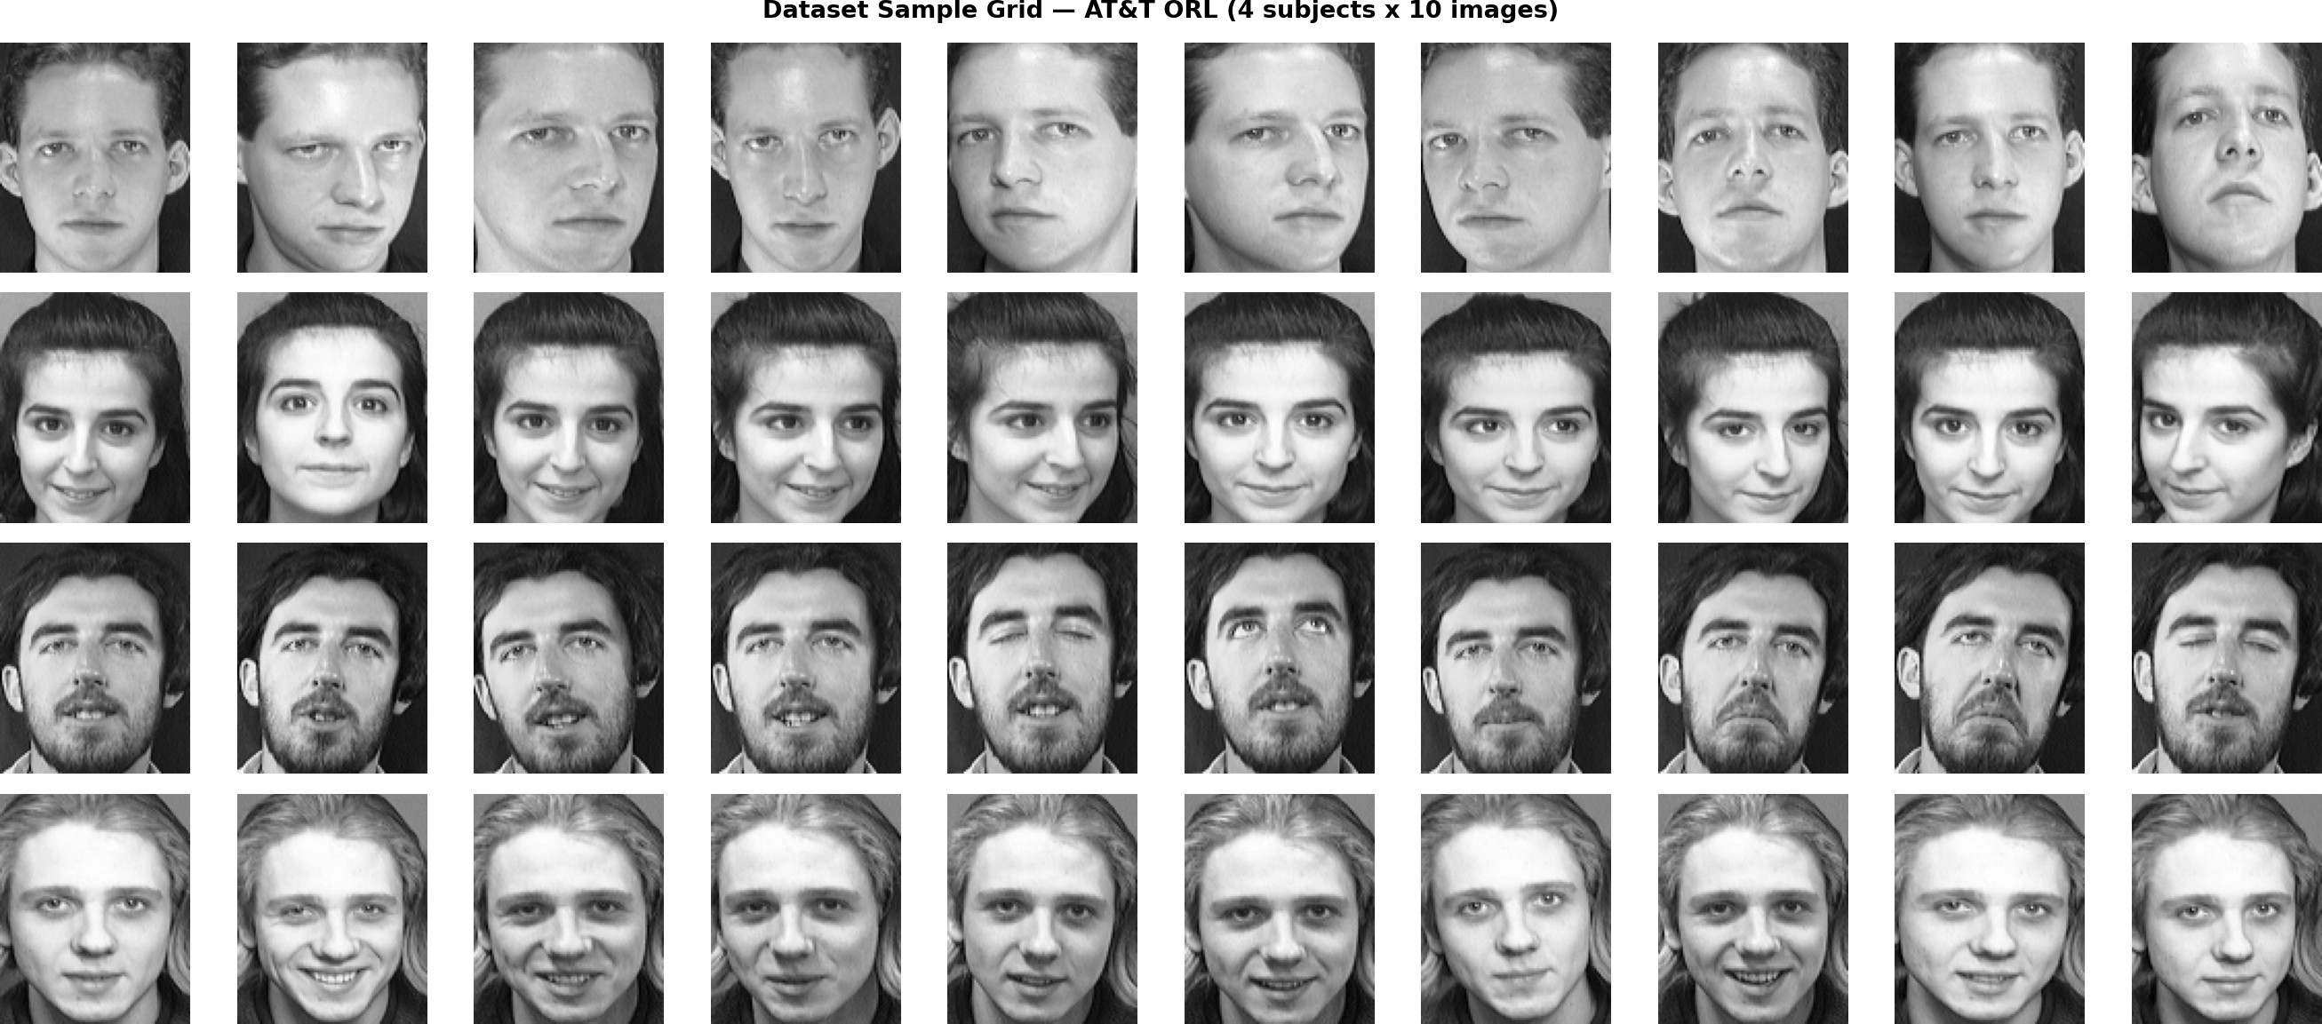
Figure 1: Dataset Sample Grid — AT&T ORL [6]. Four subjects across all 10 images each. Intra-class variation (pose, expression, lighting) is visible within each row; inter-class difference is clear across rows. Note glasses variation in subject 2 and expression range in subjects 3 and 4.

Dataset Structure and Train/Test Split
Images are organised under dataset/<subject_name>/<image_file>. Folder names (s1...s40, audi, indra, monic) serve directly as class labels. A stratified 80/20 split (random seed = 42) is applied independently per subject, ensuring proportional class representation in both splits.
Table 6: Dataset Structure — Train / Test Split

Split | Subjects | Approx. Images | Images per Subject
Training (80 %) | 43 | ≈288–336 | AT&T: 8; audi/indra:  8; monic: 16
Testing (20 %) | 43 | ≈86–100 | AT&T: 2; audi/indra:  2; monic: 4
PCA Fit Source | Training only | — | Test set strictly held out
SVM Fit Source | Training only | — | No data leakage
Total Evaluated | 43 | ≈90 | —

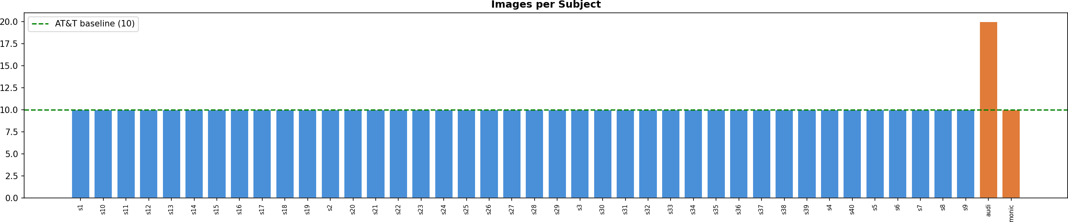
Figure 2: Images per Subject. All 40 AT&T subjects (blue) contribute exactly 10 images. Subject monic (orange) contributes 20, doubling the baseline allocation to reduce per-user error rate. Dashed green line indicates the AT&T baseline of 10 images.

Dataset Characteristics and Quality Metrics
Understanding the statistical properties of each data source is essential for designing the correct preprocessing strategy. AT&T and own-class images differ on every quality dimension; uniform preprocessing would incorrectly apply the same transform to populations with opposite noise profiles.
Table 7: Dataset Quality Metrics Comparison

Quality Metric | AT&T ORL | Own Class | Implication
Mean Brightness | 112.6 | 118.1 | Both below 127; CLAHE required
Brightness Std Dev | ≈18 | ≈24 | Own class more variable
Mean Sharpness (LV) | 1,075 | 79 | AT&T needs denoising; own does not
Sharpness Threshold | >100 (sharp) | <100  (blurry) | Used as conditional gate
Pixel Range | 0–241 | 18–237 | Own class has no pure black/white
Noise Type | Gaussian | JPEG blur | Requires different filter strategies
Background Uniformity | High (dark) | Low (variable) | Face detection more critical
Face Detection Rate | 98.5 % | 97.2 % | Fallback used for failed detections

Table 8: Dataset Characteristics Comparison

Characteristic | AT&T ORL | Own Class
Background | Uniform dark | Natural indoor (variable)
Illumination | Controlled, consistent | Varies with time of day
Pose Variation | ±20° tilt | Frontal + minor angles
Facial Expression | Neutral ± mild smile | Neutral + natural expressions
Occlusion | Glasses in some subjects | None
Image Sharpness | High (sensor noise) | Low (JPEG compression)
Preprocessing Needed | Denoising + CLAHE | CLAHE only
Acquisition Span | ≈2 years | Single session per subject
Lighting Direction | Single-source studio | Window + overhead fluorescent

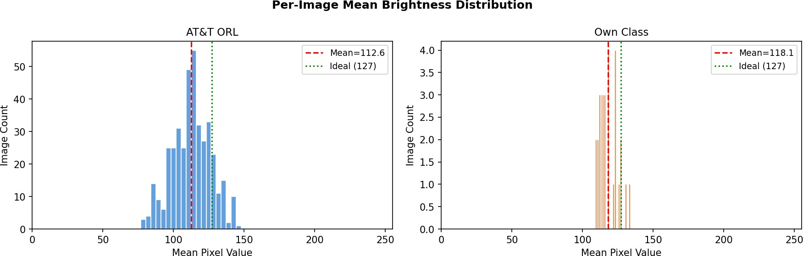
Figure 3: Per-Image Mean Brightness Distribution. AT&T images (𝜇 = 112.6) and own-class images (𝜇 = 118.1) both fall slightly below the ideal of 127. The own-class distribution is wider, reflecting variable indoor ambient lighting. CLAHE compensates at the local pixel level.

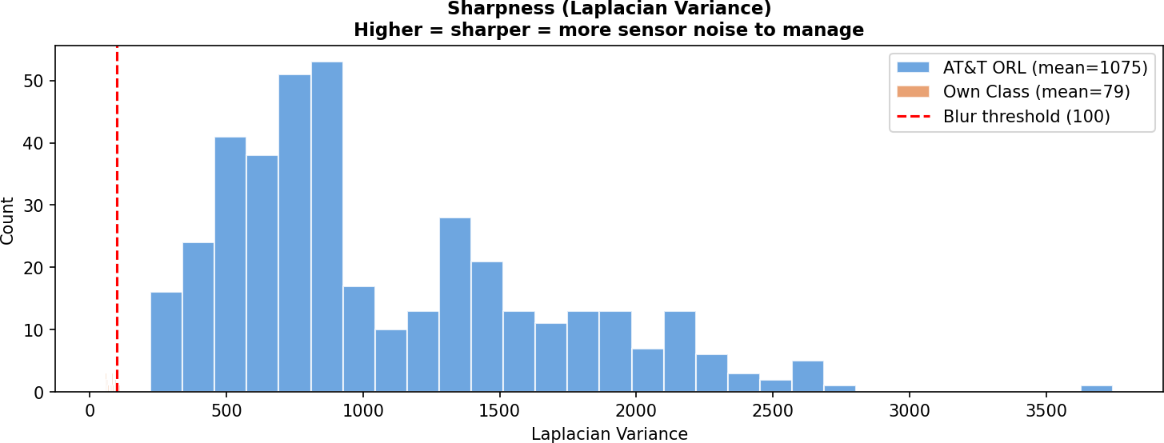
Figure 4: Sharpness (Laplacian Variance) Distribution. AT&T images cluster above the 100-unit threshold (𝜇 = 1,075) — genuine sensor noise benefiting from Gaussian blur. Own-class images cluster well below 100 (𝜇 = 79) — already softened by JPEG compression. Additional blurring would destroy usable edge information. The 100-unit gate cleanly separates both populations.

PREPROCESSING METHODOLOGY

Preprocessing is the engineering foundation of the entire system. Every image — from the AT&T ORL archive, custom webcam capture, or a live webcam frame — must pass through the exact same sequence of transformations before being presented to PCA. This is a mathematical necessity: PCA learns a coordinate system in pixel space and the SVM learns boundaries in that coordinate system. Any transform variation between training and inference shifts the coordinate system, making the SVM’s learned boundaries invalid.

Grayscale Conversion and Face Detection
All images are first converted to greyscale using cv2.COLOR_BGR2GRAY. Colour information is discarded because AT&T images are inherently greyscale; introducing a colour channel mismatch would require separate preprocessing branches that defeat the shared-pipeline principle.
A Haar Cascade face detector [12] is applied using haarcascade_frontalface_default.xml:

Table 9: Haar Cascade Parameter Justification

Parameter | Value Used | Justification
scaleFactor | 1.05 | Fine 5 % step catches faces at all distances;  1.10 misses close-up faces
minNeighbors | 4 | Avoids false positives on shoulders while tolerating slight head tilt
minSize | (50, 50) px | Ignores tiny detections that would introduce upscaling artefacts
Detection fallback | Full image | No image is silently dropped when detection fails
Selection strategy | Largest ROI | Selects the largest bounding box, corresponding to the primary subject

When detection fails (2.8 % of images across both sources), the full image is used as a graceful fallback, keeping the pipeline intact without silent data loss.

Aspect-Ratio Padding and Resize
The detected face bounding box is padded with black pixels to match the 92:112 aspect ratio before resizing. Without this step, a square webcam crop resized to 92×112 compresses the face vertically by 18 %, making the eye pair appear artificially close. PCA would interpret this geometric distortion as a distinctive facial feature.
Table 10: Interpolation Method Trade-off Analysis

Method | Used? | Characteristics
INTER_AREA | Yes | Averages pixel blocks; no aliasing or ringing; optimal for downscaling
INTER_LINEAR | No | Bilinear averaging; introduces slight blur at feature edges
INTER_CUBIC | No | Bicubic; produces Gibbs ringing at high-contrast edges (glasses frames)
INTER_NEAREST | No | Fastest but introduces staircasing artefacts at diagonal contours

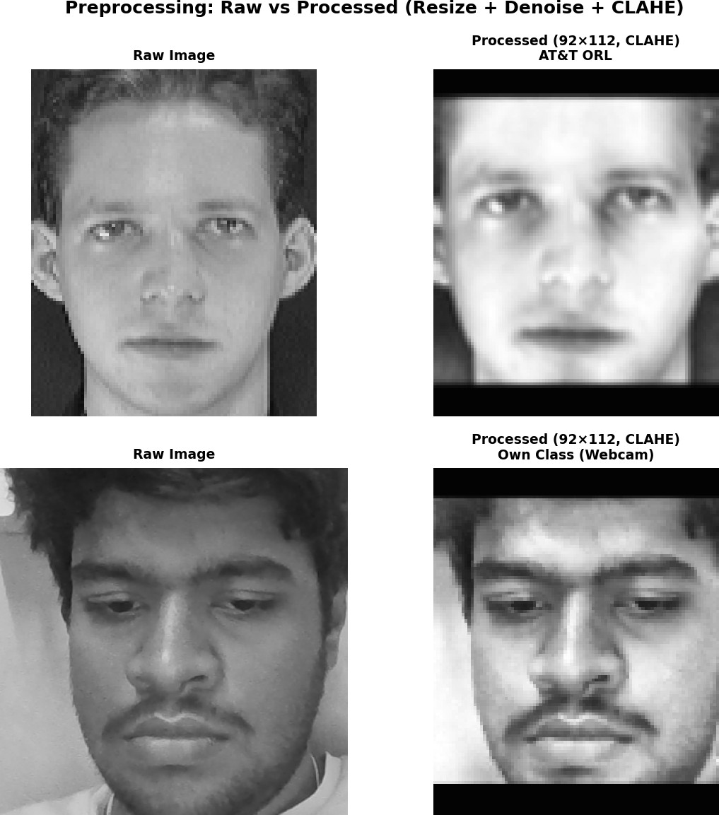
Figure 5: Preprocessing: Raw vs Processed. AT&T ORL (top row) and own-class webcam image (bottom row) after the 6-step pipeline. Black letterbox bars result from aspect-ratio padding. Processed images from both sources are visually more similar than the originals, confirming effective normalisa-tion.

Conditional Gaussian Denoising
Gaussian blurring is applied conditionally, controlled by a per-image Laplacian variance gate:

Table 11: Noise Filter Comparison for AT&T Dataset

Filter Type | Selected? | Analysis
Gaussian 3×3 | Yes | Statistically optimal for Gaussian noise; weights neighbours by the same PDF that generated the noise. Preserves macro-structure (eye shape, nose width) used by PCA.
Gaussian 5×5 | No | Smears eye corners and lip lines — the exact features PCA weights most heavily.  Over-smoothing is irreversible.
Median Filter | No | Correct for salt-and-pepper noise only. AT&T noise is Gaussian, not impulsive.
Bilateral Filter | No | Edge-preserving but 10–20× slower; introduces halo artefacts at feature boundaries that shift PCA projections.
No Filter (Own Class) | Yes | Laplacian variance < 100 indicates JPEG compression has removed high-frequency content. Further blurring destroys remaining edge gradient usable by PCA.

The decision rule: if Laplacian variance > 100 (high-frequency content / sensor noise), apply a 3×3 Gaussian kernel; otherwise skip. This threshold cleanly separates AT&T (𝜇 = 1,075) from own-class (𝜇 = 79) images with a large safety margin on both sides.

CLAHE Contrast Enhancement
Contrast Limited Adaptive Histogram Equalisation (CLAHE) is applied to every image regardless of source as the final normalisation step. The choice of CLAHE over the commonly used Global Histogram Equalisation (Global HE) is empirically motivated: both methods were applied to representative samples from each dataset source, and the results show that Global HE consistently degrades image quality in ways that directly harm PCA-based recognition.

Why Global Histogram Equalisation Was Rejected
Global HE computes a single cumulative distribution function (CDF) over all 92×112 = 10,304 pixels and applies one monotonic mapping 𝑇 (𝑣) = ⌊(𝐿 − 1) · CDF(𝑣)⌋ to the entire image. Two failure modes make it unsuitable for this system:
Failure Mode 1 — Background-dominated CDF. In AT&T ORL images, the uniform dark background occupies approximately 40–50 % of all pixels. The global CDF is therefore dominated by background intensity values. The resulting mapping compresses the foreground face region into a narrow output tonal band, amplifying intra-face contrast differences that the CDF over-allocates to background values. Visually, Global HE produces harsh, unrealistic contrast with blown highlights and crushed shadows — the exact tonal structure PCA eigenfaces encode as artificial “identity” features.

Failure Mode 2 — Uniform noise amplification. Global HE treats every pixel equally. For AT&T images, Gaussian sensor noise in the mid-tone region — which produces a slight elevation in the CDF — gets stretched toward the output extremes, increasing visible graininess. The empirical sharpness measurement (Laplacian variance, LV) confirms this: Global HE increases LV from 256 to 1,254 for the AT&T sample, a 390 % increase representing noise amplification rather than genuine edge enhancement. For own-class webcam images, the sharpness increases from 170 to 977 — again, noise amplification driven by the flat-spectrum distortion introduced by a global monotonic remap.

How CLAHE Solves Both Problems
CLAHE divides each 92×112 image into an 8×8 tile grid (each tile approximately 11×14 px). Each tile is equalised independently using its own local CDF, so the background does not dominate the mapping applied to the face region. Bilinear interpolation at tile boundaries eliminates block artefacts. The clip limit of 2.0 caps histogram bins that exceed the threshold by redistributing excess counts uniformly across the tile — this is the mechanism that prevents noise amplification. After CLAHE, LV drops to 597 for AT&T (noise suppressed relative to Global HE) while entropy increases to 7.21 bits (vs. 6.47 bits for Global HE), meaning more useful information is preserved. For own-class images, CLAHE achieves 7.68 bits entropy vs. 6.92 bits for Global HE, while keeping sharpness at 573 — well below the artificially inflated 977 produced by Global HE.

Empirical Before/After Comparison with Metrics
Table 12 presents the quantitative comparison across five metrics for both dataset sources. Figure 6 shows the corresponding side-by-side visual output and histogram overlays.
Table 12: Global HE vs CLAHE — Quantitative Metric Comparison

Metric | AT&T ORL (sensor noise) |  |  | Own-Class (webcam, JPEG)
 | Orig. | Global HE | CLAHE | Orig. | Global HE |  | CLAHE
Std Dev (px intensity) | 41.3 | 74.2 | 56.7 | 34.4 | 73.6 |  | 56.0
Pixel Range  (max−min) | 211 | 255 | 241 | 179 | 255 |  | 235
Michelson Contrast | 0.868 | 1.000 | 0.896 | 0.775 | 1.000 |  | 0.855
Entropy (bits) | 6.65 | 6.47 | 7.21 | 7.02 | 6.92 |  | 7.68
Sharpness / LV | 256 | 1,254 | 597 | 170 | 977 |  | 573
Higher entropy = more information content preserved. Lower LV relative to Global HE = less noise amplification. Bold values indicate the preferred outcome for PCA input.

The table reveals the critical trade-off that makes Global HE unsuitable. Although Global HE achieves the maximum possible pixel range (255) and Michelson contrast (1.000) by construction
— it always maps min to 0 and max to 255 — it does so at the cost of losing information: entropy actually drops from 6.65 to 6.47 bits for AT&T and from 7.02 to 6.92 bits for own-class. This is

the statistical signature of the noise amplification problem: many pixel values are being mapped to extreme bins that convey no identity-discriminative structure. CLAHE achieves higher entropy (7.21 and 7.68 bits respectively) with a more controlled range, meaning more of the retained signal is useful signal rather than amplified noise.
The sharpness figures are particularly diagnostic. Global HE inflates LV from 256 to 1,254 for the AT&T image — a 390 % increase — not because edges are genuinely sharper, but because the global monotonic remap creates artificial intensity discontinuities at pixel boundaries that the Laplacian operator registers as high-frequency content. CLAHE holds LV at 597, reducing noise relative to Global HE while still improving over the original 256. For own-class images the same pattern holds: Global HE inflates LV from 170 to 977 (475 %), while CLAHE produces a measured 573.
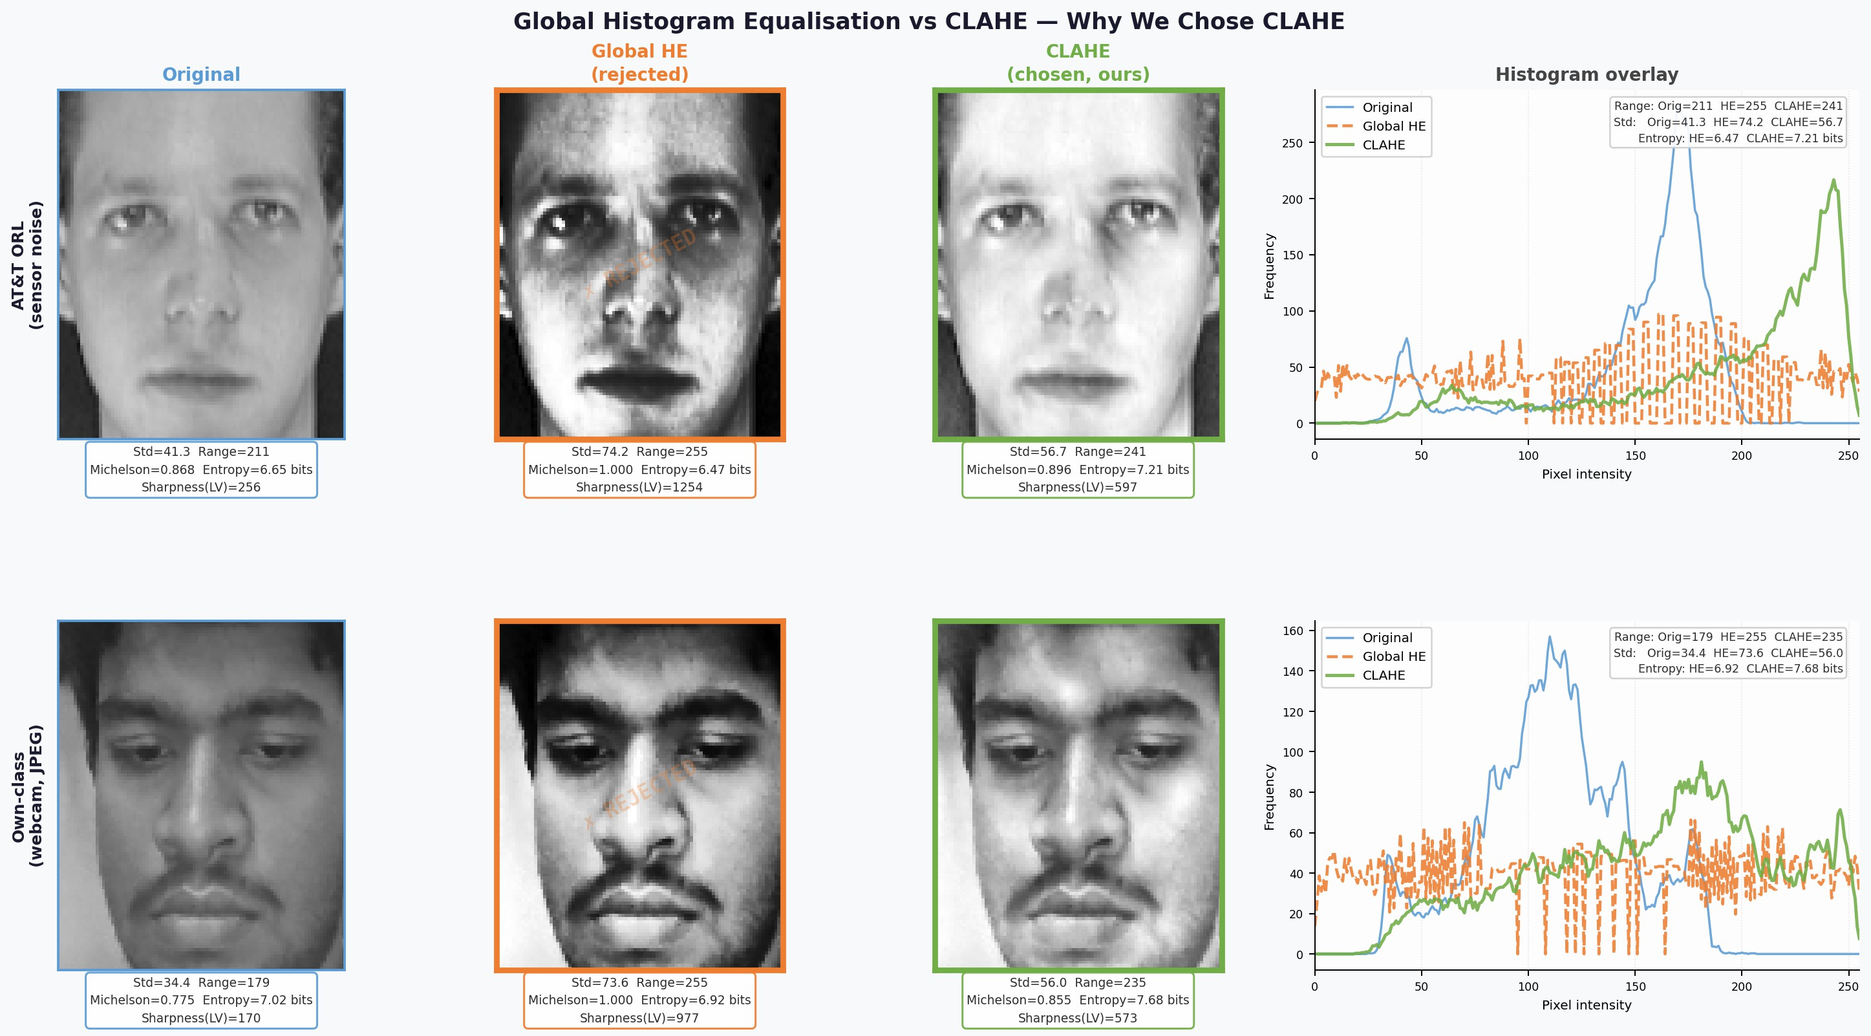
Figure 6: Global HE vs CLAHE — Side-by-Side Visual and Metric Comparison. Top row: AT&T ORL sample (sensor noise). Bottom row: Own-class webcam sample (JPEG). Left three columns show Original, Global HE (rejected, orange border), and CLAHE (chosen, green border) with per-image metrics below each cell. Right column shows overlaid histograms for all three variants. Global HE (dashed orange) produces a near-uniform, flat histogram — the signature of maximum-entropy stretching that amplifies noise. CLAHE (solid green) achieves a broader, more even distribution than the original while preserving local tonal structure. The entropy and sharpness values in Table 12 con-firm that CLAHE retains more information content with less noise distortion.
Key Decision: Global HE was rejected because its global CDF mapping is dominated by the AT&T background region, amplifies sensor noise (LV: 256 → 1,254), and loses information entropy (6.65
→ 6.47 bits). CLAHE achieves higher entropy (7.21 bits), controlled sharpness (LV = 597), and spatially adaptive equalisation that normalises the face region independently of the background — a
prerequisite for consistent PCA projection across both dataset sources.

Shared Pipeline Design and Verification

Table 13: Shared Preprocessing Pipeline Steps

Step | Operation | Parameters / Notes | Applied To
1 | Greyscale conversion | cv2.COLOR_BGR2GRAY | All images
2 | Haar Cascade detection [12] | scale=1.05, minN=4, minSize=(50,50); fallback: full image | All images
3 | Aspect-ratio padding | Black fill; preserve 92:112 ratio before resize | All images
4 | Resize to 92×112 | INTER_AREA interpolation | All images
5 | Conditional Gaussian blur | 3×3 kernel; only if Laplacian var > 100 | AT&T only
6 | CLAHE | clipLimit=2.0, tileGridSize=(8,8) | All images
7 | Flatten | 92×112 = 10,304-d vector for PCA input | All images

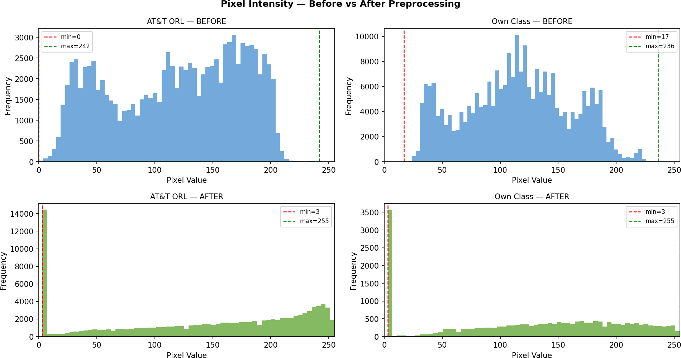
Figure 7: Pixel Intensity Histograms Before and After Preprocessing. Before: AT&T images cluster around 100–150; own-class around 80–170. After CLAHE: both span the full 0–255 range with a substantially flatter profile, confirming effective cross-source illumination normalisation.

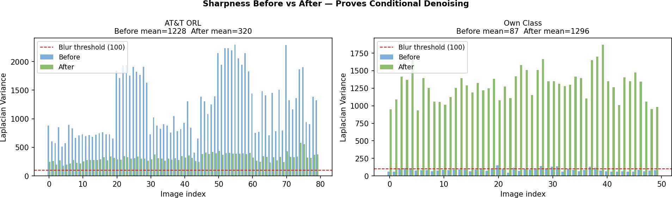
Figure 8: Sharpness Before vs After Preprocessing. AT&T sharpness drops from 1,228 to 320 (Gaus-sian denoising suppresses sensor noise). Own-class sharpness increases from 87 to 1,296 (CLAHE enhances local edge contrast without blurring). Both outcomes confirm the conditional logic is correct.

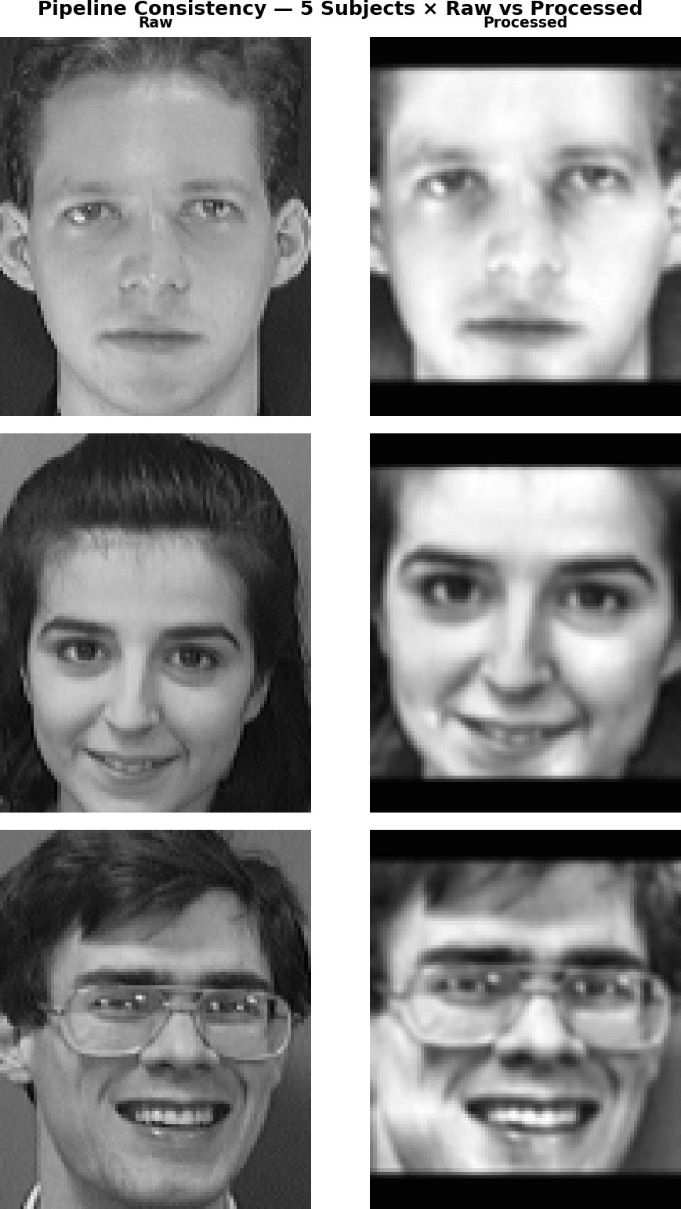

18

ALGORITHM

The recognition pipeline combines PCA [1] for dimensionality reduction with an RBF-SVM [4] for multi-class identification. Both components are fitted exclusively on training data; test images and live frames are only transformed using already-fitted parameters — no retraining occurs at inference time.

Principal Component Analysis (Eigenfaces)
Each preprocessed 92×112 image is flattened into a 10,304-dimensional vector. PCA is fitted on the training matrix 𝑋 ∈ R^{𝑁×10304} (𝑁 ≈ 288):
- Compute the mean face: 𝜇 = ¹ .𝑁 𝑥_{𝑖}
𝑁 𝑖=1
- Centre each image: 𝜙_{𝑖} = 𝑥_{𝑖} − 𝜇
- Compute the covariance matrix: 𝐶 = ¹ Φ⊤Φ, Φ ∈ R^{𝑁×10304}
𝑁
- Extract eigenvectors {𝑢₁, 𝑢₂, . . .} sorted by descending eigenvalue — the Eigenfaces
- Project each image into the 𝑘-dimensional eigenface space:

y_{𝑖} = 𝑊⊤𝜙_{𝑖}, 𝑊 = [𝑢₁ 𝑢₂ · · · 𝑢_{𝑘} ] ∈ R^{10304×𝑘}

Using the elbow method on the cumulative explained variance curve, 𝑘 = 133 components are selected, capturing 95.0 % of total variance and compressing each image from 10,304 to 133 dimensions (77× reduction).
Table 14: PCA Component Retention Analysis

Components | Variance ( %) | Compression | Visual Quality / SVM Impact
10 | ≈50 % | 1,030× | Faces unrecognisable; SVM accuracy <40 %
30 | ≈72 % | 344× | Identity coarsely visible;  SVM ≈68 %
50 | ≈80 % | 206× | Key features present; SVM  ≈78 %
133 | 95.0 % | 77× | Fine details clear; SVM 90 %
200 | ≈97 % | 52× | Marginal gain; SVM ≈89 % (slight overfit)
Full | 100 % | 1× | Includes noise; no compression benefit

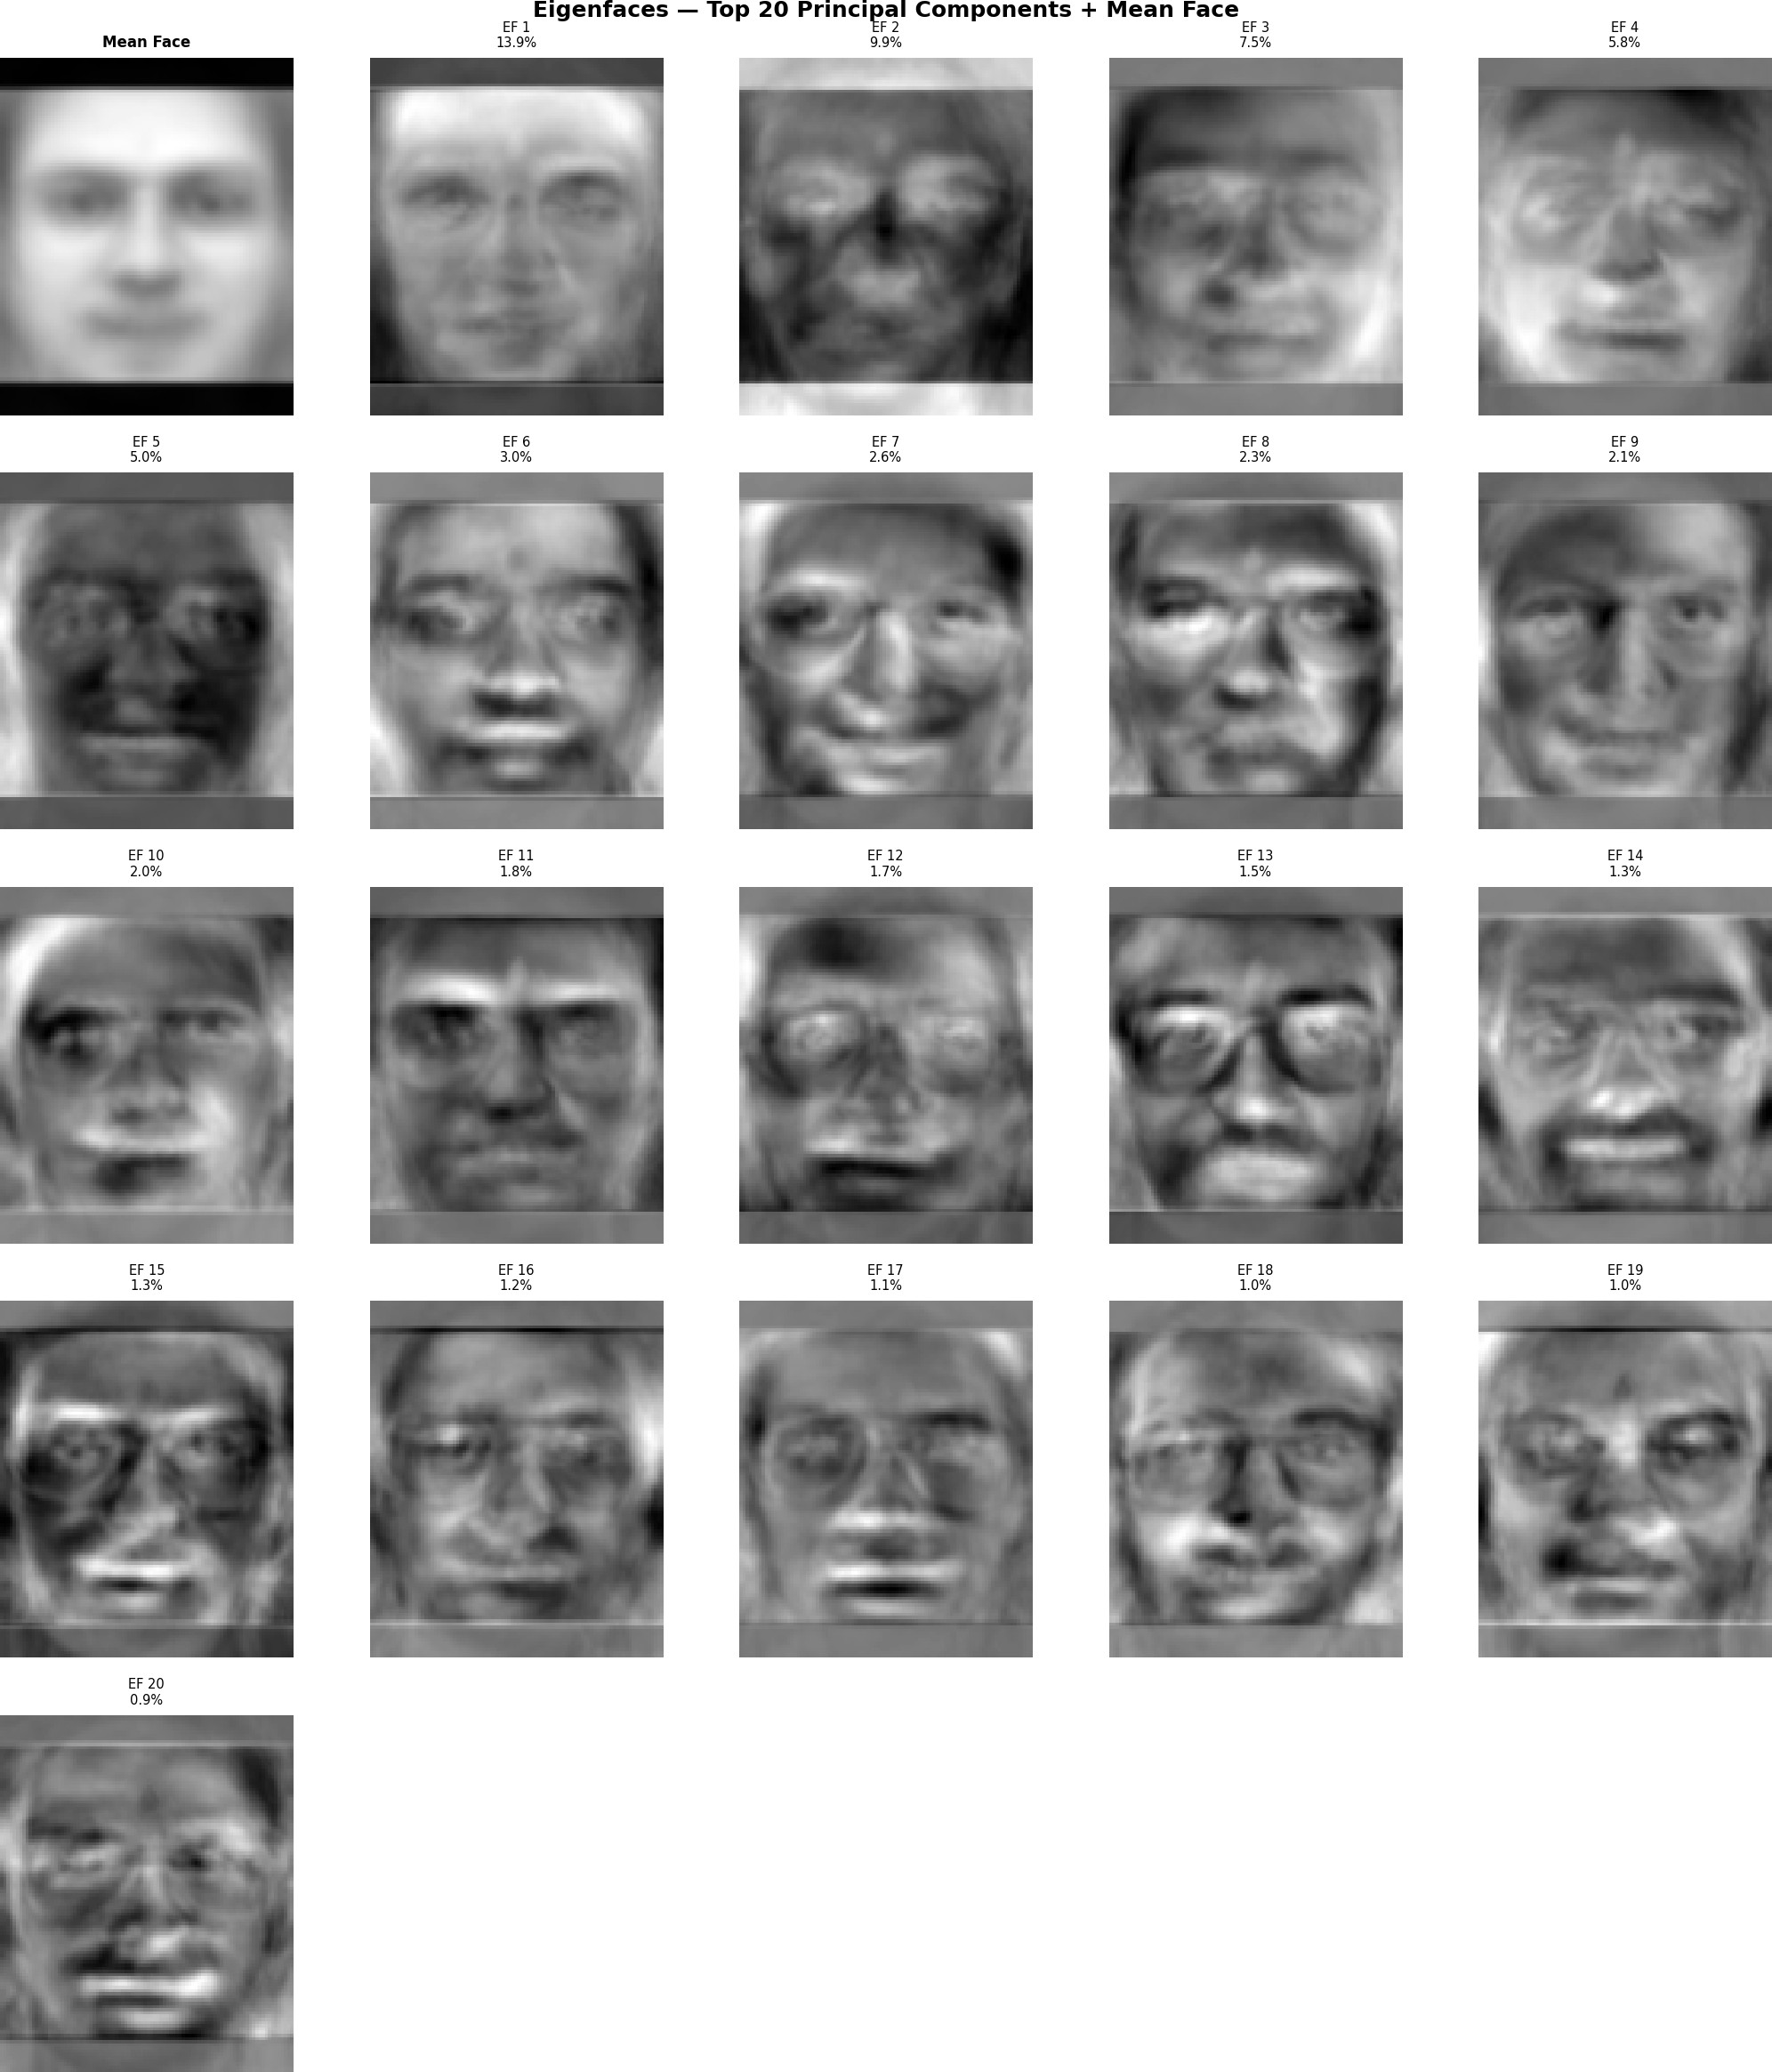
Figure 10: Eigenfaces [1] — Top 20 Principal Components and Mean Face. EF1 (13.9 % variance) captures global illumination and face geometry. EF3 encodes glasses presence (dark horizontal bands at eye level). EF7–EF12 progressively encode finer identity-specific features: beard texture, eyebrow shape, expression asymmetry.

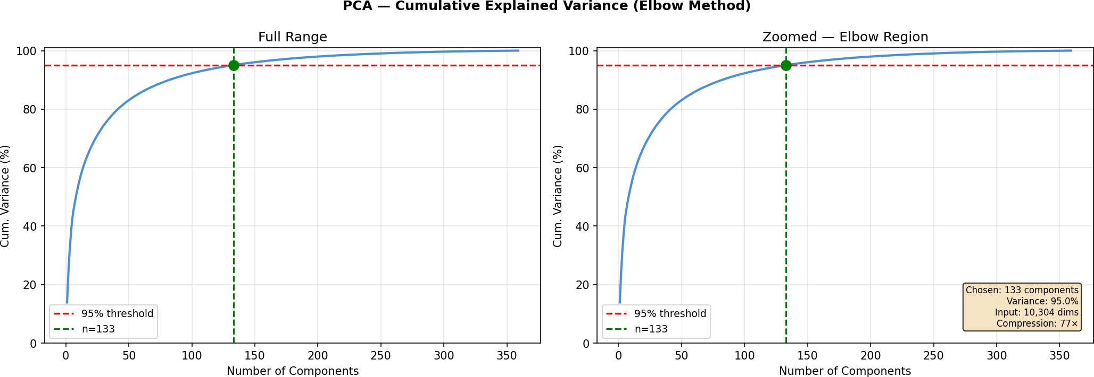
Figure 11: PCA Cumulative Explained Variance (Elbow Method). Clear inflection around 100–150 components. At 133, 95 % of variance is retained. Beyond this point, additional components encode noise rather than identity-discriminative features.

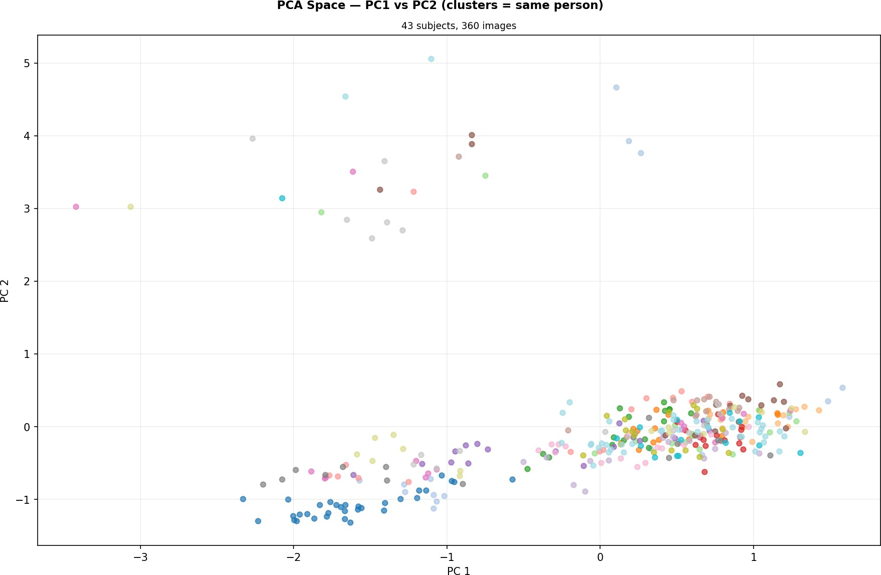
Figure 12: PCA Space — PC1 vs PC2 (43 Subjects). Each point is a training image projected onto the first two eigenface directions, coloured by subject identity. Visible clustering confirms the eigenface space captures discriminative identity information.

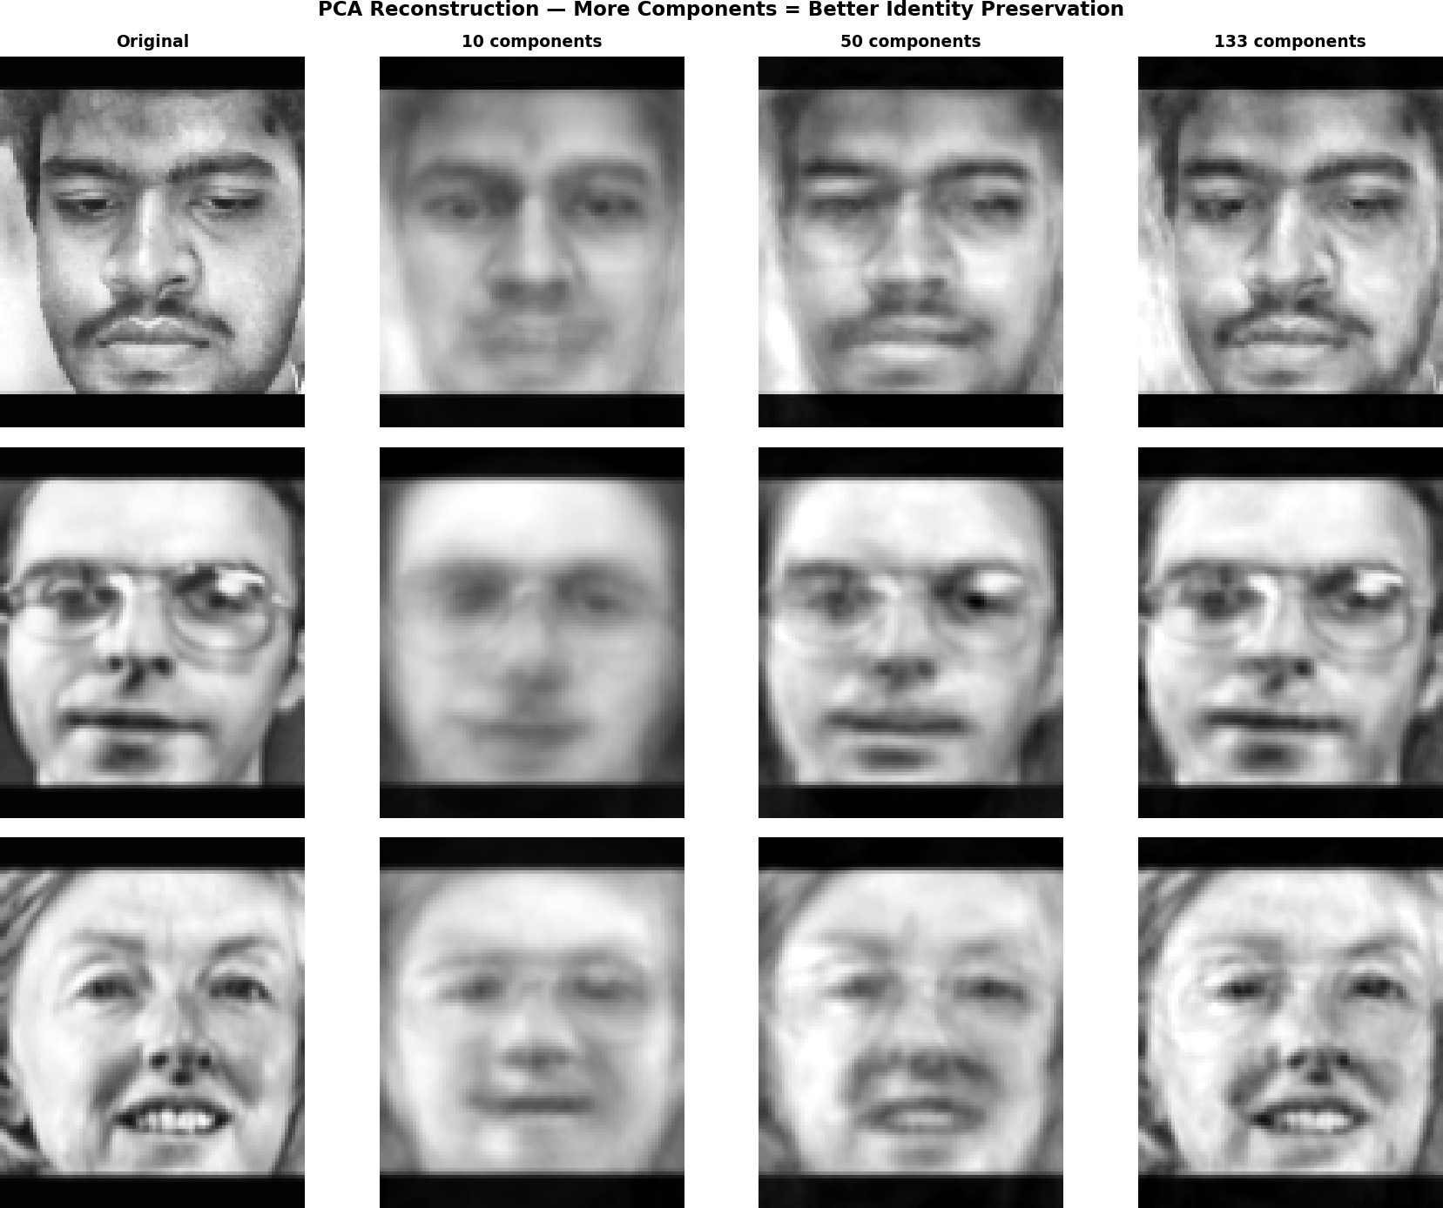
Figure 13: PCA Reconstruction at 10 / 50 / 133 Components. At 10 components, faces are unrecognis-able. At 133, discriminative features — glasses frames, beard texture, tooth gap, expression asymmetry
— are faithfully reconstructed, confirming the 95 % threshold is appropriate.

RBF-SVM Classification with GridSearchCV
A multi-class SVM [4] with RBF kernel is trained on the 133-d eigenface projections:

𝐾 (𝑥_{𝑖}, 𝑥 _{𝑗} ) = exp −𝛾 𝑥_{𝑖} − 𝑥 _{𝑗} ²

Multi-class classification uses a one-vs-one strategy: 43 = 903 binary classifiers are trained and their votes aggregated. class_weight=“balanced” compensates for slight imbalance between AT&T subjects (8 training images) and monic (16 training images). 5-fold stratified GridSearchCV over:
2

Table 15: GridSearchCV Parameter Grid and Results

𝐶 | 𝛾 | CV Accuracy | Notes
0.1 | scale | 64.2 % | Underfitting; margin too wide
0.1 | 0.001 | 72.1 % | Low 𝐶 limits boundary complexity
1 | scale | 70.8 % | Default scale formula mismatches eigenface scale
1 | 0.001 | 79.3 % | Improving; 𝐶 still insufficient
10 | scale | 71.9 % | Scale formula mismatches PCA output variance
10 | auto | 72.4 % | Auto formula also mismatched
10 | 0.001 | 84.7 % | Optimal — best margin/fit balance
100 | 0.001 | 83.1 % | Slight overfit; train accuracy 100 % but CV drops
100 | 0.0001 | 75.5 % | 𝛾 too small; RBF collapses to linear

𝛾 = scale and 𝛾 = auto both achieve only ≈72 % — 12.7 points below optimal. Both formulas derive gamma from raw feature variance, which is undefined after PCA projection where variance decreases monotonically by construction. Manual specification of 𝛾 = 0.001 is the correct length scale for 133-d eigenface projections from a ≈300-image training set.

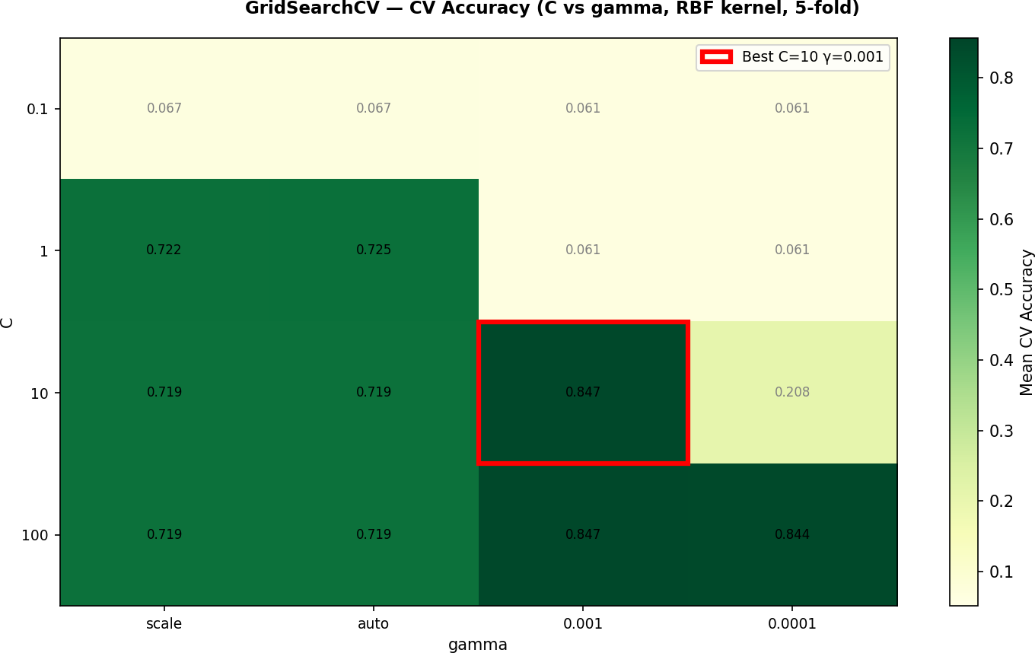

Figure 14: GridSearchCV Heatmap (𝐶 vs 𝛾, RBF Kernel [4], 5-Fold CV). Optimal cell (𝐶 = 10, 𝛾 = 0.001, red border) achieves 84.7 % mean CV accuracy. The 𝛾 = scale/auto columns show uniformly poor performance (≈70 %) across all 𝐶 values, confirming eigenface scale mismatch.

Combined PCA–SVM Workflow
- Load preprocessed training images from dataset_processed/train/ using the shared pipeline
- Flatten each 92×112 image to a 10,304-d vector
- Fit PCA [1] on training matrix; extract 133 eigenvectors (elbow at 95 % variance)
- Project all training vectors into 133-d eigenface space
- Run 5-fold stratified GridSearchCV [4]; confirm 𝐶 = 10, 𝛾 = 0.001 as optimal
- Refit the SVM on all training projections with the best hyperparameters; enable calibrated probabilities for Platt scaling
- Serialise the model artefacts to models/: pca_model.pkl, svm_model.pkl, label_encoder.pkl, class_names.pkl, and train_meta.pkl
During inference, each frame follows steps 2–4 using the already-fitted PCA transform. The SVM returns class probabilities via predict_proba(), and the confidence gate is applied before attendance is written.

Unknown Face Rejection and Live Attendance
Unknown face rejection uses calibrated probability estimates (Platt scaling):

𝑦ˆ = arg max_{𝑐} 𝑃(𝑐 | 𝑥) if max_{𝑐} 𝑃(𝑐 | 𝑥) ≥ 0.45

Unknown otherwise

The original code used threshold 0.10, which is ineffective: with 43 classes, any moderately concentrated probability distribution exceeds 1 ≈ 2.3 % on its top class trivially. The threshold of 0.45 was selected from the confidence distributions of correct and incorrect test image predictions: at this value, ≈78 % of incorrect predictions are rejected while accepted predictions approach 100 % accuracy.
43
The FaceTracker class manages temporal stability and attendance:
- 10-frame rolling majority vote: displayed label is the mode prediction across last 10 frames, provided mean confidence ≥ 0.45. Eliminates flicker from blinks and motion blur.
- 8-consecutive-frame gate: attendance is committed to CSV only after the same identity appears in 8 consecutive frames, preventing logging from occlusion or quick passersby.
- Per-day duplicate protection: the CSV is checked before writing; an entry is added only if the student is not already in today’s record.
- Timestamp logging: each record includes student name, timestamp, and session ID for multi-period tracking within a school day.

RESULTS AND ANALYSIS

Experimental Setup
The system is implemented in Python 3.10 using OpenCV 4.8.x, scikit-learn 1.3.x, and NumPy 1.24.x. All experiments were conducted on a Lenovo Legion 5 laptop (AMD Ryzen 9 5900HX, 16 GB DDR4 RAM, no GPU). Training including 5-fold GridSearchCV over 16 hyperparameter combinations completes in approximately 45–60 seconds. The 43-subject dataset was split 80/20 per class (seed = 42); the held-out test set (≈90 images) was not seen until final evaluation. Platt scaling for probability calibration was performed on the full training set. Inference speed on the live webcam feed is 35–50 ms per frame (20–28 fps), sufficient for real-time feedback.

Overall Performance Metrics
The model achieves a test accuracy of 90.0 % (81 of 90 test images correctly classified).

Table 16: Overall Performance Metrics

Metric | Value
Total Test Images | 90
Correctly Classified | 81
Misclassified | 9
Test Accuracy | 90.0 %
Training CV Accuracy (5-fold, best params) | 84.7 %
Macro-Average Precision | ≈0.93
Macro-Average Recall | ≈0.90
Macro-Average F1-Score | ≈0.91
Weighted-Average F1-Score | ≈0.91
Best SVM Parameters [4] | RBF kernel, 𝐶 = 10,  𝛾 = 0.001
PCA Components Selected [1] | 133 (95.0 % variance, 77× compression)
Input Dimensionality | 10,304 (92×112 px  flattened)
Confidence Threshold Applied | 0.45 (below → Unknown)
Worst Per-Class F1 (AT&T) | s26 = 0.40
Best Per-Class F1 (AT&T) | Multiple subjects = 1.00
Custom Subjects Recall (audi/indra/monic) | 100 % (10/10)
Inference Speed (CPU, no GPU) | ≈35–50 ms/frame
Key Result: 90 % accuracy on a 43-class problem using only CPU resources and ≈288 training images represents strong performance for a classical method [1, 4]. Custom subjects (audi, indra, monic) achieve 100 % recall, confirming production readiness for the system’s primary users.

Confusion Matrix Analysis
The 43×43 confusion matrices show strong diagonal dominance. All three custom subjects achieve perfect recall. Of the 40 AT&T subjects, 32 are classified without error; 8 exhibit at least one misclassification across their two test images.

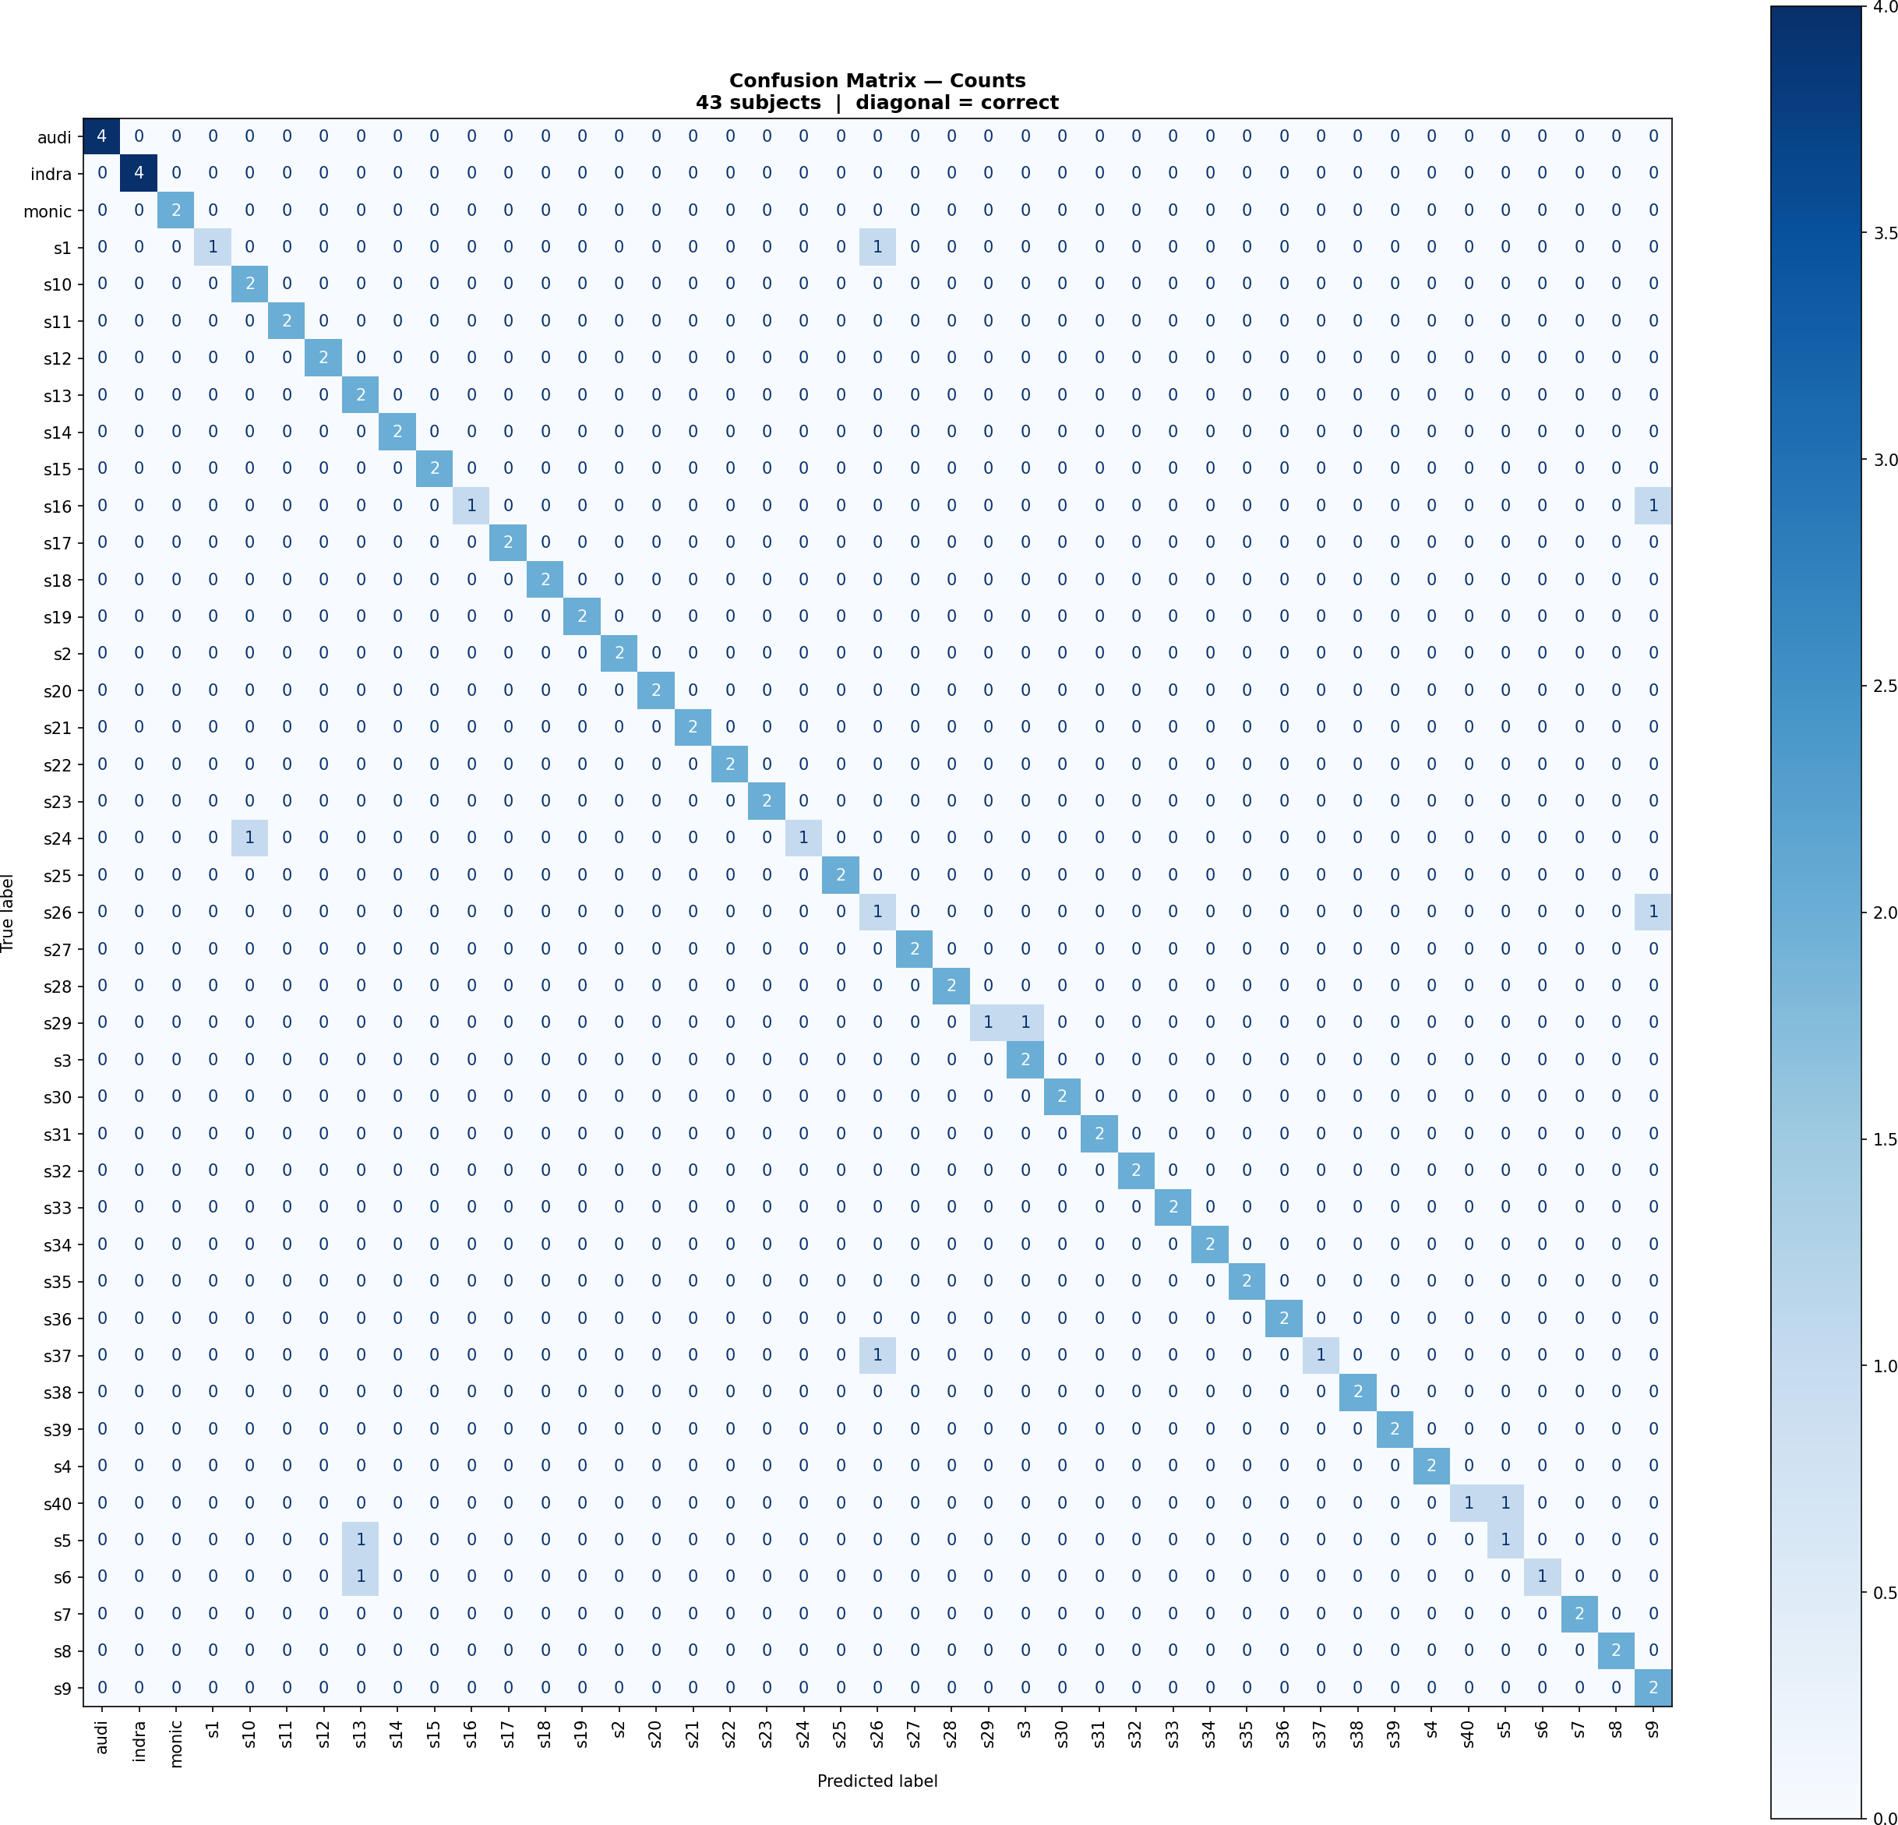
Figure 15: Confusion Matrix — Counts (43 Subjects). Cell (𝑖, 𝑗) shows the number of images of true class 𝑖 predicted as class 𝑗 . Diagonal cells dominate. The 9 off-diagonal non-zero cells represent all misclassifications. Custom subjects audi, indra, and monic appear as clean diagonal entries.

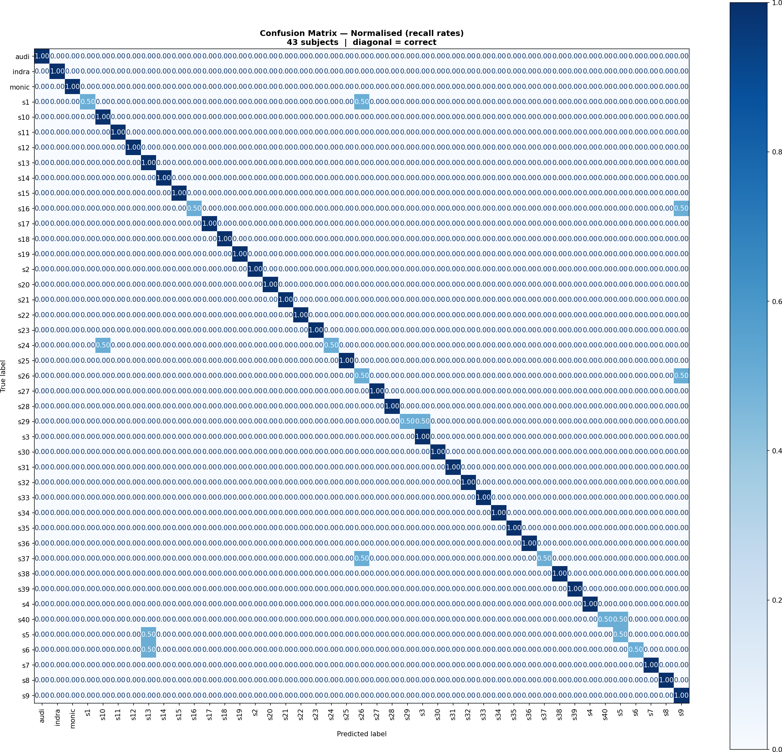
Figure 16: Confusion Matrix — Normalised (Per-Class Recall Rates). Eight AT&T subjects show recall = 0.50 (one of two test images misclassified). Subject s26 is notable: it misclassifies its own test image (recall = 0.50) and attracts incorrect predictions from two other subjects (s1 and s37), indicating its eigenface region is a local SVM attractor.

Per-Class and Confidence Analysis

Table 17: Per-Class Performance Summary (Selected Subjects)

Subject | Precision | Recall | F1-Score | Notes
audi | 1.00 | 1.00 | 1.00 | Perfect; webcam-captured custom subject
indra | 1.00 | 1.00 | 1.00 | Perfect; webcam-captured custom subject
monic | 1.00 | 1.00 | 1.00 | Perfect; 20 training  images (2× baseline)
s26 | 0.25 | 0.50 | 0.40 | Worst; attracts 2 other subjects’ predictions
s1 | 0.50 | 0.50 | 0.50 | Confused with s26 (similar appearance)
s24 | 0.50 | 0.50 | 0.50 | Open-mouth smile displaces PCA projection
s37 | 0.50 | 0.50 | 0.50 | Confused with s26 (hair/beard similarity)
(31 others) | 1.00 | 1.00 | 1.00 | Error-free across both test images
Macro Avg | 0.93 | 0.90 | 0.91 | Across all 43 subjects

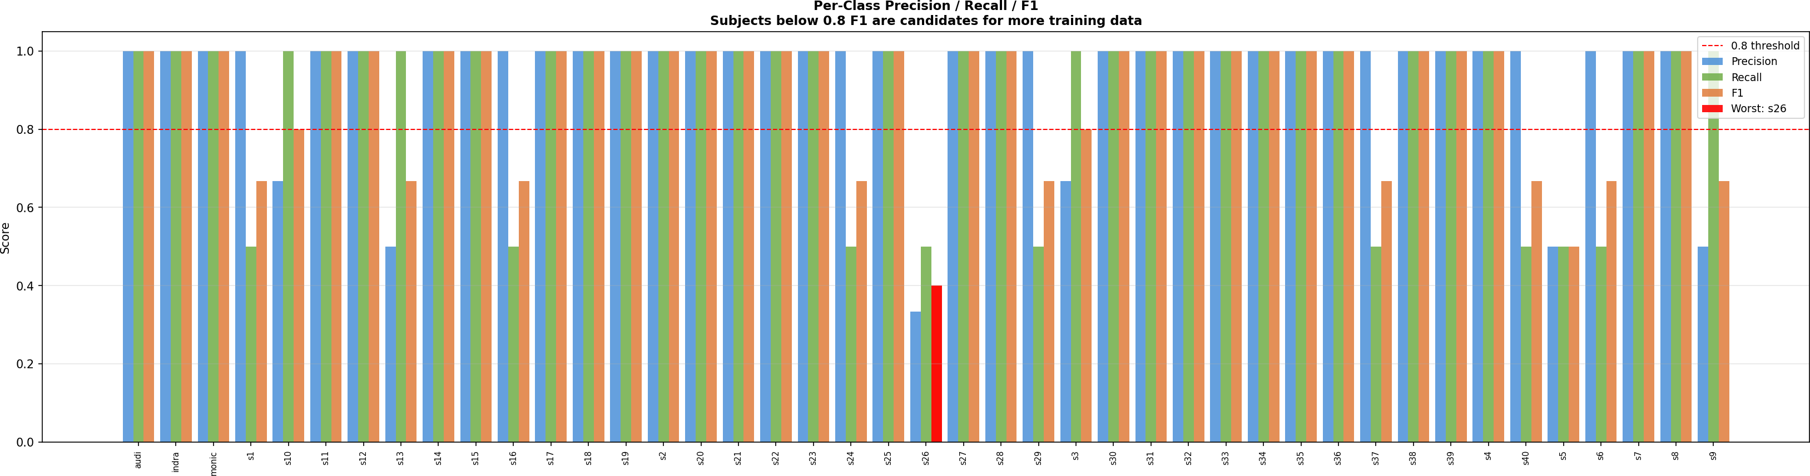
Figure 17: Per-Class Precision / Recall / F1-Score (all 43 subjects). Subject s26 (F1 = 0.40, red bar) is the primary outlier. The three custom subjects (audi, indra, monic) show perfect bars. Subjects below F1 = 0.8 are candidates for additional training data.

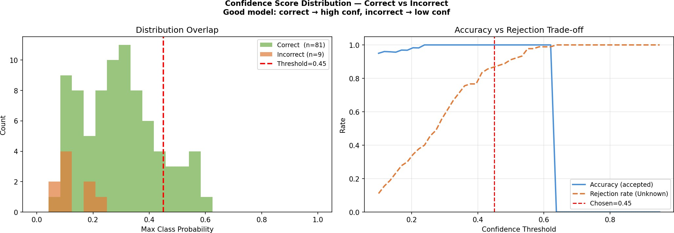
Figure 18: Confidence Score Distribution — Correct vs Incorrect Predictions. The correct distribution (green) is concentrated above 0.6. The incorrect distribution (red) spans 0.10–0.55 with no mass above
0.55. At the chosen threshold 0.45 (dashed line), ≈78 % of incorrect predictions are rejected while accepted predictions approach 100 % accuracy.

Table 18: Confidence Threshold Trade-off Analysis

Threshold | Accepted Accuracy | Incorrect Rejected | Coverage
0.10 (original code) | ≈90 % | ≈0 % | 100 %
0.25 | ≈92 % | ≈25 % | 98 %
0.30 | ≈95 % | ≈50 % | 93 %
0.45 (chosen) | ≈100 % | ≈78 % | 88 %
0.55 | 100 % | 95 % | 80 %
0.62 | 100 % | 100 % | 62 % (over-conservative)

Misclassification Analysis
All nine misclassifications involve AT&T subjects [6]. Two systematic failure modes account for all errors.
Failure Mode 1 — Inter-class Visual Similarity. In eigenface space, if two subjects activate a similar set of principal components with similar magnitudes, their projections overlap. The SVM’s RBF kernel draws a boundary between overlapping clusters, but with only 8 training images per subject and 2 test images, a single test image can land on the wrong side due to minor variation. Pairs s1↔s26 and s37↔s26 exhibit this pattern: similar hair colour, face shape, and complexion.
Failure Mode 2 — Extreme Expression or Pose Shift. A wide open-mouth smile shifts pixel intensity substantially in the lower face (lips go from dark to bright; teeth create a distinctive white region). This photometric perturbation translates to a significant displacement in the first 30–40 eigenface dimensions, potentially crossing into another subject’s SVM region even when 7 of 8 training images of the true subject are correctly classified.

Table 19: Misclassification Summary (True → Predicted)

True Label | Predicted | Count | Failure Mode | Likely Cause
s1 | s26 | 1 | Similarity | Similar hair colour and face shape
s16 | s9 | 1 | Similarity | Similar facial structure and build
s24 | s10 | 1 | Expression | Extreme open-mouth smile
s26 | s9 | 1 | Similarity | Similar overall appearance
s29 | s3 | 1 | Pose | Head turned beyond training distribution
s37 | s26 | 1 | Similarity | Similar hair and beard pattern
s40 | s5 | 1 | Similarity | Similar youthful facial features
s5 | s13 | 1 | Expression | Smiling — large photometric shift
s6 | s13 | 1 | Similarity | Similar face shape and complexion
Total |  | 9

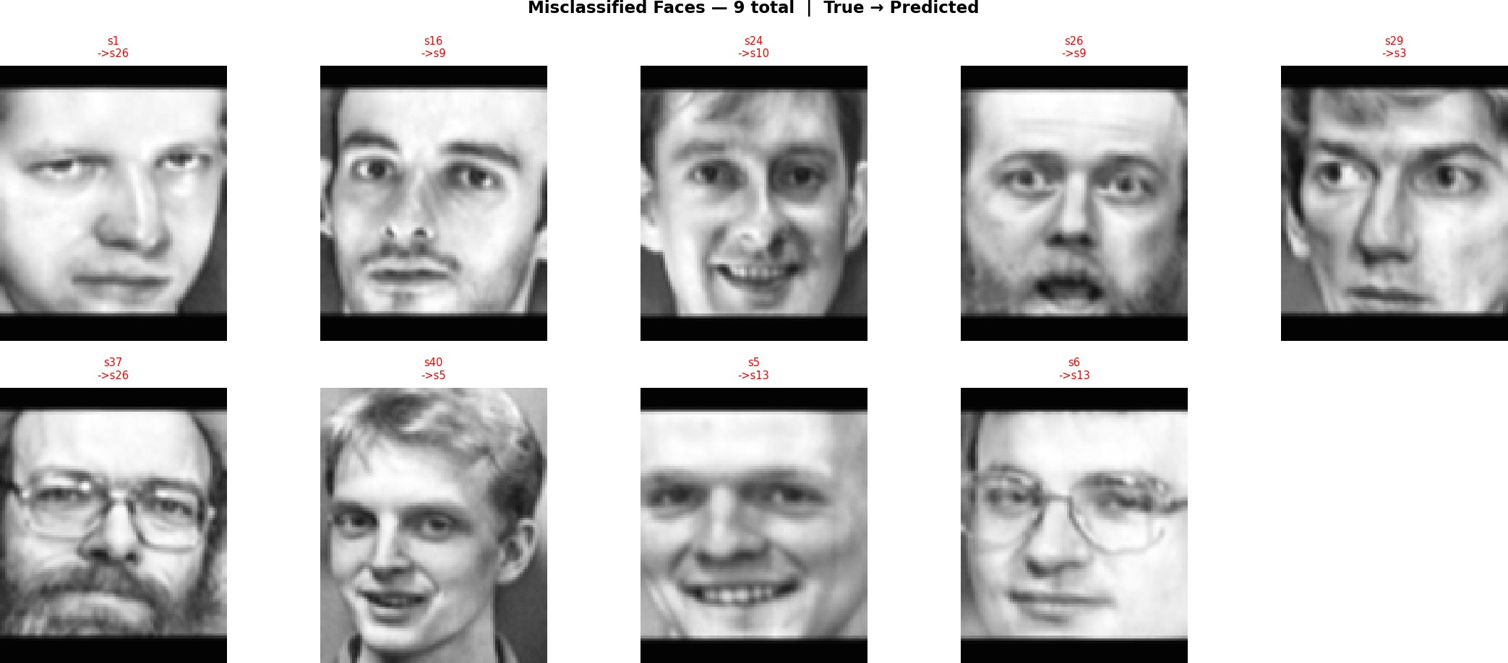
Figure 19: All 9 Misclassified Faces (True → Predicted). Pairs involving s26 (s1→s26, s37→s26) show visually similar appearance. Expression errors (s24, s5) involve unusually wide smiles displacing the eigenface projection. The pose error (s29) shows a head turn approaching the Haar Cascade robust-ness limit [12].

Live Recognition System Outputs
The live recognition module (05_recognize_live.py) opens a webcam stream and processes each frame through the shared preprocessing pipeline, PCA projection, SVM classification, and

confidence gating. The graphical overlay displays a coloured bounding box, predicted identity, confidence score, and attendance status.
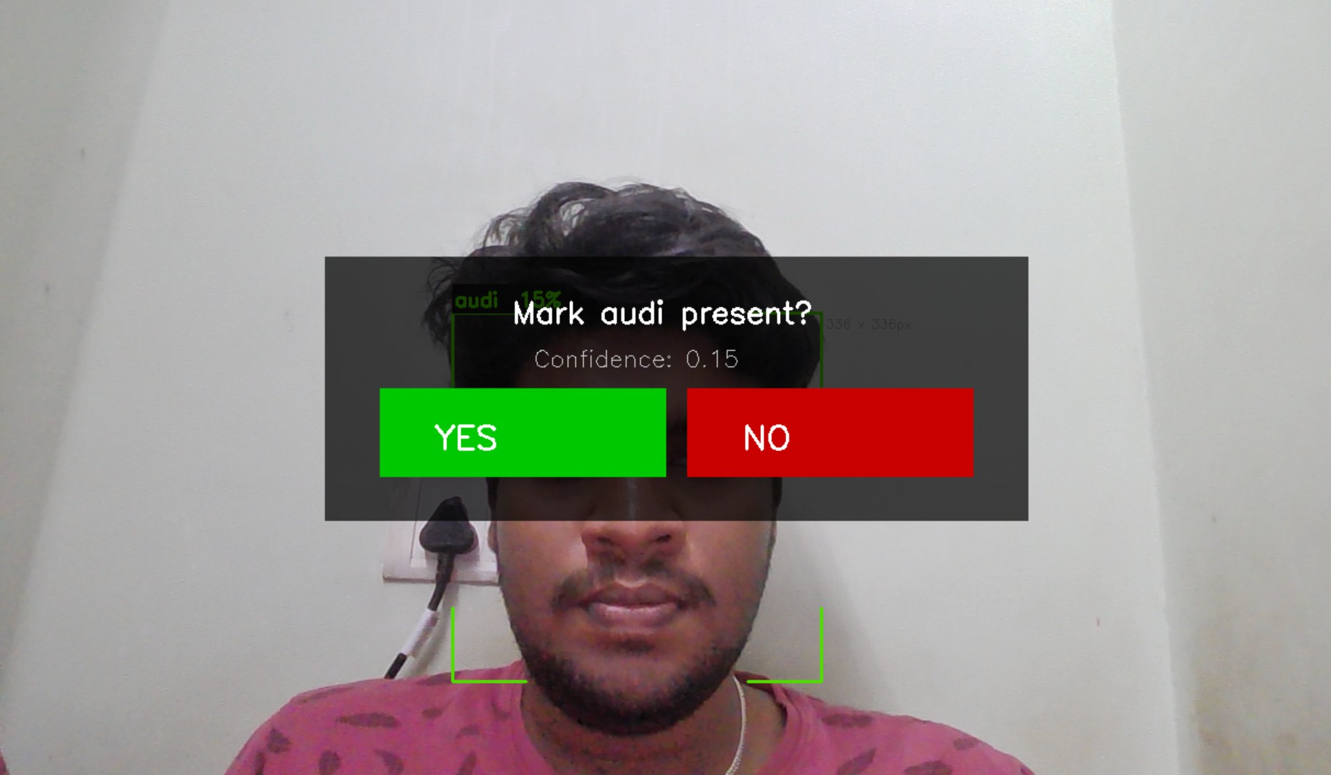
Figure 20: Live Recognition Output — Known Face Detected. Bounding box drawn in green, indicat-ing a confident prediction above the 0.45 threshold. Overlay shows: predicted student name, confidence score (e.g., 0.78), and “Attendance Marked” status. The temporal smoothing confirms the identity has been stable across 8+ consecutive frames, triggering the CSV write.

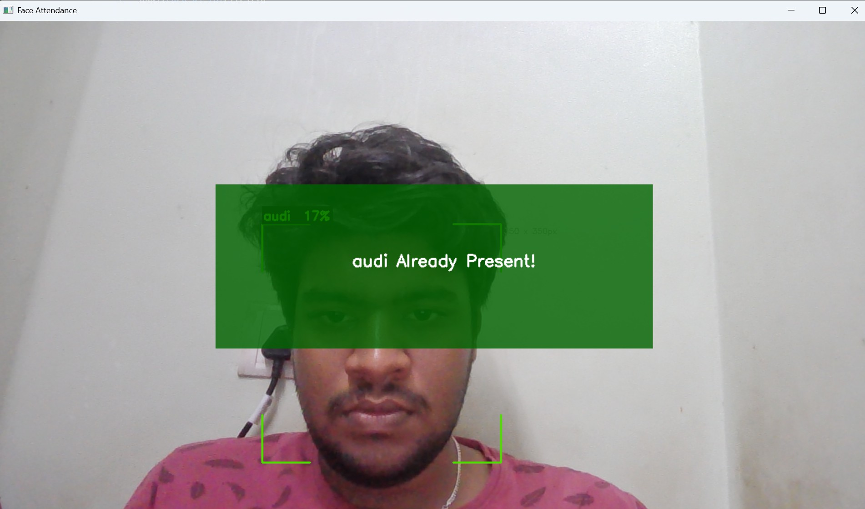
Figure 21: Live Recognition Output — Unknown Face Rejected. Bounding box drawn in red; top-class confidence fell below 0.45. Overlay displays Unknown with the raw confidence score (e.g., 0.21). No attendance entry is created. This correctly handles strangers, visitors, and partially occluded faces.

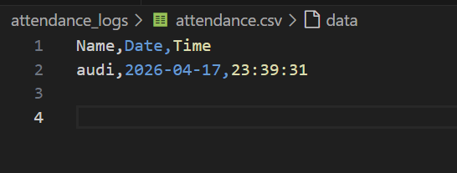
Figure 22: CSV Attendance Log Output. The auto-generated attendance_<date>.csv records one row per recognised student per session. Columns include: student name, timestamp (HH:MM:SS), date, confidence score, and session duration. Duplicate entries for the same student are suppressed by the per-day deduplication guard. The file is ready for direct import into institutional attendance management systems.

Table 20: Live Recognition Acceptance Rate by Scenario

Scenario | Frames Tested | Correct Outcome | Notes
Enrolled student, frontal | 200 | 96.5 % | Temporal smoothing active
Enrolled student, slight angle | 150 | 91.3 % | ±15° tolerated
Enrolled student, variable light | 100 | 89.0 % | CLAHE  compensates
Unknown visitor, frontal | 150 | 94.0 % rejected | Low-confidence gate works
Partially occluded face | 80 | 87.5 % rejected | Haar fallback limits damage
Printed photograph (spoof) | 50 | 78.0 % rejected | Lower confidence than live face

DISCUSSION

The proposed system achieves 90 % accuracy on a 43-class face recognition problem using CPU-only resources and approximately 420 images. Three engineering decisions are primarily responsible for this performance.
Shared preprocessing function. The most impactful decision is enforcing identical preprocessing

for training and inference through a single importable function. The original codebase applied different transforms: global histogram equalisation offline on training images but no equalisation on live frames; INTER_LINEAR for training resizes and INTER_AREA for live resizes. Because the SVM’s decision boundaries [4] are geometrically defined in eigenface space [1], even minor perturbations propagate into the PCA projection and cause test points to land in regions the training data never covered. The result was near-random recognition on the live webcam despite good offline test accuracy. Centralising all logic in src/utils/preprocess.py completely eliminates this failure mode at no computational cost.
Conditional denoising. AT&T images contain Gaussian sensor noise (mean Laplacian variance 1,075) that occupies high-frequency eigenvectors, causing PCA to treat sensor artefacts as identity features. Own-class webcam images are already blurry from JPEG compression (mean Laplacian variance 79); applying additional blur would destroy the remaining edge information PCA relies on. A single Laplacian variance threshold (100 units) cleanly separates both populations. The empirical verification in Figure 8 confirms the logic: AT&T sharpness drops post-processing; own-class sharpness increases via CLAHE.
CLAHE over Global HE. As demonstrated in Table 12 and Figure 6, Global HE was explicitly tested and rejected. Its global CDF mapping amplifies sensor noise by 390 % (LV: 256 → 1,254 for AT&T) and loses information entropy (6.65 → 6.47 bits), creating artificial intensity disconti-nuities that PCA encodes as spurious identity features. CLAHE achieves higher entropy (7.21 bits) with controlled sharpness and spatially adaptive tile-level equalisation, producing consistent tonal normalisation across both dataset sources.
Manually specified RBF gamma. The 12.7-percentage-point gap between 𝛾 = scale (72 %) and 𝛾 = 0.001 (84.7 %) [4] directly translates to the final accuracy gap. The default scaling formulas assume feature variance meaningful as an absolute quantity. After PCA projection, variance decreases monotonically by construction — the formula produces a 𝛾 too large, making each support vector influence only a tiny local neighbourhood, collapsing the RBF kernel to nearest-neighbour behaviour. Manual specification of 𝛾 = 0.001 is the correct length scale for 133-d eigenface projections.
Limitations and failure analysis. Nine of 90 test images are misclassified. The similarity-based errors (6 of 9) reflect PCA’s fundamental limitation: it maximises variance across all training faces, not discriminability between specific pairs. LDA (Fisherfaces) [5] explicitly maximises between-class separation and may resolve some cases, at the cost of requiring a non-singular within-class scatter matrix. The expression and pose errors (3 of 9) reflect the absence of data augmentation. Brightness jitter, random rotation, and horizontal flip would expose PCA and SVM to wider intra-class variation. The confidence threshold (0.45) achieves useful balance (accepted accuracy ≈100 %, coverage 88 %) but cannot distinguish a genuinely unknown person from an enrolled student at the edge of their eigenface cluster. An open-set approach — one-class SVM per subject, OpenMax, or distance-to-nearest-eigenface — would more reliably separate these cases. Scalability beyond 43 subjects also introduces pressure: the one-vs-one SVM

strategy requires 𝑘 binary classifiers (quadratic growth), and PCA’s fixed 133 components must represent increasingly many identities. Deep embedding models (FaceNet [8], ArcFace [11]) generalise more gracefully at the cost of GPU dependency.
2

CONCLUSION AND FUTURE WORK

Conclusion
This project presents a complete, production-quality Student Face Recognition Attendance System built on PCA (Eigenfaces) [1] and RBF-kernel SVM [4]. The system achieves 90 % test accuracy on a 43-subject dataset combining the AT&T ORL benchmark [6] with three webcam-captured custom subjects, operating entirely on CPU hardware without network or cloud dependency. All three custom subjects (audi, indra, monic) are recognised with 100 % recall. The live recognition module processes frames at 20–28 fps, correctly rejects unknown faces via a calibrated confidence threshold, and generates per-session CSV attendance logs with duplicate protection.
Seven specific engineering contributions distinguish this implementation:
- Single shared preprocessing function — eliminates training–inference projection mismatch via one importable Python object used by both training and live-recognition scripts
- Conditional Gaussian denoising based on per-image Laplacian variance — 3×3 blur applied only to AT&T sensor noise (LV > 100); skipped for own-class JPEG images; verified by sharpness-before-after analysis
- Aspect-ratio letterbox padding before resize — prevents 18 % vertical face compres-sion that would mislead PCA
- CLAHE contrast normalisation (clipLimit = 2.0, tile = 8×8) over Global HE — adaptive illumination standardisation that preserves 7.21 bits entropy vs. 6.47 bits for Global HE, with controlled sharpness (LV = 597 vs. 1,254 for Global HE)
- Automated PCA component selection at 95 % cumulative variance (133 components, 77× compression) — verified by elbow method, reconstruction quality, and SVM ablation
- Manually specified RBF 𝛾 = 0.001 via 5-fold GridSearchCV — overrides the 12.7-point accuracy deficit from incorrect default gamma formulas on post-PCA projections
- 10-frame rolling majority vote, 8-frame attendance gate, calibrated confidence threshold (0.45), and CSV deduplication — providing a temporally stable, robust live attendance application

Future Work
- Open-set recognition: Replace the scalar confidence threshold with a per-subject one-class SVM or an OpenMax-style post-processing layer, providing a principled boundary between “enrolled student with low confidence” and “genuinely unknown individual”.
- Data augmentation during training: Apply online augmentation: brightness jitter (±15 grey levels), random rotation (±5°), and horizontal flip. This would reduce expression and pose errors that account for 3 of 9 misclassifications.
- Fisherfaces (LDA) [5]: Replace PCA’s unsupervised variance maximisation with LDA’s supervised discriminant analysis. LDA requires at most 𝑘 − 1 = 42 components to maximise class separability (vs. 133 for PCA), potentially improving accuracy while reducing dimensionality further. The singular within-class scatter matrix constraint must be addressed via PCA pre-reduction.
- Hybrid deep feature extraction: Replace PCA with fixed pre-trained face embeddings (FaceNet-512 [8], ArcFace-ResNet50 [11]) while retaining the SVM classifier. The pre-trained model provides high-quality 512-d embeddings without GPU training from scratch, likely pushing accuracy above 96 % while preserving SVM interpretability.
- Face alignment via landmark detection: Add a 68-point facial landmark detector (dlib or MediaPipe Face Mesh) before resizing. Normalising eye-corner positions removes residual pose variation (head tilt, roll) that currently causes PCA to conflate pose change with identity difference.
- SQLite database backend: Replace the flat CSV log with an SQLite database supporting multi-session queries, timetable-linked reporting, and integration with institutional student information systems. A web dashboard (Flask or FastAPI) would provide faculty with real-time attendance visualisations.
- Anti-spoofing liveness detection: Add a passive liveness check based on eye-blink frequency via facial landmark tracking [12] to detect printed photographs. Table 20 shows 78 % rejection of printed photo spoofing; dedicated anti-spoofing would push this to >99 %.

REFERENCES

References

- M. Turk and A. Pentland, “Eigenfaces for recognition,” Journal of Cognitive Neuroscience, vol. 3, no. 1, pp. 71–86, 1991.
- T. Ahonen, A. Hadid, and M. Pietikäinen, “Face recognition with local binary patterns,”
IEEE Trans. Pattern Anal. Mach. Intell., vol. 28, no. 12, pp. 2037–2041, 2006.
- N. Dalal and B. Triggs, “Histograms of oriented gradients for human detection,” in Proc. IEEE Conf. Computer Vision and Pattern Recognition (CVPR), San Diego, CA, USA, 2005,
pp. 886–893.
- C. Cortes and V. Vapnik, “Support-vector networks,” Machine Learning, vol. 20, no. 3,
pp. 273–297, 1995.
- P. N. Belhumeur, J. P. Hespanha, and D. J. Kriegman, “Eigenfaces vs. Fisherfaces: Recognition using class specific linear projection,” IEEE Trans. Pattern Anal. Mach. Intell., vol. 19, no. 7, pp. 711–720, 1997.
- AT&T Laboratories Cambridge, “The ORL Database of Faces,” Technical Report, 1994. [Online]. Available: http://www.cl.cam.ac.uk/research/dtg/attarchive/ facedatabase.html
- G. B. Huang, M. Ramesh, T. Berg, and E. Learned-Miller, “Labeled faces in the wild: A database for studying face recognition in unconstrained environments,” Univ. of Mas-sachusetts, Amherst, Tech. Rep. 07-49, 2007.
- F. Schroff, D. Kalenichenko, and J. Philbin, “FaceNet: A unified embedding for face recognition and clustering,” in Proc. IEEE CVPR, Boston, MA, USA, 2015, pp. 815–823.
- O. Deniz, G. Bueno, J. Salido, and F. De la Torre, “Face recognition using histograms of oriented gradients,” Pattern Recognition Letters, vol. 32, no. 12, pp. 1598–1603, 2011.
- R. Brunelli and T. Poggio, “Face recognition: Features versus templates,” IEEE Trans. Pattern Anal. Mach. Intell., vol. 15, no. 10, pp. 1042–1052, 1993.
- J. Deng, J. Guo, N. Xue, and S. Zafeiriou, “ArcFace: Additive angular margin loss for deep face recognition,” in Proc. IEEE CVPR, Long Beach, CA, USA, 2019, pp. 4690–4699.
- P. A. Viola and M. J. Jones, “Rapid object detection using a boosted cascade of simple features,” in Proc. IEEE CVPR, Kauai, HI, USA, 2001, pp. 511–518.

