**Developer Tool Specifications**

Owner: Josh Sanders

Last Revised: 4/7/14

**Table Of Contents**

Overview .…………………………………………………………………………… 3

Use Cases .…………………………………………………………………………. 3

Needed Functionality …………………………………………………………….... 3–7

Still Needed/ Incomplete ……………………………………………….……........ 8

**Overview**

The Developer Tool offers the ability to access Kazoo APIs for trial-and-error

testing purposes, as well as general exploration in to what’s possible with the currently available APIs.

**Use Cases**

– a potential developer wants to play around with the APIs before deciding to use Kazoo as a product

– an independent developer has a specific product/ goal in mind, but is unsure if the Kazoo APIs will meet his/her needs for the intended use. This offers them a way to play around with the APIs and make sure that they will have the intended outcome

– a company is sourcing options for its next product, so an employed developer is tasked with finding the best option for the company to use. The Developer Tool allows this developer to browse and test the Kazoo APIs, which allows them to make a better-informed decision

**Needed Functionality**

– user needs ability to view/ select from all the available (testable?) APIs

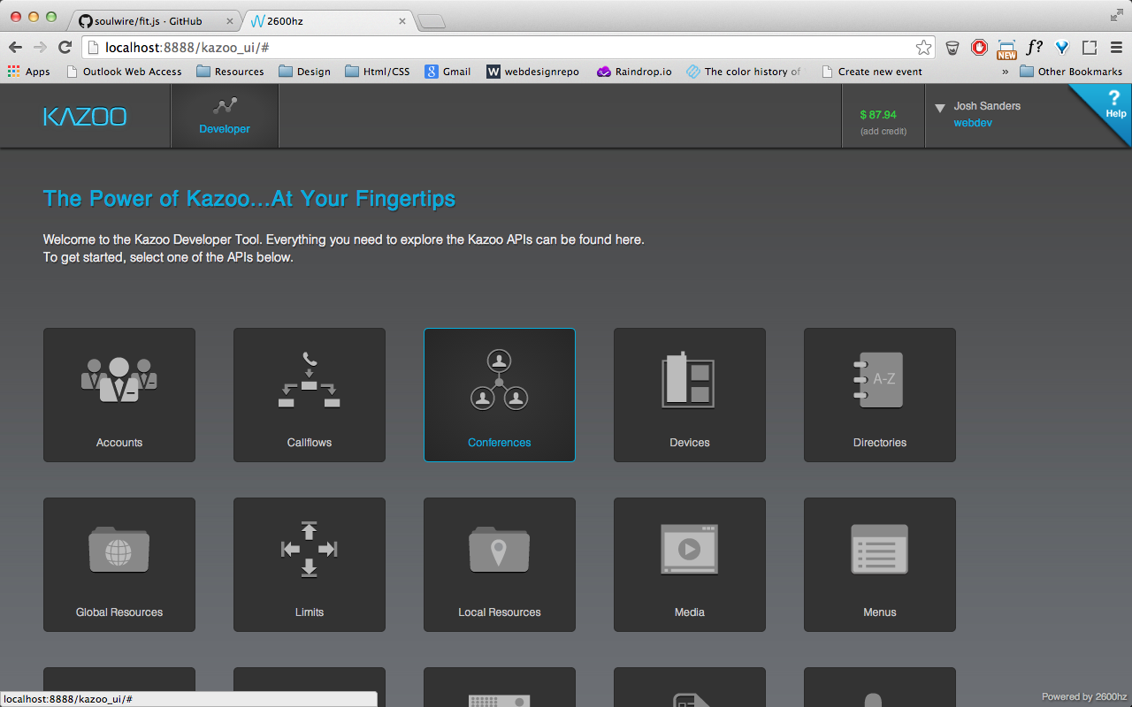

­– API credentials (key) need to be generated in order tor the user to be able to test out the APIs

**Currently there are 3 credentials given:

1. API URL
2. Account ID
3. Auth. Token

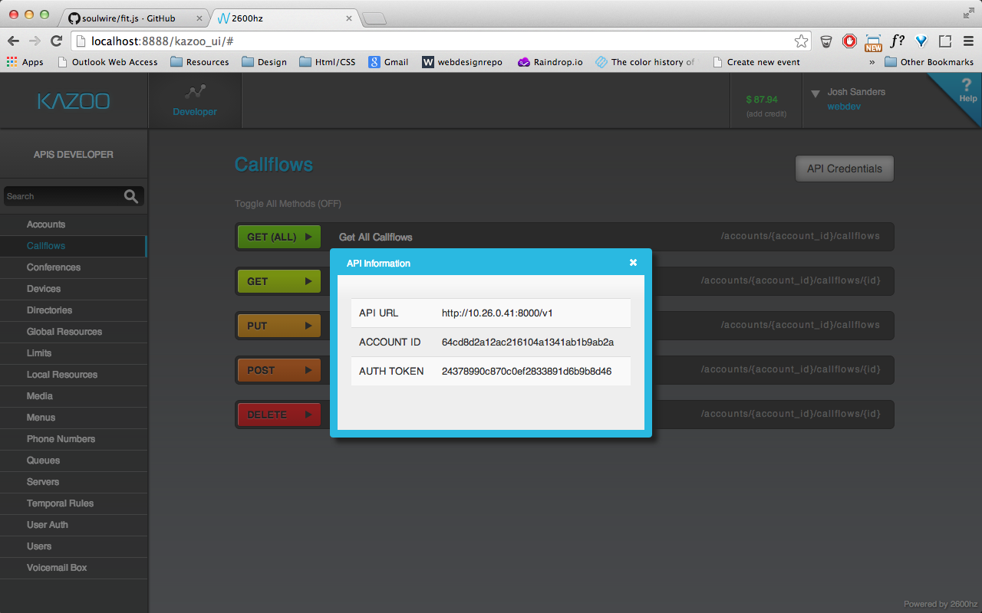

– after selecting an API to test, all request methods (GET ALL, GET, PUT, POST, DELETE) for that given API need to be presented

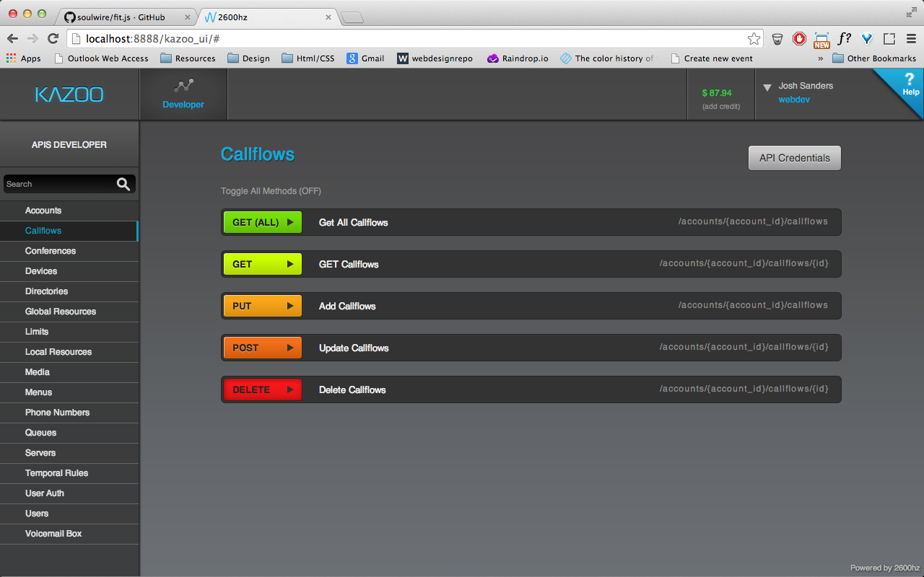

­ A) within each method presented, there is a short description and the URL path

B) there needs to be the option to toggle all methods on/ off depending on what the user decides

– when user clicks on a specific request method, the information for that given

method request needs to be presented in a clear and concise manner

This information is currently a table with the following info:

- Parameter

- Value

- Type

- Description

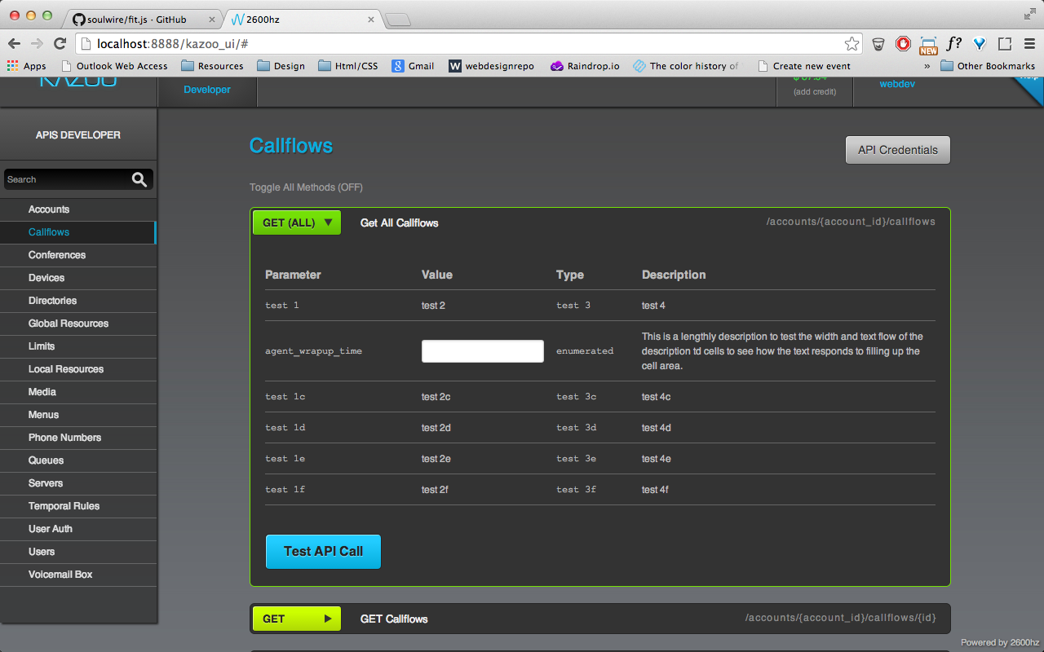

– Within each specific request method—directly following the list of parameters and options—there is a ‘Test API Call’ button that simulates the API call. This will display another set of information, including:

- Request URL

- Response code

- Response Headers

- Response Body

- Sample Code

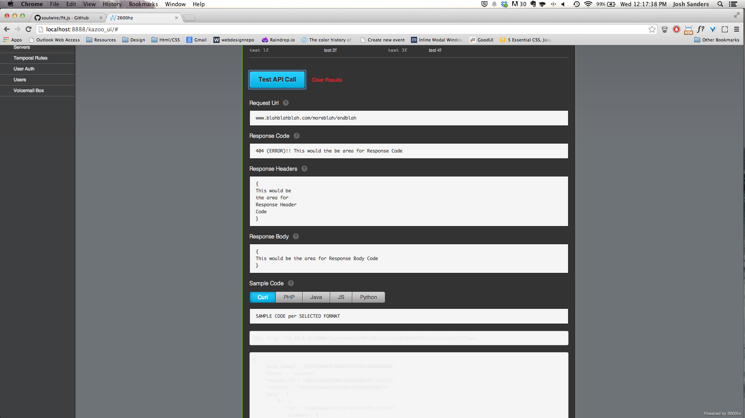

A) Once the ‘Test API Call’ button is clicked and the test call returns the information listed above, there is a ‘Clear Results’ button that clears the test info and allows the user to test another API call with perhaps a different selection of parameters

– Within the Sample Code section, there should be toggles that allow the sample code to be displayed in different coding languages, including:

- Curl

- PHP

- Java

- JavaScript

- Python

**What’s Still Needed/ Incomplete**

– Once a specific API is selected and the user has chosen a specific request method (GET ALL, GET, PUT, POST, DELETE) within that API to test, the table that displays the information/ parameters for that API request needs to be populated with actual content (right now its just placeholder copy).

– Currently, the information from the simulated API call is displayed right away, but should be hidden until the ‘Test API Call’ button is pressed.

– Once the ‘Test API Call’ button is clicked, the simulated test call information should be populated with actual content (REQUEST URL, RESPONSE BODY, RESPONSE HEADERS, and RESPONSE BODY). Currently they are just populated with placeholder/ descriptive text.

– The Sample Code section that contains the toggle buttons for viewing the sample code in different languages needs to have the intended functionality put in place. Currently the only sample code format displayed is Curl.

– Re-skin (visual design) the tool once functionality is complete, so that it matches the visual style of the new Monster UI and can live inside Monster as another App that is available for users.