Congratulation! You got your report generated and that is an explaination graph for you

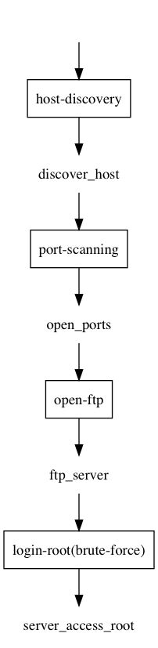

|  |  |  |
| --- | --- | --- |
| 1 | host-discovery | this is host discovery |
| 3 | open-ftp | this is ftp |
| 4 | directory-traversal | this is directory traversal |
| 5 | login-root(brute-force) | brute force for root |
| 6 | open-ssh | this is ssh port22 |

Instructions to how to use the virtual machine