Paper Template for ICMC2016
Audra Searcy
Sophomore
Audra.searcy@umconnect.umt.edu

ABSTRACT
I decided to dabble with a previous project and ended up being able to create a bubble like effect at the bottom of the page. That sparked the idea of creating an island with bubbles coming out from under it.

- Introduction
The idea of the bubble effect within my project came from the said previous project because I wanted to go off of a previous experiment and see what more I could do with it. From then on I wanted to see how I could change the colors or blend modes and see how they would look adjusting each one with a different effect or color. I finally came to an interesting pastel color that reminded me of the book, “The Rainbow Fish”, from my childhood mixed with a unicorn. In the end I figure an island would look interesting having bubbles come out from under it.
.
- Background
Your document should contain, at a minimum, the following sections;
- Background and/or Related Literature – This section/s might describe your background with the topic of your project, if appropriate. You also should discuss related work in this section. This will include work or artists that directly influenced your project/research. This section should also prove your knowledge about similar work that you may or may not have referenced during the creative/research process..
- References – You are expected to cite work throughout this document. These citations should be placed at the end of the document, following the format provided in this template.
  - Supporting Material
Please include images of your project, progress, etc. These should be referenced in the text of your document.
- Process
I took a previous assignment that had a class in it and messed around with the colors, blend modes, and where the x and y coordinates would stop at. I then added code from another assignment that looked cool together but I couldn’t figure out how to make it so that my function would either bounce off the box in the middle or that it would change colors once it entered the box. Because my function had a bunch of different objects along with different speeds and sizes I would have had to redo my entire code and hope that the outcome would still be the same. I just didn’t have time to try and mess around with it since I have 4 other projects to work on as well. The biggest issue was the time. Because code is so time consuming that you can spend 12 hours just trying to figure out what went wrong with your code. So I ended up being able to make these bubbles and decided that I would find something fun to put with it and add in sounds and whatnot as well to make it more interactive.
- Problems and Solutions
  - Pictures
I was unable to see the pictures that I embedded into my code. I tried multiple ways to go about putting my photo in my code, whether it be in the class.js or the sketch.js. I talked to one of my friends who is in the second level coding class and she told me how it was something wrong with PC’s that they block them. She told me to download this program to try to get through but that didn’t work for me either, saying that I didn’t have any servers to go to.

  - Solution
  - Sound
I had a problem with sound as well not working for me. I am not sure why but I just couldn’t figure out what was wrong, because even talking to my friend again she said I did everything right and she didn’t understand why it wasn’t working either.
  - Solution

- Findings or Discoveries
Throughout this semester and especially with this project I have realized that code is hit or miss with people. Either you get it and can flourish or you do not understand it at all and try to do the best you can even though it may not seem like it. I have learned that regardless of watching the video tutorials or being in class that I am one who does not understand code whatsoever. However I still learned a bit about code and how one can accomplish amazing things with coding and it gives me so much more respect towards those who do code.
  - Second Level Headings
Second level headings are in Times 10pt bold, flush left, with 1 line of space above the section head, and 1/2 space below it. The first letter of each significant word is capitalized.
    - Third and Further Level Headings
Third level headings are in Times 10pt italic, flush left, with 1/2 line of space above the section head, and 1/2 space below it. The first letter of each significant word is capitalized.
Using more than three levels of headings is strongly discouraged.
- Future Work

If you were to continue with this project, based on your results and findings, what would you do next? Or does this project suggest a need for further study down a different path?

I would try to create waves in the background to surround the island to make it come to life more. Then maybe see if there was a way to make it look like fish were jumping out of the water around the island, I could probable achieve that by adding a sprite to it. Then I could add birds flying as well, or make the mouse a bird and then make it so that if the bird (mouse) touches one of the fishes jumping out the fish will disappear making it look like the bird has eaten the fish. Giving it an animation plus it being interactive as well. Of course one would need to further their study to be able to understand how to do this affectively so that way they don’t run into errors or so that way one can know what is attainable and what isn’t.

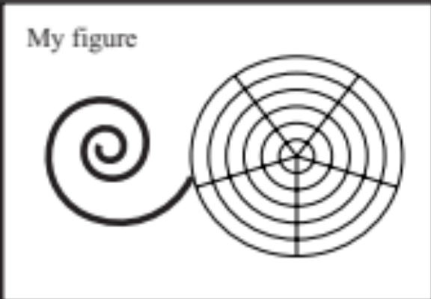
Figure 1. Figure captions should be placed below the figure, exactly like this. Please note that the printed proceedings will be black and white.
Always refer to tables and figures in the main text, for example: see Figure 1 and Table 1. Figures and tables may extend across both columns to a maximum width of 17.2cm.
Vectorial figures are preferred. For example when using Matlab, export using either Postscript or PDF format. Also, in order to optimize readability, the font size of text within a figure should be at list identical to footnote font size. If bitmap figures are used, please make sure that the resolution is enough for print quality.
  - Footnotes
Indicate footnotes with a number in the text. Use 8pt type for footnotes. Place the footnotes at the bottom of the page on which they appear. Precede the footnote with a 0.5pt horizontal rule.

- Citations
All bibliographical references should be listed at the end, inside a section named “REFERENCES”.
References must be numbered in order of appearance. Please avoid listing references that do not appear in the text.
Reference numbers should appear within square brackets, such as in [1] or [2, 3].
- Conclusions
This project was one of the most difficult and time consuming pieces I have had in this class. Along with having the most problems with this one as well.
- References
- A. Someone, B. Someone, and C. Someone, “The ti- tle of the journal paper,” J. New Music Research, vol. 111, no. 22, pp. 111–222, 2009.
- X. Someone and Y. Someone, The Title of the Book. Springer-Verlag, 2004.
- A. Someone, B. Someone, and C. Someone, “The Title of the Conference Paper,” Proceedings of the 2005 International Computer Music Conference, Barcelona, 2005, pp. 213-218.

This is a footnote.

