Audio Builders Workshop

Hosting a learn to solder build event

### Introduction

ABW currently has two learn to solder kits (metronome and low pass filter) that are intended to help people interested in DIY audio get a start with a simple project. To further make it easier for people ABW hosts learn to solder events to provide basic guidance to people.

This document is only meant as a guideline to assist in your own event planning; you should modify this as needed to meet the needs of your own event.

### About the audio builders workshop (ABW)

The ABW <https://www.audiobuildersworkshop.com/builds> is a working group of the Boston Chapter of Audio Engineering Society. The ABW promotes interest in electronics construction and design for applications with audio. In addition to kit building the ABW sponsors all day seminars on various technical topics related to audio and recording of audio. The Boston AES also runs shorter (1 to 2 hours) lectures, company visits, and networking events once or twice a month. All ABW and Boston AES events are free to attend, though there are materials fees for purchasing kits.

Many of the events are posted on the ABW You Tube channel, including a substantial back catalog of talks: https://www.youtube.com/audiobuildersworkshop

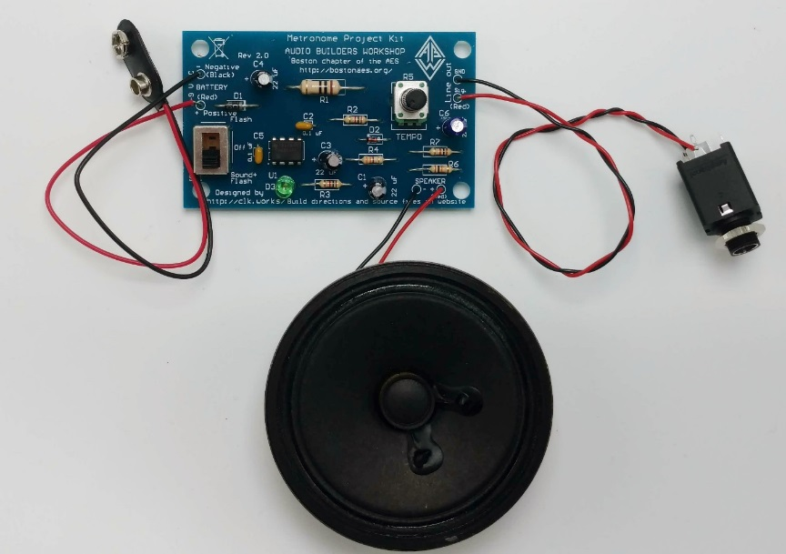

# Basics

ABW has held learn to solder events at a number of locations and with a range of participant skill levels, from people who have never touched a soldering iron through those that regularly solder and thought the kit was a fun idea to try.

We’ll let you decide how to advertise/promote the event, as well as determine how to pay for the kits and collect that from the attendees.

## Number of people per Session

It’s going to be limited by the number of soldering stations and the number of volunteers. A normal ABW build event can accommodate 10 people, though we’ve run them with 16 with some extra borrowed equipment.

We could imagine a practical upper limit is probably around a max of two dozen people.

## Event staffing

* Leader to outline the build process to attendees, make announcements, etc
* One assistant per 5 attendees. (i.e. for 10 people you have one leader and two helpers)

## The room

* Have good lighting. Hotel conference rooms can be lacking in this regard.
* Tables where accidents from hot solder, etc., won’t result in a bill.
* Power drops at each workstation.
* Enough space for the builders to spread out the build guide, tools, parts, etc.
* Good ventilation – the fumes from soldering flux are benign (it’s fundamentally tree sap) but you don’t want to breath the stuff

# Which kit?

The Metronome kit is the easier one and if this is the first time you’ve organized a build event we would suggest only doing that kit.

If you’ve done other events then you can give people the option of either the Metronome or the Filter kit.

The Filter kit does take longer than the Metronome, typically 15 to 30 minutes more.

The Metronome kit can be built in < 30 minutes by an experienced builder, but typically half the people finish in 90 minutes and about 95% are done in 2 hours.

Success rate is typically 90%+ with the Metronome kit, and the rest the mistake is located quickly.

# Equipment

We suggest using leaded solder as it’s so much easier to work with and repair than lead-free ones. However people should take all the usual precautions.

Use no-clean solder. It may not look pretty but it means there’s no need to try and clean the boards.

We’ve seen soldering irons fail and tools break so a spare set is probably a good idea.

## For each attendee

Basics:

* Soldering iron with controllable temperature. Make sure the tips are in good shape. Low wattage (< 20W) ones may be a problem for soldering on to the larger items. OTOH large irons will probably overheat things
* Solder sponge or pad for cleaning
* Needle nose pliers
* Diagonal wire cutters
* Wire stripper
* Dish for parts (a paper plate works well)
* The kit with battery
* The Learn to Solder comic (black and white)
* The build directions (color) in a 3 ring binder (so it lays flat)
* Solder 67/37 no clean flux

Optional

* Third hand
* Magnifier

## For the host

* Desoldering station (optional, but really helpful)
* Solderwick
* Meter
* Small scope (optional, but helpful if some board is acting really whacky)
* Hand tools
* Hot melt gun with glue sticks
* Extra anti-static bags
* Electrical tape
* Extra wire
* Extra parts in case a kit is short or parts get damaged/dropped etc
* Spare batteries
* Audio cables and adapters (for testing filter kit)
* Powered speaker (for testing filter kit)
* Signal source (for testing filter kit)
* (optional) scrap PCB and parts for demonstrating soldering
* A built up kit to show people
* Schematic (yeah the design is obvious but if someone’s board isn’t working this is helpful)

# Before the event

* Organize the workstation materials. Test that the irons heats up.
* Organize the host materials.
* It’s not a bad idea for the volunteers to build the kit so they understand the specifics of the build directions, etc.

# Day of

Allow at least 30 minutes to get the workstations set up with the tools, etc. Recheck the soldering irons, tin the tips, but assuming they’re not auto-sleep then shut them off.

People that arrive early should review the Solder comic and the kit build directions.

# Ready, Set, …

* Tell people to review the entire solder and build guides so they know where they are trying to end up.
* Demonstrate tip tinning and cleaning.
* Ask attendees to leave the irons off until they’re ready to begin, and if they leave for a break to shut them off
* Avoid the solder fumes.
* Caution about trimming leads and flying wires.
* Caution about washing hands after handling solder.
* Anyone who hasn’t soldered before should be identified. After reading the solder comic offer to have a volunteer show them inserting a part, soldering, and trim a lead on a scrap board/parts (if available) or on the kit. Review the attendees first connection.
* Tell them the build guide follows the “low to high parts” principal of kit construction – larger/more complex kits will probably do things by sections, etc.
* The build guide has detailed directions so point people to page 1 and tell them to ask questions if they feel stuck. We’ve found that even a first time builder may only ask 2 or 3 questions.
* If they’re uncertain on polarized parts encourage them to ask BEFORE they solder them in.
* Tell them not to apply power until one of the volunteers can double check the board.
* Show them a finished kit(s) in operation
* Point out that the wires will need strain relief and there’s a hot melt gun available after they have tested their board.
* Let them know where they can find the build guide and design on-line

We have found that even people that have never soldered do not need “practice” on a dummy board - we have them start right in on the kit. We only suggest the dummy parts for the volunteer to demonstrate with so that the person’s kit doesn’t have to be used.

# The good stuff

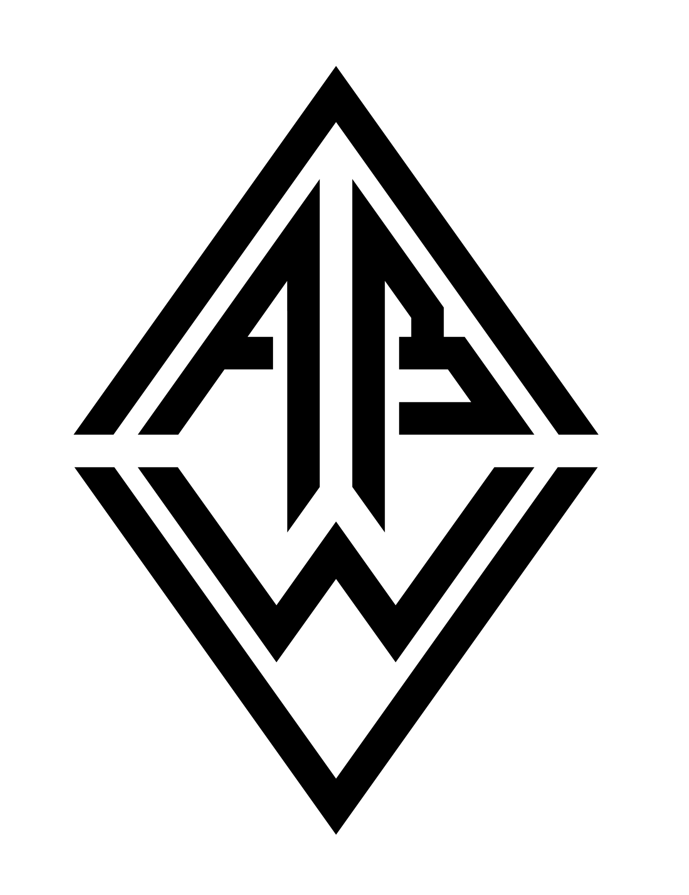This document and all of the source files associated with this project are Copyright 2018 by the Audio Builders Workshop (ABW).

<https://www.facebook.com/groups/AudioBuildersWorkshop/>

a working group of the Boston AES

<http://bostonaes.org/>

All materials are licensed by the ABW under the Creative Commons Attribution-Share-Alike license CC-BY-SA: <https://creativecommons.org/licenses/by-sa/4.0/legalcode>

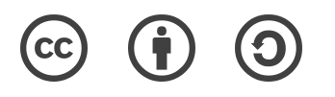

Design and documentation developed by Clockworks Signal Processing LLC for ABW.

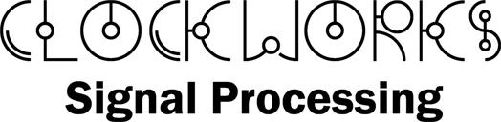

<http://clk.works/>