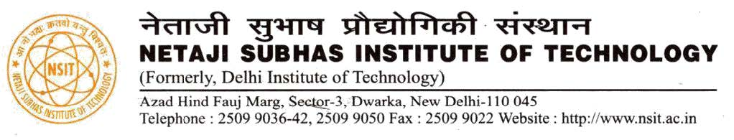

**CERTIFICATE**

The project titled “**Spoken Language Identification using Neural Networks**” by

**Aditya Jain (210/CO/13), Anmol Pandey (233/CO/12) and Anmol Varshney (234/CO/12)** is a record of bona fide work carried out by us, in the Division of Computer Engineering, Netaji Subhas Institute of Technology, New Delhi, under the supervision and guidance of **Dr. Shampa Chakraverty** in partial fulfilment of requirement for the award of the degree of Bachelor of Engineering in Computer Engineering, University of Delhi in the academic year 2016 - 2017.

**Dr. Shampa Chakraverty**

Prof. and Head of Department

Computer Engineering Department

Netaji Subhas Institute of Technology

New Delhi

Date: ___________________