Q1. Part a

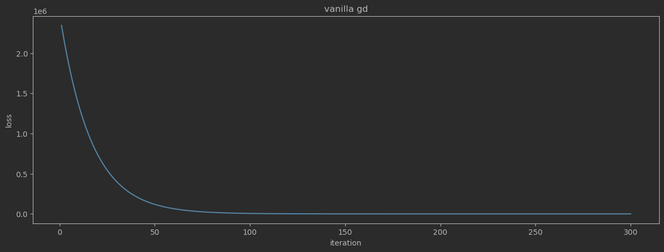

Part b

2.

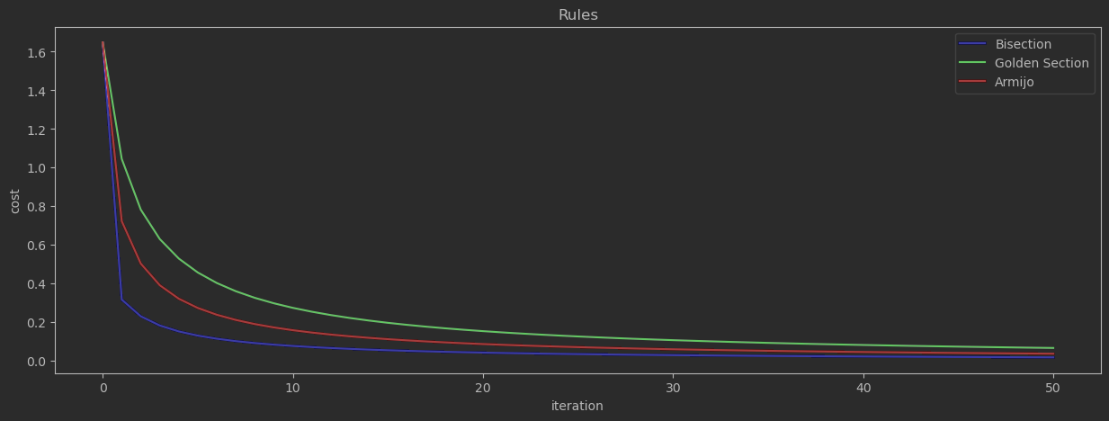

3.

