Quantitative Research Methods – Assignment #4 (Exploratory Factor Analysis and Reliability Analysis)

For this guided portion, we are using SAQ.sav data set available on Canvas. In order to run the EFA analysis, go to Analyze à Dimension Reduction à Factor. Then, parameterize SPSS as follows. Select all variables and move them into the Variables box:

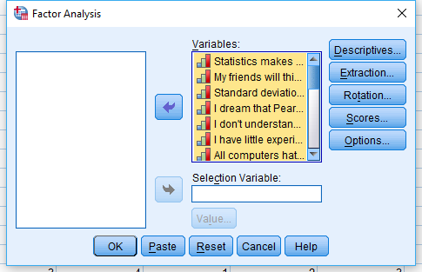

Select all options under the Descriptives button:

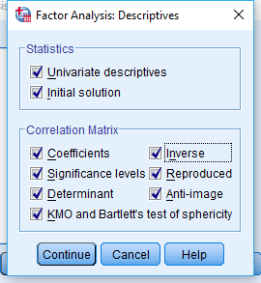

Under the Extraction button select Principal axis factoring as the extraction method, and check the Scree plot box:

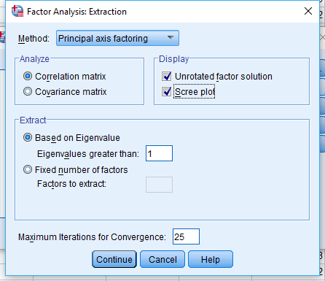

Under Rotation select either Varimax or Direct Oblimin, depending on which one you want to run (only one per run of each analysis):

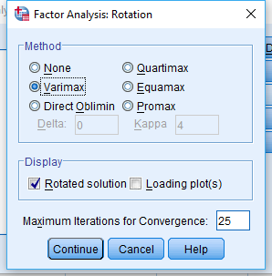

Under Options check Sorted by Size (aids in the interpretation of the loadings) and change the value to .3 (.4 is also commonly used, but not higher than that; this will omit small loadings from showing in the final results):

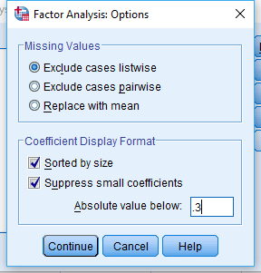

Then run the EFA analysis.

As usual, we start with some descriptive statistics about each of the variables (here you could also look into their distribution with histograms, boxplots, normality tests, etc. as well):

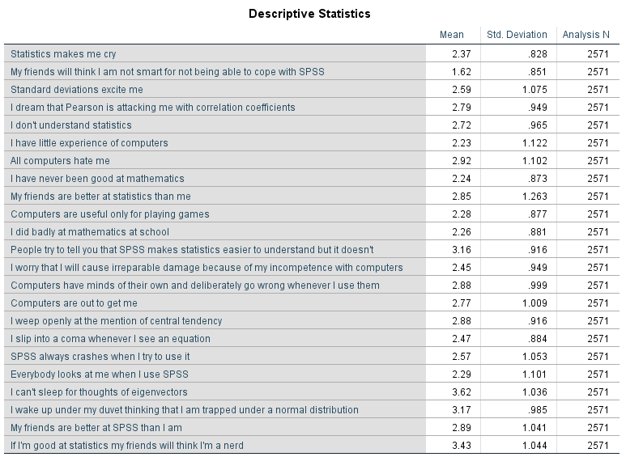

The Kaiser-Meyer-Olkin (KMO) is a measure of sampling adequacy. Specifically, it represents the ratio of the squared correlation between variables to the squared partial correlation between variables. The KMO statistic varies between 0 and 1. A value of 0 indicates that the sum of partial correlations is large relative to the sum of correlations, indicating diffusion in the pattern of correlations (hence, factor analysis is likely to be inappropriate). A value close to 1 indicates that patterns of correlations are relatively compact and so factor analysis should yield distinct and reliable factors. Bartlett’s test tells us whether our correlation matrix is significantly different from an identity matrix (one where the diagonal is all 1s and all other off-diagonal elements are 0s). If it is significant then it means that the correlations between variables are (overall) significantly different from zero. As this test tends to be significant (which is what you want) in any reasonably large samples, it is not very informative (unless it is not significant, in which case there is something very wrong with your data).

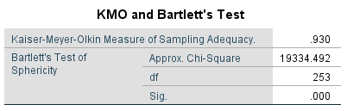

The KMO values for individual variables are produced in the diagonal of the anti-image correlation matrix. We want to check that the diagonal elements of the anti-image matrix are above the bare minimum of 0.5 (and preferably higher). If you find variables below 0.5 you should consider excluding them from the analysis (or run your analysis with and without them and see if it makes much of a difference). Removal of a variable affects the KMO statistics, so any change to the variable list requires rerunning the analyses. The off-diagonal elements of the anti-image correlation matrix are the partial correlations between variables; ideally, we want these to be very small (the smaller the better).

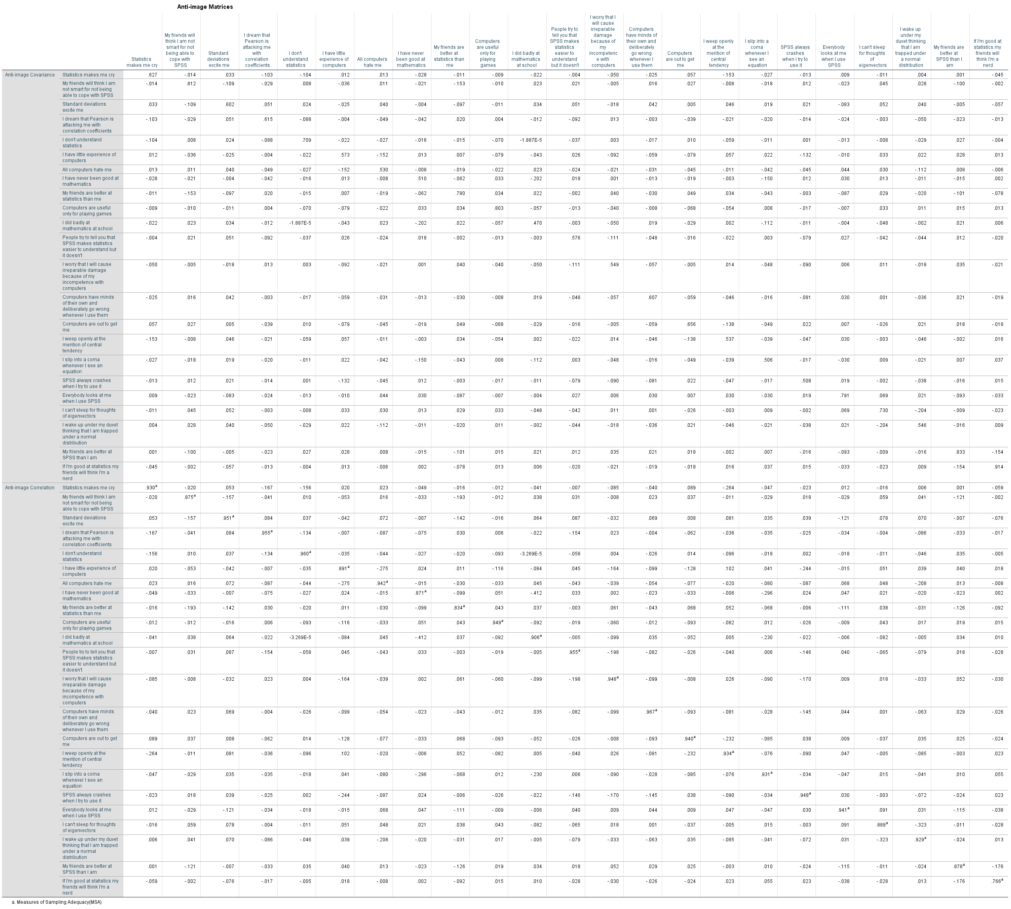

Next, we look at the correlations table for the individual items. Here we are looking for variables that are not correlated to anything (most correlations less than .3) or that are too strongly correlated (e.g., correlations above .9), which may be indicative of multicollinearity (and will cause trouble for the analysis). Multicollinearity can also be detected by looking at the determinant of the correlation matrix (produced at the bottom of the matrix by SPSS). A heuristic is that it should be greater than .00001.

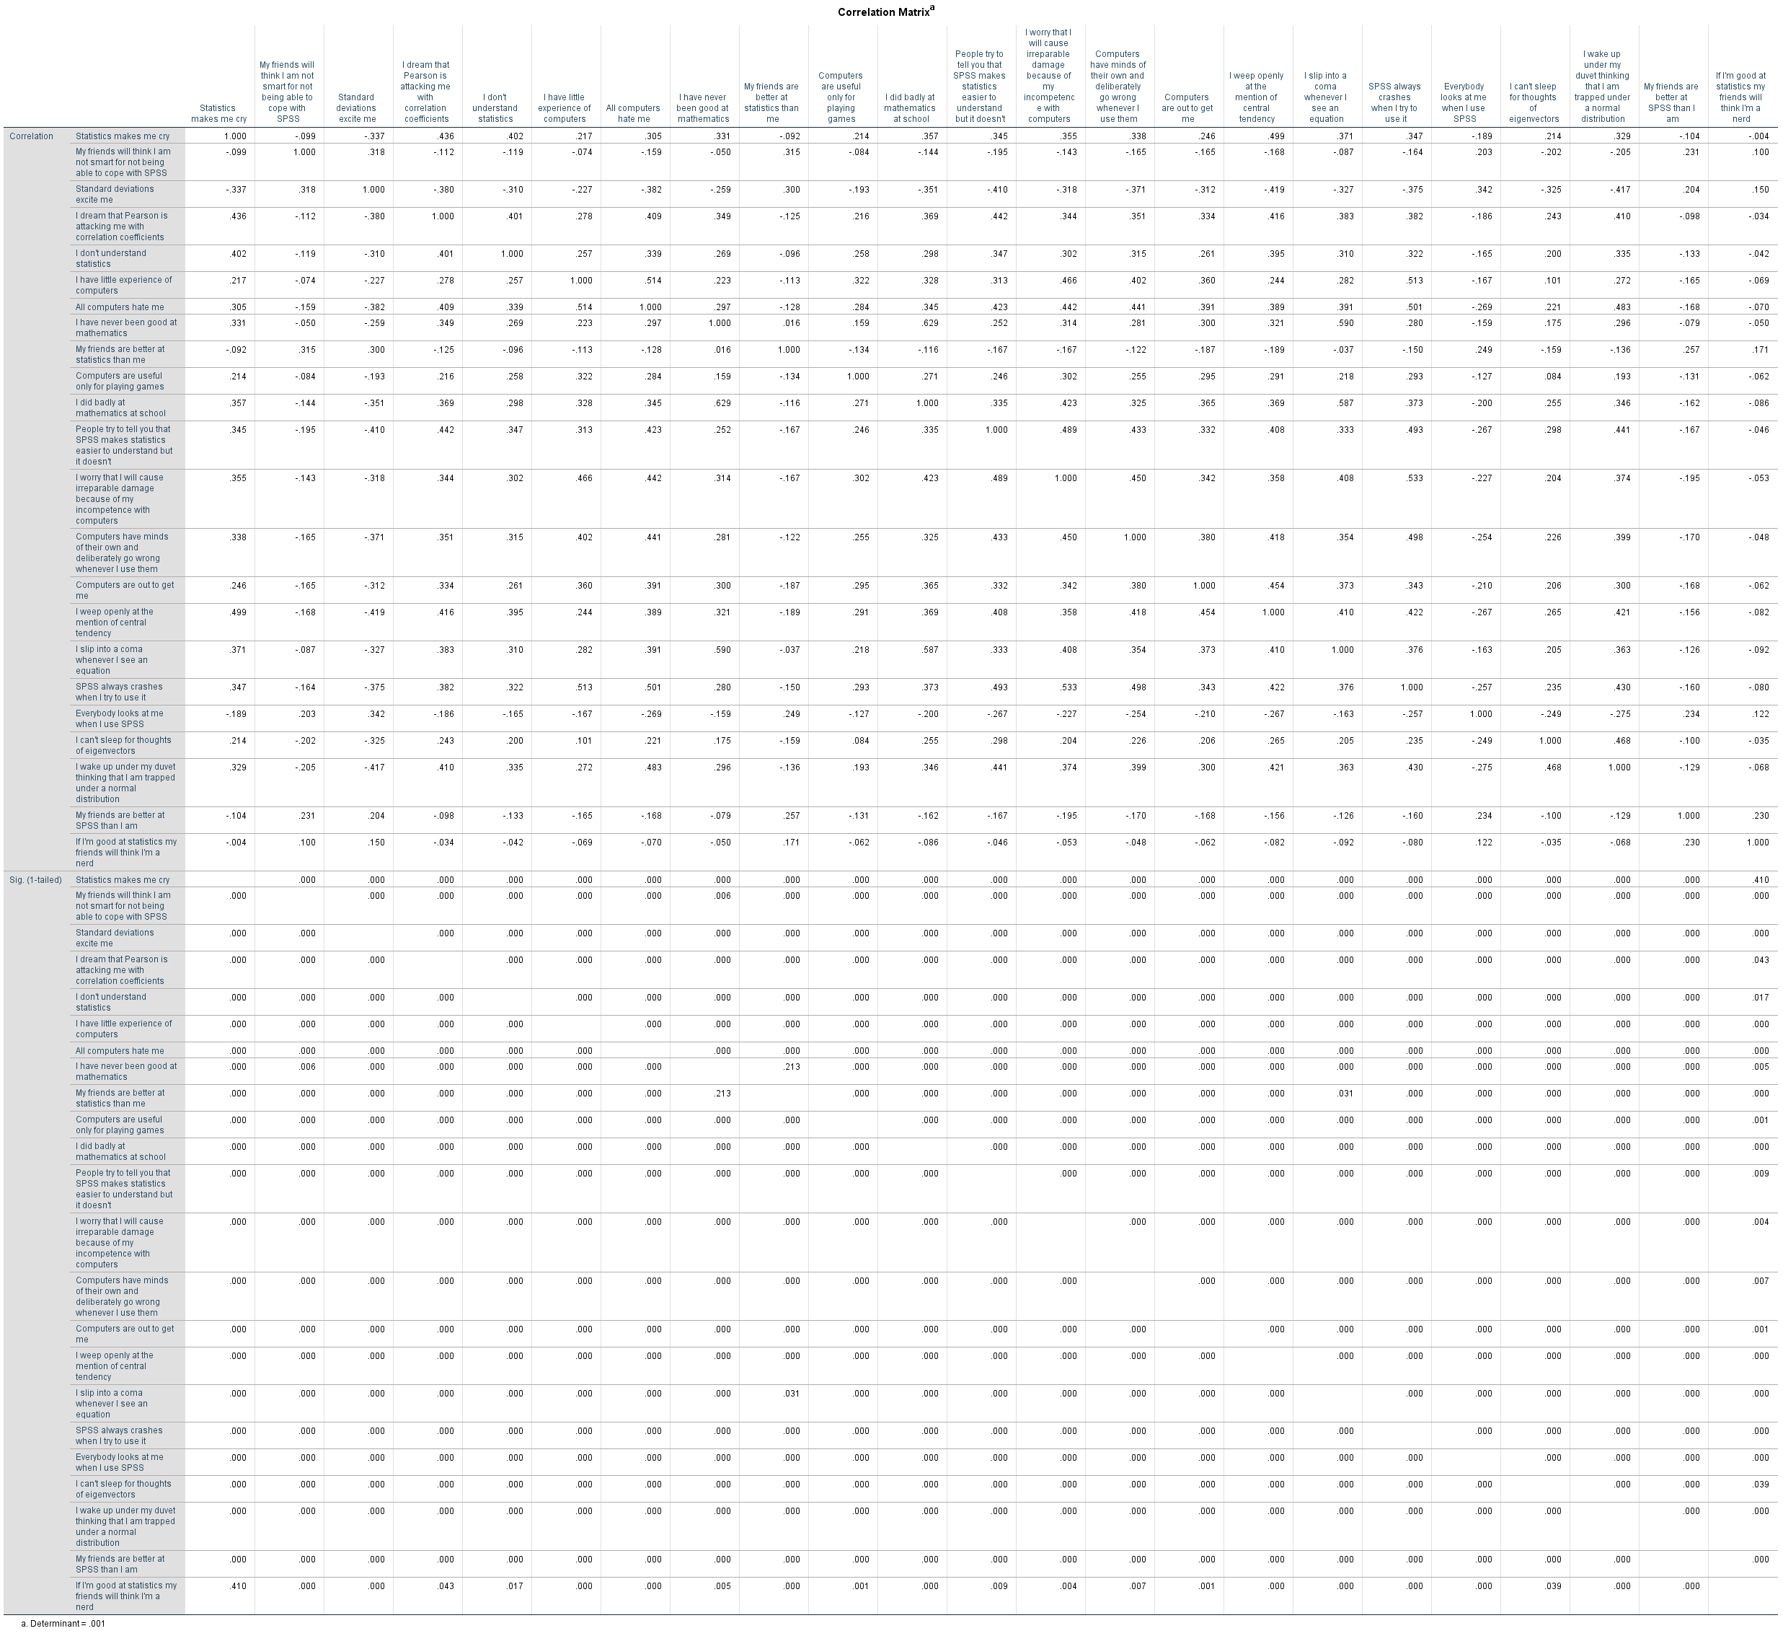

The decision of how many factors to extract is a critical one in this process. There are a number of possible criteria; the most common are eigenvalues > 1 (the SPSS default), eigenvalues > .7 (a more liberal, but also much less common, criterion), the expected number of factors (if any), factors encompassing at least 50% of the variance in the sample, usage of a scree plot and its inflexion point, and a combination of these. The relevant outputs here are the Total Variance Explained table and the scree plot.

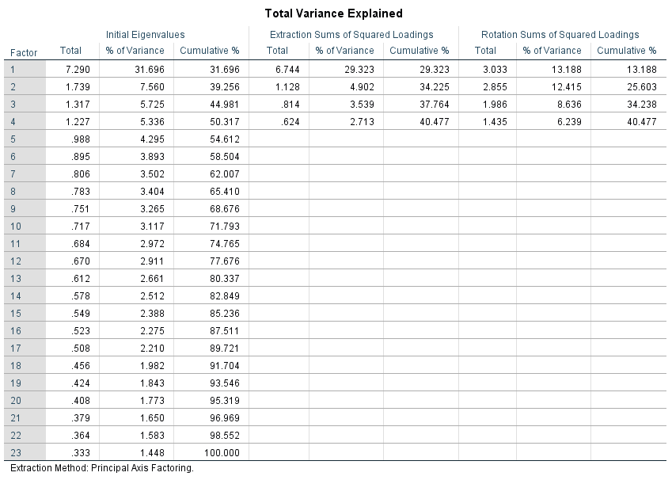

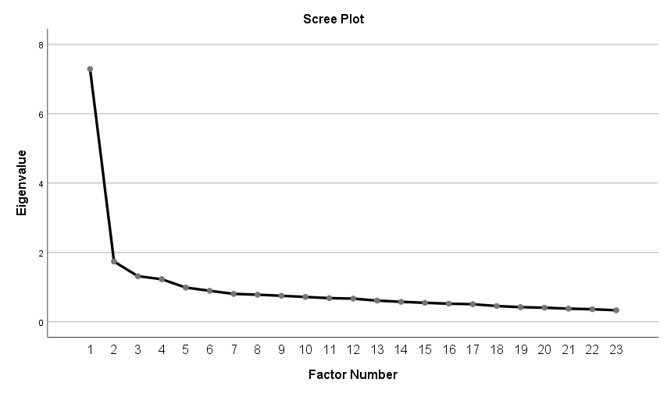

The table Reproduced Correlations shows the best estimate of the correlations between the variables based on the extracted factors. The bottom of the table shows the residual correlation, calculated as the original value for the correlation minus the best estimate from the top portion of the table. Ideally, we would want these residuals to be small, which would indicate that the best estimates implied by the model are close to the actual values. A rule of thumb here is that residuals less than .05 are desirable (the footnote to the table notes how many of these are there). There are no set rules for the percentage of residuals above .05 that would be considered problematic, but if those are, for example, more than half, then there are grounds for concern.

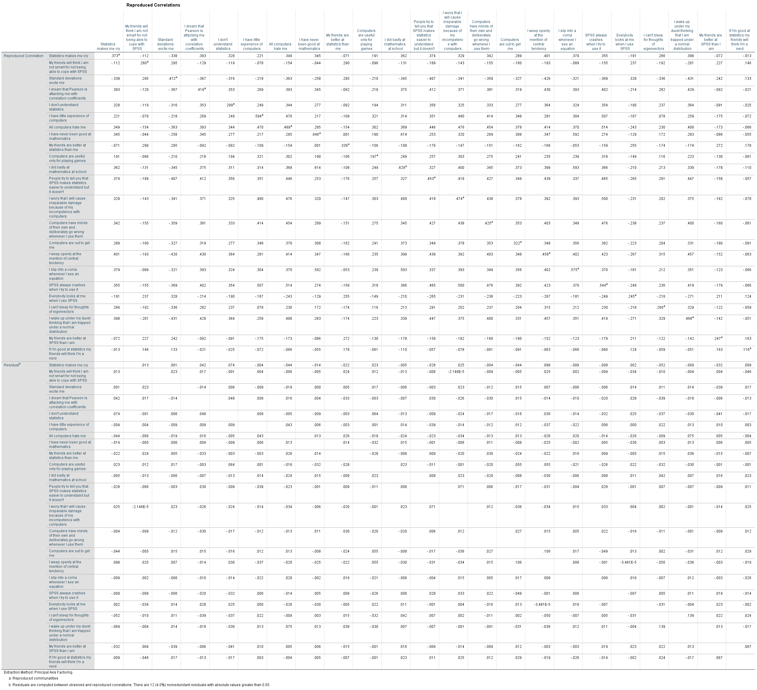

The rotation employed so far is the varimax option (which is a type of orthogonal rotation, where the underlying factors are uncorrelated). This produces the following table of loadings (note that loadings less than .3 have been omitted, as specified in the SPSS options above).

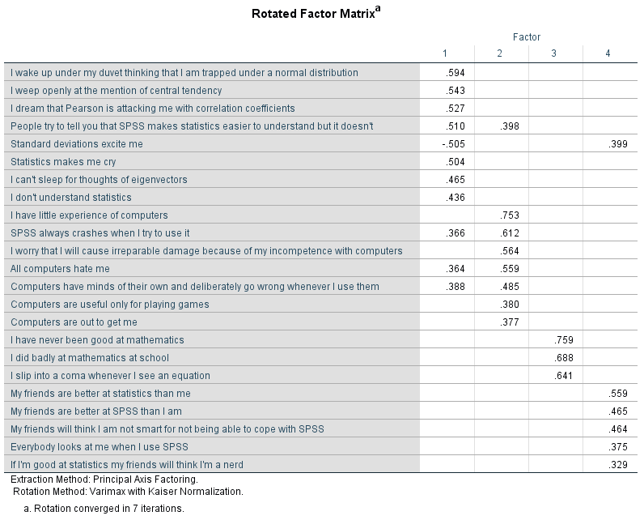

Rerunning the data with the direct oblimin option (which is a type of non-orthogonal rotation, where the underlying factors are allowed to be correlated) leads to the following table of loadings.

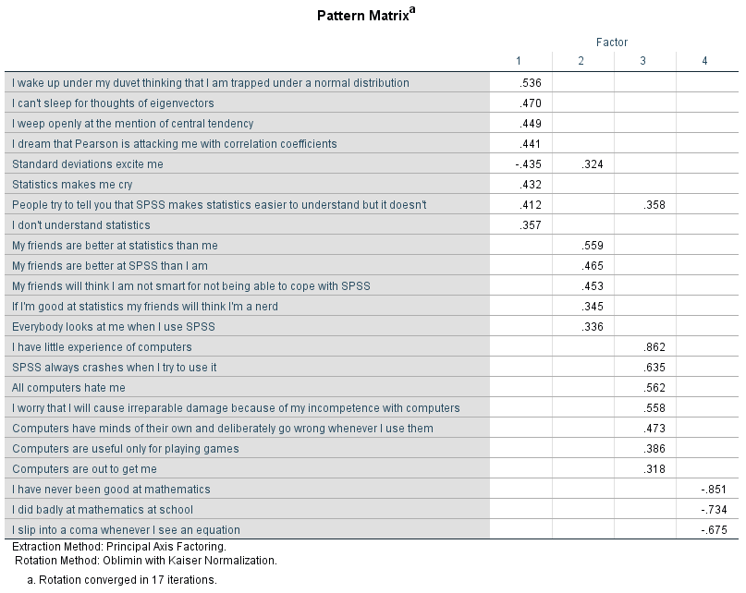

Which of these options is chosen and reported and used to determine which items are grouped into each subscale, is to some extent a matter of personal preference, combined with theoretical reasons for why one approach or the other would be more desirable. In this case, the results are not drastically different. As a result, we will group these variables into four scales (note that item numbers refer to the original item ordering):

#1: “Fear of statistics”: items 1, 3, 4, 5, 12, 16, 20, 21.
#2: “Peer evaluation”: items 2, 9, 19, 22, 23.
#3: “Fear of computers”: items 6, 7, 10, 13, 14, 15, 18.
#4: “Fear of mathematics”: items 8, 11, 17.

For the reliability analyses, please note that item 3 (“Standard deviations excite me”) has been reverse-coded so that its responses are in the same direction as all others in the scale (otherwise, the reliability analysis would be invalidated). The results of the analysis for each scale follows.

For the Reliability analyses go to Analyze à Scale à Reliability Analysis. There, select the variables into the subscale you are analyzing and move them into the Items box. You can also give the scale a meaningful name (“Fear of Math”). Under Statistics check the box Scale if item deleted:

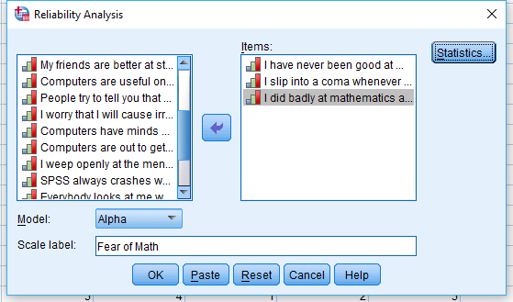

Fear of Statistics

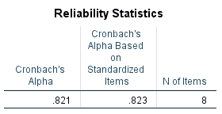
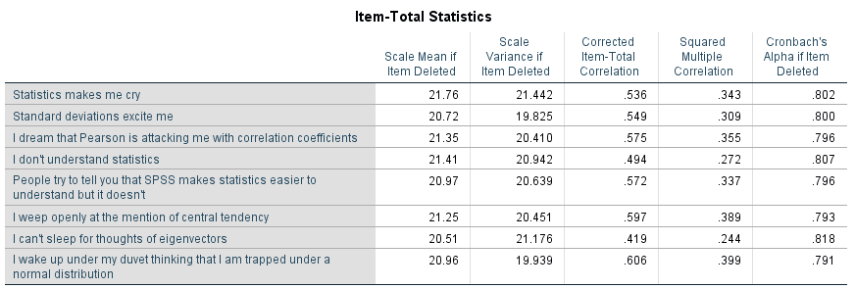

Peer Evaluation

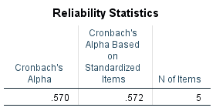
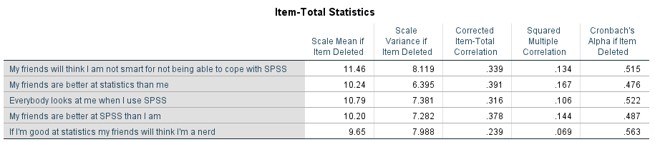

Fear of Computers

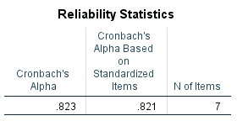
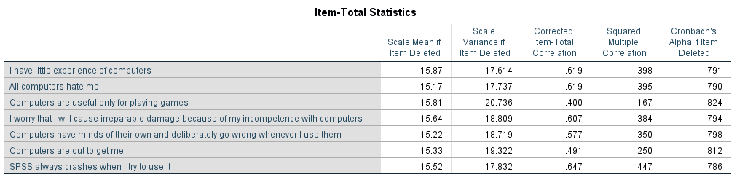

Fear of Mathematics

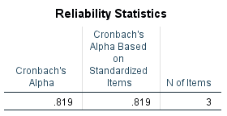
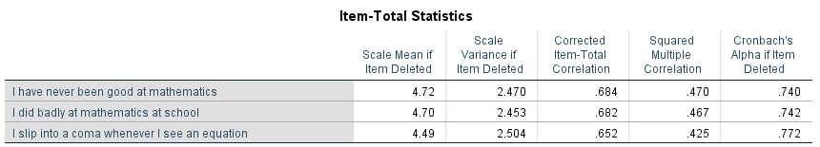

A principal axis factor analysis (FA) was conducted on the 23 items with oblique rotation (direct oblimin). The Kaiser-Meyer-Olkin measure verified the sampling adequacy for the analysis, KMO = .93 (‘marvelous’ according to Kaiser and Rice, 1974), and all KMO values for individual items were greater than .77, which is well above the acceptable limit of .50. An initial analysis was run to obtain eigenvalues for each factor in the data. Four factors had eigenvalues over Kaiser’s criterion of 1 and in combination explained 50.32% of the variance. The scree plot was ambiguous and showed inflexions that would justify retaining both two and four factors. We retained four factors because of the large sample size and the convergence of the scree plot and Kaiser’s criterion on this value. The table above shows the factor loadings after rotation [note: this table is the main one that should always be reported in an EFA]. The items that cluster on the same factor suggest that factor 1 represents fear of statistics, factor 2 represents peer evaluation concerns, factor 3 a fear of computers and factor 4 a fear of math. The fear of computers, fear of statistics, and fear of math subscales all had high reliabilities, with all Cronbach’s alphas = .82. However, the fear of negative peer evaluation subscale had relatively low reliability, Cronbach’s alpha = .57.

