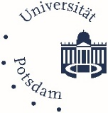

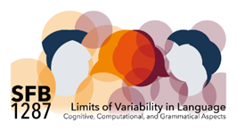

**Post- Doc position in the SFB 1287 “Limits of Variability in Language”   
(Project B05)**

## The SFB–project B05 “[(Limits of) variability in speech planning”](https://www.sfb1287.uni-potsdam.de/en/project-b05/) within the DFG funded project “[SFB 1287 - Variability in language”](https://www.uni-potsdam.de/en/sfb1287/index) at the University of Potsdam, Germany, is recruiting a Post-doctoral researcher (f/m/d) for a full time position (40 hours per week; TVL 13), for a period of 11 months (preferred starting date: 01.07.2024 or as soon as possible thereafter). The end of the contract is defined by the end of the funding period of the first phase of the SFB (30.06.2025). An extension may be possible.

We are looking for a highly motivated candidate with a background in psycholinguistics, experimental linguistics, or experimental psychology (Ph.D. in Psychology, Cognitive Science, or Linguistics). The ideal candidate has expertise in experimental data analysis and excellent written communication skills in English. Programming skills (e.g., Python, Matlab) are a plus.

The candidate will work on a project investigating the links between language planning and available cognitive resources across the life span using a driving simulator and eyetracker. His/her tasks will include: Writing and editing of journal articles, statistical analyses of existing data, collection, pre-processing and statistical analyses of novel experimental data.

The candidate will also become a member of the Research Group Cognitive Science: Methods and Language (CSML) led by A. Bürki.

Applications including CV, cover letter, PhD thesis or two published articles, two letters of recommendation to be sent by email to buerki@uni-potsdam.de by May 15th 2024.

You can find more information about working at the University of Potsdam at https://www.uni-potsdam.de/de/arbeiten-an-der-up/arbeitgeberin/uebersicht.  
The University of Potsdam values the diversity of its community and pursues the goals of equal opportunity regardless of gender, nationality, ethnic and social origin, religion/belief, disability, age, and sexual orientation and identity.

Contact for further questions and your application is: Audrey Bürki (buerki@uni-potsdam.de)

(Audrey Bürki)