Diamond Prices Part 1

Audrey Ekuban

6 March 2016

library(ggplot2)  
data("diamonds")  
summary(diamonds)

## carat cut color clarity   
## Min. :0.2000 Fair : 1610 D: 6775 SI1 :13065   
## 1st Qu.:0.4000 Good : 4906 E: 9797 VS2 :12258   
## Median :0.7000 Very Good:12082 F: 9542 SI2 : 9194   
## Mean :0.7979 Premium :13791 G:11292 VS1 : 8171   
## 3rd Qu.:1.0400 Ideal :21551 H: 8304 VVS2 : 5066   
## Max. :5.0100 I: 5422 VVS1 : 3655   
## J: 2808 (Other): 2531   
## depth table price x   
## Min. :43.00 Min. :43.00 Min. : 326 Min. : 0.000   
## 1st Qu.:61.00 1st Qu.:56.00 1st Qu.: 950 1st Qu.: 4.710   
## Median :61.80 Median :57.00 Median : 2401 Median : 5.700   
## Mean :61.75 Mean :57.46 Mean : 3933 Mean : 5.731   
## 3rd Qu.:62.50 3rd Qu.:59.00 3rd Qu.: 5324 3rd Qu.: 6.540   
## Max. :79.00 Max. :95.00 Max. :18823 Max. :10.740   
##   
## y z   
## Min. : 0.000 Min. : 0.000   
## 1st Qu.: 4.720 1st Qu.: 2.910   
## Median : 5.710 Median : 3.530   
## Mean : 5.735 Mean : 3.539   
## 3rd Qu.: 6.540 3rd Qu.: 4.040   
## Max. :58.900 Max. :31.800   
##

str(diamonds)

## 'data.frame': 53940 obs. of 10 variables:  
## $ carat : num 0.23 0.21 0.23 0.29 0.31 0.24 0.24 0.26 0.22 0.23 ...  
## $ cut : Ord.factor w/ 5 levels "Fair"<"Good"<..: 5 4 2 4 2 3 3 3 1 3 ...  
## $ color : Ord.factor w/ 7 levels "D"<"E"<"F"<"G"<..: 2 2 2 6 7 7 6 5 2 5 ...  
## $ clarity: Ord.factor w/ 8 levels "I1"<"SI2"<"SI1"<..: 2 3 5 4 2 6 7 3 4 5 ...  
## $ depth : num 61.5 59.8 56.9 62.4 63.3 62.8 62.3 61.9 65.1 59.4 ...  
## $ table : num 55 61 65 58 58 57 57 55 61 61 ...  
## $ price : int 326 326 327 334 335 336 336 337 337 338 ...  
## $ x : num 3.95 3.89 4.05 4.2 4.34 3.94 3.95 4.07 3.87 4 ...  
## $ y : num 3.98 3.84 4.07 4.23 4.35 3.96 3.98 4.11 3.78 4.05 ...  
## $ z : num 2.43 2.31 2.31 2.63 2.75 2.48 2.47 2.53 2.49 2.39 ...

#?diamonds

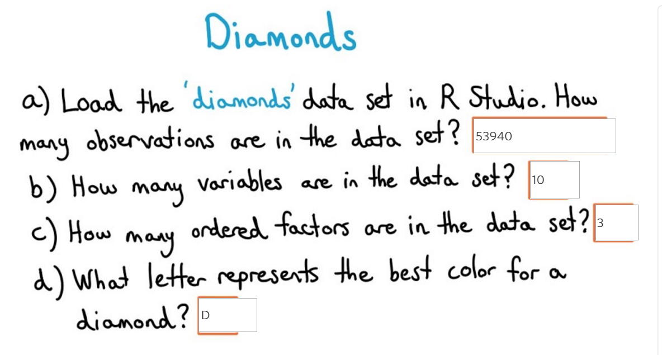

ggplot(aes(x = price), data = diamonds) +   
 geom_histogram(binwidth = 500, aes(x=diamonds$price)) +  
 ggtitle("Diamond Price Histogram") +   
 xlab("Diamond Price U$") +   
 ylab("Frequency")

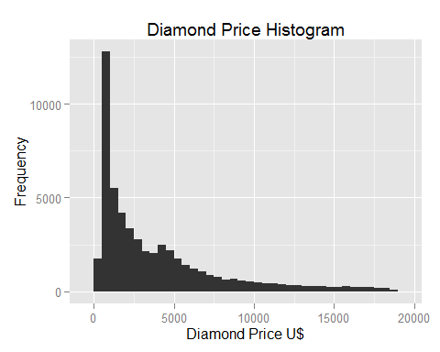

Plot is long tailed.

summary(diamonds$price)

## Min. 1st Qu. Median Mean 3rd Qu. Max.   
## 326 950 2401 3933 5324 18820

mean(diamonds$price)

## [1] 3932.8

median(diamonds$price)

## [1] 2401

sum(diamonds$price < 500)

## [1] 1729

sum(diamonds$price < 250)

## [1] 0

sum(diamonds$price >= 15000)

## [1] 1656

ggplot(aes(x = price), data = diamonds) +   
 geom_histogram(binwidth = 125, aes(x=diamonds$price)) +  
 ggtitle("Diamond Price Histogram") +   
 xlab("Diamond Price U$") +   
 ylab("Frequency") +  
 xlim(0,1250) +  
 scale_x_continuous(limits = c(0, 1250), breaks = seq(0, 1250, 125))

## Scale for 'x' is already present. Adding another scale for 'x', which will replace the existing scale.

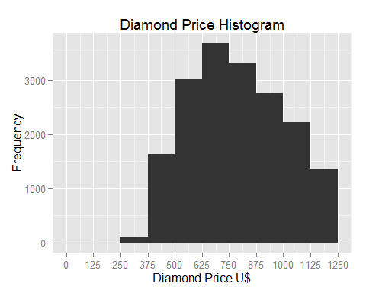

ggplot(aes(x = price), data = diamonds) +   
 geom_histogram(binwidth = 85, aes(x=diamonds$price)) +  
 ggtitle("Diamond Price Histogram") +   
 xlab("Diamond Price U$") +   
 ylab("Frequency") +  
 xlim(0,850) +  
 scale_x_continuous(limits = c(0, 850), breaks = seq(0, 850, 85))

## Scale for 'x' is already present. Adding another scale for 'x', which will replace the existing scale.

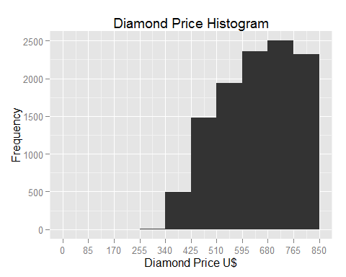

ggplot(aes(x = price), data = diamonds) +   
 geom_histogram(binwidth = 10, aes(x=diamonds$price)) +  
 ggtitle("Diamond Price Histogram") +   
 xlab("Diamond Price U$") +   
 ylab("Frequency") +  
 xlim(0,850) +  
 scale_x_continuous(limits = c(0, 850), breaks = seq(0, 850, 100))

## Scale for 'x' is already present. Adding another scale for 'x', which will replace the existing scale.

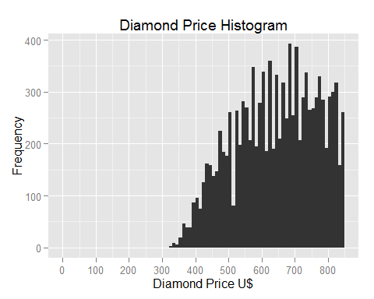

sum(diamonds$price < 500)

## [1] 1729

sum(diamonds$price < 250)

## [1] 0

sum(diamonds$price >= 15000)

## [1] 1656

ggplot(data=diamonds) + geom_histogram(binwidth=500, aes(x=diamonds$price)) +   
 ggtitle("Diamond Price Histogram by Cut") + xlab("Diamond Price U$") +  
 ylab("Frequency") + facet_wrap(~cut)

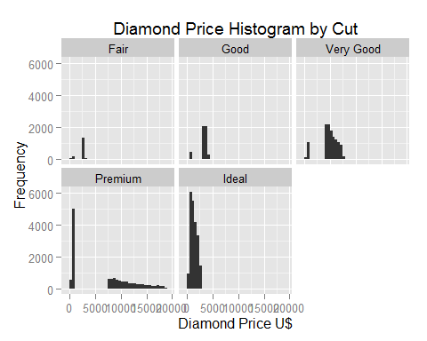

subset(diamonds, price == max(price))$cut

## [1] Premium  
## Levels: Fair < Good < Very Good < Premium < Ideal

subset(diamonds, price == min(price))$cut

## [1] Ideal Premium  
## Levels: Fair < Good < Very Good < Premium < Ideal

subset(diamonds, price == min(by(diamonds$price, diamonds$cut, median)))$cut

## [1] Ideal Ideal Ideal  
## Levels: Fair < Good < Very Good < Premium < Ideal

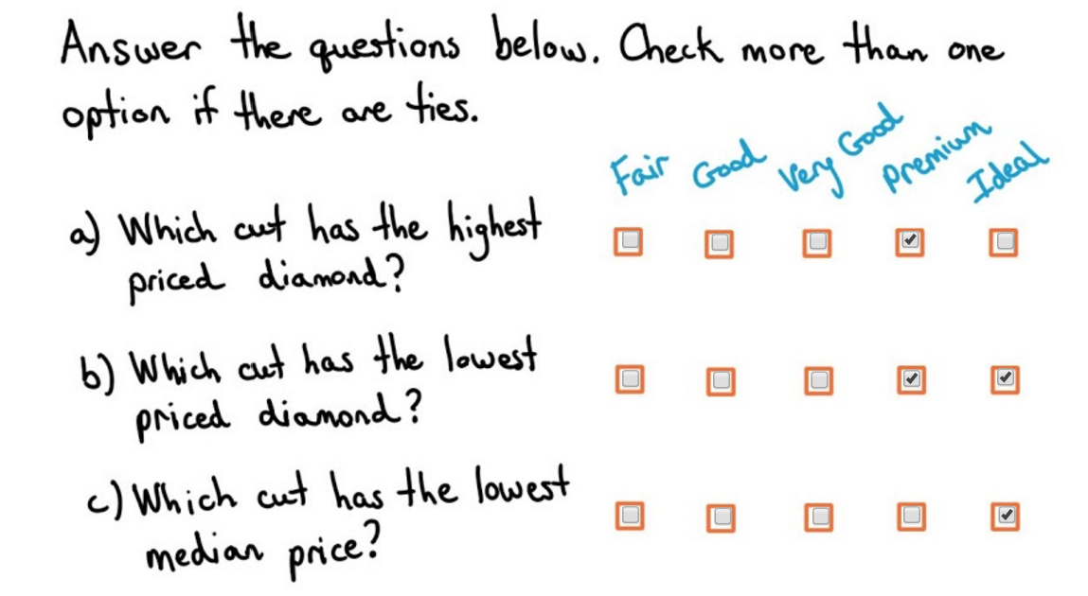

qplot(x = price, data = diamonds) +   
 facet_wrap(~cut, scales="free_y")

## stat_bin: binwidth defaulted to range/30. Use 'binwidth = x' to adjust this.  
## stat_bin: binwidth defaulted to range/30. Use 'binwidth = x' to adjust this.  
## stat_bin: binwidth defaulted to range/30. Use 'binwidth = x' to adjust this.  
## stat_bin: binwidth defaulted to range/30. Use 'binwidth = x' to adjust this.  
## stat_bin: binwidth defaulted to range/30. Use 'binwidth = x' to adjust this.

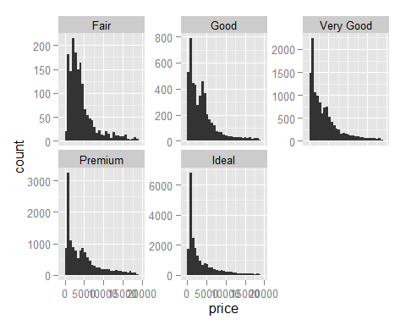

ggplot(aes(x = price), data = diamonds) +   
 geom_histogram(binwidth = 0.05, aes(x=diamonds$price/diamonds$carat)) +  
 ggtitle("Diamond Price per Carat Histogram") +   
 xlab("Diamond Price per Carat U$ - Log 10") +   
 ylab("Frequency") +  
 facet_wrap(~cut, scales="free_y") + scale_x_log10()

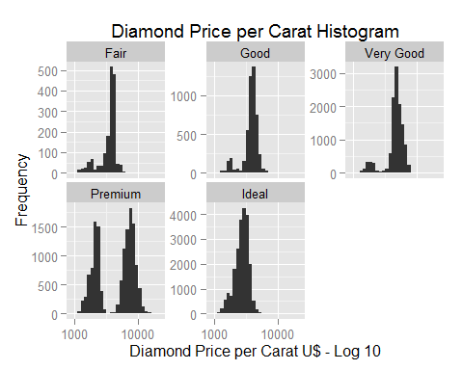

ggplot(aes(factor(cut), price, fill=cut), data = diamonds) +   
 geom_boxplot() +  
 ggtitle("Diamond Price / Cut Box Plot") +   
 xlab("Cut") +   
 ylab("Frequency") +  
 coord_cartesian(ylim=c(0,20000))

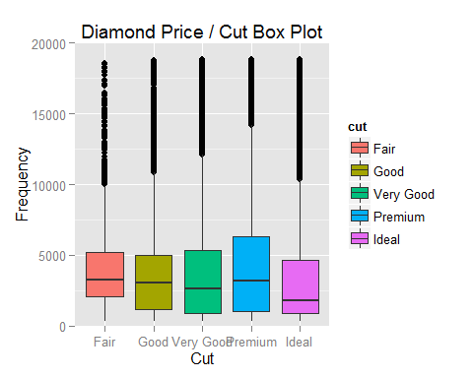

quantile(subset(diamonds, color == 'D')$price)

## 0% 25% 50% 75% 100%   
## 357.0 911.0 1838.0 4213.5 18693.0

quantile(subset(diamonds, color == 'J')$price)

## 0% 25% 50% 75% 100%   
## 335.0 1860.5 4234.0 7695.0 18710.0

IQR(subset(diamonds, color == 'D')$price)

## [1] 3302.5

IQR(subset(diamonds, color == 'J')$price)

## [1] 5834.5

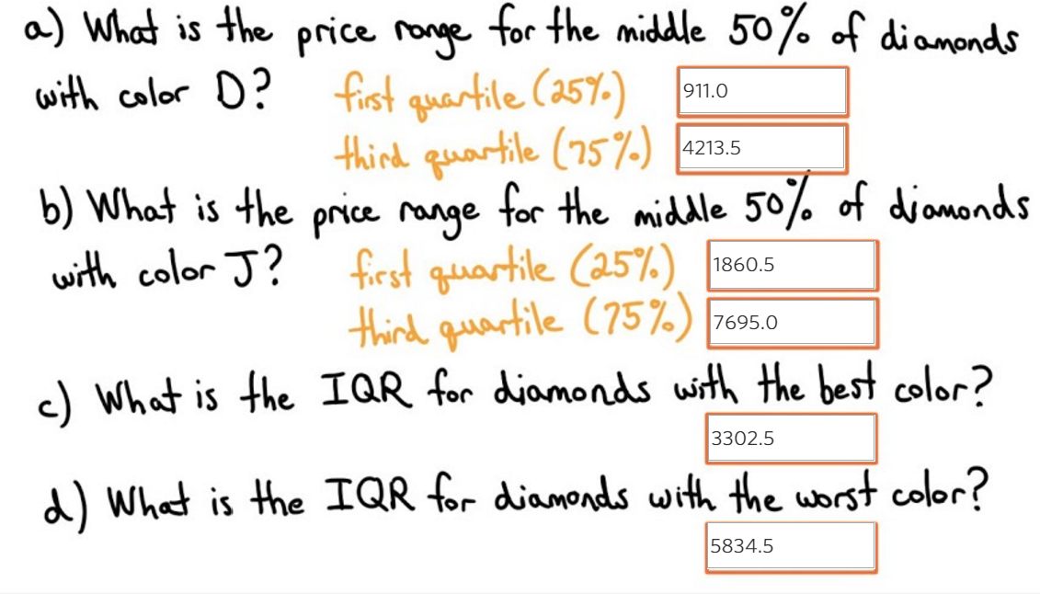

ggplot(aes(factor(color), price/carat, fill=color), data = diamonds) +   
 geom_boxplot() +  
 ggtitle("Diamond Price per Carat / Color Box Plot") +   
 xlab("Color") +   
 ylab("Frequency") +  
 coord_cartesian(ylim=c(0,15000))

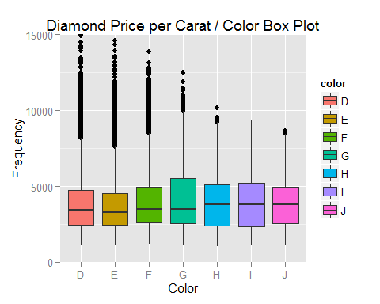

ggplot(aes(x = carat), data = diamonds) +   
 geom_freqpoly(binwidth = 0.01) +  
 ggtitle("Diamond Carat Frequency") +   
 xlab("Diamond Carat") +   
 ylab("Count") +  
 xlim(0,2) +  
 scale_x_continuous(limits = c(0, 2), breaks = seq(0, 2, 0.1))

## Scale for 'x' is already present. Adding another scale for 'x', which will replace the existing scale.

## Warning: Removed 2 rows containing missing values (geom_path).

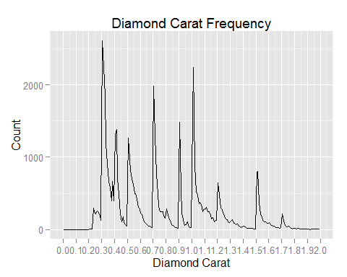

ggplot(aes(x = carat), data = diamonds) +   
 geom_freqpoly(binwidth = 0.01) +  
 ggtitle("Diamond Carat Frequency") +   
 xlab("Diamond Carat") +   
 ylab("Count") +  
 xlim(0,1.02) +  
 scale_x_continuous(limits = c(0, 1.02), breaks = seq(0, 1.1, 0.05))

## Scale for 'x' is already present. Adding another scale for 'x', which will replace the existing scale.

## Warning: Removed 2 rows containing missing values (geom_path).

