Diamond Prices Part 2

Audrey Ekuban

6 March 2016

library(ggplot2)  
data("diamonds")  
summary(diamonds)

## carat cut color clarity   
## Min. :0.2000 Fair : 1610 D: 6775 SI1 :13065   
## 1st Qu.:0.4000 Good : 4906 E: 9797 VS2 :12258   
## Median :0.7000 Very Good:12082 F: 9542 SI2 : 9194   
## Mean :0.7979 Premium :13791 G:11292 VS1 : 8171   
## 3rd Qu.:1.0400 Ideal :21551 H: 8304 VVS2 : 5066   
## Max. :5.0100 I: 5422 VVS1 : 3655   
## J: 2808 (Other): 2531   
## depth table price x   
## Min. :43.00 Min. :43.00 Min. : 326 Min. : 0.000   
## 1st Qu.:61.00 1st Qu.:56.00 1st Qu.: 950 1st Qu.: 4.710   
## Median :61.80 Median :57.00 Median : 2401 Median : 5.700   
## Mean :61.75 Mean :57.46 Mean : 3933 Mean : 5.731   
## 3rd Qu.:62.50 3rd Qu.:59.00 3rd Qu.: 5324 3rd Qu.: 6.540   
## Max. :79.00 Max. :95.00 Max. :18823 Max. :10.740   
##   
## y z   
## Min. : 0.000 Min. : 0.000   
## 1st Qu.: 4.720 1st Qu.: 2.910   
## Median : 5.710 Median : 3.530   
## Mean : 5.735 Mean : 3.539   
## 3rd Qu.: 6.540 3rd Qu.: 4.040   
## Max. :58.900 Max. :31.800   
##

str(diamonds)

## 'data.frame': 53940 obs. of 10 variables:  
## $ carat : num 0.23 0.21 0.23 0.29 0.31 0.24 0.24 0.26 0.22 0.23 ...  
## $ cut : Ord.factor w/ 5 levels "Fair"<"Good"<..: 5 4 2 4 2 3 3 3 1 3 ...  
## $ color : Ord.factor w/ 7 levels "D"<"E"<"F"<"G"<..: 2 2 2 6 7 7 6 5 2 5 ...  
## $ clarity: Ord.factor w/ 8 levels "I1"<"SI2"<"SI1"<..: 2 3 5 4 2 6 7 3 4 5 ...  
## $ depth : num 61.5 59.8 56.9 62.4 63.3 62.8 62.3 61.9 65.1 59.4 ...  
## $ table : num 55 61 65 58 58 57 57 55 61 61 ...  
## $ price : int 326 326 327 334 335 336 336 337 337 338 ...  
## $ x : num 3.95 3.89 4.05 4.2 4.34 3.94 3.95 4.07 3.87 4 ...  
## $ y : num 3.98 3.84 4.07 4.23 4.35 3.96 3.98 4.11 3.78 4.05 ...  
## $ z : num 2.43 2.31 2.31 2.63 2.75 2.48 2.47 2.53 2.49 2.39 ...

#?diamonds

ggplot(aes(x = price, y = x), data = diamonds) +   
 geom_point() +  
 ggtitle("Diamond Price Scatter Plot")

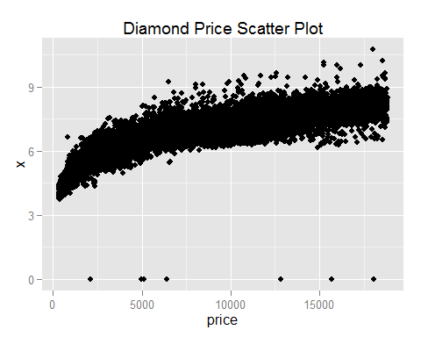

There appears to be a positive correlation and an exponentional relationship between price and x.There are some outliers (7)

cor.test(diamonds$x, diamonds$price)

##   
## Pearson's product-moment correlation  
##   
## data: diamonds$x and diamonds$price  
## t = 440.16, df = 53938, p-value < 2.2e-16  
## alternative hypothesis: true correlation is not equal to 0  
## 95 percent confidence interval:  
## 0.8825835 0.8862594  
## sample estimates:  
## cor   
## 0.8844352

cor.test(diamonds$y, diamonds$price)

##   
## Pearson's product-moment correlation  
##   
## data: diamonds$y and diamonds$price  
## t = 401.14, df = 53938, p-value < 2.2e-16  
## alternative hypothesis: true correlation is not equal to 0  
## 95 percent confidence interval:  
## 0.8632867 0.8675241  
## sample estimates:  
## cor   
## 0.8654209

cor.test(diamonds$z, diamonds$price)

##   
## Pearson's product-moment correlation  
##   
## data: diamonds$z and diamonds$price  
## t = 393.6, df = 53938, p-value < 2.2e-16  
## alternative hypothesis: true correlation is not equal to 0  
## 95 percent confidence interval:  
## 0.8590541 0.8634131  
## sample estimates:  
## cor   
## 0.8612494



ggplot(aes(x = depth, y = price), data = diamonds) +   
 geom_point() +  
 ggtitle("Diamond Price Scatter Plot")

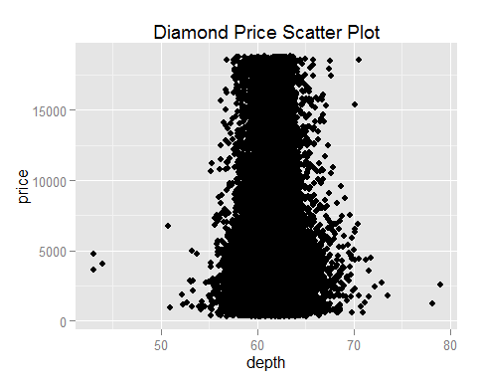

ggplot(data = diamonds, aes(x = depth, y = price)) +   
 geom_point(alpha = 1/100) +   
 scale_x_continuous(breaks = seq(40,80,2), labels = seq(40,80,2))

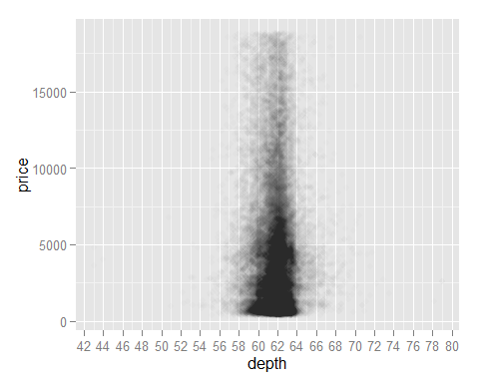 

cor.test(diamonds$depth, diamonds$price)

##   
## Pearson's product-moment correlation  
##   
## data: diamonds$depth and diamonds$price  
## t = -2.473, df = 53938, p-value = 0.0134  
## alternative hypothesis: true correlation is not equal to 0  
## 95 percent confidence interval:  
## -0.019084756 -0.002208537  
## sample estimates:  
## cor   
## -0.0106474



ggplot(data = diamonds,aes(x = carat, y = price)) +   
 xlim(0,quantile(diamonds$carat,0.99)) +  
 ylim(0,quantile(diamonds$price,0.99)) +  
 geom_point()

## Warning: Removed 926 rows containing missing values (geom_point).

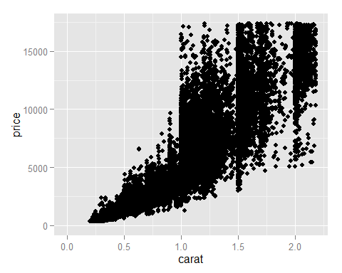

diamonds$volume = diamonds$x*diamonds$y*diamonds$z  
str(diamonds)

## 'data.frame': 53940 obs. of 11 variables:  
## $ carat : num 0.23 0.21 0.23 0.29 0.31 0.24 0.24 0.26 0.22 0.23 ...  
## $ cut : Ord.factor w/ 5 levels "Fair"<"Good"<..: 5 4 2 4 2 3 3 3 1 3 ...  
## $ color : Ord.factor w/ 7 levels "D"<"E"<"F"<"G"<..: 2 2 2 6 7 7 6 5 2 5 ...  
## $ clarity: Ord.factor w/ 8 levels "I1"<"SI2"<"SI1"<..: 2 3 5 4 2 6 7 3 4 5 ...  
## $ depth : num 61.5 59.8 56.9 62.4 63.3 62.8 62.3 61.9 65.1 59.4 ...  
## $ table : num 55 61 65 58 58 57 57 55 61 61 ...  
## $ price : int 326 326 327 334 335 336 336 337 337 338 ...  
## $ x : num 3.95 3.89 4.05 4.2 4.34 3.94 3.95 4.07 3.87 4 ...  
## $ y : num 3.98 3.84 4.07 4.23 4.35 3.96 3.98 4.11 3.78 4.05 ...  
## $ z : num 2.43 2.31 2.31 2.63 2.75 2.48 2.47 2.53 2.49 2.39 ...  
## $ volume : num 38.2 34.5 38.1 46.7 51.9 ...

# There are some outliers. Some diamonds have a valume of 0.   
length(which(diamonds$volume == 0))

## [1] 20

diamonds.set = subset(diamonds, volume != 0 & volume < 800 )  
cor.test(diamonds.set$volume, diamonds.set$price)

##   
## Pearson's product-moment correlation  
##   
## data: diamonds.set$volume and diamonds.set$price  
## t = 559.19, df = 53915, p-value < 2.2e-16  
## alternative hypothesis: true correlation is not equal to 0  
## 95 percent confidence interval:  
## 0.9222944 0.9247772  
## sample estimates:  
## cor   
## 0.9235455



ggplot(diamonds.set, aes(x = volume, y = price)) +  
 geom_point(alpha = 0.10) +  
 geom_smooth(method = "lm") +  
 coord_cartesian(ylim = c(0,20000))

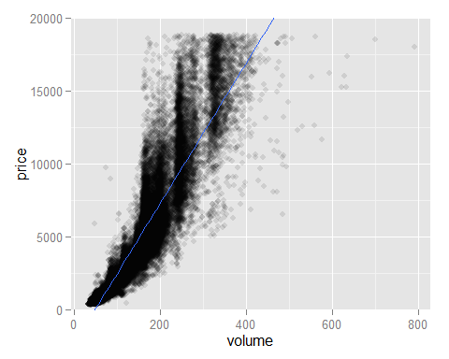

# Looking at polynimoal functions of order 2  
ggplot(diamonds.set, aes(x = volume, y = price)) +  
 geom_point(alpha = 0.10) +  
 geom_smooth(method = "lm", formula = y ~ poly(x, 2)) +  
 coord_cartesian(ylim = c(0,20000))

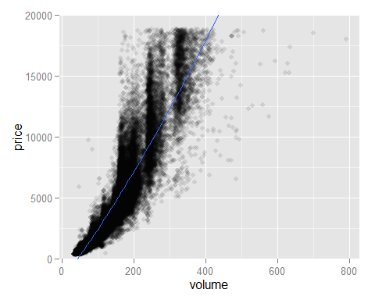

In the absence of another model, probably yes due to the correlation. However, there does appear to be a lot of random scattering which suggests that there may be alternative models.

suppressMessages(library(ggplot2))  
suppressMessages(library(dplyr))  
data(diamonds)  
  
diamondsByClarity = group_by(diamonds,clarity) %>%   
 summarise(  
 mean_price = mean(price),  
 median_price = median(as.numeric(price)),  
 min_price = min(price),  
 max_price = max(price),  
 n = n())  
head(diamondsByClarity)

## Source: local data frame [6 x 6]  
##   
## clarity mean_price median_price min_price max_price n  
## (fctr) (dbl) (dbl) (int) (int) (int)  
## 1 I1 3924.169 3344 345 18531 741  
## 2 SI2 5063.029 4072 326 18804 9194  
## 3 SI1 3996.001 2822 326 18818 13065  
## 4 VS2 3924.989 2054 334 18823 12258  
## 5 VS1 3839.455 2005 327 18795 8171  
## 6 VVS2 3283.737 1311 336 18768 5066

data(diamonds)  
library(dplyr)  
  
#install.packages("gridExtra")  
library(gridExtra)

## Warning: package 'gridExtra' was built under R version 3.2.4

##   
## Attaching package: 'gridExtra'

## The following object is masked from 'package:dplyr':  
##   
## combine

diamonds_by_clarity <- group_by(diamonds, clarity)  
diamonds_mp_by_clarity <- summarise(diamonds_by_clarity, mean_price = mean(price))  
  
diamonds_by_color <- group_by(diamonds, color)  
diamonds_mp_by_color <- summarise(diamonds_by_color, mean_price = mean(price))  
  
plot1 = ggplot(aes(x = clarity, y = mean_price), data = diamonds_mp_by_clarity) +  
 geom_bar(stat = "identity")  
  
plot2 = ggplot(aes(x = color, y = mean_price), data = diamonds_mp_by_color) +  
 geom_bar(stat = "identity")  
  
grid.arrange(plot1,plot2, ncol = 1)

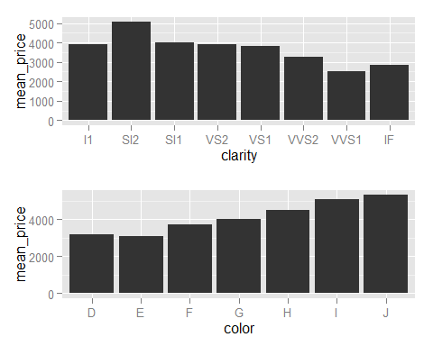

Mean price increases with color.