IB Diploma Programme — Computer Science
Internal Assessment
Driving Theory Practice
A revision tool for the Lithuanian driving theory test
Candidate: Liepa Šveikauskaitė
Candidate code: [TO COMPLETE] Session: [TO COMPLETE]
Word count: 1992
(excluding headings, tables, figures, captions, code, references and acknowledgements)
Contents
Criterion A: Problem specification
Criterion B: Planning
Criterion C: System overview
Criterion D: Development
Criterion E: Evaluation
References, acknowledgement of AI use, appendices

Criterion A: Problem specification

Problem scenario
Learner drivers in Lithuania must pass the theory test at Regitra, a computer-based test of 30 multiple-choice questions on the road traffic rules [2]. Learners prepare by answering practice questions, and a practice tool only helps if it does not repeat questions within a session, shows straight away whether an answer was right and why, shows which kinds of question are answered badly, and lets the learner return to earlier mistakes. Regitra updates its exam questions from time to time [1], so the question bank must be editable without programming.
The solution must therefore load a question bank from a CSV file, run sessions of 30 unique questions in random order, score answers by difficulty, give immediate feedback with an explanation, summarise the results by difficulty, and store every session on the device so that the most-missed questions can be practised again. It must load 500 questions in under 2 seconds and mark an answer in under 0.2 seconds.

Computational context
The solution is a single-page web application written in plain JavaScript and run in a web browser (Table A1). A browser is already on every laptop, so nothing is installed, and it handles mouse and keyboard events. Everything runs on the user's device: the built-in bank is read from CSV files in the project folder, a user's own bank is read with the File API, and results are kept in the browser's localStorage, so no answers leave the computer. CSV was chosen because a non-programmer can edit it in a spreadsheet.
Context | Chosen | Alternatives considered | Justification
Language | JavaScript (ES6), HTML | Python + Tkinter; Java + JavaFX | Runs in any browser with no installation; DOM events give mouse and keyboard input directly. Python and Java need a runtime on every laptop.
Libraries / frameworks | None for logic; Tailwind CSS 3.4 for styling, built into css/styles.css | React; PapaParse for CSV | Four screens do not need a component framework. Tailwind is built once into css/styles.css, so the app needs no build step to run. The CSV parser is written by hand so the algorithm is visible (Criterion D).
Software environment | Web browser, page served by a local http server (python3 -m http.server) | Opening index.html from disk | Browsers block fetch() of the built-in bank from file://; the app then offers a manual file picker instead (bank.js).
Hardware | Any laptop that runs a current browser | Mobile phone | Keyboard control (A–D, Enter) suits a laptop; no special hardware is used.
Data environment | CSV, UTF-8, 10 columns; built-in bank of 221 questions in Lithuanian and English with 221 pictures | SQL database; JSON | Editable in a spreadsheet; no database server. The two language files share id, correct, difficulty and picture.
Storage of results | Browser localStorage, JSON | Server database; IndexedDB | No server or accounts; answers stay on the device (Criterion D, Technique 6).
Table A1 — Computational context

Success criteria
No. | Success criterion (measurable)
1 | CSV import: questions load from a CSV file (built-in or the user's own). Rows with empty question text, a correct answer outside 1–4, a difficulty outside 1–3, or a correct answer pointing at an empty option are skipped, and the numbers loaded and skipped are reported.
2 | Session: a session holds 30 questions (all of them if fewer than 30 are loaded), with no question repeated, in random order.
3 | Weighted scoring: each question shows its difficulty (Easy, Medium, Hard); a correct answer scores 1, 2 or 3 points respectively.
4 | Immediate feedback: after each answer the app states whether it was correct, marks the correct option green and a wrong choice red, shows the explanation, and locks the options.
5 | Accurate score: the total equals the sum of the points earned; the percentage is calculated against the points available for the questions answered.
6 | Optional timer: when enabled, timing starts at the first question and stops at the end; the elapsed time is reported to the nearest second.
7 | Results: the end screen shows the total score, the numbers of correct and incorrect answers, correct/total and % per difficulty, and the time if timed. A session can be ended early; its results then cover the questions answered.
8 | Restart: a new session can be started without reloading the page; it is reshuffled and all counters and the timer are reset.
9 | History and mistakes: every session is saved on the device under a profile name; a history screen shows past scores, a progress chart and the most-missed questions; “Practise my mistakes” runs a session of up to 30 previously missed questions.
10 | Own question bank: the user can load their own CSV file with their own images; picture names that are not among the selected images are reported.
Table A2 — Functional success criteria (CfS)
Criterion | Measure
Performance | A bank of 500 questions loads in under 2 s; an answer is marked in under 0.2 s.
Usability | A session starts with one click once the bank has loaded; the question number, the A–D labels and the key hint are visible on every question; the interface and the built-in bank are available in Lithuanian and English.
Reliability | An empty or invalid file gives an error message, keeps Start disabled and does not crash the app; corrupted stored data gives an empty history; the app works without an internet connection.
Accessibility | A whole session can be completed with the keyboard only.
Portability | Runs in a current browser with no installation and no server-side code.
Maintainability | The questions can be changed by editing the CSV file only, without changing any source file.
Table A3 — Non-functional criteria

Criterion B: Planning
Figure B1 decomposes the problem into six components; every success criterion belongs to at least one of them. The plan in Figure B2 has two iterations. In iteration 1 (weeks 1–7) one component of the core product (CfS 1–8) is designed, built, tested and evaluated each week, so a working program exists at the end of every week. Research comes first: the browser File API, the CSV format [3] and the Fisher–Yates shuffle [4]. Iteration 2 (weeks 8–12) adds history, own banks and the second language (CfS 9–10), and ends with a full test run, the evaluation and the video.
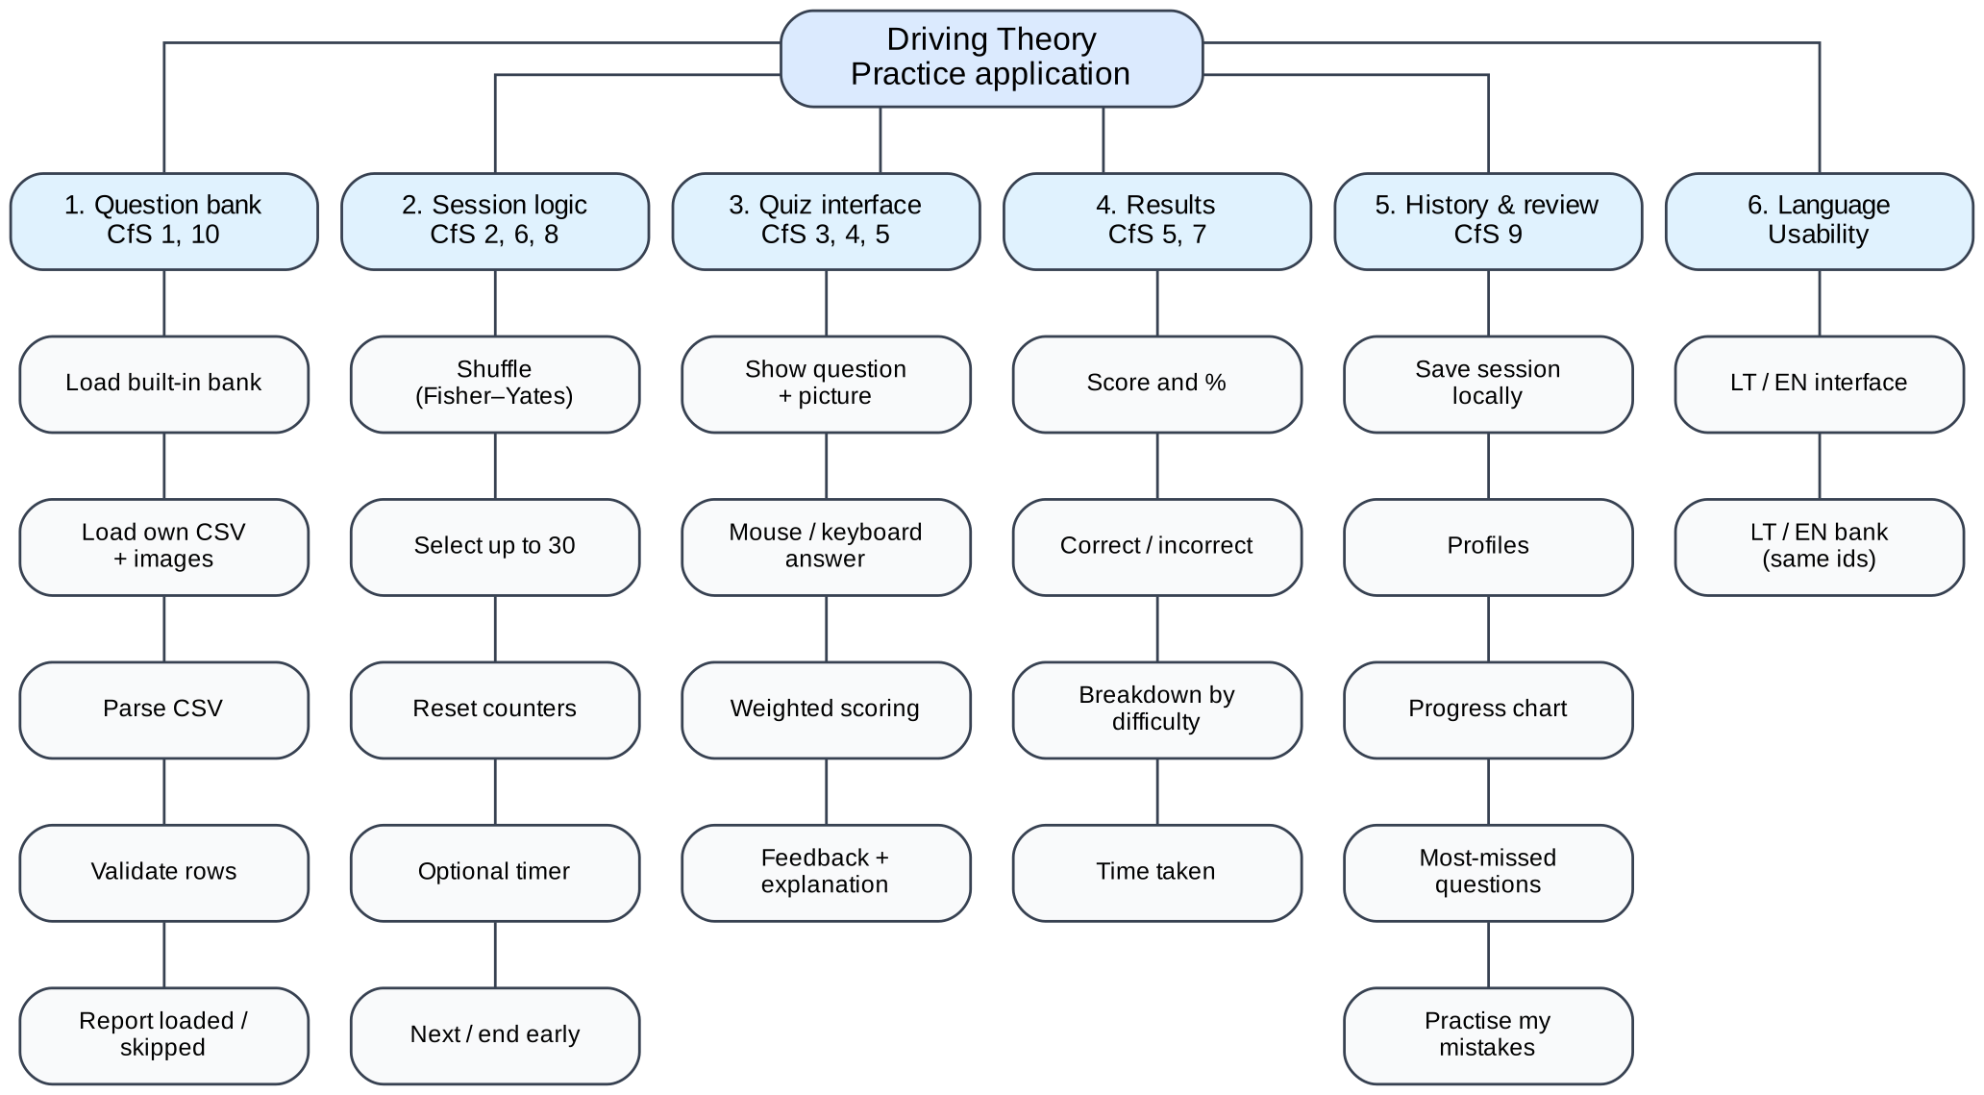
Figure B1 — Decomposition of the problem into components, with the success criteria each one serves
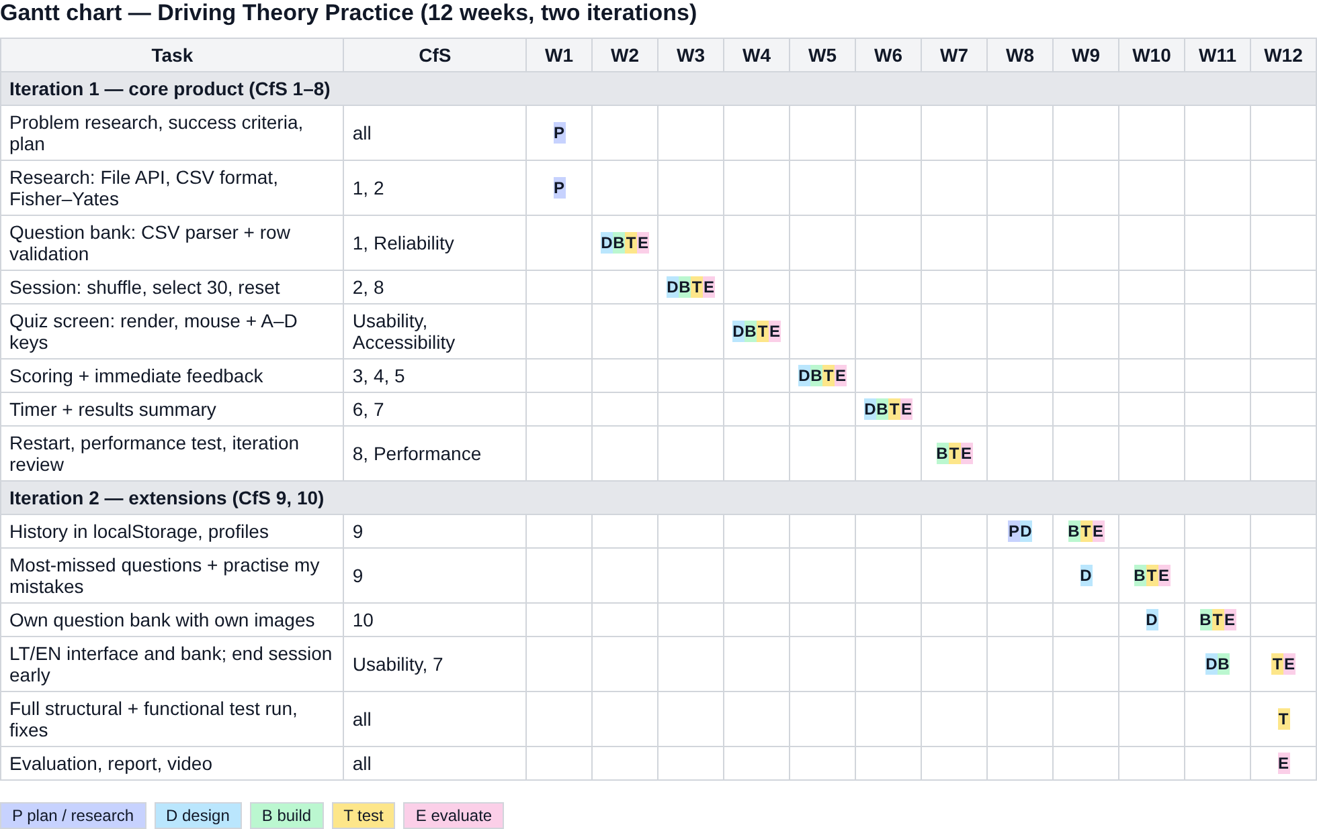
Figure B2 — Gantt chart: each component is designed (D), built (B), tested (T) and evaluated (E)

Criterion C: System overview

System model
Figure C1 shows the eight JavaScript files loaded by index.html, the data stores and the calls between them. The rules of interaction are: listeners for the controls in index.html are attached only in app.js, while buttons created at run time get theirs where they are created (ui.js, history.js); the session counters declared in app.js are changed only by session.js and ui.js; storage.js is the only file that reads or writes localStorage; and interface text is looked up in i18n.js, so the language can be switched.
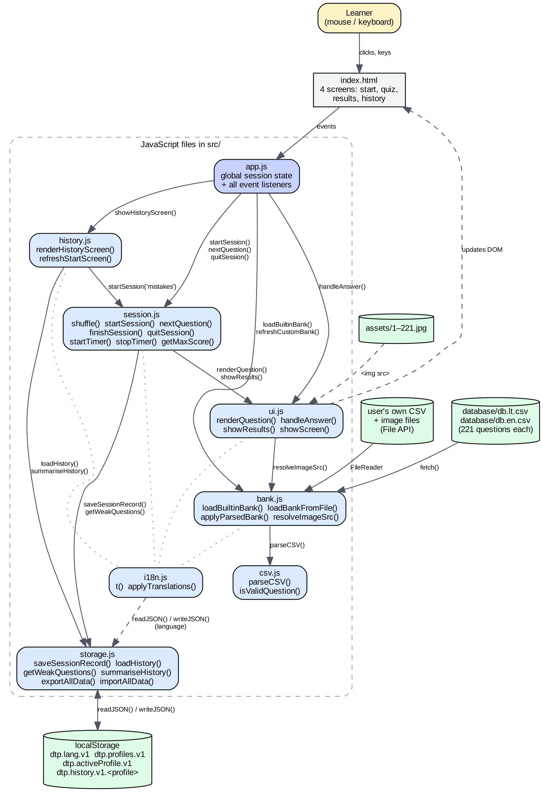
Figure C1 — System model: files, data stores and the functions through which they interact

Data
Column | Type | Rule (✓ = checked by isValidQuestion)
id | text | Identifies the question; the same id in db.lt.csv and db.en.csv is the same question.
question | text | ✓ Must not be empty.
option_a … option_d | text | Up to 4 options; unused options are empty.
correct | integer 1–4 | ✓ Must be 1–4 and point at a non-empty option.
difficulty | integer 1–3 | ✓ Must be 1–3: 1 Easy, 2 Medium, 3 Hard.
explanation | text | Optional; shown after answering.
picture | text | Optional; a file name (assets/ or a selected image) or an https:// link.
Table C1 — CSV question format (fields may be quoted and contain commas, quotes and line breaks)
Variable (app.js) | Type | Meaning
questions | array of question objects | All valid questions of the loaded bank.
sessionQuestions | array (≤ 30) | The questions of the current session.
currentIndex | integer | Position of the question on screen.
score, correctCount, incorrectCount | integers | Running totals.
answered | boolean | True once the current question has been answered.
diffStats | {1|2|3: {correct, total}} | Breakdown by difficulty.
sessionAnswers | array of {qid, chosen, correct, difficulty, ok} | One record per answer; snippets of text are added for wrong answers.
timerEnabled, startTime, elapsedSeconds | boolean, ms timestamp, integer | Timer state.
activeProfile, currentBank, currentLanguage | text | Whose history is used, which bank is loaded, "en" or "lt".
Table C2 — Session state
localStorage key | Contents
dtp.history.v1.<profile> | Array of session records (newest 100): id, date, profile, bank, mode ("all" or "mistakes"), score, maxScore, percent, correct, incorrect, total, planned, abandoned, timerEnabled, seconds, diffStats, answers.
dtp.profiles.v1 | List of profile names used on this device.
dtp.activeProfile.v1 | Name of the profile selected last.
dtp.lang.v1 | "en" or "lt".
Table C3 — Data stored in the browser (storage.js, i18n.js)

User interface
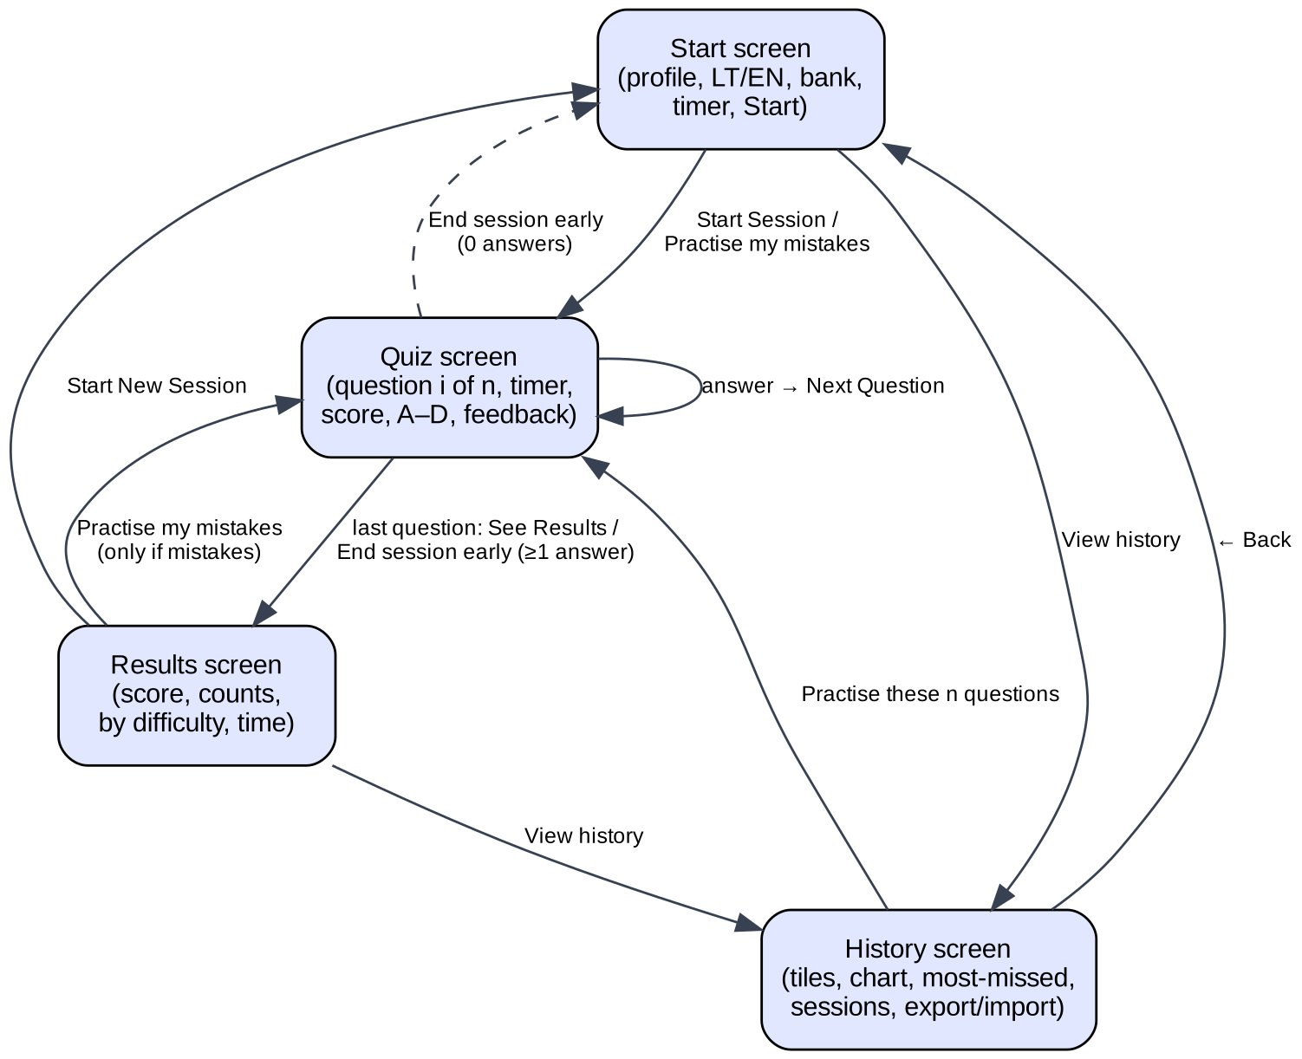
Figure C2 — The four screens and the controls that move between them
  Figure C3 — Start screen | 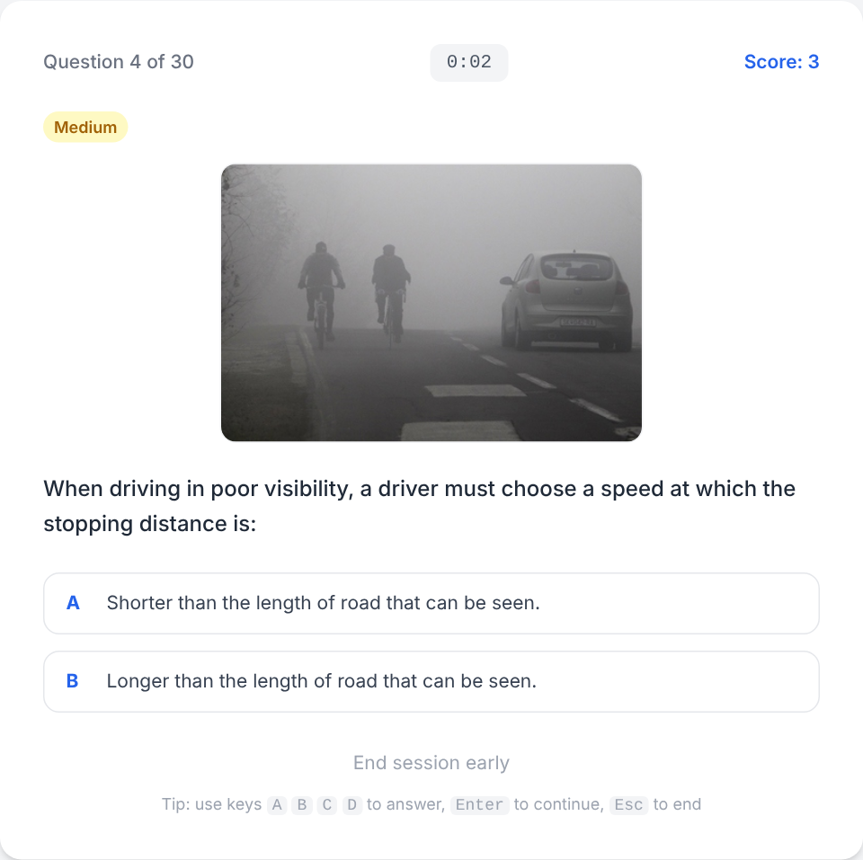  Figure C4 — Quiz screen (timer on)
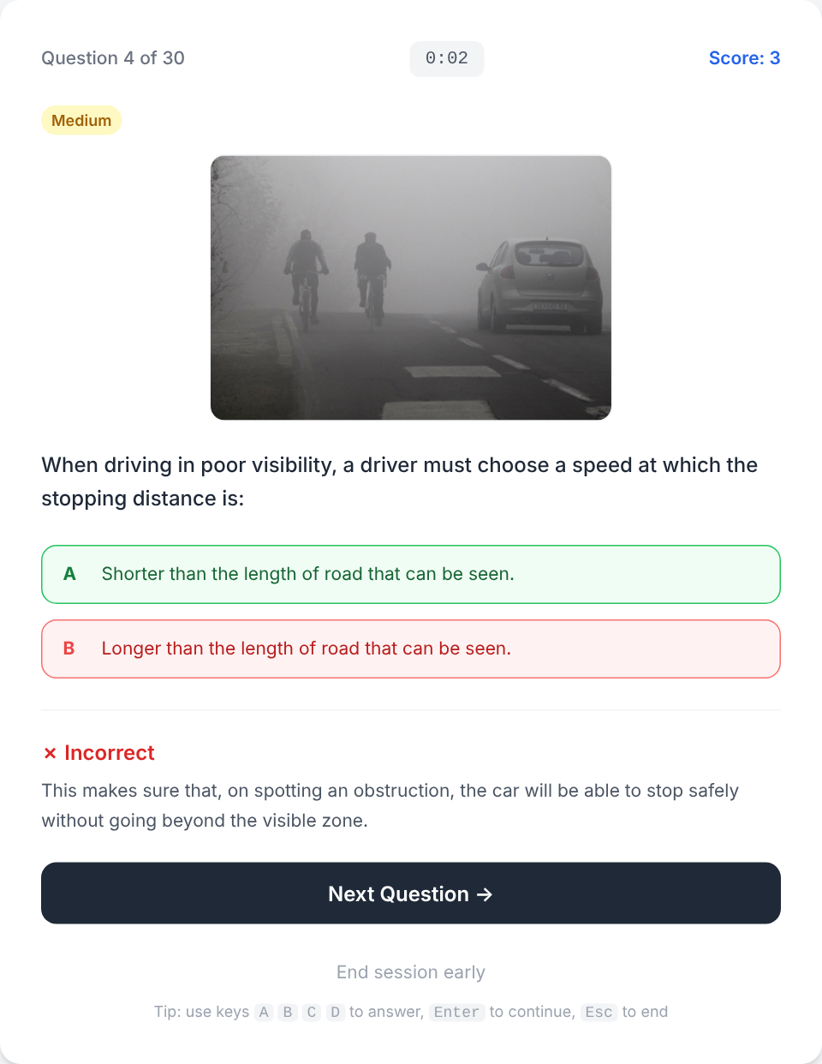  Figure C5 — Feedback after a wrong answer | 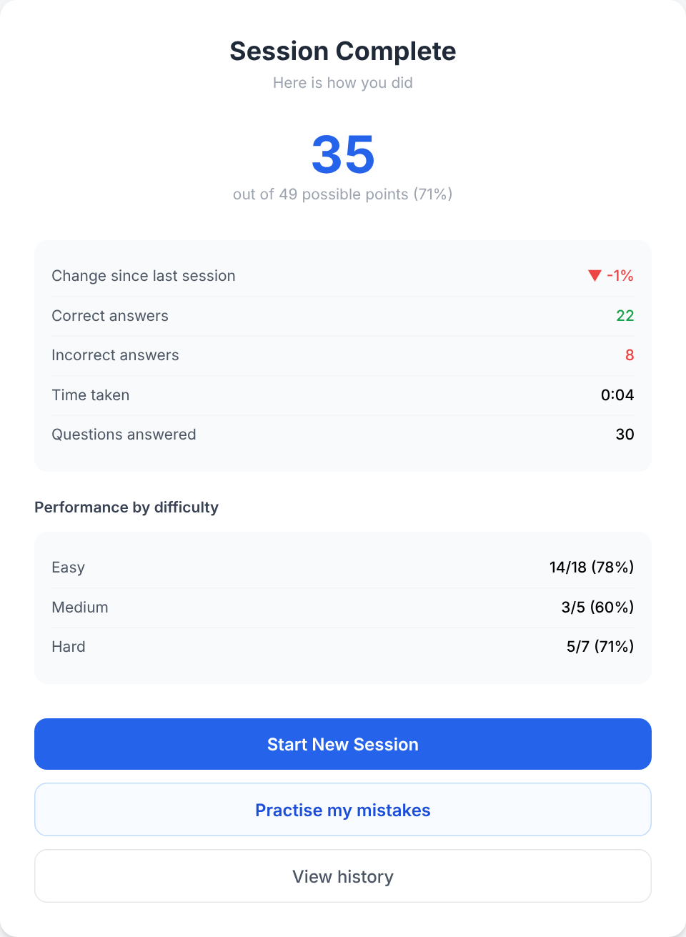  Figure C6 — Results screen
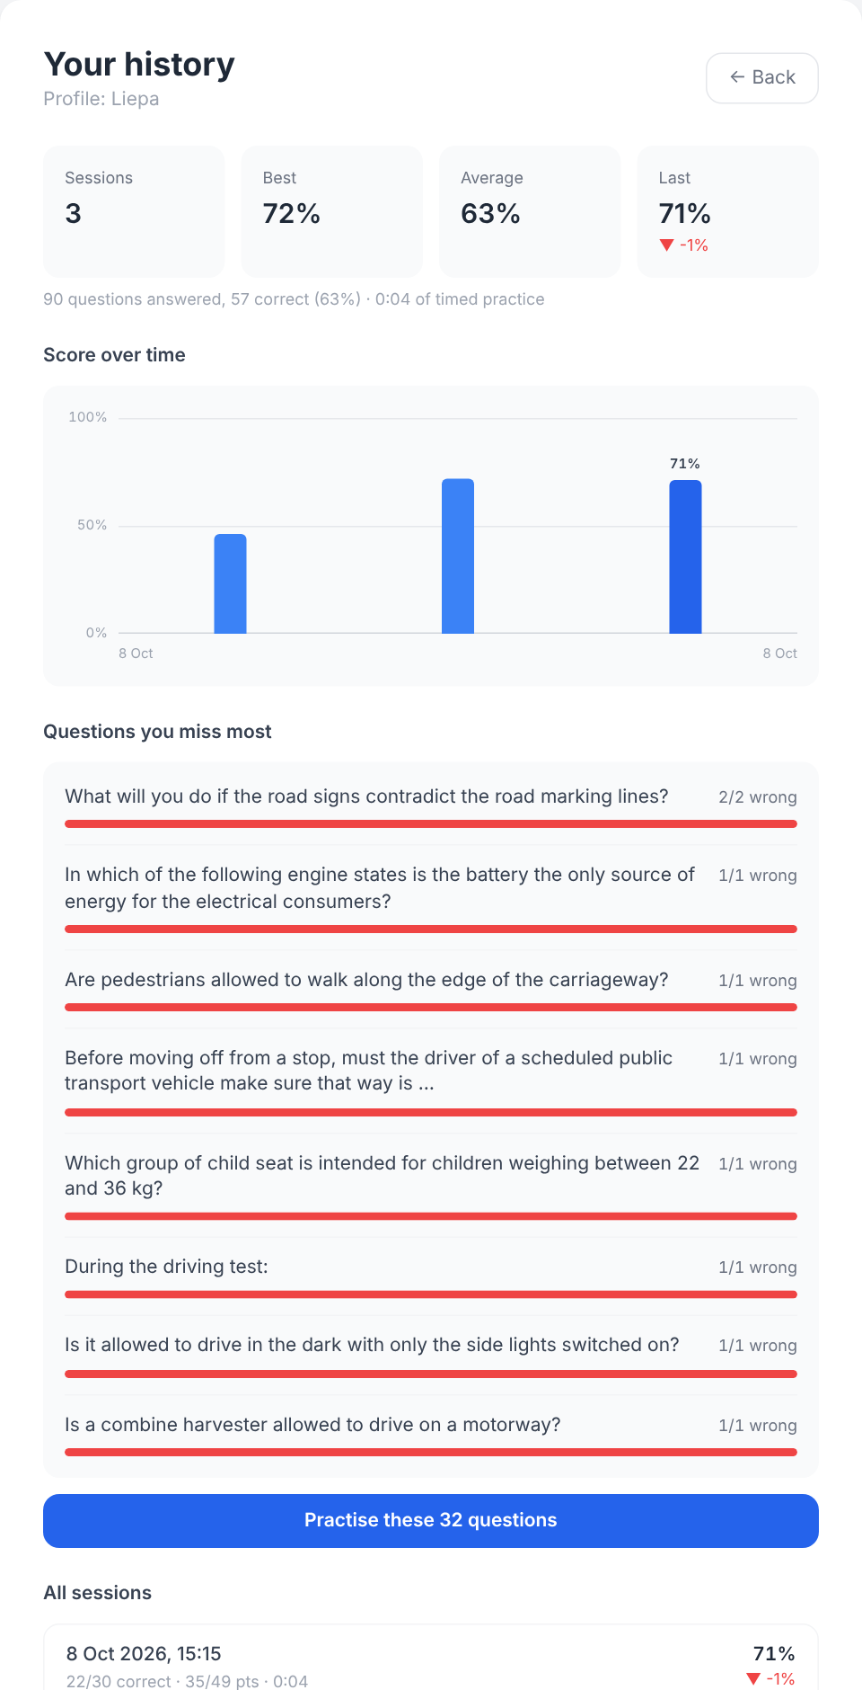  Figure C7 — History: statistics, progress chart, most-missed questions | 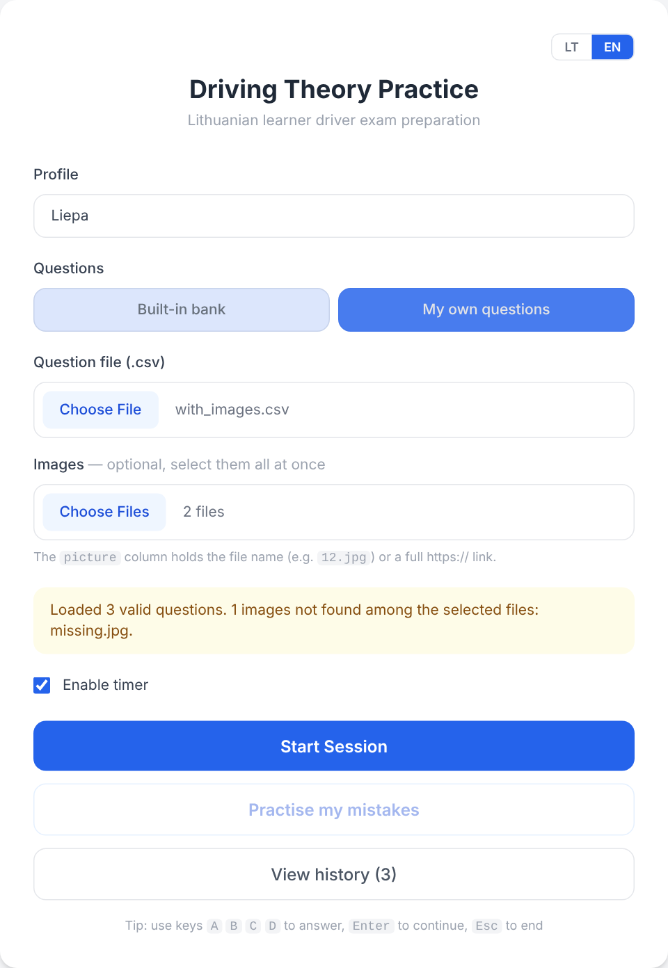  Figure C8 — Own question bank with images  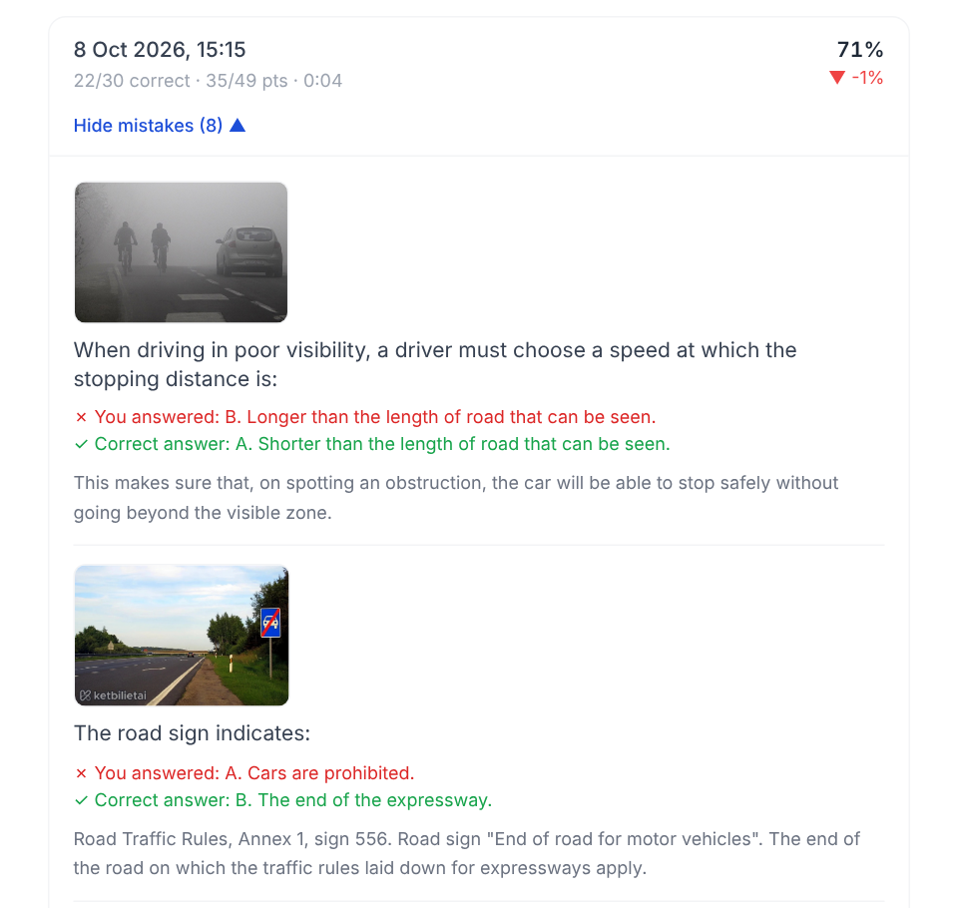  Figure C9 — History: review of one session's mistakes

Algorithms
Flowcharts C10–C15 give the main flow of the program and the algorithms of the components that carry its logic.
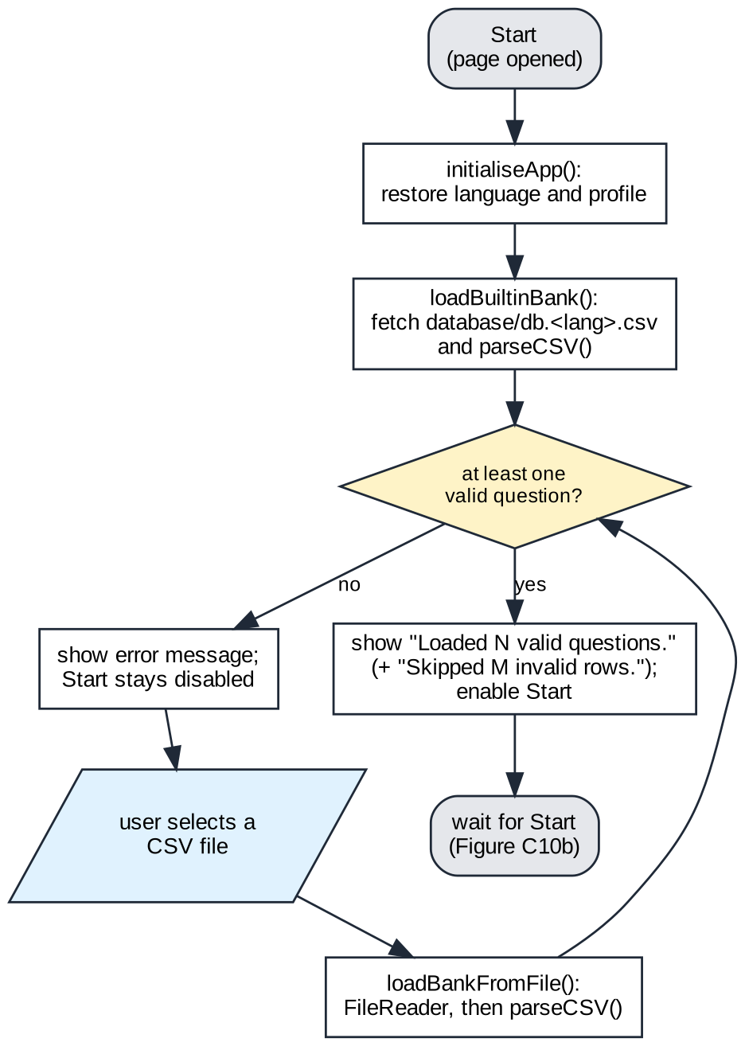
Figure C10a — Main flow, part 1: loading a question bank (app.js, bank.js)
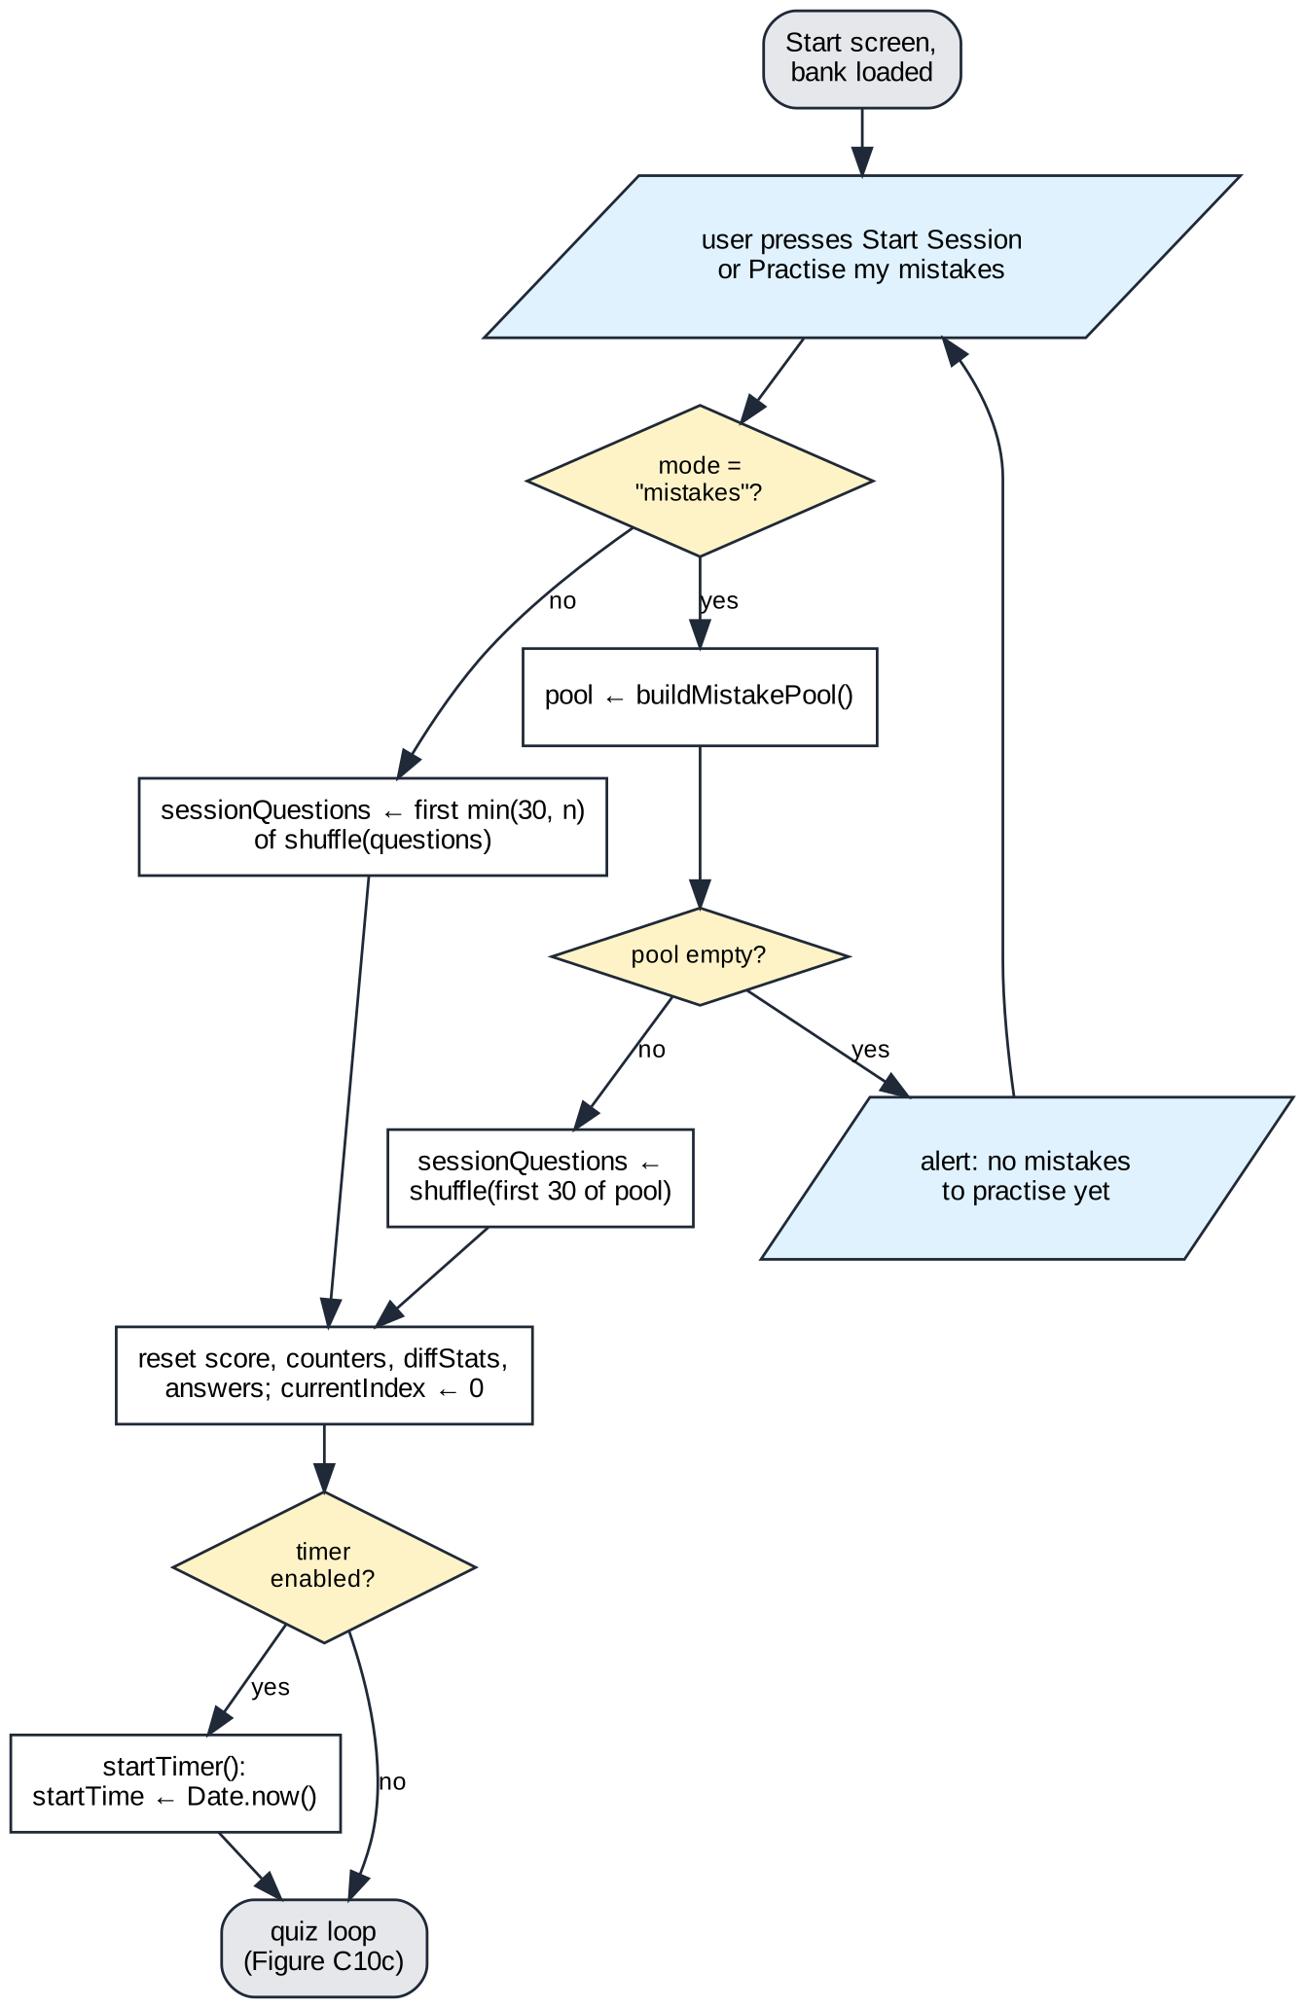
Figure C10b — Main flow, part 2: starting a session (session.js)
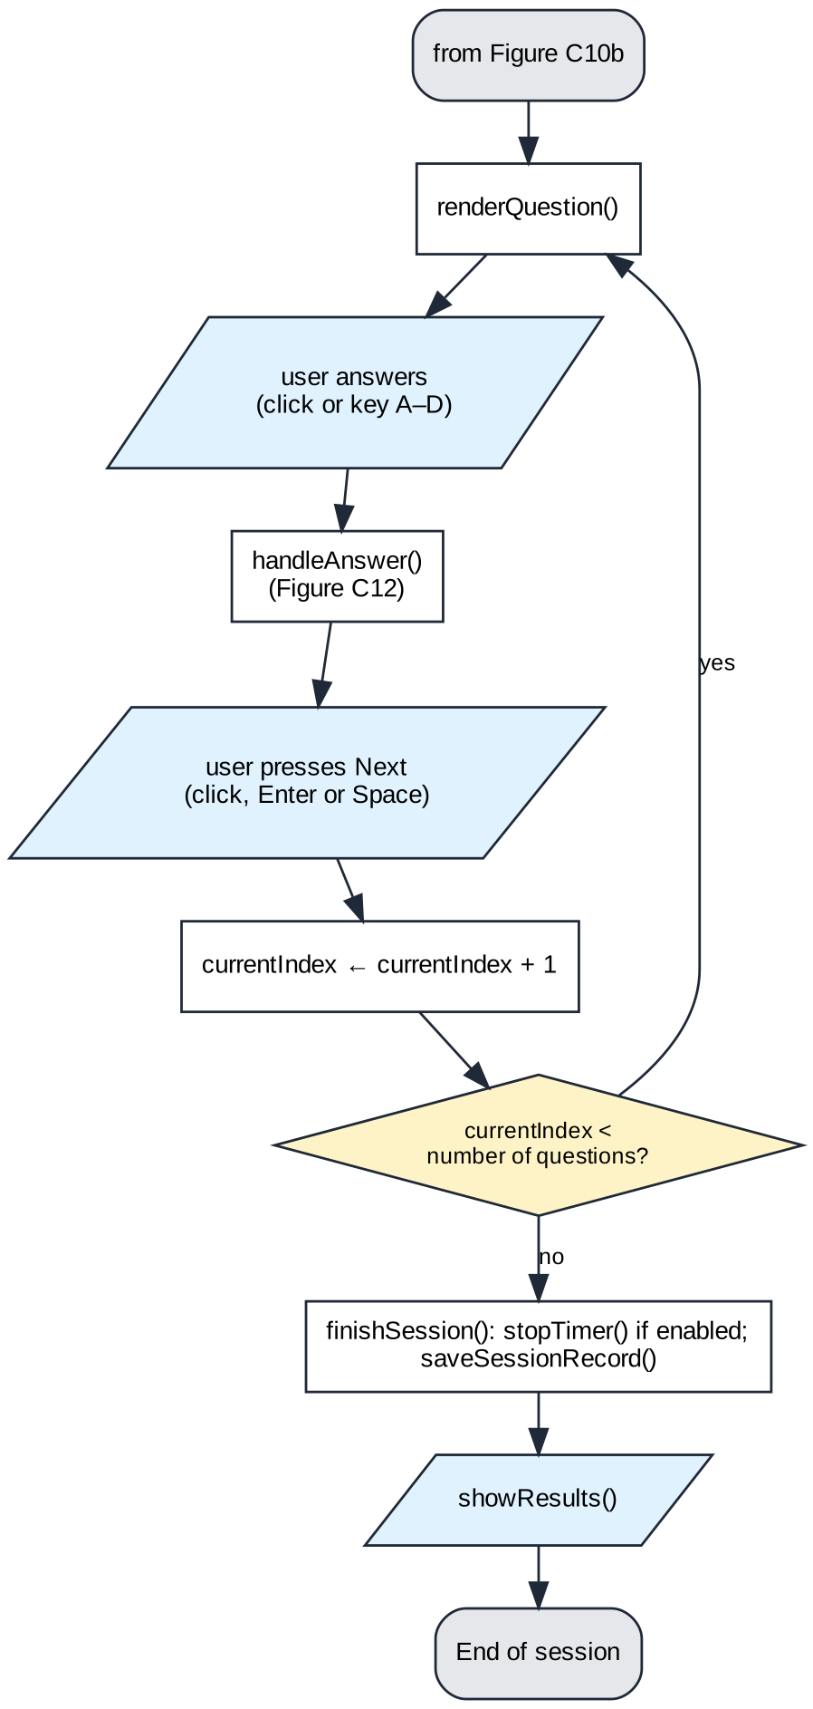
Figure C10c — Main flow, part 3: the quiz loop (session.js, ui.js)
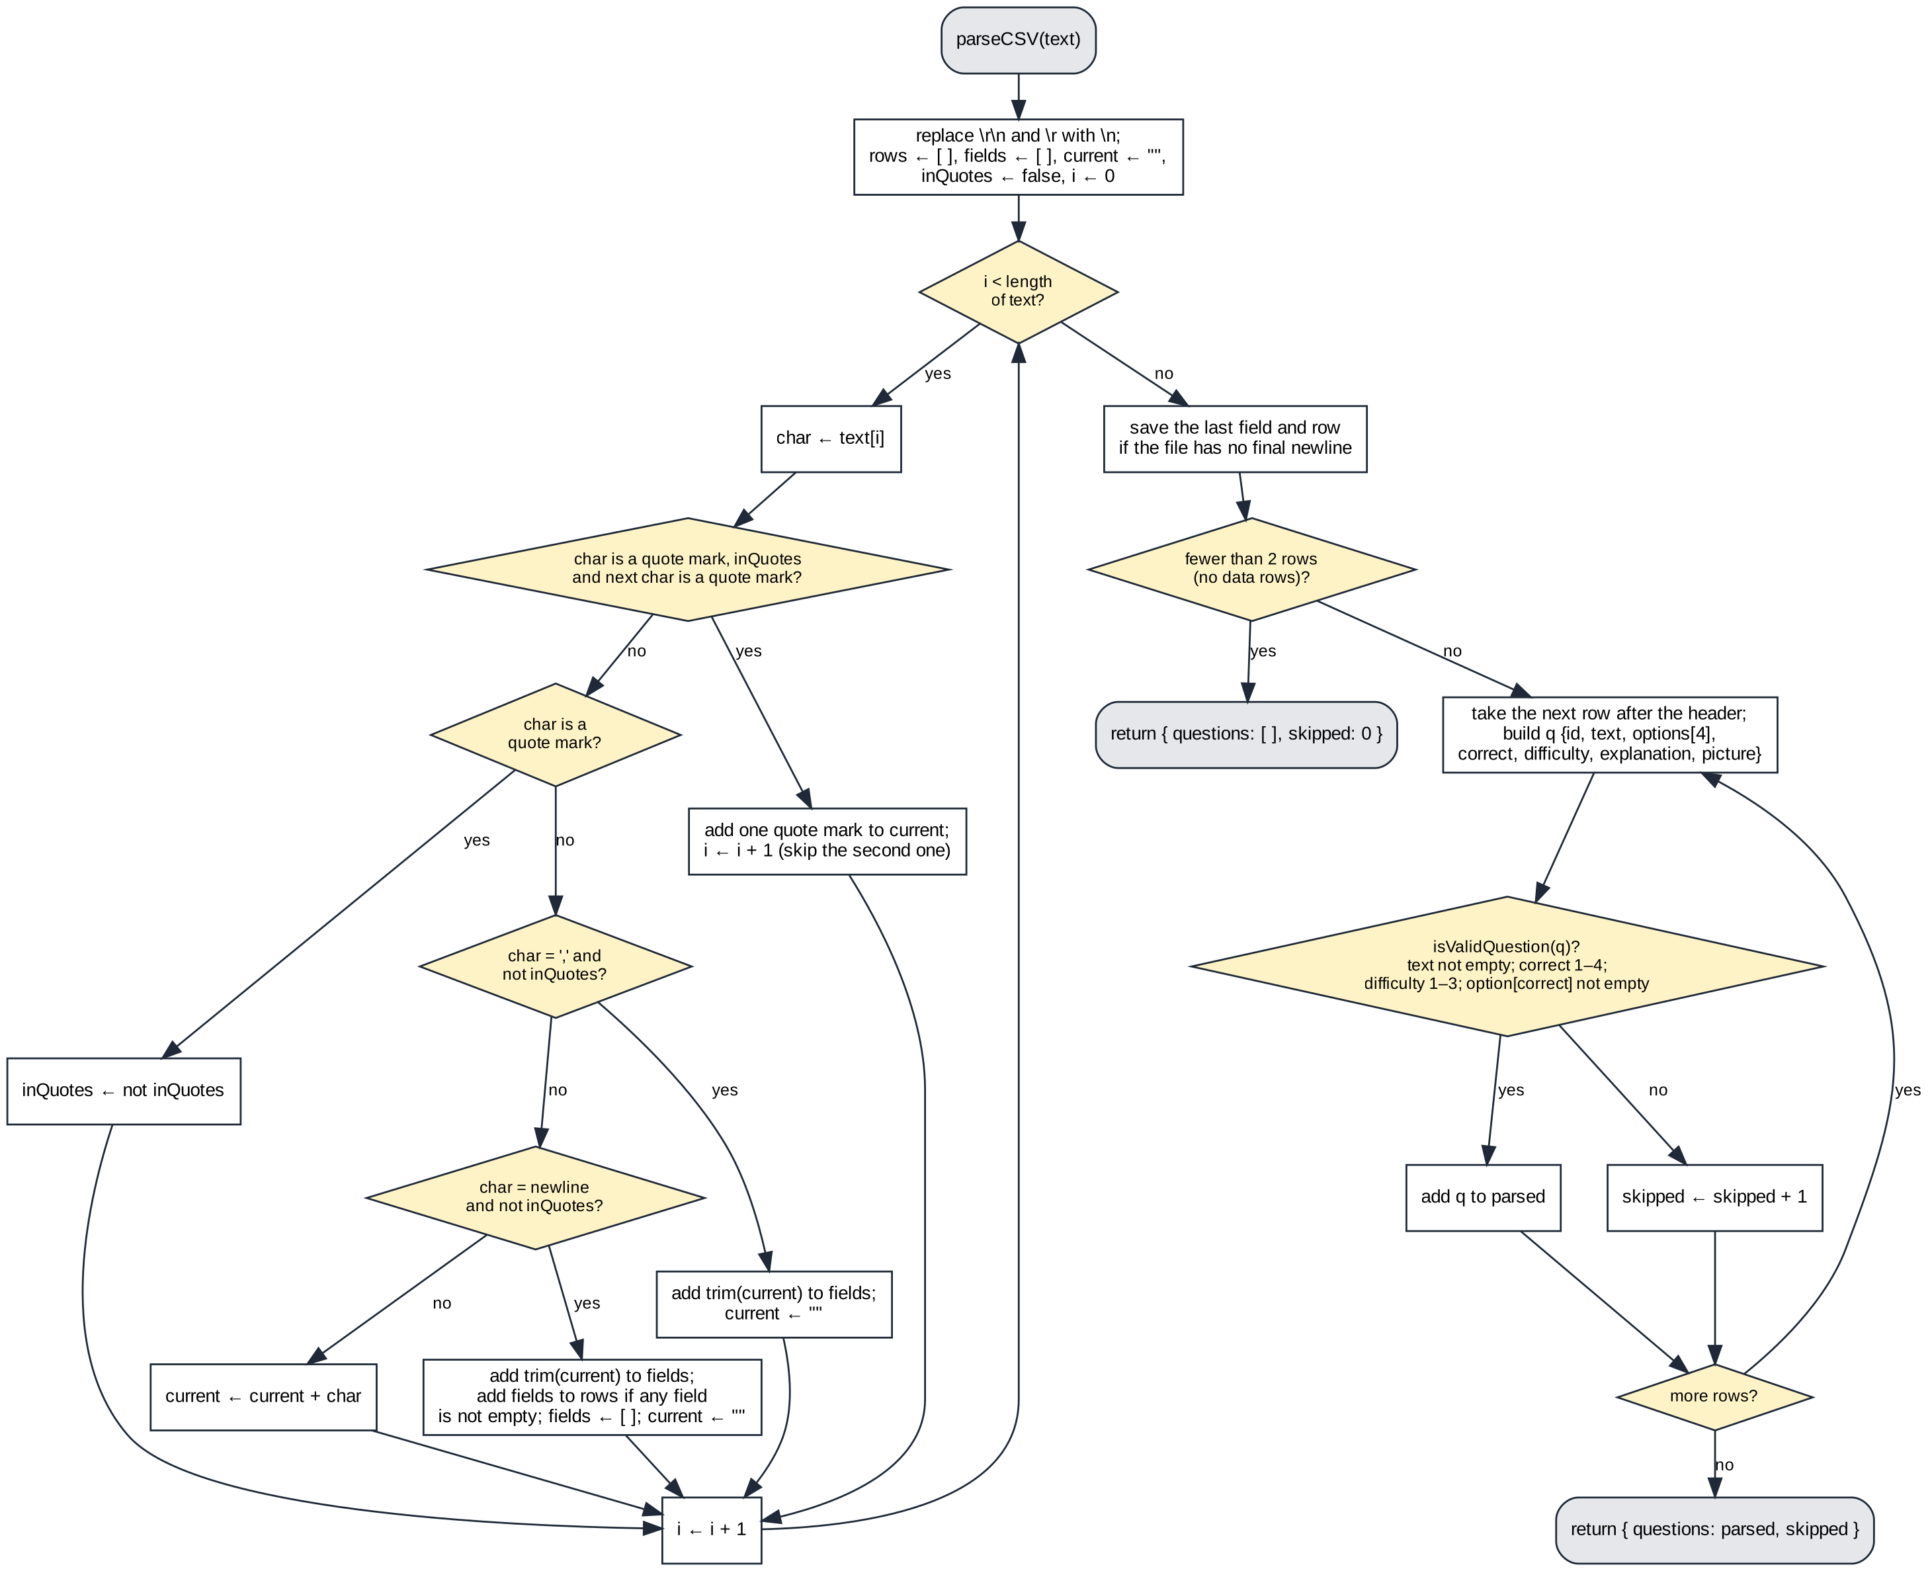
Figure C11 — parseCSV() and isValidQuestion() (csv.js)
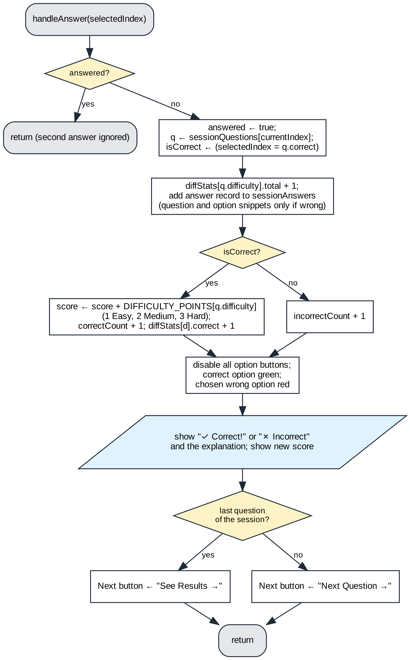
Figure C12 — handleAnswer() (ui.js)
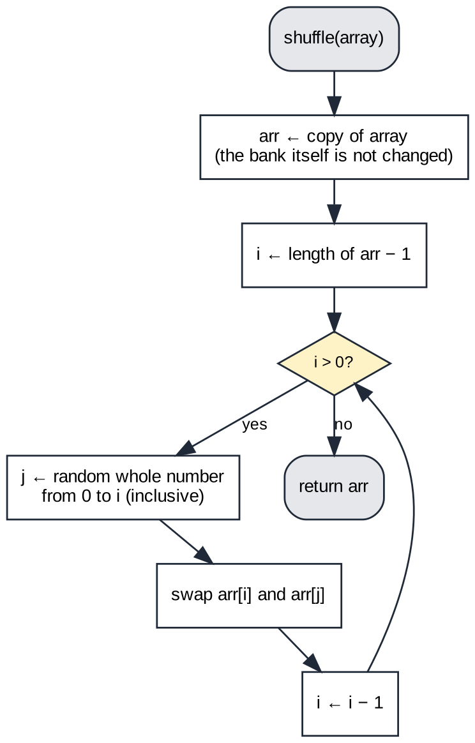
Figure C13 — shuffle(): Fisher–Yates shuffle on a copy (session.js)
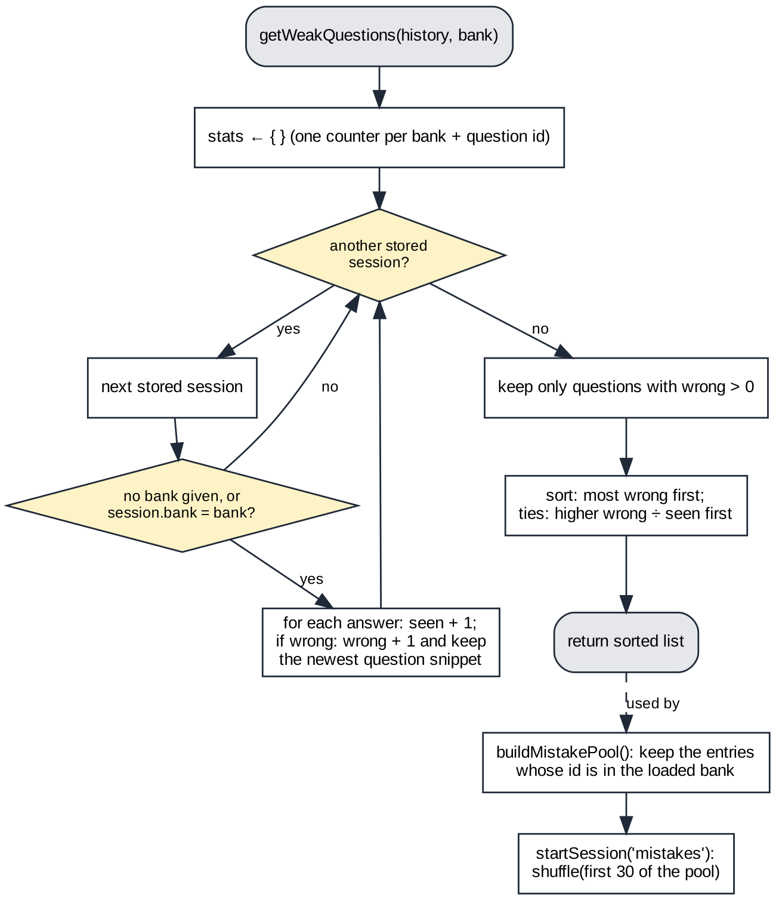
Figure C14 — getWeakQuestions() and the “Practise my mistakes” pool (storage.js, session.js)
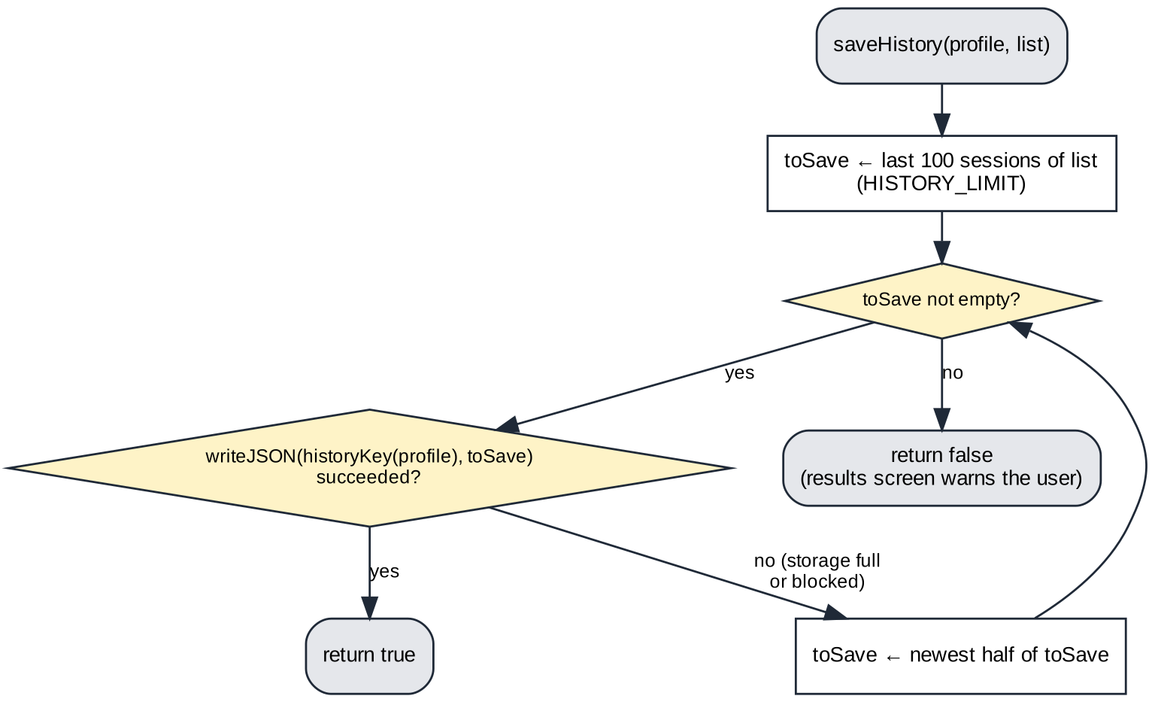
Figure C15 — saveHistory(): keeps the newest sessions when storage is full (storage.js)

Testing strategy
Testing is done at two levels. Structural (white-box) tests (Table C5) call each major function inside the running application with valid, extreme and invalid data, so that the main branches and the error paths for invalid rows, corrupted storage and full storage are exercised. Functional (black-box) tests (Table C4) check every success criterion through the interface only, by clicking, typing and uploading files, and look up the correct answers in the CSV file rather than in the program. Generated test files (Table C6) make the expected results exact: fixed_30.csv holds ten questions of each difficulty, so its maximum score is 60 by hand calculation. Both levels are automated so that they can be repeated after every change.
No. | Criterion | Test | Expected outcome
F1 | CfS 1 | Open the app; built-in bank loads | "Loaded 221 valid questions." in green; Start enabled
F2 | CfS 1 | Upload mixed_10.csv (7 valid, 3 invalid rows) | 7 loaded, 3 skipped, session can start
F3 | CfS 2 | Full session on the built-in bank; note every question | 30 questions, none repeated; "Question 1 of 30" … "Question 30 of 30"
F4 | CfS 2 | Start two sessions and compare their first five questions | different order
F5 | CfS 2 | Upload small_10.csv and play the session | 10 questions, no crash, "Question 1 of 10"
F6 | CfS 3 | Answer an Easy, a Medium and a Hard question correctly | label shown; score rises by 1, 2, 3
F7 | CfS 4 | Choose a wrong option | "✗ Incorrect"; chosen option red, correct option green; all options locked
F8 | CfS 4 | Choose the correct option | "✓ Correct!"; option green; explanation shown
F9 | CfS 5 | fixed_30.csv: answer all 30 correctly; then only the 10 Hard ones | 60 of 60 (100%); then 30 of 60 (50%)
F10 | CfS 6 | Timer on: play small_10.csv for about 7 s, measured independently by the test script | timer starts at 0:00; reported time within 1 s of the measured time
F11 | CfS 6 | Timer off: complete a session | no timer during the quiz; no time row on results
F12 | CfS 7 | Complete a session (every third answer wrong) and read the results screen | total score; correct + incorrect = 30; correct/total and % for each difficulty
F13 | CfS 8 | On the results screen press "Start New Session", then Start | "Question 1 of 30", score 0, timer 0:00, page not reloaded
F14 | Performance | Upload valid_500.csv, then answer 10 questions | loaded in under 2 s; each answer marked in under 0.2 s
F15 | Usability | Open the app with no setup and start a session; check every question screen | session starts with one click after the bank loads; question number, A–D labels and key hint visible on all 30 questions
F16 | Reliability | Upload empty.csv, then header_only.csv, then a valid file | error message; Start disabled; no crash; the valid file then loads
F17 | Accessibility | Complete a session with the keyboard only (Enter on Start, A–D keys, Enter to continue, Enter on Start New Session) | no mouse needed; 60 of 60; back on the start screen
F18 | Portability | Run every other test in Chromium 141.0.7390.37 (the engine also used by Chrome and Edge), with no installation and no server-side code | all other structural and functional tests pass
F19 | Maintainability | Edit the text of question 1 in a copy of db.en.csv only, reload, and play until it appears | edited text appears in the app; no source file changed
F20 | CfS 9 | Miss the 10 Easy questions of fixed_30.csv; open history; then "Practise my mistakes" | history lists the session; drill button offers 10; drill contains exactly the 10 missed questions
F21 | CfS 10 | Select sign1.jpg and sign2.jpg, then with_images.csv (which also names missing.jpg) | 3 questions loaded; missing.jpg reported; a selected picture is shown in the quiz
F22 | Usability (language) | Switch the interface to LT | Lithuanian labels; Lithuanian bank of 221 questions loaded
F23 | CfS 7 (end early) | Answer 3 questions, then "End session early" | "Session Ended"; results cover the 3 answered questions
F24 | Reliability (offline) | Block every request that leaves the computer, open the app and answer a question | only the start screen is shown; the bank loads; a question can be answered
Table C4 — Functional test plan
No. | Function | Type | Test data | Expected outcome
S1 | parseCSV() | Valid | quoted.csv: 3 rows; a comma and a line break inside quoted fields | 3 questions, skipped 0, comma and line break kept
S2 | parseCSV() | Valid | quoted_crlf.csv (Windows CRLF line endings) | same result as the LF file
S3 | parseCSV() | Extreme | header_only.csv; quoted_no_final_newline.csv | {questions: [], skipped: 0}; last row still read (3 questions)
S4 | parseCSV() | Extreme | escaped quotes: "The sign ""Cyclists"" warns of what?" | The sign "Cyclists" warns of what?
S5 | parseCSV() | Invalid | empty string "" (the content of empty.csv) | {questions: [], skipped: 0}, no exception
S6 | isValidQuestion() | Valid | correct = 1 and 4; difficulty = 1 and 3 | true, true
S7 | isValidQuestion() | Extreme | only 2 options (C and D empty), correct = 2 | true
S8 | isValidQuestion() | Invalid | correct = "0.5", "B", blank; difficulty = 0, "Hard"; empty text; correct = 3 pointing at an empty option C | false for all 7
S9 | shuffle() | Valid | array of the 221 question ids | same length and same ids; original array unchanged
S10 | shuffle() | Valid | shuffle [1, 2, 3] 60,000 times and count the 6 orders | all 6 orders appear, each 10,000 ± 3%
S11 | shuffle() | Extreme | empty array []; one-element array [x] | [] and [x], no error
S12 | startSession() | Valid | bank of 221 questions | 30 questions, no repeated id
S13 | startSession() | Extreme | banks of 10, 30 and 31 questions | sessions of 10, 30 and 30
S14 | startSession() | Valid | start a new session straight after a finished one | score, correctCount, incorrectCount, currentIndex, elapsedSeconds, diffStats totals and answers all 0
S15 | handleAnswer() | Valid | correct answer to a difficulty 1, 2 and 3 question | score rises by 1, 2, 3; correctCount 3; diffStats[d].correct 1 each
S16 | handleAnswer() | Invalid | wrong answer (option 2) to an Easy question | score 0; incorrectCount 1; diffStats[1].total 1, .correct 0
S17 | handleAnswer() | Extreme | called 4 times on the same Hard question | points added once: score 3, correctCount 1, 1 answer stored
S18 | keydown listener | Valid | keys A, b, C, d on a 4-option question | A→1, b→2, C→3, d→4
S19 | keydown listener | Invalid | keys E, Q, 1, and C, D on a 2-option question | all ignored: nothing answered
S20 | keydown listener | Extreme | Enter before answering; A then Enter; A pressed on the results screen | index stays 0; then moves to 1; results-screen key ignored (1 answer)
S21 | formatTime() | Valid | formatTime(75); formatTime(0) | "1:15"; "0:00"
S22 | formatTime() | Extreme | formatTime(59), (60), (3600) | "0:59", "1:00", "60:00"
S23 | stopTimer() | Invalid | stopTimer() when the timer was never started | no error; elapsedSeconds stays 0
S24 | getMaxScore(), showResults() | Valid | fixed_30.csv: all 10 Hard and 6 Medium right, rest wrong | score 42, maxScore 60, "(70%)" shown
S25 | showResults() | Extreme | all answers wrong; all right; a session with no Hard questions | 0 of 60 (0%); 60 of 60 (100%); no Hard row
S26 | getMaxScore(), quitSession() | Invalid | session quit before any answer (maxScore = 0) | no division by zero or error; maxScore 0; nothing saved
S27 | saveSessionRecord(), loadHistory() | Valid | read back the session just finished in S24 | stored record: score 42, maxScore 60, percent 70, 30 answers
S28 | readJSON(), loadHistory() | Invalid | corrupted JSON stored under the history key | empty history [], no crash
S29 | getWeakQuestions() | Valid | q1 wrong 2/2, q2 wrong 2/4, q3 wrong 1/1, q4 never wrong | order q1, q2, q3 (most mistakes, then error rate); q4 left out
S30 | saveHistory() | Extreme | 100 sessions while storage refuses values over 20,000 characters | returns true; keeps only the newest sessions (last id s99)
S31 | importAllData() | Invalid | the same backup imported twice; then a file that is not JSON | first adds 2, second adds 0 (no duplicates); non-JSON file returns null
Table C5 — Structural test plan (valid, extreme and invalid data)
File (tests/data/) | Contents | Used in
valid_500.csv | 500 valid questions | F14
mixed_10.csv | 7 valid rows; 3 invalid: blank question, correct = 5, difficulty “Hard” | F2
fixed_30.csv | 10 Easy, 10 Medium, 10 Hard (maximum 60 points) | F6–F9, F12, F17, F20, S14, S24–S27
small_10.csv | 10 valid questions | F5, F10, F11, F16
quoted.csv, quoted_crlf.csv, quoted_no_final_newline.csv | A comma, a line break and escaped quotes inside fields; Windows line endings; no final newline | S1–S4
with_images.csv + images/ | 3 questions; 2 of the 3 named pictures provided | F21
empty.csv, header_only.csv | 0 bytes; header row only | F16, S3 (S5 parses the same empty text directly)
Table C6 — Test data, generated by tools/make_test_data.py

Criterion D: Development

Structure of the product
The product has eight JavaScript files (Table D1), grouped by the components of Figure B1, plus app.js for the shared state and the event listeners. This let each part be tested on its own (S1–S31).
File | Lines | Responsibility | Component (Figure B1) | CfS
csv.js | 112 | Parse and validate CSV text | 1. Question bank | 1
bank.js | 240 | Built-in or own bank; pictures; load messages | 1. Question bank | 1, 10
session.js | 216 | Shuffle, select, timer, start/finish/quit | 2. Session logic | 2, 6, 8
ui.js | 307 | Render questions, mark answers, results | 3. Quiz interface, 4. Results | 3, 4, 5, 7
storage.js | 338 | localStorage, statistics, export/import | 5. History & review | 9
history.js | 537 | History screen, chart, mistake review | 5. History & review | 9
i18n.js | 353 | Interface text in English and Lithuanian | 6. Language | Usability
app.js | 284 | Shared state and all static event listeners | — | Accessibility
Table D1 — Files of the product (full source code in Appendix A)

Technique 1 — CSV parsing as a state machine (CfS 1)
21 for (let i = 0; i < text.length; i++) {
22 const char = text[i];
23
24 if (char === '"' && inQuotes && text[i + 1] === '"') {
25 // Two quotes inside a quoted field stand for one real quote mark
26 current += '"';
27 i++; // skip the second quote
28 } else if (char === '"') {
29 // Toggle quote mode — content inside quotes is treated as one field
30 inQuotes = !inQuotes;
31 } else if (char === "," && !inQuotes) {
32 // Comma outside quotes ends the current field
33 fields.push(current.trim());
34 current = "";
35 } else if (char === "\n" && !inQuotes) {
36 // Newline outside quotes ends the current row
37 fields.push(current.trim());
38 current = "";
39 // Only save rows that have at least some content
40 if (fields.some(function (f) { return f.length > 0; })) {
41 rows.push(fields);
42 }
43 fields = [];
44 } else {
45 // Any other character (including newlines inside quotes) is added to the field
46 current += char;
47 }
48 }
Code D1 — parseCSV() main loop — src/csv.js, lines 21–48 (Appendix A)
Technique. parseCSV() reads the text once, character by character, as a two-state machine: the inQuotes flag decides whether a comma or a line break ends a field (Code D1, Figure C11). isValidQuestion() (lines 97–112) then rejects rows that cannot be used; they are counted and reported instead of stopping the import.
Evaluation. Splitting the text on line breaks and then on commas is simpler but fails on this data: 48 questions in db.lt.csv contain a line break inside a quoted field and 131 contain a comma in the question or an option, so their columns would shift. The PapaParse library [5] would handle this but adds a dependency and hides the algorithm. One pass is O(n) in the length of the file; 500 questions loaded in 16 ms (F14). A weakness remains: an unclosed quote turns the rest of the file into one field, and the faulty line is not reported.
Testing. S1–S8, F1, F2 and F16. Extreme test S4 found a real defect: two quotes inside a quoted field were dropped, so “Cyclists” lost its quotation marks. 50 questions in db.en.csv and 22 in db.lt.csv contain quotation marks. Lines 24–27 now read two quotes as one; S4 fails on the earlier commit 12a16ba and passes now.

Technique 2 — Fisher–Yates shuffle and session selection (CfS 2, 8)
9 function shuffle(array) {
10 const arr = [...array]; // copy so we don't modify the original
11 for (let i = arr.length - 1; i > 0; i--) {
12 const j = Math.floor(Math.random() * (i + 1));
13 // Swap elements at positions i and j
14 [arr[i], arr[j]] = [arr[j], arr[i]];
15 }
16 return arr;
17 }
Code D2 — shuffle() — src/session.js, lines 9–17 (Appendix A)
Technique. shuffle() copies the array and, from the last position down, swaps each element with a random element at or before it (Code D2, Figure C13). startSession() then takes the first min(30, n) questions (line 101). Because the result is a permutation, no question can appear twice.
Evaluation. Re-drawing duplicate random indexes gets slower as the session fills. The shortcut sort(() => Math.random() - 0.5) is biased: in my experiment (tools/compare_shuffles.js, 60,000 shuffles of [1, 2, 3]) it gave the order 123 22,630 times and 312 only 3,694 times, while Fisher–Yates gave every order 9,860–10,107 times. Shuffling a copy keeps the bank intact for the next session (CfS 8). Math.random() cannot be seeded, so the tests check properties (no repeats, even distribution) rather than fixed orders.
Testing. S9–S14 and F3–F5. In S10 each of the six orders appeared 9,790–10,182 times.

Technique 3 — Weighted scoring with a lookup table (CfS 3, 5)
53 const DIFFICULTY_POINTS = { 1: 1, 2: 2, 3: 3 };
Code D3a — points per difficulty — src/app.js, lines 53–53 (Appendix A)
104 function handleAnswer(selectedIndex) {
105 // Prevent answering the same question twice
106 if (answered) return;
107 answered = true;
108
109 const q = sessionQuestions[currentIndex];
110 const isCorrect = selectedIndex === q.correct;
111
112 // Update per-difficulty stats for the results breakdown
113 diffStats[q.difficulty].total++;
114
…
132 // Add points based on difficulty level if the answer is correct
133 if (isCorrect) {
134 score += DIFFICULTY_POINTS[q.difficulty];
135 correctCount++;
136 diffStats[q.difficulty].correct++;
137 } else {
138 incorrectCount++;
139 }
Code D3b — handleAnswer(), scoring part — src/ui.js, lines 104–139 (Appendix A)
Technique. The points are kept in one lookup object, DIFFICULTY_POINTS, keyed by the difficulty number 1–3. handleAnswer() adds the points, updates diffStats and records the answer; the answered flag lets it run only once per question. getMaxScore() (session.js, lines 78–82) sums the points of the questions actually answered.
Evaluation. Nested conditionals would also work, but the lookup table keeps the rule in one line and works on the number, not on the translated label (“Easy” or “Lengvas”). Points are whole numbers, so the total cannot contain rounding errors (CfS 5); only the percentage is rounded. Without the answered flag a double click would score twice.
Testing. S15–S17, S24–S26, F6 and F9 (60/60 and 30/60, as calculated by hand).

Technique 4 — Event-driven interface and keyboard control (CfS 4, Accessibility)
256 document.addEventListener("keydown", function (e) {
257 // Only respond to keyboard when the quiz screen is visible
258 if (document.getElementById("screen-quiz").classList.contains("hidden")) return;
259
260 // Escape ends the session; the confirmation makes an accidental
261 // press harmless
262 if (e.key === "Escape") {
263 quitSession();
264 return;
265 }
266
267 const key = e.key.toUpperCase();
268
269 // Map A/B/C/D key presses to answer indices 1-4
270 if (["A", "B", "C", "D"].includes(key) && !answered) {
271 const index = ["A", "B", "C", "D"].indexOf(key) + 1; // convert to 1-based
272 const q = sessionQuestions[currentIndex];
273 // Only answer if this option actually exists (not an empty slot)
274 if (q.options[index - 1] && q.options[index - 1].length > 0) {
275 handleAnswer(index);
276 }
277 }
278
279 // Enter or Space moves to the next question once the current one is answered
280 if ((e.key === "Enter" || e.key === " ") && answered) {
281 e.preventDefault(); // prevent Space from scrolling the page
282 nextQuestion();
283 }
284 });
Code D4 — the single keydown listener — src/app.js, lines 256–284 (Appendix A)
Technique. Every answer, clicked or typed, goes through handleAnswer(). One keydown listener on the document (Code D4) maps A–D to options 1–4 and Enter or Space to the next question.
Evaluation. A document listener survives the buttons being rebuilt for each question, and mouse and keyboard call the same function, so they cannot disagree. Line 258 ignores keys on other screens, line 274 ignores options that a question does not have, and line 280 ignores Enter until the question is answered, so feedback cannot be skipped (CfS 4). Two weaknesses were fixed late: the key hint appeared only on the start screen (F15 failed), and option text was inserted with innerHTML, so a user's own CSV could inject HTML; it is now set with textContent.
Testing. S18–S20, F7, F8, F15 and F17 (a whole session by keyboard only).

Technique 5 — Timestamp-based timer (CfS 6)
20 function startTimer() {
21 startTime = Date.now();
22 timerInterval = setInterval(updateTimerDisplay, 1000);
23 }
24
25 // Stops the timer and saves the total elapsed seconds
26 function stopTimer() {
27 if (timerInterval) {
28 clearInterval(timerInterval);
29 timerInterval = null;
30 }
31 if (startTime) {
32 elapsedSeconds = Math.floor((Date.now() - startTime) / 1000);
33 }
34 }
Code D5 — startTimer() and stopTimer() — src/session.js, lines 20–34 (Appendix A)
Technique. startTimer() stores Date.now(); stopTimer() subtracts it at the end. setInterval only refreshes the clock on screen.
Evaluation. Counting setInterval ticks would drift, because browsers delay timers in busy or background tabs [6]; subtracting timestamps does not. Math.floor rounds down, so the time can be up to one second short instead of the nearest second.
Testing. In F10 the app showed 0:07 while the test script measured 7.66 s; S21–S23 test the formatting and stopping a timer that never started.

Technique 6 — Local history and “Practise my mistakes” (CfS 9)
212 function getWeakQuestions(history, bank) {
213 const stats = computeQuestionStats(history, bank);
214
215 return Object.keys(stats)
216 .map(function (qid) { return stats[qid]; })
217 .filter(function (s) { return s.wrong > 0; })
218 .sort(function (a, b) {
219 // Most mistakes first; ties broken by the higher error rate
220 if (b.wrong !== a.wrong) return b.wrong - a.wrong;
221 return (b.wrong / b.seen) - (a.wrong / a.seen);
222 });
223 }
Code D6 — getWeakQuestions() — src/storage.js, lines 212–223 (Appendix A)
Technique. Each session with at least one answer is stored as one JSON record (Table C3) under a key per profile. getWeakQuestions() derives statistics per question from the stored sessions with map, filter and a two-key sort (Code D6, Figure C14); buildMistakePool() keeps those present in the loaded bank, and up to 30 of them form a “Practise my mistakes” session.
Evaluation. A server database would allow several devices but needs accounts and sends answers off the device; IndexedDB's asynchronous API is more than these small records need. localStorage, however, belongs to one browser and is erased with the site data, so Export and Import write and merge a JSON backup without duplicating session ids. Statistics are recalculated from the sessions, so they cannot disagree with them. Reads and writes use try/catch, and when storage is full saveHistory() keeps the newest half until it fits (Figure C15).
Testing. S27–S31 and F20 (the drill held exactly the ten questions missed before).

Technique 7 — Own question bank with own pictures (CfS 10)
31 function resolveImageSrc(picture, bank) {
32 if (!picture) return "";
33
34 if (/^https?:\/\//i.test(picture)) return picture;
35
36 if ((bank || BUILTIN_BANK) === BUILTIN_BANK) return "assets/" + picture;
37
38 return customImages.get(picture) || "";
39 }
Code D7 — resolveImageSrc() — src/bank.js, lines 31–39 (Appendix A)
Technique and evaluation. Selected images become blob URLs in a Map keyed by file name, and resolveImageSrc() chooses between an https:// link, the assets folder and these URLs. A user's bank never falls back to assets/, where 5.jpg would show a picture of a different question; a missing picture is reported instead (F21). For the same reason every record stores its bank, and statistics are kept apart by bank.

Testing: deployment and effectiveness
The structural tests are in tests/test.html, which loads the real application in a frame and calls its functions. tests/run_tests.js serves the project over http, runs that page and then the functional tests in Chromium 141.0.7390.37, and writes tests/results.json. In the final run 31 of 31 structural and 24 of 24 functional tests passed (Tables D2 and D3). The test suite was written with the help of an AI tool (see the acknowledgement).
The strategy was effective: it exposed three defects that normal use had not shown, all now fixed: S4 (escaped quotes), F15 (key hint missing on the quiz screen) and F24 (offline, Tailwind CSS could not load from its CDN, so all four screens appeared at once; the stylesheet is now built into css/styles.css). All three tests fail on commit 12a16ba and pass now (tests/results_before_fix.txt), which shows they detect what they claim to. Extreme and invalid data were the most productive, and randomness was tested statistically because one run proves nothing. Its limits: one browser engine on a Linux computer rather than a school laptop, usability measured through the interface rather than with users, and no automatic test of a failed bank download or a file-read error.
No. | Function | Type | Actual result | Result
S1 | parseCSV() | Valid | 3 questions, skipped 0, text 1 = "If a road is wet, icy or snowy, what must you do?" | Pass
S2 | parseCSV() | Valid | identical | Pass
S3 | parseCSV() | Extreme | header only: 0/0; no final newline: 3 questions | Pass
S4 | parseCSV() | Extreme | The sign "Cyclists" warns of what? | Pass
S5 | parseCSV() | Invalid | {"questions":[],"skipped":0} | Pass
S6 | isValidQuestion() | Valid | true, true | Pass
S7 | isValidQuestion() | Extreme | true | Pass
S8 | isValidQuestion() | Invalid | false, false, false, false, false, false, false | Pass
S9 | shuffle() | Valid | 221 ids, same members: true, original unchanged: true | Pass
S10 | shuffle() | Valid | 123: 10016, 132: 10182, 213: 10012, 231: 9790, 312: 9850, 321: 10150 | Pass
S11 | shuffle() | Extreme | [] and ["x"] | Pass
S12 | startSession() | Valid | 30 questions, 30 unique ids | Pass
S13 | startSession() | Extreme | 10, 30, 30 | Pass
S14 | startSession() | Valid | 0, 0, 0, 0, 0, 0, 0 | Pass
S15 | handleAnswer() | Valid | rises: 1, 2, 3; correctCount 3; diffStats correct 1/1/1 | Pass
S16 | handleAnswer() | Invalid | score 0; incorrectCount 1; total 1, correct 0 | Pass
S17 | handleAnswer() | Extreme | score 3, correctCount 1, answers stored 1 | Pass
S18 | keydown listener | Valid | A→1, b→2, C→3, d→4 | Pass
S19 | keydown listener | Invalid | answered false, answers 0 | Pass
S20 | keydown listener | Extreme | index 0 → 1; answers after key on results: 1 | Pass
S21 | formatTime() | Valid | 1:15; 0:00 | Pass
S22 | formatTime() | Extreme | 0:59, 1:00, 60:00 | Pass
S23 | stopTimer() | Invalid | no error; elapsedSeconds 0 | Pass
S24 | getMaxScore(), showResults() | Valid | score 42, maxScore 60, screen: out of 60 possible points (70%) | Pass
S25 | showResults() | Extreme | true, true, true | Pass
S26 | getMaxScore(), quitSession() | Invalid | no error; maxScore 0; sessions saved 6 → 6 | Pass
S27 | saveSessionRecord(), loadHistory() | Valid | score 42, maxScore 60, percent 70, answers 30 | Pass
S28 | readJSON(), loadHistory() | Invalid | [] | Pass
S29 | getWeakQuestions() | Valid | 1 2/2; 2 2/4; 3 1/1 | Pass
S30 | saveHistory() | Extreme | returned true; kept 6 sessions, newest s99 | Pass
S31 | importAllData() | Invalid | first 2, second 0, non-JSON null | Pass
Table D2 — Structural test results (2026-10-09, Chromium 141.0.7390.37)
No. | Criterion | Actual result | Result
F1 | CfS 1 | "Loaded 221 valid questions."; green; Start enabled | Pass
F2 | CfS 1 | "Loaded 7 valid questions. Skipped 3 invalid rows. None of these questions use a picture."; Start enabled | Pass
F3 | CfS 2 | 30 questions, 30 unique; "Question 1 of 30" … "Question 30 of 30" | Pass
F4 | CfS 2 | 0 of 5 positions identical | Pass
F5 | CfS 2 | "Question 1 of 10", 10 questions played, results shown: true | Pass
F6 | CfS 3 | Easy +1, Medium +2, Hard +3 | Pass
F7 | CfS 4 | "✗ Incorrect"; chosen red, correct green, locked: true | Pass
F8 | CfS 4 | "✓ Correct!"; green; explanation visible: true | Pass
F9 | CfS 5 | 60/60 (100%); 30/60 (50%) | Pass
F10 | CfS 6 | start 0:00; app 0:07, measured 7.66 s | Pass
F11 | CfS 6 | timer visible: false; time row: false | Pass
F12 | CfS 7 | score 41 of 60 (68%); correct 20 + incorrect 10; Easy 6/10 (60%), Medium 7/10 (70%), Hard 7/10 (70%) | Pass
F13 | CfS 8 | "Question 1 of 30", score 0, timer 0:00, not reloaded: true | Pass
F14 | Performance | loaded in 16 ms (upload to message); slowest answer 0.5 ms | Pass
F15 | Usability | Start ready after 67 ms; 1 click to start; visible on every question: true | Pass
F16 | Reliability | "No valid questions found. Please check the CSV file format." (Start disabled); header only: Start disabled; retry: "Loaded 10 valid questions. None of these questions use a picture." | Pass
F17 | Accessibility | results "60/60/100"; start screen shown again: true | Pass
F18 | Portability | all 54 other tests passed in Chromium 141.0.7390.37 | Pass
F19 | Maintainability | edited question shown: true; source files changed: false | Pass
F20 | CfS 9 | history shows session: true; button "Practise my mistakes (10)"; drill 10 questions, all previously missed: true | Pass
F21 | CfS 10 | "Loaded 3 valid questions. 1 images not found among the selected files: missing.jpg."; picture shown: true | Pass
F22 | Usability (language) | "Įkelta tinkamų klausimų: 221."; Start button "Pradėti testą" | Pass
F23 | CfS 7 (end early) | true; "Ended after 3 of 30": true | Pass
F24 | Reliability (offline) | screens shown at start: 1; status "Loaded 221 valid questions."; feedback shown: true | Pass
Table D3 — Functional test results (2026-10-09, Chromium 141.0.7390.37)

Criterion E: Evaluation
Criterion | Extent met | Evidence and evaluation
1 CSV import | Met | F1, F2, F16: counts reported; invalid rows skipped. An unclosed quote is not located for the user.
2 Session | Met | F3–F5: 30 unique questions; 10 when only 10 exist; first five questions differed between two sessions.
3 Weighted scoring | Met | F6: Easy +1, Medium +2, Hard +3, label shown.
4 Feedback | Met | F7, F8: red/green marking, options locked, explanation shown.
5 Accurate score | Met | F9 matched hand calculation (60/60, 30/60); S24 42/60 = 70 %.
6 Timer | Partly met | F10 within 1 s of an independent measurement, but Math.floor rounds down instead of to the nearest second.
7 Results | Met | F12, F23: all required rows; a session ended early is labelled and scored on the answered questions.
8 Restart | Met | F13: new session, counters 0, timer 0:00, no reload.
9 History and mistakes | Met | F20, S27–S31: history saved; drill holds exactly the missed questions; backup import has no duplicates.
10 Own bank | Met | F21: own pictures shown; missing picture named.
Performance | Met | F14: 16 ms load, 0.5 ms per answer, on a fast computer; not yet measured on a school laptop.
Usability | Met | F15, F22: one click to start; hints always visible; Lithuanian interface and bank.
Reliability | Met | F16, F24, S28: bad files and corrupted storage handled; works offline after the fix.
Accessibility | Met | F17: whole session by keyboard.
Portability | Partly met | Shown only in Chromium on Linux; Chrome and Edge on Windows still to be checked.
Maintainability | Met | F19: an edited CSV question appeared with no source file changed.
Table E1 — Extent to which the success criteria were met
Nine of the ten functional criteria are fully met. The timer is met only within a tolerance: F10 was within one second of an independent measurement, but Math.floor rounds down rather than to the nearest second. Portability is partly met, because the product has run only in Chromium on Linux, and the performance margins (16 ms against 2,000 ms) were measured on a fast computer, not a school laptop. Reliability is the strongest result: testing found three defects, one of which made the product unusable offline, and all were fixed.

Improvements
1. Mock-exam mode. Practice sessions give feedback after every answer, which helps learning but is unlike the real test, which allows one minute per question and requires 80 % correct answers [2]. A mode that delays feedback to the end and applies that time limit and pass mark would show whether the learner is ready. It can reuse startSession() and showResults(), with a flag in handleAnswer() to delay feedback.
2. Topics. The problem scenario mentions weak areas, but questions are classified only by difficulty and getWeakQuestions() works per question. A topic column in the CSV (for example signs, priority, speed) would let the results and the history group mistakes by topic, which tells the learner what to revise instead of which single questions to repeat.
3. Timer rounding. Using Math.round instead of Math.floor in stopTimer() would meet CfS 6 exactly.
4. Clearer messages. “1 images not found” (Figure C8) uses one plural form for every number, and an unclosed quote is not located. Choosing the plural form in i18n.js (Lithuanian needs three) and reporting the line of an unclosed quote would let a non-programmer correct a file without help.

References
[1] Regitra. “Atnaujinami teorijos egzamino klausimai” (news). https://www.regitra.lt/naujienos/atnaujinami-teorijos-egzamino-klausimai/ (accessed 8 October 2026).
[2] RoboKET. “Regitra teorijos egzaminas – temos, struktūra ir reikalavimai”. https://roboket.lt/ket/regitra-teorijos-egzaminas (accessed 8 October 2026).
[3] Shafranovich, Y. (2005). RFC 4180: Common Format and MIME Type for Comma-Separated Values (CSV) Files. IETF. https://www.rfc-editor.org/rfc/rfc4180
[4] Knuth, D. E. (1997). The Art of Computer Programming, Vol. 2: Seminumerical Algorithms, 3rd ed., section 3.4.2 (Algorithm P). Addison-Wesley.
[5] PapaParse. https://www.papaparse.com (accessed 8 October 2026).
[6] MDN Web Docs. “Window: setTimeout() method — Reasons for delays longer than specified”. https://developer.mozilla.org/en-US/docs/Web/API/Window/setTimeout (accessed 8 October 2026).
[7] MDN Web Docs. “Window: localStorage property” and “FileReader”. https://developer.mozilla.org (accessed 8 October 2026).
[8] Tailwind CSS v3.4. https://v3.tailwindcss.com (used to build css/styles.css).
[9] Playwright. https://playwright.dev (used to run the automated tests).
[10] Source of the 221 questions, explanations and pictures in database/ and assets/: [TO COMPLETE — name the source of the questions and of each picture, or state that they are the author's own].

Acknowledgement of the use of AI
[TO REVIEW AND COMPLETE BY THE CANDIDATE] Claude (Anthropic), an AI assistant, was used in October 2026 to check this report against the code, to write the automated tests (tests/), the test-data generator (tools/make_test_data.py) and the shuffle comparison (tools/compare_shuffles.js), to fix the three defects described in Criterion D, to generate the diagrams in docs/ia/, to record the demonstration video with tools/record_video.js, to draft the text of its commentary (tools/narration.json), which the candidate recorded in her own voice, and to draft the text of this report. Every statement about the product was checked against the source code and tests/results.json. [Add: any other AI use, e.g. for the English translation of the question bank (tools/translations/), with the prompts and dates.]

Appendices (submitted separately)
Appendix A — Full source code with line numbers (IA_Appendix_A_Source_Code.docx). Appendix B — Test code, test data and full results (tests/). Video — IA_video_Driving_Theory_Practice.mp4: every success criterion named and then shown working, with examples of structural and functional testing and a spoken commentary recorded by the candidate (screen recorded by tools/record_video.js; 3:16).

