**Deploy ASP.NET Application to IIS**

This blog guides you how to deploy your ASP.NET/MVC application to IIS web server. And make it public to internet. There are totally 4 steps:

* Install required components in IIS.
* Publish files to IIS: copy files to server and create website in IIS.
* Add Port Exception to Windows Firewall.
* Assign public IP Address to your website.

1. **Install required components in IIS**

Control Panel-> Programs and Features

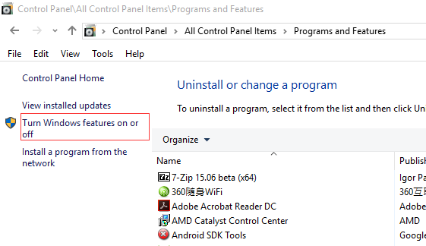

Select IIS(Internet Information Services)

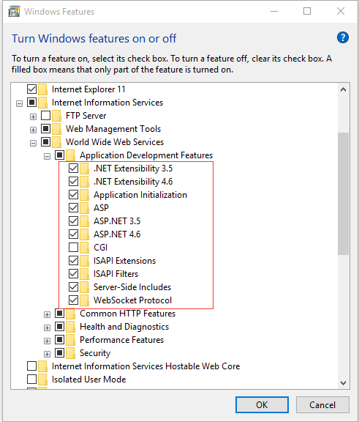

1. **Publish files to IIS**
   1. In Visual Studio, select project - > Publish…

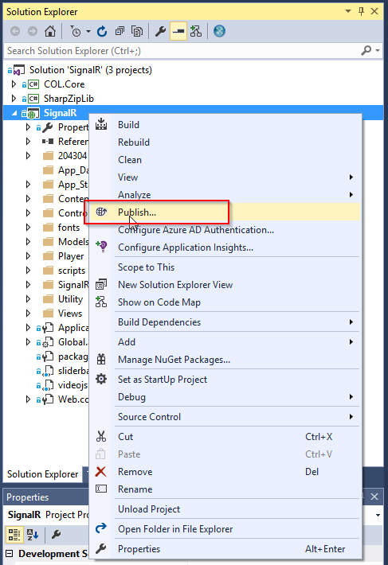

* 1. Create a new profile

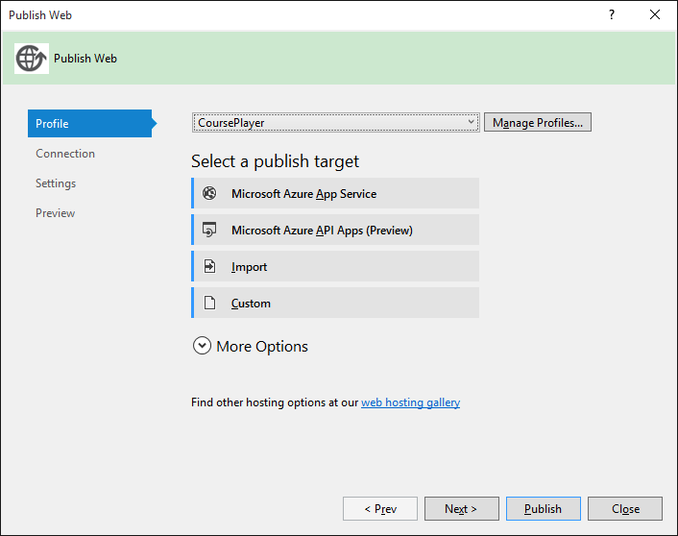

* 1. Connection, configure server and website. Here we choose the default website.

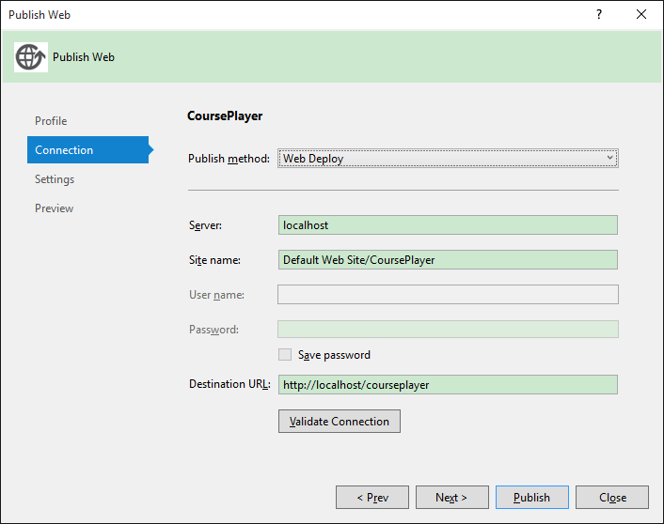

* 1. Settings, choose ‘Release’.

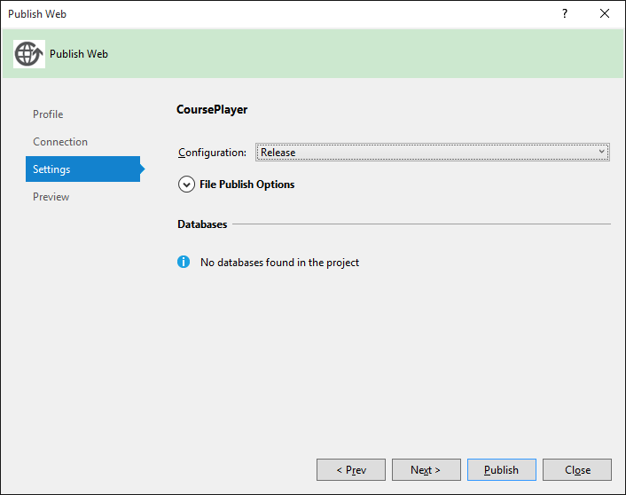

* 1. Preview, check what files are to be deployed.

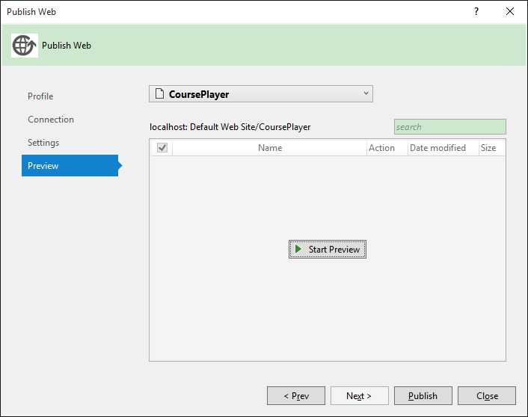

* 1. After publish, all of files are copied to ‘C:\inetpub\wwwroot\CoursePlayer’.

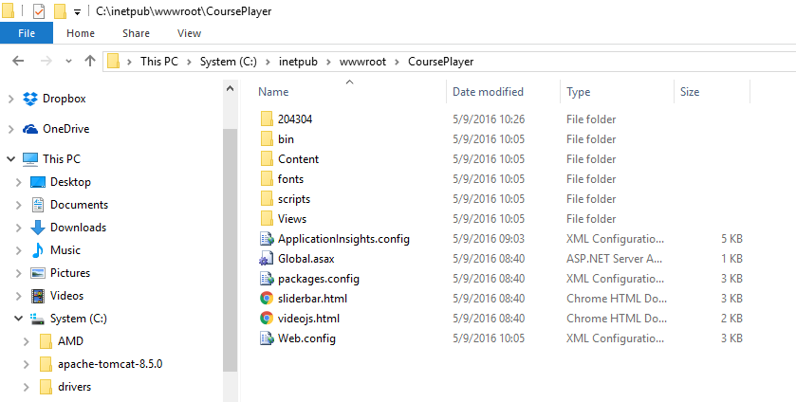

Your web browser is opened automatically and accesses your website.

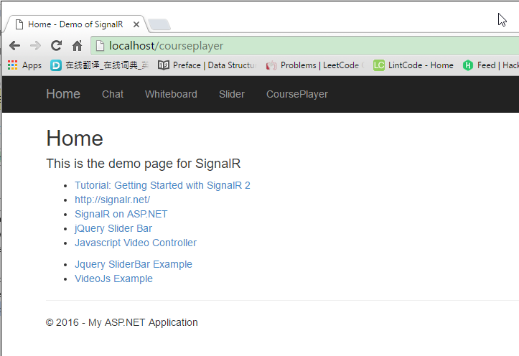

1. **Add Port Exception to Firewall**
   1. Control Panel -> Windows Firewall
   2. Advanced setting

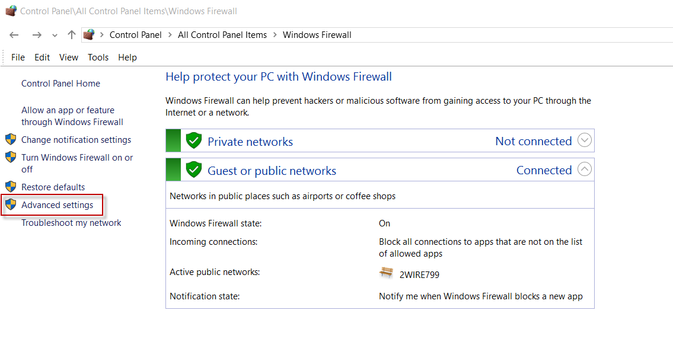

* 1. Inbound Rules -> New Rule…

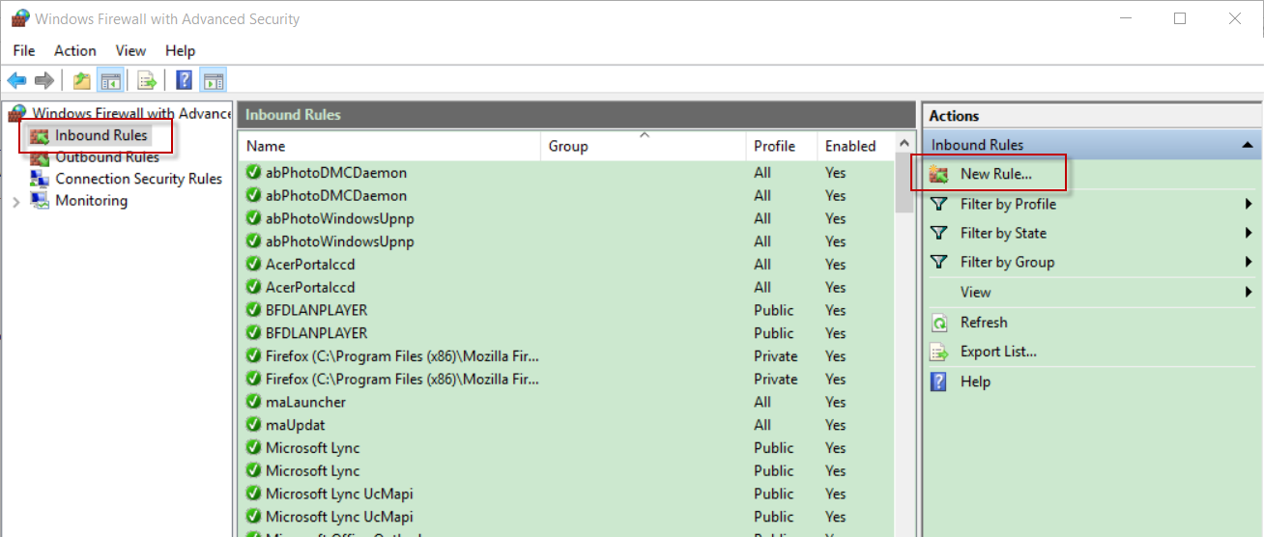

* 1. Rule Type

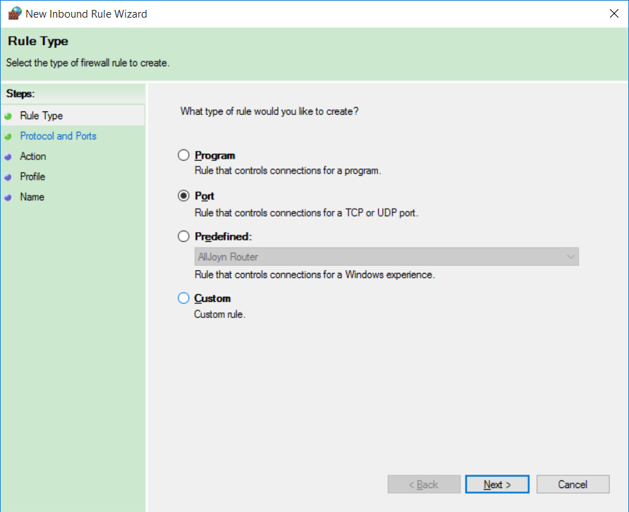

* 1. Protocol and Ports

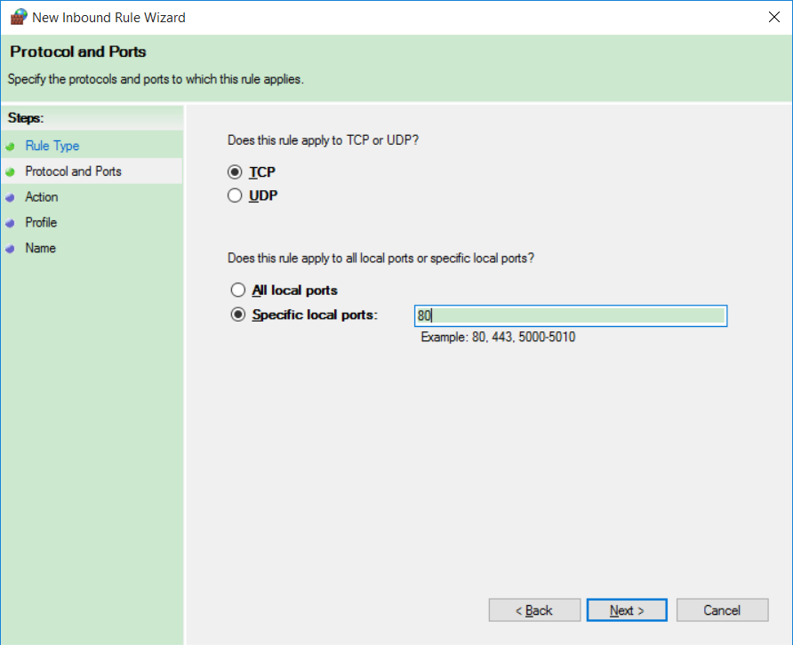

* 1. Action

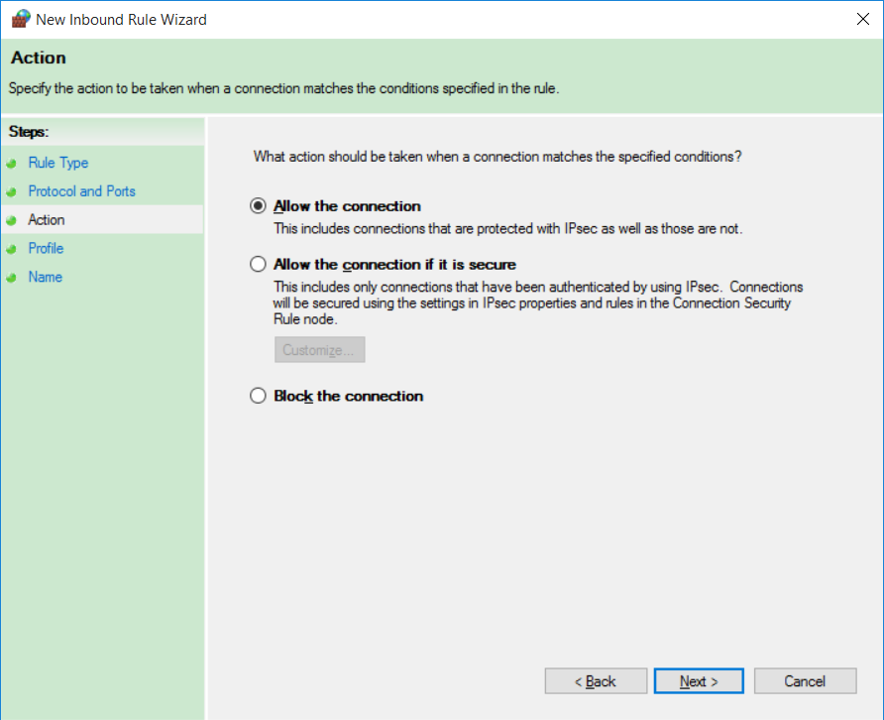

* 1. Profile

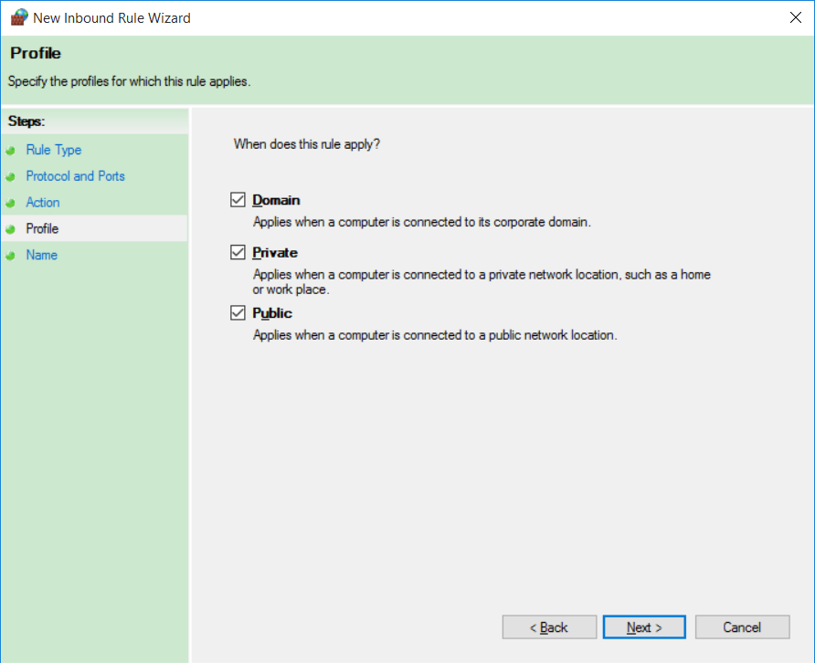

* 1. Name

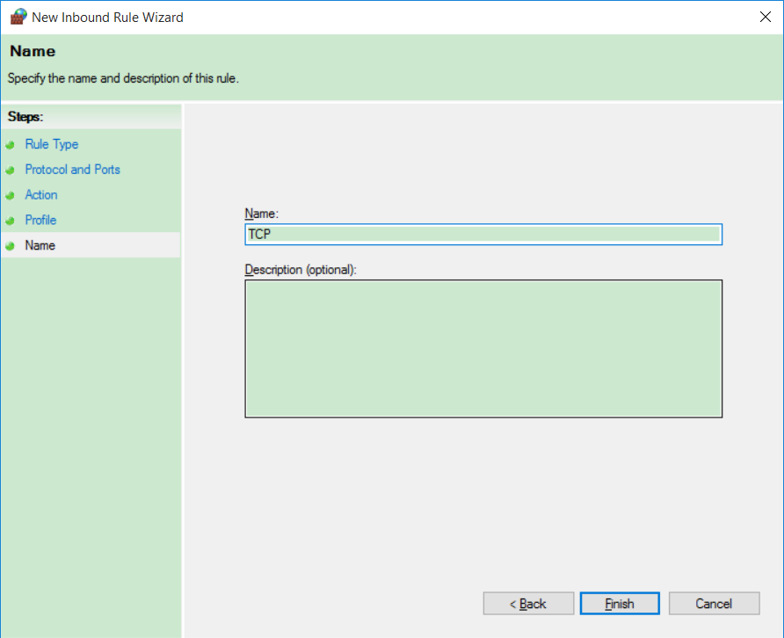

After the above steps, your machine is exposed to the outside world.

1. **Assign Public IP address to your website.**
   1. In IIS, add Binding to web site

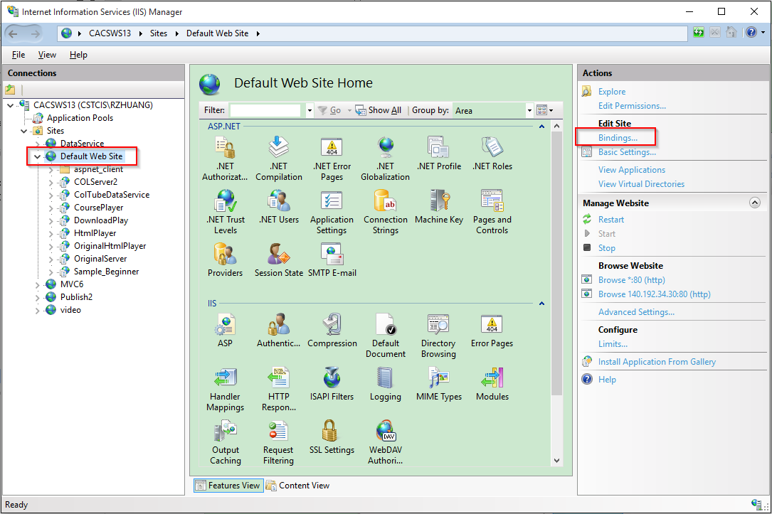

* 1. Set IP Address and Port.

If you choose another port, you must add the port number to firewall exception, refer to step 3.

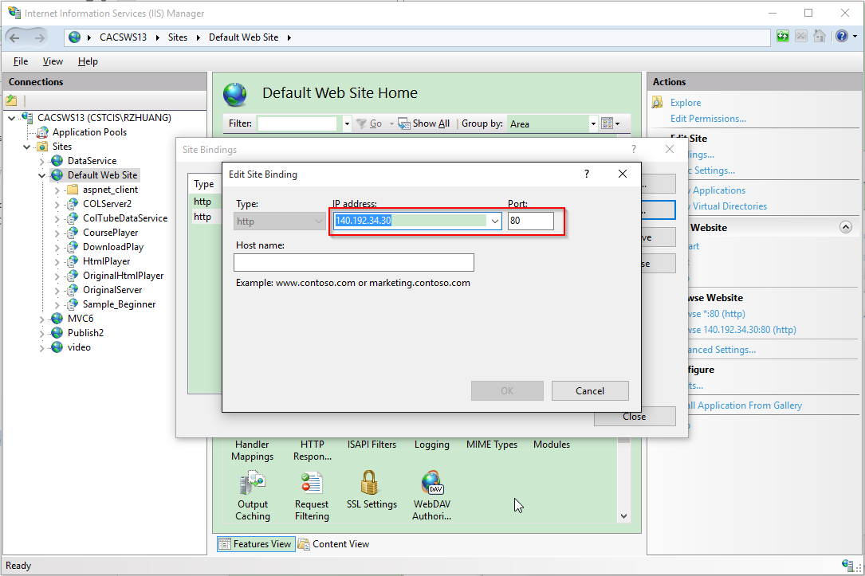

* 1. Access website with ip address, don’t miss the last slash.

<http://140.192.34.30/courseplayer>

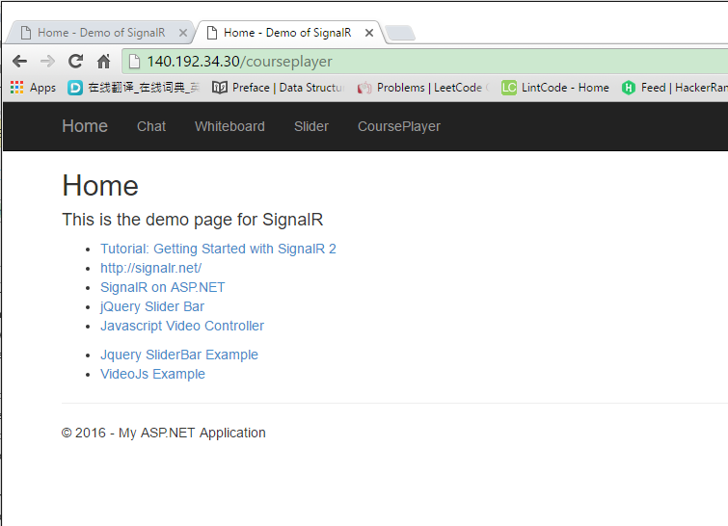

* 1. Try this address in another machine.