**Online Course Player with SignalR**

This web application is developed by SignalR based on WebSocket. There are several samples in this application which demonstrate what SignalR can do, described as follows:

* Chart
* Drawing Board
* Screen and Whiteboard
* Realtime Course Player

1. **Home Page**

Some resources which helped to build this application.

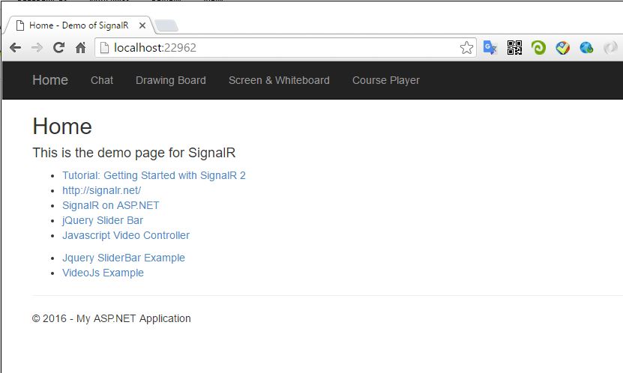

1. **Chat**

Use SignalR to implement an online chatting room. The basic feature of websocket, boardcasting.

* 1. First User (chrome)

To join the chatting room, you must provide a user name first.

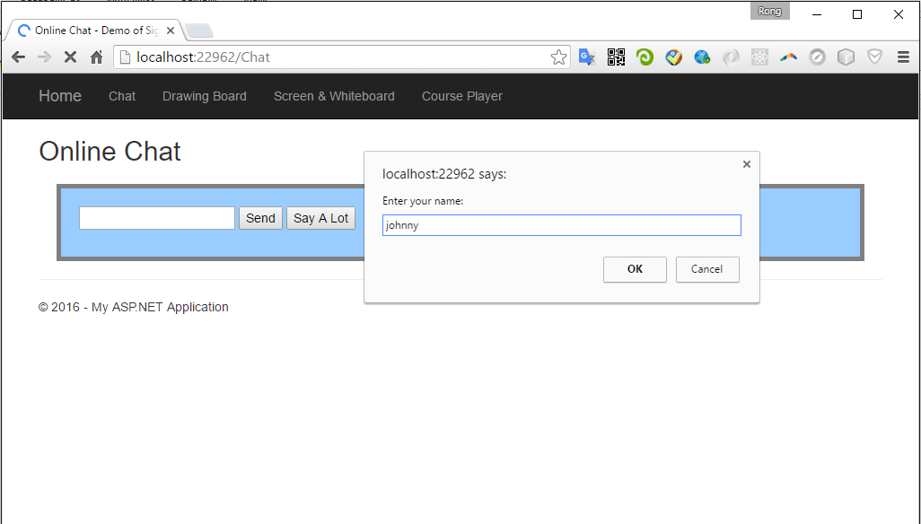

Input the message and click ‘Send’.

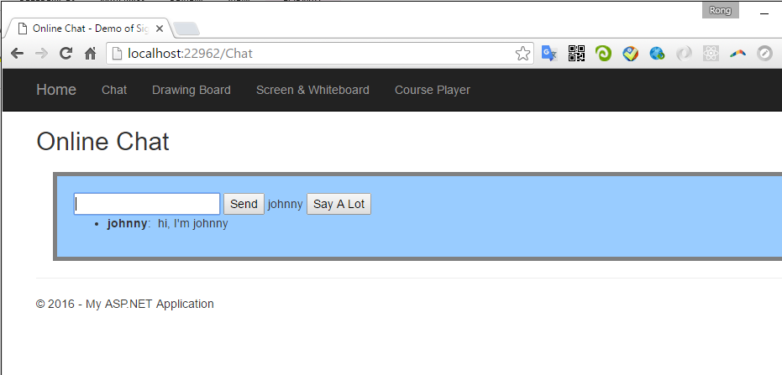

* 1. Second User(Firefox)

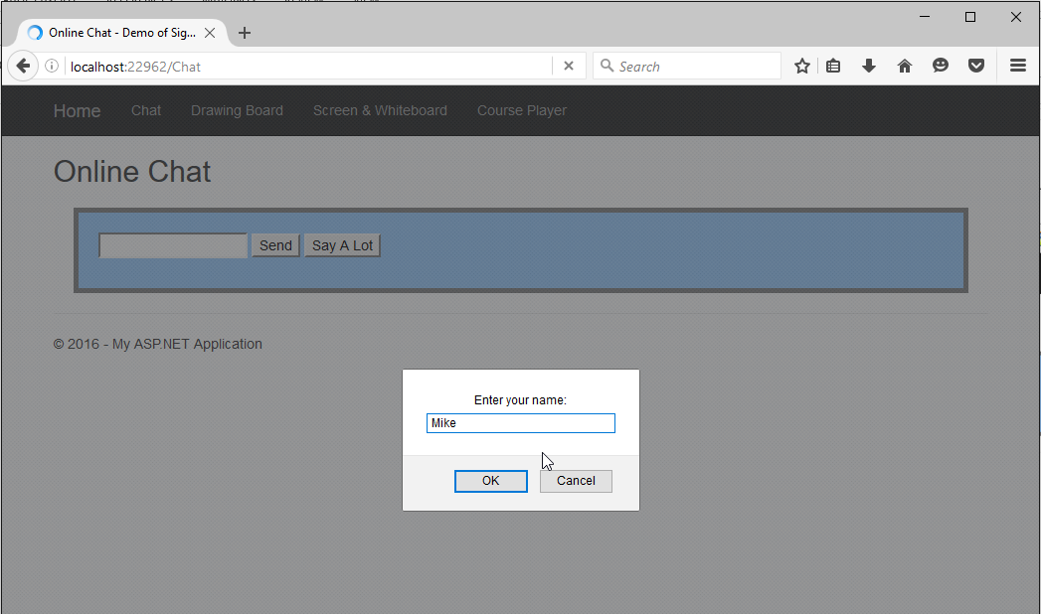

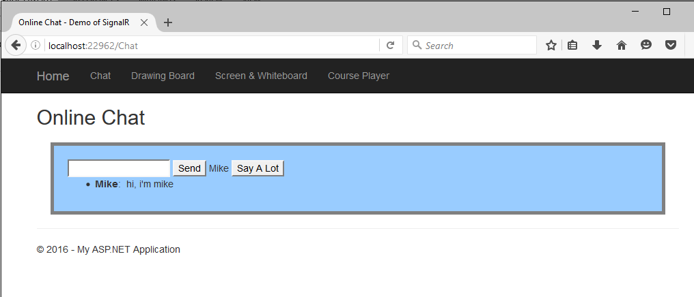

* 1. Go back to the first user. The message from mike is displayed without refreshing the web page.

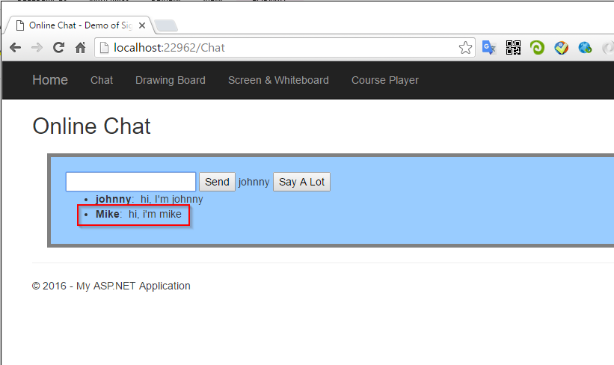

1. **Drawing Board**

User html5 canvas and SignalR to implement a drawing board. Any user can draw on the canvas and other users will see it immediately in their own boards.

* 1. Open drawing board with two browser, chrome and firebox.

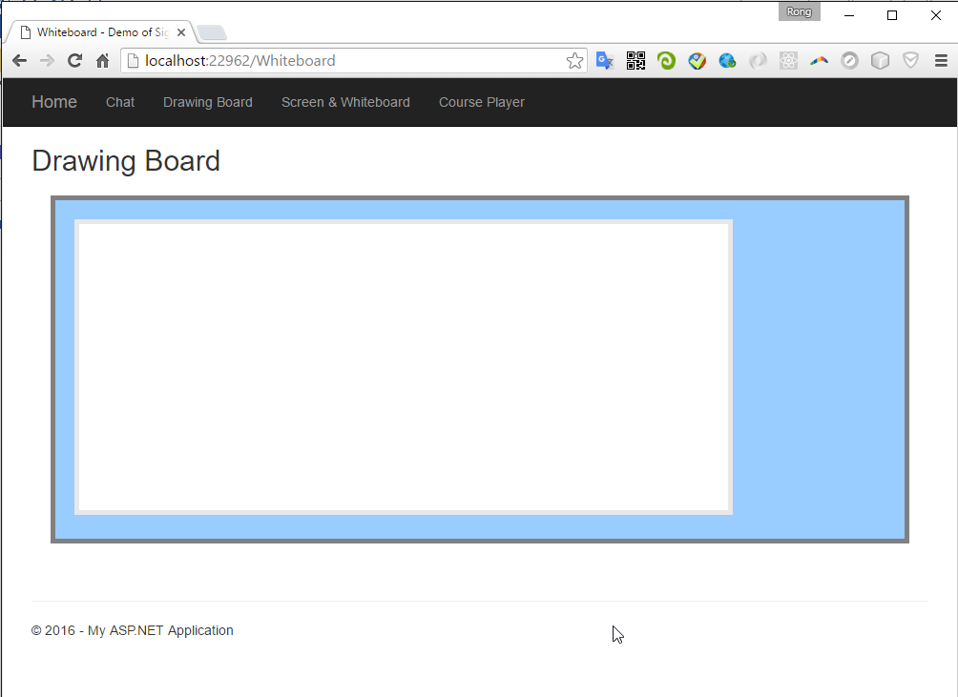

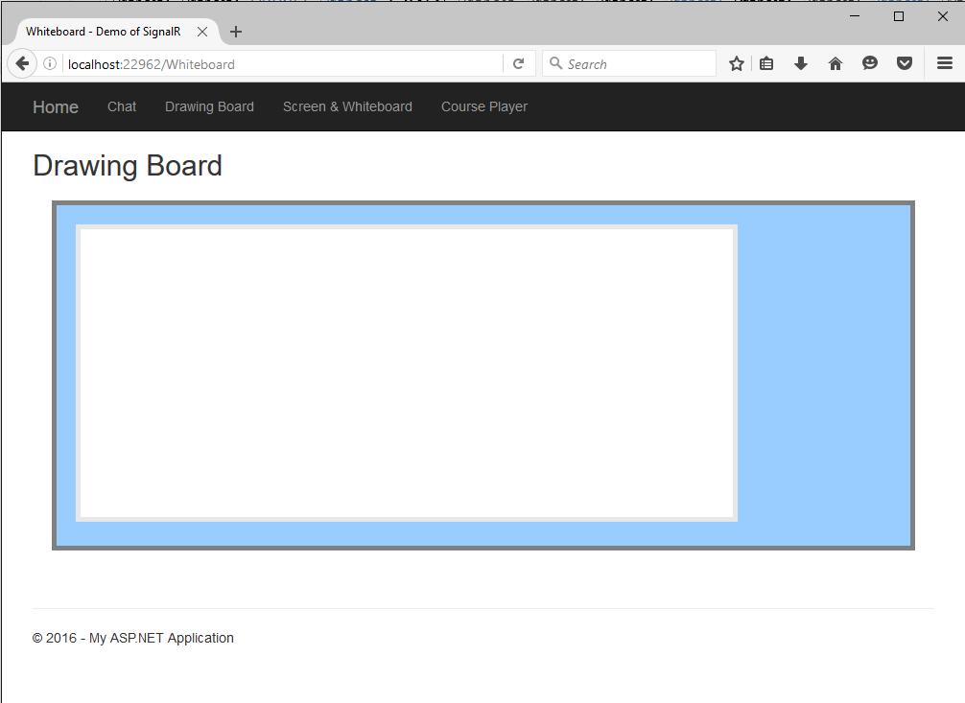

* 1. Begin drawing in chrome

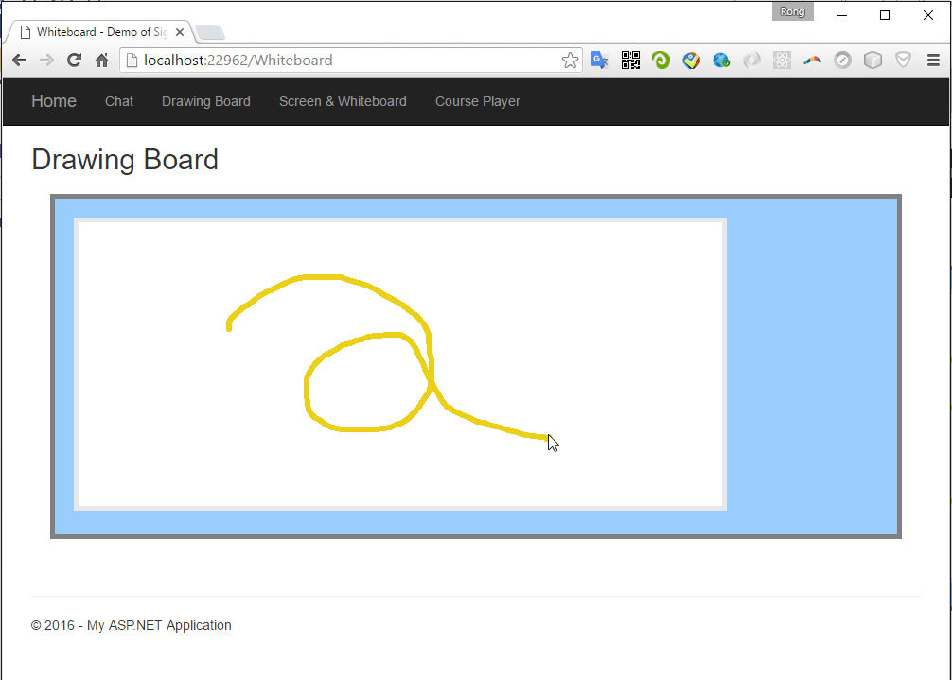

* 1. User two see the drawing in realtime.

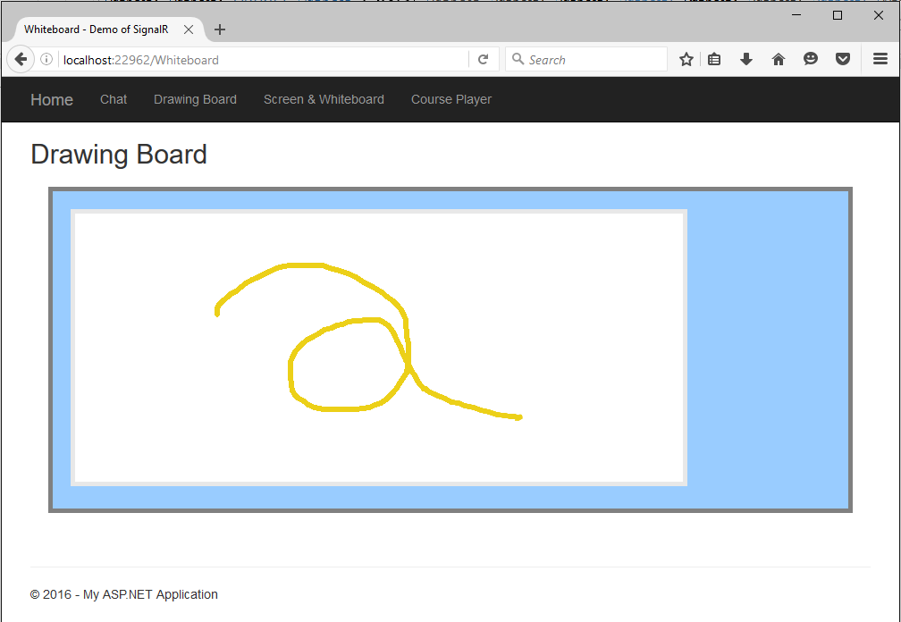

1. **Screen & Whiteboard**

A course play consists of three components, video, screen(images from project), whiteboard(drawing on the whiteboard from the instructor). The content of screen and whiteboard is synchronized alogn with the video. In this demo, I use a slider bar to simulate the video player.

Customer can purchase products, add them to the shopping cart and place order finally. And they can edit the quantity of the items in the cart.

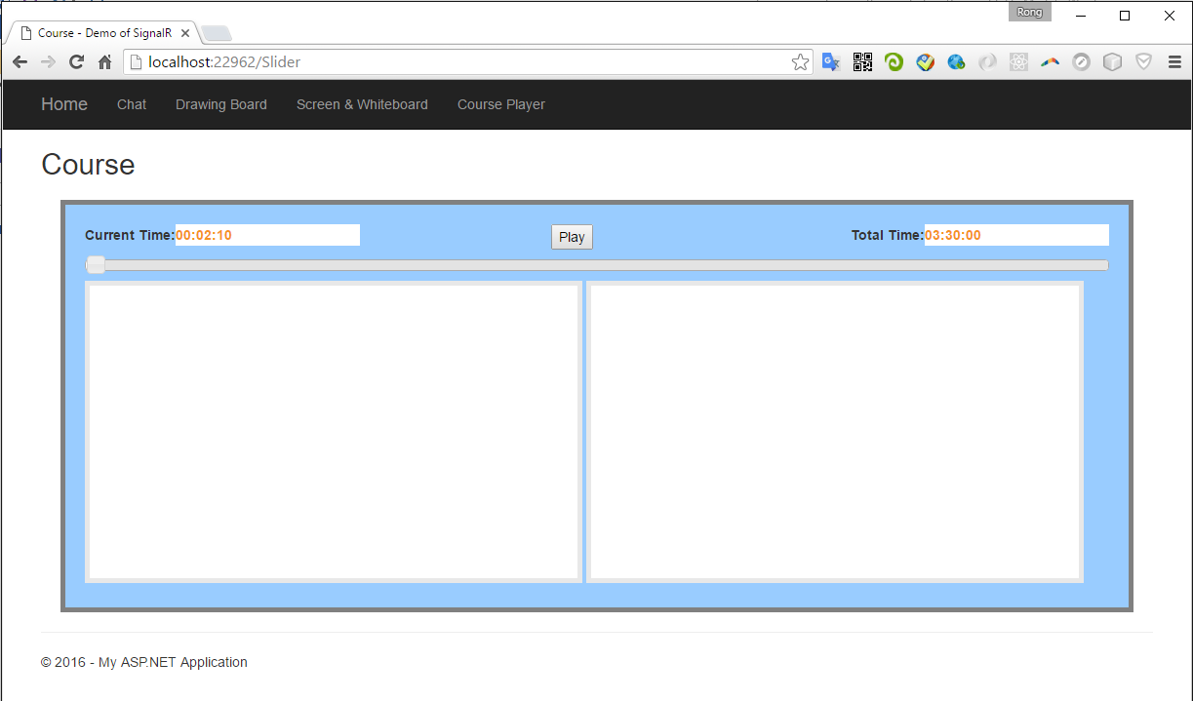

Provide address and credit card information.

Order is generated.

View My Order list. Here, you can cancel your order.

* 1. Play

Login with the default user ‘storemanager’ and password ‘storemanager’. Select the user type of ‘Store Manager’.

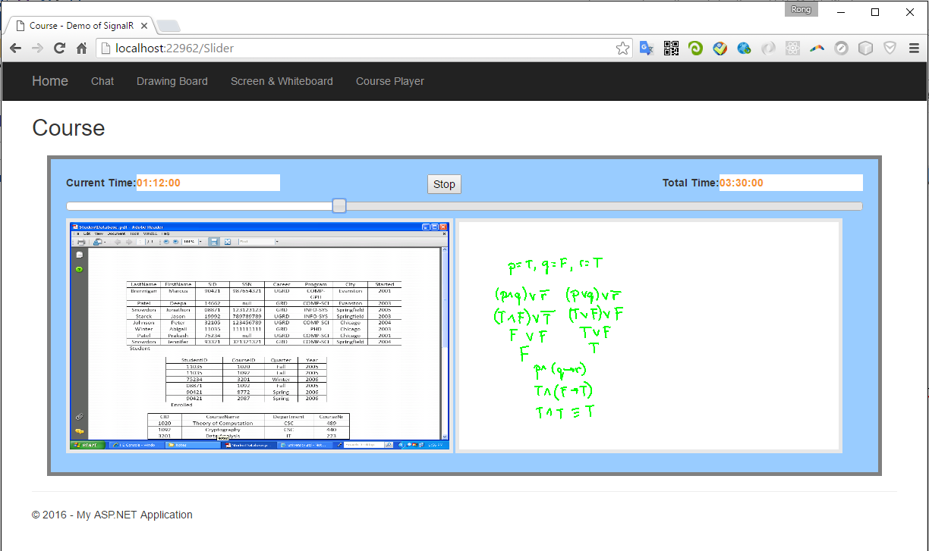

1. **Course Player**

Based on the previous sample, add the html 5 viedo player.

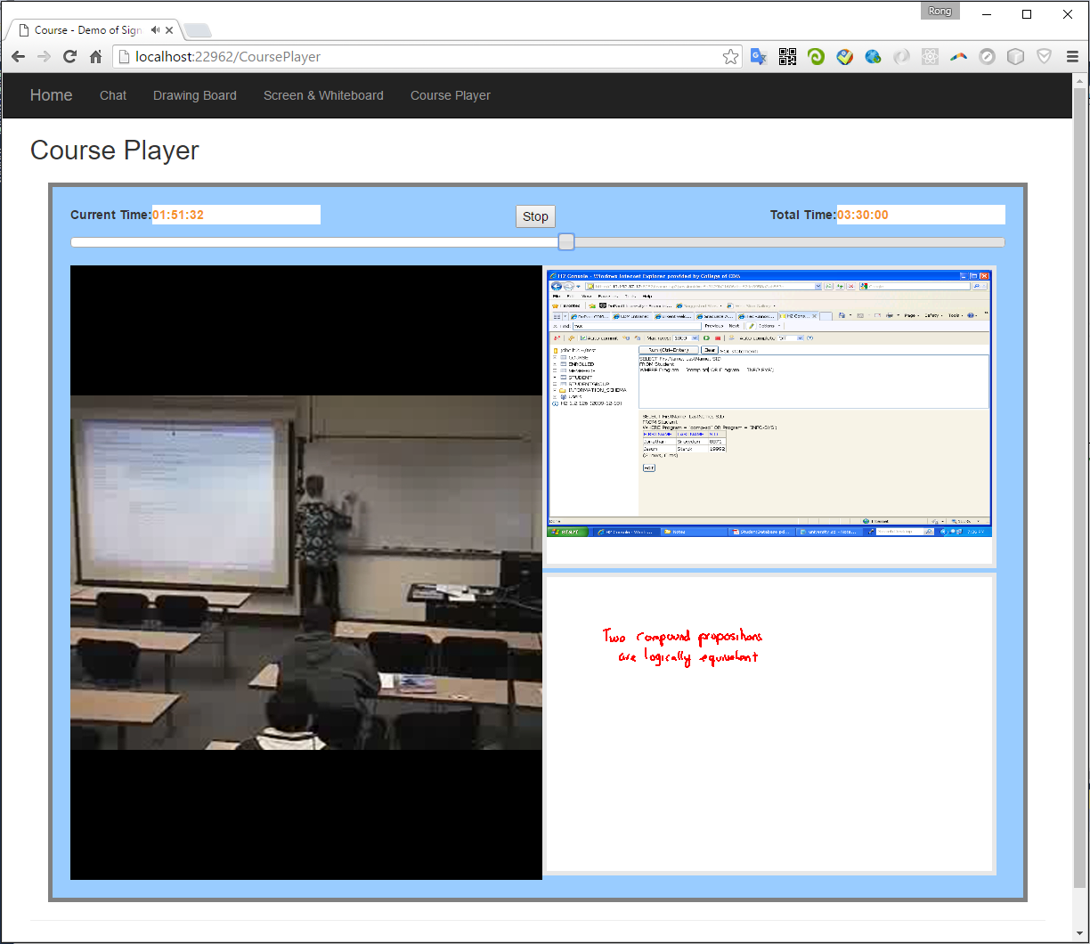

1. **Conclusion**

Cross-platform

Without install flash player, Silverlight.