Ethan Saenz

Intro to Graphics

Assignment 4

11/24/25

Part I (1 hour)
Prior to this portion of the assignment I reviewed the code from example 12 covered in class. It took me a while to understand, and frankly I still don’t really understand. I have been lost since we went to 3D but that’s another problem, I was able to use the cube shape code from assignment 3 and once I had that I ported the code from example 12 with some tweaks trying to understand the logic. I had an issue with certain faces remaining black regardless of the light position, I found out that I was applying the rotation to the light position as well so once I made the light position fixed, there was proper reflection and illumination for the square.
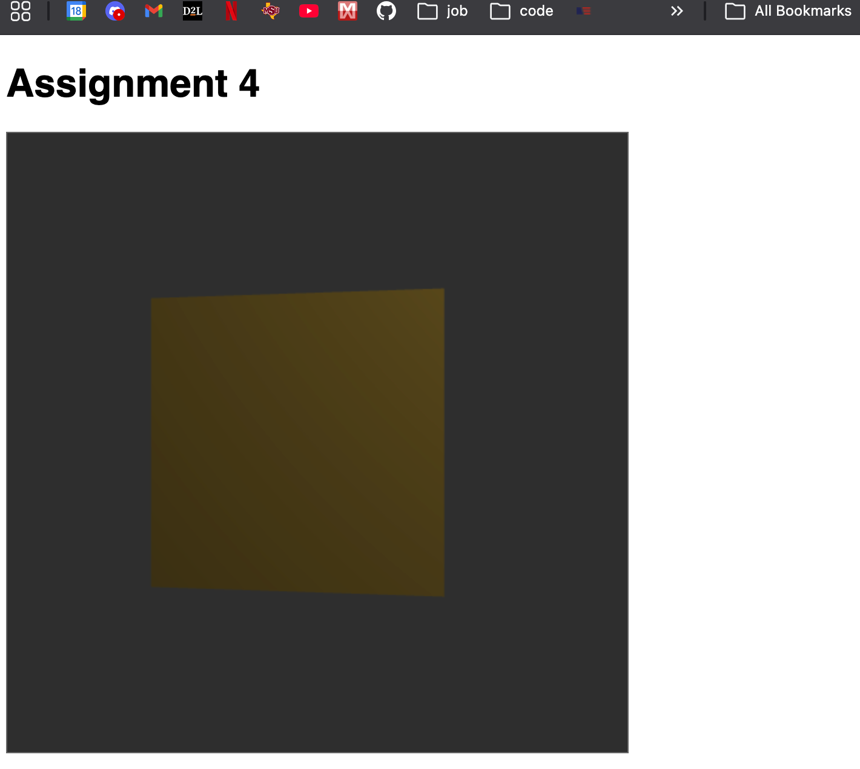

Part II (1 ½ hours)
I thought this portion would be quickest since all I thought I had to do was bring my shape code from assignment 3 and apply the rotation and lighting, it was more difficult than that, most likely self-inflicted. I went one at a time and got them to work starting with the tetrahedron down to the sphere. At this point I also used the materials.js from example 12 for the different materials and implemented code to allow for different materials to be selected in real-time. This was a bit difficult and I had to consult Gemini to help me get it working but once it was functional it was a very nice feature and really showed the importance of object material in illumination.
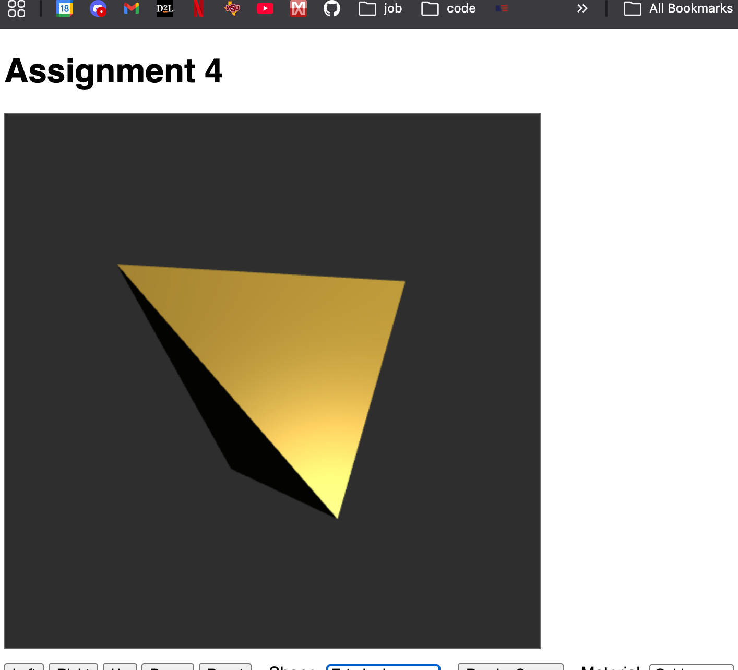
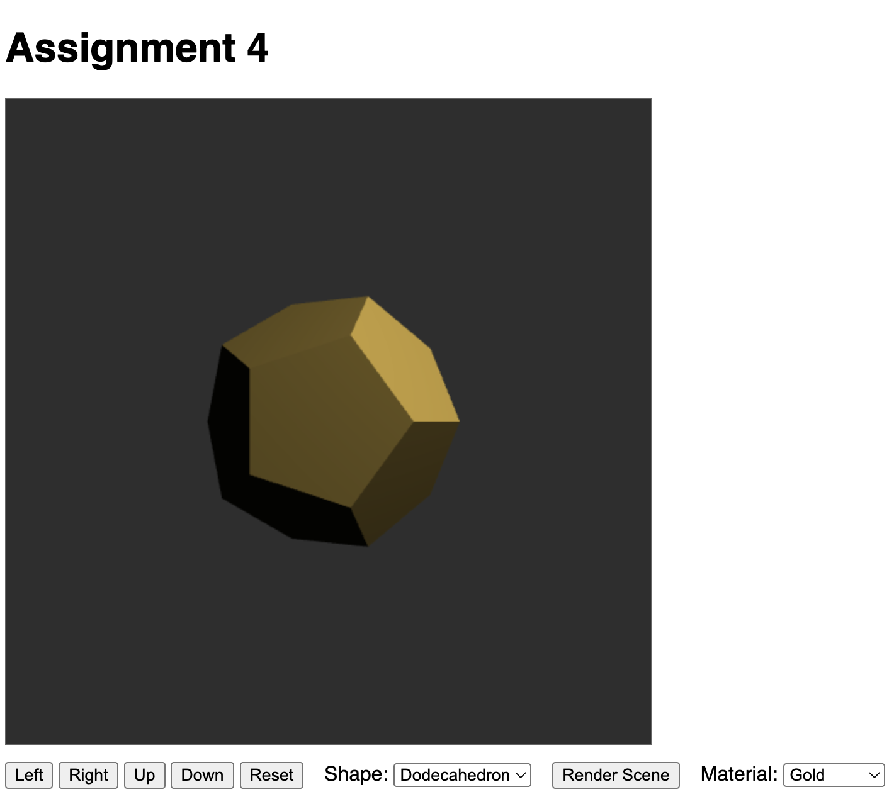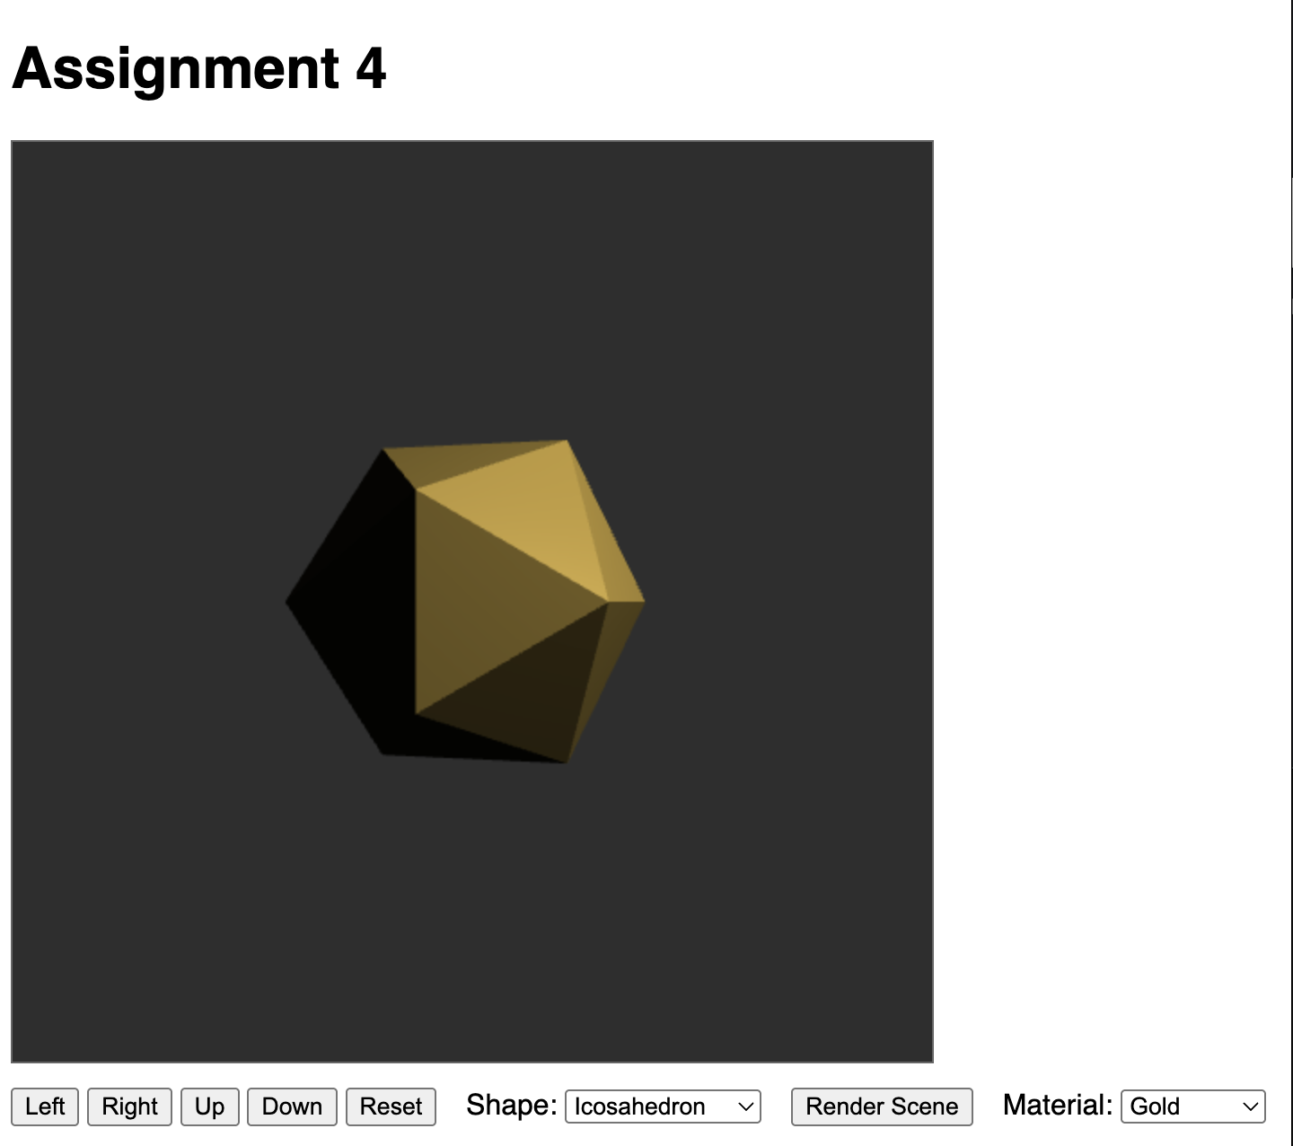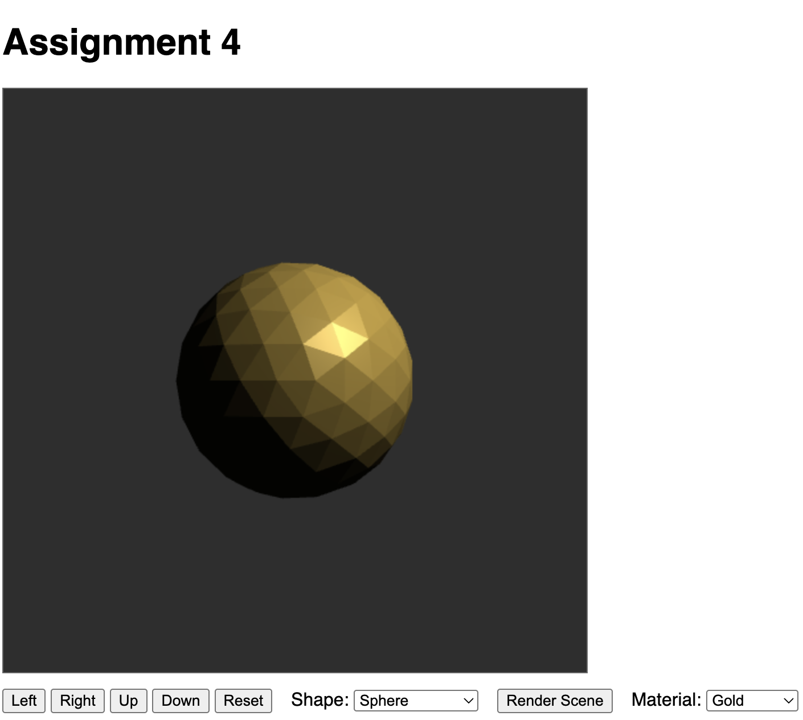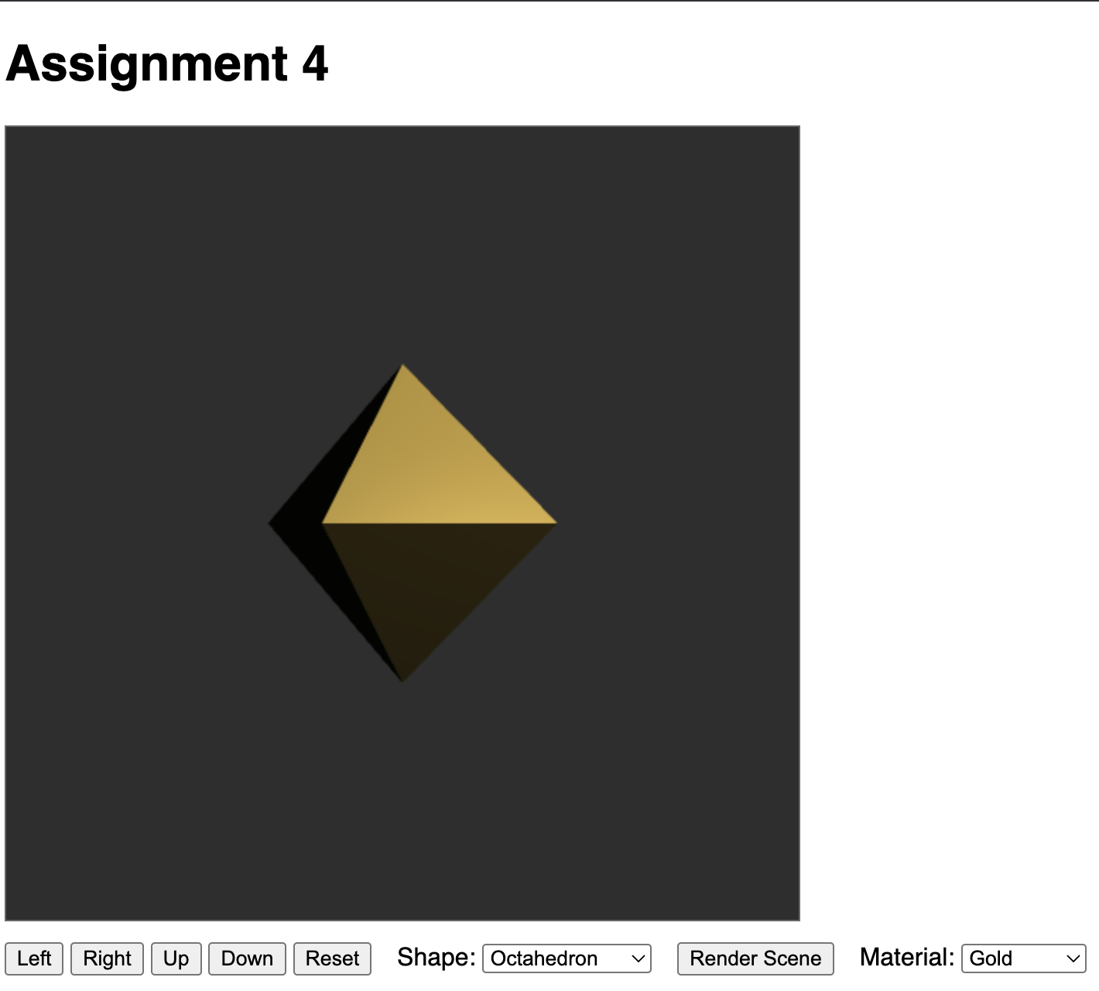
Part III (2 ½ hours)
This part took the longest due to the idea I had in mind. I had an idea to scale the existing scene from assignment 3 to make it to where all of the shapes were able to be rendered into the scene. I essentially took the scene from assignment 3 with the cube and added the lighting to it, this was the first piece. I then began experimenting with the tetrahedron to see what that code would look like. This took me a bit to get everything changed up from the existing scene with the cube to be able to handle the different vertices and faces from the other various shapes. But once I got the geometry and topology handled, adding the lighting wasn’t too difficult. Just using the existing code from the individual shapes to light the scene with constant rotation. I primarily used the scene API and UI to auto-rotate, light rotation, material switching, and illumination model cycling.

