

**Zhaokang Wang** received the BS degree in Nanjing University, China, in 2013. He is

currently working towards the Ph.D. degree in Nanjing University. His research

interests include large scale graph analysis algorithms and graph processing systems.



**Yunpan Wang** received the BS degree in University of Electronic Science and

Technology of China in 2018. He is currently working towards the Master degree in

Nanjing University. His research interests include distribute deep learning , graph

computing systems.

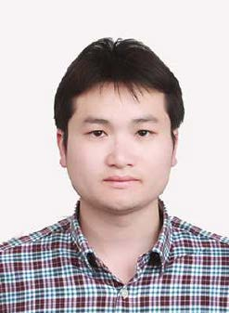

**Rong Gu** is an assistant researcher at State Key Laboratory for Novel Software

Technology, Nanjing University, China. Dr. Gu received the Ph.D. degree in

computer science from Nanjing University in December 2016. His research interests

include parallel computing, distributed systems and distributed machine learning.

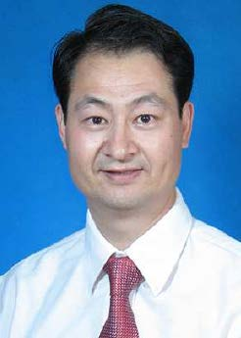

**Yihua Huang** is currently a professor in computer science department and State Key

Laboratory for Novel Software Technology, Nanjing University, China. He received

his bachelor, master and Ph.D. degrees in computer science from Nanjing University.

His main research interests include parallel and distributed computing, big data

parallel processing, distributed machine learning algorithm and system, and Web

information mining.



**Chunfeng Yuan** is currently a professor in the computer science department and

State Key Laboratory for Novel Software Technology, Nanjing University, China.

She received her bachelor and master degrees in computer science from Nanjing

University. Her main research interests include computer architecture, parallel and

distributed computing and information retrieval.