**LESS THAN OR GREATER THAN**

**FLOW CHART**

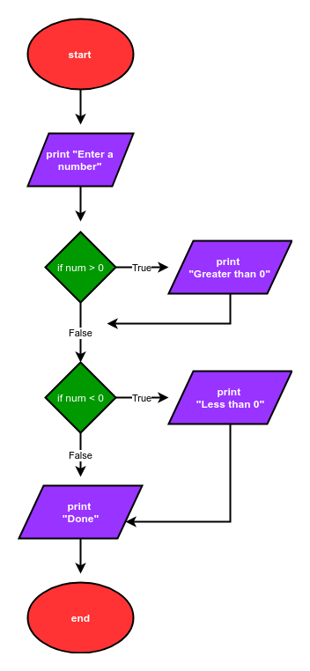

**PROGRAM**

num = input('Enter a number: ')

num = float(num)

if num>0:

print('num greater than zero')

if num<0:

print('num less than zero')

print('Done')