**MINIMUM NUMBER**

**FLOW CHART**

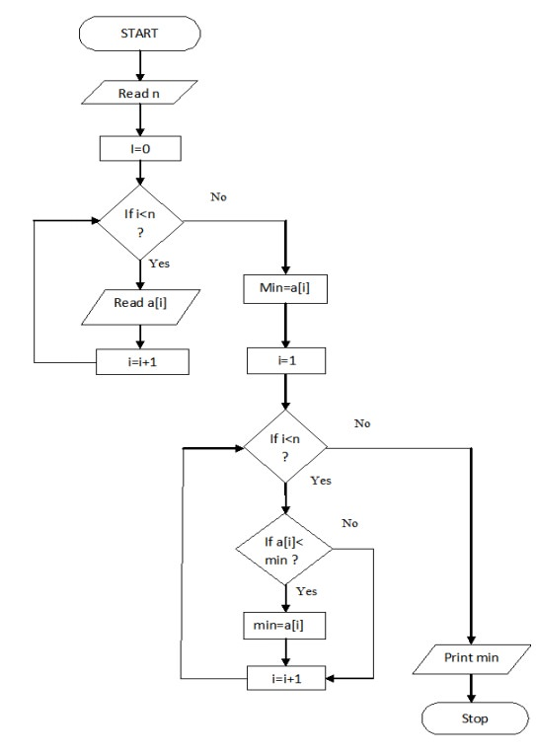

**PROGRAM**

BEGIN READ n

FOR i=0 to n, then

READ a[i]

INCREMENT i

END FOR

COMPUTE min=a[0]

FOR i=1 to n, then

IF a[i]<min, then

CALCULATE min=a[i]

INCREMENT i

ELSE

INCREMENT i

END IF-ELSE

END FOR

PRINT min

END