**INSERT A CARD IN A LIST OF SORTED CARDS**

**FLOW CHART**

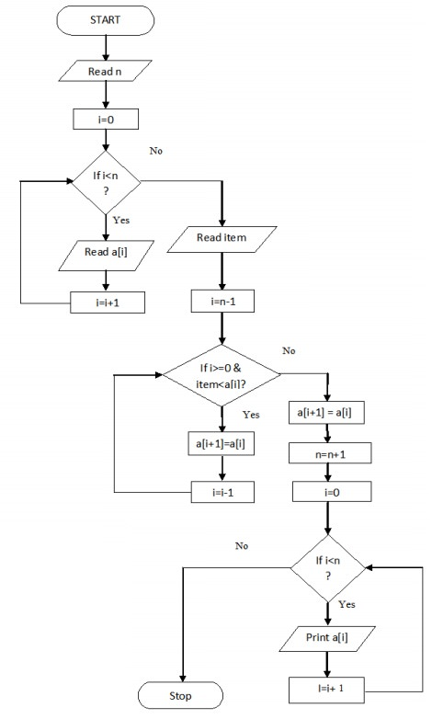

**PROGRAM**

READ n

FOR i=0 to n, then

READ a[i]

INCREMENT i

END FOR

READ item

FOR i=n-1 to 0 and item<a[i], then

CALCULATE a[i+1]=a[i]

DECREMENT i

END FOR

COMPUTE a[i+1]=a[i]

COMPUTE n=n+1

FOR i=0 to n, then

PRINT a[i]

INCREMENT i

END FOR

END