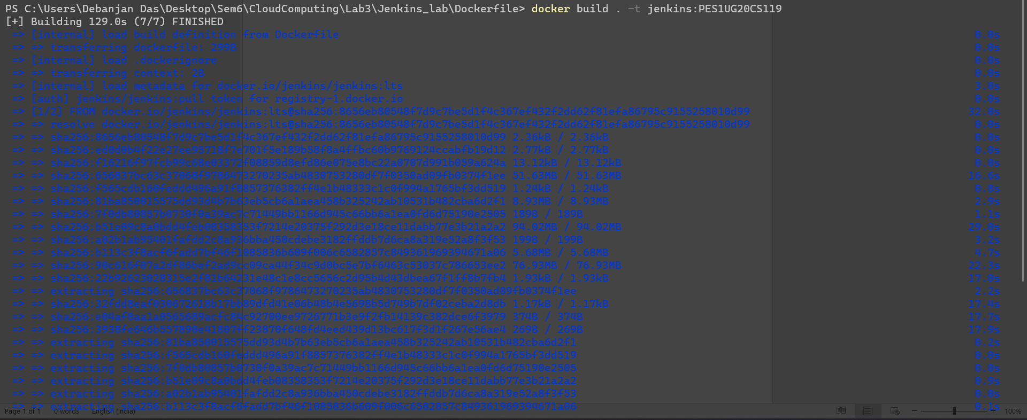

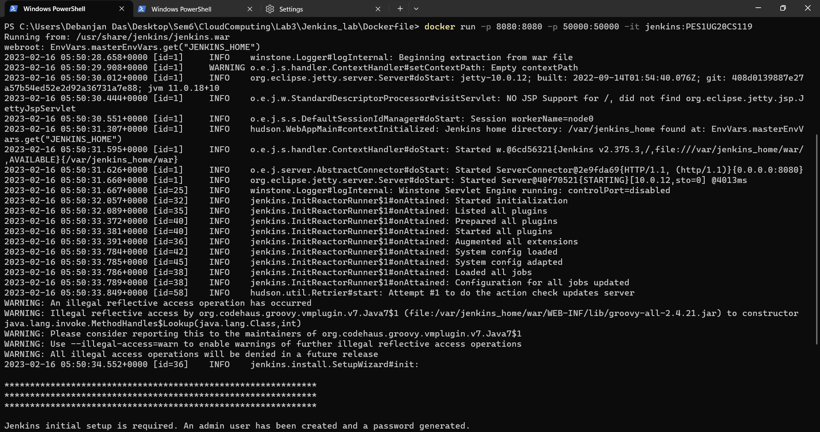

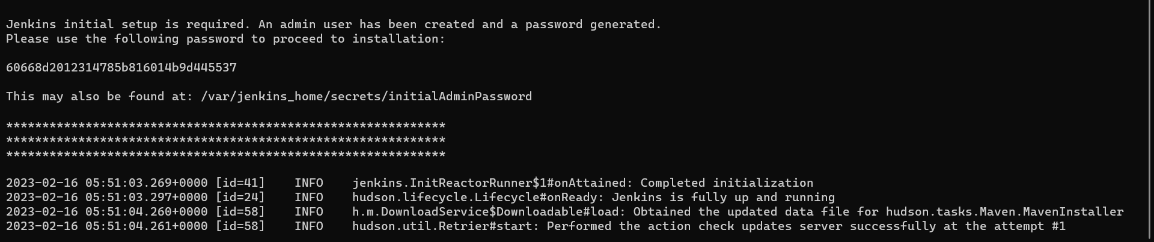

60668d2012314785b816014b9d445537

sflka813ujjhjsbdf2@