**上海电力学院**

**虚拟现实技术**

**实验报告**



**题目 keyboard**

**姓名 顾佳辉**

**专业 电子信息工程**

**班级 2015071**

**学号 20150744**

1. **实验目的**

运用键盘控制物体移动

1. **实验代码**

|  |  |
| --- | --- |
|  | #include <stdlib.h> |
|  | #include<GL/glut.h> |
|  | static int shoulder = 0, elbow = 0; |
|  |  |
|  | void init(void) |
|  | { |
|  | glClearColor (0.0, 0.0, 0.0, 0.0); |
|  | glShadeModel (GL_FLAT); |
|  | } |
|  |  |
|  | void display(void) |
|  | { |
|  | glClear (GL_COLOR_BUFFER_BIT); |
|  | glPushMatrix(); |
|  | glTranslatef (-1.0, 0.0, 0.0); |
|  | glRotatef ((GLfloat) shoulder, 0.0, 0.0, 1.0); |
|  | glTranslatef (1.0, 0.0, 0.0); |
|  | glPushMatrix(); |
|  | glScalef (2.0, 0.4, 1.0); |
|  | glutWireCube (1.0); |
|  | glPopMatrix(); |
|  |  |
|  | glTranslatef (1.0, 0.0, 0.0); |
|  | glRotatef ((GLfloat) elbow, 0.0, 0.0, 1.0); |
|  | glTranslatef (1.0, 0.0, 0.0); |
|  | glPushMatrix(); |
|  | glScalef (2.0, 0.4, 1.0); |
|  | glutWireCube (1.0); |
|  | glPopMatrix(); |
|  |  |
|  | glPopMatrix(); |
|  | glutSwapBuffers(); |
|  | } |
|  |  |
|  | void reshape (int w, int h) |
|  | { |
|  | glViewport (0, 0, (GLsizei) w, (GLsizei) h); |
|  | glMatrixMode (GL_PROJECTION); |
|  | glLoadIdentity (); |
|  | gluPerspective(65.0, (GLfloat) w/(GLfloat) h, 1.0, 20.0); |
|  | glMatrixMode(GL_MODELVIEW); |
|  | glLoadIdentity(); |
|  | glTranslatef (0.0, 0.0, -5.0); |
|  | } |
|  |  |
|  | void keyboard (unsigned char key, int x, int y) |
|  | { |
|  | switch (key) { |
|  | case 's': |
|  | shoulder = (shoulder + 5) % 360; |
|  | glutPostRedisplay(); |
|  | break; |
|  | case 'w': |
|  | shoulder = (shoulder - 5) % 360; |
|  | glutPostRedisplay(); |
|  | break; |
|  | case 'a': |
|  | elbow = (elbow + 5) % 360; |
|  | glutPostRedisplay(); |
|  | break; |
|  | case 'd': |
|  | elbow = (elbow - 5) % 360; |
|  | glutPostRedisplay(); |
|  | break; |
|  | case 27: |
|  | exit(0); |
|  | break; |
|  | default: |
|  | break; |
|  | } |
|  | } |
|  |  |
|  | int main(int argc, char** argv) |
|  | { |
|  | glutInit(&argc, argv); |
|  | glutInitDisplayMode (GLUT_DOUBLE | GLUT_RGB); |
|  | glutInitWindowSize (500, 500); |
|  | glutInitWindowPosition (100, 100); |
|  | glutCreateWindow (argv[0]); |
|  | init (); |
|  | glutDisplayFunc(display); |
|  | glutReshapeFunc(reshape); |
|  | glutKeyboardFunc(keyboard); |
|  | glutMainLoop(); |
|  | return 0; |
|  | } |

1. **结果截图**

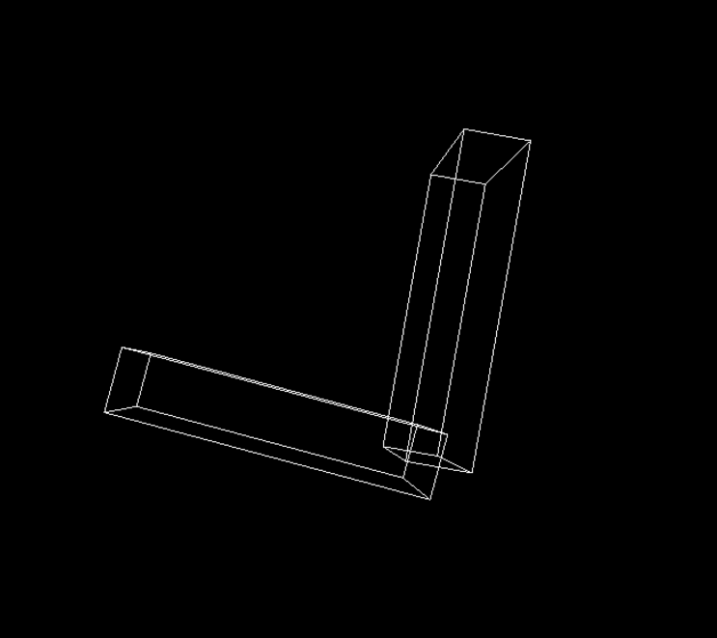

## 注释：通过键盘上的按键wsad控制机械臂的旋转，ws控制外臂，ad控制内臂。

1. **实验小结**

通过本次实验，我了解了键盘控制机械臂运作的操作流程和简单的原理，也对虚拟机有了更深一步的了解。