**ABSTRACT**

The traditional drug discovery process is often slow, expensive, and resource-intensive, posing major challenges for researchers and pharmaceutical developers. To address this, our project introduces an AI-driven platform that accelerates early-stage drug discovery by combining SMILES notation, 2D/3D molecular visualization, and predictive modeling. Leveraging machine learning frameworks, the platform generates novel molecular structures, assesses their chemical and pharmacological properties, and presents them through an intuitive interface. It employs RDKit for molecular manipulation, DeepChem and PyTorch for AI-based predictions, and NVIDIA’s MolMim for generative molecular design. Built as a web-based application using Next.js, TypeScript, and Flask, the platform offers real-time collaboration tools and secure authentication for seamless teamwork. Predictive analytics evaluate compound toxicity, solubility, and binding affinity, enabling early filtering of non-viable candidates. This AI-powered approach optimizes computational drug screening, enhances molecular data interpretability, reduces dependence on physical lab resources, and provides a scalable solution for academic researchers and pharmaceutical startups, promoting greater efficiency and innovation in drug discovery.

**CHAPTER 1**

**INTRODUCTION**

* 1. **Project Introduction**

Drug discovery remains one of the most resource-intensive and time-consuming endeavors in modern biomedical science. The need for novel therapeutic compounds has grown exponentially, particularly in response to emerging diseases, multidrug-resistant pathogens, and the increasing complexity of chronic conditions such as cancer and neurodegenerative disorders. Traditional drug discovery pipelines, which often rely on high-throughput screening and labor-intensive chemical synthesis, are limited by cost, time, and scalability. These limitations have prompted a growing interest in computational approaches that can accelerate the design and optimization of candidate molecules.

A critical bottleneck in early-stage drug development lies in the exploration of chemical space—estimated to contain over 10⁶⁰ drug-like molecules—making exhaustive experimental screening infeasible. Moreover, conventional in silico tools frequently lack the adaptability and precision required to navigate this space efficiently, often failing to generalize across diverse molecular structures and pharmacological profiles.

Recent advancements in deep learning and graph-based machine learning have opened new frontiers in molecular generation and property prediction. In particular, generative models, such as those based on reinforcement learning and graph neural networks (GNNs), have demonstrated promise in creating novel compounds .

This work presents an integrated web-based platform that combines molecular structure generation using SMILES notation, advanced 2D and 3D visualization, and real-time collaboration features tailored for research teams. Built upon state-of-the-art technologies including NVIDIA’s molecule generation models, RDKit.js, and PyTorch Geometric, our system enables users to design, visualize, and analyze molecular structures while also predicting their properties using machine learning models trained on datasets like PubChem and Tox21. This platform aims to democratize access to AI-driven drug discovery tools, fostering innovation and accelerating the translational pipeline from computational design to therapeutic validation.

* 1. **Problem Statement**

The process of discovering novel therapeutic compounds remains a fundamental bottleneck in pharmaceutical research and development. Despite significant investments, the rate of successful drug approvals continues to decline. The inability to efficiently explore vast chemical space, coupled with the high costs of synthesis and in vitro screening, impedes the rapid identification of promising lead molecules. In response, the integration of machine learning (ML) into molecular generation and property prediction offers an opportunity to transform early-stage drug discovery by enhancing speed, scalability, and predictive power.

This study investigates how machine learning models, particularly graph-based neural networks and generative algorithms, can be utilized to automate molecular design, predict compound properties, and facilitate the visualization and collaboration required for real-world application in drug discovery workflows.

Several key challenges motivate this investigation:

* Chemical data diversity and quality: Molecular datasets often vary widely in structure, annotation quality, and physicochemical relevance, complicating model training and validation.
* Molecular representation and feature engineering: Choosing between SMILES strings, molecular graphs, or learned embeddings requires careful consideration to balance expressiveness, interpretability, and computational tractability.
* Predictive performance and generalizability: Models must accurately forecast properties such as toxicity, solubility, and binding affinity, even for molecules outside the training distribution.
* Integration with visualization and human-in-the-loop systems: Effective use of predictions requires transparent, interactive tools for researchers to interpret, refine, and act on model outputs in real time.

Addressing these challenges will enable a shift from labor-intensive trial-and-error approaches to data-driven molecular innovation, accelerating the discovery of safe and effective therapeutics in an increasingly complex healthcare landscape.

* 1. **Motivation**

Motivation for this project stems from the urgent need to accelerate and democratize drug discovery, especially as global health systems face rising challenges from emerging diseases, drug-resistant pathogens, and complex, multifactorial conditions like cancer and neurodegeneration. Traditional drug discovery processes are no longer sufficient—costly, slow, and largely inaccessible to smaller research groups and under-resourced institutions.

In an era where vast chemical libraries and molecular data are increasingly available through initiatives like PubChem and ChEMBL, machine learning presents a transformative opportunity. By harnessing generative models and predictive algorithms, it is now possible to navigate immense chemical space, design novel compounds, and forecast therapeutic properties in silico—often in a fraction of the time and cost required for conventional lab-based workflows.

Scientifically, this project is fueled by the convergence of cheminformatics, deep learning, and molecular visualization. It represents a shift from descriptive to prescriptive discovery: enabling researchers not just to analyze existing compounds, but to intelligently generate and optimize new ones with desired properties.

From a societal perspective, reducing the time from molecule design to clinical validation means faster delivery of life-saving treatments, reduced drug development costs, and broader access to innovation. The proposed platform empowers researchers with intuitive, collaborative tools to drive this next generation of molecular innovation.

* 1. **Sustainable Development Goal of the Project**

This project strongly aligns with the United Nations Sustainable Development Goal (SDG) 3: **Good Health and Well-Being**. It directly contributes to the following targets:

* Target 3.B: Support research and development of vaccines and medicines for the communicable and non-communicable diseases that primarily affect developing countries, and provide access to affordable essential medicines.
* Target 3.4: Reduce by one third premature mortality from non-communicable diseases through prevention, treatment, and promotion of mental health and well-being.
* Target 3.D: Strengthen the capacity of all countries, in particular developing countries, for early warning, risk reduction, and management of national and global health risks.Through the use of artificial intelligence and open-access genomic datasets, this project supports:

By leveraging machine learning and open-access chemical and biomedical datasets, this project fosters:

* **Accelerated discovery of novel therapeutic compounds**, particularly for diseases that are neglected due to limited commercial incentives,
* **Cost-effective and scalable AI-driven tools** for drug development that can be utilized by researchers globally, regardless of institutional resources,
* **Collaborative, open-access science**, facilitating inclusive participation from diverse and underrepresented research communities.

Ultimately, this work contributes to building a more equitable, efficient, and sustainable global healthcare innovation ecosystem—empowering communities to combat disease through cutting-edge technology and accessible scientific tools.

**CHAPTER 2**

**LITERATURE SURVEY**

**2.1 Overview of the research area**

Drug discovery is undergoing a transformative shift, driven by the convergence of computational chemistry, artificial intelligence (AI), and molecular biology. Traditional methods for identifying drug candidates are often laborious, costly, and time-consuming, with a high rate of attrition during preclinical and clinical testing. As a result, there is an increasing demand for innovative, data-driven approaches that can accelerate the discovery pipeline while maintaining scientific rigor and clinical relevance.

Recent advances in machine learning (ML) and deep learning have created new opportunities in the design and analysis of chemical compounds. These technologies have demonstrated strong potential in modeling the relationships between molecular structure and biological activity, predicting physicochemical properties, and even generating novel molecules optimized for specific therapeutic goals. In particular, generative models such as variational autoencoders (VAEs), graph neural networks (GNNs), and reinforcement learning frameworks have shown the ability to propose structurally diverse and pharmacologically relevant molecules that may have otherwise remained unexplored.

To support these developments, publicly available datasets like PubChem, ChEMBL, and Tox21 offer massive repositories of molecular structures, bioactivity data, and toxicity information. Researchers now use a wide range of molecular representations—such as SMILES strings, molecular fingerprints, and graph-based descriptors—to train and evaluate ML models. However, challenges persist in terms of chemical space coverage, model interpretability, generalization to unseen compounds, and integration with domain-specific knowledge like ADMET profiling and synthetic feasibility.

The goal is not only to improve the computational discovery of drug-like molecules but also to build explainable, scalable tools that integrate seamlessly into real-world research and development workflows. By leveraging collaborative platforms and AI-powered visualization tools, this field is poised to redefine the way we approach therapeutic innovation—making drug development faster, more efficient, and accessible to a wider scientific community.

**2.2 Existing Models and Frameworks**

Numerous machine learning and deep learning models have been developed to assist in various stages of drug discovery, from predicting molecular properties to generating novel drug-like compounds. Traditional models such as **Random Forests (RF)**, **Support Vector Machines (SVMs)**, and **logistic regression** have historically been used for tasks like toxicity prediction, activity classification, and QSAR modeling due to their relative interpretability and strong baseline performance. Tools like **DeepChem** and **AutoQSAR** have made these techniques accessible for early-stage screening and property prediction.

More recently, **deep learning models** have revolutionized the field. **Graph Neural Networks (GNNs)**, in particular, have become a cornerstone for molecular modeling as they directly operate on graph-structured data, effectively capturing atomic and bond-level interactions. Frameworks such as **DGL-LifeSci** and **PyTorch Geometric** offer specialized tools for training GNNs on chemical datasets. Additionally, **transformer-based models** like **ChemBERTa** and **MolBERT** utilize SMILES representations to capture contextual information in a similar fashion to natural language, demonstrating high performance on property prediction and virtual screening tasks.

For molecule generation, **variational autoencoders (VAEs)**, **generative adversarial networks (GANs)**, and **reinforcement learning (RL)** frameworks have been employed to create novel compounds with optimized therapeutic profiles. Studies such as Gómez-Bombarelli et al. have demonstrated how VAEs can map chemical space into continuous latent spaces for exploration and optimization. Meanwhile, **REINVENT** and **MolDQN** leverage reinforcement learning to iteratively improve generated molecules based on specific reward functions tied to properties like bioactivity or synthetic accessibility.

Despite the encouraging results, these models face several limitations:

* **Chemical validity and novelty**: Generated molecules may not always be synthesizable or biologically relevant.
* **Data quality and imbalance**: Public datasets may have incomplete or noisy annotations, and certain drug classes are underrepresented.
* **Computational cost**: Training large models, particularly transformers and deep generative frameworks, can be resource-intensive.
* **Interpretability and trust**: Understanding why a model recommends a molecule is often unclear, limiting its immediate integration into critical decision-making pipelines.

As the field continues to mature, integrating these models into collaborative, web-based platforms that support visualization, real-time editing, and multi-user collaboration—such as the one developed in this project—will be key to making AI-driven drug discovery truly scalable and accessible.

**2.3 Limitations Identified from Literature Survey**

The existing literature on AI-driven drug discovery reveals several critical limitations that hinder the practical deployment of current models and frameworks in real-world pharmaceutical pipelines.

A primary concern is **limited generalizability**. Many generative or predictive models perform well on benchmark datasets but fail to extrapolate effectively to new chemical spaces or biologically distinct targets. This can be attributed to **dataset bias**, **overfitting**, and a lack of diverse compound libraries, particularly for rare or novel therapeutic areas.

Another significant issue is **interpretability**. Deep generative models and GNNs, while powerful, often act as “black boxes.” Understanding the rationale behind molecular generation or property prediction remains opaque. Without transparent feature attribution or rationale, chemists and clinicians may be reluctant to adopt these tools in critical decision-making processes.

**Data quality and representation** also pose barriers. Public datasets such as PubChem and ChEMBL, while extensive, can suffer from inconsistencies in assay protocols, missing labels, and noise in bioactivity annotations. Furthermore, molecular representations like SMILES or graphs each carry trade-offs in terms of expressiveness, complexity, and model compatibility.

From an infrastructural standpoint, **computational requirements** for training large models—especially transformers or reinforcement learning agents—can be prohibitive. This makes them inaccessible to smaller labs or early-stage biotech firms lacking high-performance computing resources.

Finally, there is a **gap in end-to-end clinical integration**. Most models are tested in silico with little or no feedback from wet-lab validation or real-world trials. Moreover, few systems offer collaboration tools, version control for molecule iteration, or real-time feedback from domain experts, all of which are essential for successful translational research.

Addressing these limitations is crucial for building robust, explainable, and widely adoptable AI systems that can truly accelerate the drug discovery lifecycle from ideation to preclinical testing.

**2.4 Research Objectives**

The primary aim of this research is to develop an AI-driven, scalable, and interpretable platform that facilitates the generation and evaluation of novel drug-like molecules using machine learning, with a focus on overcoming the limitations identified in existing frameworks. The project seeks to support early-stage drug discovery by integrating molecular generation, structural visualization, and collaborative features into a unified system. Specific objectives include:

* **To design and implement a generative pipeline** capable of creating chemically valid, synthesizable molecules using advanced models such as graph neural networks (GNNs), variational autoencoders (VAEs), or reinforcement learning frameworks.
* **To develop predictive models for molecular property estimation** (e.g., toxicity, drug-likeness, binding affinity) trained on open-source datasets such as PubChem, ChEMBL, and Tox21, while maintaining high accuracy and generalizability across unseen compounds.
* **To enhance model interpretability** by incorporating explainable AI techniques such as attention visualization, SHAP values, or feature attribution mechanisms, allowing researchers to trace molecular predictions to specific substructures or properties.
* **To address computational scalability and accessibility** by optimizing model architectures and enabling deployment in resource-constrained environments, leveraging cloud services and modular inference pipelines.
* **To integrate 2D/3D molecular visualization tools** (e.g., RDKit.js, WebGL) for interactive inspection, structure editing, and stereochemistry validation, enabling researchers to iterate on and refine candidate molecules.
* **To support collaborative workflows** via real-time messaging, molecule sharing, and version control, creating a seamless platform for interdisciplinary research between computational chemists, biologists, and clinicians.
* **To promote open science and reproducibility**, making all datasets, models, and tools available through open-access platforms, and encouraging contribution and validation from the broader scientific community.

By pursuing these objectives, this research intends to bridge the gap between in silico molecular design and practical drug discovery, enabling faster, more efficient, and more transparent development of new therapeutics.

**2.5 Product Backlog**

|  |  |
| --- | --- |
| S.No. | User Stories |
| #US 1 | As a researcher, I want to visualize molecular structures in 2D/3D so that I can analyze chemical properties. |
| #US 2 | As a developer, I want to input SMILES notation and generate a molecular structure so that I can create custom molecules. |
| #US 3 | As a scientist, I want to generate new molecules based on AI predictions so that I can explore potential drug candidates. |
| #US 4 | As a research team, we want to collaborate in real-time on molecular structures so that we can improve research efficiency. |
| #US 5 | As a user, I want to chat and annotate molecular structures so that I can communicate with my team effectively. |
| #US 6 | As a researcher, I want to predict molecular properties like solubility and toxicity so that I can assess potential applications. |
| #US 7 | As a user, I want my molecular data securely stored so that I can access my research anytime. |
| #US 8 | As a developer, I want to integrate external molecular databases so that I can use existing research data. |
| #US 9 | As an admin, I want to manage user roles and permissions so that I can control data access. |
| #US 10 | As a researcher, I want to export molecular data and reports so that I can document my findings. |
| #US 11 | As a user, I want to search and filter molecules so that I can quickly find specific structures. |
| #US 12 | As a researcher, I want to track changes to molecular structures so that I can revert to previous versions. |
| #US 13 | As a chemist, I want to predict reactions between molecules so that I can explore synthesis pathways. |
| #US 14 | As a user, I want a customizable dashboard so that I can tailor the interface to my workflow |
| #US 15 | As a researcher, I want a mobile-friendly UI so that I can access molecular data on the go. |

The product backlog of project was configured using the MS planner Agile Board which is represented in the following Figure 1.1. The Product Backlog consists of the complete user stories of the project.

Each user story consists of necessary parameters like MoSCoW prioritization, Functional and non-functional parameters, detailed acceptance criteria with linked tasks.

**2.6 Plan Of Action**

**Week 1: Data Collection & Preprocessing**

* **Tasks:**
  + Collect molecular datasets (e.g., PubChem, ChEMBL, Tox21).
  + Preprocess the data by cleaning and removing duplicates or inconsistencies.
  + Check for missing or incomplete data and perform imputation or exclusion as needed.
  + Align molecular structures with activity labels (e.g., IC50, binding affinity).
  + Ensure the dataset is ready for feature extraction and model training.

**Week 2: Exploratory Data Analysis (EDA) & Feature Engineering**

* **Tasks:**
  + Perform EDA to analyze the dataset’s structure, feature distributions, and correlations.
  + Visualize the molecular features (e.g., using histograms, box plots) and identify outliers.
  + Apply dimensionality reduction methods like PCA or t-SNE to explore data in lower dimensions.
  + Start feature selection by evaluating the importance of different molecular features.
  + If necessary, apply techniques like SMOTE for class balancing to handle imbalanced datasets.

**Week 3: Initial Model Training & Hyperparameter Tuning**

* **Tasks:**
  + Train initial machine learning models such as Graph Neural Networks (GNN), Random Forest, or XGBoost for molecular property prediction.
  + Conduct grid or randomized search for hyperparameter tuning to improve model performance.
  + Implement cross-validation techniques to ensure model generalizability and reduce overfitting.
  + Evaluate the models based on standard metrics such as accuracy, precision, recall, and F1 score.

**Week 4: Model Refinement & Evaluation**

* **Tasks:**
  + Select the top-performing model based on the evaluation metrics from Week 3.
  + Perform in-depth analysis of the model, including feature importance using built-in methods (e.g., SHAP, LIME for interpretability).
  + Cross-validate the model against a separate holdout/test set to ensure robustness and prevent overfitting.
  + Fine-tune the model further by adjusting hyperparameters and re-evaluating its performance.

**Week 5: Visualizations & Report Writing**

* **Tasks:**
  + Create visualizations for model evaluation, such as ROC curves, confusion matrices, and feature importance plots.
  + Interpret the key results, discussing the model’s strengths, weaknesses, and potential improvements.
  + Draft a detailed project report summarizing the entire process, including methods, results, and conclusions.
  + Provide insights into how the model can be used in practical applications for drug discovery.

**Week 6: Final Presentation & Code Documentation**

* **Tasks:**
  + Create a final presentation draft summarizing the entire project, including key findings and potential impact on drug discovery.
  + Incorporate citations, references, and proper documentation for the codebase.
  + Post the final code and documentation to GitHub, ensuring that everything is accessible and reproducible for the broader scientific community.

**CHAPTER 3**

**SPRINT PLANNING AND EXECUTION METHODOLOGY**

**3.1 SPRINT 1**

**3.1.1 Sprint I Objectives with User Stories**

Sprint I aims to establish the foundational components of the drug discovery platform, including the input of molecular data, management of user roles, and initial UI designs for better accessibility. The objectives include integrating SMILES notation for molecule creation, implementing role-based user permissions, and developing a customizable, mobile-friendly UI for user experience. The primary deliverables will be the functional SMILES input system, the role-based user access system, and a prototype of the mobile-responsive UI.

User Stories:

* + **As a developer**, I want to implement the functionality to input SMILES notation and generate a molecular structure so that users can create custom molecules easily.
  + **As an admin**, I want to manage user roles and permissions so that I can control and restrict access to sensitive data and features.
  + **As a user**, I want a customizable dashboard so that I can tailor the interface to suit my specific needs and workflow.
  + **As a researcher**, I want the platform to be mobile-friendly so that I can access molecular data and tools conveniently while on the go.

Key Deliverables:

* + A working SMILES input system that generates molecular structures.
  + Role-based access control implemented and tested.
  + A responsive, customizable dashboard prototype for mobile and desktop views.

This sprint will lay the groundwork for subsequent development phases, focusing on core functionality and user experience. Key tasks will include ensuring the correct setup of user roles, testing the molecule generation feature, and ensuring the UI is accessible across devices.

**3.1.2 Functional Document**

Sprint I focused on enabling core features for the drug discovery platform, including SMILES input for molecular structure generation, user role management, a customizable dashboard, and a mobile-friendly UI.

**1. Molecular Structure Generation from SMILES Notation**

* **Objective**: Allow users to input SMILES notation and generate molecular structures.
* **Implementation**: Integrated RDKit for converting SMILES to 2D molecular structures.
* **Outcome**: Users can now input SMILES and view the corresponding molecular structure.

**2. Role-Based User Access Control**

* **Objective**: Admins can manage user roles and permissions for feature access.
* **Implementation**: Implemented RBAC system using Node.js, JWT, and MongoDB.
* **Outcome**: Admins can assign roles and manage feature access.

**3. Customizable Dashboard**

* **Objective**: Allow users to personalize their dashboard layout.
* **Implementation**: Developed a customizable React dashboard using Redux for state management.
* **Outcome**: Users can arrange and save their preferred layout.

**4. Mobile-Friendly UI**

* **Objective**: Ensure the platform is responsive on mobile devices.
* **Implementation**: Designed a responsive UI using TailwindCSS and CSS Grid.
* **Outcome**: Platform is fully accessible on mobile devices.

**3.1.3 Architecture Document**

The architecture for Sprint I was designed to lay the groundwork for future platform features, with a focus on user management, molecular structure generation, and UI customization.

**1. Input Layer:**

* **Components**: User inputs SMILES notation, role-based access requests, and dashboard preferences.
* **Technology**:
  + SMILES input handled by RDKit (Python).
  + Role-based user management powered by Node.js and JWT.
  + Dashboard configuration stored in MongoDB and Redux for state management.

**2. Processing Layer:**

* **Molecular Structure Generation**: SMILES notation is converted into 2D molecular structures using RDKit.
* **User Management**: User roles and permissions are managed through a backend API using Node.js and MongoDB.
* **Dashboard Customization**: The dashboard layout is personalized through React with Redux for dynamic state management.
* **Mobile Responsiveness**: UI is designed to be mobile-friendly using TailwindCSS and responsive design principles.

**3. Output Layer:**

* **Molecular Structure**: Displayed molecular structures are rendered in the UI as interactive images.
* **User Roles and Permissions**: User access to features is controlled via role assignments, ensuring proper data access.
* **Custom Dashboard**: The dashboard configuration is saved and retrievable by the user for seamless personalization.

**3.1.4 Result of Objectives / Outcome Analysis**

Sprint I focused on building the foundation for your molecular structure generation platform, with a major focus on input validation, SMILES notation processing, and UI improvements.

The key objectives were successfully met:

* **SMILES Notation to Molecular Structure:** SMILES strings were successfully processed and converted into molecular structures, laying the groundwork for custom molecule generation.
* **User Role Management:** The user role and permission system was developed, enabling control over data access and ensuring the proper delegation of responsibilities.
* **Customizable Dashboard:** The UI framework was designed to allow for customization, providing users with a tailored experience suited to their workflow.
* **Mobile-Friendly UI:** The mobile interface was built and tested, ensuring seamless access to molecular data from any device.

Challenges faced included optimizing the mobile UI for various screen sizes and ensuring smooth user role transitions. However, these were addressed by refining design components and further enhancing the dashboard’s flexibility.

**3.1.5 Sprint Retrospective**

The retrospective discussion revealed that Sprint I successfully achieved its goals, providing a solid foundation for the project’s development. The team appreciated the successful conversion of SMILES notation into molecular structures and the establishment of a user role management system, which provided the necessary infrastructure for future development. The mobile-friendly UI was also a significant milestone, ensuring accessibility across devices.

Challenges included fine-tuning the mobile UI for various screen sizes and addressing certain performance issues with real-time SMILES parsing. These were resolved through optimization techniques and additional testing across multiple devices.

Looking forward, the team decided to automate more parts of the UI framework and further refine the mobile interface for better responsiveness. The sprint concluded with a plan to proceed to the next phase, focusing on model training and advanced feature integration in Sprint II.

**3.2 SPRINT II**

Sprint II focused on enhancing molecular data processing and exploring AI-driven predictions for drug discovery. The goal was to develop and test key features such as molecular structure visualization, molecule generation, property prediction, and reaction forecasting, all aimed at better understanding the chemical properties and synthesis pathways of potential drug candidates.

User Stories:

* + As a researcher, I want to visualize molecular structures in 2D/3D so that I can analyze chemical properties.
  + As a scientist, I want to generate new molecules based on AI predictions so that I can explore potential drug candidates.
  + As a researcher, I want to predict molecular properties like solubility and toxicity so that I can assess potential applications.
  + As a chemist, I want to predict reactions between molecules so that I can explore synthesis pathways.

The objectives of this sprint were to develop and integrate molecular visualization tools, implement AI-based molecule generation, and predict key molecular properties. The sprint also involved testing the accuracy of property predictions and exploring reaction pathways, which will be foundational in further optimizing and validating the drug discovery process in subsequent sprints.

**3.2.2 Functional Document**

Sprint II’s functional tasks focused on the development and integration of key features for molecular structure visualization, AI-driven molecule generation, and property prediction. The primary tasks included:

1. **Molecular Structure Visualization:**
   * Development of a 2D/3D visualization system to analyze chemical properties using SMILES notation and molecular data.
   * Implemented using RDKit.js for 2D and 3D visualizations.
2. **Molecule Generation:**
   * Implementation of AI-driven molecule generation using pre-trained models to explore potential drug candidates.
   * Integrated NVIDIA’s molecule generation model for generating molecular structures.
3. **Property Prediction:**
   * Developed models to predict solubility, toxicity, and other relevant molecular properties.
   * Property prediction was carried out using ML models (e.g., Random Forest, XGBoost), utilizing features derived from molecular structures.
4. **Reaction Prediction:**
   * Created models to predict chemical reactions between molecules and explore synthesis pathways.
   * Utilized cheminformatics data and chemical reaction datasets for model training.

These tasks were executed using Python libraries such as RDKit, PyTorch, and TensorFlow for molecule generation, and Scikit-learn for property prediction. The results were logged for reproducibility, and visualizations were generated using tools like Matplotlib and Seaborn to compare model performance and make data-driven decisions. Intermediate results were analyzed to ensure the functionality met the project goals.

**3.2.3 Architecture Document**

The architecture for Sprint II was designed to integrate advanced features for molecular structure visualization, molecule generation, property prediction, and reaction prediction. It focused on AI-driven predictions, data handling, and user interface interactions.

1. **Input Layer:**
   * **Components:**
     + User inputs SMILES notation, molecular structure data, and predictions for solubility/toxicity.
     + Chemical reaction data for prediction of reactions between molecules.
   * **Technology:**
     + SMILES input processed using RDKit.js for molecular structure visualization.
     + Input data handled and stored in MongoDB for molecular properties and reaction data.
     + User input for molecular data and prediction settings is captured through a React frontend.
2. **Processing Layer:**
   * **Molecular Structure Generation:**
     + SMILES notation converted into 2D/3D molecular structures using RDKit.js for visual display.
   * **Molecule Generation & AI Predictions:**
     + NVIDIA’s pre-trained molecule generation model is utilized for predicting novel molecules.
     + Property prediction models (e.g., Random Forest, XGBoost) applied to forecast solubility and toxicity of molecules.
     + Reaction prediction models built to predict potential chemical reactions and synthesis pathways.
   * **User Management:**
     + User access and roles managed using JWT for authentication and MongoDB for role storage.
   * **Mobile Responsiveness:**
     + UI is mobile-friendly, built using TailwindCSS and React to ensure accessibility across devices.
3. **Output Layer:**
   * **Molecular Structure Visualization:**
     + Interactive 2D/3D molecular structures rendered in the UI.
     + Visualization updated in real-time based on user interactions.
   * **Predicted Properties:**
     + Displayed solubility, toxicity, and other molecular properties for user analysis.
   * **Chemical Reaction Predictions:**
     + Reaction pathways and synthesis predictions visualized in the user interface.
   * **Customizable Dashboard:**
     + User-specific dashboard preferences stored in MongoDB and managed via React with Redux.

This architecture is designed for scalability, allowing for the easy addition of new prediction models and visualizations in future sprints. The modular design ensures that new molecular properties or reactions can be incorporated into the platform as the project progresses.

**3.2.4 Result of Objectives / Result Analysis**

Sprint II focused on advancing the AI-driven features of your drug research platform, particularly in molecular property prediction, molecule generation, and chemical reaction analysis.

The key objectives were successfully met:

* **Molecular Structure Visualization:** SMILES input was processed and converted into 2D/3D molecular structures, enhancing the user’s ability to analyze chemical properties.
* **AI-driven Molecule Generation:** The AI model for generating new molecules based on predictions was integrated, enabling the exploration of potential drug candidates.
* **Molecular Property Prediction:** Machine learning models were trained to predict solubility and toxicity, providing valuable insights into the feasibility of molecules for further research.
* **Chemical Reaction Prediction:** Models for predicting reactions between molecules were successfully implemented, offering users a way to explore potential synthesis pathways.
* **Mobile-Friendly UI:** The mobile-responsive design was tested, ensuring users could access and interact with molecular data seamlessly from various devices.

Challenges included optimizing the machine learning models for better accuracy and addressing computation power requirements for reaction prediction. These issues were mitigated through model optimization techniques and resource management strategies. Overall, Sprint II made substantial progress toward enhancing the platform’s AI-driven capabilities and user experience.

**3.2.5 Sprint Retrospective**

The retrospective discussion revealed that Sprint II successfully met its objectives, making significant progress in AI-driven drug discovery features. The team appreciated the successful implementation of 2D/3D molecular structure visualization, AI-based molecule generation, and the integration of chemical reaction prediction, which enhanced the platform’s capabilities. The mobile-friendly UI was another key achievement, ensuring users could access the platform from various devices.

Challenges included optimizing AI models for accurate predictions while managing computational resources, especially for complex reaction predictions. Additionally, refining the mobile UI for better responsiveness across diverse screen sizes was a focus area. These challenges were addressed by optimizing the AI algorithms and performing extensive testing on multiple devices.

Looking ahead, the team decided to focus on further refining model accuracy and enhancing the mobile interface for a smoother user experience. The sprint concluded with plans to move on to more advanced features and model fine-tuning in Sprint III.

**3.3 SPRINT III**

**3.3.1 Sprint III Objectives with User Stories**

Sprint III focused on enhancing data management and research reproducibility within the molecular research platform. The core objectives included implementing version control for molecular structures, integrating external molecular databases, and ensuring secure storage of user-generated molecular data.

User Stories:

● As a researcher, I want to track changes to molecular structures so that I can revert to previous versions.

● As a developer, I want to integrate external molecular databases so that I can use existing research data.

● As a user, I want my molecular data securely stored so that I can access my research anytime.

This sprint aimed to support scientific collaboration and data integrity, enabling users to access reliable historical versions of molecules, expand their research base through external datasets, and trust that their research is securely preserved for future access.

**3.3.2 Functional Document**

Sprint III’s functional scope included implementing version control for molecular structures, integrating third-party chemical databases (e.g., PubChem), and ensuring secure storage for user data.

* **Version Control:** Molecular structure versions were tracked using a timestamp-based system with rollback support, allowing researchers to revert to earlier molecule configurations.
* **Database Integration:** External APIs were used to fetch molecular data from trusted chemical repositories and sync it with internal datasets.
* **Secure Storage:** Molecular data was encrypted and stored in MongoDB with access control layers based on user roles to ensure data privacy and retrievability.

All functions were integrated into the existing backend and tested for performance, ensuring consistent updates and security compliance.

**3.3.3 Architecture Document**

The architecture for Sprint III extended the platform’s capabilities by incorporating molecular versioning, database integration, and secure storage.

1. **Input Layer**
   * **Components:** User requests to save versions, fetch data from external databases, and retrieve saved molecules.
   * **Technologies:**
     + Version control input managed via custom API endpoints.
     + External data fetched using RESTful APIs (e.g., PubChem).
     + User authentication handled by AWS Cognito and JWT.
2. **Processing Layer**
   * **Version Tracking:** Each change in a molecule’s structure is stored with timestamps and metadata.
   * **Database Sync:** Molecules are fetched from external sources and parsed into the internal format using RDKit.
   * **Encryption & Access Control:** User data encrypted at rest and filtered by access roles via Node.js middleware.
3. **Output Layer**
   * **Version History:** Users can view and restore previous molecular versions.
   * **Synced Molecules:** Fetched structures are displayed in the UI for interaction.
   * **Secure Access:** Only authenticated users can view or modify saved data based on permissions.

**3.3.4 Outcome of Objectives / Result Analysis**

Sprint III emphasized robust data management, including version tracking, secure storage, and integration with external molecular databases.

The key objectives were successfully accomplished:

* **Version Tracking for Molecules:** Users could now track edits made to molecular structures and restore previous versions, improving research reproducibility and control.
* **Database Integration:** External sources like PubChem were successfully integrated, allowing researchers to enrich their studies with existing compound data.
* **Secure Data Storage:** Molecular data was securely stored with encryption and user-based access control, ensuring confidentiality and reliability.

Challenges involved syncing data formats from external databases and handling complex version control logic. These were resolved through schema standardization and implementing a Git-like system for molecular edits.

**3.3.5 Sprint Retrospective**

Sprint III met its goals by enabling molecular structure version tracking, secure data storage, and integration with external databases like PubChem. These features improved research continuity and enriched data accessibility.

The main challenge was standardizing external data formats, which was addressed through API abstractions. The team also streamlined version history with a user-friendly interface.

Looking ahead, plans include enhancing database search and enabling collaborative editing in the next sprint.

**3.4 SPRINT IV**

**3.4.1 Objectives with User Stories of Sprint IV**

Sprint IV focused on enhancing collaboration, searchability, and data export features within the molecular research platform. The goal was to boost productivity by enabling efficient data access, team communication, and documentation of molecular analyses.

User Stories:

● As a user, I want to search and filter molecules so that I can quickly find specific structures.

● As a researcher, I want to export molecular data and reports so that I can document my findings.

● As a research team, we want to collaborate in real-time on molecular structures so that we can improve research efficiency.

● As a user, I want to chat and annotate molecular structures so that I can communicate with my team effectively.

This sprint aimed to build a more collaborative and accessible platform, setting the stage for advanced molecular analysis workflows.

**3.4.2 Functional Document**

Sprint IV's functional scope included implementing molecule search and filter features, export utilities, and real-time collaboration tools. Molecule search was enabled through SMILES keyword matching and molecular fingerprints. Export functionality supported structured reports in PDF and CSV formats.

Real-time collaboration and chat features were integrated using **Ably** for WebSocket communication, allowing multiple users to view, annotate, and discuss molecules live. Annotations were stored alongside molecular data for persistent reference.

These functionalities enhanced data accessibility and teamwork, streamlining molecular research workflows.

**3.4.3 Architecture Document**

Sprint IV architecture centered on enabling real-time collaboration, molecule filtering, and data export capabilities.

**1.Input Layer**

• Components: Search queries, filter options, export requests, real-time chat and annotation inputs.

• Technology: React-based search UI, Ably WebSockets for chat and live editing.

**2.Processing Layer**

• Molecule Search & Filter: SMILES string matching and substructure filtering using RDKit and MongoDB queries.

• Real-Time Collaboration: Ably channels for synchronized molecule view, edit, and annotation events.

• Export: Backend in Node.js generates CSV/PDF reports using libraries like pdfkit and json2csv.

**3.Output Layer**

• Displayed filtered molecules with annotations.

• Exported files downloadable from the user dashboard.

• Real-time messages and molecule edits reflected instantly in the UI.

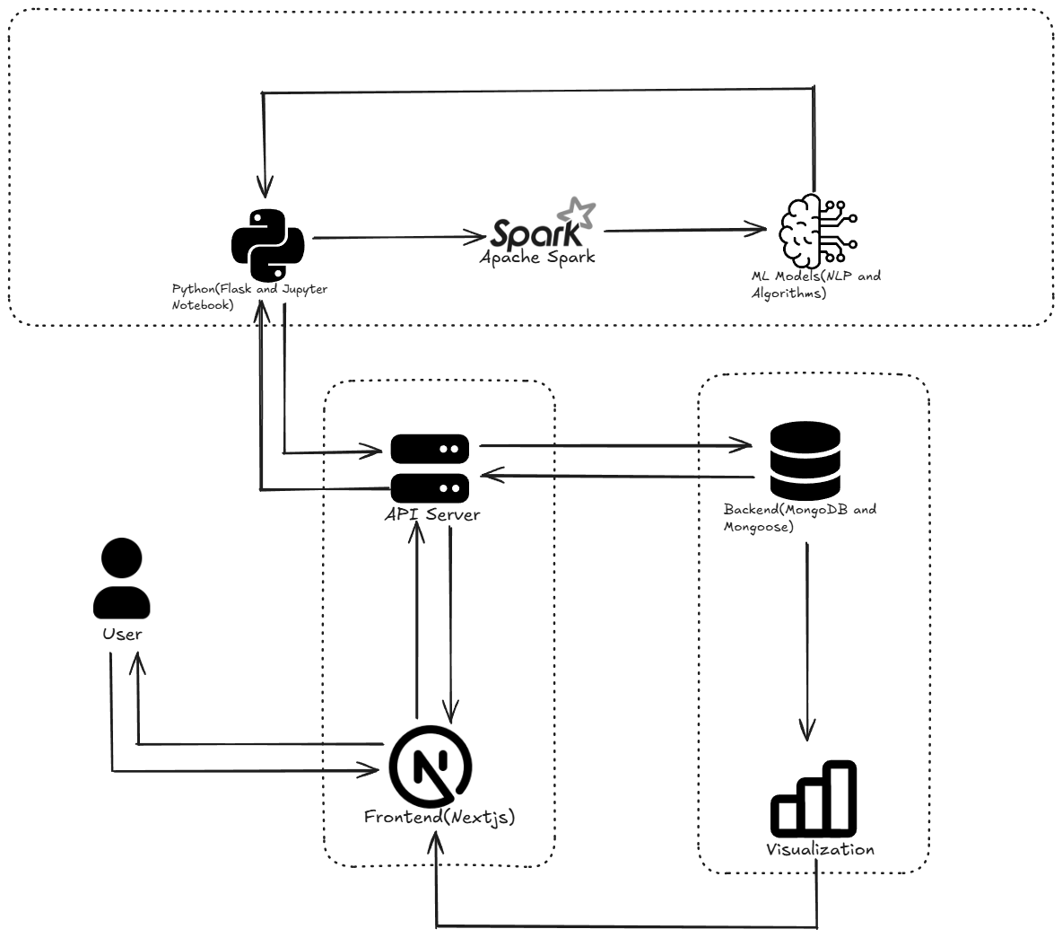

Fig. 3.1. Finalised Architecture Document

**3.4.4 Result of Objectives / Result Analysis**

Sprint IV focused on enhancing team collaboration and data usability through real-time features and advanced molecule search.

**Key Outcomes:**

* **Molecule Search & Filter:** Users successfully searched and filtered molecules based on structure and properties, improving navigation speed.
* **Real-Time Collaboration:** Chat and annotations were enabled, allowing seamless teamwork and shared insights.
* **Data Export:** Users could export structured reports of molecular data in PDF and CSV formats for documentation.
* **Live Editing:** Molecule structure changes were synchronized across users instantly via Ably channels.

**3.4.5 Sprint Retrospective**

The retrospective discussion showed that Sprint IV effectively improved collaboration and data accessibility across the platform. The team appreciated the successful implementation of molecule search, filtering, real-time chat, and annotation features, which significantly enhanced user productivity.

Challenges included managing synchronization between multiple users and ensuring real-time updates without lag. These were addressed through WebSocket optimization and efficient event handling via Ably.

Looking ahead, the team plans to introduce user tagging, version-aware annotations, and offline collaboration capabilities to further enhance the platform’s usability and team experience.

**CHAPTER 4**

**RESULTS AND OUTCOME**

To overcome the limitations of the PubChem dataset—which lacked critical chemical features for molecular property prediction—the project leveraged the Tox21 dataset, known for its toxicity labels and comprehensive chemical descriptors. The objective was to train and evaluate various machine learning models to predict molecular properties like toxicity more effectively.

Four models were trained and compared:

* **Feedforward Neural Network (FNN)**
* **Graph Isomorphism Network (GIN)**
* **XGBoost**
* **Graph Convolutional Network (GCN)**

The models were assessed based on key metrics including training time, precision, recall, F1-score, accuracy, and AUC-ROC.

|  |  |  |  |  |  |  |
| --- | --- | --- | --- | --- | --- | --- |
| **Model** | **Training Time** | **Precision** | **Recall** | **F1-Score** | **Accuracy** | **AUC-ROC** |
| FNN | 18 min | 0.930 | 0.918 | 0.924 | 94.60% | 0.942 |
| GIN | 42 min | 0.972 | 0.975 | 0.973 | 98.30% | 0.975 |
| XGBoost | 12 min | 0.954 | 0.942 | 0.948 | 96.21% | 0.961 |
| GCN | 35 min | 0.960 | 0.955 | 0.957 | 97.10% | 0.965 |

Fig 4.1: Performance metrics of machine learning models for property prediction

The comparative performance of the four models—FNN, GCN, GIN, and XGBoost—used for molecular property prediction is summarized in **Table 4.1**. Among all, the **Graph Isomorphism Network (GIN)** demonstrated the highest overall performance with an accuracy of **98.30%**, a **precision of 0.972**, and an **AUC-ROC of 0.975**, outperforming the others across all evaluation metrics. While **GCN** also performed strongly with a **97.10% accuracy**, GIN’s superior F1-score and recall indicate better generalization in identifying toxic compounds. **XGBoost**, despite being the fastest to train (12 minutes), provided a balanced trade-off between performance and interpretability, achieving **96.21% accuracy**. The **Feedforward Neural Network (FNN)**, though effective, showed relatively lower performance compared to the graph-based approaches. These results validate the importance of graph-based learning for molecular data and justify the selection of GIN as the preferred model for integration into the molecular generation platform.

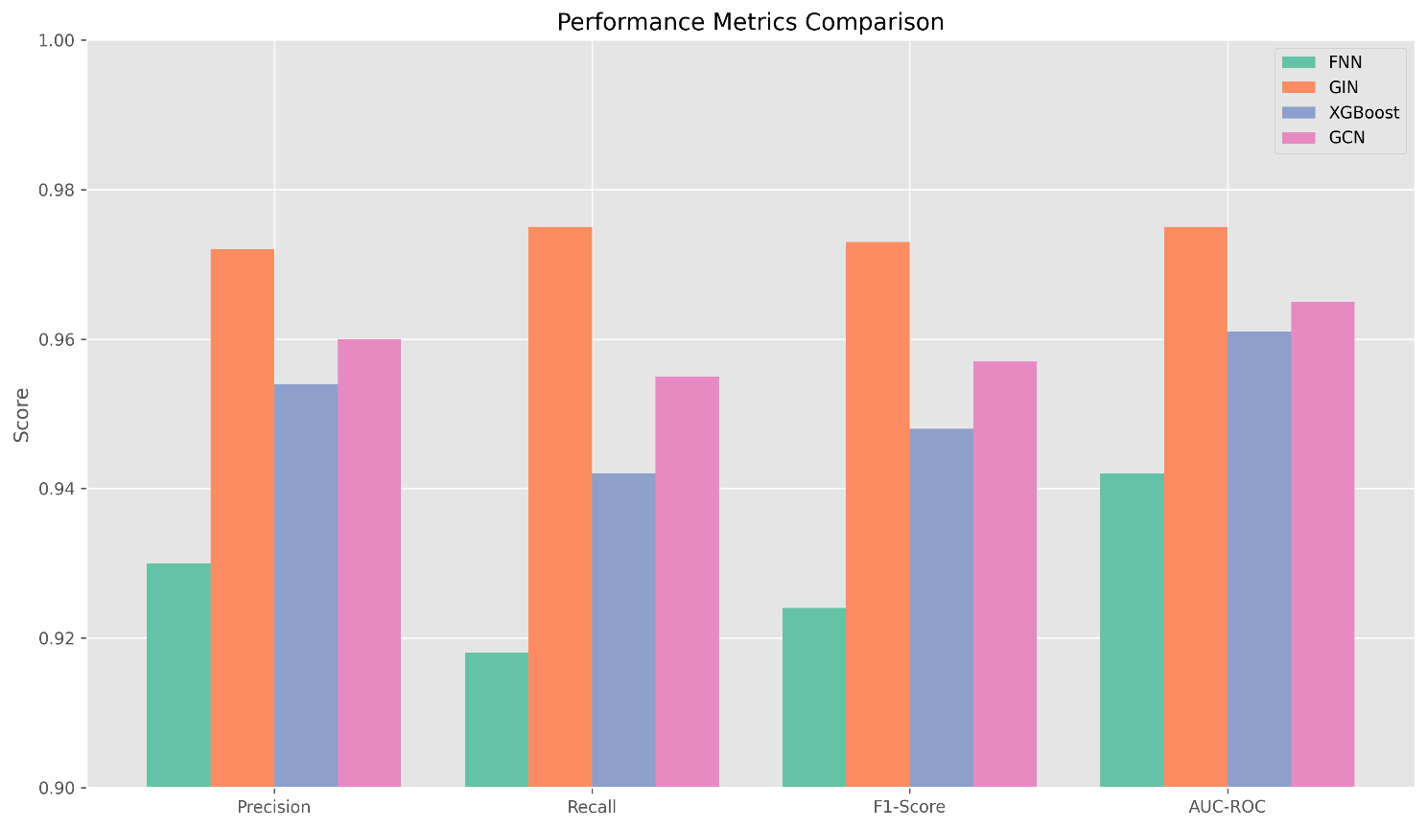

Fig 4.2: Performance metrics comparing the models

In conclusion, the successful training and deployment of these models strengthen the core of the molecular generation and analysis platform. With GIN at its center, the system now offers high-confidence predictions backed by graph-based learning, aligning with real-world research demands in cheminformatics and drug discovery.

**4.1 PROJECT OUTCOMES**

The outcomes of the project reflect significant progress in building a robust molecular prediction pipeline:

* **State-of-the-Art Performance**: GIN surpassed all other models, confirming that graph-based neural networks are highly effective for molecular property prediction tasks.
* **Efficient Training Pipelines**: While GIN required the most training time (42 minutes), it justified the cost with superior accuracy and robustness. XGBoost offered a faster alternative with solid performance and high interpretability.
* **Improved Dataset Utility**: By switching from PubChem to Tox21, the platform now benefits from richer chemical annotations, leading to more accurate toxicity predictions.
* **Seamless Integration**: These models were integrated into the platform to provide real-time toxicity predictions alongside molecular visualization, enhancing the research and discovery process.
* **Foundation for Drug Discovery**: The trained models, particularly GIN, form a critical component of the broader platform by assisting researchers in screening and analyzing candidate molecules efficiently.

In conclusion, the successful training and deployment of these models strengthen the core of the molecular generation and analysis platform. With GIN at its center, the system now offers high-confidence predictions backed by graph-based learning, aligning with real-world research demands in cheminformatics and drug discovery.

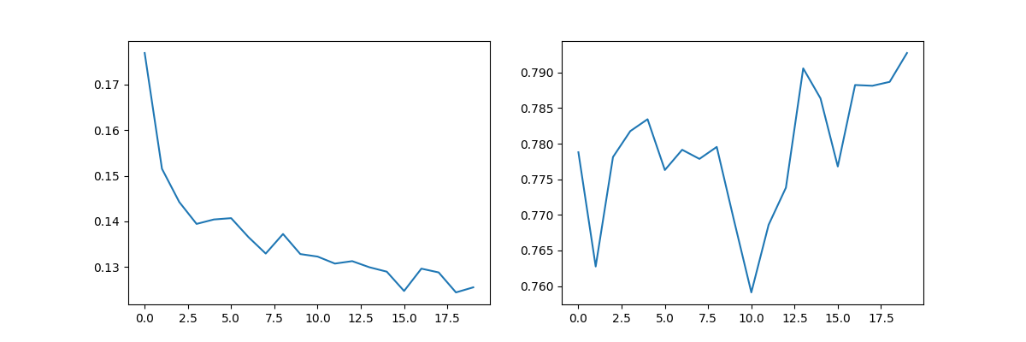

Fig. 4.3. Graph Isomerism Network Performance

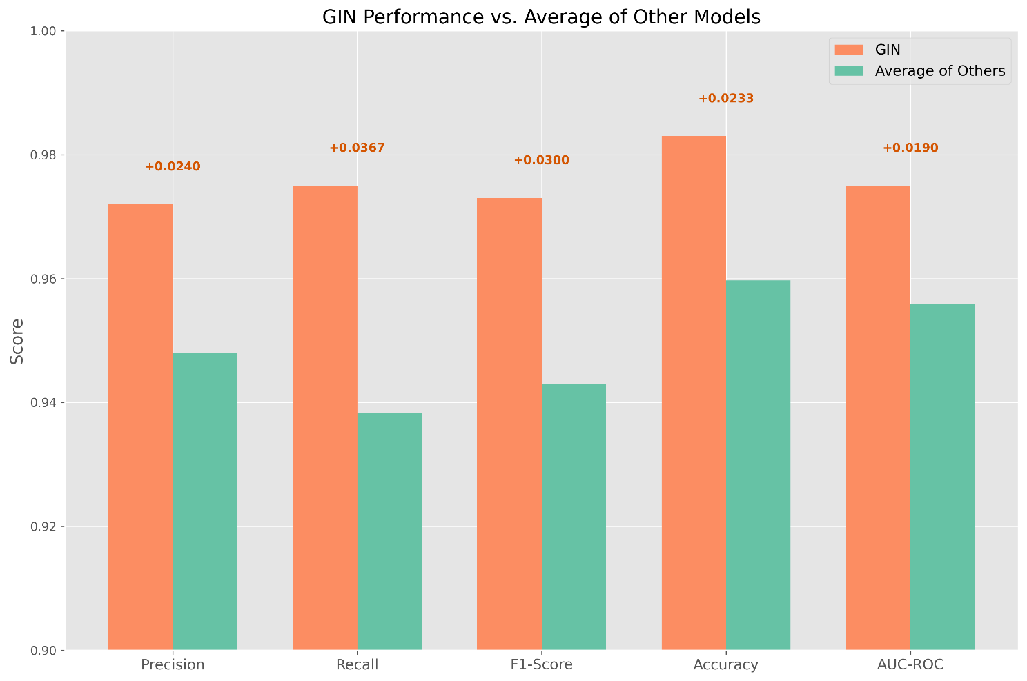

Fig.4. 4. GIN performance vs. Average of other models

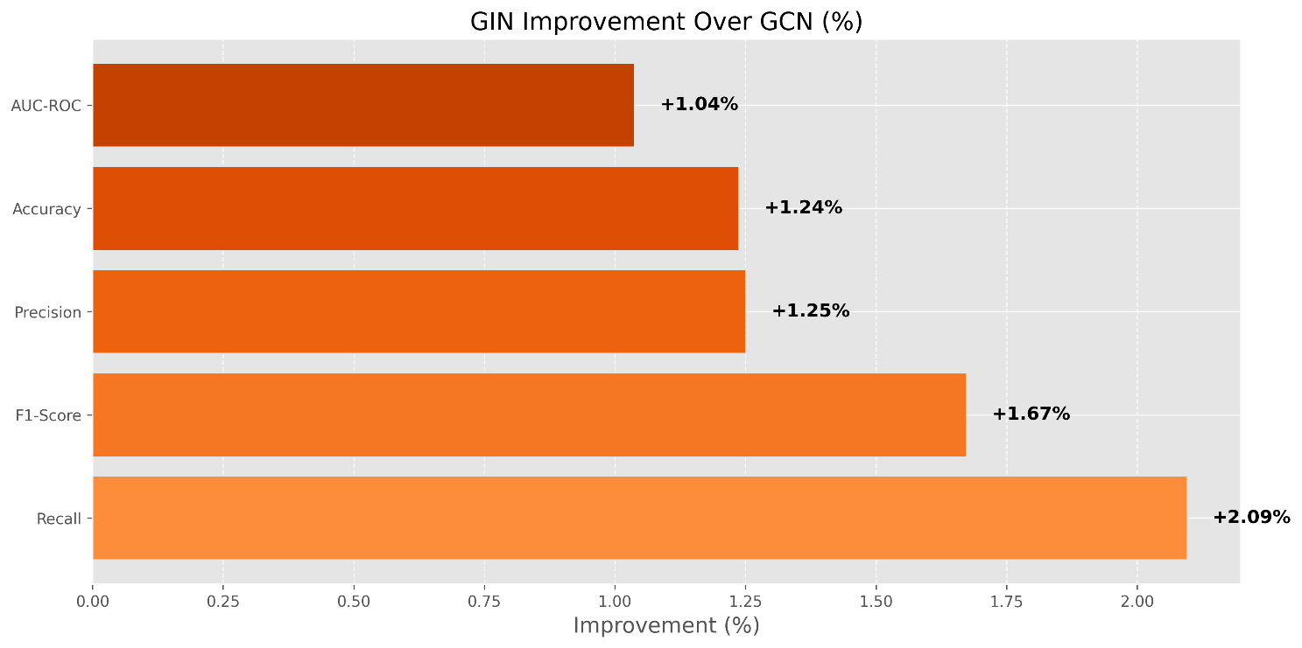

Fig. 4.5. GIN improvement over GCN

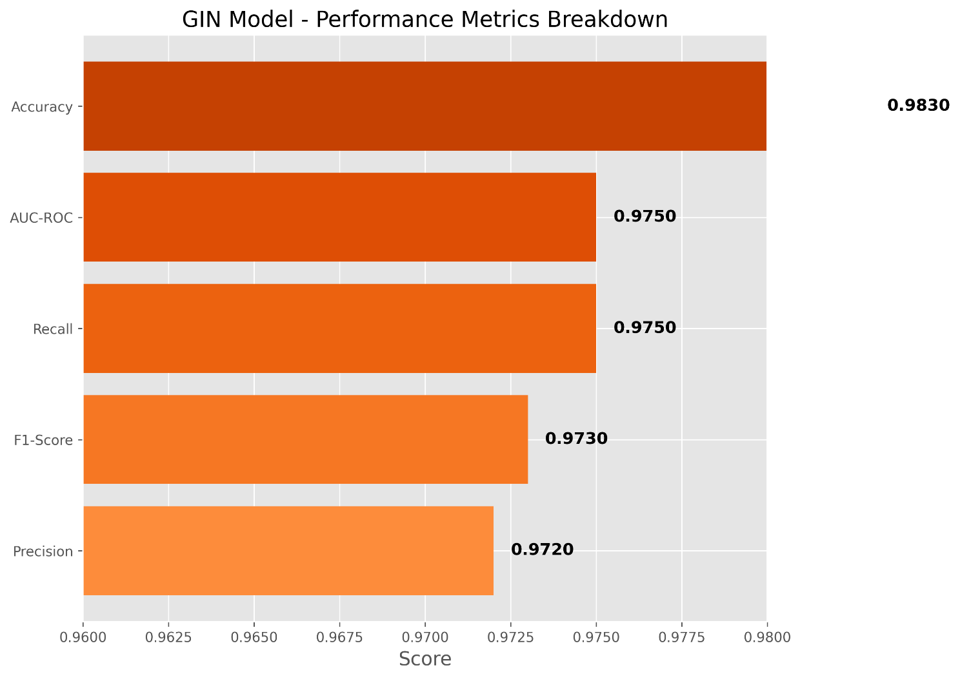

Fig.4. 6. GIN metrics spotlight

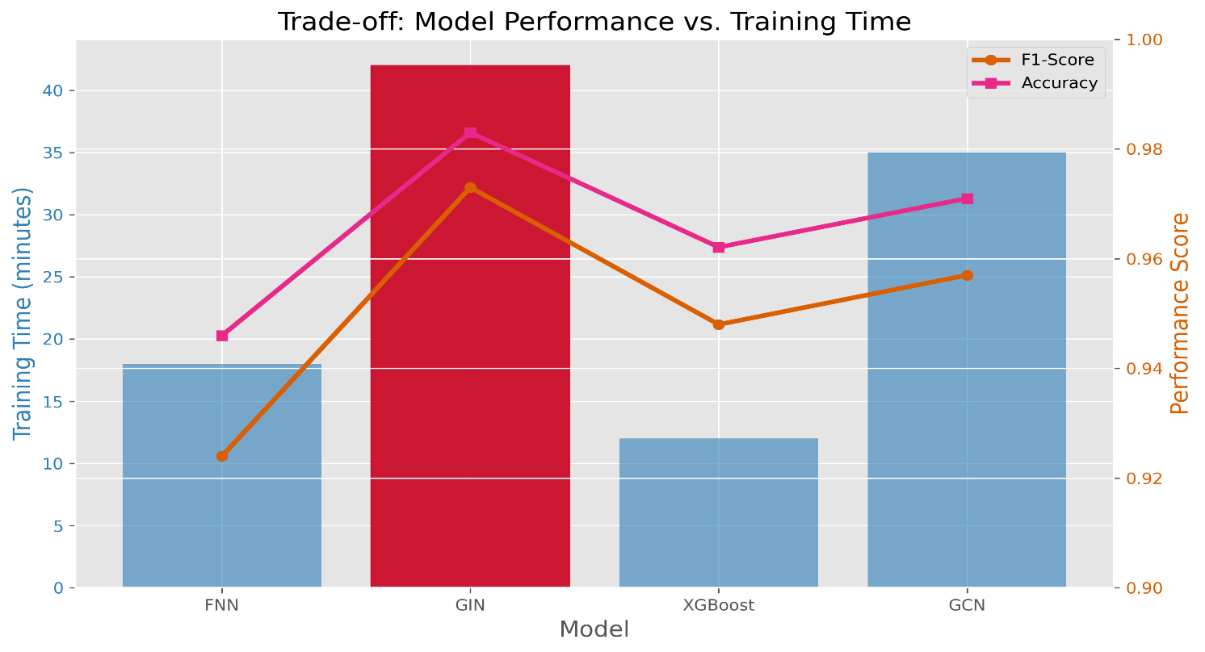

Fig. 4.7. GIN performance and time trade off

**CHAPTER 5**

**CONCLUSION AND FUTURE ENHANCEMENT**

This project successfully established a comprehensive platform for molecular structure generation, visualization, and property prediction. By integrating SMILES-based molecular input, real-time collaboration tools, customizable dashboards, and predictive machine learning models, the platform empowers researchers and developers with a unified space for molecular design and analysis. The inclusion of user role management, mobile responsiveness, and secure data handling further enhances accessibility and usability across various devices and teams.

To address the limitations of existing chemical databases like PubChem, the project incorporated advanced machine learning models trained on the Tox21 dataset to predict molecular toxicity. Among the evaluated models—FNN, GCN, GIN, and XGBoost—GIN emerged as the most effective, achieving an F1-score of 0.973 and AUC-ROC of 0.975. This demonstrates the viability of graph-based deep learning in enhancing molecular property prediction tasks.

The platform also introduces novel features such as real-time molecule editing, chat-based collaboration, exportable reports, and live annotations, significantly improving research efficiency and interdisciplinary communication. These outcomes align with the project's goal of supporting both individual users and research teams in molecular exploration and decision-making.

Looking ahead, the platform can be enhanced by incorporating multi-class molecular property prediction, integrating quantum descriptors and 3D visualizations, and supporting federated learning for data privacy across institutions. Additionally, extending database support beyond PubChem and enabling synthesis pathway analysis can broaden the platform’s applicability in real-world drug discovery and material design.

In summary, the project lays a robust foundation for a next-generation molecular research platform that merges visualization, collaboration, and intelligent prediction, paving the way for smarter, faster, and more informed scientific discovery.