OVERVIEW
NSA/CSS has locations across the United States. In addition to the Maryland headquarters at Fort Meade, there are four cryptologic centers within the United States in Colorado, Georgia, Hawaii, and Texas, and two additional offices in Alaska and Utah. Personnel are deployed to all major military commands and to locations around the globe where there is a U.S. military presence to support our military customers. Many of our deployed personnel serve in Cryptologic Services Groups, providing dedicated support at the combatant command or headquarters level.
HEADQUARTERS
NSA Washington (NSAW)
Located at Fort Meade, Maryland, NSA Washington is the most well-known location. It has served as home for operations since the late 1950s following the establishment of the agency in 1952. Since moving to Fort Meade, NSAW’s campus has expanded, including a visit from President Ronald Reagan for the dedication of two buildings in 1986. Expansion continues to the present day with the addition of the East Campus, where the National Security Operations Center resides inside the Morrison Center.
CRYPTOLOGIC CENTERS
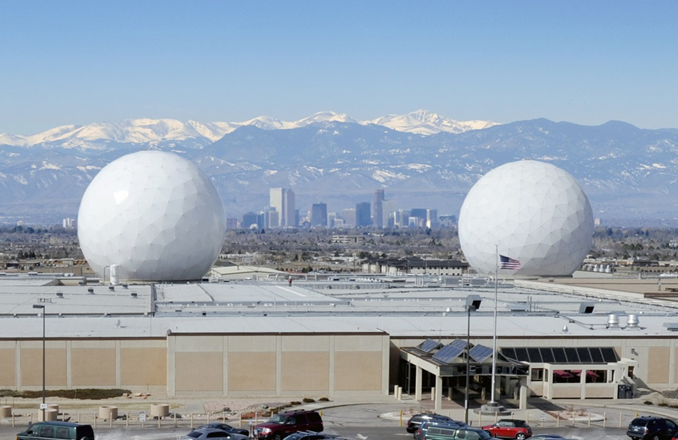
NSA Colorado (NSAC)
Located just outside of Denver, NSA Colorado is situated within the Aerospace Data Facility Colorado (ADF-C) on Buckley Space Force Base. Here, the NSA/CSS team works alongside the National Reconnaissance Office and the National Geospatial-Intelligence Agency-Denver to produce integrated intelligence to defense, intelligence, and civil agencies supporting the U.S. government and its allies. NSAC is the overhead technical SIGINT collection and processing enterprise center, the global overhead SIGINT mission management hub, a cryptologic discovery leader, and the electronic intelligence (ELINT) analysis and tradecraft development focal point for the NSA/CSS enterprise.
NSA Colorado was established in 2003 and is a fully integrated partner in the unique multi-agency, multi-national ADF-C, helping deliver collaborative mission outcomes at the IC level. Academic and community engagement are pillars of NSA Colorado’s work.

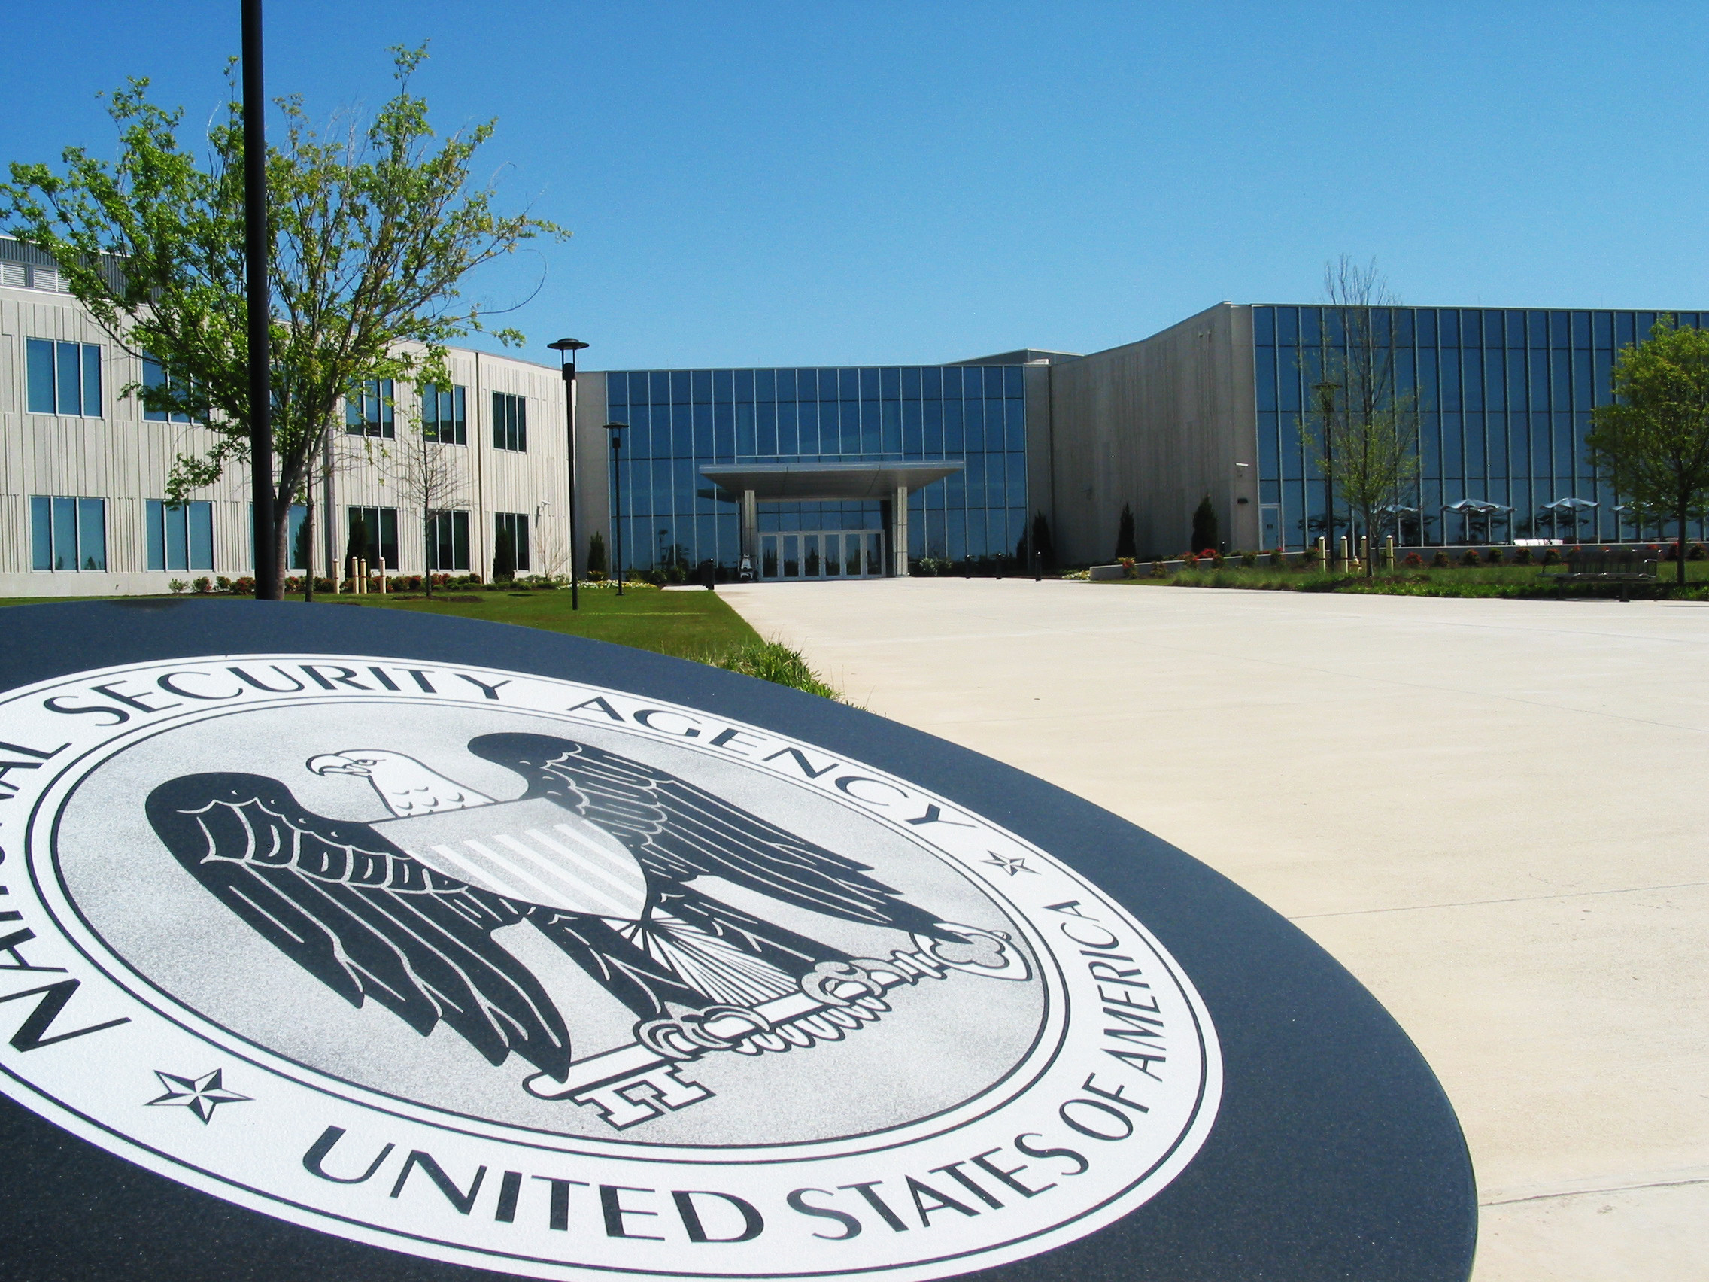NSA Georgia (NSAG)
Housed at Fort Gordon in Augusta, NSA Georgia conducts time-sensitive operations for tactical, operational, and national-level indications and warning requirements which support global and regional security objectives. NSAG also employs capabilities and expertise required to harden and defend national security systems. It specializes in working closely with military customers to understand their operations, their requirements, and their culture to ensure that signals intelligence is tailored and responsive to the needs of the warfighter.
Founded in 1995, NSA Georgia has been located at Fort Gordon, Georgia, for its entire existence. It has grown substantially in the intervening years, both in terms of personnel and physical footprint, including state of the art office spaces. NSA Georgia has a history of operational excellence, winning numerous awards annually as a high performing cryptologic agency.

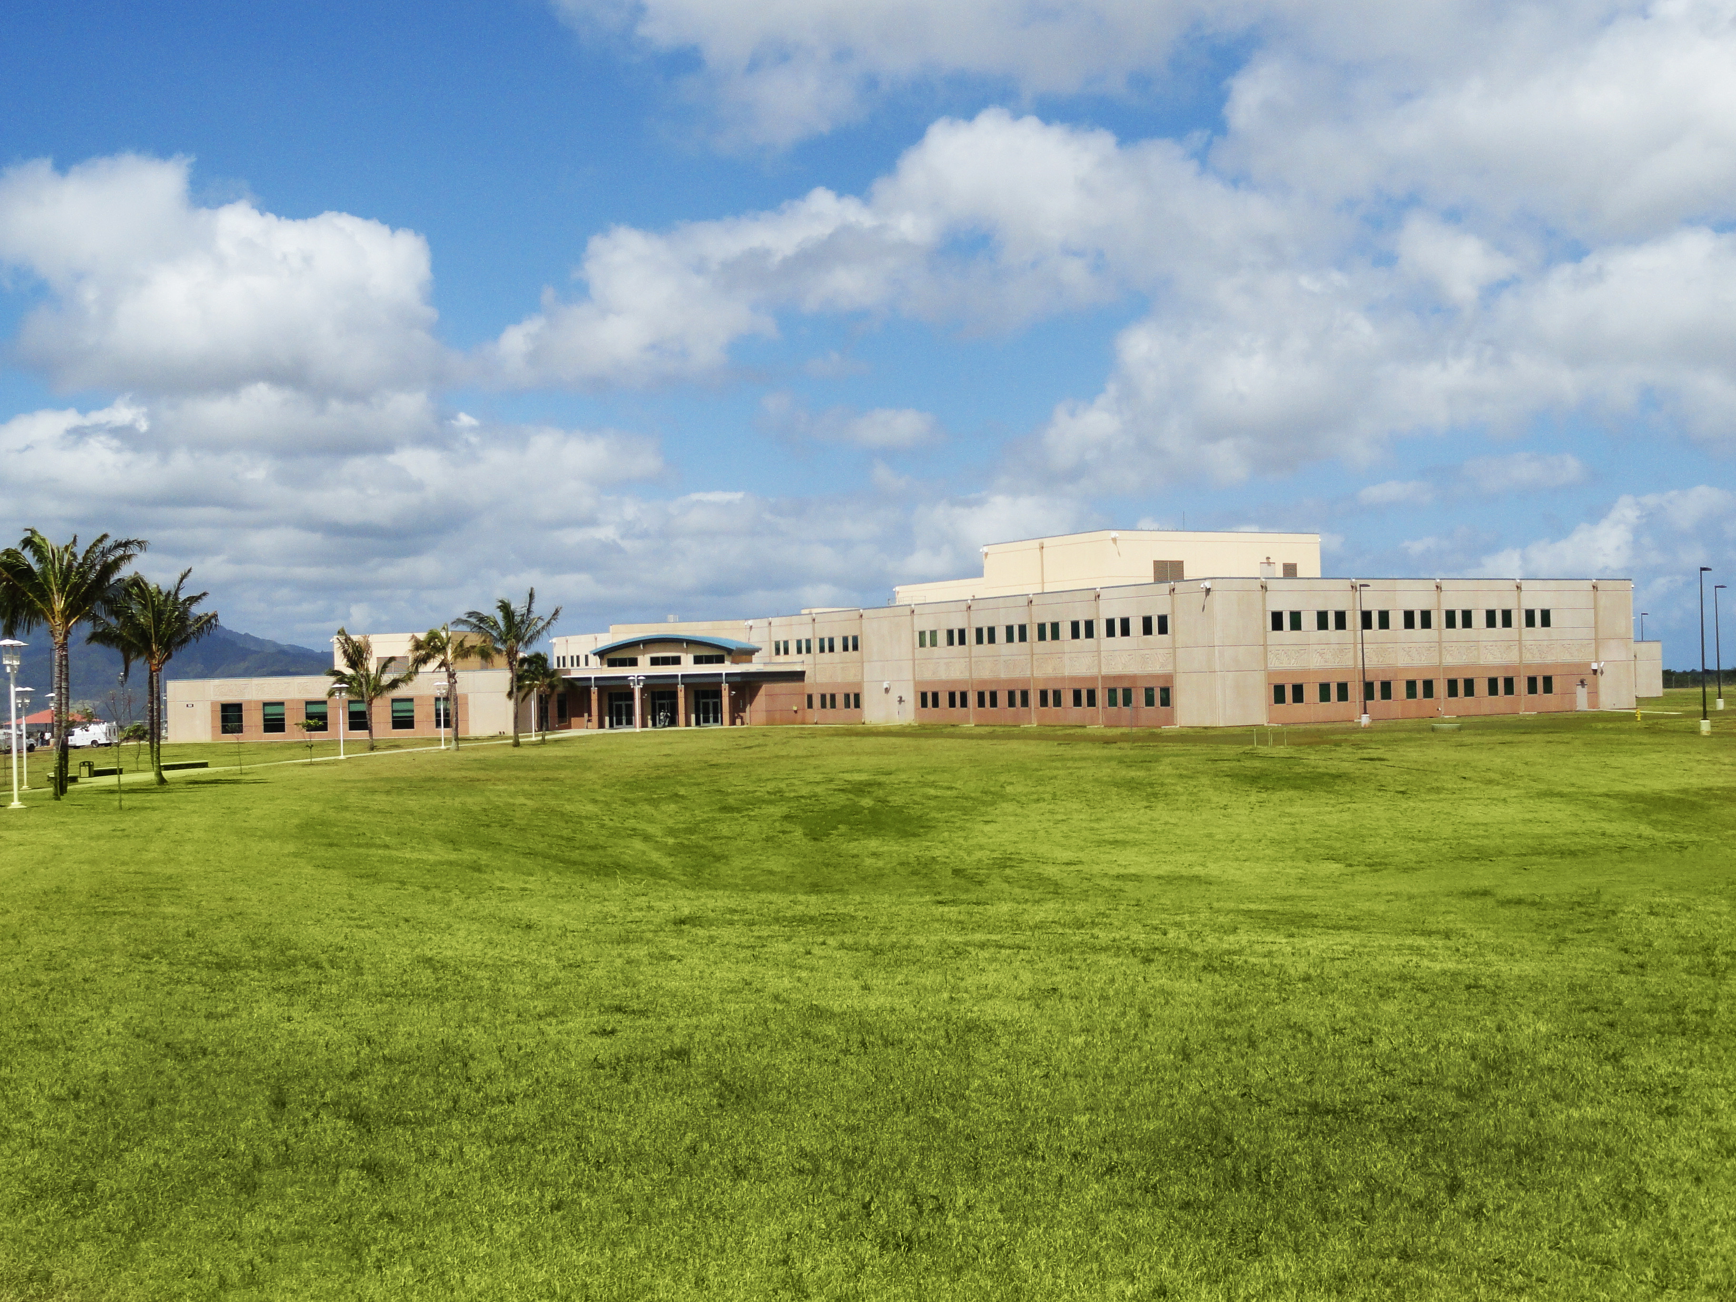
NSA Hawai'i (NSAH)
NSA Hawai'i’s unique location on the island of Oahu in the Pacific puts it at the forefront of national security issues related to strategic competition. Employees at NSAH routinely work with other agencies, private industry, and foreign governments across the Indo-Pacific region to deliver critical cybersecurity and signals intelligence and directly influence and execute U.S. national policy. NSAH combines geographic and functional expertise to accomplish this mission, while also investing in the long-term development of cyber threat knowledge.
NSA Hawai'i was established in 2011 as the successor to the Kunia Regional SIGINT Operations Center activated in 1980. NSAH’s spirit is embodied in the Hawaiian word emblazoned on its seal, kīnā’ole, meaning the essence of doing the right thing, in the right way, at the right time, for the right reason.

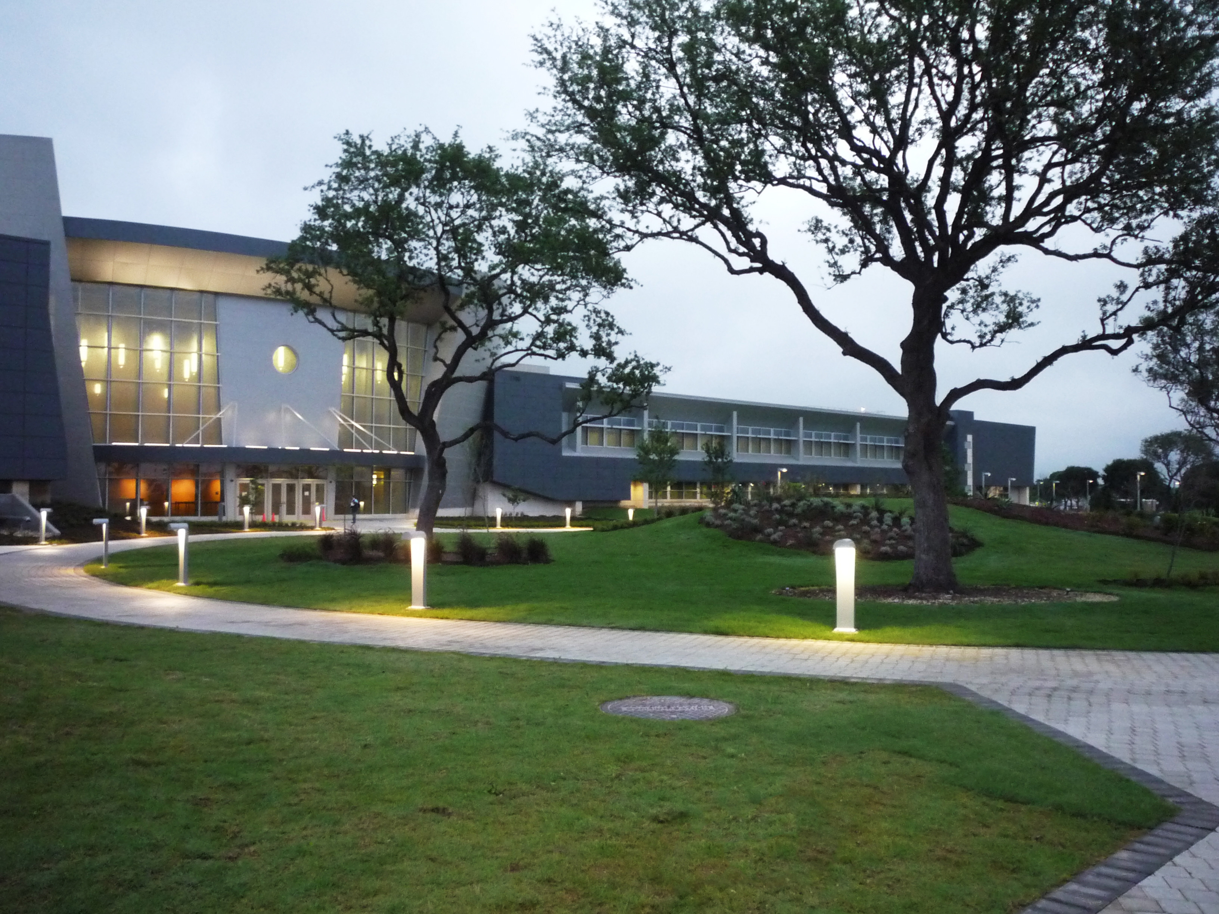
NSA Texas (NSAT)
Headquartered in San Antonio, NSAT is located in one of the nation’s largest cybersecurity hubs. NSAT conducts foreign signals intelligence activities to inform policymakers and defeat adversaries, performs cybersecurity operations to prevent and eradicate threats to National Security Systems, and develops new and innovative capabilities to support both missions. NSAT oversees the Texas Security Operations Center and other NSA 24/7 functions, and thereby serves as a nerve center for NSA management of global, time-sensitive activities, including the ever-present duty of information assurance.
NSA Texas was established in 2007, building on existing deep mission partnerships with Department of Defense and other U.S. government agencies located across San Antonio, to include U.S. Cyber Command. NSAT leverages this talent-rich environment to facilitate hiring, research and technology collaboration, and academic outreach for the benefit of all NSA missions.
OTHER LOCATIONS
NSA Alaska (NSAA)
Located on the Joint Base Elmendorf and Richardson(JBER) outside of Anchorage, the state’s largest city, NSA Alaska focuses on strategic competition, working with partners to provide critical information and protect the nation. NSAA was established in 2020 from the former Alaska Mission Operations Center (AMOC). It has a 24/7 watch floor, Alaska Security Operations Center (ASOC).
NSA Utah (NSAU)
Located in Bluffdale, 20 miles outside of Salt Lake City, NSA Utah excels at language capabilities.

