**Making sense of clicks and squeaks: Mammal Society launches Ecobat, an online tool to help interpret bat survey**

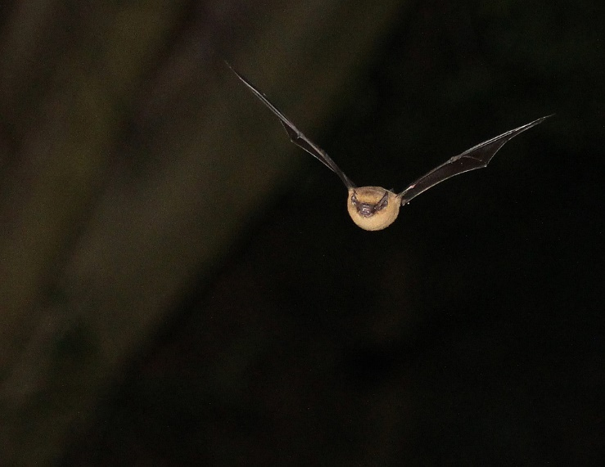Photo by James Miller

**Embargoed until xx December 2017**

Bats make high pitched calls inaudible to the human ear. These secret sounds can be recorded using specialised equipment, and the approach is frequently used to help determine whether bats are likely to be adversely affected by proposed developments such as new housing or roads. However, there are currently no standardised techniques interpreting these data. This makes it difficult to assess the likely impacts of developments, or to choose between two alternative locations for a development.

All species of bat are protected by UK and European law (e.g. Habitats Directive). These key pieces of legislation protect bats and their habitats, and Local Authorities must take impacts on bats into consideration when making decisions about planning permissions.

The Mammal Society is launching a new Web-based tool, Ecobat, which addresses the need for a more robust way of interpreting the results from acoustic surveys for ecological assessments.

Ecobat offers users an easy, standardised, and objective method for analysing bat activity data. It allows ecologists to compare data across sites on both a regional and national basis, generating a numerical indicator of how important surveying results, such as a bat activity are for that site. It can therefore enable better decision to be made about the development potential or conservation value of the location.

Dr Paul Lintott from the University of the West of England, one of the creators of Ecobat says: “We realised that there was huge variation in the way different people were interpreting the same evidence about bats. This is because any individual, however experienced, only has a limited number of similar survey sites with which to compare their data. What Ecobat does is allow users to compare their data with that collected at other similar sites, and therefore assess whether the site is of high importance for bats or relatively unimportant. We hope that its use will help made decisions on planning permission involving bats more consistent, and therefore help to conserve some of Britain and Ireland’s most threatened mammals”.

A key aspect of Ecobat is that it has been made available free and open-source and as the underlying algorithms are already developed it could be easily expanded to new geographic regions and species groups. Prof Fiona Mathews, Chair of the Mammal Society says “A big incentive to use Ecobat is that it gives ecologists — for free — ready to use graphs that help them assess how likely it is that a roost is close by. The system is built on the data submitted by the ecological community, so the more Ecobat is used, the better the outputs become”.

Ecobat can be accessed at [www.ecobat.org.uk](http://www.ecobat.org.uk)

ENDS

For further information and imagery please contact:

Rina Quinlan   
Information Officer   
Mammal Society  
[info@themammalsociety.org](mailto:info@themammalsociety.org)  
02380 010981

Editors notes:

1. Ecobat is a tool to support evidence-based decision-making by offering a standardised method of interpreting bat activity data, offering:
   1. Quantify bat activity relative to local and national datasets
   2. Download easy-to-use, report-ready summaries
   3. Graphical summaries of nightly variability in bat activity
2. The Mammal Society works at the interface of science, policy making and practice. As the only society with an interest in all British mammals, its mission is to provide the scientific evidence-base for effective conservation and management.
3. The Mammal Society has conducted the first review of the Population and Conservation Status of British Mammals for more than 20 years. It will be published by Natural England in March 2018, together with the first Red List of Threatened Mammals for Great Britain.