Ecobat Bat Activity Analysis

NA

08/08/2017

### Summary

Bat surveys were conducted at Hatherly, for 45 nights between 2016-05-03 and 2016-09-20, using Titley Scientific static bat detectors. The maximum of passes recorded in a single night was 163 passes, and 3 species were recorded.

The reference range dataset was stratified to include:

* Only records from within 30 days of the survey date.
* Only records from within 100km2 of the survey location.
* Records using any make of bat detector.

#### Table 1

Summary table showing the number of nights recorded bat activity fell into each activity band for each species.

|  |  |  |  |  |  |  |
| --- | --- | --- | --- | --- | --- | --- |
| Location | Species/Species Group | Nights of High Activity | Nights of Moderate/ High Activity | Nights of Moderate Activity | Nights of Low/ Moderate Activity | Nights of Low Activity |
| Hatherly | *Myotis* | 0 | 1 | 2 | 28 | 53 |
| Hatherly | *Pipistrellus pipistrellus* | 35 | 32 | 37 | 22 | 20 |
| Hatherly | *Pipistrellus pygmaeus* | 11 | 34 | 41 | 29 | 32 |

#### Table 2

Summary table showing key metrics for each species recorded.

|  |  |  |  |  |  |  |
| --- | --- | --- | --- | --- | --- | --- |
| Location | Species/Species Group | Median Percentile | 95% CIs | Max Percentile | Nights Recorded | Reference Range |
| Hatherly | *Myotis* | 14 | 0 - 35 | 74 | 84 | 338 |
| Hatherly | *Pipistrellus pipistrellus* | 56 | 66 - 81 | 99 | 146 | 590 |
| Hatherly | *Pipistrellus pygmaeus* | 47 | 52 - 62 | 91 | 147 | 594 |

### Figures

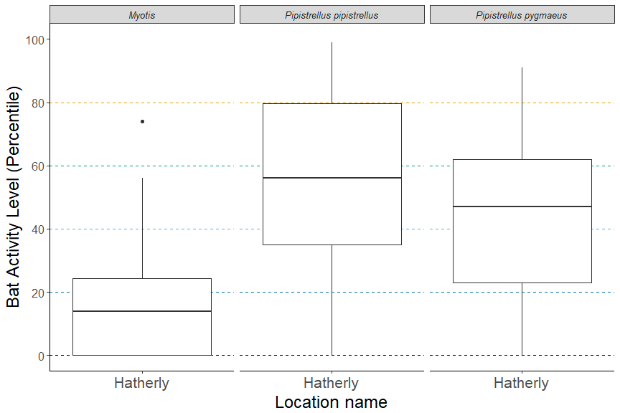

**Figure 1.** Differences in bat activity between static detector locations. The centre line indicates the median activity level whereas the box represents the interquartile range (the spread of the middle 50% of nights of activity)

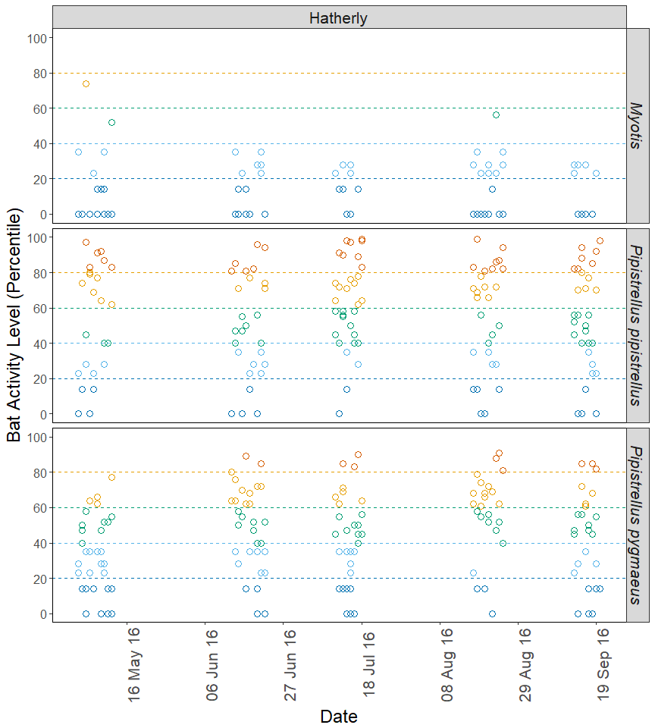

**Figure 2.** The activity level (percentile) of bats recorded across each night of the bat survey, split by location and species.