Ecobat: Nightly Bat Activity Analysis

NA

23/01/2019

## Roost Emergence Time and Bat Observation

Based on: *Russ, Jon. 2012. British Bat Calls a Guide to Species Identification.* *Pelagic Publishing.*

For more information see <https://rbats-blog.updog.co/2018/05/29/bat-emergence/>

## Sun Times

**The times of sunrise and sunset for each survey night, along with the length of the night in hours.**

|  |  |  |  |
| --- | --- | --- | --- |
| Night (y-m-d) | Sunset (hh:mm) | Sunrise (hh:mm) | Night Length (hours) |
| 2018-07-06 | 22:00 | 04:52 | 6.9 |
| 2018-07-07 | 21:59 | 04:53 | 6.9 |
| 2018-07-08 | 21:59 | 04:54 | 6.9 |
| 2018-07-09 | 21:58 | 04:55 | 7.0 |
| 2018-07-10 | 21:57 | 04:56 | 7.0 |
| 2018-07-11 | 21:56 | 04:58 | 7.0 |
| 2018-07-12 | 21:55 | 04:59 | 7.1 |
| 2018-07-13 | 21:54 | 05:00 | 7.1 |
| 2018-07-14 | 21:53 | 05:02 | 7.1 |
| 2018-07-15 | 21:51 | 05:03 | 7.2 |
| 2018-07-16 | 21:50 | 05:04 | 7.2 |
| 2018-07-17 | 21:49 | 05:06 | 7.3 |
| 2018-07-18 | 21:48 | 05:07 | 7.3 |
| 2018-07-19 | 21:46 | 05:09 | 7.4 |
| 2018-07-20 | 21:45 | 05:11 | 7.4 |
| 2018-07-21 | 21:43 | 05:12 | 7.5 |
| 2018-07-22 | 21:42 | 05:14 | 7.5 |
| 2018-07-23 | 21:40 | 05:15 | 7.6 |
| 2018-07-24 | 21:39 | 05:17 | 7.6 |
| 2018-07-25 | 21:37 | 05:19 | 7.7 |
| 2018-07-26 | 21:36 | 05:20 | 7.7 |
| 2018-07-27 | 21:34 | 05:22 | 7.8 |
| 2018-07-28 | 21:32 | 05:24 | 7.9 |
| 2018-07-29 | 21:30 | 05:26 | 7.9 |
| 2018-07-30 | 21:29 | 05:27 | 8.0 |
| 2018-07-31 | 21:27 | 05:29 | 8.0 |
| 2018-08-01 | 21:25 | 05:31 | 8.1 |
| 2018-08-02 | 21:23 | 05:33 | 8.2 |
| 2018-08-03 | 21:21 | 05:35 | 8.2 |
| 2018-08-04 | 21:19 | 05:36 | 8.3 |
| 2018-08-05 | 21:17 | 05:38 | 8.4 |
| 2018-08-06 | 21:15 | 05:40 | 8.4 |
| 2018-08-07 | 21:13 | 05:42 | 8.5 |
| 2018-08-08 | 21:11 | 05:44 | 8.5 |
| 2018-08-09 | 21:09 | 05:46 | 8.6 |
| 2018-08-10 | 21:07 | 05:48 | 8.7 |
| 2018-08-12 | 21:02 | 05:51 | 8.8 |
| 2018-08-13 | 21:00 | 05:53 | 8.9 |
| 2018-08-14 | 20:58 | 05:55 | 8.9 |
| 2018-08-15 | 20:56 | 05:57 | 9.0 |
| 2018-08-16 | 20:54 | 05:59 | 9.1 |
| 2018-08-17 | 20:51 | 06:01 | 9.2 |
| 2018-08-18 | 20:49 | 06:03 | 9.2 |
| 2018-08-19 | 20:47 | 06:04 | 9.3 |
| 2018-08-20 | 20:44 | 06:06 | 9.4 |
| 2018-08-21 | 20:42 | 06:08 | 9.4 |
| 2018-08-22 | 20:40 | 06:10 | 9.5 |
| 2018-08-23 | 20:37 | 06:12 | 9.6 |
| 2018-08-24 | 20:35 | 06:14 | 9.6 |
| 2018-08-25 | 20:32 | 06:16 | 9.7 |
| 2018-08-26 | 20:30 | 06:18 | 9.8 |
| 2018-08-27 | 20:28 | 06:19 | 9.9 |
| 2018-08-28 | 20:25 | 06:21 | 9.9 |
| 2018-08-29 | 20:23 | 06:23 | 10.0 |
| 2018-08-30 | 20:20 | 06:25 | 10.1 |
| 2018-08-31 | 20:18 | 06:27 | 10.2 |
| 2018-09-01 | 20:15 | 06:29 | 10.2 |
| 2018-09-02 | 20:13 | 06:31 | 10.3 |
| 2018-09-03 | 20:10 | 06:32 | 10.4 |
| 2018-09-04 | 20:08 | 06:34 | 10.4 |
| 2018-09-05 | 20:05 | 06:36 | 10.5 |
| 2018-09-06 | 20:03 | 06:38 | 10.6 |
| 2018-09-07 | 20:00 | 06:40 | 10.7 |
| 2018-09-08 | 19:58 | 06:42 | 10.7 |
| 2018-09-09 | 19:55 | 06:44 | 10.8 |
| 2018-09-11 | 19:50 | 06:47 | 11.0 |
| 2018-09-12 | 19:47 | 06:49 | 11.0 |
| 2018-09-13 | 19:45 | 06:51 | 11.1 |
| 2018-09-14 | 19:42 | 06:53 | 11.2 |
| 2018-09-16 | 19:37 | 06:57 | 11.3 |
| 2018-09-17 | 19:34 | 06:58 | 11.4 |

## Counts of Bat Passes (All Detectors)

**The total number of passes recorded for each species across all of the detectors, and the percentage of recorded calls that each species constitutes.**

|  |  |  |
| --- | --- | --- |
| Species Name | Count (No) | Percentage (%) |
| Pipistrellus pygmaeus | 1354 | 48.0482612 |
| Nyctalus spp. | 835 | 29.6309439 |
| Nyctalus noctula | 261 | 9.2618879 |
| Nyctalus leisleri | 165 | 5.8552165 |
| Pipistrellus pipistrellus | 103 | 3.6550745 |
| Myotis spp. | 71 | 2.5195174 |
| Plecotus auritus | 24 | 0.8516678 |
| Pipistrellus spp. | 5 | 0.1774308 |

## Counts of Bat Passes (Per Detector)

**The total number of passes recorded for each species at each detector, and the percentage of recorded calls that each species constitutes at each detector.**

|  |  |  |  |
| --- | --- | --- | --- |
| Species Name | Detector | Count (No) | Percentage by Location (%) |
| Pipistrellus pygmaeus | A2 | 857 | 62.0564808 |
| Nyctalus spp. | A2 | 281 | 20.3475742 |
| Nyctalus noctula | A2 | 95 | 6.8790731 |
| Pipistrellus pipistrellus | A2 | 54 | 3.9102100 |
| Nyctalus leisleri | A2 | 43 | 3.1136857 |
| Myotis spp. | A2 | 38 | 2.7516293 |
| Plecotus auritus | A2 | 9 | 0.6517017 |
| Pipistrellus spp. | A2 | 4 | 0.2896452 |
| Nyctalus spp. | A5 | 288 | 45.8598726 |
| Pipistrellus pygmaeus | A5 | 165 | 26.2738854 |
| Nyctalus noctula | A5 | 101 | 16.0828025 |
| Nyctalus leisleri | A5 | 41 | 6.5286624 |
| Pipistrellus pipistrellus | A5 | 21 | 3.3439490 |
| Myotis spp. | A5 | 8 | 1.2738854 |
| Plecotus auritus | A5 | 4 | 0.6369427 |
| Pipistrellus pygmaeus | B8 | 332 | 41.0383189 |
| Nyctalus spp. | B8 | 266 | 32.8800989 |
| Nyctalus leisleri | B8 | 81 | 10.0123609 |
| Nyctalus noctula | B8 | 65 | 8.0346106 |
| Pipistrellus pipistrellus | B8 | 28 | 3.4610630 |
| Myotis spp. | B8 | 25 | 3.0902349 |
| Plecotus auritus | B8 | 11 | 1.3597033 |
| Pipistrellus spp. | B8 | 1 | 0.1236094 |

## Bat Passes by Night (All Detectors)

**The number of passes per survey night by each species, summed across all detectors.**

Table continues below

|  |  |  |  |  |  |  |  |  |
| --- | --- | --- | --- | --- | --- | --- | --- | --- |
|  | 2018-07-06 | 2018-07-07 | 2018-07-08 | 2018-07-09 | 2018-07-10 | 2018-07-11 | 2018-07-12 | 2018-07-13 |
| **Myotis spp.** | 0 | 2 | 0 | 0 | 0 | 1 | 1 | 0 |
| **Nyctalus leisleri** | 9 | 13 | 4 | 1 | 3 | 4 | 2 | 2 |
| **Nyctalus noctula** | 17 | 35 | 6 | 6 | 18 | 6 | 16 | 17 |
| **Nyctalus spp.** | 46 | 44 | 24 | 31 | 33 | 18 | 24 | 63 |
| **Pipistrellus pipistrellus** | 0 | 1 | 7 | 1 | 2 | 2 | 1 | 3 |
| **Pipistrellus pygmaeus** | 11 | 9 | 12 | 6 | 32 | 2 | 11 | 24 |
| **Pipistrellus spp.** | 0 | 0 | 0 | 0 | 1 | 0 | 0 | 0 |
| **Plecotus auritus** | 3 | 2 | 0 | 0 | 0 | 0 | 0 | 0 |

Table continues below

|  |  |  |  |  |  |  |  |  |
| --- | --- | --- | --- | --- | --- | --- | --- | --- |
|  | 2018-07-14 | 2018-07-15 | 2018-07-16 | 2018-07-17 | 2018-07-18 | 2018-07-19 | 2018-07-20 | 2018-07-21 |
| **Myotis spp.** | 0 | 0 | 1 | 1 | 0 | 2 | 0 | 1 |
| **Nyctalus leisleri** | 0 | 0 | 0 | 3 | 0 | 1 | 0 | 4 |
| **Nyctalus noctula** | 4 | 0 | 18 | 7 | 3 | 8 | 0 | 1 |
| **Nyctalus spp.** | 12 | 3 | 33 | 23 | 19 | 14 | 0 | 8 |
| **Pipistrellus pipistrellus** | 0 | 0 | 6 | 4 | 2 | 5 | 0 | 2 |
| **Pipistrellus pygmaeus** | 3 | 0 | 17 | 9 | 19 | 10 | 1 | 3 |
| **Pipistrellus spp.** | 0 | 0 | 0 | 0 | 0 | 0 | 0 | 0 |
| **Plecotus auritus** | 0 | 0 | 2 | 0 | 1 | 0 | 0 | 0 |

Table continues below

|  |  |  |  |  |  |  |  |  |
| --- | --- | --- | --- | --- | --- | --- | --- | --- |
|  | 2018-07-22 | 2018-07-23 | 2018-07-24 | 2018-07-25 | 2018-07-26 | 2018-07-27 | 2018-07-28 | 2018-07-29 |
| **Myotis spp.** | 1 | 1 | 1 | 0 | 0 | 1 | 0 | 0 |
| **Nyctalus leisleri** | 4 | 0 | 0 | 0 | 0 | 1 | 1 | 0 |
| **Nyctalus noctula** | 1 | 1 | 0 | 0 | 0 | 1 | 0 | 0 |
| **Nyctalus spp.** | 11 | 7 | 3 | 1 | 2 | 4 | 2 | 2 |
| **Pipistrellus pipistrellus** | 0 | 1 | 2 | 0 | 0 | 1 | 1 | 1 |
| **Pipistrellus pygmaeus** | 8 | 5 | 12 | 1 | 2 | 2 | 2 | 0 |
| **Pipistrellus spp.** | 0 | 0 | 0 | 0 | 0 | 0 | 0 | 0 |
| **Plecotus auritus** | 0 | 0 | 0 | 0 | 0 | 0 | 0 | 0 |

Table continues below

|  |  |  |  |  |  |  |  |  |
| --- | --- | --- | --- | --- | --- | --- | --- | --- |
|  | 2018-07-30 | 2018-07-31 | 2018-08-01 | 2018-08-02 | 2018-08-03 | 2018-08-04 | 2018-08-05 | 2018-08-06 |
| **Myotis spp.** | 0 | 1 | 0 | 0 | 2 | 4 | 0 | 0 |
| **Nyctalus leisleri** | 2 | 3 | 0 | 4 | 4 | 10 | 10 | 2 |
| **Nyctalus noctula** | 1 | 3 | 0 | 2 | 5 | 20 | 1 | 4 |
| **Nyctalus spp.** | 13 | 17 | 1 | 18 | 29 | 51 | 18 | 6 |
| **Pipistrellus pipistrellus** | 5 | 0 | 0 | 0 | 1 | 3 | 1 | 1 |
| **Pipistrellus pygmaeus** | 7 | 14 | 0 | 2 | 6 | 38 | 32 | 8 |
| **Pipistrellus spp.** | 1 | 0 | 0 | 0 | 0 | 0 | 0 | 0 |
| **Plecotus auritus** | 0 | 0 | 0 | 0 | 0 | 3 | 0 | 3 |

Table continues below

|  |  |  |  |  |  |  |  |  |
| --- | --- | --- | --- | --- | --- | --- | --- | --- |
|  | 2018-08-07 | 2018-08-08 | 2018-08-09 | 2018-08-10 | 2018-08-12 | 2018-08-13 | 2018-08-14 | 2018-08-15 |
| **Myotis spp.** | 0 | 1 | 0 | 1 | 1 | 3 | 0 | 0 |
| **Nyctalus leisleri** | 2 | 15 | 0 | 6 | 3 | 13 | 0 | 2 |
| **Nyctalus noctula** | 0 | 3 | 1 | 0 | 1 | 7 | 0 | 10 |
| **Nyctalus spp.** | 16 | 26 | 2 | 2 | 12 | 24 | 0 | 11 |
| **Pipistrellus pipistrellus** | 0 | 0 | 0 | 1 | 2 | 2 | 0 | 0 |
| **Pipistrellus pygmaeus** | 12 | 7 | 18 | 13 | 53 | 114 | 7 | 40 |
| **Pipistrellus spp.** | 1 | 0 | 0 | 0 | 0 | 2 | 0 | 0 |
| **Plecotus auritus** | 0 | 1 | 0 | 0 | 0 | 2 | 0 | 0 |

Table continues below

|  |  |  |  |  |  |  |  |  |
| --- | --- | --- | --- | --- | --- | --- | --- | --- |
|  | 2018-08-16 | 2018-08-17 | 2018-08-18 | 2018-08-19 | 2018-08-20 | 2018-08-21 | 2018-08-22 | 2018-08-23 |
| **Myotis spp.** | 0 | 1 | 0 | 3 | 5 | 0 | 6 | 0 |
| **Nyctalus leisleri** | 2 | 0 | 0 | 9 | 5 | 4 | 2 | 0 |
| **Nyctalus noctula** | 0 | 0 | 1 | 6 | 10 | 0 | 1 | 0 |
| **Nyctalus spp.** | 1 | 0 | 4 | 16 | 27 | 5 | 14 | 1 |
| **Pipistrellus pipistrellus** | 0 | 0 | 1 | 3 | 8 | 1 | 1 | 0 |
| **Pipistrellus pygmaeus** | 5 | 2 | 6 | 89 | 47 | 10 | 29 | 2 |
| **Pipistrellus spp.** | 0 | 0 | 0 | 0 | 0 | 0 | 0 | 0 |
| **Plecotus auritus** | 0 | 0 | 0 | 0 | 3 | 0 | 0 | 0 |

Table continues below

|  |  |  |  |  |  |  |  |  |
| --- | --- | --- | --- | --- | --- | --- | --- | --- |
|  | 2018-08-24 | 2018-08-25 | 2018-08-26 | 2018-08-27 | 2018-08-28 | 2018-08-29 | 2018-08-30 | 2018-08-31 |
| **Myotis spp.** | 1 | 0 | 0 | 2 | 1 | 2 | 3 | 1 |
| **Nyctalus leisleri** | 0 | 1 | 0 | 0 | 0 | 5 | 0 | 2 |
| **Nyctalus noctula** | 0 | 8 | 1 | 4 | 0 | 0 | 1 | 0 |
| **Nyctalus spp.** | 3 | 12 | 8 | 17 | 5 | 8 | 12 | 3 |
| **Pipistrellus pipistrellus** | 1 | 3 | 0 | 1 | 2 | 1 | 0 | 0 |
| **Pipistrellus pygmaeus** | 2 | 28 | 0 | 63 | 7 | 91 | 28 | 5 |
| **Pipistrellus spp.** | 0 | 0 | 0 | 0 | 0 | 0 | 0 | 0 |
| **Plecotus auritus** | 0 | 0 | 0 | 0 | 1 | 0 | 0 | 0 |

Table continues below

|  |  |  |  |  |  |  |  |  |  |  |  |  |  |  |  |
| --- | --- | --- | --- | --- | --- | --- | --- | --- | --- | --- | --- | --- | --- | --- | --- |
|  | 2018-09-01 | | 2018-09-02 | | 2018-09-03 | | 2018-09-04 | | 2018-09-05 | | 2018-09-06 | | 2018-09-07 | | 2018-09-08 |
| **Myotis spp.** | 0 | | 0 | | 1 | | 11 | | 1 | | 2 | | 3 | | 0 |
| **Nyctalus leisleri** | 0 | | 3 | | 2 | | 1 | | 0 | | 0 | | 0 | | 1 |
| **Nyctalus noctula** | 0 | | 2 | | 0 | | 0 | | 0 | | 0 | | 1 | | 3 |
| **Nyctalus spp.** | 0 | | 10 | | 4 | | 2 | | 1 | | 1 | | 1 | | 4 |
| **Pipistrellus pipistrellus** | 0 | | 1 | | 3 | | 5 | | 0 | | 0 | | 0 | | 0 |
| **Pipistrellus pygmaeus** | 3 | | 1 | | 55 | | 46 | | 3 | | 6 | | 30 | | 4 |
| **Pipistrellus spp.** | 0 | | 0 | | 0 | | 0 | | 0 | | 0 | | 0 | | 0 |
| **Plecotus auritus** | 0 | | 0 | | 0 | | 1 | | 1 | | 0 | | 1 | | 0 |
|  | | 2018-09-09 | | 2018-09-11 | | 2018-09-12 | | 2018-09-13 | | 2018-09-14 | | 2018-09-16 | | 2018-09-17 | |
| **Myotis spp.** | | 0 | | 0 | | 0 | | 0 | | 1 | | 0 | | 1 | |
| **Nyctalus leisleri** | | 0 | | 0 | | 0 | | 0 | | 0 | | 0 | | 0 | |
| **Nyctalus noctula** | | 0 | | 0 | | 0 | | 0 | | 0 | | 0 | | 0 | |
| **Nyctalus spp.** | | 0 | | 0 | | 1 | | 0 | | 2 | | 0 | | 0 | |
| **Pipistrellus pipistrellus** | | 1 | | 2 | | 7 | | 1 | | 1 | | 2 | | 0 | |
| **Pipistrellus pygmaeus** | | 9 | | 84 | | 93 | | 18 | | 3 | | 13 | | 0 | |
| **Pipistrellus spp.** | | 0 | | 0 | | 0 | | 0 | | 0 | | 0 | | 0 | |
| **Plecotus auritus** | | 0 | | 0 | | 0 | | 0 | | 0 | | 0 | | 0 | |

## Bat Passes by Night (By Detector)

**The number of passes at each detector per survey night by each species.**

Table continues below

|  |  |  |  |  |  |  |
| --- | --- | --- | --- | --- | --- | --- |
|  | 2018-07-06 | 2018-07-07 | 2018-07-08 | 2018-07-09 | 2018-07-10 | 2018-07-11 |
| **Myotis spp. : A2** | 0 | 1 | 0 | 0 | 0 | 1 |
| **Myotis spp. : A5** | 0 | 1 | 0 | 0 | 0 | 0 |
| **Myotis spp. : B8** | 0 | 0 | 0 | 0 | 0 | 0 |
| **Nyctalus leisleri : A2** | 0 | 7 | 4 | 1 | 3 | 4 |
| **Nyctalus leisleri : A5** | 9 | 4 | 0 | 0 | 0 | 0 |
| **Nyctalus leisleri : B8** | 0 | 2 | 0 | 0 | 0 | 0 |
| **Nyctalus noctula : A2** | 2 | 9 | 3 | 0 | 6 | 3 |
| **Nyctalus noctula : A5** | 13 | 14 | 3 | 3 | 10 | 2 |
| **Nyctalus noctula : B8** | 2 | 12 | 0 | 3 | 2 | 1 |
| **Nyctalus spp. : A2** | 17 | 15 | 5 | 6 | 10 | 9 |
| **Nyctalus spp. : A5** | 20 | 19 | 11 | 11 | 17 | 8 |
| **Nyctalus spp. : B8** | 9 | 10 | 8 | 14 | 6 | 1 |
| **Pipistrellus pipistrellus : A2** | 0 | 0 | 7 | 1 | 1 | 2 |
| **Pipistrellus pipistrellus : A5** | 0 | 1 | 0 | 0 | 1 | 0 |
| **Pipistrellus pipistrellus : B8** | 0 | 0 | 0 | 0 | 0 | 0 |
| **Pipistrellus pygmaeus : A2** | 3 | 2 | 4 | 2 | 1 | 0 |
| **Pipistrellus pygmaeus : A5** | 7 | 6 | 8 | 3 | 30 | 2 |
| **Pipistrellus pygmaeus : B8** | 1 | 1 | 0 | 1 | 1 | 0 |
| **Pipistrellus spp. : A2** | 0 | 0 | 0 | 0 | 1 | 0 |
| **Pipistrellus spp. : B8** | 0 | 0 | 0 | 0 | 0 | 0 |
| **Plecotus auritus : A2** | 3 | 0 | 0 | 0 | 0 | 0 |
| **Plecotus auritus : A5** | 0 | 0 | 0 | 0 | 0 | 0 |
| **Plecotus auritus : B8** | 0 | 2 | 0 | 0 | 0 | 0 |

Table continues below

|  |  |  |  |  |  |  |
| --- | --- | --- | --- | --- | --- | --- |
|  | 2018-07-12 | 2018-07-13 | 2018-07-14 | 2018-07-15 | 2018-07-16 | 2018-07-17 |
| **Myotis spp. : A2** | 1 | 0 | 0 | 0 | 1 | 1 |
| **Myotis spp. : A5** | 0 | 0 | 0 | 0 | 0 | 0 |
| **Myotis spp. : B8** | 0 | 0 | 0 | 0 | 0 | 0 |
| **Nyctalus leisleri : A2** | 1 | 0 | 0 | 0 | 0 | 2 |
| **Nyctalus leisleri : A5** | 1 | 1 | 0 | 0 | 0 | 1 |
| **Nyctalus leisleri : B8** | 0 | 1 | 0 | 0 | 0 | 0 |
| **Nyctalus noctula : A2** | 9 | 3 | 0 | 0 | 3 | 0 |
| **Nyctalus noctula : A5** | 4 | 12 | 3 | 0 | 6 | 4 |
| **Nyctalus noctula : B8** | 3 | 2 | 1 | 0 | 9 | 3 |
| **Nyctalus spp. : A2** | 13 | 5 | 1 | 2 | 4 | 4 |
| **Nyctalus spp. : A5** | 9 | 41 | 9 | 1 | 16 | 15 |
| **Nyctalus spp. : B8** | 2 | 17 | 2 | 0 | 13 | 4 |
| **Pipistrellus pipistrellus : A2** | 1 | 0 | 0 | 0 | 2 | 0 |
| **Pipistrellus pipistrellus : A5** | 0 | 2 | 0 | 0 | 1 | 2 |
| **Pipistrellus pipistrellus : B8** | 0 | 1 | 0 | 0 | 3 | 2 |
| **Pipistrellus pygmaeus : A2** | 4 | 3 | 0 | 0 | 2 | 4 |
| **Pipistrellus pygmaeus : A5** | 5 | 12 | 2 | 0 | 14 | 4 |
| **Pipistrellus pygmaeus : B8** | 2 | 9 | 1 | 0 | 1 | 1 |
| **Pipistrellus spp. : A2** | 0 | 0 | 0 | 0 | 0 | 0 |
| **Pipistrellus spp. : B8** | 0 | 0 | 0 | 0 | 0 | 0 |
| **Plecotus auritus : A2** | 0 | 0 | 0 | 0 | 0 | 0 |
| **Plecotus auritus : A5** | 0 | 0 | 0 | 0 | 1 | 0 |
| **Plecotus auritus : B8** | 0 | 0 | 0 | 0 | 1 | 0 |

Table continues below

|  |  |  |  |  |  |  |
| --- | --- | --- | --- | --- | --- | --- |
|  | 2018-07-18 | 2018-07-19 | 2018-07-20 | 2018-07-21 | 2018-07-22 | 2018-07-23 |
| **Myotis spp. : A2** | 0 | 2 | 0 | 0 | 0 | 0 |
| **Myotis spp. : A5** | 0 | 0 | 0 | 1 | 1 | 1 |
| **Myotis spp. : B8** | 0 | 0 | 0 | 0 | 0 | 0 |
| **Nyctalus leisleri : A2** | 0 | 0 | 0 | 0 | 1 | 0 |
| **Nyctalus leisleri : A5** | 0 | 1 | 0 | 4 | 3 | 0 |
| **Nyctalus leisleri : B8** | 0 | 0 | 0 | 0 | 0 | 0 |
| **Nyctalus noctula : A2** | 1 | 0 | 0 | 0 | 1 | 1 |
| **Nyctalus noctula : A5** | 2 | 5 | 0 | 1 | 0 | 0 |
| **Nyctalus noctula : B8** | 0 | 3 | 0 | 0 | 0 | 0 |
| **Nyctalus spp. : A2** | 4 | 2 | 0 | 0 | 5 | 2 |
| **Nyctalus spp. : A5** | 11 | 7 | 0 | 4 | 2 | 2 |
| **Nyctalus spp. : B8** | 4 | 5 | 0 | 4 | 4 | 3 |
| **Pipistrellus pipistrellus : A2** | 0 | 0 | 0 | 1 | 0 | 1 |
| **Pipistrellus pipistrellus : A5** | 1 | 5 | 0 | 0 | 0 | 0 |
| **Pipistrellus pipistrellus : B8** | 1 | 0 | 0 | 1 | 0 | 0 |
| **Pipistrellus pygmaeus : A2** | 7 | 7 | 0 | 0 | 1 | 1 |
| **Pipistrellus pygmaeus : A5** | 9 | 1 | 1 | 2 | 5 | 4 |
| **Pipistrellus pygmaeus : B8** | 3 | 2 | 0 | 1 | 2 | 0 |
| **Pipistrellus spp. : A2** | 0 | 0 | 0 | 0 | 0 | 0 |
| **Pipistrellus spp. : B8** | 0 | 0 | 0 | 0 | 0 | 0 |
| **Plecotus auritus : A2** | 1 | 0 | 0 | 0 | 0 | 0 |
| **Plecotus auritus : A5** | 0 | 0 | 0 | 0 | 0 | 0 |
| **Plecotus auritus : B8** | 0 | 0 | 0 | 0 | 0 | 0 |

Table continues below

|  |  |  |  |  |  |  |
| --- | --- | --- | --- | --- | --- | --- |
|  | 2018-07-24 | 2018-07-25 | 2018-07-26 | 2018-07-27 | 2018-07-28 | 2018-07-29 |
| **Myotis spp. : A2** | 1 | 0 | 0 | 0 | 0 | 0 |
| **Myotis spp. : A5** | 0 | 0 | 0 | 1 | 0 | 0 |
| **Myotis spp. : B8** | 0 | 0 | 0 | 0 | 0 | 0 |
| **Nyctalus leisleri : A2** | 0 | 0 | 0 | 0 | 0 | 0 |
| **Nyctalus leisleri : A5** | 0 | 0 | 0 | 1 | 1 | 0 |
| **Nyctalus leisleri : B8** | 0 | 0 | 0 | 0 | 0 | 0 |
| **Nyctalus noctula : A2** | 0 | 0 | 0 | 0 | 0 | 0 |
| **Nyctalus noctula : A5** | 0 | 0 | 0 | 1 | 0 | 0 |
| **Nyctalus noctula : B8** | 0 | 0 | 0 | 0 | 0 | 0 |
| **Nyctalus spp. : A2** | 1 | 0 | 1 | 1 | 0 | 0 |
| **Nyctalus spp. : A5** | 1 | 1 | 0 | 0 | 2 | 0 |
| **Nyctalus spp. : B8** | 1 | 0 | 1 | 3 | 0 | 2 |
| **Pipistrellus pipistrellus : A2** | 0 | 0 | 0 | 0 | 1 | 0 |
| **Pipistrellus pipistrellus : A5** | 1 | 0 | 0 | 1 | 0 | 0 |
| **Pipistrellus pipistrellus : B8** | 1 | 0 | 0 | 0 | 0 | 1 |
| **Pipistrellus pygmaeus : A2** | 1 | 0 | 1 | 1 | 0 | 0 |
| **Pipistrellus pygmaeus : A5** | 4 | 0 | 1 | 1 | 1 | 0 |
| **Pipistrellus pygmaeus : B8** | 7 | 1 | 0 | 0 | 1 | 0 |
| **Pipistrellus spp. : A2** | 0 | 0 | 0 | 0 | 0 | 0 |
| **Pipistrellus spp. : B8** | 0 | 0 | 0 | 0 | 0 | 0 |
| **Plecotus auritus : A2** | 0 | 0 | 0 | 0 | 0 | 0 |
| **Plecotus auritus : A5** | 0 | 0 | 0 | 0 | 0 | 0 |
| **Plecotus auritus : B8** | 0 | 0 | 0 | 0 | 0 | 0 |

Table continues below

|  |  |  |  |  |  |  |
| --- | --- | --- | --- | --- | --- | --- |
|  | 2018-07-30 | 2018-07-31 | 2018-08-01 | 2018-08-02 | 2018-08-03 | 2018-08-04 |
| **Myotis spp. : A2** | 0 | 1 | 0 | 0 | 0 | 2 |
| **Myotis spp. : A5** | 0 | 0 | 0 | 0 | 2 | 1 |
| **Myotis spp. : B8** | 0 | 0 | 0 | 0 | 0 | 1 |
| **Nyctalus leisleri : A2** | 0 | 0 | 0 | 1 | 3 | 2 |
| **Nyctalus leisleri : A5** | 2 | 3 | 0 | 3 | 1 | 6 |
| **Nyctalus leisleri : B8** | 0 | 0 | 0 | 0 | 0 | 2 |
| **Nyctalus noctula : A2** | 0 | 1 | 0 | 0 | 0 | 3 |
| **Nyctalus noctula : A5** | 1 | 2 | 0 | 0 | 3 | 12 |
| **Nyctalus noctula : B8** | 0 | 0 | 0 | 2 | 2 | 5 |
| **Nyctalus spp. : A2** | 1 | 3 | 0 | 1 | 6 | 2 |
| **Nyctalus spp. : A5** | 5 | 12 | 0 | 10 | 13 | 41 |
| **Nyctalus spp. : B8** | 7 | 2 | 1 | 7 | 10 | 8 |
| **Pipistrellus pipistrellus : A2** | 0 | 0 | 0 | 0 | 0 | 1 |
| **Pipistrellus pipistrellus : A5** | 4 | 0 | 0 | 0 | 1 | 1 |
| **Pipistrellus pipistrellus : B8** | 1 | 0 | 0 | 0 | 0 | 1 |
| **Pipistrellus pygmaeus : A2** | 0 | 0 | 0 | 0 | 2 | 14 |
| **Pipistrellus pygmaeus : A5** | 3 | 14 | 0 | 2 | 4 | 20 |
| **Pipistrellus pygmaeus : B8** | 4 | 0 | 0 | 0 | 0 | 4 |
| **Pipistrellus spp. : A2** | 0 | 0 | 0 | 0 | 0 | 0 |
| **Pipistrellus spp. : B8** | 1 | 0 | 0 | 0 | 0 | 0 |
| **Plecotus auritus : A2** | 0 | 0 | 0 | 0 | 0 | 0 |
| **Plecotus auritus : A5** | 0 | 0 | 0 | 0 | 0 | 3 |
| **Plecotus auritus : B8** | 0 | 0 | 0 | 0 | 0 | 0 |

Table continues below

|  |  |  |  |  |  |  |
| --- | --- | --- | --- | --- | --- | --- |
|  | 2018-08-05 | 2018-08-06 | 2018-08-07 | 2018-08-08 | 2018-08-09 | 2018-08-10 |
| **Myotis spp. : A2** | 0 | 0 | 0 | 1 | 0 | 1 |
| **Myotis spp. : A5** | 0 | 0 | 0 | 0 | 0 | 0 |
| **Myotis spp. : B8** | 0 | 0 | 0 | 0 | 0 | 0 |
| **Nyctalus leisleri : A2** | 2 | 0 | 0 | 2 | 0 | 1 |
| **Nyctalus leisleri : A5** | 0 | 0 | 0 | 0 | 0 | 0 |
| **Nyctalus leisleri : B8** | 8 | 2 | 2 | 13 | 0 | 5 |
| **Nyctalus noctula : A2** | 1 | 4 | 0 | 3 | 1 | 0 |
| **Nyctalus noctula : A5** | 0 | 0 | 0 | 0 | 0 | 0 |
| **Nyctalus noctula : B8** | 0 | 0 | 0 | 0 | 0 | 0 |
| **Nyctalus spp. : A2** | 11 | 1 | 12 | 9 | 2 | 1 |
| **Nyctalus spp. : A5** | 0 | 0 | 0 | 0 | 0 | 0 |
| **Nyctalus spp. : B8** | 7 | 5 | 4 | 17 | 0 | 1 |
| **Pipistrellus pipistrellus : A2** | 0 | 1 | 0 | 0 | 0 | 1 |
| **Pipistrellus pipistrellus : A5** | 0 | 0 | 0 | 0 | 0 | 0 |
| **Pipistrellus pipistrellus : B8** | 1 | 0 | 0 | 0 | 0 | 0 |
| **Pipistrellus pygmaeus : A2** | 11 | 5 | 8 | 1 | 3 | 5 |
| **Pipistrellus pygmaeus : A5** | 0 | 0 | 0 | 0 | 0 | 0 |
| **Pipistrellus pygmaeus : B8** | 21 | 3 | 4 | 6 | 15 | 8 |
| **Pipistrellus spp. : A2** | 0 | 0 | 1 | 0 | 0 | 0 |
| **Pipistrellus spp. : B8** | 0 | 0 | 0 | 0 | 0 | 0 |
| **Plecotus auritus : A2** | 0 | 2 | 0 | 0 | 0 | 0 |
| **Plecotus auritus : A5** | 0 | 0 | 0 | 0 | 0 | 0 |
| **Plecotus auritus : B8** | 0 | 1 | 0 | 1 | 0 | 0 |

Table continues below

|  |  |  |  |  |  |  |
| --- | --- | --- | --- | --- | --- | --- |
|  | 2018-08-12 | 2018-08-13 | 2018-08-14 | 2018-08-15 | 2018-08-16 | 2018-08-17 |
| **Myotis spp. : A2** | 1 | 2 | 0 | 0 | 0 | 1 |
| **Myotis spp. : A5** | 0 | 0 | 0 | 0 | 0 | 0 |
| **Myotis spp. : B8** | 0 | 1 | 0 | 0 | 0 | 0 |
| **Nyctalus leisleri : A2** | 0 | 0 | 0 | 0 | 2 | 0 |
| **Nyctalus leisleri : A5** | 0 | 0 | 0 | 0 | 0 | 0 |
| **Nyctalus leisleri : B8** | 3 | 13 | 0 | 2 | 0 | 0 |
| **Nyctalus noctula : A2** | 1 | 6 | 0 | 8 | 0 | 0 |
| **Nyctalus noctula : A5** | 0 | 0 | 0 | 0 | 0 | 0 |
| **Nyctalus noctula : B8** | 0 | 1 | 0 | 2 | 0 | 0 |
| **Nyctalus spp. : A2** | 11 | 5 | 0 | 3 | 0 | 0 |
| **Nyctalus spp. : A5** | 0 | 0 | 0 | 0 | 0 | 0 |
| **Nyctalus spp. : B8** | 1 | 19 | 0 | 8 | 1 | 0 |
| **Pipistrellus pipistrellus : A2** | 2 | 1 | 0 | 0 | 0 | 0 |
| **Pipistrellus pipistrellus : A5** | 0 | 0 | 0 | 0 | 0 | 0 |
| **Pipistrellus pipistrellus : B8** | 0 | 1 | 0 | 0 | 0 | 0 |
| **Pipistrellus pygmaeus : A2** | 52 | 90 | 7 | 24 | 1 | 2 |
| **Pipistrellus pygmaeus : A5** | 0 | 0 | 0 | 0 | 0 | 0 |
| **Pipistrellus pygmaeus : B8** | 1 | 24 | 0 | 16 | 4 | 0 |
| **Pipistrellus spp. : A2** | 0 | 2 | 0 | 0 | 0 | 0 |
| **Pipistrellus spp. : B8** | 0 | 0 | 0 | 0 | 0 | 0 |
| **Plecotus auritus : A2** | 0 | 0 | 0 | 0 | 0 | 0 |
| **Plecotus auritus : A5** | 0 | 0 | 0 | 0 | 0 | 0 |
| **Plecotus auritus : B8** | 0 | 2 | 0 | 0 | 0 | 0 |

Table continues below

|  |  |  |  |  |  |  |
| --- | --- | --- | --- | --- | --- | --- |
|  | 2018-08-18 | 2018-08-19 | 2018-08-20 | 2018-08-21 | 2018-08-22 | 2018-08-23 |
| **Myotis spp. : A2** | 0 | 3 | 4 | 0 | 2 | 0 |
| **Myotis spp. : A5** | 0 | 0 | 0 | 0 | 0 | 0 |
| **Myotis spp. : B8** | 0 | 0 | 1 | 0 | 4 | 0 |
| **Nyctalus leisleri : A2** | 0 | 1 | 1 | 0 | 2 | 0 |
| **Nyctalus leisleri : A5** | 0 | 0 | 0 | 0 | 0 | 0 |
| **Nyctalus leisleri : B8** | 0 | 8 | 4 | 4 | 0 | 0 |
| **Nyctalus noctula : A2** | 1 | 6 | 6 | 0 | 1 | 0 |
| **Nyctalus noctula : A5** | 0 | 0 | 0 | 0 | 0 | 0 |
| **Nyctalus noctula : B8** | 0 | 0 | 4 | 0 | 0 | 0 |
| **Nyctalus spp. : A2** | 1 | 10 | 16 | 2 | 10 | 0 |
| **Nyctalus spp. : A5** | 0 | 0 | 0 | 0 | 0 | 0 |
| **Nyctalus spp. : B8** | 3 | 6 | 11 | 3 | 4 | 1 |
| **Pipistrellus pipistrellus : A2** | 0 | 3 | 3 | 0 | 0 | 0 |
| **Pipistrellus pipistrellus : A5** | 0 | 0 | 0 | 0 | 0 | 0 |
| **Pipistrellus pipistrellus : B8** | 1 | 0 | 5 | 1 | 1 | 0 |
| **Pipistrellus pygmaeus : A2** | 4 | 77 | 28 | 1 | 7 | 2 |
| **Pipistrellus pygmaeus : A5** | 0 | 0 | 0 | 0 | 0 | 0 |
| **Pipistrellus pygmaeus : B8** | 2 | 12 | 19 | 9 | 22 | 0 |
| **Pipistrellus spp. : A2** | 0 | 0 | 0 | 0 | 0 | 0 |
| **Pipistrellus spp. : B8** | 0 | 0 | 0 | 0 | 0 | 0 |
| **Plecotus auritus : A2** | 0 | 0 | 1 | 0 | 0 | 0 |
| **Plecotus auritus : A5** | 0 | 0 | 0 | 0 | 0 | 0 |
| **Plecotus auritus : B8** | 0 | 0 | 2 | 0 | 0 | 0 |

Table continues below

|  |  |  |  |  |  |  |
| --- | --- | --- | --- | --- | --- | --- |
|  | 2018-08-24 | 2018-08-25 | 2018-08-26 | 2018-08-27 | 2018-08-28 | 2018-08-29 |
| **Myotis spp. : A2** | 1 | 0 | 0 | 1 | 0 | 0 |
| **Myotis spp. : A5** | 0 | 0 | 0 | 0 | 0 | 0 |
| **Myotis spp. : B8** | 0 | 0 | 0 | 1 | 1 | 2 |
| **Nyctalus leisleri : A2** | 0 | 0 | 0 | 0 | 0 | 2 |
| **Nyctalus leisleri : A5** | 0 | 0 | 0 | 0 | 0 | 0 |
| **Nyctalus leisleri : B8** | 0 | 1 | 0 | 0 | 0 | 3 |
| **Nyctalus noctula : A2** | 0 | 2 | 1 | 3 | 0 | 0 |
| **Nyctalus noctula : A5** | 0 | 0 | 0 | 0 | 0 | 0 |
| **Nyctalus noctula : B8** | 0 | 6 | 0 | 1 | 0 | 0 |
| **Nyctalus spp. : A2** | 1 | 5 | 8 | 15 | 3 | 5 |
| **Nyctalus spp. : A5** | 0 | 0 | 0 | 0 | 0 | 0 |
| **Nyctalus spp. : B8** | 2 | 7 | 0 | 2 | 2 | 3 |
| **Pipistrellus pipistrellus : A2** | 1 | 2 | 0 | 0 | 2 | 1 |
| **Pipistrellus pipistrellus : A5** | 0 | 0 | 0 | 0 | 0 | 0 |
| **Pipistrellus pipistrellus : B8** | 0 | 1 | 0 | 1 | 0 | 0 |
| **Pipistrellus pygmaeus : A2** | 2 | 14 | 0 | 39 | 6 | 88 |
| **Pipistrellus pygmaeus : A5** | 0 | 0 | 0 | 0 | 0 | 0 |
| **Pipistrellus pygmaeus : B8** | 0 | 14 | 0 | 24 | 1 | 3 |
| **Pipistrellus spp. : A2** | 0 | 0 | 0 | 0 | 0 | 0 |
| **Pipistrellus spp. : B8** | 0 | 0 | 0 | 0 | 0 | 0 |
| **Plecotus auritus : A2** | 0 | 0 | 0 | 0 | 0 | 0 |
| **Plecotus auritus : A5** | 0 | 0 | 0 | 0 | 0 | 0 |
| **Plecotus auritus : B8** | 0 | 0 | 0 | 0 | 1 | 0 |

Table continues below

|  |  |  |  |  |  |  |
| --- | --- | --- | --- | --- | --- | --- |
|  | 2018-08-30 | 2018-08-31 | 2018-09-01 | 2018-09-02 | 2018-09-03 | 2018-09-04 |
| **Myotis spp. : A2** | 1 | 0 | 0 | 0 | 0 | 6 |
| **Myotis spp. : A5** | 0 | 0 | 0 | 0 | 0 | 0 |
| **Myotis spp. : B8** | 2 | 1 | 0 | 0 | 1 | 5 |
| **Nyctalus leisleri : A2** | 0 | 0 | 0 | 0 | 0 | 0 |
| **Nyctalus leisleri : A5** | 0 | 0 | 0 | 0 | 0 | 0 |
| **Nyctalus leisleri : B8** | 0 | 2 | 0 | 3 | 2 | 1 |
| **Nyctalus noctula : A2** | 0 | 0 | 0 | 2 | 0 | 0 |
| **Nyctalus noctula : A5** | 0 | 0 | 0 | 0 | 0 | 0 |
| **Nyctalus noctula : B8** | 1 | 0 | 0 | 0 | 0 | 0 |
| **Nyctalus spp. : A2** | 7 | 0 | 0 | 10 | 2 | 2 |
| **Nyctalus spp. : A5** | 0 | 0 | 0 | 0 | 0 | 0 |
| **Nyctalus spp. : B8** | 5 | 3 | 0 | 0 | 2 | 0 |
| **Pipistrellus pipistrellus : A2** | 0 | 0 | 0 | 1 | 3 | 4 |
| **Pipistrellus pipistrellus : A5** | 0 | 0 | 0 | 0 | 0 | 0 |
| **Pipistrellus pipistrellus : B8** | 0 | 0 | 0 | 0 | 0 | 1 |
| **Pipistrellus pygmaeus : A2** | 19 | 2 | 2 | 1 | 46 | 33 |
| **Pipistrellus pygmaeus : A5** | 0 | 0 | 0 | 0 | 0 | 0 |
| **Pipistrellus pygmaeus : B8** | 9 | 3 | 1 | 0 | 9 | 13 |
| **Pipistrellus spp. : A2** | 0 | 0 | 0 | 0 | 0 | 0 |
| **Pipistrellus spp. : B8** | 0 | 0 | 0 | 0 | 0 | 0 |
| **Plecotus auritus : A2** | 0 | 0 | 0 | 0 | 0 | 1 |
| **Plecotus auritus : A5** | 0 | 0 | 0 | 0 | 0 | 0 |
| **Plecotus auritus : B8** | 0 | 0 | 0 | 0 | 0 | 0 |

Table continues below

|  |  |  |  |  |  |  |  |  |  |  |  |
| --- | --- | --- | --- | --- | --- | --- | --- | --- | --- | --- | --- |
|  | 2018-09-05 | | 2018-09-06 | | 2018-09-07 | | 2018-09-08 | | 2018-09-09 | | 2018-09-11 |
| **Myotis spp. : A2** | 0 | | 1 | | 2 | | 0 | | 0 | | 0 |
| **Myotis spp. : A5** | 0 | | 0 | | 0 | | 0 | | 0 | | 0 |
| **Myotis spp. : B8** | 1 | | 1 | | 1 | | 0 | | 0 | | 0 |
| **Nyctalus leisleri : A2** | 0 | | 0 | | 0 | | 1 | | 0 | | 0 |
| **Nyctalus leisleri : A5** | 0 | | 0 | | 0 | | 0 | | 0 | | 0 |
| **Nyctalus leisleri : B8** | 0 | | 0 | | 0 | | 0 | | 0 | | 0 |
| **Nyctalus noctula : A2** | 0 | | 0 | | 1 | | 3 | | 0 | | 0 |
| **Nyctalus noctula : A5** | 0 | | 0 | | 0 | | 0 | | 0 | | 0 |
| **Nyctalus noctula : B8** | 0 | | 0 | | 0 | | 0 | | 0 | | 0 |
| **Nyctalus spp. : A2** | 1 | | 1 | | 1 | | 4 | | 0 | | 0 |
| **Nyctalus spp. : A5** | 0 | | 0 | | 0 | | 0 | | 0 | | 0 |
| **Nyctalus spp. : B8** | 0 | | 0 | | 0 | | 0 | | 0 | | 0 |
| **Pipistrellus pipistrellus : A2** | 0 | | 0 | | 0 | | 0 | | 0 | | 2 |
| **Pipistrellus pipistrellus : A5** | 0 | | 0 | | 0 | | 0 | | 0 | | 0 |
| **Pipistrellus pipistrellus : B8** | 0 | | 0 | | 0 | | 0 | | 1 | | 0 |
| **Pipistrellus pygmaeus : A2** | 3 | | 5 | | 7 | | 2 | | 9 | | 80 |
| **Pipistrellus pygmaeus : A5** | 0 | | 0 | | 0 | | 0 | | 0 | | 0 |
| **Pipistrellus pygmaeus : B8** | 0 | | 1 | | 23 | | 2 | | 0 | | 4 |
| **Pipistrellus spp. : A2** | 0 | | 0 | | 0 | | 0 | | 0 | | 0 |
| **Pipistrellus spp. : B8** | 0 | | 0 | | 0 | | 0 | | 0 | | 0 |
| **Plecotus auritus : A2** | 1 | | 0 | | 0 | | 0 | | 0 | | 0 |
| **Plecotus auritus : A5** | 0 | | 0 | | 0 | | 0 | | 0 | | 0 |
| **Plecotus auritus : B8** | 0 | | 0 | | 1 | | 0 | | 0 | | 0 |
|  | | 2018-09-12 | | 2018-09-13 | | 2018-09-14 | | 2018-09-16 | | 2018-09-17 | |
| **Myotis spp. : A2** | | 0 | | 0 | | 0 | | 0 | | 0 | |
| **Myotis spp. : A5** | | 0 | | 0 | | 0 | | 0 | | 0 | |
| **Myotis spp. : B8** | | 0 | | 0 | | 1 | | 0 | | 1 | |
| **Nyctalus leisleri : A2** | | 0 | | 0 | | 0 | | 0 | | 0 | |
| **Nyctalus leisleri : A5** | | 0 | | 0 | | 0 | | 0 | | 0 | |
| **Nyctalus leisleri : B8** | | 0 | | 0 | | 0 | | 0 | | 0 | |
| **Nyctalus noctula : A2** | | 0 | | 0 | | 0 | | 0 | | 0 | |
| **Nyctalus noctula : A5** | | 0 | | 0 | | 0 | | 0 | | 0 | |
| **Nyctalus noctula : B8** | | 0 | | 0 | | 0 | | 0 | | 0 | |
| **Nyctalus spp. : A2** | | 1 | | 0 | | 1 | | 0 | | 0 | |
| **Nyctalus spp. : A5** | | 0 | | 0 | | 0 | | 0 | | 0 | |
| **Nyctalus spp. : B8** | | 0 | | 0 | | 1 | | 0 | | 0 | |
| **Pipistrellus pipistrellus : A2** | | 7 | | 0 | | 1 | | 1 | | 0 | |
| **Pipistrellus pipistrellus : A5** | | 0 | | 0 | | 0 | | 0 | | 0 | |
| **Pipistrellus pipistrellus : B8** | | 0 | | 1 | | 0 | | 1 | | 0 | |
| **Pipistrellus pygmaeus : A2** | | 87 | | 14 | | 3 | | 7 | | 0 | |
| **Pipistrellus pygmaeus : A5** | | 0 | | 0 | | 0 | | 0 | | 0 | |
| **Pipistrellus pygmaeus : B8** | | 6 | | 4 | | 0 | | 6 | | 0 | |
| **Pipistrellus spp. : A2** | | 0 | | 0 | | 0 | | 0 | | 0 | |
| **Pipistrellus spp. : B8** | | 0 | | 0 | | 0 | | 0 | | 0 | |
| **Plecotus auritus : A2** | | 0 | | 0 | | 0 | | 0 | | 0 | |
| **Plecotus auritus : A5** | | 0 | | 0 | | 0 | | 0 | | 0 | |
| **Plecotus auritus : B8** | | 0 | | 0 | | 0 | | 0 | | 0 | |

## Bat Passes per Hour

**This calculates the average bat passes per hour through the night by dividing the total number of bat passess for the night by the the night length (hrs) (sunrise - sunset).**

Table continues below

|  |  |  |  |  |  |  |
| --- | --- | --- | --- | --- | --- | --- |
|  | 2018-07-06 | 2018-07-07 | 2018-07-08 | 2018-07-09 | 2018-07-10 | 2018-07-11 |
| **Myotis spp.** | 0 | 0.3 | 0 | 0 | 0 | 0.1 |
| **Nyctalus leisleri** | 1.3 | 1.9 | 0.6 | 0.1 | 0.4 | 0.6 |
| **Nyctalus noctula** | 2.5 | 5.1 | 0.9 | 0.9 | 2.6 | 0.9 |
| **Nyctalus spp.** | 6.7 | 6.4 | 3.5 | 4.5 | 4.7 | 2.6 |
| **Pipistrellus pipistrellus** | 0 | 0.1 | 1 | 0.1 | 0.3 | 0.3 |
| **Pipistrellus pygmaeus** | 1.6 | 1.3 | 1.7 | 0.9 | 4.6 | 0.3 |
| **Pipistrellus spp.** | 0 | 0 | 0 | 0 | 0.1 | 0 |
| **Plecotus auritus** | 0.4 | 0.3 | 0 | 0 | 0 | 0 |

Table continues below

|  |  |  |  |  |  |  |
| --- | --- | --- | --- | --- | --- | --- |
|  | 2018-07-12 | 2018-07-13 | 2018-07-14 | 2018-07-15 | 2018-07-16 | 2018-07-17 |
| **Myotis spp.** | 0.1 | 0 | 0 | 0 | 0.1 | 0.1 |
| **Nyctalus leisleri** | 0.3 | 0.3 | 0 | 0 | 0 | 0.4 |
| **Nyctalus noctula** | 2.3 | 2.4 | 0.6 | 0 | 2.5 | 1 |
| **Nyctalus spp.** | 3.4 | 8.9 | 1.7 | 0.4 | 4.6 | 3.2 |
| **Pipistrellus pipistrellus** | 0.1 | 0.4 | 0 | 0 | 0.8 | 0.5 |
| **Pipistrellus pygmaeus** | 1.6 | 3.4 | 0.4 | 0 | 2.3 | 1.2 |
| **Pipistrellus spp.** | 0 | 0 | 0 | 0 | 0 | 0 |
| **Plecotus auritus** | 0 | 0 | 0 | 0 | 0.3 | 0 |

Table continues below

|  |  |  |  |  |  |  |
| --- | --- | --- | --- | --- | --- | --- |
|  | 2018-07-18 | 2018-07-19 | 2018-07-20 | 2018-07-21 | 2018-07-22 | 2018-07-23 |
| **Myotis spp.** | 0 | 0.3 | 0 | 0.1 | 0.1 | 0.1 |
| **Nyctalus leisleri** | 0 | 0.1 | 0 | 0.5 | 0.5 | 0 |
| **Nyctalus noctula** | 0.4 | 1.1 | 0 | 0.1 | 0.1 | 0.1 |
| **Nyctalus spp.** | 2.6 | 1.9 | 0 | 1.1 | 1.5 | 0.9 |
| **Pipistrellus pipistrellus** | 0.3 | 0.7 | 0 | 0.3 | 0 | 0.1 |
| **Pipistrellus pygmaeus** | 2.6 | 1.4 | 0.1 | 0.4 | 1.1 | 0.7 |
| **Pipistrellus spp.** | 0 | 0 | 0 | 0 | 0 | 0 |
| **Plecotus auritus** | 0.1 | 0 | 0 | 0 | 0 | 0 |

Table continues below

|  |  |  |  |  |  |  |
| --- | --- | --- | --- | --- | --- | --- |
|  | 2018-07-24 | 2018-07-25 | 2018-07-26 | 2018-07-27 | 2018-07-28 | 2018-07-29 |
| **Myotis spp.** | 0.1 | 0 | 0 | 0.1 | 0 | 0 |
| **Nyctalus leisleri** | 0 | 0 | 0 | 0.1 | 0.1 | 0 |
| **Nyctalus noctula** | 0 | 0 | 0 | 0.1 | 0 | 0 |
| **Nyctalus spp.** | 0.4 | 0.1 | 0.3 | 0.5 | 0.3 | 0.3 |
| **Pipistrellus pipistrellus** | 0.3 | 0 | 0 | 0.1 | 0.1 | 0.1 |
| **Pipistrellus pygmaeus** | 1.6 | 0.1 | 0.3 | 0.3 | 0.3 | 0 |
| **Pipistrellus spp.** | 0 | 0 | 0 | 0 | 0 | 0 |
| **Plecotus auritus** | 0 | 0 | 0 | 0 | 0 | 0 |

Table continues below

|  |  |  |  |  |  |  |
| --- | --- | --- | --- | --- | --- | --- |
|  | 2018-07-30 | 2018-07-31 | 2018-08-01 | 2018-08-02 | 2018-08-03 | 2018-08-04 |
| **Myotis spp.** | 0 | 0.1 | 0 | 0 | 0.2 | 0.5 |
| **Nyctalus leisleri** | 0.3 | 0.4 | 0 | 0.5 | 0.5 | 1.2 |
| **Nyctalus noctula** | 0.1 | 0.4 | 0 | 0.2 | 0.6 | 2.4 |
| **Nyctalus spp.** | 1.6 | 2.1 | 0.1 | 2.2 | 3.5 | 6.2 |
| **Pipistrellus pipistrellus** | 0.6 | 0 | 0 | 0 | 0.1 | 0.4 |
| **Pipistrellus pygmaeus** | 0.9 | 1.7 | 0 | 0.2 | 0.7 | 4.6 |
| **Pipistrellus spp.** | 0.1 | 0 | 0 | 0 | 0 | 0 |
| **Plecotus auritus** | 0 | 0 | 0 | 0 | 0 | 0.4 |

Table continues below

|  |  |  |  |  |  |  |
| --- | --- | --- | --- | --- | --- | --- |
|  | 2018-08-05 | 2018-08-06 | 2018-08-07 | 2018-08-08 | 2018-08-09 | 2018-08-10 |
| **Myotis spp.** | 0 | 0 | 0 | 0.1 | 0 | 0.1 |
| **Nyctalus leisleri** | 1.2 | 0.2 | 0.2 | 1.8 | 0 | 0.7 |
| **Nyctalus noctula** | 0.1 | 0.5 | 0 | 0.4 | 0.1 | 0 |
| **Nyctalus spp.** | 2.2 | 0.7 | 1.9 | 3 | 0.2 | 0.2 |
| **Pipistrellus pipistrellus** | 0.1 | 0.1 | 0 | 0 | 0 | 0.1 |
| **Pipistrellus pygmaeus** | 3.8 | 1 | 1.4 | 0.8 | 2.1 | 1.5 |
| **Pipistrellus spp.** | 0 | 0 | 0.1 | 0 | 0 | 0 |
| **Plecotus auritus** | 0 | 0.4 | 0 | 0.1 | 0 | 0 |

Table continues below

|  |  |  |  |  |  |  |
| --- | --- | --- | --- | --- | --- | --- |
|  | 2018-08-12 | 2018-08-13 | 2018-08-14 | 2018-08-15 | 2018-08-16 | 2018-08-17 |
| **Myotis spp.** | 0.1 | 0.3 | 0 | 0 | 0 | 0.1 |
| **Nyctalus leisleri** | 0.3 | 1.5 | 0 | 0.2 | 0.2 | 0 |
| **Nyctalus noctula** | 0.1 | 0.8 | 0 | 1.1 | 0 | 0 |
| **Nyctalus spp.** | 1.4 | 2.7 | 0 | 1.2 | 0.1 | 0 |
| **Pipistrellus pipistrellus** | 0.2 | 0.2 | 0 | 0 | 0 | 0 |
| **Pipistrellus pygmaeus** | 6 | 12.8 | 0.8 | 4.4 | 0.6 | 0.2 |
| **Pipistrellus spp.** | 0 | 0.2 | 0 | 0 | 0 | 0 |
| **Plecotus auritus** | 0 | 0.2 | 0 | 0 | 0 | 0 |

Table continues below

|  |  |  |  |  |  |  |
| --- | --- | --- | --- | --- | --- | --- |
|  | 2018-08-18 | 2018-08-19 | 2018-08-20 | 2018-08-21 | 2018-08-22 | 2018-08-23 |
| **Myotis spp.** | 0 | 0.3 | 0.5 | 0 | 0.6 | 0 |
| **Nyctalus leisleri** | 0 | 1 | 0.5 | 0.4 | 0.2 | 0 |
| **Nyctalus noctula** | 0.1 | 0.6 | 1.1 | 0 | 0.1 | 0 |
| **Nyctalus spp.** | 0.4 | 1.7 | 2.9 | 0.5 | 1.5 | 0.1 |
| **Pipistrellus pipistrellus** | 0.1 | 0.3 | 0.9 | 0.1 | 0.1 | 0 |
| **Pipistrellus pygmaeus** | 0.7 | 9.6 | 5 | 1.1 | 3.1 | 0.2 |
| **Pipistrellus spp.** | 0 | 0 | 0 | 0 | 0 | 0 |
| **Plecotus auritus** | 0 | 0 | 0.3 | 0 | 0 | 0 |

Table continues below

|  |  |  |  |  |  |  |
| --- | --- | --- | --- | --- | --- | --- |
|  | 2018-08-24 | 2018-08-25 | 2018-08-26 | 2018-08-27 | 2018-08-28 | 2018-08-29 |
| **Myotis spp.** | 0.1 | 0 | 0 | 0.2 | 0.1 | 0.2 |
| **Nyctalus leisleri** | 0 | 0.1 | 0 | 0 | 0 | 0.5 |
| **Nyctalus noctula** | 0 | 0.8 | 0.1 | 0.4 | 0 | 0 |
| **Nyctalus spp.** | 0.3 | 1.2 | 0.8 | 1.7 | 0.5 | 0.8 |
| **Pipistrellus pipistrellus** | 0.1 | 0.3 | 0 | 0.1 | 0.2 | 0.1 |
| **Pipistrellus pygmaeus** | 0.2 | 2.9 | 0 | 6.4 | 0.7 | 9.1 |
| **Pipistrellus spp.** | 0 | 0 | 0 | 0 | 0 | 0 |
| **Plecotus auritus** | 0 | 0 | 0 | 0 | 0.1 | 0 |

Table continues below

|  |  |  |  |  |  |  |
| --- | --- | --- | --- | --- | --- | --- |
|  | 2018-08-30 | 2018-08-31 | 2018-09-01 | 2018-09-02 | 2018-09-03 | 2018-09-04 |
| **Myotis spp.** | 0.3 | 0.1 | 0 | 0 | 0.1 | 1.1 |
| **Nyctalus leisleri** | 0 | 0.2 | 0 | 0.3 | 0.2 | 0.1 |
| **Nyctalus noctula** | 0.1 | 0 | 0 | 0.2 | 0 | 0 |
| **Nyctalus spp.** | 1.2 | 0.3 | 0 | 1 | 0.4 | 0.2 |
| **Pipistrellus pipistrellus** | 0 | 0 | 0 | 0.1 | 0.3 | 0.5 |
| **Pipistrellus pygmaeus** | 2.8 | 0.5 | 0.3 | 0.1 | 5.3 | 4.4 |
| **Pipistrellus spp.** | 0 | 0 | 0 | 0 | 0 | 0 |
| **Plecotus auritus** | 0 | 0 | 0 | 0 | 0 | 0.1 |

Table continues below

|  |  |  |  |  |  |  |  |  |  |  |  |
| --- | --- | --- | --- | --- | --- | --- | --- | --- | --- | --- | --- |
|  | 2018-09-05 | | 2018-09-06 | | 2018-09-07 | | 2018-09-08 | | 2018-09-09 | | 2018-09-11 |
| **Myotis spp.** | 0.1 | | 0.2 | | 0.3 | | 0 | | 0 | | 0 |
| **Nyctalus leisleri** | 0 | | 0 | | 0 | | 0.1 | | 0 | | 0 |
| **Nyctalus noctula** | 0 | | 0 | | 0.1 | | 0.3 | | 0 | | 0 |
| **Nyctalus spp.** | 0.1 | | 0.1 | | 0.1 | | 0.4 | | 0 | | 0 |
| **Pipistrellus pipistrellus** | 0 | | 0 | | 0 | | 0 | | 0.1 | | 0.2 |
| **Pipistrellus pygmaeus** | 0.3 | | 0.6 | | 2.8 | | 0.4 | | 0.8 | | 7.7 |
| **Pipistrellus spp.** | 0 | | 0 | | 0 | | 0 | | 0 | | 0 |
| **Plecotus auritus** | 0.1 | | 0 | | 0.1 | | 0 | | 0 | | 0 |
|  | | 2018-09-12 | | 2018-09-13 | | 2018-09-14 | | 2018-09-16 | | 2018-09-17 | |
| **Myotis spp.** | | 0 | | 0 | | 0.1 | | 0 | | 0.1 | |
| **Nyctalus leisleri** | | 0 | | 0 | | 0 | | 0 | | 0 | |
| **Nyctalus noctula** | | 0 | | 0 | | 0 | | 0 | | 0 | |
| **Nyctalus spp.** | | 0.1 | | 0 | | 0.2 | | 0 | | 0 | |
| **Pipistrellus pipistrellus** | | 0.6 | | 0.1 | | 0.1 | | 0.2 | | 0 | |
| **Pipistrellus pygmaeus** | | 8.4 | | 1.6 | | 0.3 | | 1.1 | | 0 | |
| **Pipistrellus spp.** | | 0 | | 0 | | 0 | | 0 | | 0 | |
| **Plecotus auritus** | | 0 | | 0 | | 0 | | 0 | | 0 | |

## Bat Passes per Month (All detectors)

**The total number of bat passes of each species in each month.** *Note to me - is this useful? Needs dividing by number of survey nights I think?*

|  |  |  |  |
| --- | --- | --- | --- |
|  | Jul | Aug | Sep |
| **Myotis spp.** | 14 | 37 | 20 |
| **Nyctalus leisleri** | 57 | 101 | 7 |
| **Nyctalus noctula** | 169 | 86 | 6 |
| **Nyctalus spp.** | 457 | 352 | 26 |
| **Pipistrellus pipistrellus** | 47 | 33 | 23 |
| **Pipistrellus pygmaeus** | 222 | 764 | 368 |
| **Pipistrellus spp.** | 2 | 3 | 0 |
| **Plecotus auritus** | 8 | 13 | 3 |

## Bat Passes per Month (Per Detector) - Table

**The total number of bat passes of each species in each month at each detector.** *Note to me - is this useful? Needs dividing by number of survey nights I think?*

|  |  |  |  |  |
| --- | --- | --- | --- | --- |
| Species | Detector ID | Jul | Aug | Sep |
| Myotis spp. | A2 | 9 | 20 | 9 |
| Myotis spp. | A5 | 5 | 3 | 0 |
| Myotis spp. | B8 | 0 | 14 | 11 |
| Nyctalus leisleri | A2 | 23 | 19 | 1 |
| Nyctalus leisleri | A5 | 31 | 10 | 0 |
| Nyctalus leisleri | B8 | 3 | 72 | 6 |
| Nyctalus noctula | A2 | 42 | 47 | 6 |
| Nyctalus noctula | A5 | 86 | 15 | 0 |
| Nyctalus noctula | B8 | 41 | 24 | 0 |
| Nyctalus spp. | A2 | 111 | 147 | 23 |
| Nyctalus spp. | A5 | 224 | 64 | 0 |
| Nyctalus spp. | B8 | 122 | 141 | 3 |
| Pipistrellus pipistrellus | A2 | 17 | 18 | 19 |
| Pipistrellus pipistrellus | A5 | 19 | 2 | 0 |
| Pipistrellus pipistrellus | B8 | 11 | 13 | 4 |
| Pipistrellus pygmaeus | A2 | 44 | 514 | 299 |
| Pipistrellus pygmaeus | A5 | 139 | 26 | 0 |
| Pipistrellus pygmaeus | B8 | 39 | 224 | 69 |
| Pipistrellus spp. | A2 | 1 | 3 | 0 |
| Pipistrellus spp. | B8 | 1 | 0 | 0 |
| Plecotus auritus | A2 | 4 | 3 | 2 |
| Plecotus auritus | A5 | 1 | 3 | 0 |
| Plecotus auritus | B8 | 3 | 7 | 1 |

## Bat Passes per Month (Per Detector) - Figures

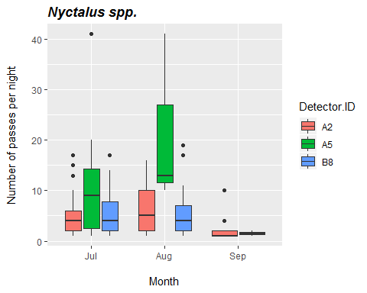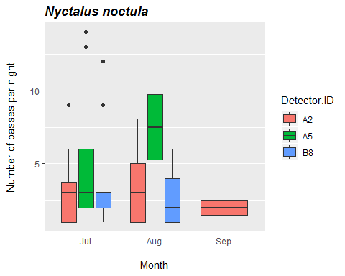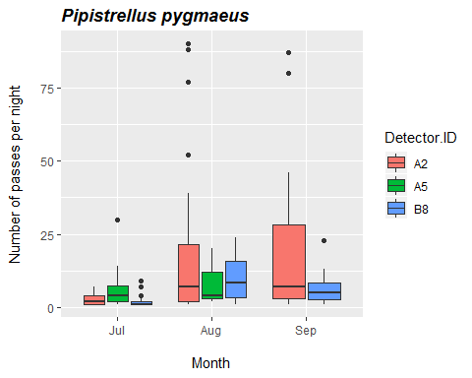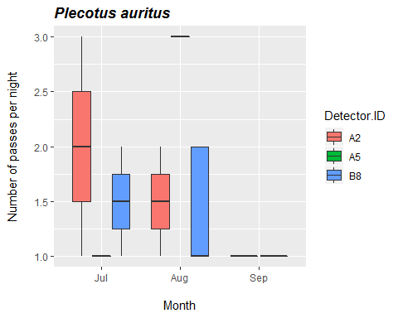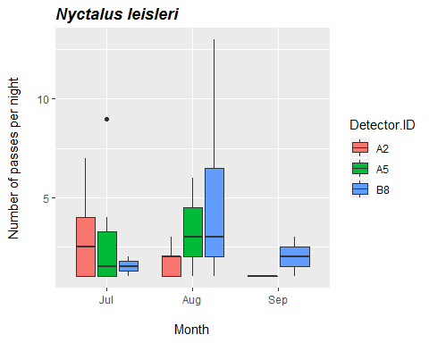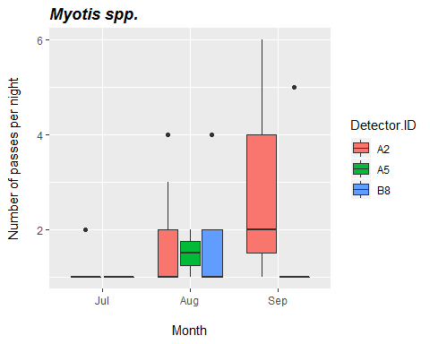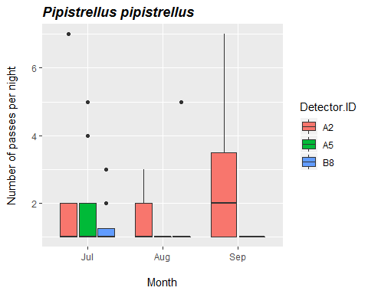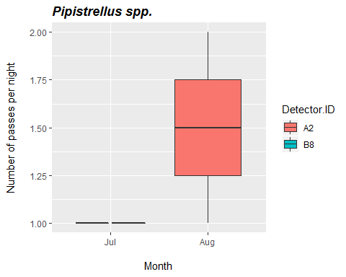

## Bat Passes per Month (by Survey Effort)

**The average number of bat passes of each species per night throughout each month. This is calculated by taking the total number of passes each month and dividing by the number of survey nights in that month.** *Note to self - still writing the code for this*

|  |  |  |  |
| --- | --- | --- | --- |
|  | Jul | Aug | Sep |
| **Myotis spp.** | 14 | 37 | 20 |
| **Nyctalus leisleri** | 57 | 101 | 7 |
| **Nyctalus noctula** | 169 | 86 | 6 |
| **Nyctalus spp.** | 457 | 352 | 26 |
| **Pipistrellus pipistrellus** | 47 | 33 | 23 |
| **Pipistrellus pygmaeus** | 222 | 764 | 368 |
| **Pipistrellus spp.** | 2 | 3 | 0 |
| **Plecotus auritus** | 8 | 13 | 3 |

## Hourly Bat Passes after Sunset (All Detectors)

**The average number of bat passes per hour, for each hour after sunset.**

|  |  |  |  |  |  |  |  |  |  |  |  |  |
| --- | --- | --- | --- | --- | --- | --- | --- | --- | --- | --- | --- | --- |
| Species | 0 | 1 | 2 | 3 | 4 | 5 | 6 | 7 | 8 | 9 | 10 | 11 |
| Myotis spp. | 0 | 0 | 2 | 16 | 14 | 11 | 13 | 8 | 6 | 1 | 0 | 0 |
| Nyctalus leisleri | 2 | 31 | 36 | 28 | 10 | 20 | 14 | 11 | 11 | 1 | 0 | 1 |
| Nyctalus noctula | 0 | 39 | 46 | 51 | 39 | 24 | 34 | 19 | 5 | 1 | 0 | 3 |
| Nyctalus spp. | 3 | 103 | 154 | 132 | 125 | 119 | 95 | 65 | 26 | 8 | 1 | 4 |
| Pipistrellus pipistrellus | 0 | 11 | 18 | 19 | 22 | 18 | 7 | 3 | 2 | 3 | 0 | 0 |
| Pipistrellus pygmaeus | 1 | 102 | 103 | 432 | 220 | 220 | 134 | 68 | 30 | 32 | 10 | 2 |
| Pipistrellus spp. | 0 | 0 | 0 | 1 | 1 | 1 | 2 | 0 | 0 | 0 | 0 | 0 |
| Plecotus auritus | 0 | 0 | 5 | 4 | 5 | 2 | 6 | 0 | 2 | 0 | 0 | 0 |

## Nightly Bat Activity (By Detector)

**Timing of bat calls plotted as minutes before/after sunset, whereby 0 on the y axis represents sunset. Sunset throughout the survey period is depicted as the red dashed line.**

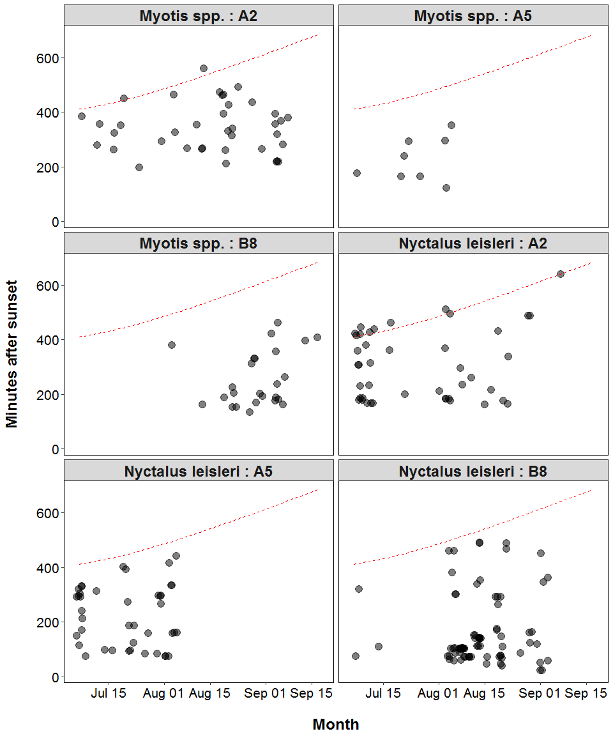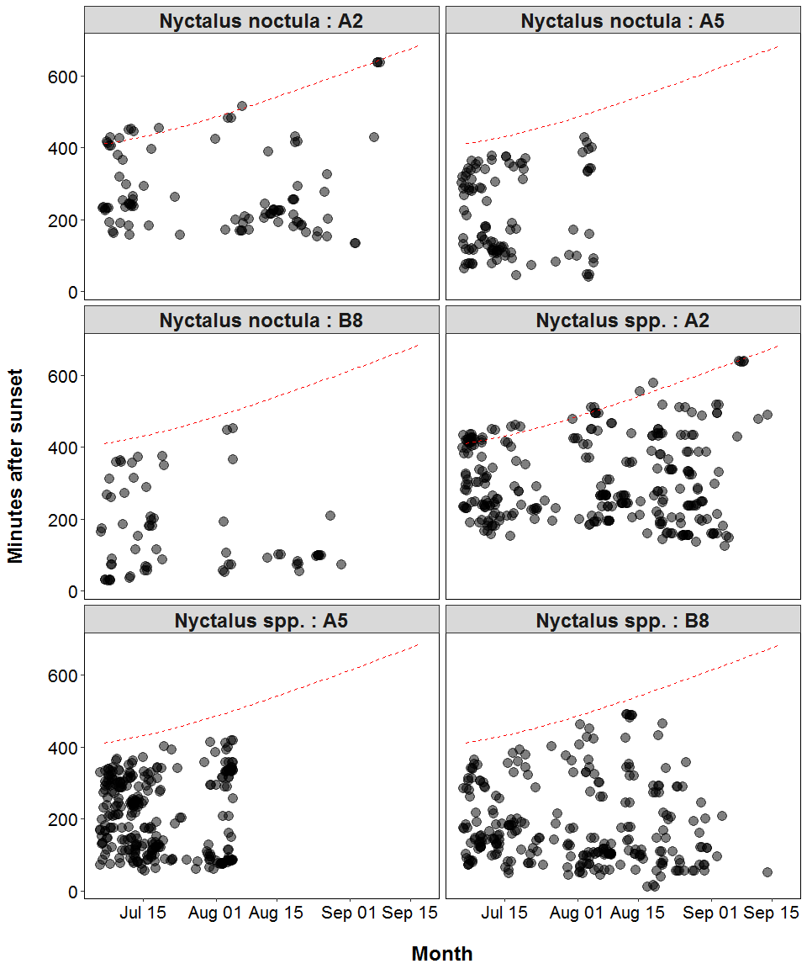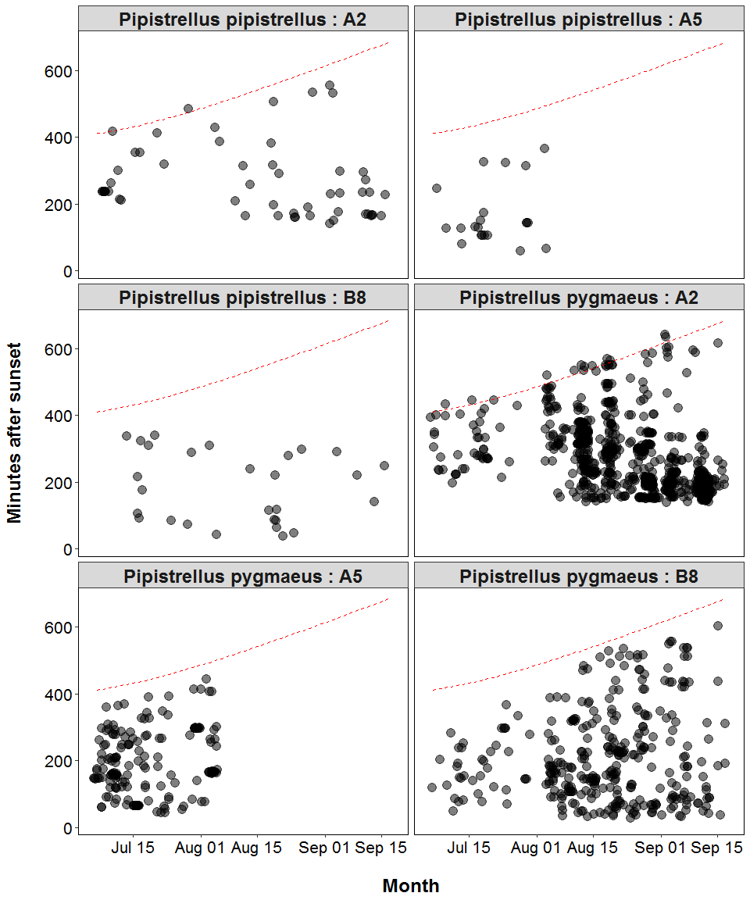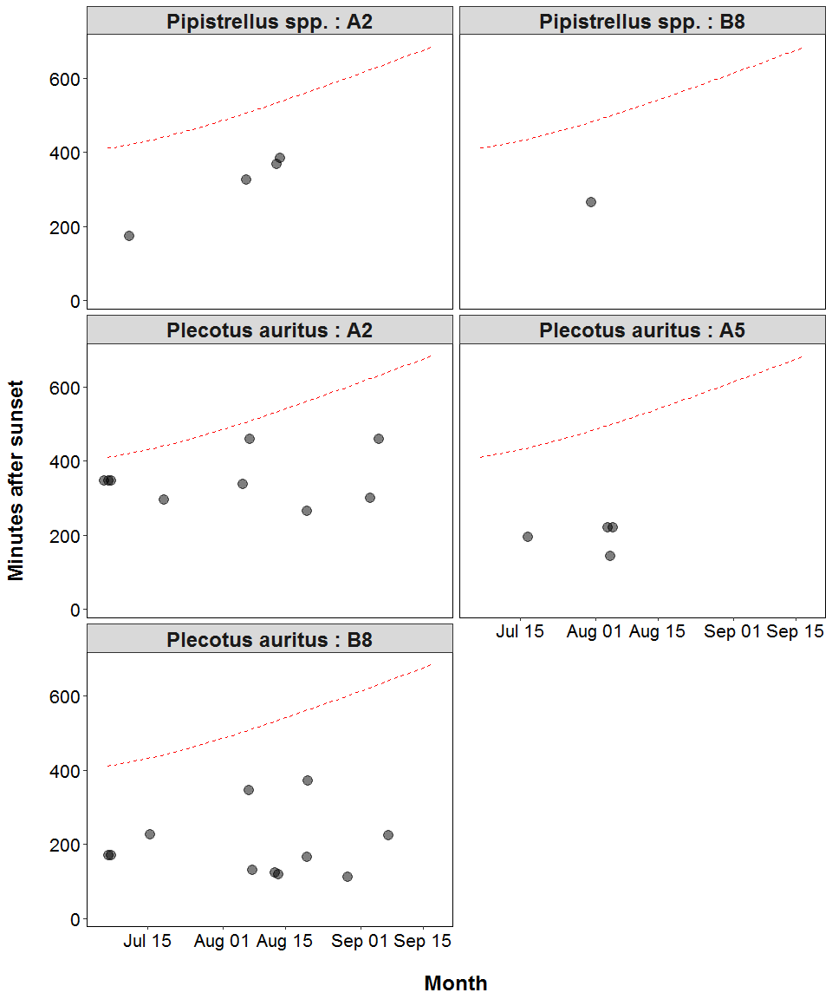

## Bat Passes *Near* a Roost (Russ 2012) - Table

**Bat calls recorded within the time range that each species emerges from the roost are indicative of a nearby roost**

|  |  |  |  |
| --- | --- | --- | --- |
| Species | Detector ID | 2018-08-18 | 2018-08-25 |
| Nyctalus spp. | B8 | 3 | 0 |
| Pipistrellus pygmaeus | B8 | 0 | 1 |

## Bat Passes *Near* a Roost by Night (Russ 2012) - Figures

**Bat calls recorded within the time range that each species emerges from the roost are indicative of a nearby roost. Time range for emergences are shown as grey bars and the time of each recorded call is shown. If the points overlap the grey bars, this is indicative of a nearby roost.**

