Ecobat: Nightly Bat Activity Analysis

Author: NA

08/02/2019



This report was produced free of charge by the Mammal Society to support evidence-based conservation of bats.

*The analyses are based on data supplied by the user to the Mammal Society’s Ecobat website. The outputs are designed to assist decision-making, but do not replace expert interpretation by the user. The creation of the Ecobat tool was supported by the Natural Environment Research Council (NERC).*

# Summary

Bat surveys were conducted on **49** nights between **2018-07-09** and **2018-09-09**, using **5** static bat detectors. Throughout this period **7** species were recorded. Detectors were placed at the following locations:

|  |  |  |
| --- | --- | --- |
| Detector ID | Latitude | Longitude |
| d6 | 55.02690 | -6.821783 |
| d7 | 55.02458 | -6.821733 |
| d8 | 55.02213 | -6.821350 |
| d9 | 55.01965 | -6.820650 |
| d10 | 55.01728 | -6.819750 |

##### Page Break

# Sunrise and Sunset Times

**The times of sunset and sunrise the following morning for surveys beginning on the date shown.**

|  |  |  |  |
| --- | --- | --- | --- |
| Night (y-m-d) | Sunset (hh:mm) | Sunrise (hh:mm) | Night Length (hours) |
| 2018-07-09 | 22:05 | 05:02 | 7.0 |
| 2018-07-10 | 22:04 | 05:04 | 7.0 |
| 2018-07-11 | 22:03 | 05:05 | 7.0 |
| 2018-07-12 | 22:02 | 05:06 | 7.1 |
| 2018-07-13 | 22:01 | 05:07 | 7.1 |
| 2018-07-14 | 22:00 | 05:09 | 7.1 |
| 2018-07-15 | 21:59 | 05:10 | 7.2 |
| 2018-07-16 | 21:58 | 05:12 | 7.2 |
| 2018-07-17 | 21:56 | 05:13 | 7.3 |
| 2018-07-18 | 21:55 | 05:15 | 7.3 |
| 2018-07-22 | 21:49 | 05:21 | 7.5 |
| 2018-07-23 | 21:48 | 05:23 | 7.6 |
| 2018-07-24 | 21:46 | 05:24 | 7.6 |
| 2018-07-25 | 21:45 | 05:26 | 7.7 |
| 2018-07-26 | 21:43 | 05:28 | 7.7 |
| 2018-07-29 | 21:38 | 05:33 | 7.9 |
| 2018-07-30 | 21:36 | 05:35 | 8.0 |
| 2018-08-01 | 21:32 | 05:38 | 8.1 |
| 2018-08-02 | 21:30 | 05:40 | 8.2 |
| 2018-08-03 | 21:28 | 05:42 | 8.2 |
| 2018-08-04 | 21:26 | 05:44 | 8.3 |
| 2018-08-05 | 21:24 | 05:46 | 8.4 |
| 2018-08-06 | 21:22 | 05:47 | 8.4 |
| 2018-08-07 | 21:20 | 05:49 | 8.5 |
| 2018-08-08 | 21:18 | 05:51 | 8.5 |
| 2018-08-09 | 21:16 | 05:53 | 8.6 |
| 2018-08-10 | 21:14 | 05:55 | 8.7 |
| 2018-08-11 | 21:12 | 05:57 | 8.7 |
| 2018-08-12 | 21:10 | 05:59 | 8.8 |
| 2018-08-13 | 21:08 | 06:00 | 8.9 |
| 2018-08-15 | 21:03 | 06:04 | 9.0 |
| 2018-08-16 | 21:01 | 06:06 | 9.1 |
| 2018-08-17 | 20:59 | 06:08 | 9.2 |
| 2018-08-19 | 20:54 | 06:12 | 9.3 |
| 2018-08-20 | 20:52 | 06:14 | 9.4 |
| 2018-08-22 | 20:47 | 06:17 | 9.5 |
| 2018-08-24 | 20:42 | 06:21 | 9.6 |
| 2018-08-25 | 20:40 | 06:23 | 9.7 |
| 2018-08-27 | 20:35 | 06:27 | 9.9 |
| 2018-08-29 | 20:30 | 06:30 | 10.0 |
| 2018-08-30 | 20:28 | 06:32 | 10.1 |
| 2018-09-01 | 20:23 | 06:36 | 10.2 |
| 2018-09-02 | 20:20 | 06:38 | 10.3 |
| 2018-09-03 | 20:18 | 06:40 | 10.4 |
| 2018-09-04 | 20:15 | 06:42 | 10.4 |
| 2018-09-05 | 20:12 | 06:43 | 10.5 |
| 2018-09-07 | 20:07 | 06:47 | 10.7 |
| 2018-09-08 | 20:05 | 06:49 | 10.7 |
| 2018-09-09 | 20:02 | 06:51 | 10.8 |

##### Page Break

# Counts of Bat Passes

## All detectors

**The total number of passes recorded for each species across all of the detectors.**

|  |  |  |
| --- | --- | --- |
| Species | Count (No) | Percentage of total (%) |
| Pipistrelle spp. | 7 | 0.3 |
| Common pipistrelle | 563 | 26.3 |
| Soprano pipistrelle | 199 | 9.3 |
| Nathusius’ | 44 | 2.1 |
| Leisler’s | 1296 | 60.6 |
| Brown long-eared | 4 | 0.2 |
| Myotis spp. | 25 | 1.2 |
| Total | 2138 | 100.0 |

##### Page Break# Counts of Bat Passes

## Per Detector

**The number of passes recorded for each species at each detector.**

|  |  |  |  |
| --- | --- | --- | --- |
| Species | Detector ID | Count (No) | Percentage by Detector (%) |
| Pipistrelle spp. | d10 | 3 | 0.6 |
| Pipistrelle spp. | d6 | 2 | 0.5 |
| Pipistrelle spp. | d8 | 2 | 0.3 |
| Common pipistrelle | d10 | 100 | 19.1 |
| Common pipistrelle | d6 | 195 | 44.3 |
| Common pipistrelle | d7 | 49 | 16.6 |
| Common pipistrelle | d8 | 144 | 24.2 |
| Common pipistrelle | d9 | 75 | 26.4 |
| Soprano pipistrelle | d10 | 42 | 8.0 |
| Soprano pipistrelle | d6 | 41 | 9.3 |
| Soprano pipistrelle | d7 | 42 | 14.2 |
| Soprano pipistrelle | d8 | 50 | 8.4 |
| Soprano pipistrelle | d9 | 24 | 8.5 |
| Nathusius’ | d10 | 9 | 1.7 |
| Nathusius’ | d6 | 9 | 2.0 |
| Nathusius’ | d7 | 8 | 2.7 |
| Nathusius’ | d8 | 11 | 1.8 |
| Nathusius’ | d9 | 7 | 2.5 |
| Leisler’s | d10 | 361 | 69.0 |
| Leisler’s | d6 | 193 | 43.9 |
| Leisler’s | d7 | 191 | 64.7 |
| Leisler’s | d8 | 380 | 63.8 |
| Leisler’s | d9 | 171 | 60.2 |
| Brown long-eared | d10 | 2 | 0.4 |
| Brown long-eared | d7 | 1 | 0.3 |
| Brown long-eared | d8 | 1 | 0.2 |
| Myotis spp. | d10 | 6 | 1.1 |
| Myotis spp. | d7 | 4 | 1.4 |
| Myotis spp. | d8 | 8 | 1.3 |
| Myotis spp. | d9 | 7 | 2.5 |

##### Page Break

# Species Composition of Passes at each Detector

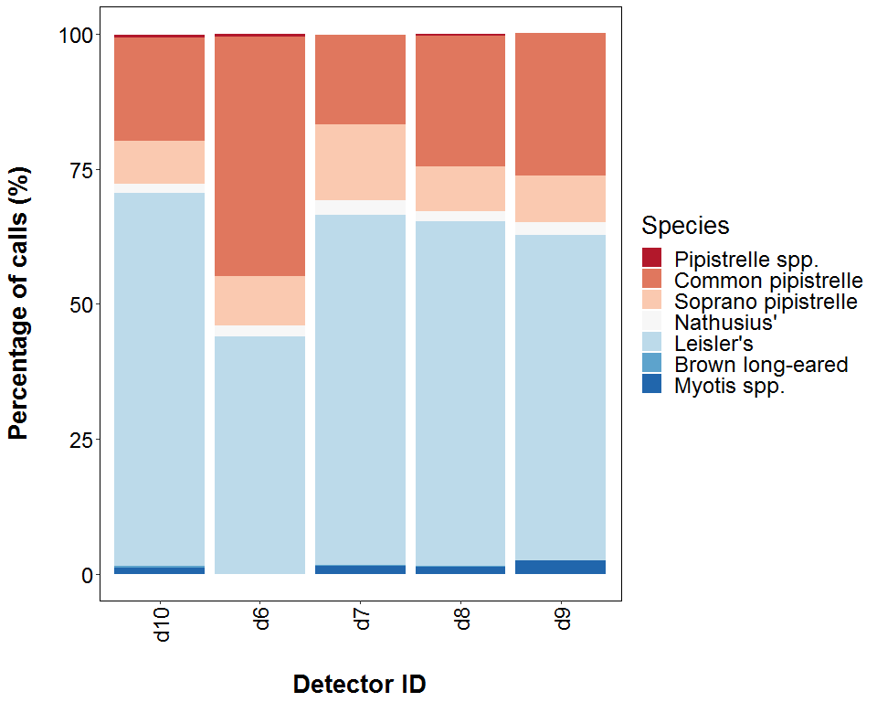

##### Page Break

# Bat Passes per Month

## Per Detector

**The total number of bat passes of each species in each month at each detector.**

|  |  |  |  |  |
| --- | --- | --- | --- | --- |
| Species | Detector ID | Jul | Aug | Sep |
| Pipistrelle spp. | d10 | 0 | 2 | 1 |
| Pipistrelle spp. | d6 | 0 | 1 | 1 |
| Pipistrelle spp. | d8 | 0 | 1 | 1 |
| Common pipistrelle | d10 | 33 | 57 | 10 |
| Common pipistrelle | d6 | 37 | 104 | 54 |
| Common pipistrelle | d7 | 6 | 43 | 0 |
| Common pipistrelle | d8 | 17 | 103 | 24 |
| Common pipistrelle | d9 | 26 | 43 | 6 |
| Soprano pipistrelle | d10 | 4 | 27 | 11 |
| Soprano pipistrelle | d6 | 1 | 37 | 3 |
| Soprano pipistrelle | d7 | 20 | 22 | 0 |
| Soprano pipistrelle | d8 | 5 | 39 | 6 |
| Soprano pipistrelle | d9 | 3 | 19 | 2 |
| Nathusius’ | d10 | 1 | 6 | 2 |
| Nathusius’ | d6 | 1 | 8 | 0 |
| Nathusius’ | d7 | 0 | 8 | 0 |
| Nathusius’ | d8 | 0 | 7 | 4 |
| Nathusius’ | d9 | 0 | 5 | 2 |
| Leisler’s | d10 | 141 | 209 | 11 |
| Leisler’s | d6 | 58 | 134 | 1 |
| Leisler’s | d7 | 84 | 107 | 0 |
| Leisler’s | d8 | 132 | 227 | 21 |
| Leisler’s | d9 | 101 | 64 | 6 |
| Brown long-eared | d10 | 1 | 1 | 0 |
| Brown long-eared | d7 | 1 | 0 | 0 |
| Brown long-eared | d8 | 0 | 0 | 1 |
| Myotis spp. | d10 | 0 | 4 | 2 |
| Myotis spp. | d7 | 1 | 3 | 0 |
| Myotis spp. | d8 | 1 | 6 | 1 |
| Myotis spp. | d9 | 0 | 7 | 0 |

##### Page Break

## Bat Pass Rates

# Survey Effort

**The number of survey nights per month.**

|  |  |
| --- | --- |
| Month | No of Survey Nights |
| Jul | 17 |
| Aug | 24 |
| Sep | 8 |

**The average number of bat passes of each species per night throughout each month. Calculated with (Number of passes each month) / (Number of survey nights each month). Values are given to 1 decimal place.**

|  |  |  |  |  |
| --- | --- | --- | --- | --- |
| Species | Detector ID | Jul | Aug | Sep |
| Pipistrelle spp. | d10 | 0.0 | 0.1 | 0.1 |
| Pipistrelle spp. | d6 | 0.0 | 0.0 | 0.1 |
| Pipistrelle spp. | d8 | 0.0 | 0.0 | 0.1 |
| Common pipistrelle | d10 | 1.9 | 2.4 | 1.2 |
| Common pipistrelle | d6 | 2.2 | 4.3 | 6.8 |
| Common pipistrelle | d7 | 0.4 | 1.8 | 0.0 |
| Common pipistrelle | d8 | 1.0 | 4.3 | 3.0 |
| Common pipistrelle | d9 | 1.5 | 1.8 | 0.8 |
| Soprano pipistrelle | d10 | 0.2 | 1.1 | 1.4 |
| Soprano pipistrelle | d6 | 0.1 | 1.5 | 0.4 |
| Soprano pipistrelle | d7 | 1.2 | 0.9 | 0.0 |
| Soprano pipistrelle | d8 | 0.3 | 1.6 | 0.8 |
| Soprano pipistrelle | d9 | 0.2 | 0.8 | 0.2 |
| Nathusius’ | d10 | 0.1 | 0.2 | 0.2 |
| Nathusius’ | d6 | 0.1 | 0.3 | 0.0 |
| Nathusius’ | d7 | 0.0 | 0.3 | 0.0 |
| Nathusius’ | d8 | 0.0 | 0.3 | 0.5 |
| Nathusius’ | d9 | 0.0 | 0.2 | 0.2 |
| Leisler’s | d10 | 8.3 | 8.7 | 1.4 |
| Leisler’s | d6 | 3.4 | 5.6 | 0.1 |
| Leisler’s | d7 | 4.9 | 4.5 | 0.0 |
| Leisler’s | d8 | 7.8 | 9.5 | 2.6 |
| Leisler’s | d9 | 5.9 | 2.7 | 0.8 |
| Brown long-eared | d10 | 0.1 | 0.0 | 0.0 |
| Brown long-eared | d7 | 0.1 | 0.0 | 0.0 |
| Brown long-eared | d8 | 0.0 | 0.0 | 0.1 |
| Myotis spp. | d10 | 0.0 | 0.2 | 0.2 |
| Myotis spp. | d7 | 0.1 | 0.1 | 0.0 |
| Myotis spp. | d8 | 0.1 | 0.2 | 0.1 |
| Myotis spp. | d9 | 0.0 | 0.3 | 0.0 |

##### Page Break

## Median Nightly Bat Passes for each Month

# Per Detector

**The median number of bat passes of each species throughout each month. If NA, then no bat passes.**

Bat pass rates are often highly variable between nights, with some nights having few or no passes and other nights having high activity. In these circumstances, the median is likely to be a more useful summary of the ‘average’ activity than is the mean. (For further information see: *Lintott, P. R., & Mathews, F. (2018). Basic mathematical errors may make ecological assessments unreliable. Biodiversity and Conservation, 27(1), 265-267.)* <https://doi.org/10.1007/s10531-017-1418-5>

|  |  |  |  |  |
| --- | --- | --- | --- | --- |
| Species | Detector ID | Jul | Aug | Sep |
| Pipistrelle spp. | d10 | NA | 1.0 | 1.0 |
| Pipistrelle spp. | d6 | NA | 1.0 | 1.0 |
| Pipistrelle spp. | d8 | NA | 1.0 | 1.0 |
| Common pipistrelle | d10 | 2.0 | 11.0 | 5.0 |
| Common pipistrelle | d6 | 4.5 | 8.0 | 3.5 |
| Common pipistrelle | d7 | 3.0 | 2.0 | NA |
| Common pipistrelle | d8 | 2.0 | 3.0 | 5.0 |
| Common pipistrelle | d9 | 1.0 | 1.0 | 3.0 |
| Soprano pipistrelle | d10 | 1.0 | 2.5 | 2.0 |
| Soprano pipistrelle | d6 | 1.0 | 2.0 | 1.5 |
| Soprano pipistrelle | d7 | 3.0 | 2.5 | NA |
| Soprano pipistrelle | d8 | 1.0 | 2.0 | 3.0 |
| Soprano pipistrelle | d9 | 1.5 | 2.0 | 2.0 |
| Nathusius’ | d10 | 1.0 | 1.5 | 1.0 |
| Nathusius’ | d6 | 1.0 | 1.0 | NA |
| Nathusius’ | d7 | NA | 1.5 | NA |
| Nathusius’ | d8 | NA | 1.5 | 2.0 |
| Nathusius’ | d9 | NA | 2.0 | 1.0 |
| Leisler’s | d10 | 6.5 | 4.0 | 4.0 |
| Leisler’s | d6 | 3.0 | 2.5 | 1.0 |
| Leisler’s | d7 | 2.0 | 4.0 | NA |
| Leisler’s | d8 | 5.0 | 5.0 | 5.0 |
| Leisler’s | d9 | 5.0 | 2.0 | 2.0 |
| Brown long-eared | d10 | 1.0 | 1.0 | NA |
| Brown long-eared | d7 | 1.0 | NA | NA |
| Brown long-eared | d8 | NA | NA | 1.0 |
| Myotis spp. | d10 | NA | 1.0 | 1.0 |
| Myotis spp. | d7 | 1.0 | 1.5 | NA |
| Myotis spp. | d8 | 1.0 | 1.0 | 1.0 |
| Myotis spp. | d9 | NA | 1.0 | NA |

##### Page Break

# Bat Passes per Month

## Per Detector - Figures

Figures show boxplots for the number of bat passes by detector each month. The ‘box’ shows the interquartile range, which is where the middle 50% of the data lie. The line dividing the box is the median, the mid-point of the data. The ‘whiskers’ extend from the box and represent the ranges for the bottom 25% and the top 25% of the data values, excluding outliers. An outlier is any extreme value that lies further away from the box than 1.5 times the interquartile range. Outliers are shown as dots. Where very few passes are recorded it is not possible to produce the box, so the data are shown as a line.

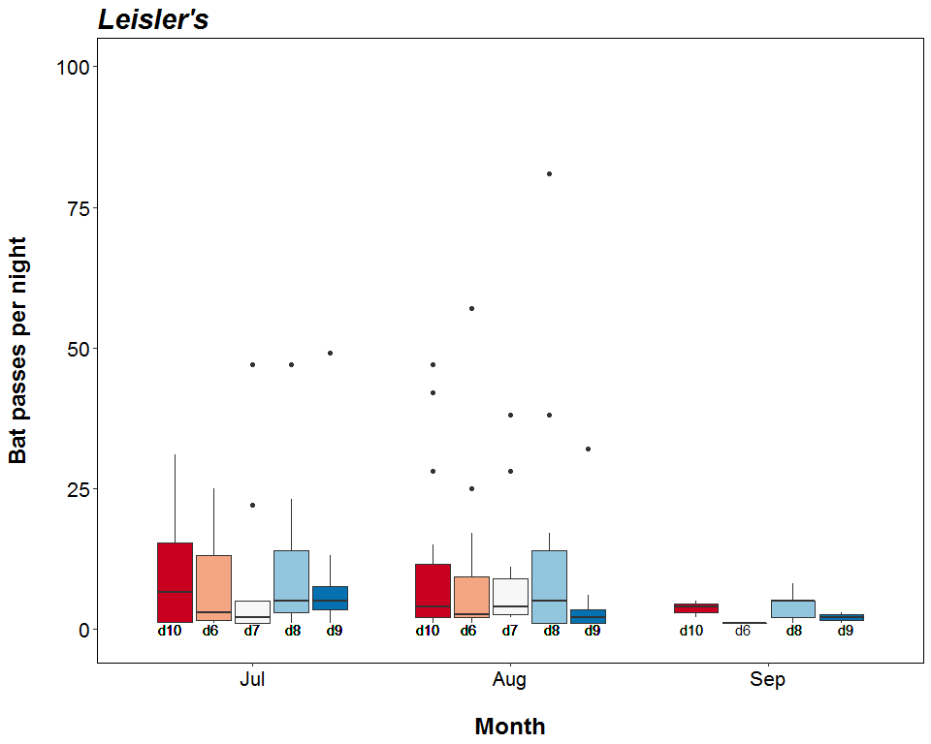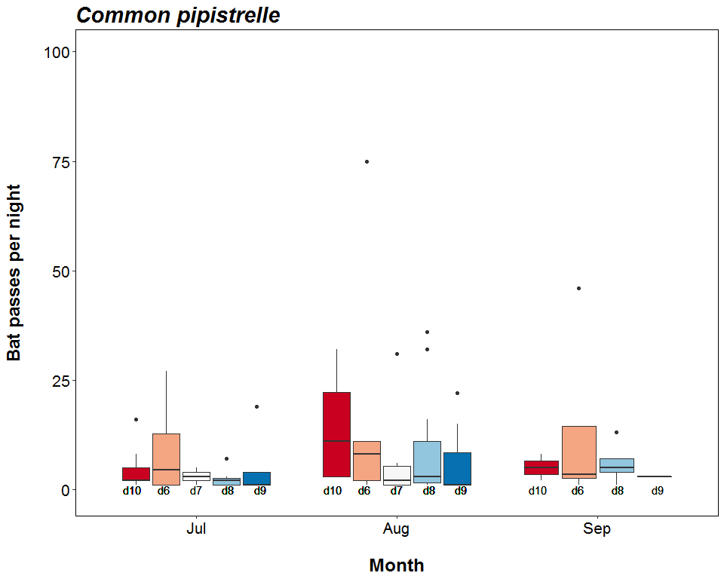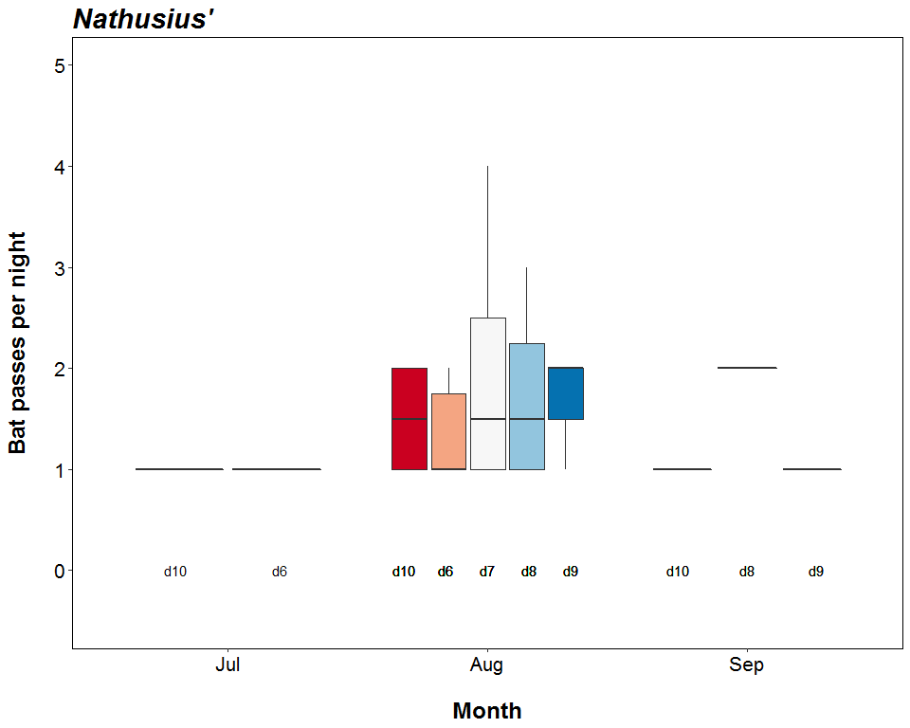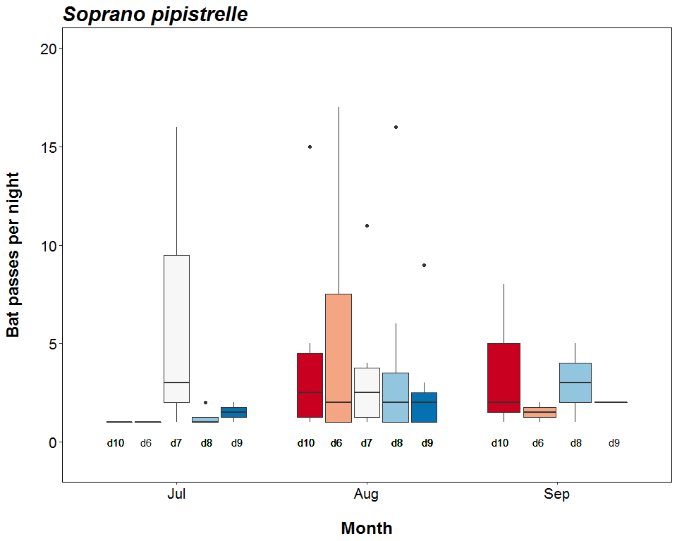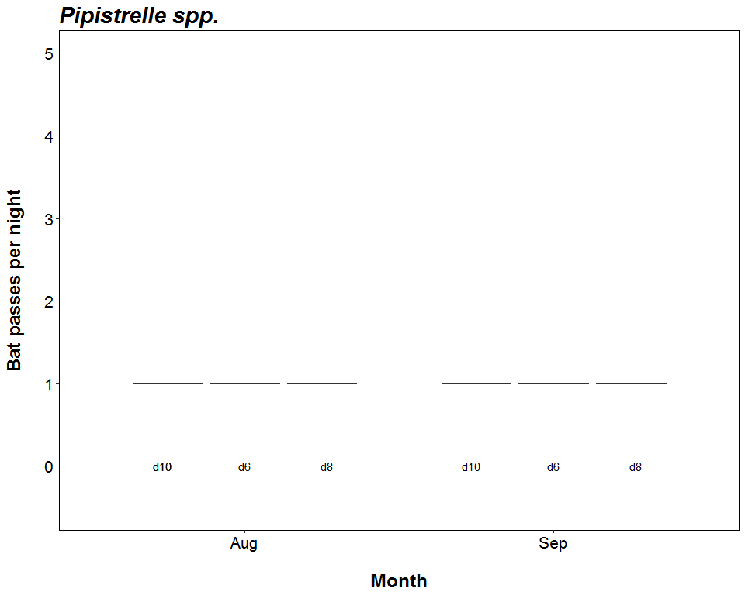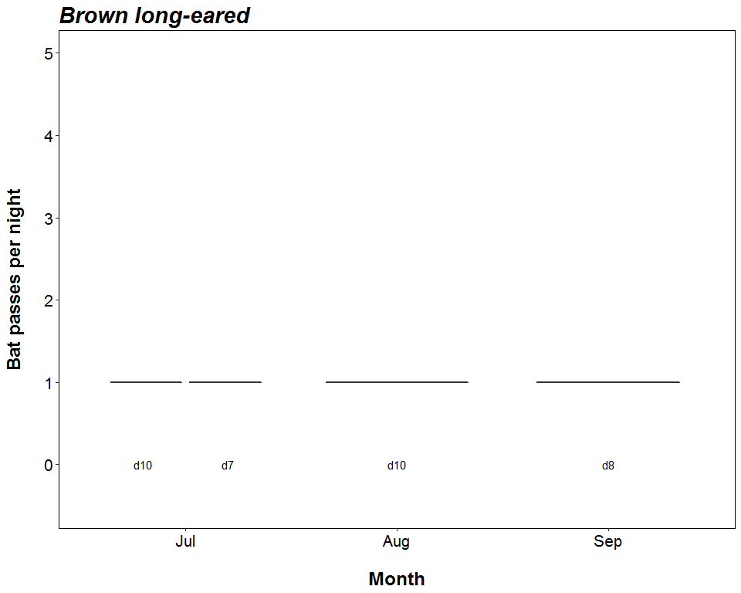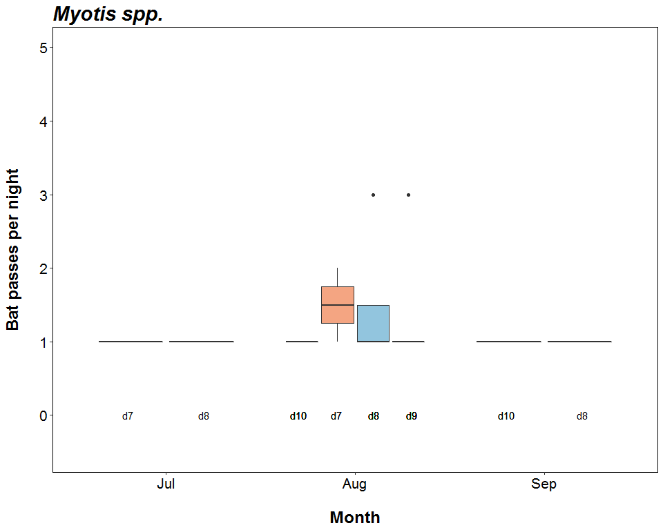

##### Page Break

# Distribution of Bat Passes Across Hours of the Night

## All Detectors

**The total number of bat passes occuring during each hour after sunset.**

|  |  |  |  |  |  |  |  |  |  |  |  |
| --- | --- | --- | --- | --- | --- | --- | --- | --- | --- | --- | --- |
| Species | Detector ID | 0 | 1 | 2 | 3 | 4 | 5 | 6 | 7 | 8 | 9 |
| Pipistrelle spp. | d10 | 0 | 2 | 0 | 1 | 0 | 0 | 0 | 0 | 0 | 0 |
| Pipistrelle spp. | d6 | 0 | 2 | 0 | 0 | 0 | 0 | 0 | 0 | 0 | 0 |
| Pipistrelle spp. | d8 | 0 | 1 | 0 | 1 | 0 | 0 | 0 | 0 | 0 | 0 |
| Common pipistrelle | d10 | 1 | 53 | 26 | 8 | 10 | 0 | 1 | 1 | 0 | 0 |
| Common pipistrelle | d6 | 0 | 118 | 55 | 4 | 7 | 3 | 2 | 6 | 0 | 0 |
| Common pipistrelle | d7 | 0 | 41 | 6 | 2 | 0 | 0 | 0 | 0 | 0 | 0 |
| Common pipistrelle | d8 | 10 | 101 | 18 | 6 | 4 | 1 | 0 | 4 | 0 | 0 |
| Common pipistrelle | d9 | 0 | 42 | 26 | 6 | 1 | 0 | 0 | 0 | 0 | 0 |
| Soprano pipistrelle | d10 | 0 | 12 | 15 | 3 | 5 | 2 | 3 | 2 | 0 | 0 |
| Soprano pipistrelle | d6 | 0 | 11 | 21 | 4 | 1 | 1 | 2 | 1 | 0 | 0 |
| Soprano pipistrelle | d7 | 0 | 27 | 3 | 8 | 2 | 1 | 0 | 0 | 1 | 0 |
| Soprano pipistrelle | d8 | 0 | 19 | 16 | 7 | 4 | 3 | 0 | 1 | 0 | 0 |
| Soprano pipistrelle | d9 | 0 | 6 | 12 | 2 | 2 | 0 | 2 | 0 | 0 | 0 |
| Nathusius’ | d10 | 0 | 1 | 1 | 4 | 2 | 1 | 0 | 0 | 0 | 0 |
| Nathusius’ | d6 | 0 | 0 | 1 | 2 | 6 | 0 | 0 | 0 | 0 | 0 |
| Nathusius’ | d7 | 0 | 0 | 0 | 8 | 0 | 0 | 0 | 0 | 0 | 0 |
| Nathusius’ | d8 | 0 | 1 | 5 | 1 | 2 | 2 | 0 | 0 | 0 | 0 |
| Nathusius’ | d9 | 0 | 3 | 0 | 3 | 1 | 0 | 0 | 0 | 0 | 0 |
| Leisler’s | d10 | 6 | 160 | 107 | 16 | 39 | 9 | 8 | 9 | 5 | 2 |
| Leisler’s | d6 | 2 | 111 | 36 | 25 | 2 | 9 | 2 | 0 | 5 | 1 |
| Leisler’s | d7 | 0 | 111 | 50 | 12 | 8 | 3 | 6 | 0 | 1 | 0 |
| Leisler’s | d8 | 6 | 209 | 73 | 18 | 40 | 12 | 10 | 8 | 0 | 4 |
| Leisler’s | d9 | 1 | 76 | 22 | 13 | 41 | 10 | 6 | 1 | 0 | 1 |
| Brown long-eared | d10 | 0 | 0 | 0 | 0 | 1 | 0 | 0 | 1 | 0 | 0 |
| Brown long-eared | d7 | 0 | 0 | 0 | 1 | 0 | 0 | 0 | 0 | 0 | 0 |
| Brown long-eared | d8 | 0 | 0 | 0 | 0 | 0 | 0 | 0 | 1 | 0 | 0 |
| Myotis spp. | d10 | 0 | 0 | 0 | 1 | 3 | 1 | 0 | 1 | 0 | 0 |
| Myotis spp. | d7 | 0 | 0 | 1 | 1 | 1 | 0 | 1 | 0 | 0 | 0 |
| Myotis spp. | d8 | 0 | 0 | 0 | 2 | 2 | 1 | 3 | 0 | 0 | 0 |
| Myotis spp. | d9 | 0 | 0 | 1 | 0 | 2 | 3 | 1 | 0 | 0 | 0 |

##### Page Break

# Distribution of Bat Passes Across Hours of the Night

## All Detectors

**Cumulative number of bat passes throughout the night.**

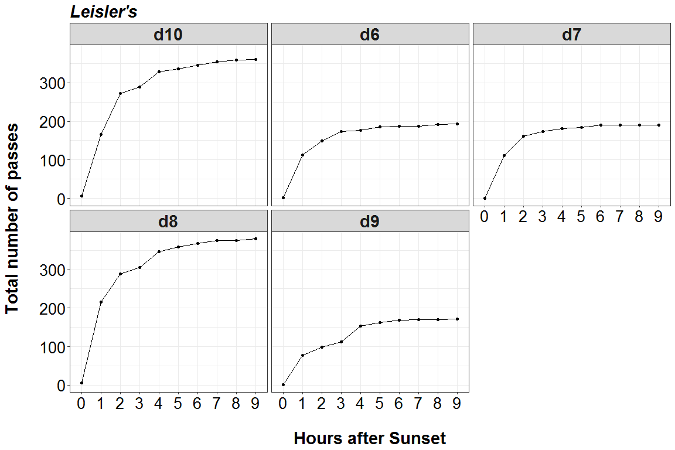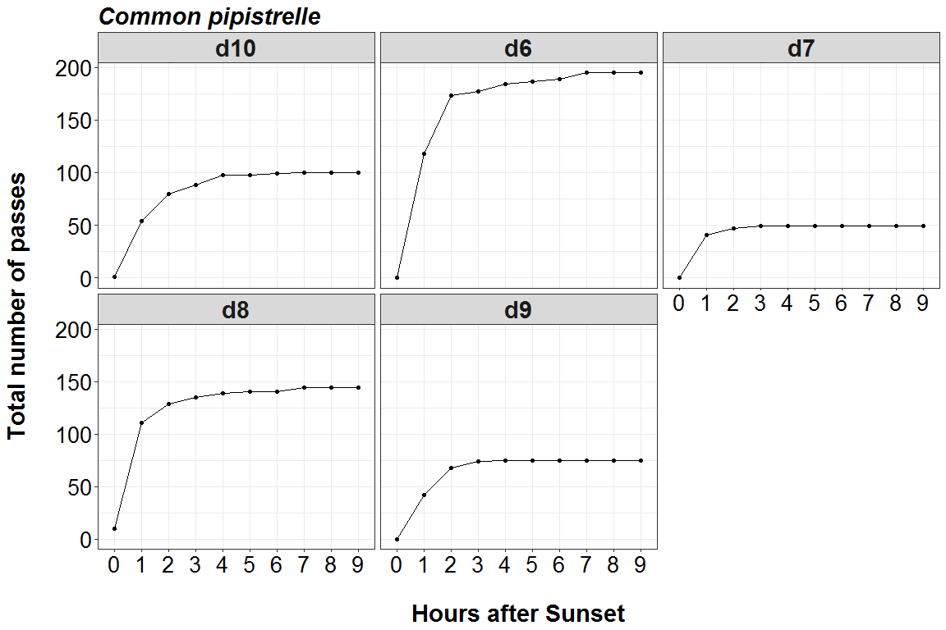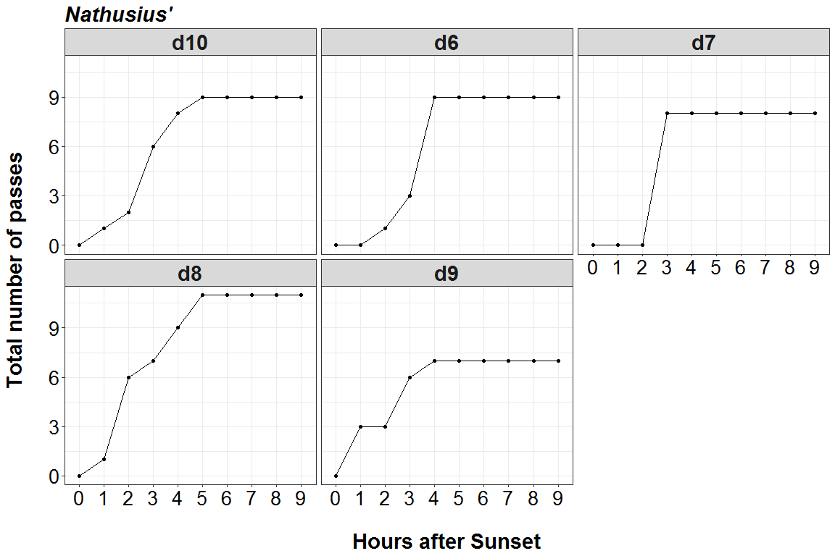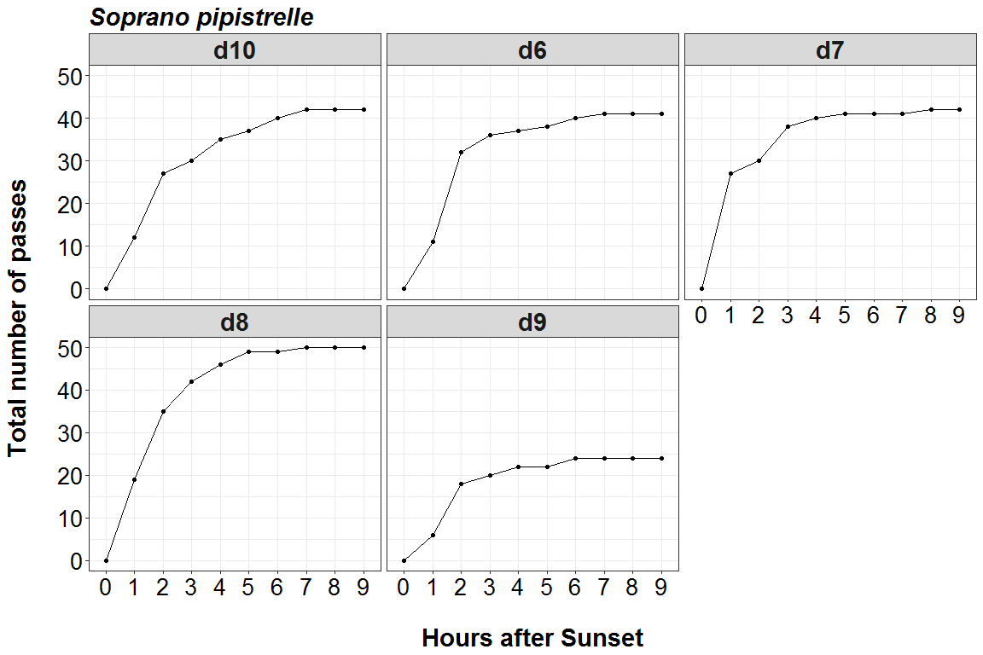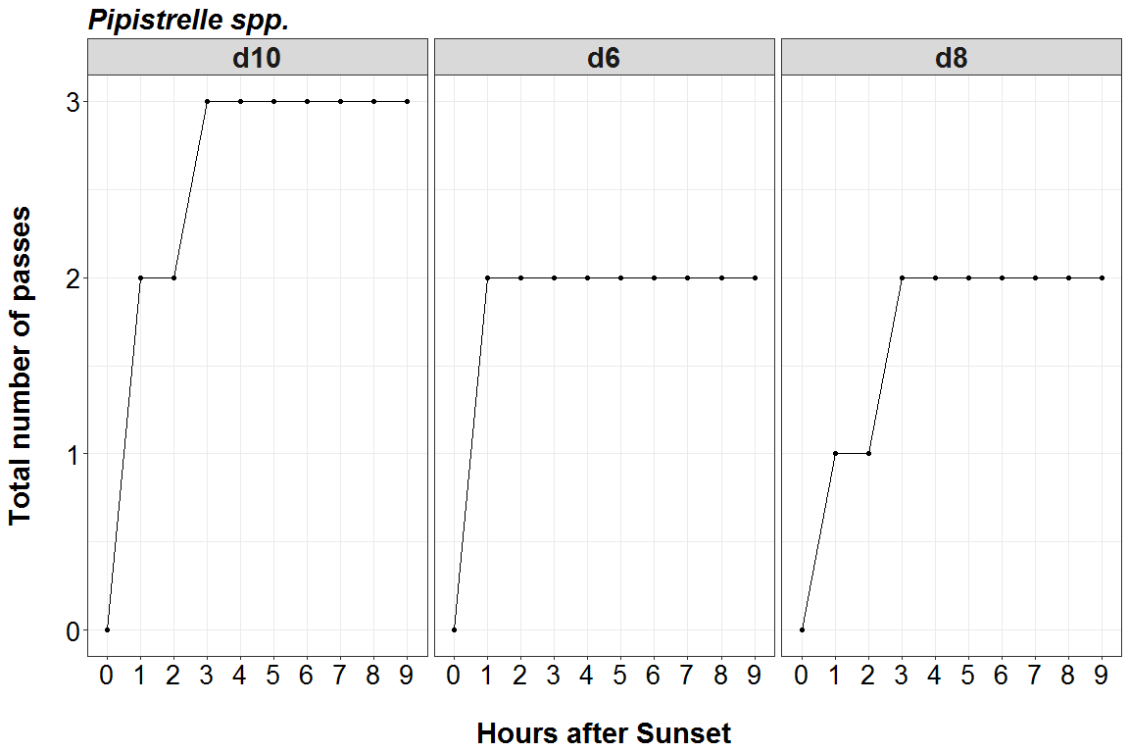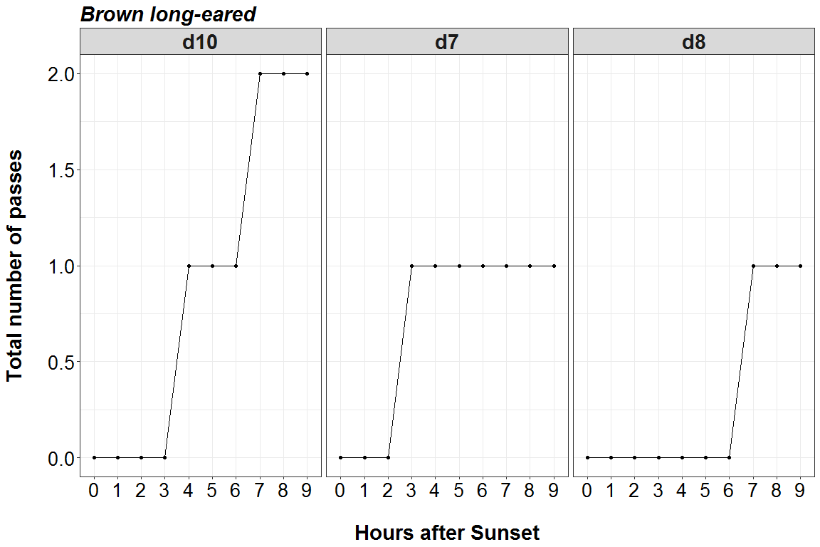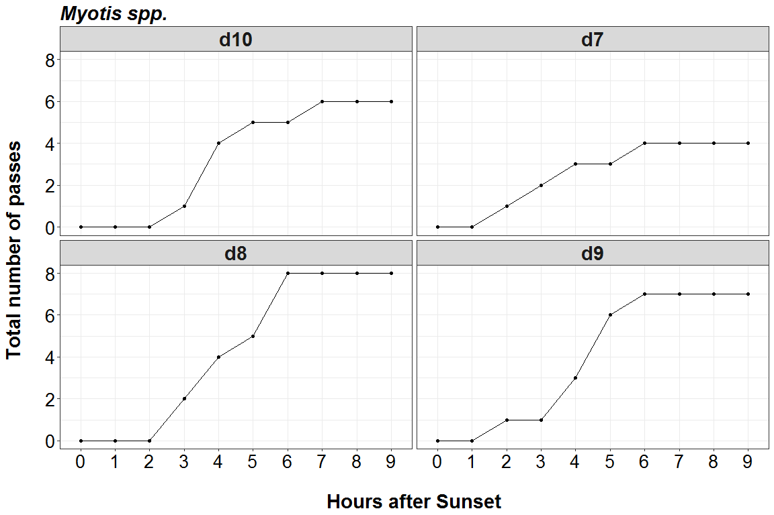

##### Page Break

# Distribution of Bat Activity Across the Night through Time

## Per Detector

**Timing of bat calls plotted as minutes before/after sunset, whereby 0 on the y axis represents sunset. Sunrise throughout the survey period is depicted as the red dashed line.**

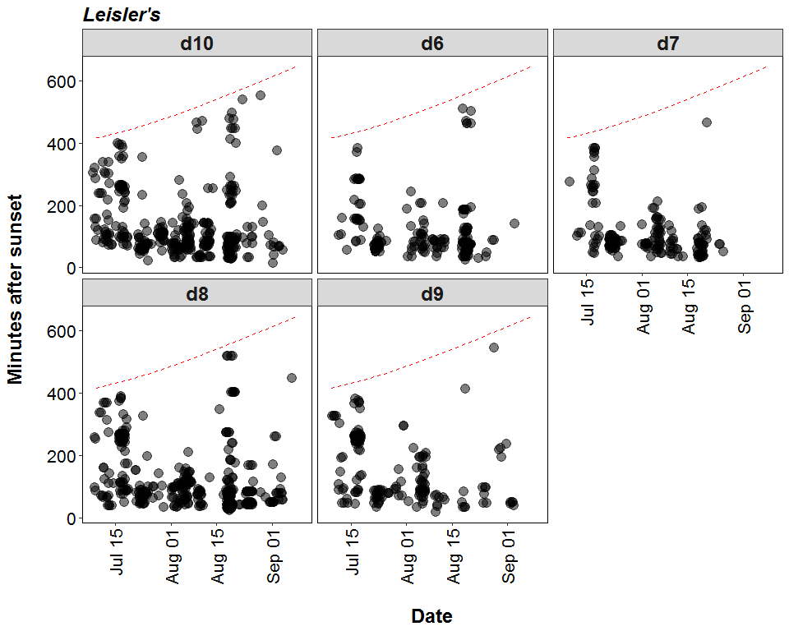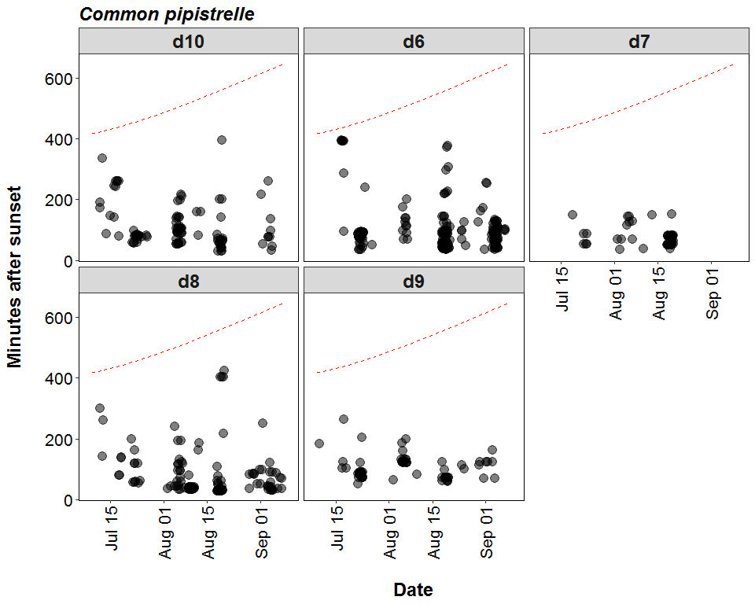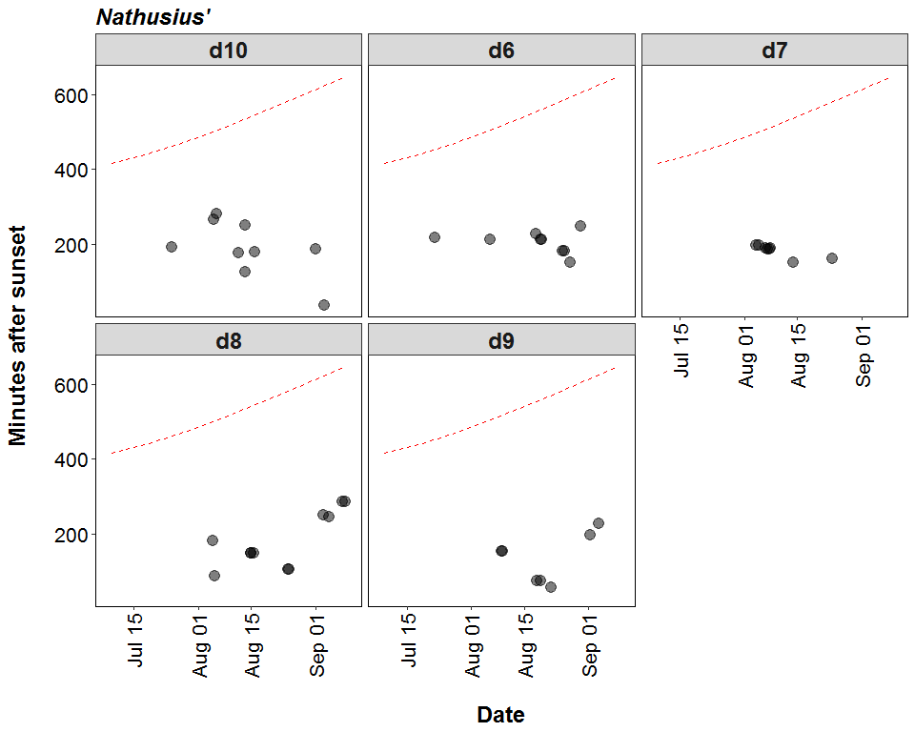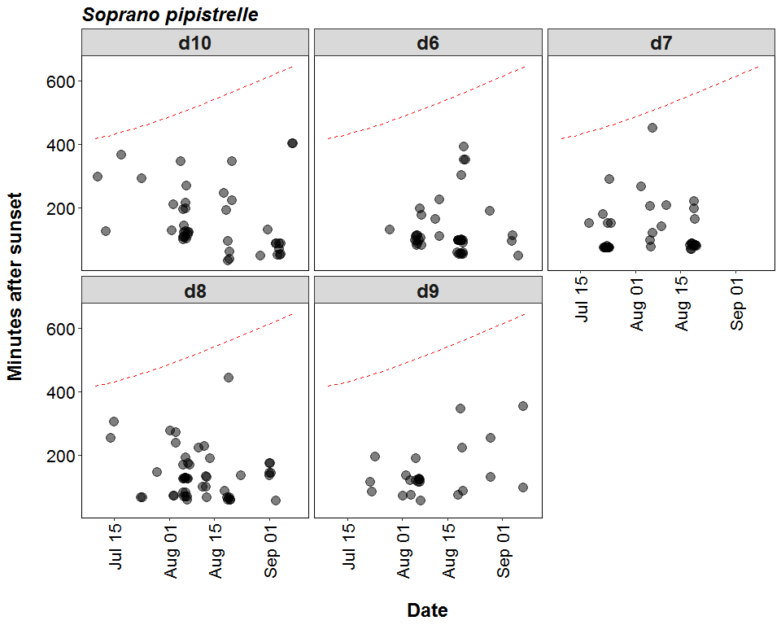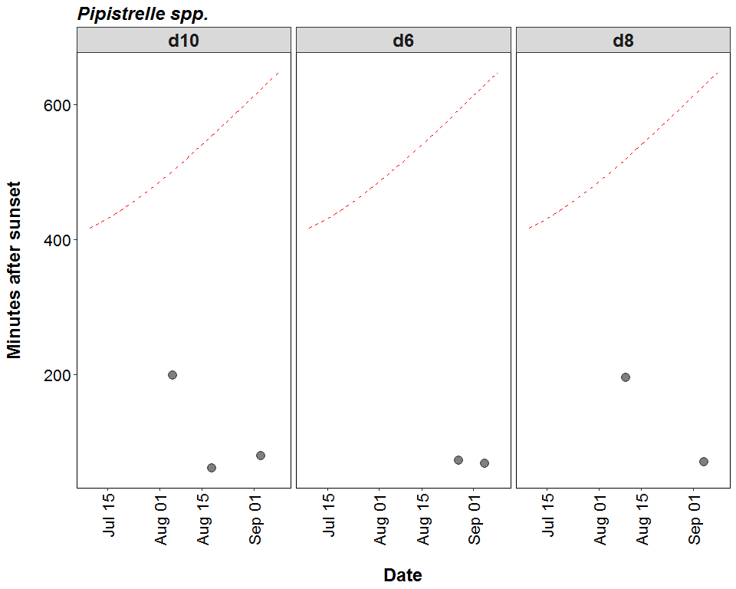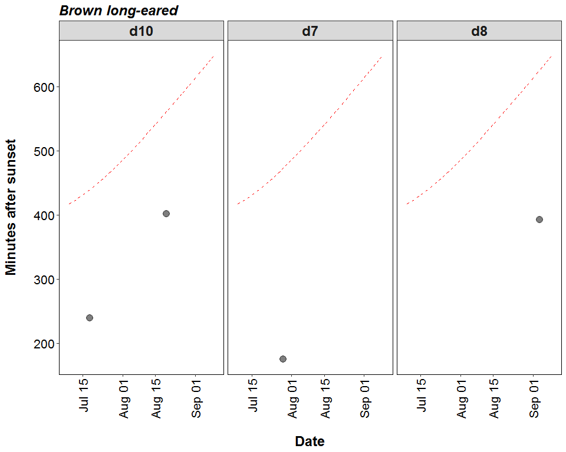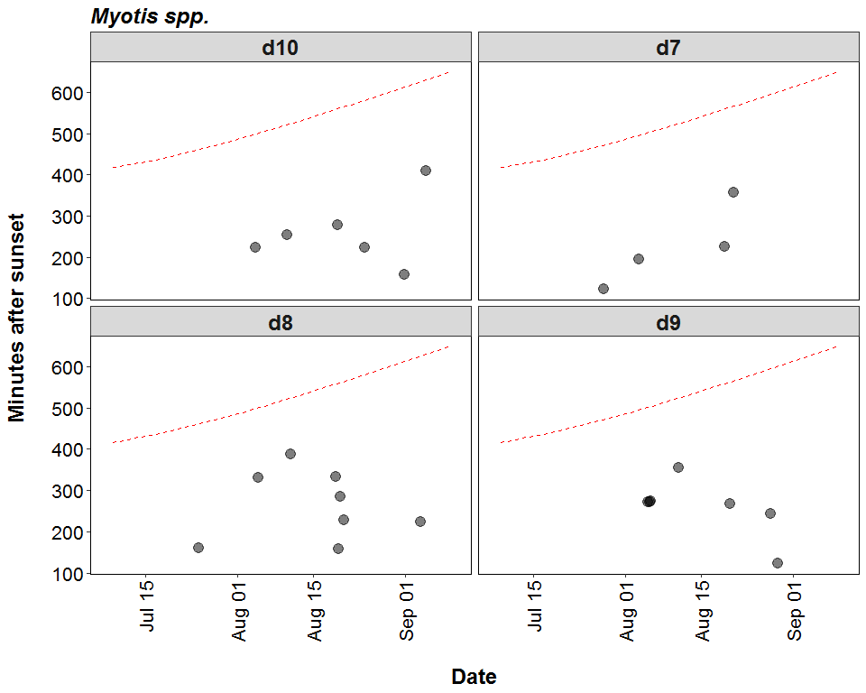

##### Page Break

# Roost Emergence Time and Bat Observation

Based on: *Russ, Jon. 2012. British Bat Calls a Guide to Species Identification.* *Pelagic Publishing.*

For more information see <https://rbats-blog.updog.co/2018/05/29/bat-emergence/>

## Bat Passes Potentially Indicating Close Proximity to a Roost (Russ 2012) - Table

**Number of bat calls recorded within the species-specific emergence time range, and which therefore may potentially indicate the presence of a nearby roost.**

|  |  |  |  |  |
| --- | --- | --- | --- | --- |
| Species | Detector ID | 2018-08-19 | 2018-09-01 | 2018-09-04 |
| Common pipistrelle | d10 | 3 | 0 | 0 |
| Common pipistrelle | d8 | 27 | 0 | 4 |
| Leisler’s | d10 | 0 | 1 | 0 |

##### Page Break

### Bat Passes Potentially Indicating Close Proximity to a Roost (Russ 2012) - Figures

**Figures show time from 15 minutes before to 90 minutes after sunset. Species-specific emergence time ranges are shown as grey bars. Bat passes overlapping species-specific grey bars may potentially indicate the presence of a nearby roost.**

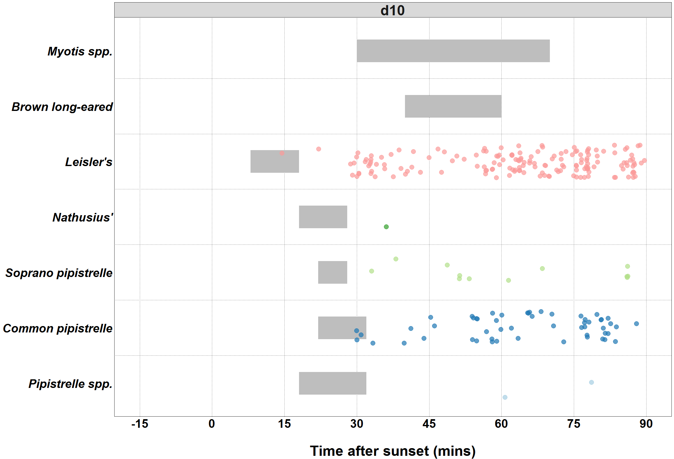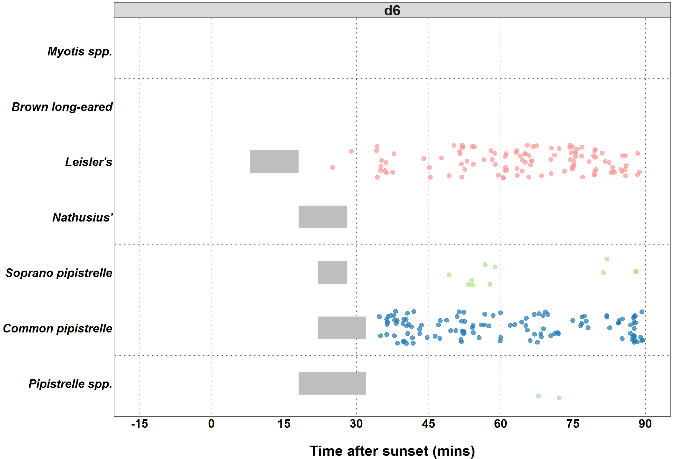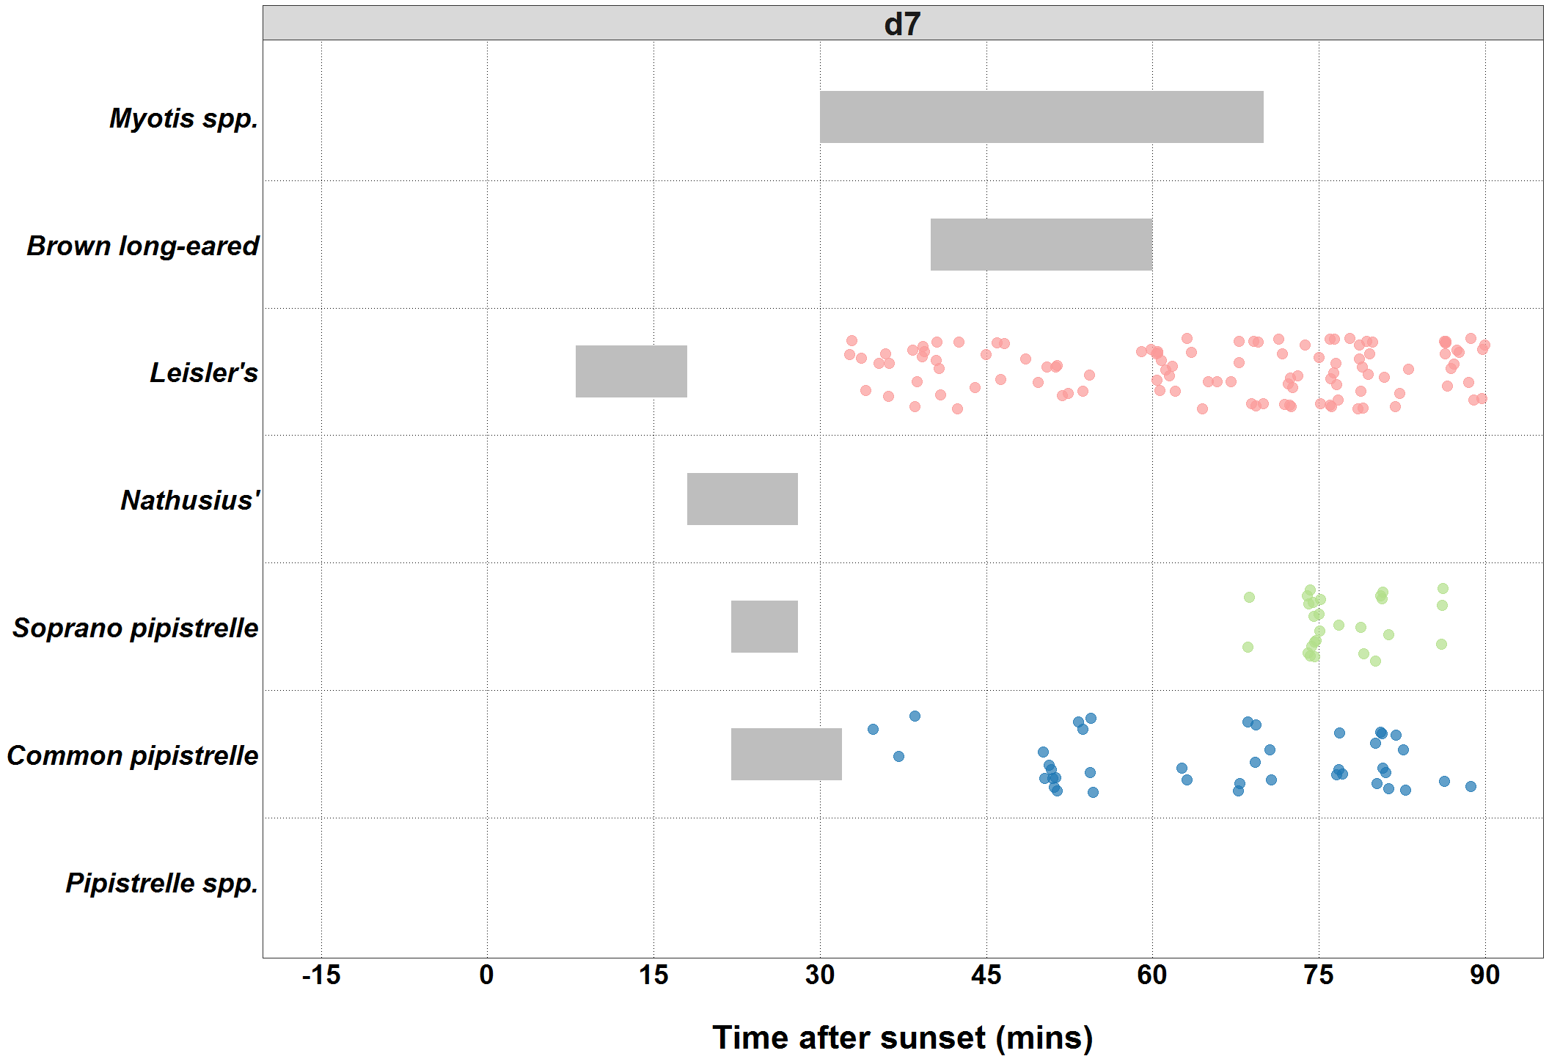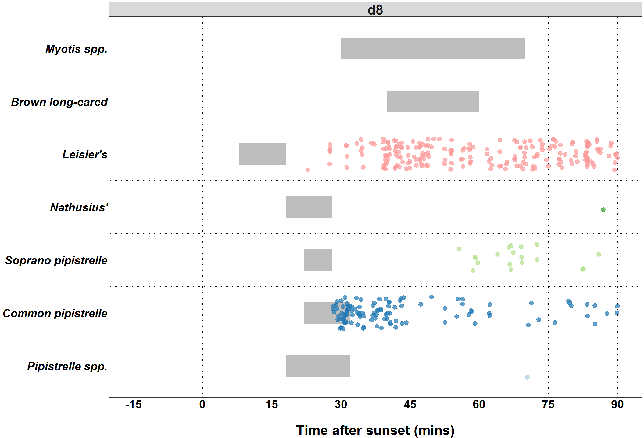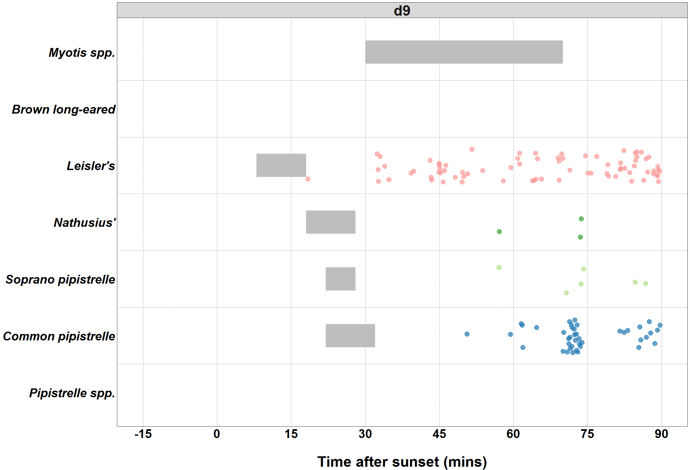

##### Page Break ###Bat Passes Potentially Indicating Close Proximity to a Roost (Maternity Period Only)

*Maternity period defined as 15th June - 30th July*

[1] "No records near a roost during maternity period"

##### Page Break ###Bat Passes Potentially Indicating Close Proximity to a Roost (Maternity Period Only)

*Maternity period defined as 15th June - 30th July*

