**NAME:AUGUSTAS NIXON**

**ROLL NO:19**

**ADDITION OF TWO 16BIT UNSIGNED NUMBERS**

**AIM**: To add two 16-bit unsigned numbers stored in memory locations.

**ALGORITHM**

Step 1-Start

Step 2-Setup a Logical Data Segment

Step 3-Intialize the logical code segment. Initialize the DS register with the starting address of the logical data segment.

Step 4-Load 0000H into CX register (for carry)

Step 5-Load first operand into AX register (Accumulator)

Step 6-Add second operand to AX

Step 7-Jump if no carry

Step 8-Increment CX by 1

Step 9-Move content from AX to SUM

Step 10- Move content from CX to SUM+2

Step 11-Move 4CH to AH register to terminate execution and call the DOS function call INT 21H

Step 12-Stop

**PROGRAM**

DATA1 SEGMENT

NUM1 DW 1234H

NUM2 DW 0F562H

SUM DW 2 DUP (0)

DATA1 ENDS

CODE1 SEGMENT

ASSUME CS: CODE1, DS: DATA1

START: MOV AX, DATA1;

MOV DS, AX

MOV CX, 0000H

MOV AX, NUM1

ADD AX, NUM2

JNC L1

INC CX

L1: MOV SUM, AX

MOV SUM+2, CX

MOV AH, 4CH

INT 21H

CODE1 ENDS

END START

**OUTPUT**

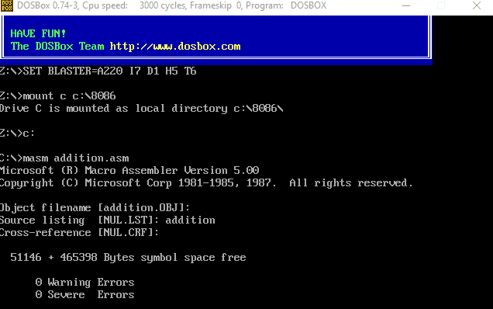

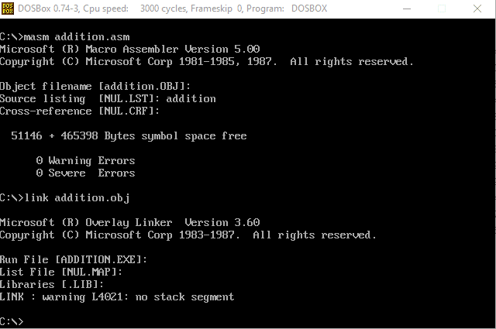

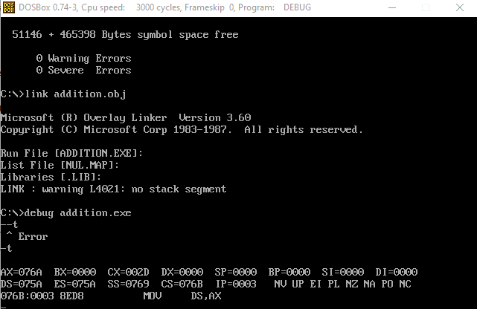

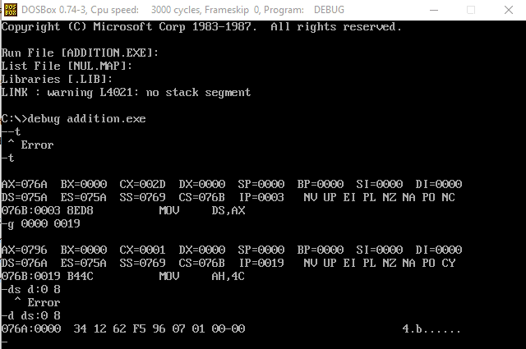

**SAMPLE OUTPUT**

1234 H + F562 H = 0001 0796 H