**NAME:AUGUSTAS NIXON**

**ROLL NO:19**

**SUBTRACTION OF TWO 16BIT UNSIGNED NUMBERS**

**AIM**: To subtract two 16 bit unsigned numbers stored in memory locations.

**ALGORITHM**

Step 1-Start

Step 2-Setup a Logical Data Segment

Step 3-Intialize the logical code segment. Initialize the DS register with the starting address of the logical data segment.

Step 4-Load 0000H into CX register (for borrow)

Step 5-Load first operand into AX register (Accumulator)

Step 6-Subtract second operand from AX

Step 7-Jump if no carry

Step 8-Increment CX by 1

Step 9-Take 2’s complement of AX

Step 10-Move content from AX to DIFF

Step 11- Move content from CX to DIFF+2

Step 12-Move 4CH to AH register to terminate execution and call the DOS function call INT 21H

Step 13-Stop

**PROGRAM**

DATA1 SEGMENT

NUM1 DW 1243H

NUM2 DW 0F231H

DIFF DW 2 DUP (0)

DATA1 ENDS

CODE1 SEGMENT

ASSUME CS: CODE1, DS: DATA1

START: MOV AX, DATA1

MOV DS, AX

MOV CX, 0000H

MOV AX, NUM1

SUB AX, NUM2

JNC L1

INC CX

NEG AX

L1: MOV DIFF, AX

MOV DIFF+2, CX

MOV AH, 4CH

INT 21H

CODE1 ENDS

END START

**OUTPUT**

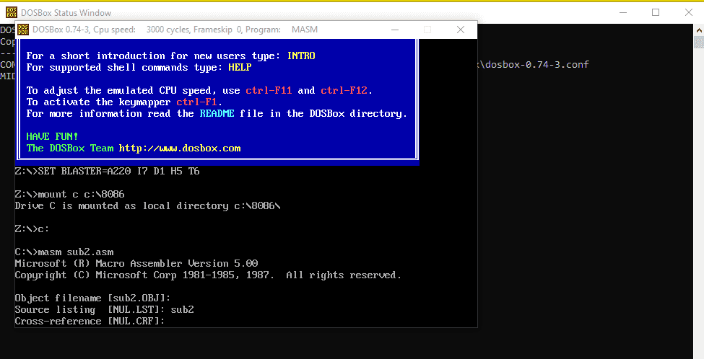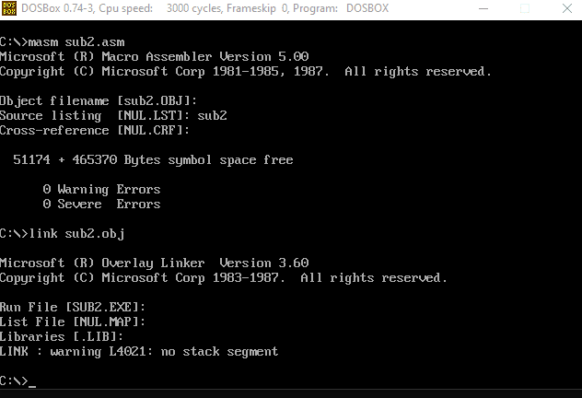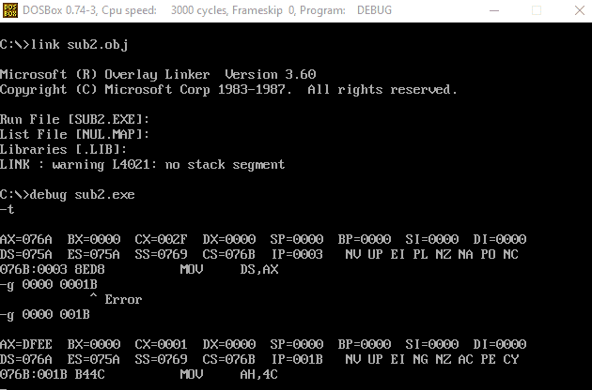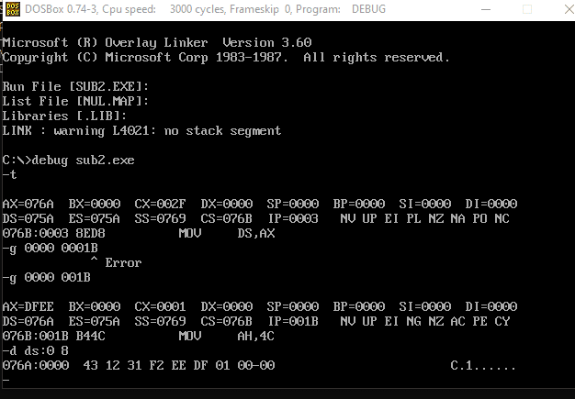

**SAMPLE INPUT AND OUTPUT**

1234 H – F231 H = 1 DFEE H