LAPLAND 2022 console program manual

**Table of contents**

1. Opening program on console:

1.1 Downloading JAVA;

1.2 Launching the app;

1. Using the application:

2.1 Options for the menu table;

2.2 Printing all children and all presents;

2.3 Printing only children with present assigned;

2.4 Printing only children without present assigned;

2.5 Printing all unassigned presents;

2.6 Creating a new child;

2.7 Creating a new present;

2.8 Assigning specific present to a random child;

2.9 Assigning specific present to a particular child;

2.10 Quitting system;

1. **OPENING PROGRAM ON CONSOLE**

**1.1 Downloading JAVA**

To run this program, JAVA must be installed. That can be checked by typing ‘java’ to the console. If the suggested parameters appear, JAVA is already installed.

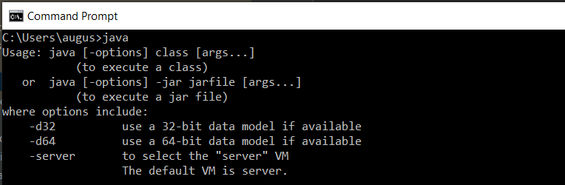

Pict. 1: Confirmation that JAVA is installed

If nothing happens or error occurs, JAVA is not installed. Installation can easily be done by going to the official JAVA web page and picking “Download’’ in the menu options or simply following this link: <https://www.java.com/en/download/> . After pressing the Install button, the newest JAVA version will be downloaded. Newly downloaded file can be found in the Downloads folder.



Pict. 2: JAVA file on Downloads folder

After opening this JAVA file, confirmation for permissions must be done and the app will install, this might take up to a few minutes. When the process is finished, press OK and try typing “java” to the console again. If everything is ok, parameters should be seen as in Pict 1. That means JAVA is working correctly and will be able to read our console program.

**1.2 Launching the app**

To start the program, please open the run.bat file (Pict. 3).



Pict. 3: Lapland 2022 launching file

After opening, the greeting message and main menu should be visible in the new console window (Pict. 4).

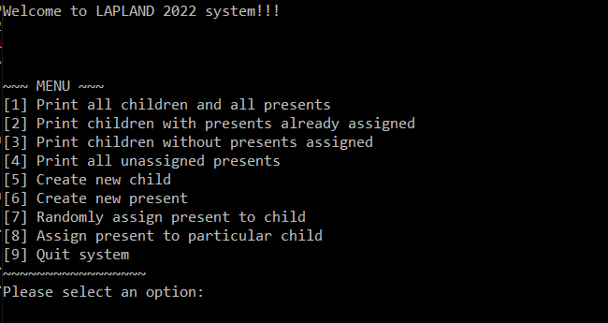

Pict. 4: Console after opening the run.bat file

1. **USING THE APPLICATION**

**2.1 Options for the menu table**

After every action program will ask if going back to the menu is needed. Only two options are available: Y/N (Pict. 7). Uppercase and lowercase letters are both acceptable.



Pict. 7: Alert visible after every complete action

Typing “Y” to the console will bring the main menu back. Typing “N” will show a goodbye message (Pict. 8) and the program will stop working.



Pict. 8: Goodbye message after typing “N” to the console

**2.2 Printing all children and all presents**



Pict. 5: First option in the menu

To print full children and presents lists, number 1 should be entered to the console. After that, all children and presents will be shown regardless of its status (assigned / unassigned).

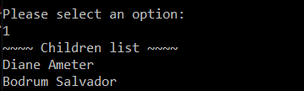

Pict. 6: Example of the outcome, after typing 1 to the console

**2.3 Printing only children with present assigned**



Pict. 9: Second option in the menu

To print only the children with the present already assigned, number 2 should be entered to the console. After that, the list of children with present assigned (and also presents name), the amount of children with present in total and menu options (2.2) will appear (Pict. 10).

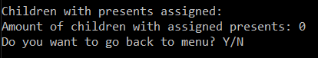

Pict. 10: Example of the outcome, after typing 2 to the console

**2.4 Printing only children without present assigned**



Pict. 11: Third option in the menu

To print only the children without a present already assigned, number 3 should be entered to the console. After that, the list of children without a present assigned, the amount of children without present in total and menu options (2.2) will appear (Pict. 12).

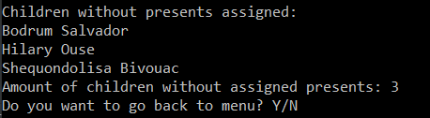

Pict. 12: Example of the outcome, after typing 3 to the console

**2.5 Printing all unassigned presents**



Pict. 13 Fourth option in the menu

To see all the unassigned presents, number 4 should be entered to the console. After that, the list of available presents, amount of them and menu options (2.2) will appear (Pict. 14).

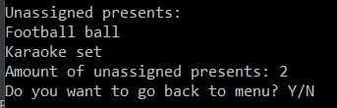

Pict. 14: Example of the outcome, after typing 4to the console

**2.6 Creating a new child**



Pict. 15 Fifth option in the menu

To add a new child to the list, type 5 to the console and press enter. After that, a new child creation message and an input for a child’s name will appear (Pict. 16).

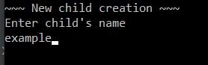

Pict. 16: New child creation message and input for name

After typing the name, another input for surname appears (Pict. 17).



Pict. 17: Input for a surname

After entering the surname and pressing enter, confirmation for successful child creation and menu options (2.2) will appear (Pict. 18).



Pict. 18: Message after successfully creating a new child

If the child already exists, an error message will occur and menu options (2.2) will appear (Pict. 19).



Pict. 19: Error message after trying to add an existing child

**2.7 Creating a new present**



Pict. 20: Sixth option in the menu

To create a new present, type 5 to the console and press enter. After that, a new present creation message and input for message creation will be visible (Pict. 21).

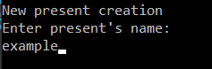

Pict. 21: New present creation message and input for present’s name

After typing the present name, click enter and confirmation for successful present creation and menu options (2.2) will appear (Pict. 22). Two or more identical presents can be created.



Pict. 22: Message after successfully creating a new present

**2.8 Assigning specific present to a random child**



Pict. 23: Seventh option in the menu

In order to assign a specific present to a random child, number 7 must be chosen in the menu. After pressing enter, a list of all available presents will appear (Pict. 24). Present pick is done the same way as in menu by choosing one option and typing its name to the console.

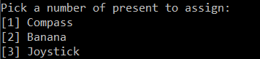

Pict. 24: Example of the menu

After picking the present and pressing enter, it will be assigned to a randomly picked child. Present name, success message and child’s name will be visible alongside menu options (2.2) (Pict. 25).



Pict. 25: Example of successful present assignment

**2.9 Assigning specific present to a particular child**



Pict. 26: Eighth option in the menu

In order to assign a specific present to a particular child, number 8 must be chosen in the menu. After pressing enter, a list of all available presents will appear (Pict. 27). Present pick is done the same way as in menu by choosing one option and typing its name to the console.

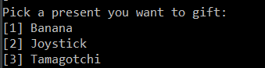

Pict. 27: Example of the menu

After picking the gift, another menu appears (Pict. 28) in which a child must be selected the same way as in other menus - typing menu option number in the console.

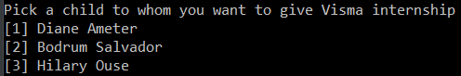

Pict. 28: Example of the menu

When the child is picked, the present name, success message and child’s name will be shown alongside the menu options (2.2) (Pict. 29).



Pict. 29: Example of successful present assignment

**2.10 Quitting system**



Pict. 30: Ninth option in the menu

If all the job is done, option 9 in the menu can be chosen and after pressing enter, a goodbye message appears and the system stops (Pict.31). In order to start working again, the program must be closed and reopened again.



Pict. 31: Goodbye message