Matplotlib Plot:

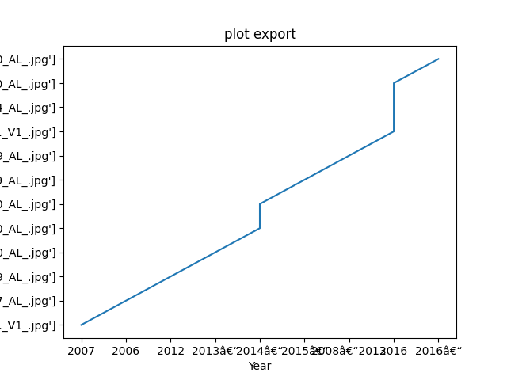

Description or caption for the plot.