# Rendu Projet Python

### Title : The soul of Henry Jones

### Author : Ray Cummings

image origale



image modifiée



Fait par : augustin moquin

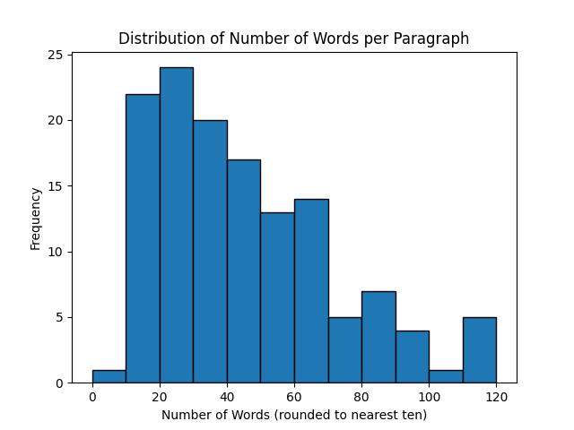

In this plot we can see that out of the 133, the most frequent number of words is 20.  
 We find that the min number of word in a paragraph is 0, and the max is 120