* Initial project setup
  + Create VS project
  + Setup dependencies (if any)
  + Choose additional tools
* Design data-model

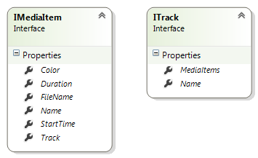

* Implement time ruler control (with zooming capabilities)



* Design two ItemControls

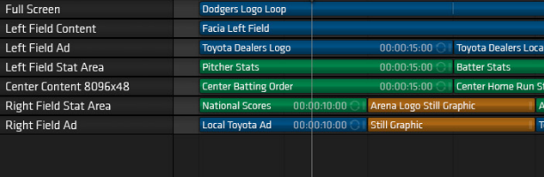

**TracksListbox**

**MediaItemsItemControl**

* Synchronize vertical scrollbars of two ItemControls
* To be continued…