Project Coversheet
Full Name | Augustine Cudjoe
Project Title (Example – Week1, Week2, Week3, Week 4) | Week 2-Project: Sales & Customer Behaviour Insights – Green Cart Ltd.
Instructions:
Students must download this cover sheet, use it as the first page of their project, and then save the entire document as a PDF before submission.
Project Guidelines and Rules
1. Formatting and Submission
- Format: Use a readable font (e.g., Arial/Times New Roman), size 12, 1.5 line spacing.
- Title: Include Week and Title (Example - Week 1: Travel Ease Case Study.)
- File Format: Submit as PDF or Word file
- Page Limit: 4–5 pages, including the title and references.
2. Answer Requirements
- Word Count: Each answer should be within 100–150 words; Maximum 800–1,200 words.
- Clarity: Write concise, structured answers with key points.
- Tone: Use formal, professional language.
3. Content Rules
- Answer all questions thoroughly, referencing case study concepts.
- Use examples where possible (e.g., risk assessment techniques).
- Break complex answers into bullet points or lists.
4. Plagiarism Policy
- Submit original work; no copy-pasting.
- Cite external material in a consistent format (e.g., APA, MLA).
5. Evaluation Criteria
- Understanding: Clear grasp of business analysis principles.
- Application: Effective use of concepts like cost-benefit analysis and Agile/Waterfall.
- Clarity: Logical, well-structured responses.
- Creativity: Innovative problem-solving and examples.
- Completeness: Answer all questions within the word limit.
6. Deadlines and Late Submissions
- Deadline: Submit on time; trainees who fail to submit the project will miss the “Certificate of Excellence”
7. Additional Resources
- Refer to lecture notes and recommended readings.
- Contact the instructor or peers for clarifications before the deadline.
SECTION 1
Introduction
This report presents an analysis of sales and customer behaviour for Green Cart Ltd., an e-commerce company specialising in eco-friendly products. The dataset used includes sales transactions, product details, and customer information, which were merged to provide a comprehensive view of business performance.The purpose of this report is to examine revenue trends, customer purchasing behaviour, and delivery performance, and to generate insights that support data-driven decision-making for the company’s Q2 performance review.
SECTION 2
Data Cleaning Summary
Data cleaning involved removing duplicate records using order_id to ensure accurate transaction counts. Missing values were handled appropriately: key identifiers like customer_id were removed if missing, numerical fields were imputed using median values, and categorical fields (e.g., delivery_status, payment_method) were filled with “Unknown,” while missing discounts (517) were set to 0. In addition, inconsistent labels in variables such as delivery_status and loyalty_tier were standardised to ensure consistency and reliable analysis.
SECTION 3
Feature Engineering Summary
Six new columns were created from the merged dataset to enable richer analysis:
Feature | Formula / Method | Purpose
revenue | quantity × unit_price × (1 - discount_applied) | Actual revenue after discount
order_week | .dt.isocalendar().week | Group orders into ISO weeks for trend analysis
price_band | pd.cut: Low <£15 / Medium £15–30 / High >£30 | Segment products by price tier
days_to_order | (order_date - launch_date).dt.days.abs() | Time between product launch and purchase
email_domain | .str.split('@').str[1] | Identify customer email providers
is_late | delivery_status == 'Delayed' True/False | Boolean flag for late delivery analysis

SECTION 4
Key Findings & Trends
Chart 1 — Weekly revenue trends by region.
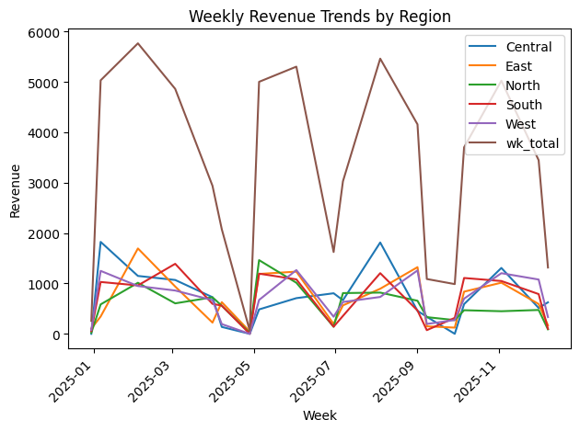
Revenue shows clear weekly volatility with central consistently generating the highest single-week totals throughout 2025. All four regions show a similar pattern of peaks and troughs, suggesting demand fluctuations affect the whole platform rather than individual

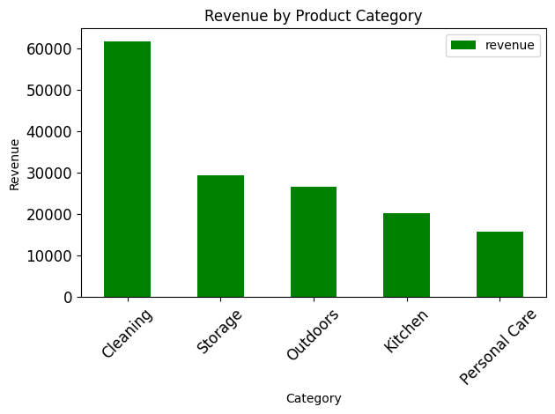
Chart 2 Top 5 categories by revenue

Cleaning is the top revenue category with £60k+ followed by Storage(£30+) , Outdoors (£25k+), and Kitchen((£20k+). Personal care is the weakest performer at £15k+. 30,536).
Chart 3 Quantity distribution by category and price band.
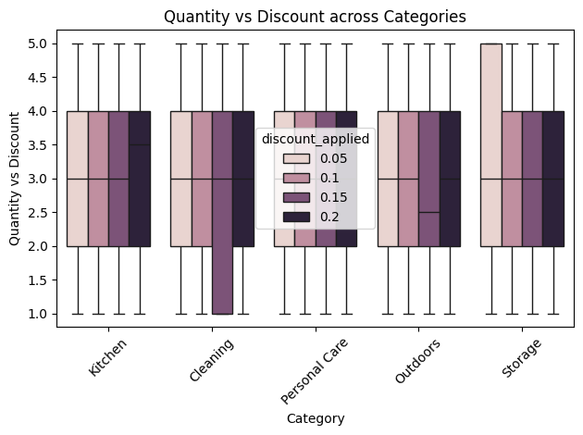
Discounts do not appear to strongly influence the number of items purchased, suggesting that factors other than pricing such as product necessity or customer preference may be driving sales.

Chart 4 — Correlation heatmap: Revenue and quantity are positively correlated (0.72), which is expected as larger orders generate more revenue. Discount and revenue show a slight negative correlation (-0.12), confirming discounts modestly reduce revenue per order without meaningfully increasing volume.
Chart 5 — Loyalty orders: Gold tiers drive the most orders across all regions, with East leading.
Chart 6 — Delivery by price band: Delayed and delivered deliveries are most
SECTION 5
Business Question Answers
1.Which product categories drive the most revenue, and in which regions?
Cleaning is the top category in every region, with East generating the highest cleaning revenue (£13,641). West leads overall with £32432 total revenue. Personal Care performs disproportionately poorly in South suggesting low demand in that region. North is the weakest across all categories.
2. Do discounts lead to more items sold?
Our correlation analysis yielded a coefficient of -0.02 , indicating a near-total lack of relationship between discount depth and quantity sold.0.20 has the lowers order.

3. Which loyalty tier generates the most value?

Gold generates the most total revenue (£86,643) with the largest quantity ordered.

4. Are certain regions struggling with delivery delays?
Logistics performance is critical in all areas, with the South region recording the greatest criticality, reaching a delay rate of 41.4% followed by East with 40.5%.

5.Do customer signup patterns influence purchasing activity?
Early customers (≤14 days) show a higher strategic value, with an average spend (84.0) and quantity per order (3.2) consistently higher than late customers.

SECTION 5 — STRETCH TASKS

Optional Stretch Task Results

.query() extractions:
Three customers satisfied the criteria. This shows that the combination of high discounts and rapid purchase behaviour is relatively uncommon.
MinMaxScaler — revenue normalisation:
Revenue was scaled to a 0–1 range using MinMaxScaler. Minimum revenue per order: £6.8 (scaled 0.000). Maximum: £236. (scaled 1.000). Mean scaled revenue: 0.31 indicating most orders cluster in the lower-to-mid revenue range, with a long tail of high-value orders.
Underperforming product flags:
Products were flagged as underperforming if: quantity below median AND discount = 20% AND delivery_status = Delayed. 68 records met all three criteria across 10+ products.

Recommendations
- Focus marketing investment on Gold in East and West
- Audit and reduce the platform-wide delivery delay rate

Data Issues or Risks
- A major data quality issue identified was the high proportion of missing values in the order_date column, which limited the scope of time-based analysis.
- This issue can be addressed by improving data collection processes at the source, such as enforcing mandatory date entry and implementing validation checks to ensure completeness and accuracy in future datasets.

