CUSTOMER SIGN-UP BEHAVIOUR & DATA QUALITY AUDIT
RapidScale SaaS — Monthly Business Review
Business Intelligence Team | January – December 2024
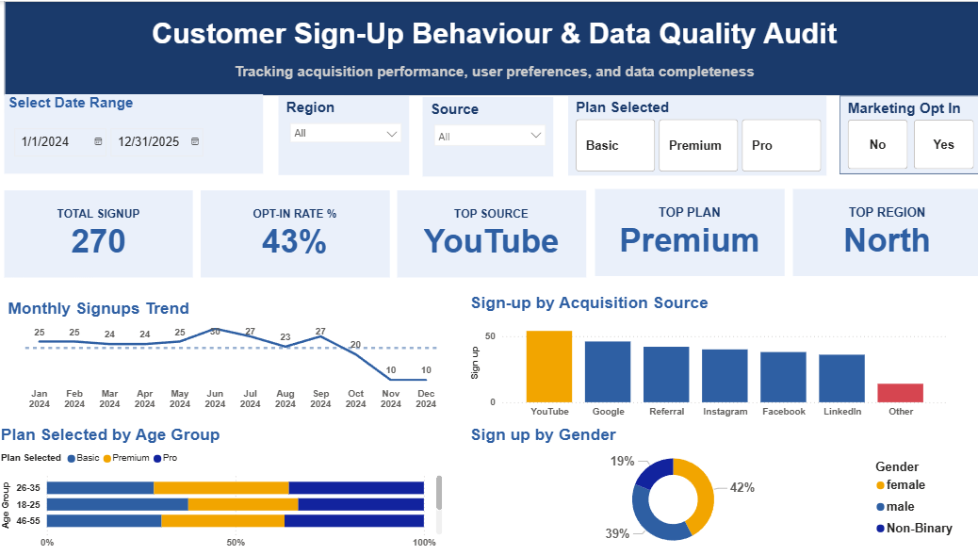
1. Introduction
RapidScale is a fast-growing SaaS company offering tiered subscription plans — Basic, Professional, and Premium. Each month the Business Intelligence team supports the Monthly Business Review (MBR) by analysing user behaviour data to inform the decisions of the Marketing and Onboarding teams. This report presents the findings of a data quality audit and user acquisition analysis conducted on the customer sign-up dataset for the period January to December 2024. The analysis was commissioned to help the Marketing and Onboarding teams understand where data quality gaps exist, how users are acquiring and selecting plans, and which customer segments present the greatest engagement opportunity.
Dataset Overview
- Primary dataset: customer_signups.csv — 281 raw records, 270 valid after cleaning
- Optional dataset: support_tickets.csv — joined for stretch task analysis
- Analysis period: 1 January 2024 to 10 December 2024
- Tools used: SQL (data quality audit), Python / pandas (cleaning and analysis), Power BI (executive dashboard)

2. Data Cleaning Summary
- Removed duplicate records based on customer_id
- Standardised plan labels (e.g., ‘PRO’, ‘pro’,‘Pro’ → ‘Pro’)
- Converted signup_date to datetime format
- Handled missing values:
• Region and email identified as critical missing fields
- Normalised gender values (case consistency)
2.1 Initial Audit — SQL
Before loading the data into Python, a SQL audit was conducted directly against the database to identify issues at source. The query counted missing values per column and calculated the percentage of records affected. The results are shown in the table below.

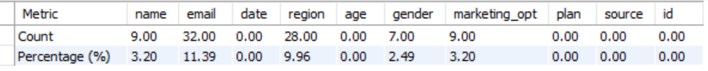
The audit confirmed that email (11.39%) and region (9.96%) had the highest missing rates, representing the most significant data quality risks.
2.2 Duplicates Removed
Duplicate rows were identified using customer_id as the unique key. Duplicate records were removed keeping only the first occurrence. The total number of duplicates identified and removed is documented in the Jupyter notebook output. After deduplication, invalid ID filtering, null-name removal, and outlier treatment, the clean dataset contained 270 valid records.
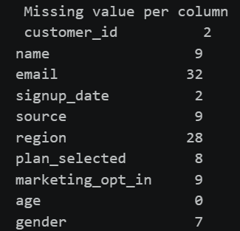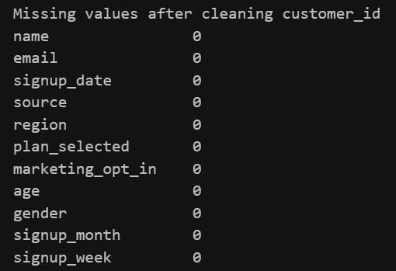
Figure 3 — Missing values before and after cleaning
2.3 Standardisation of Inconsistent Values
Several text columns contained inconsistent casing, abbreviations, placeholder strings, and invalid entries. The following standardisations were applied systematically using Python:

Column | Raw Inconsistent Values | Standardisation Applied
plan_selected | PRO, pro, Proo | Pro → Pro
plan_selected | Unknown, NaN, blank | Mapped to 'Other' per brief
gender | 123, NaN, None, blank | Mapped → 'Other'
source | blank, ??, None, NaN | Mapped to 'Untracked'
region | blank | Filled with 'Unknown'
marketing_opt_in | Nil, None, 123, NaN, blank | Mapped to 'No'

3. Key Findings & Trends
3.1 Sign-ups per week (grouped by signup_date)
The weekly average of 5.6 registrations peaked at 9 in the week 24 of 10 June 2024 and reached a critical low of 1 in late November. An immediate investigation is needed to identify any seasonal declines or technical errors in tracking.

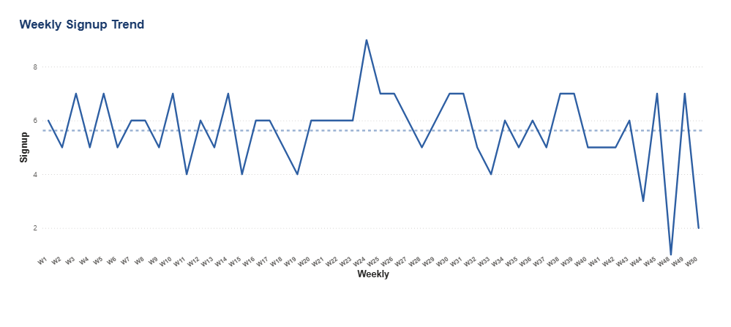
3.2 Sign-ups by source, region, and plan_selected
YouTube and Google remain the most effective acquisition channels, driving the majority of new subscribers on the Basic and Professional plans. It's recommended to reallocate budget from underperforming social channels to video and search to optimize overall ROI
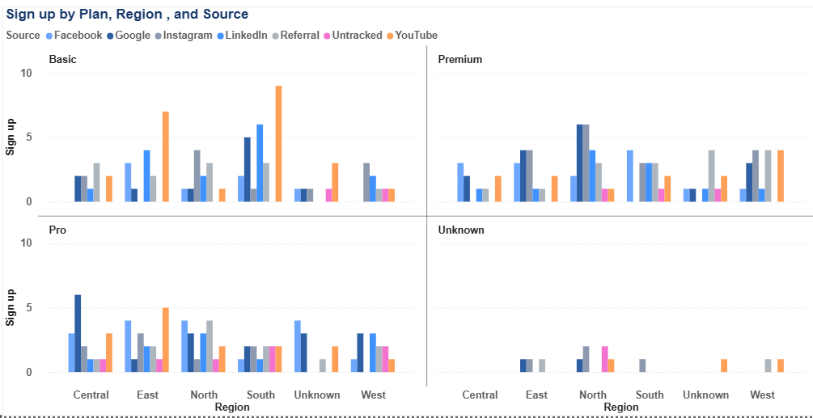
3.3. Marketing opt-in counts by gender

Female users represent the highest opt-in segment, but the overall opt-in rate is limited to 43%. The negative trend in opt-out data across all segments indicates the need to review the communication strategy to improve retention.

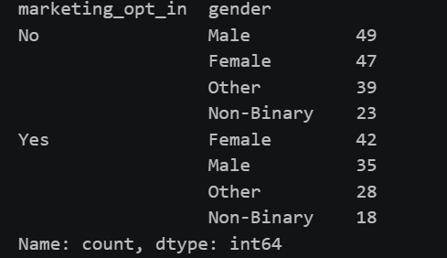

3.4. Age summary: min, max, mean, median, null count
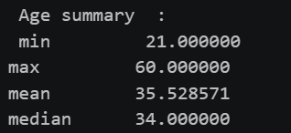
The age distribution data confirms a mature user base with a median age of 34 and a mean of 35.53. The demographic is tightly bound between the ages of 21 and 60, indicating that the product is most resonant with a professional working-age audience.

4. Business Question Answers
Q1 — Which acquisition source brought in the most users last month?

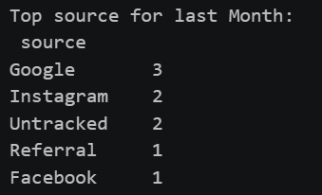
Across the full year, YouTube was the leading acquisition source. Based on the data for last month, Google is the top acquisition source with 3 sign-ups, followed by Instagram and Untracked with 2 each. Referral and Facebook contributed the remaining volume with 1 sign-up, indicating a fragmented but search-heavy lead generation profile. Focus marketing spend on Google Search during low-volume periods to maintain a reliable baseline for lead generation.
Q2 — Which region shows signs of missing or incomplete data?

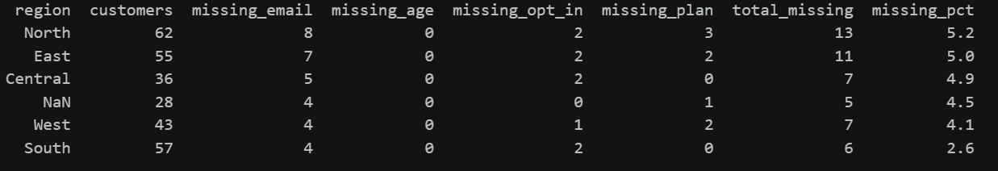
The North region exhibits the poorest data integrity with a 5.2% missing rate, largely driven by its failure to capture 8 email addresses. To improve overall data quality, the organization should implement mandatory email validation fields within the North region's sign-up workflow to address its disproportionately high volume of incomplete records.
Q3 — Are older users more or less likely to opt in to marketing?

Demographic analysis highlights a greater propensity to opt-in among senior segments, with a peak of 48% in the 36-45 age group compared to a low of 40% among 18-25 age group. It is recommended to focus content on professional audiences, given their greater receptivity to marketing campaigns.

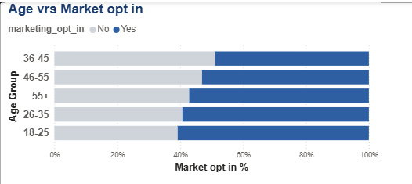

Q4 — Which plan is most commonly selected, and by which age group?

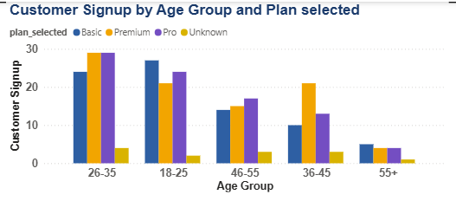
The 26–35 age group serves as the primary revenue driver, favoring high-tier Premium and Professional plans, while the 18–25 segment typically starts with Basic entry-level options. Across the entire dataset, Premium remains the dominant plan selection, though a small "Other" category persists for sign-ups with unidentifiable raw data.
Q5 (Stretch) — Which plan's users are most likely to contact support?

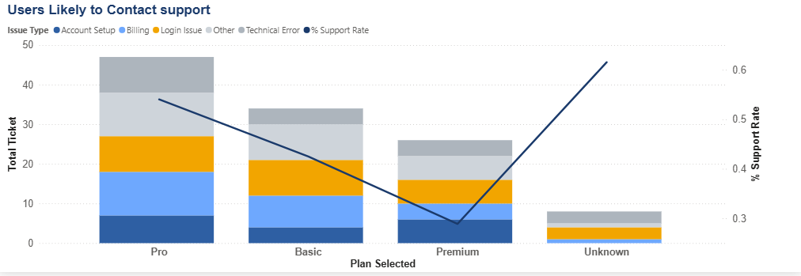

Professional plan users are most likely to contact support, accounting for the highest volume of inquiries at 47 total tickets. While Basic plan users follow with 38 contacts, the Professional segment shows the highest demand for assistance across almost all categories, particularly for Billing and miscellaneous Other issues. Excessive billing and technical inquiries from Professional users indicate a need for a more intuitive billing interface and targeted high-tier tutorials.

Stretch Task 1 .Count how many customers contacted support within 2 weeks of sign-up

A total of 70 customers contacted support within the first two weeks of their sign-up. This represents the majority of total support inquiries, indicating a critical need for enhanced onboarding resources or clearer documentation during the initial user experience phase. The concentration of support tickets within the first 14 days proves that reducing initial user friction is essential to lowering operational costs.

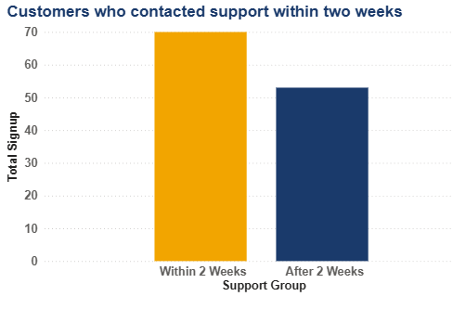
Stretch Task 2 : Summarise support activity by plan and region (Group by plan and region)

Professional plan users are mostly concentrated in the East and North regions, while the South uniquely shows the highest demand within the Basic tier. This regional variance indicates that while high-tier users drive most tickets globally, localized onboarding or billing issues are significantly impacting lower-tier users in the Southern territory. High demand for Basic plan support in the South suggests localized issues that require region-specific onboarding adjustments.
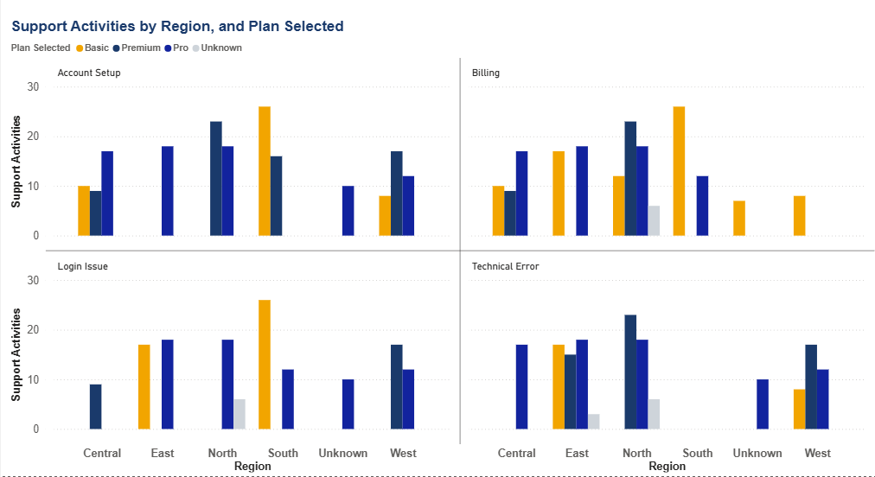

5. Recommendations
- Data Entry Optimization: Make Region and Email fields mandatory to eliminate current gaps (~11%), while implementing drop-down menus and UTM tracking to address channel attribution anomalies.
- 18-25 Upgrade Campaign: Launch a targeted offer in early 2025 to convert users in the 18-25 age group from the Basic plan to the Premium plan, with the goal of an upgrade rate of 10-15%.
- A/B Testing on Opt-in: Revising marketing information copywriting to increase the opt-in rate from 43% to over 55% by improving the communication of the value offered.

6. Data Issues & Risks
- Attribution Gaps: 8-10% of signups are untraceable (null or incorrect values), compromising ROI calculations and marketing budget decisions; input must be tied to the source.
- Database Inconsistency: Multiple labels for the same plans (e.g., "Pro" vs. "Professional") require database-level constraints to be implemented to ensure future data integrity.
End of Report
RapidScale SaaS | Customer Sign-Up Behaviour & Data Quality Audit | Week 1 Project | Uptrail

