BOM de PCB para BMS v1.1. Fecha 03/05/2021

Reference | Quantity | Value | Footprint
C1 C4 C11 | 3 | 100n | SmartBMS:R_1206_3216Metric
C10 | 1 | 12-22pF | SmartBMS:R_1206_3216Metric
C12 | 1 | 100nF | SmartBMS:R_1206_3216Metric
C17 C18 C19 C13 C14 C15 C16 C22 C23 C24 C20 C21 | 12 | 10n | SmartBMS:R_1206_3216Metric
C25 | 1 | 100nF | Resistor_SMD:R_1206_3216Metric
C3 C2 | 2 | 27pF | SmartBMS:R_1206_3216Metric
C8 C6 C5 | 3 | 1u | SmartBMS:R_1206_3216Metric
C9 | 1 | 12-22 pF | SmartBMS:R_1206_3216Metric
F1 | 1 | fuse 1A | Fuse:Fuseholder_Cylinder-5x20mm_Stelvio-Kontek_PTF78_Horizontal_Open
F2 | 1 | fuse 1 A | Fuse:Fuseholder_Cylinder-5x20mm_Stelvio-Kontek_PTF78_Horizontal_Open
H1 H2 H3 H4 | 4 | MountingHole | MountingHole:MountingHole_3.2mm_M3
J1 | 1 | Conn_ADC | SmartBMS:PinHeader_1x05_P2.54mm_Vertical
J10 | 1 | Conn_I2C_1 | SmartBMS:PinHeader_1x04_P2.54mm_Vertical
J11 | 1 | Conn_I2C_2 | SmartBMS:PinHeader_1x04_P2.54mm_Vertical
J12 | 1 | Conn_UART | SmartBMS:PinHeader_1x04_P2.54mm_Vertical
J13 | 1 | Conn_GPIO | SmartBMS:PinHeader_1x05_P2.54mm_Vertical
J14 | 1 | Conn_ICSP | SmartBMS:PinHeader_2x03_P2.54mm_Vertical
J15 | 1 | V+_EXT | SmartBMS:PinHeader_1x02_P2.54mm_Vertical
J2 | 1 | Conn_GPIO2 | SmartBMS:PinHeader_1x05_P2.54mm_Vertical
J3 | 1 | Conn_CAN | SmartBMS:PinHeader_1x02_P2.54mm_Vertical
J4 | 1 | Conn_CAN_2 | Connector_PinSocket_2.54mm:PinSocket_2x02_P2.54mm_Vertical
J5 | 1 | Conn_T21-T32 | SmartBMS:JST_XH_B14B-XH-A_1x14_P2.50mm_Vertical
J6 | 1 | Conn_T1-T10 | SmartBMS:JST_XH_B14B-XH-A_1x14_P2.50mm_Vertical
J7 | 1 | Conn_T11-T20 | SmartBMS:JST_XH_B14B-XH-A_1x14_P2.50mm_Vertical
J8 | 1 | Conn_FTDI | SmartBMS:PinHeader_2x03_P2.54mm_Vertical
J9 | 1 | Conn_Batt | SmartBMS:JST_XH_B14B-XH-A_1x14_P2.50mm_Vertical
JP1 JP2 | 2 | Jumper_3_Open | Jumper:SolderJumper-3_P1.3mm_Open_Pad1.0x1.5mm

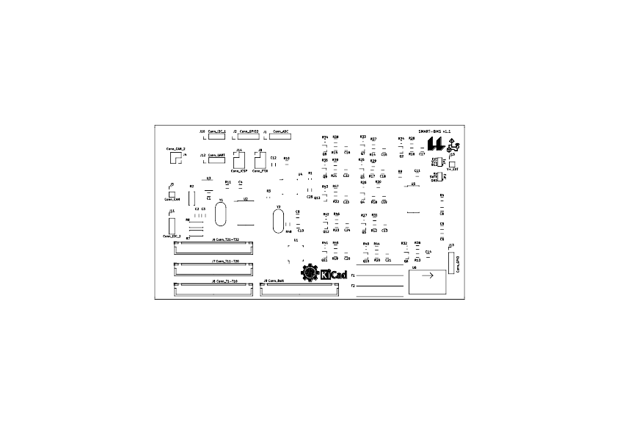

Q2 Q3 Q4 Q5 Q10 Q7 Q6 Q13 Q9 Q8 Q11 Q12 | 12 | BSS308PE | Package_TO_SOT_SMD:SOT-23
R1 | 1 | 10K | Resistor_SMD:R_0805_2012Metric_Pad1.15x1.40mm_HandSolder
R10 | 1 | 10k | SmartBMS:R_1206_3216Metric
R11 | 1 | 1k | SmartBMS:R_1206_3216Metric
R24 R25 R26 R27 R40 R33 R32 R43 R35 R34 R41 R42 | 12 | 1k | Resistor_SMD:R_0805_2012Metric_Pad1.15x1.40mm_HandSolder
R28 R29 R30 R31 R44 R37 R36 R47 R39 R38 R45 R46 | 12 | 10R, 2W | SmartBMS:R_1206_3216Metric
R3 | 1 | 10k | Resistor_SMD:R_0805_2012Metric_Pad1.15x1.40mm_HandSolder
R4 | 1 | 5k | Resistor_SMD:R_1206_3216Metric_Pad1.42x1.75mm_HandSolder
R48 | 1 | 1M | Resistor_SMD:R_1206_3216Metric
R7 R8 R2 | 3 | 120R | Resistor_THT:R_Axial_DIN0207_L6.3mm_D2.5mm_P7.62mm_Horizontal
R9 R16 R17 R18 R12 R13 R14 R15 R21 R22 R23 R19 R20 | 13 | 100R | SmartBMS:R_1206_3216Metric
U1 | 1 | ADG731 | Package_QFP:TQFP-48_7x7mm_P0.5mm
U2 | 1 | MCP2515-xSO | Package_SO:SOIC-18W_7.5x11.6mm_P1.27mm
U3 | 1 | TJA1050T | Package_SO:SOIC-8_3.9x4.9mm_P1.27mm
U4 | 1 | ATmega328P-PU | SmartBMS:TQFP-32_7x7mm_P0.8mm
U5 | 1 | LTC6804-2 | SmartBMS:SSOP-48_7.5x15.9mm_P0.635mm
U6 | 1 | MP2307 | SmartBMS:MP2307
Y1 | 1 | 8MHz | SmartBMS:Crystal_HC49-4H_Vertical
Y2 | 1 | 16MHz | SmartBMS:Crystal_HC49-4H_Vertical

