**The effect of physical activity on oxidative stress biomarker induced by fine particulate air pollution: a crossover trial**

Yuanfei Pan1*（潘远飞，学号16301020001）

*1School of Public Health, Fudan University, Shanghai, China*

*\*correspondence:* [yfpan16@fudan.edu.cn](mailto:yfpan16@fudan.edu.cn)

**Abstract**

Attentions have been drawn on whether physical activity could intensify or weaken the adverse health impact of fine particulate (PM2.5) air pollution. To resolve the dilemma, we conducted a randomized crossover trail among 29 college students. Participants were instructed to run at the speed of 5km/h for 30 minutes outdoor for four days as treatment and do no physical exercise for four days as control sequentially. There was a washout period of five days between treatment and control. Individual exposure to PM2.5 were measured with portable data loggers. Oxidative stress biomarker uric 8-isoprostane was used as the major outcome. We used linear mixed-effect models to analyze the associations between PM2.5 exposure and 8-isoprostane among treatment and control. The results showed that physical activity did not directly affect level of oxidative stress and was uncorrelated with PM2.5 induced oxidative stress. This suggested physical activity is probably neutral, that it neither protects people from PM2.5 induced oxidative stress nor intensifies oxidative stress.

**Introduction**

Fine particulate matter (aerodynamic diameter ≤ 2.5μm, PM2.5) air pollution has been considered as an important environmental risk factor, and it is reported to be associated with increased mortality and morbidity of various human diseases (Apte et al. 2015, Xing et al. 2016). Given the prevalence and severity of PM2.5 air pollution in many countries, attentions have been drawn on whether physical activity (especially outdoor activities) could intensify or weaken the adverse health impact of PM2.5 (Qin et al. 2019). Regular physical activity can either improve health, or it might also increase the risk of pollution exposure, which would fall into a dilemma.

On one hand, previous studies demonstrated that exposure to air pollutant during physical activities could cause inflammation (Lovinsky-Desir et al. 2016), cognitive impairment (Bos et al. 2014), and increased oxidative stress (Lu et al. 2015). On the other hand, however, some studies indicated that regular physical activity might reverse the adverse health impact of the air pollution (Silva-Renno et al. 2018, Giles and Koehle 2014, Normando et al. 2013). Thus, it is in urgent need to investigate the combined effect of physical activity and air pollution on health. Here in this study, we conducted a randomized crossover trial to explore the effect of physical activity on oxidative stress induced by fine particulate air pollution.

**Materials and Methods**

***Study design and study participants***

We carried out a randomized crossover trial among 29 healthy college students in fenglin campus. The inclusion criteria were no history of alcohol addiction, no clinically diagnosed chronic diseases, and having time to undergo all health measurements during the study period. The exclusion criteria were regular medication, in poor physical condition that is unsuitable to perform moderate level of physical activity, and had experienced recent (within one month) infections. During the study period, participants were requested not to do extra sporting or any intensive physical activities.

Our study followed a cross-over design. The 29 participants were randomly assigned to each of group A and B, in which participants were asked to do moderate level of physical exercise outdoor for four days (running at the speed of 5 km/h for 30 mins) and do no physical exercise for another four days (i.e. the controls) sequentially (Figure 1). The group A starts with the treatment period followed by a control period, and the group starts with control then followed the treatment. Between the two experiment stages, there was a washout period of five days. We conducted follow-ups at the 1st, 5th, 10th, and 14th day since the start of this experiment (Nov.4). In each follow-up, we collected first morning urine samples and measured uric 8-isoprostane concentration for each participant. We also instructed participants to complete questionnaire (available at <https://www.wjx.cn/jq/96121222.aspx>) every day to record their physical activity, dietary and sleeping conditions.

***Exposure measurement***

PM2.5 exposure was measured at individual level. In particular, each participant was provided with a data logger (Ruxiang Information Technology Co., Shanghai) to record real-time concentrations of PM2.5 as well as PM1 and PM10. The sampling interval was set at five minutes.

***Biomarker assay***

We measured uric 8-isoprostane as major outcome in this study. Specifically, 15 mL of morning urine was collected at each of the four follow-ups. Urine samples had been stored in a -20℃ refrigerator until we conducted biomarker assay at Nov.17. In the lab, urine samples were centrifugated (1000×g, 20mins) and only supernatants were used for the following biomarker assay. We then measured concentration of 8-isoprostane with 8-isoprostane ELISA kit (KL-8isoprostane-Hu, Kanglang Biological Technology Co., Shanghai).

***Statistical analysis***

All statistical analysis was performed with R 3.6.3. We first compared whether the changes in uric 8-isoprostane after treatment were significantly different from the control with paired t test. Then, linear mixed-effect models were used to analyze the associations between PM2.5 and 8-isoprostane in treatment and control groups. In the model, concentration of 8-isoprostane was log-transformed to improve normality. We included either average concentration of PM2.5 at one day, two days and four days as fixed-effect term and a random intercept for each participant in order to account for non-independence due to repeated measurement. We adjusted the above basic models with several probable confounding factors: experiment stage, age, sex, PM10 exposure (4 days mean) and whether participant have allergic disease. We followed the method of Lin et al. (2020) to transform the estimated slope of PM2.5 into percentage changes in 8-isoprostane per 10μg/m3 increase in PM2.5 to assess the strength of association between PM2.5 and 8-isoprostane. Then we compared the percentage changes between treatment and control with 95% confident intervals.

**Results**

In the first follow-up, all 29 participants provided their urine samples. In the second follow-up, only 22 participants (3 and 4 missed in group and group B respectively) provided urine samples. In the third round, one participants in group A and one in group B missed the follow-up. In the last follow-up, only one participants in group B missed. Finally, because of the loss to follow-ups, there were only 20 valid participants (11 in group A and 9 in group B) were included in statistical analysis. See supplementary materials (Figure S1) for details of loss to follow-ups. Baseline characteristics of participants were similar between the two groups (Table 1).

There is no significant difference in uric 8-isoprostane between treatment and control (Figure 2; paired t test, group A: *p* = 0.8711; group B: *p* = 0.8079; overall: *p* = 0.7657). The result from linear mixed-effect model showed that effect of PM2.5 exposure on 8-isoprostane did not differ significantly between treatment and control (Figure 3).

**Discussion**

We observed that moderate level of physical activity did not directly affect level of oxidative stress and was uncorrelated with PM2.5-induced oxidative stress as measured by uric 8-isoprostane concentration.

These results suggested that moderate level of physical activity (see Rennie et al. 2003 for definition), for example running at the speed of 5km/h for 30mins, is neutral that it neither protects people from PM2.5 induced oxidative stress nor intensifies oxidative stress. Our results were consistent with some previous studies which found no significant association between physical activity and adverse health impact of PM2.5. For example, Giradot et al. (2006) found there was no significant association between daily hiking and air-pollutant-related changes of pulmonary function. And Gomes et al. (2010) found the similar results with daily running.

However, our findings were largely unreliable based on the following reasons. First, the treatment period (four days) in our study is too short to induce significant change in oxidative stress biomarker. Typically, the change in uric 8-isoprostane could lag behind its change in blood (Graille et al. 2020), and thus previous studies which used uric 8-isoprostane as a outcome typically have longer period of treatment for example at least one week (Sun 2020). Thus, the insignificant result could partly due to lack of time for the treatment to induce change in uric 8-isoprostane.

Second, the washout period is also too short, so that the control was affected by lagging effect of previous treatment. According to Sun (2020), the washout period for PM2.5 induced oxidative stress is properly at least one week.

Third, many participants did not actually follow the instructions well. For example, some participant did not do required physical activity (treatment) when he/she was in treatment group. And many participants did not complete the daily follow-ups questionnaires as they were required to, so that the confounding effect of some factors (e.g. daily physical activity besides the treatment) cannot be assessed.

Fourth, due to loss to follow-up, the sample size was too small to have enough statistical power to produce significant results. As loss to follow-up distributed evenly among two groups and due to the nature of crossover design, loss-to-follow-up bias was unlikely.

**Acknowledgements**

I thank my teachers YY Xu and J Cai, as well as two TAs, YL Shen and RZ Peng for their helpful advices and instruction. And I thank my group members, JF Zhu, CJ Zhang, JX Bao, T Sun, Y Zhu, Bo Zheng, BL Cheng and B Wang, for their diligent work on sample collection and biomarker assay.

**Data and code availability**

All data and codes for this paper are available on GitHub repository, which can be accessed at <https://github.com/Augustpan/pm25_trial>.

**References**

Apte, J. S., Marshall, J. D., Cohen, A. J., & Brauer, M. (2015). Addressing global mortality from ambient PM2. 5. *Environmental science & technology*, *49*(13), 8057-8066.

Bos, I., De Boever, P., Panis, L. I., & Meeusen, R. (2014). Physical activity, air pollution and the brain. *Sports Medicine*, *44*(11), 1505-1518.

Giles, L. V., & Koehle, M. S. (2014). The health effects of exercising in air pollution. *Sports Medicine*, *44*(2), 223-249.

Girardot, S. P., Ryan, P. B., Smith, S. M., Davis, W. T., Hamilton, C. B., Obenour, R. A., ... & Reed, G. D. (2006). Ozone and PM2. 5 exposure and acute pulmonary health effects: a study of hikers in the Great Smoky Mountains National Park. *Environmental health perspectives*, *114*(7), 1044-1052.

Gomes, E. C., Stone, V., & Florida-James, G. (2010). Investigating performance and lung function in a hot, humid and ozone-polluted environment. *European journal of applied physiology*, *110*(1), 199-205.

Graille, M., Wild, P., Sauvain, J. J., Hemmendinger, M., Canu, I. G., & Hopf, N. B. (2020). Urinary 8-isoprostane as a biomarker for oxidative stress. A systematic review and meta-analysis. *Toxicology Letters*.

Lin, Z., Niu, Y., Jiang, Y., Chen, B., Peng, L., Mi, T., ... & Kan, H. (2020). Protective effects of dietary fish‐oil supplementation on skin inflammatory and oxidative stress biomarkers induced by fine particulate air pollution: A pilot randomised, double‐blind, placebo‐controlled trial. *British Journal of Dermatology*.

Lovinsky-Desir, S., Jung, K. H., Rundle, A. G., Hoepner, L. A., Bautista, J. B., Perera, F. P., ... & Miller, R. L. (2016). Physical activity, black carbon exposure and airway inflammation in an urban adolescent cohort. *Environmental research*, *151*, 756-762.

Lu, J., Liang, L., Feng, Y., Li, R., & Liu, Y. (2015). Air pollution exposure and physical activity in China: current knowledge, public health implications, and future research needs. *International journal of environmental research and public health*, *12*(11), 14887-14897.

Normando, V. M. F., Mazzoli-Rocha, F., Moreira, D. K. M., Barcellos, B. C., Picanço-Diniz, D. W., & Zin, W. A. (2013). Regular exercise training attenuates pulmonary inflammatory responses to inhaled alumina refinery dust in mice. *Respiratory Physiology & Neurobiology*, *186*(1), 53-60.

Qin, F., Yang, Y., Wang, S. T., Dong, Y. N., Xu, M. X., Wang, Z. W., & Zhao, J. X. (2019). Exercise and air pollutants exposure: A systematic review and meta-analysis. *Life sciences*, *218*, 153-164.

Rennie, K. L., McCarthy, N., Yazdgerdi, S., Marmot, M., & Brunner, E. (2003). Association of the metabolic syndrome with both vigorous and moderate physical activity. *International journal of epidemiology*, *32*(4), 600-606.

Silva-Renno, A., Baldivia, G. C., Oliveira-Junior, M. C., Brandao-Rangel, M. A. R., El-Mafarjeh, E., Dolhnikoff, M., ... & Ligeiro-Oliveira, A. P. (2018). Exercise performed concomitantly with particulate matter exposure inhibits lung injury. *International journal of sports medicine*, *39*(02), 133-140.

Sun, Y. (2020). *The Effects of Negative Ion Indoor Air Filtration on Selected Biomarkers in Healthy Adults A Randomized Double-Blind Crossover Trial* (Doctoral dissertation, Duke University).

Xing, Y. F., Xu, Y. H., Shi, M. H., & Lian, Y. X. (2016). The impact of PM2. 5 on the human respiratory system. *Journal of thoracic disease*, *8*(1), E69.

**Figures and Tables**



**Figure 1.** The cross-over design of our study.

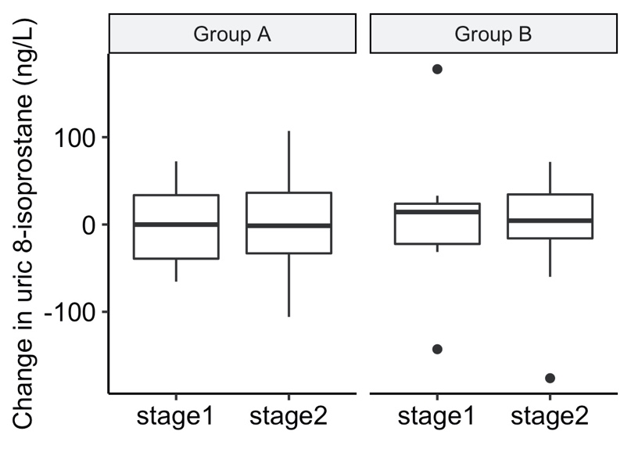

**Figure 2.** Changes in uric 8-isoprostane concentration among experiment stages and groups. Treatments were applied in stage 1 for group A and stage 2 for group B. Stage 2 for group A and stage 1 for group B were the controls.

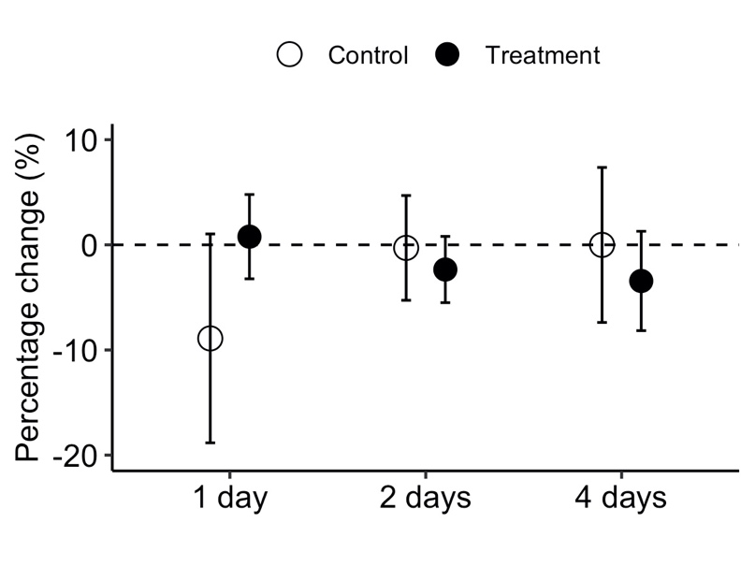

**Figure 3.** Percentage changes (means and 95% confidence intervals) in 8-isoprostane per 10μg/m3 increase in PM2.5 (1 day, 2 days and 4 days average exposure) in the control and treatment groups at different time lags.

**Table 1.** Characteristics of participants at baseline.

|  |  |  |  |
| --- | --- | --- | --- |
|  | Overall (n=29) | Group A (n=15) | Group B (n=14) |
| Age, years | 22.69 ± 0.15 | 22.49 ± 0.09 | 22.90 ± 0.18 |
| Sex, male/female | 13/16 | 6/9 | 7/7 |
| Physical activitya |  |  |  |
| Mild | 10 | 5 | 5 |
| Moderate | 9 | 6 | 3 |
| Vigorous | 7 | 3 | 4 |
| Unknown | 3 | 1 | 2 |
| Allergic disease, yes/no | 7/22 | 1/14 | 6/8 |
| Smoke, yes/no | 1/28 | 0/15 | 1/13 |
| Smoke (passively), yes/no | 2/27 | 0/15 | 2/12 |
| PM2.5 exporsureb, μg/m3 | 24.71 ± 15.27 | 25.11 ± 16.27 | 24.29 ± 12.38 |

aPhysical activity: mild 90~180 min/week; moderate, 180~360 min/week; vigorous, > 360 min/week. bPM2.5 exposure: 24-h average.

**Supplementary Materials**

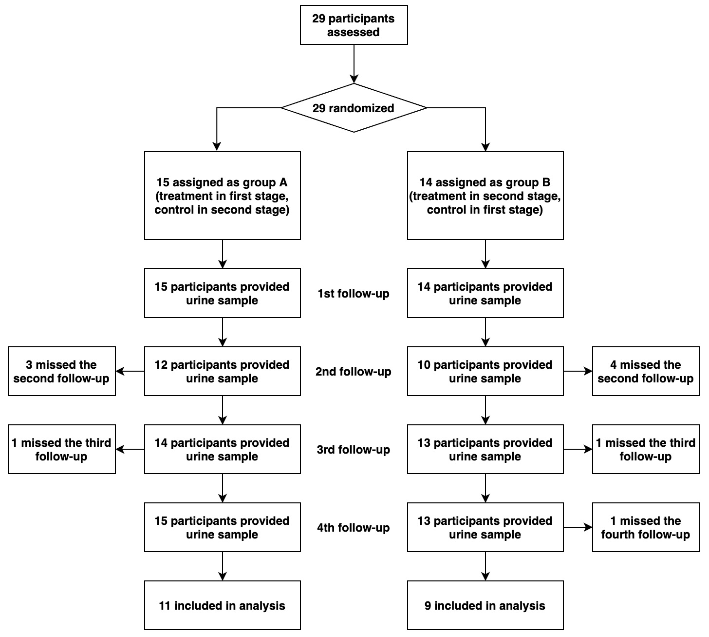

**Figure S1.** The flow diagram of enrolment and loss to follow-ups.