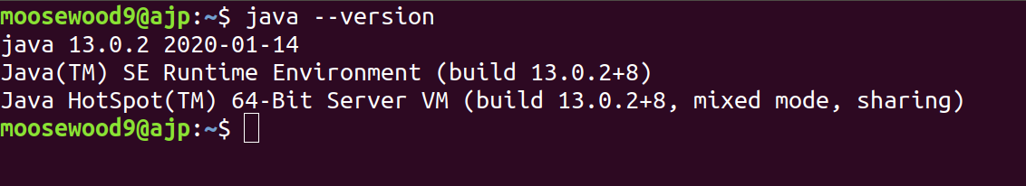
Java Version

JAVA_HOME variable
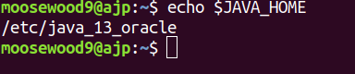

JAVAFX variable
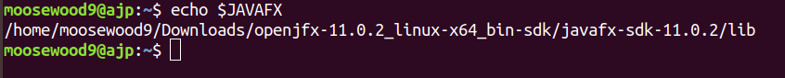
Install test
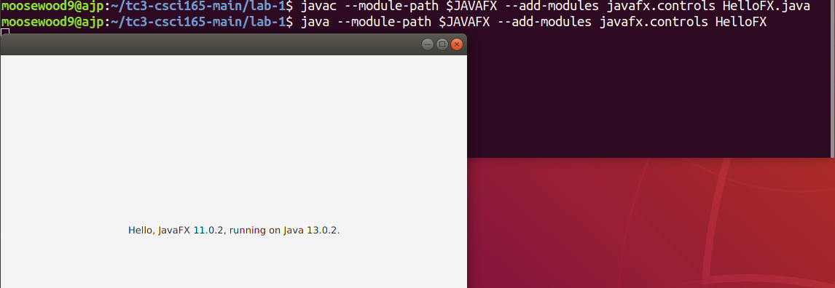

HelloWorld

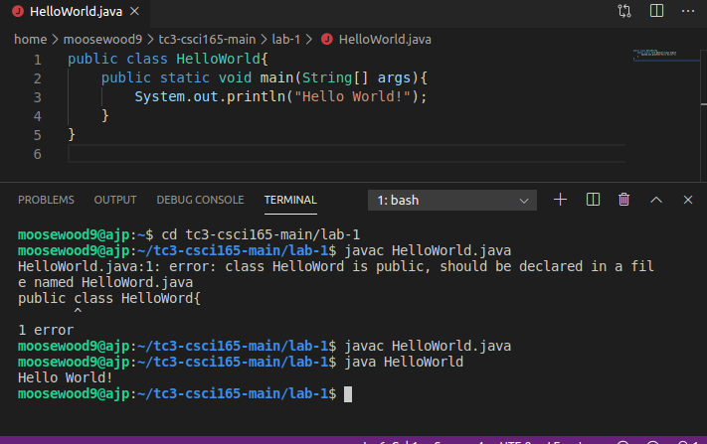

1. Puzzle Problem: Suppose your little sister asks you to show her how to use a pocket calculator so that she can calculate her homework average in her science course. Describe an algorithm that she can use to find the average of 10 homework grades.
- Create a variable to contain the sum of the numbers
- create a loop that will loop 10 times, or for the total number of sums
  - ask for a number input on each loop, add input to the sum variable
- Once loop has ran 10 times, divide the sum variable by the number of times the loop ran, to get the average

2. Puzzle Problem: A Caesar cipher is a secret code in which each letter of the alphabet is shifted by N letters to the right, with the letters at the end of the alphabet wrapping around to the beginning. For example, if N is 1, when we shift each letter to the right, the word daze would be written as ebaf. Note that the z has wrapped around to the beginning of the alphabet. Describe an algorithm that can be used to create a Caesar encoded message with a shift of 5.
- create string variable for text
- create shift, N variable == 5
- convert each character to ascii,
- (ascii +5 – 65)% 26 + 65
- convert the result back to characters

3. Puzzle Problem: Suppose you received the message, “sxccohv duh ixq,” which you know to be a Caesar cipher. Figure out what it says and then describe an algorithm that will always find what the message said regardless of the size of the shift that was used.
- Message reads “puzzlez are fun”
- Create a loop mimicking the above algorithm, each loop would add +1 to the shift, starting at one,
- user will input accept or decline resulting shift, loop will continue until result is accepted

4. Puzzle Problem: Suppose you’re talking to your little brother on the phone and he wants you to calculate his homework average. All you have to work with is a piece of chalk and a very small chalkboard—big enough to write one four-digit number. What’s more, although your little brother knows how to read numbers, he doesn’t know how to count very well so he can’t tell you how many grades there are. All he can do is read the numbers to you. Describe an algorithm that will calculate the correct average under these conditions.
- Create a sum variable
- Each grade input will be normal but each grade entered will add 1000 to the sum as a counter
- once all grades are added, divide total by 1000 to determine number of grades counted
- subtract the resulting count number multiplied by 1000 from the total sum, then divide by the count

5. Determine the Output: Suppose N is 15. What numbers would be output by the following pseudocode algorithm?
0 => Print N.
1 => If N equals 1, stop.
2 => If N is even, divide it by 2.
3 => If N is odd , triple it and add 1.
4 => Go to step 0.
- 15
  - 15*3 + 1 = 46
- 46
  - 46/2 = 23
- 23
  - 23* 3 + 1 = 70
- 70
  - 70/2 = 35
- 35
  - 35 * 3 + 1 = 106
- 106
  - 106 / 2 = 53
- 53
  - 53 * 3 + 1 = 160
- 160
  - 160 / 2 = 80
- 80
  - 80 / 2 = 40
- 40
  - 40 / 2 = 20
- 20
  - 20 / 2 = 10
- 10
  - 10 / 2 = 5
- 5
  - 5 * 3 + 1 = 16
- 16
  - 16 / 2 = 8
- 8
  - 8 / 2 = 4
- 4
  - 4 / 2 = 2
- 2
  - 2 / 2 = 1
- 1
6. Determine the Output: Suppose N is 6. What would be output by the algorithm in that case?
- 6
  - 6 / 2 = 3
- 3
  - 3 * 3 + 1 = 10
- 10
  - 10 / 2 = 5
- 5
  - 5 * 3 + 1 = 16
- 16
  - 16 / 2 = 8
- 8
  - 8 / 2 = 4
- 4
  - 4 / 2 = 2
- 2
  - 2 / 2 = 1
- 1

