**Case**

The Diamond market is highly brand and quality conscious market. Jewelers choose their source very carefully as any compromise on quality or dubious transaction can wipe the jeweler out of the market. Tribhuvan Das Javeri is a family business in the name and style of Javeri Brothers in Hyderabad selling diamonds to affluent VIP customers. They source their diamonds from Musadilal Tibarumal of Surat. The cost of standard one carat VS2 clarity, H color diamond is Rs. 240,000. Javeri brothers felt that they may be paying more to Musadilal. They also know that diamond prices vary widely based on many uncontrollable factors. They made calls to their contacts in Mumbai Diamond market and obtained the following prices for the above standard diamond there.

|  |  |  |  |  |  |  |
| --- | --- | --- | --- | --- | --- | --- |
| 222600 | 268680 | 224400 | 240300 | 240000 | 231180 | 241020 |
| 225000 | 244500 | 243600 | 256200 | 274200 | 228000 | 220320 |

**Answer:**

Since changing supplier is a very painful process, they want to be extremely careful in their decision. They engaged you as a consultant to carefully analyze the data given and help them make a decision to replace or continue with Musadilal Tibarumal.

**Objective**:

To make a decision to (or not to) replace the supplier. To decide to replace the supplier if the price per carat is statistically significantly higher than market price. The value of population parameter under NULL hypothesis μ0 = 200000.

**Assumptions:**

Normal distribution of prices assumed.

**Requirements:**

The decision to replace is very critical. Therefore we need to reduce the possibility of type I error. Therefore choose a low confidence coefficient (alpha) = 0.01.

**Hypotheses:**

H0: μ ≤ 200000

Ha: μ > 200000

We will admit the claim that μ > 270000 if we reject NULL hypothesis.

**Rejection region:**

This is a right tail test. So the rejection region is 0.01 (α) area on the right hand side of the pdf curve.

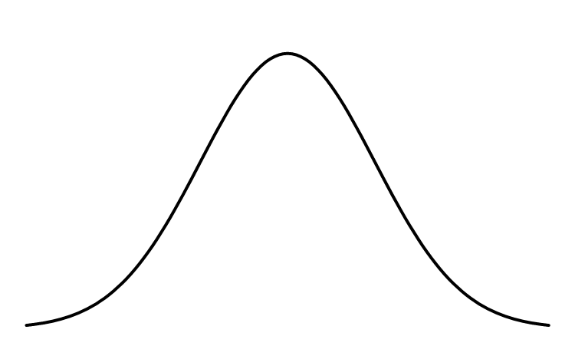

Rejection region. Area = 0.01

200000

**Test Results:**

|  |  |  |  |
| --- | --- | --- | --- |
| mu0 | 200000 |  |  |
| H0 | ❍ |  | 200000 |
| Ha | ❍ |  | 200000 |
| Test Type | 1 Tail |  | RT |
| Sample size | n |  | 14 |
| Degrees of freedom | df |  | 13 |
| Test Statistic (normality assumed,  estimated) | t |  | t |
| Confidence level | CL |  | 99% |
| Alpha |  |  | 0.01 |
| t critical | t |  | 3.012276 |
| x bar | x |  | 240000 |
| sample standard deviation | s |  | 16800.13 |
| Standard Error | SE |  | 4490.024 |
| t | t |  | 8.908638 |
| p-value | p(t) |  | 0.0000 |

**Conclusion:**

Since observed value of t statisitc (8.91) is far greater than critical value of t at 99% confidence level (t-critical = 3.01), we reject the null hypothesis. There is enough statistical evidence for over pricing. The alternate hypothesis is accepted and action recommended to replace the supplier.