**RECURSO 180 (07_13)**

**F13**

**Imagen derecha Imagen 1**

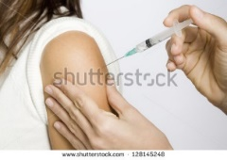 **128145248**

**Imagen derecha Imagen 2**

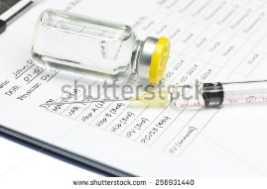 [256931440](http://www.shutterstock.com/pic-256931440/stock-photo-vaccination-record-with-syringe-and-medication-vial-document-and-information-therein-is.html?src=IVXBR_2V_DaXa4X1NvJoVQ-3-28)

**Imagen derecha Imagen 3**

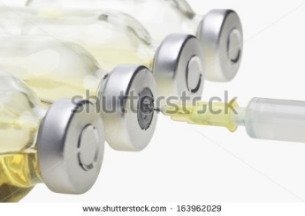 163962029

**Imagen derecha Imagen 4**

[98521067](http://www.shutterstock.com/pic-98521067/stock-photo-british-nurse-giving-injection-to-child.html?src=ExDINU79bsqv5h4V8YhZ7A-1-40)